|  |  |  |
| --- | --- | --- |
| **LAB101 Assignment** | **Type:** | **Short Assignment** |
| **Code:** | **C.S.P0045** |
| **LOC:** | **32** |
| **Slot(s):** | **1** |

**Title**

String Array Manipulations.

**Background**

N/A

**Program Specifications**

Implement a program with the following functions:

* Input a string element (ex: people name) in a string array (up to 50 elements).
* Output the string array
* Sort the string array in ascending orders alphabetically.
* Output the sorted string array.

***Function details:***

* Input the size for the string array.
* Ask users to input a number of string corresponding to the inputted size
* Output the array elements with preceding ordered numbers.

***Expectation of User interface:***

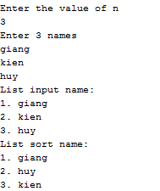

**Guidelines**

Use bubble sort algorithm to sort the array.