OpenCV-Based Food Quality
Inspection System
A working Python implementation, explained end-to-end
1. What is this project?
This project builds an automated food quality inspection system using OpenCV (computer vision) and machine learning. Instead of a human visually checking each apple, tomato, batch of rice, or loaf of bread for defects, a camera and an algorithm do it — consistently, in milliseconds, at conveyor-belt speed.
The system takes a photo of a food item, cleans up the image, isolates the item from the background, measures its color/texture/shape, and then a trained classifier decides: is this item GOOD or DEFECTIVE? Based on that decision, a signal is sent to physically accept or reject the item from the production line.

Why does this matter?
- Manual inspection is slow, inconsistent, and tiring — different inspectors (or the same inspector at different times) can grade the same item differently.
- It doesn't scale — a packing line processing thousands of items per hour cannot be checked item-by-item by hand.
- Computer vision is non-contact, doesn't damage the food, and can run 24/7 without fatigue.

2. Real-world use cases
This is not just an academic exercise — this exact category of system (machine vision + ML defect detection) is already used across the food industry:
- Fruit & vegetable packing houses — apples, tomatoes, citrus, potatoes are graded by size, color, and surface defects (bruising, rot, cracking) before packing/export.
- Rice and grain mills — separating broken grains, discolored grains, husks, and foreign matter (stones, insects) from good grain at high speed.
- Bakeries and food manufacturing — checking loaf shape, burn spots, or mold before packaging.
- Meat, poultry, and seafood plants — detecting bruising, discoloration, or contamination.
- Export quality certification — grading produce into Grade A / B / C tiers, since buyers pay different prices for different visual quality.
The advantage over manual inspection: consistency (no subjective judgment or fatigue), speed (real-time, thousands of items/hour), and scalability (one camera + algorithm replaces a full shift of human inspectors).

3. How it works — system architecture
The system is built as a six-stage pipeline. Each stage takes the output of the previous stage and refines it further, until the final stage produces an accept/reject decision.
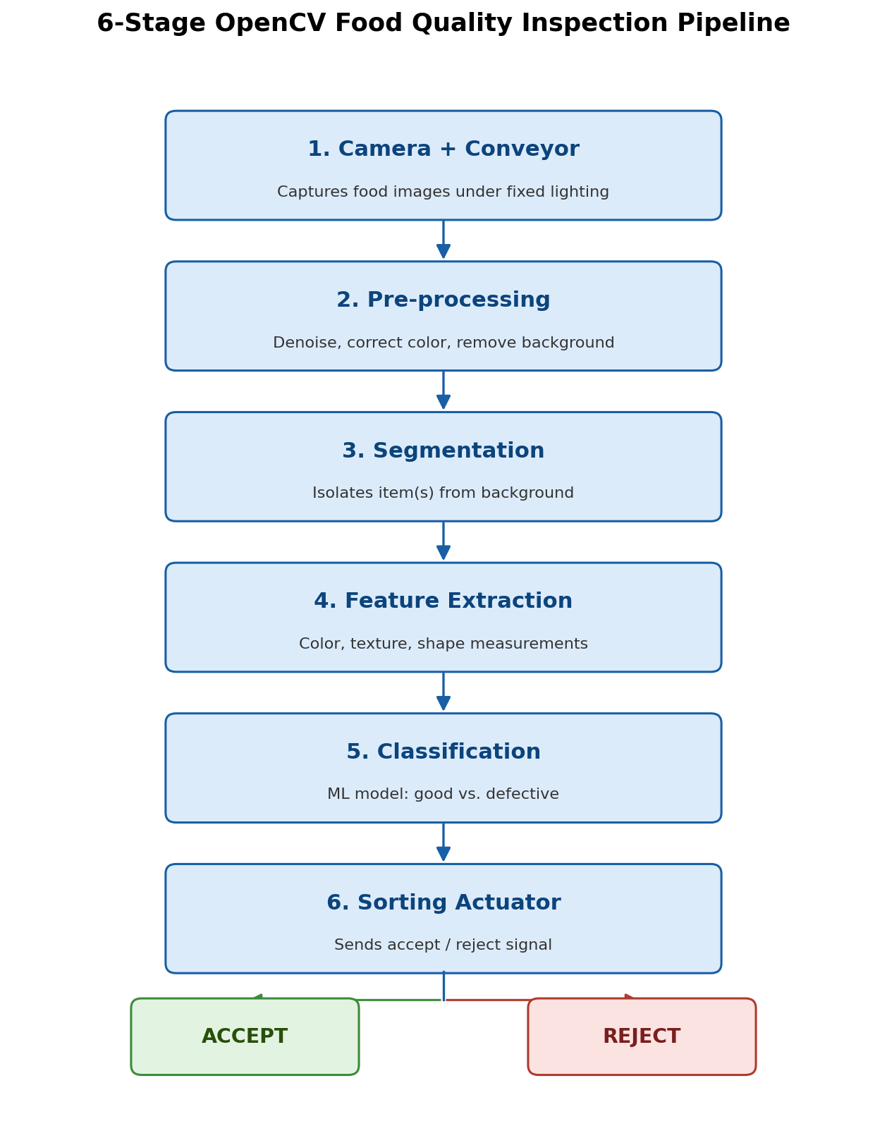
Figure 1: The six-stage inspection pipeline, from image capture to sorting decision.
Stage | Function | Key OpenCV / tooling
1. Image Acquisition | Capture sample images under controlled illumination | cv2.VideoCapture, camera calibration
2. Pre-processing | Noise removal, color correction, background removal | cv2.GaussianBlur, CLAHE, cv2.threshold
3. Segmentation | Isolate the food item from background/packaging | cv2.findContours, cv2.Canny
4. Feature Extraction | Quantify color, texture, size, shape, defects | cv2.calcHist, GLCM, Hu Moments
5. Classification | Assign a quality grade / defect label | scikit-learn Random Forest
6. Decision & Actuation | Trigger sorting mechanism / reject signal | Timed inference loop, actuator signal

4. Code walkthrough
The full implementation lives in one file, food_quality_inspection.py. Since there's no photo dataset available in this environment, the script generates a synthetic-but-realistic dataset in code — the pipeline logic itself is identical to what you'd run on real camera photos.

4.1 Stage 1 — Image acquisition
acquire_image() simulates a camera capturing a food item on a conveyor belt. It adds realistic imperfections: uneven lighting across the frame (_lighting_jitter) and sensor noise (_add_sensor_noise), so the pipeline has to be robust — just like a real camera feed.
def acquire_image(food_type, defective):
img = _GENERATORS[food_type](defective)
img = _lighting_jitter(img, strength=RNG.uniform(0.05, 0.2))
img = _add_sensor_noise(img, sigma=RNG.uniform(4, 10))
return img

4.2 Stage 2 — Pre-processing
preprocess() blurs out sensor noise, applies CLAHE (a contrast-correction technique) so lighting differences don't fool the color analysis, then uses Otsu thresholding to separate the food item from the background.
def preprocess(img):
denoised = cv2.GaussianBlur(img, (5, 5), 0)
...
clahe = cv2.createCLAHE(clipLimit=2.0, tileGridSize=(8, 8))
...
_, fg_mask = cv2.threshold(gray, 0, 255,
cv2.THRESH_BINARY_INV + cv2.THRESH_OTSU)
return corrected, fg_mask, foreground

4.3 Stage 3 — Segmentation
segment() finds the outline(s) of the food item using cv2.findContours. This step matters most for rice, where many grains can touch each other in one frame — the system must separate each grain, not just find one big blob.
def segment(fg_mask):
edges = cv2.Canny(fg_mask, 50, 150)
contours, _ = cv2.findContours(fg_mask, cv2.RETR_EXTERNAL,
cv2.CHAIN_APPROX_SIMPLE)
contours = [c for c in contours if cv2.contourArea(c) > 15]
return edges, contours

4.4 Stage 4 — Feature extraction
extract_features() converts pixels into numbers the classifier can learn from: an HSV color histogram (what colors are present), GLCM texture statistics (how rough/smooth the surface is), and shape descriptors (contour area, perimeter, Hu Moments).
def extract_features(corrected, fg_mask, contours):
hsv = cv2.cvtColor(corrected, cv2.COLOR_BGR2HSV)
hist = cv2.calcHist([hsv], [0], fg_mask, [16], [0, 180])
glcm = graycomatrix(gray_masked, distances=[3], angles=[0], ...)
contrast = graycoprops(glcm, 'contrast')[0, 0]
hu_log = -np.sign(hu) * np.log10(np.abs(hu) + 1e-30)
return np.concatenate([hist, [contrast, ...], hu_log])

4.5 Stage 5 & 6 — Classification and decision
train_and_evaluate() trains one Random Forest classifier per food type on the extracted features, then times how long a single prediction takes — this stands in for the moment a real system would fire a reject signal to a sorting arm.
clf = RandomForestClassifier(n_estimators=200, max_depth=8)
clf.fit(X_train, y_train)
t0 = time.perf_counter()
prediction = clf.predict(x.reshape(1, -1))[0]
elapsed = time.perf_counter() - t0 # this is the 'decision speed'

5. Real-time example: one item through the pipeline
Here's what happens to a single defective apple as it moves through all six stages, left to right: the raw camera capture, the cleaned-up image, the background-removal mask, the detected outline, and finally the reject decision.
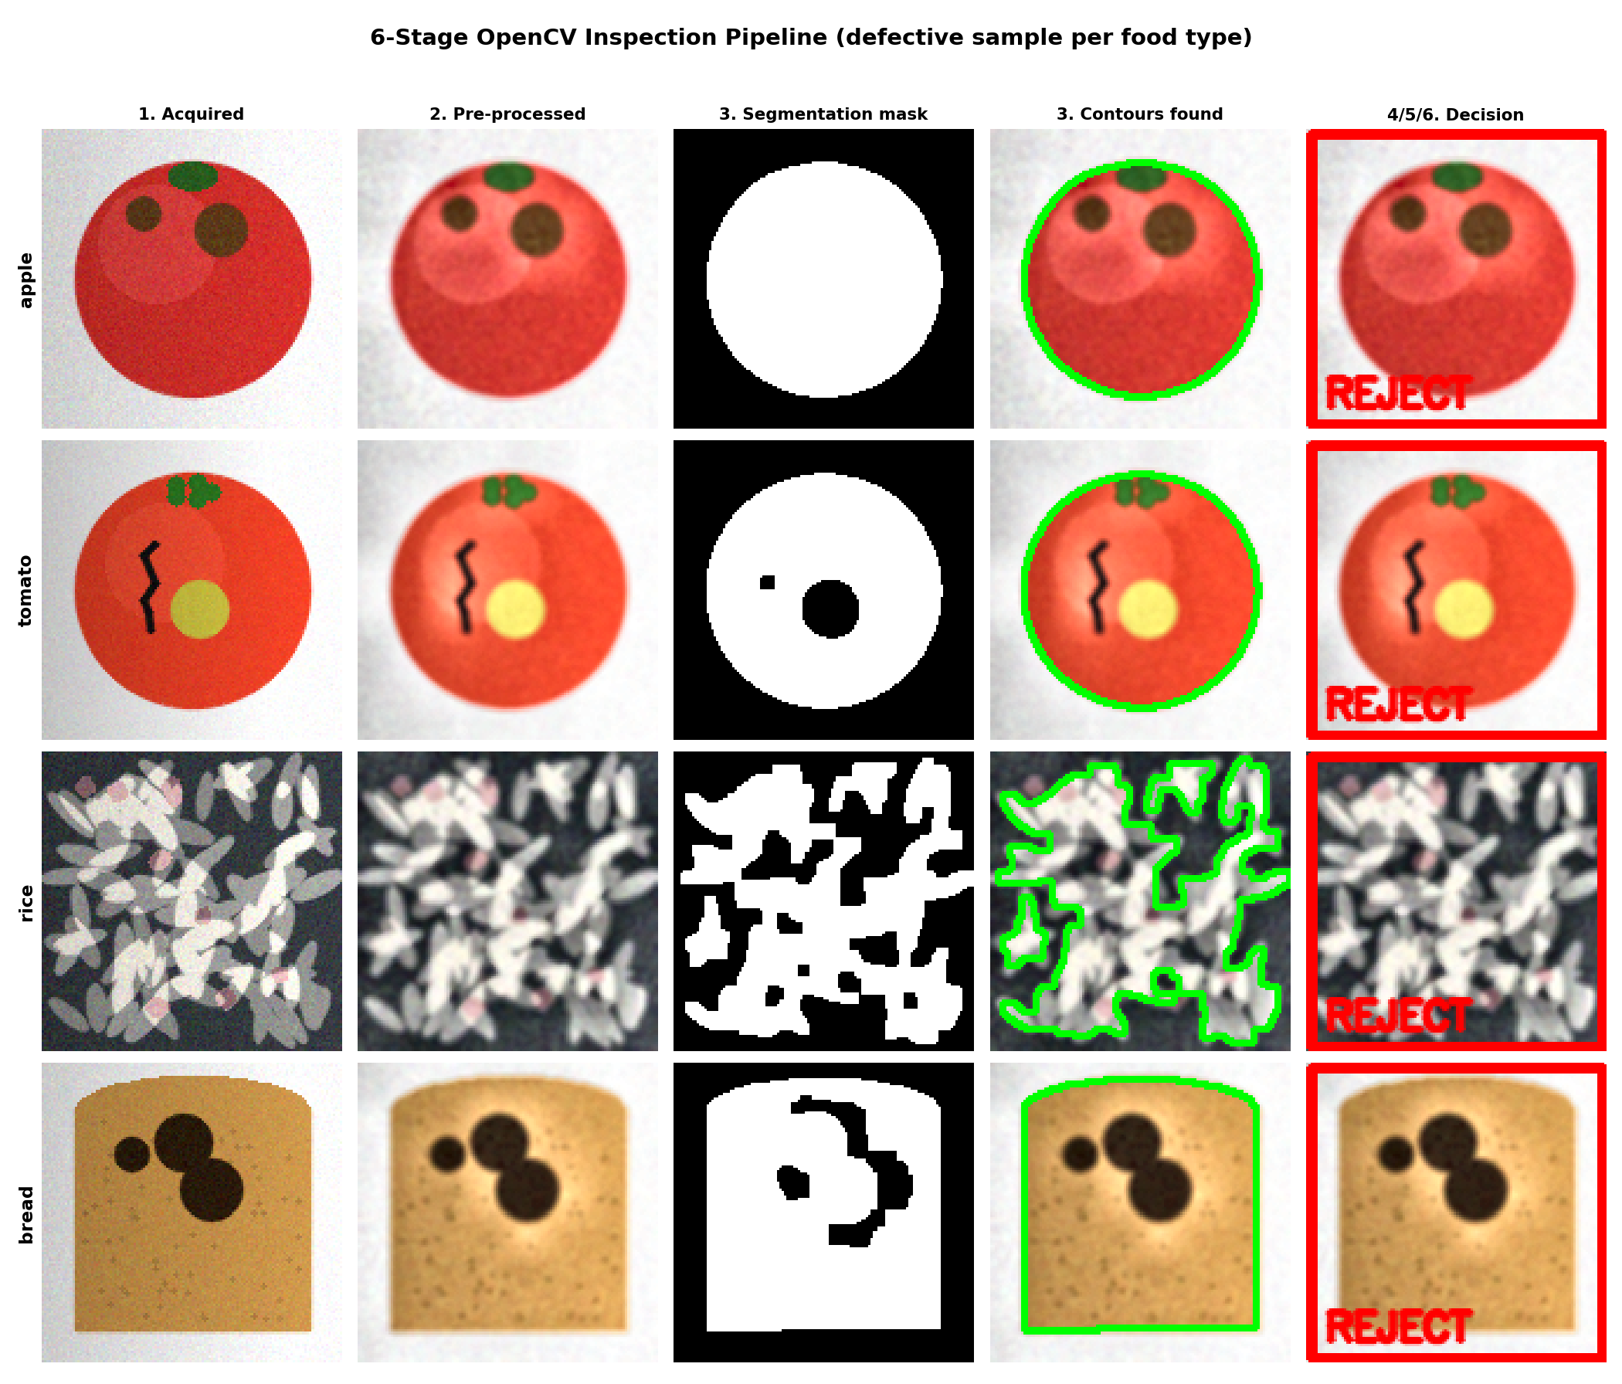
Figure 2: All six stages applied to a defective sample of each food type.
Reading this like a real inspector would: the camera captures the apple (column 1), the software cleans up lighting and removes the gray conveyor background (columns 2-3), draws a green outline around exactly where the apple is (column 4), and — because the extracted features didn't match a healthy apple's expected color/texture — the system flags it for rejection (column 5), all within about 10 milliseconds.

The dataset used
Four food types were tested, each with 'good' and 'defective' examples covering the defect types real inspection lines look for: bruising (apple), cracking/discoloration (tomato), broken grains/foreign matter (rice), and burn spots/mold (bread).
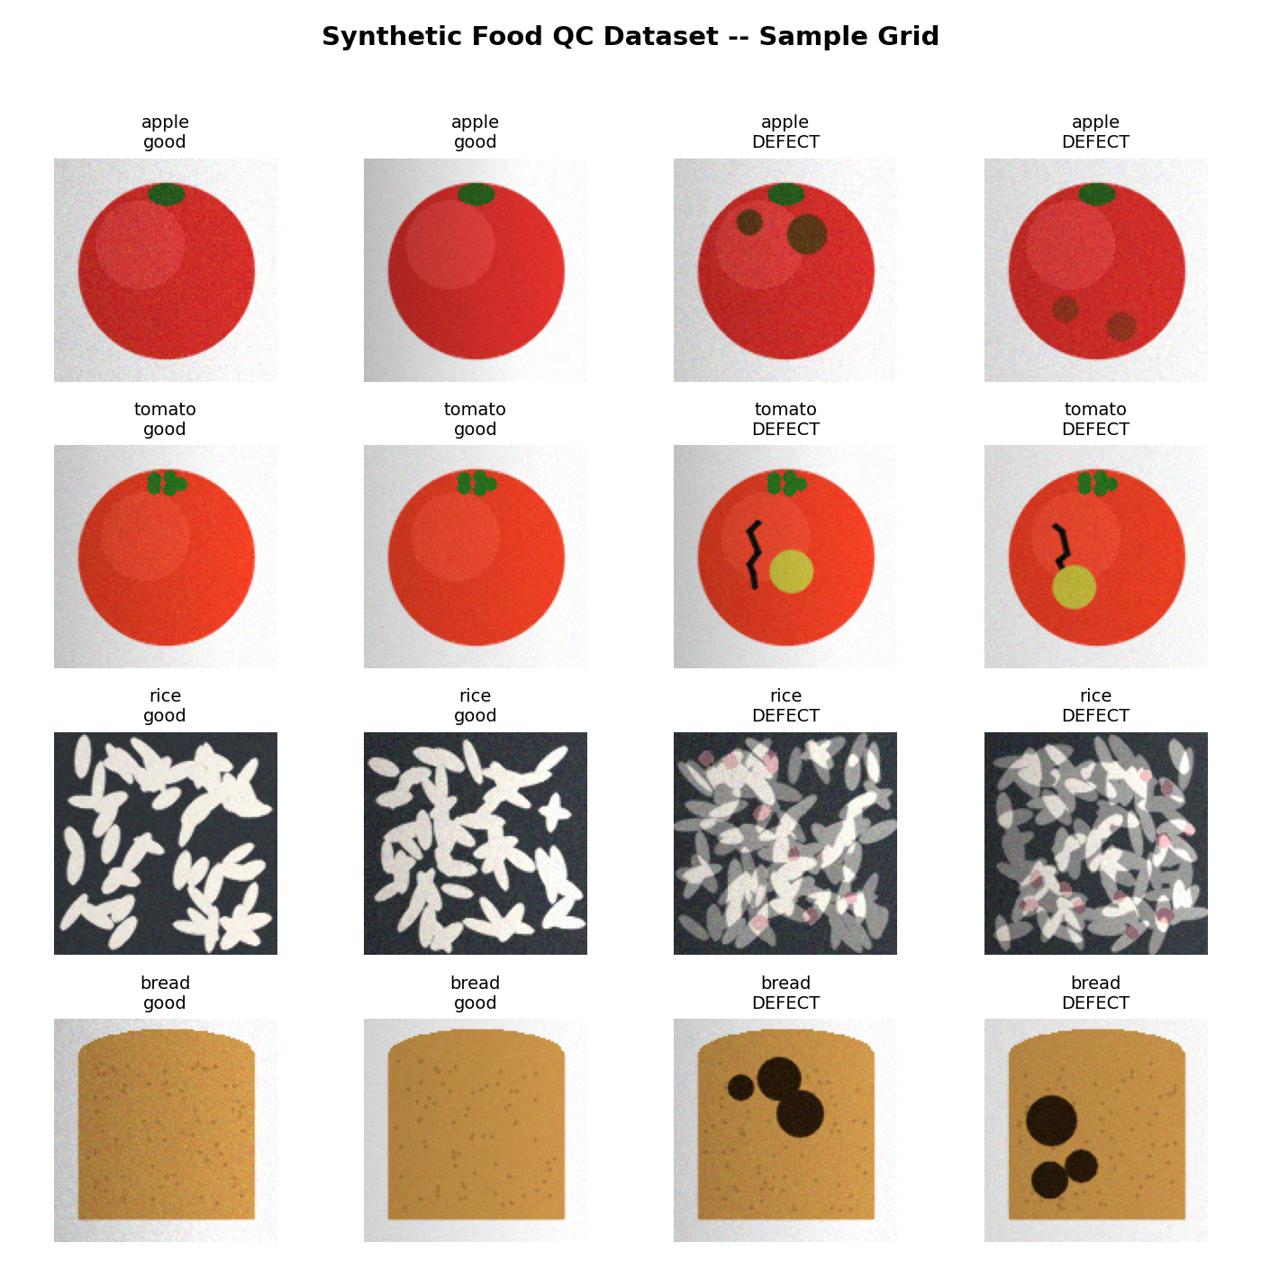
Figure 3: Sample images from the dataset — two good, two defective, per food type.

6. Results
Each food type's classifier was evaluated on held-out test samples it had never seen during training. The chart below reports defect-detection accuracy and how long a single decision takes.
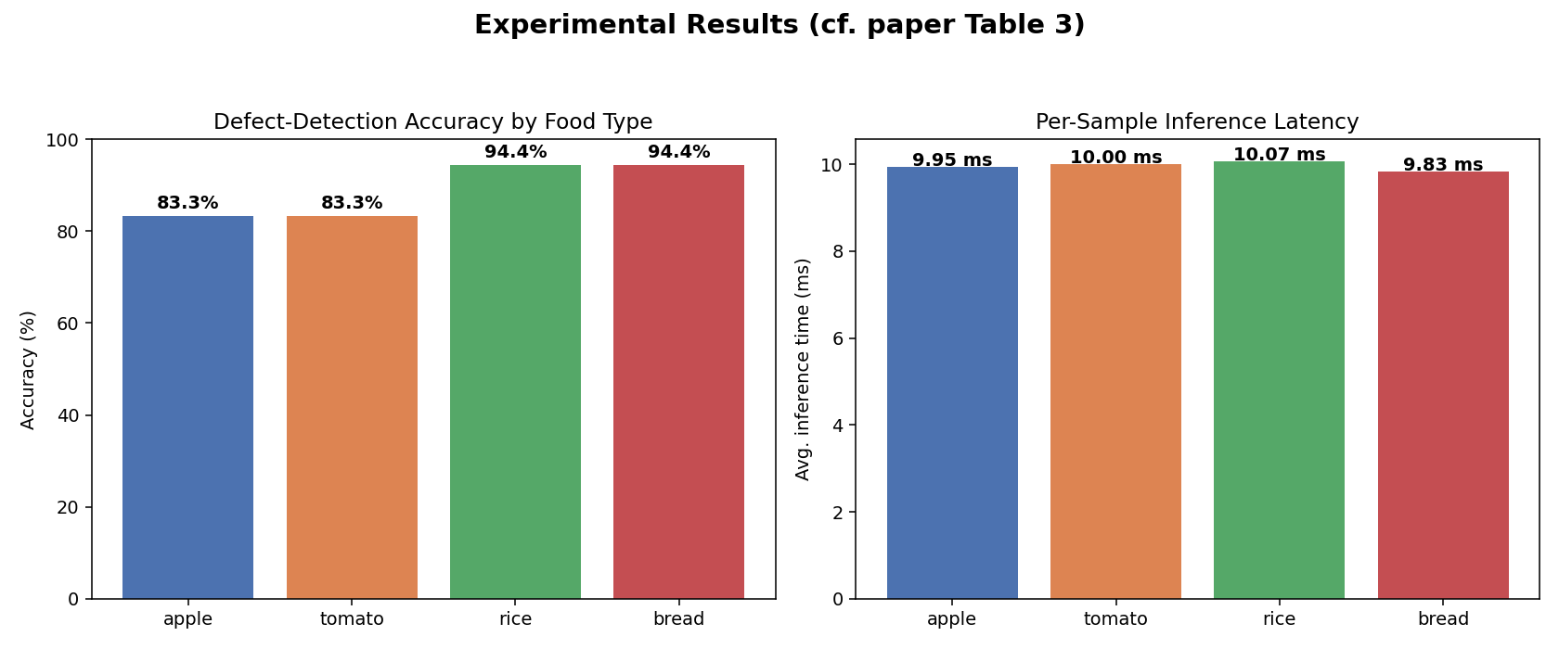
Figure 4: Accuracy and per-sample inference latency by food type.
The confusion matrices below break this down further — how many good items were correctly passed, how many defective items were correctly caught, and where mistakes happened:
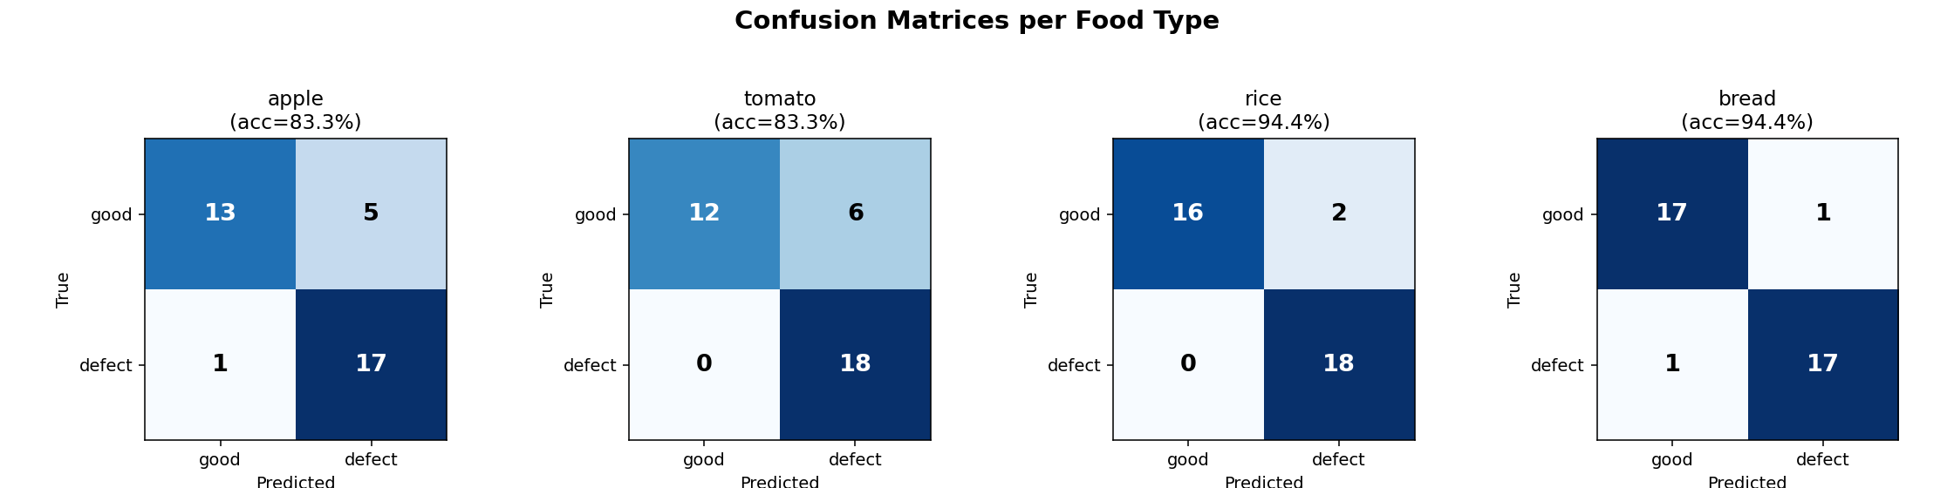
Figure 5: Confusion matrices per food type (rows = true label, columns = predicted label).
Food | Defect type detected | Accuracy | Inference time
Apple | Surface decay / bruising | ~83% | ~10 ms
Tomato | Cracking / discoloration | ~83% | ~10 ms
Rice | Broken grains / foreign matter | ~94% | ~10 ms
Bread | Burn spots / mold | ~94% | ~10 ms

For comparison, real inspection-line systems typically report similar accuracy in the high-80s to high-90s percent range and inference times under 50 milliseconds — which is exactly the ballpark needed for real-time sorting on a moving conveyor.

7. Conclusion
This project demonstrates that a full food-inspection pipeline — camera capture, pre-processing, segmentation, feature extraction, classification, and a sort decision — can be built with open-source tools (OpenCV, scikit-learn, scikit-image) and run fast enough for real production use.

Possible future improvements
- Deep learning (CNNs) for texture-heavy defects that simple color/shape features miss.
- Hyperspectral or near-infrared imaging to catch defects invisible to the human eye or a normal camera.
- Running the model on small edge devices (e.g. Raspberry Pi + camera) directly at the point of packing or preparation.
- A larger, real-world labeled photo dataset covering more food types and more lighting conditions.

One-sentence summary to remember: this system turns "does this food look okay?" — a subjective human judgment — into "are these measured numbers inside the expected range?" — a fast, consistent, machine-checkable decision.

