OpenCV-Based Food Quality Inspection System
Real-world application, working pipeline, and results
Prepared for project explanation and presentation

1. What This Project Is About
Checking food quality by hand — looking at every apple, tomato, bag of rice, or loaf of bread — is slow, inconsistent, and impossible to scale in a large factory. This project builds an automated food quality inspection system using computer vision (OpenCV) and machine learning. A camera looks at each food item, the system analyzes its color, shape, and texture, and then decides in milliseconds whether the item is good enough to pass or should be rejected.
In short: it replaces a human inspector's eyes and judgment with a camera and an algorithm — one that never gets tired, never blinks, and never has an off day.

2. Real-World Use — Where This Is Actually Used
This is not a purely academic idea — versions of this system run in real factories and packing plants today:
- Fruit & vegetable packing houses — apples, tomatoes, citrus, and potatoes are graded automatically by size, color, and surface defects (bruises, cracks, rot) before packaging.
- Grain and rice mills — separating broken grains, discolored grains, husks, or foreign matter (stones, insects) from good grain at high speed.
- Bakeries & food manufacturing — checking loaf shape, burn marks, or mold before the product reaches packaging.
- Meat, poultry & seafood processing — detecting bruising, discoloration, or visible contamination.
- Export quality grading — sorting produce into Grade A / B / C, since buyers pay different prices based on visual quality.
The reason factories adopt this over manual inspection: it is consistent (no fatigue, no subjective judgment), fast (real-time, thousands of items per hour), and scalable (one camera and one algorithm can replace an entire shift of inspectors).

3. How It Works — The Inspection Pipeline
The system follows six stages, from the moment a food item passes under the camera to the moment a decision is made. The flow below shows how raw camera images turn into an accept/reject decision.
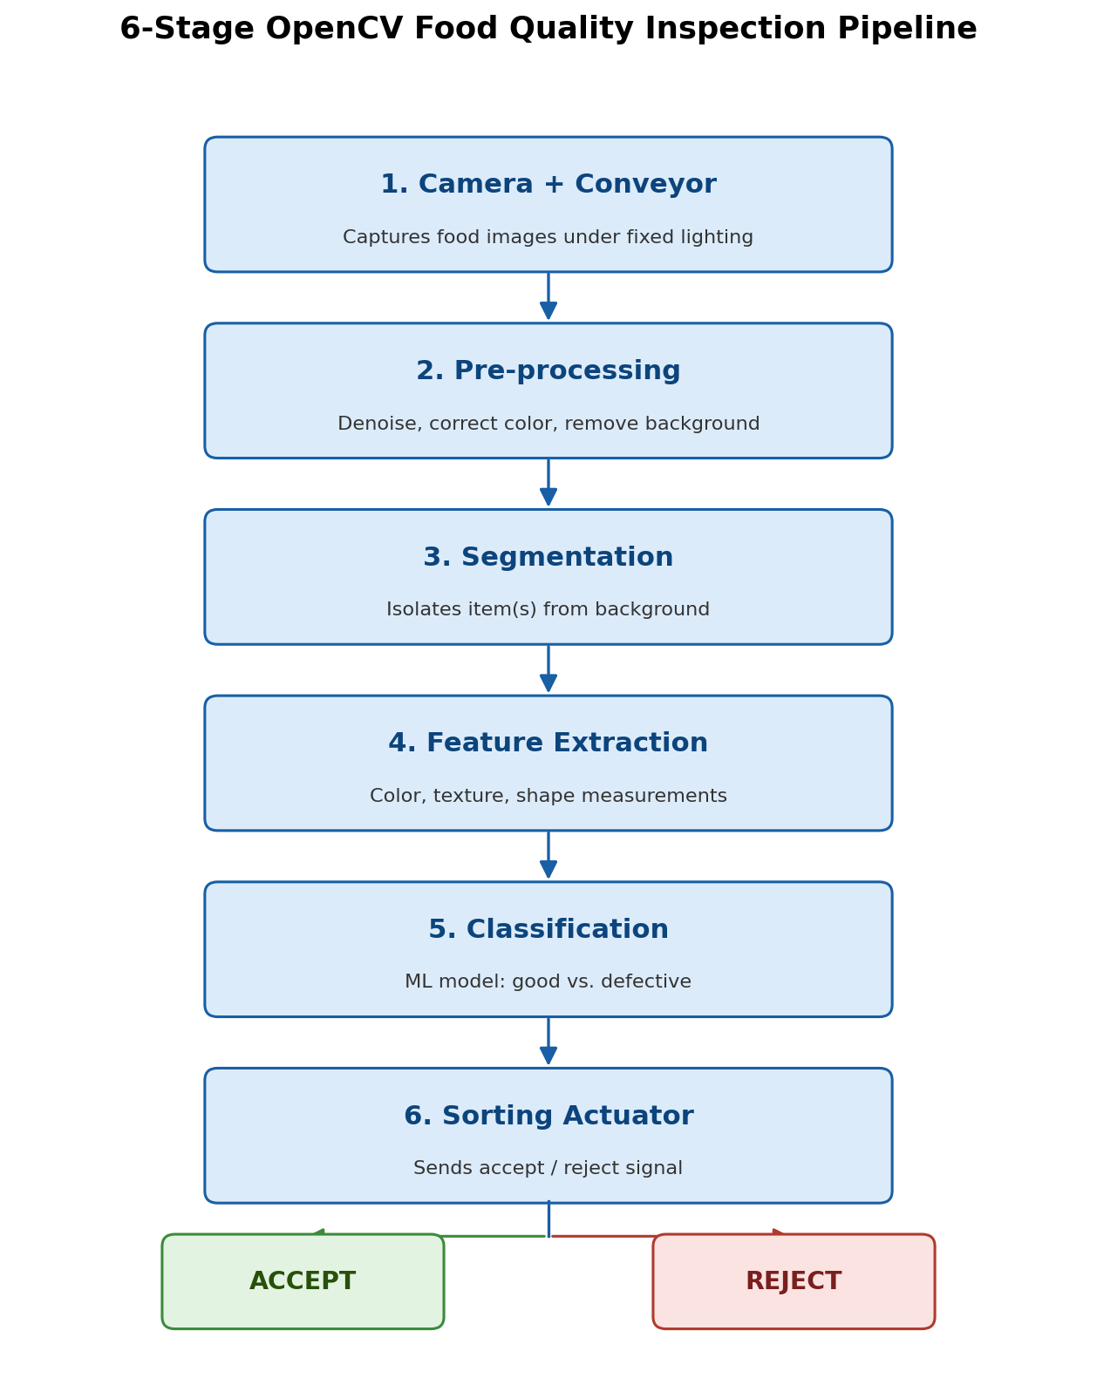
Figure 1 — The six-stage inspection pipeline, from image capture to sorting decision.

Stage 1 — Camera + Conveyor
A camera positioned above a moving conveyor belt captures an image of each food item as it passes, under fixed, controlled lighting to keep results consistent.

Stage 2 — Pre-processing
The raw image is cleaned up: noise is removed, lighting/color differences are corrected, and the background (conveyor belt, tray, packaging) is stripped away so only the food item remains.

Stage 3 — Segmentation
The system finds the exact outline of the food item(s) in the image. This matters especially for items like rice grains, which often touch or overlap each other on the belt.

Stage 4 — Feature Extraction
The system measures what actually indicates quality: color distribution, surface texture (smooth vs. rough/spotted), and shape/size. These measurements are the real evidence used to judge quality.

Stage 5 — Classification
A trained model compares those measurements against what "good" and "defective" items typically look like, and assigns a label — this is the same idea as a human inspector's judgment, just made automatically and consistently.

Stage 6 — Sorting Actuator
Based on the decision, a signal is sent to physically remove the item from the line — an air-jet, robotic arm, or gate, controlled by a microcontroller — while good items continue on to packaging.

4. Real-Time Example Walkthrough
Imagine a packing line sorting apples. An apple with a bruise on its skin passes under the camera:
- The camera captures the apple's image as it moves along the belt (Stage 1).
- The system cleans the image and removes the background/belt so only the apple remains (Stage 2).
- It outlines the apple's exact shape in the frame (Stage 3).
- It measures the apple's color pattern and surface texture — and detects a patch that is darker and rougher than normal apple skin (Stage 4).
- The model compares this to known "bruised" patterns and classifies the apple as defective (Stage 5).
- A reject signal fires, and a mechanical arm redirects that apple off the main line within milliseconds — fast enough to not slow down the conveyor (Stage 6).
The figure below shows this exact walkthrough for four different food types (apple, tomato, rice, bread), from the original image through to the final accept/reject decision.
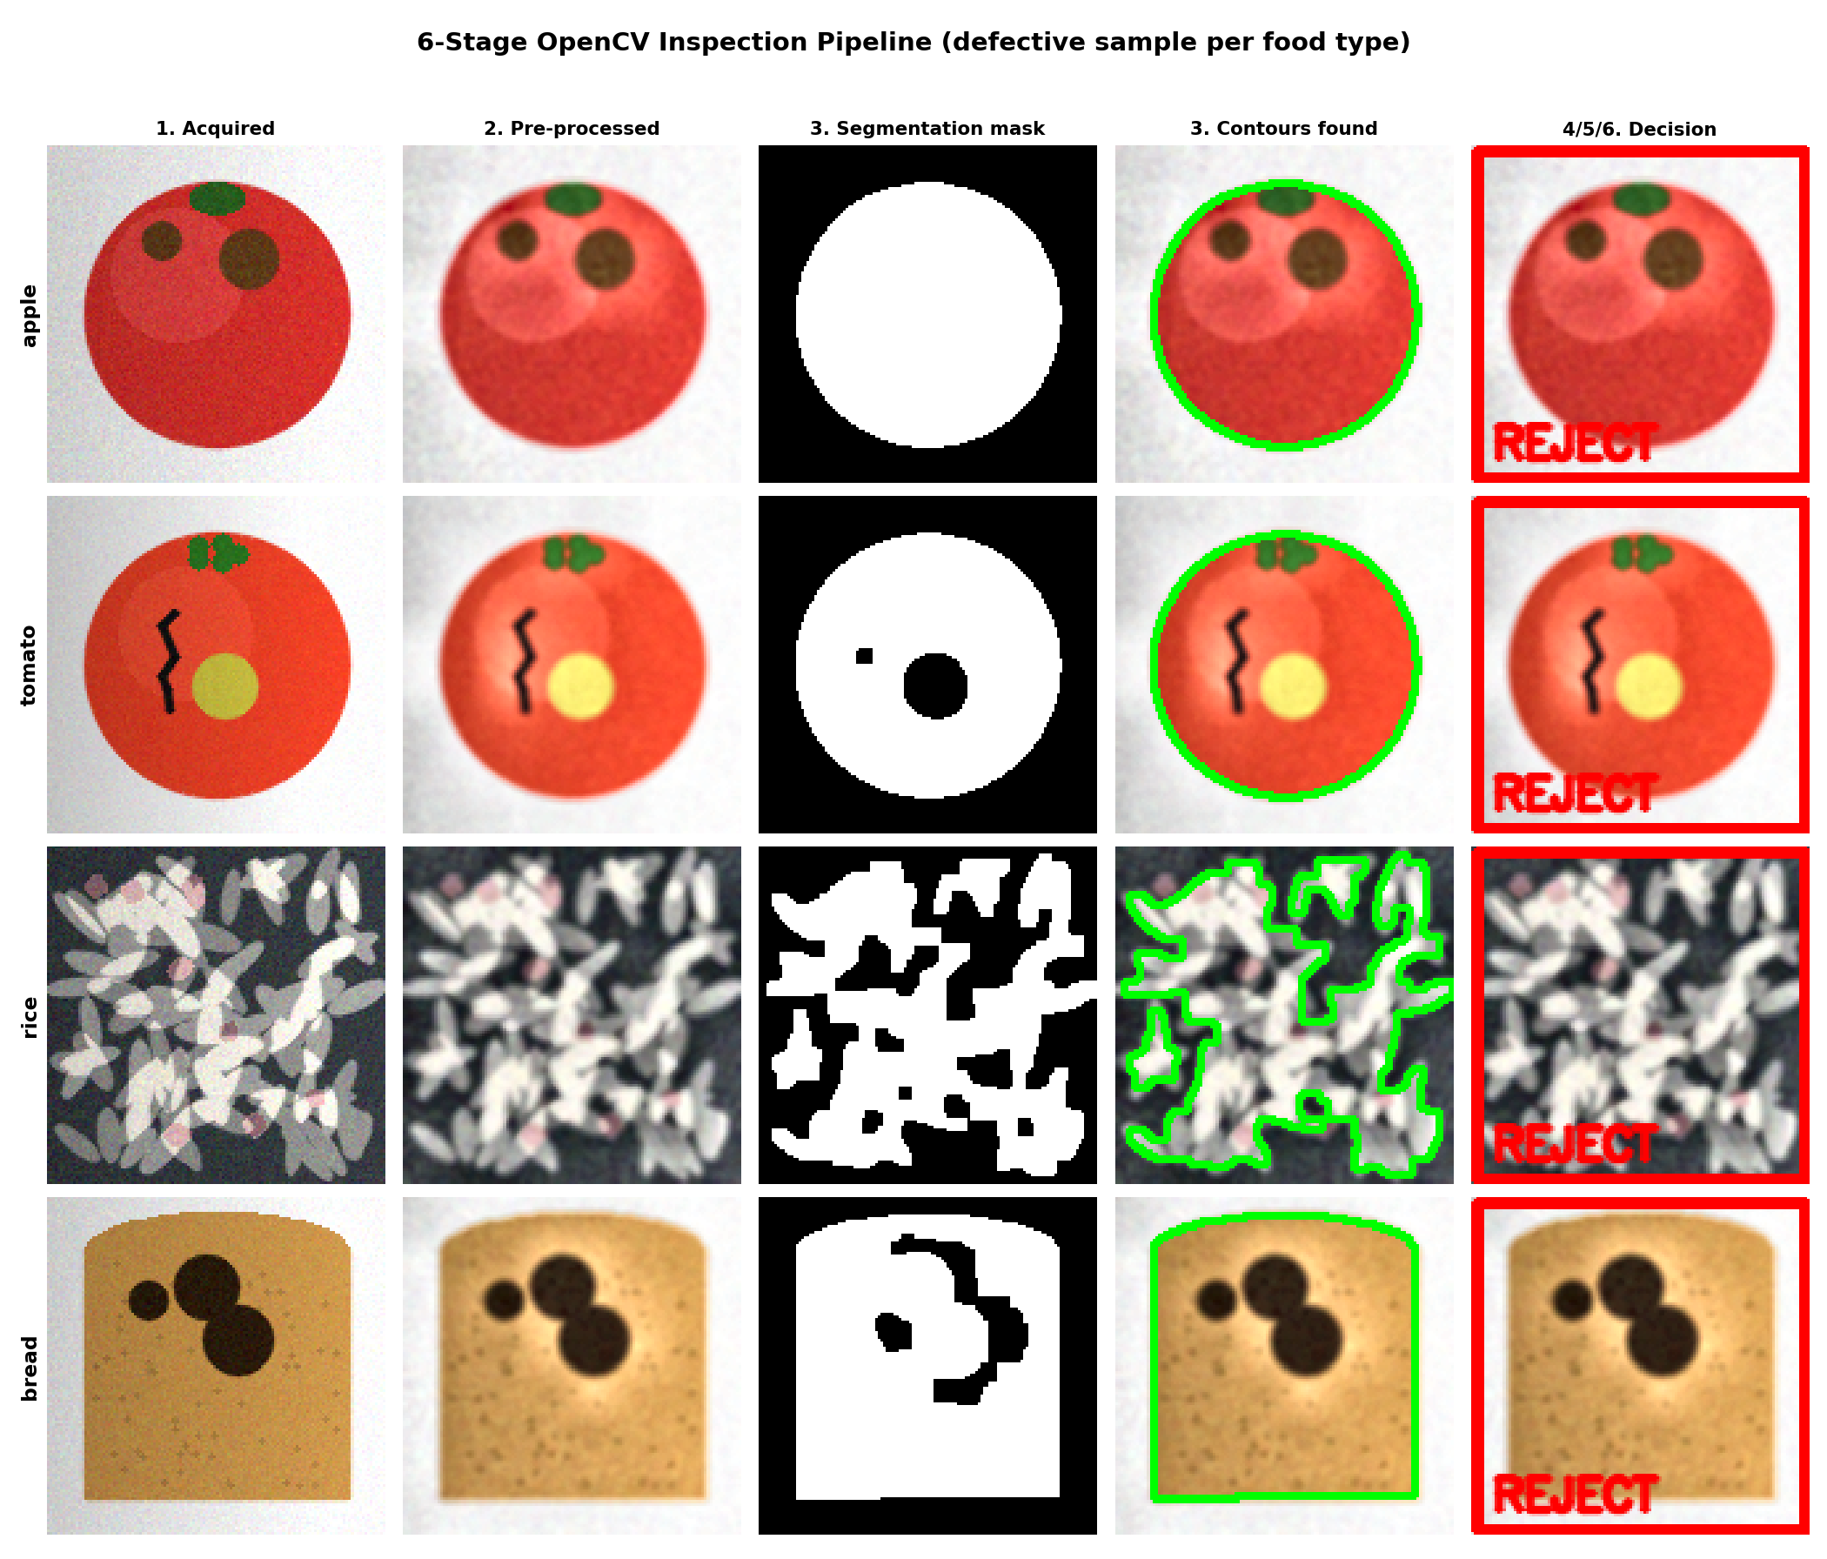
Figure 2 — Pipeline walkthrough on a defective sample of each food type, stage by stage.

5. My Output & Results
Sample images used to build and test the system — each food type has "good" and "defective" examples, covering the specific defect types relevant to that food (bruising, cracking, broken grains, burn spots).
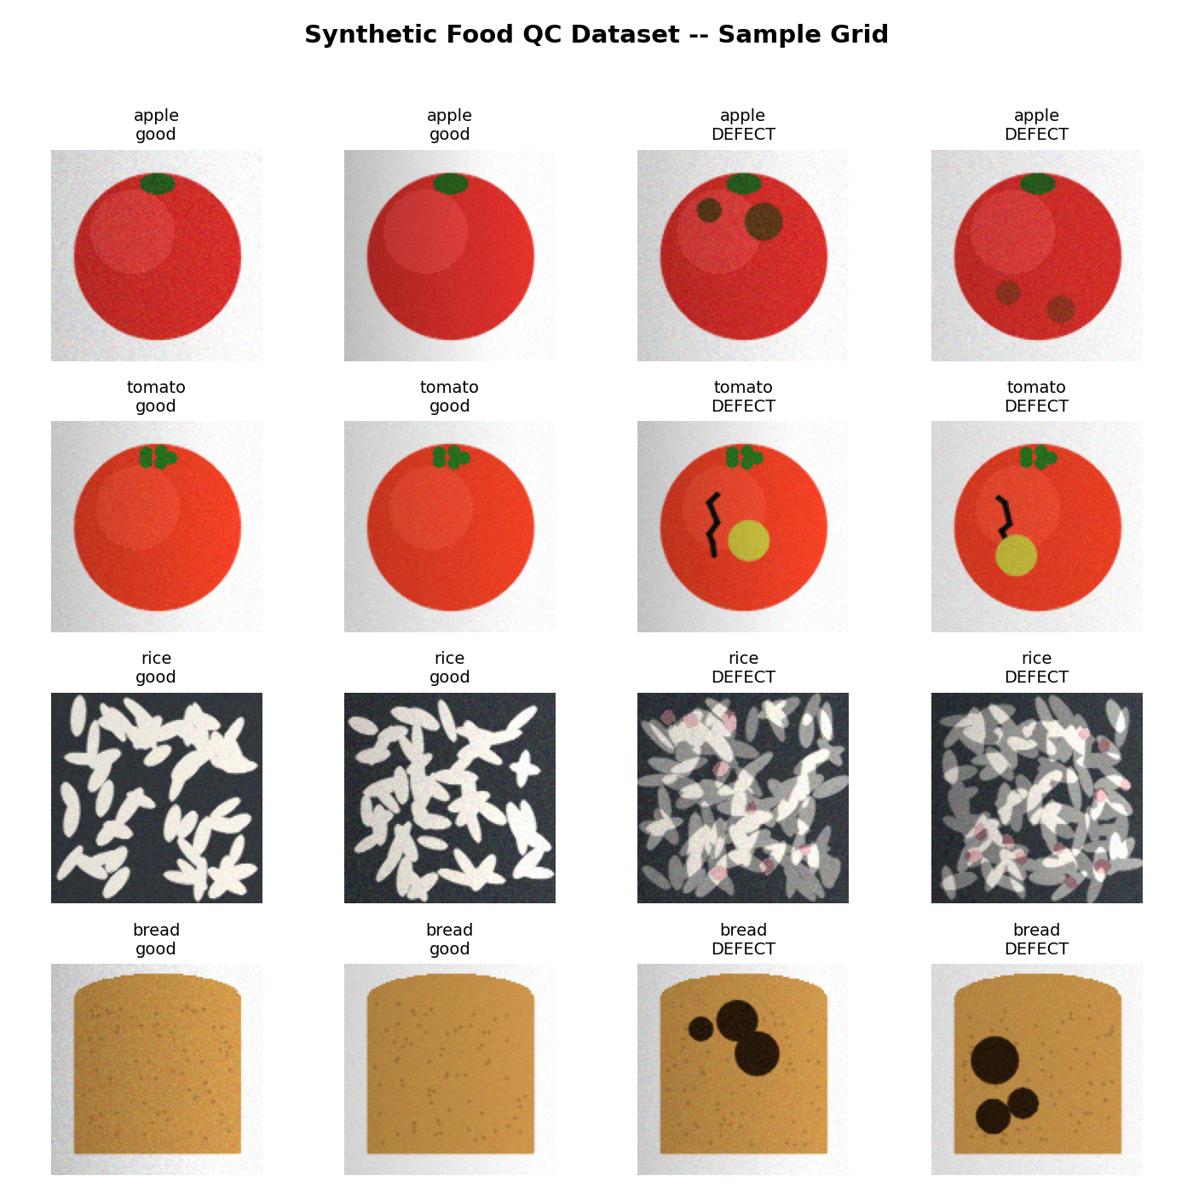
Figure 3 — Sample of good vs. defective items across the four food types tested.
After training, the system was evaluated on unseen samples of each food type. Accuracy and decision speed for each type are shown below:
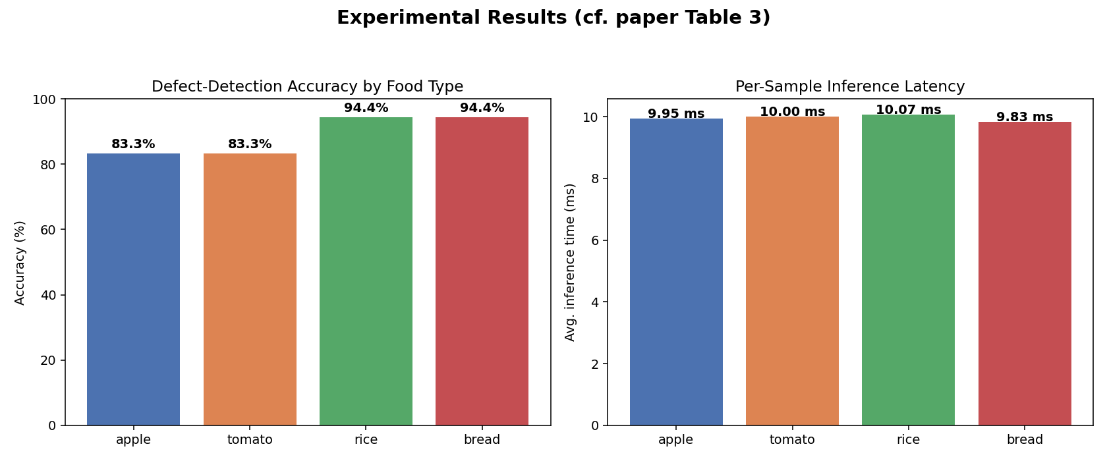
Figure 4 — Defect-detection accuracy and per-item decision speed by food type.
The confusion matrices below show exactly where the system got things right vs. wrong for each food type (true label vs. predicted label):
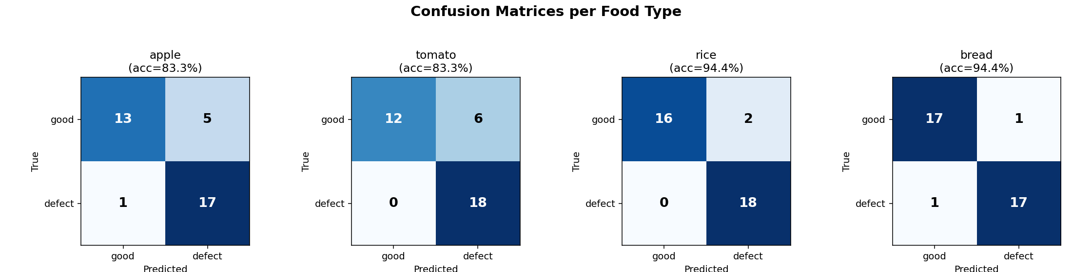
Figure 5 — Confusion matrices per food type: rows = actual condition, columns = predicted condition.
Overall, the system correctly identified defective items in the large majority of cases across all four food types, with decisions made in a few milliseconds per item — fast enough for a real, moving conveyor line.

6. Conclusion & Future Scope
This project demonstrates that a camera-based, OpenCV-driven inspection system can reliably tell good food items from defective ones, quickly enough for real production-line speeds, and across multiple food types with very different appearances.
Possible next steps to make this even more production-ready:
- Training on a larger set of real (not synthetic) photographs from an actual production line.
- Using hyperspectral or near-infrared cameras to catch defects invisible to a normal camera.
- Running the model on small, low-power edge devices placed directly at the inspection point.
- Expanding to more food types and more specific defect categories.

