修改element某一行的数据把当前行传过去，不能穿具体的值否则不会响应式更新
/**
* @Description: 设为已读
* @Author: fengyong
* @Date: 2020-05-15 15:44:29
*/

setAsRead(state) {
console.log(state);
state.readState = 1;
}
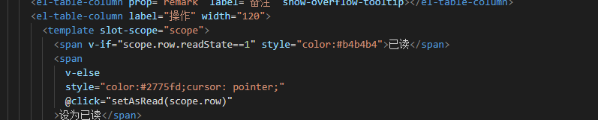
element分页器设置
:total="totalData"
:page-size="10"
@current-change="handleCurrentChange"
:current-page.sync="pageParams.page"
pageParams: {
cusName: null, //客户姓名
cusLink: null, //联系方式
brandName: null, //品牌名称
addTimeStart: null, //数据接收开始日期
addTimeEnd: null, //数据接收结束日期
readState: 1,
page: 1, //页数
size: 10 //显示条数
}

/**
* @Description:请求商户端首页数据
* @Author: fengyong
* @Date: 2020-05-15 17:39:48
*/
getHomeData() {
let params = this.pageParams;
this.$api.get("web/listProjectDataVo", params).then(data => {
if (data.code == 200) {
this.tableData = data.data.list;
console.log(data);
this.totalData = data.data.total;
}
});
},
/**
* @Description: 处理页数变化
* @Author: fengyong
* @Date: 2020-05-15 19:17:56
*/
handleCurrentChange(val){
this.pageParams.page = val
this.getHomeData()
}

