Smart Water Cleaning Robot
1.Sahil Jadhav
2.Suraj Patil
3.Shreyash Mali
4.Shrishailya Jangam⁴
MIT ADT University, Pune, India
Abstract.
River water pollution is a major Environmental concern. Reasons are Industrialization, Urbanization, mismanagement of waste disposal, Plastic remains, waste, and Chemicals. This leads to serious water contamination, harming aquatic and marine life as well as human health. Cleaning the river is only possible via heavy machinery, which leads to dependency of citizens on the government or municipal corporations. Some traditional methods require humans to swim and clean the river. These methods are slow, inefficient, and unsafe. To counter this, our paper proposes a Smart Water Cleaning Robot, which is an automated system created to function in the removal of waste from Water bodies and check the water quality. The system uses a conveyor and a net mechanism with multiple stages of purification of water. This will also look for the pH value, Turbidity, and total dissolved solids. There are various sensors connected to the ESP32/Raspberry Pi microcontroller. To collect data that will be further uploaded to the IoT cloud platform. The system is powered by solar energy, with a Li-Po battery backup. This ensures operations can be carried out in an outdoor environment. This device is cost-efficient, and it decreases dependency. Using this device, anyone can clean the river.
Introduction:
Today, river water pollution is becoming a major issue, leading to several problems that harm human beings and aquatic ecosystems in many ways. Collection of this plastic waste, garbage and industrial waste is also becoming a reason for unsafe water. Cleaning the river manually is very slow and time-consuming process. So, to overcome this problem, we are building an automated smart water cleaning robot. If we saw many traditional water cleaning robot depends on humans, it can be dangerous to go deep in water and required more efforts. So, there is a need of modern technologies which can help to prevent such conditions.
Problem Statement:
To design and develop smart water cleaning robot that can detect plastic waste, garbage and industrial pollutants from rivers and send real-time alerts.

Objective:
To clean water surface garbage (plastic, polythene, solids, debris) from rivers also it has water quality sensors such pH, TDS, turbidity sensors to analyze the water quality. For sustainability and to reduce dependency on electricity using solar energy to charge the battery. To ensure for low maintenance can be deploy to rural and semi-urban areas.
Circuit Diagram:
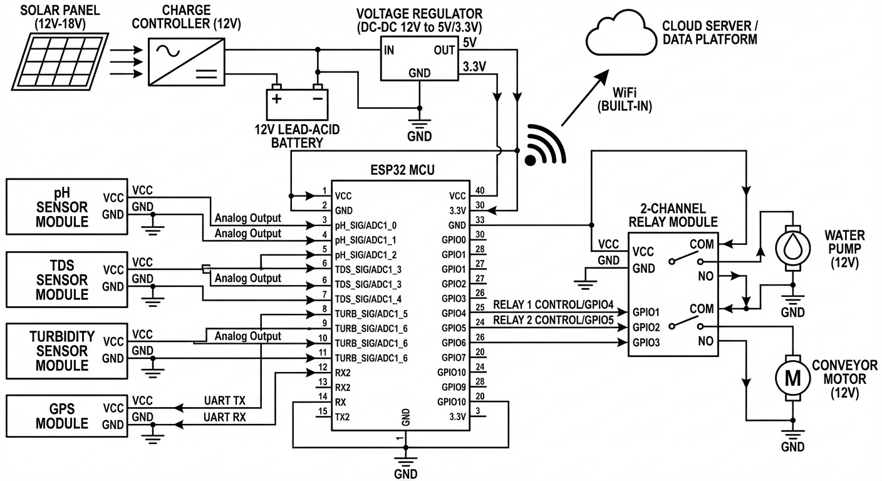

Block Diagram:

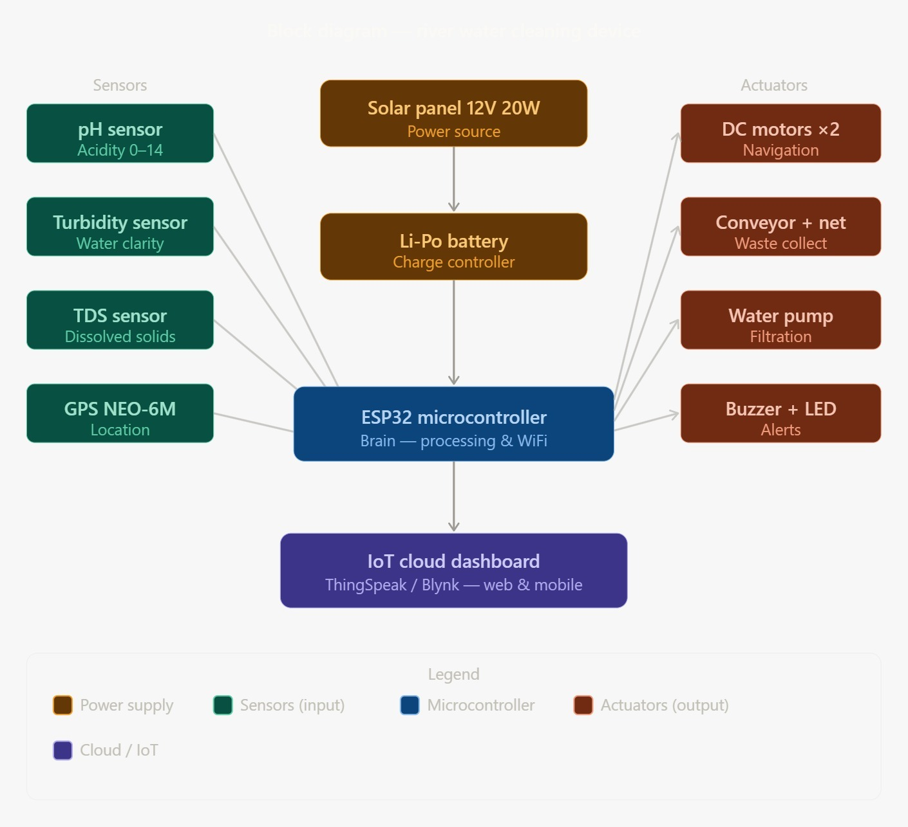
Discussion on Block Diagram:
A. Power Supply
The power for this Device comes from a 12V, 20W solar panel which is placed on the chassis. This is not connected to the circuit directly it is connected to a Li-Po Battery. These connections make sure the robot runs even in dust through solar energy stored in a battery. this Robot doesn't require any external power source.

B. Sensor Array
4 major sensors provide input to the Microcontroller ESP32/Raspberry Pi. pH sensor to test the acidity of water, the turbidity sensor detects debris in water. The TDS sensor detects the presence of metals and salts. Lastly, the GPS sensor is used to navigate.

C. Actuation Subsystem
When the microcontroller determines an action needed it uses output devices such as a DC motor to steer the robot, a conveyor belt, and a net that makes scooping floating items easy , Water pump pulls water, and filters it. Buzzer and LED for indication.

D. IoT Cloud Dashboard
It works using a conditional statement If sensors detect water as Normal and safe This data is updated on the IoT cloud, and if the water is unsafe then the Robot performs its function, and after completing the task Robot will update the water quality and all data to the dashboard. This Dashboard can be accessed using the Web or App. This ensures the Robot keeps track of data.
Conclusion:
This Water Cleaning Smart Robot will help solve major problems with water contamination which is due to floating waste. Our System works in cleaning Rivers, lakes, ponds, and other water bodies with high efficiency way. This will decrease human effort and dependencies. This system saves energy and it is cost-effective. The Smart Water Cleaning Robot can save and protect the aquatic ecosystem, and contribute to making a cleaner and healthy environment.
References:
- Zhu, J., Yang, Y., and Cheng, Y.,
“SMURF: A Fully Autonomous Water Surface Cleaning Robot with a Novel Coverage Path Planning Method,” Journal of Marine Science and Engineering, vol. 10, no. 11, 2022.
- Phirke, S., et al.,
“Design of an Autonomous Water Cleaning Bot for Collecting Floating Garbage,” Procedia CIRP, 2021.
- Hasan, M., Asrar, S., Azim, T., Sultana, S., and Khan, R.,
“Design of a Cost-Effective Floating Waste Cleaning Robot,” ResearchGate Publication, 2023.
- Kamarudin, N. A. S., et al.,
“Development of Water Surface Mobile Garbage Collector Robot,” International Journal of Environmental Science, 2021.
- “Autonomous Water Surface Cleaning Robot,” JETIR Journal of Emerging Technologies and Innovative Research, 2020.

