**Level 3 practice problem**

**---------------------------------------------------------------------------------------------------------------------------------------------------------------------**

import java.util.Scanner;

public class Level3PracticePrograms {

public static void main(String[] args) {

Scanner sc = new Scanner(System.in);

// You can test each program here by calling the respective method

// For example:

// checkLeapYearMultipleIf();

// checkLeapYearSingleIf();

// inputMarksAndGrade();

// checkPrime();

// checkArmstrong();

// countDigits();

// calculateBMI();

// checkHarshadNumber();

// checkAbundantNumber();

// calculator();

// dayOfWeek();

// For example, to test:

checkLeapYearMultipleIf();

}

// 1. Leap Year with multiple if-else

public static void checkLeapYearMultipleIf() {

Scanner sc = new Scanner(System.in);

System.out.print("Enter year (>= 1582): ");

int year = sc.nextInt();

if (year >= 1582) {

if (year % 4 == 0) {

if (year % 100 == 0) {

if (year % 400 == 0) {

System.out.println("Leap Year");

} else {

System.out.println("Not a Leap Year");

}

} else {

System.out.println("Leap Year");

}

} else {

System.out.println("Not a Leap Year");

}

} else {

System.out.println("Year must be 1582 or later.");

}

}

// 2. Leap Year with single if using logical operators

public static void checkLeapYearSingleIf() {

Scanner sc = new Scanner(System.in);

System.out.print("Enter year (>= 1582): ");

int year = sc.nextInt();

if (year >= 1582) {

if ((year % 4 == 0 && year % 100 != 0) || year % 400 == 0) {

System.out.println("Leap Year");

} else {

System.out.println("Not a Leap Year");

}

} else {

System.out.println("Year must be 1582 or later.");

}

}

// 3. Input Marks and Grade

public static void inputMarksAndGrade() {

Scanner sc = new Scanner(System.in);

System.out.print("Enter marks in Physics: ");

int physics = sc.nextInt();

System.out.print("Enter marks in Chemistry: ");

int chemistry = sc.nextInt();

System.out.print("Enter marks in Maths: ");

int maths = sc.nextInt();

int total = physics + chemistry + maths;

double percentage = total / 3.0;

System.out.println("Average Marks: " + percentage);

if (percentage >= 90) {

System.out.println("Grade: A - Excellent");

} else if (percentage >= 75) {

System.out.println("Grade: B - Good");

} else if (percentage >= 60) {

System.out.println("Grade: C - Average");

} else if (percentage >= 40) {

System.out.println("Grade: D - Pass");

} else {

System.out.println("Grade: F - Fail");

}

}

// 4. Prime Number Check

public static void checkPrime() {

Scanner sc = new Scanner(System.in);

System.out.print("Enter number: ");

int num = sc.nextInt();

boolean isPrime = true;

if (num <= 1) {

isPrime = false;

} else {

for (int i = 2; i <= num / 2; i++) {

if (num % i == 0) {

isPrime = false;

break;

}

}

}

if (isPrime) {

System.out.println(num + " is Prime.");

} else {

System.out.println(num + " is Not Prime.");

}

}

// 5. Armstrong Number

public static void checkArmstrong() {

Scanner sc = new Scanner(System.in);

System.out.print("Enter a number: ");

int num = sc.nextInt();

int original = num, sum = 0;

while (original != 0) {

int digit = original % 10;

sum += digit * digit * digit;

original /= 10;

}

if (sum == num) {

System.out.println(num + " is an Armstrong Number.");

} else {

System.out.println(num + " is Not an Armstrong Number.");

}

}

// 6. Count Digits

public static void countDigits() {

Scanner sc = new Scanner(System.in);

System.out.print("Enter number: ");

int num = sc.nextInt();

int count = 0;

while (num != 0) {

num /= 10;

count++;

}

System.out.println("Number of digits: " + count);

}

// 7. BMI Calculator

public static void calculateBMI() {

Scanner sc = new Scanner(System.in);

System.out.print("Enter weight in kg: ");

double weight = sc.nextDouble();

System.out.print("Enter height in cm: ");

double heightCm = sc.nextDouble();

double heightM = heightCm / 100;

double bmi = weight / (heightM * heightM);

System.out.println("Your BMI is: " + bmi);

if (bmi < 18.5) {

System.out.println("Underweight");

} else if (bmi < 24.9) {

System.out.println("Normal weight");

} else if (bmi < 29.9) {

System.out.println("Overweight");

} else {

System.out.println("Obese");

}

}

// 8. Harshad Number

public static void checkHarshadNumber() {

Scanner sc = new Scanner(System.in);

System.out.print("Enter number: ");

int num = sc.nextInt();

int original = num, sum = 0;

while (original != 0) {

sum += original % 10;

original /= 10;

}

if (num % sum == 0) {

System.out.println(num + " is a Harshad Number.");

} else {

System.out.println(num + " is Not a Harshad Number.");

}

}

// 9. Abundant Number

public static void checkAbundantNumber() {

Scanner sc = new Scanner(System.in);

System.out.print("Enter number: ");

int num = sc.nextInt();

int sum = 0;

for (int i = 1; i < num; i++) {

if (num % i == 0) {

sum += i;

}

}

if (sum > num) {

System.out.println(num + " is an Abundant Number.");

} else {

System.out.println(num + " is Not an Abundant Number.");

}

}

// 10. Calculator using switch

public static void calculator() {

Scanner sc = new Scanner(System.in);

System.out.print("Enter first number: ");

double first = sc.nextDouble();

System.out.print("Enter second number: ");

double second = sc.nextDouble();

System.out.print("Enter operator (+, -, *, /): ");

String op = sc.next();

switch (op) {

case "+":

System.out.println("Result: " + (first + second));

break;

case "-":

System.out.println("Result: " + (first - second));

break;

case "*":

System.out.println("Result: " + (first * second));

break;

case "/":

if (second != 0) {

System.out.println("Result: " + (first / second));

} else {

System.out.println("Cannot divide by zero.");

}

break;

default:

System.out.println("Invalid Operator");

}

}

// 11. Day of Week Calculation

public static void dayOfWeek() {

Scanner sc = new Scanner(System.in);

System.out.print("Enter month (1-12): ");

int m = sc.nextInt();

System.out.print("Enter day: ");

int d = sc.nextInt();

System.out.print("Enter year: ");

int y = sc.nextInt();

int y0 = y - (14 - m) / 12;

int x = y0 + y0 / 4 - y0 / 100 + y0 / 400;

int m0 = m + 12 * ((14 - m) / 12) - 2;

int dayOfWeek = (d + x + (31 * m0) / 12) % 7;

System.out.println("Day of the week: " + dayOfWeek + " (0=Sunday, ..., 6=Saturday)");

}

}

Level 3 Practice Programs

1. Write a LeapYear program that takes a year as input and outputs the Year is a Leap Year or not a Leap Year.

**Hint =>**

1. The LeapYear program only works for year >= 1582, corresponding to a year in the Gregorian calendar. So ensure to check for the same.
2. Further, the Leap Year is a Year divisible by 4 and not 100 unless it is divisible by 400. E.g. 1800 is not a Leap Year and 2000 is a Leap Year.
3. Write code having multiple ***if else*** statements based on conditions provided above and a second part having only one if statement and multiple logical
4. Rewrite program 1 to determine Leap Year with single if condition using logical and ***&&*** and or ***||*** operators
5. Write a program to input marks and 3 subjects physics, chemistry and maths. Compute the percentage and then calculate the grade as per the following guidelines

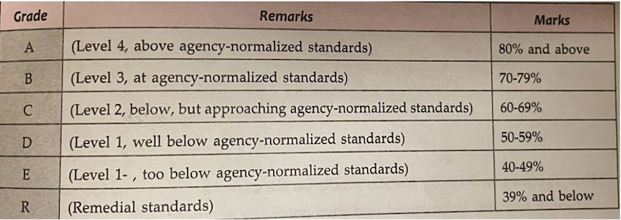

**Hint =>**

1. Ensure the Output clearly shows the Average Mark as well as the Grade and Remarks
2. Write a Program to check if the given number is a prime number or not

**Hint =>**

1. A number that can be divided exactly only by itself and 1 are Prime Numbers,
2. Prime Numbers checks are done for numbers greater than 1
3. Loop through all the numbers from 2 to the user input number and check if the reminder is zero. If the reminder is zero break out from the loop as the number is divisible by some other number and is not a prime number.
4. Use the isPrime boolean variable to store the result
5. Create a program to check if a number is armstrong or not. Use the hints to show the steps clearly in the code

**Hint =>**

1. Armstrong Number is a number whose Sum of cubes of each digit results in the original number as in for e.g. 153 = 1^3 + 5^3 + 3^3
2. Get an integer input and store it in the number variable and define sum variable, initialize it to zero and originalNumber variable and assign it to input number variable
3. Use the ***while*** loop till the originalNumber is not equal to zero
4. In the ***while*** loop find each digit which is the reminder of the modulus operation ***number % 10***. Find the cube of the number and add it to the ***sum*** variable
5. Again in while loop find the quotient of the number using the division operation ***number/10*** and assign it to the original number. This removes the last digit of the original number.
6. Finally check if the number and the sum are the same, if same its an Armstrong number else not. So display accordingly
7. Create a program to count the number of digits in an integer.

**Hint =>**

1. Get an integer input for the number variable.
2. Create an integer variable count with value 0.
3. Use a loop to iterate until number is not equal to 0.
4. Remove the last digit from number in each iteration
5. Increase count by 1 in each iteration.
6. Finally display the count to show the number of digits
7. Create a program to find the BMI of a person

**Hint =>**

1. Take user input in double for the weight (in kg) of the person and height (in cm) for the person and store it in the corresponding variable.
2. Use the formula BMI = weight / (height * height). Note unit is kg/m^2. For this convert cm to meter
3. Use the table to determine the weight status of the person

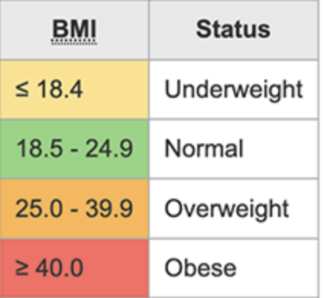

1. Create a program to check if a number taken from the user is a Harshad Number.

**Hint =>**

1. A Harshad number is an integer which is divisible by the sum of its digits.

For example, 21 which is perfectly divided by 3 (sum of digits: 2 + 1).

1. Get an integer input for the number variable.
2. Create an integer variable sum with initial value 0.
3. Create a while loop to access each digit of the number.
4. Inside the loop, add each digit of the number to sum.
5. Check if the number is perfectly divisible by the sum.
6. If the number is divisible by the sum, print Harshad Number. Otherwise, print Not a Harshad Number.
7. Create a program to check if a number is an Abundant Number.

**Hint =>**

1. An abundant number is an integer in which the sum of all the divisors of the number is greater than the number itself. For example,

Divisor of 12: 1, 2, 3, 4, 6

Sum of divisor: 1 + 2 + 3 + 4 + 6 = 16 > 12

1. Get an integer input for the number variable.
2. Create an integer variable sum with initial value 0.
3. Run a for loop from i = 1 to i < number.
4. Inside the loop, check if number is divisible by i.
5. If true, add i to sum.
6. Outside the loop Check if sum is greater than number.
7. If the sum is greater than the number, print Abundant Number. Otherwise, print Not an Abundant Number.
8. Write a program to create a calculator using ***switch...case***.

**Hint =>**

1. Create two double variables named first and second and a String variable named op.
2. Get input values for all variables.
3. The input for the operator can only be one of the four values: "+", "-", "*" or "/".
4. Run a for loop from i = 1 to i < number.
5. Based on the input value of the op, perform specific operations using the ***switch...case*** statement and print the result.
6. If op is +, perform addition between first and second; if it is -, perform subtraction and so on.
7. If op is neither of those 4 values, print Invalid Operator.
8. Write a program ***DayOfWeek*** that takes a date as input and prints the day of the week that the date falls on. Your program should take three command-line arguments: m (month), d (day), and y (year). For m use 1 for January, 2 for February, and so forth. For output print 0 for Sunday, 1 for Monday, 2 for Tuesday, and so forth. Use the following formulas, for the Gregorian calendar (where / denotes integer division):

