Single Loop
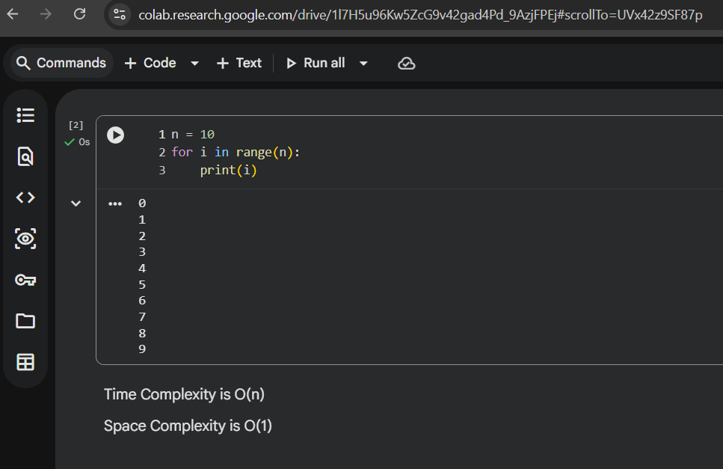
Nested Loop
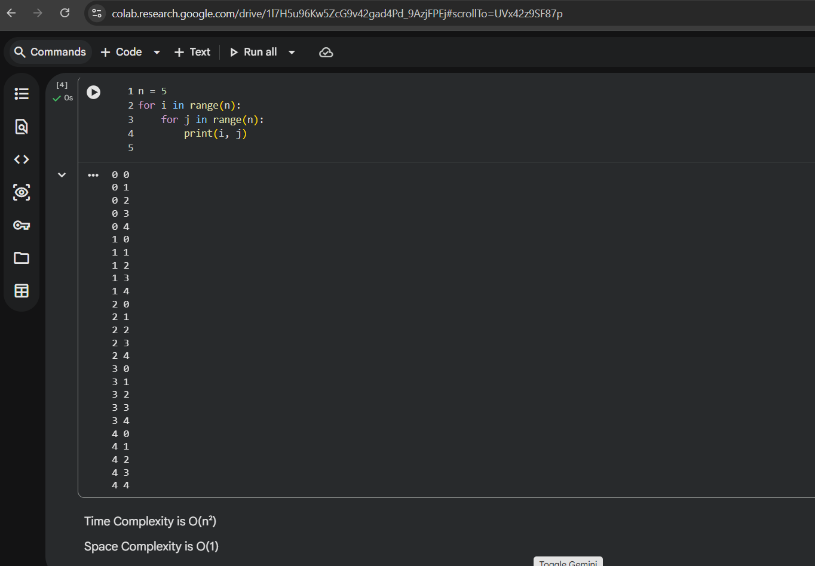
Linear vs Binary Search
- Linear search → check one by one. if list has 10 items, maybe look at all 10. O(n)
- Binary search → divide the list in half, keep checking middle, done in log n steps. Fast if list is sorted. O(log n)
linear = lazy but simple, binary = smart but list must be sorted

what happens when input size doubles?
- For O(n) → time roughly doubles. n=10 → 10 steps, n=20 → 20 steps
- For O(n²) → time becomes like 4x. n=10 → 100 steps, n=20 → 400 steps lol
- For O(log n) → time barely changes. n=10 → 3-ish, n=20 → 4-ish

