DSA DAY-4

Practice Work
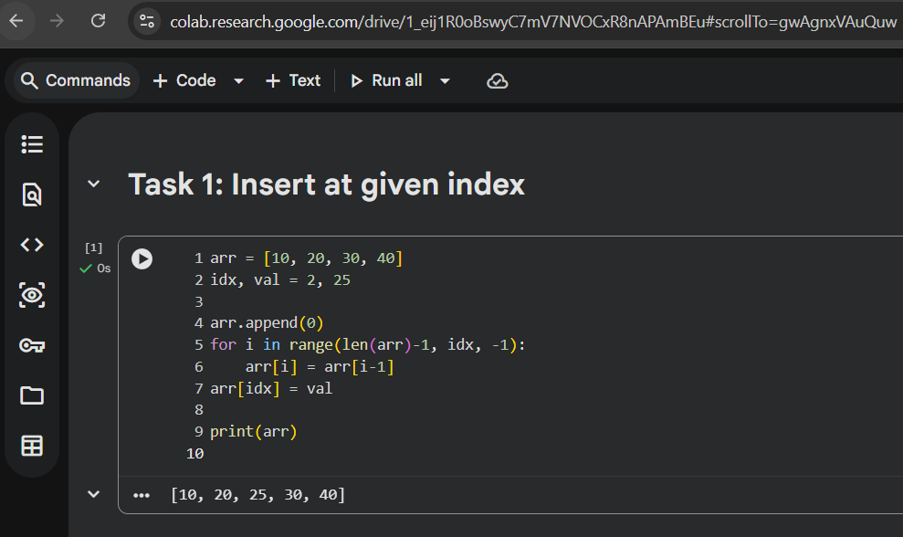

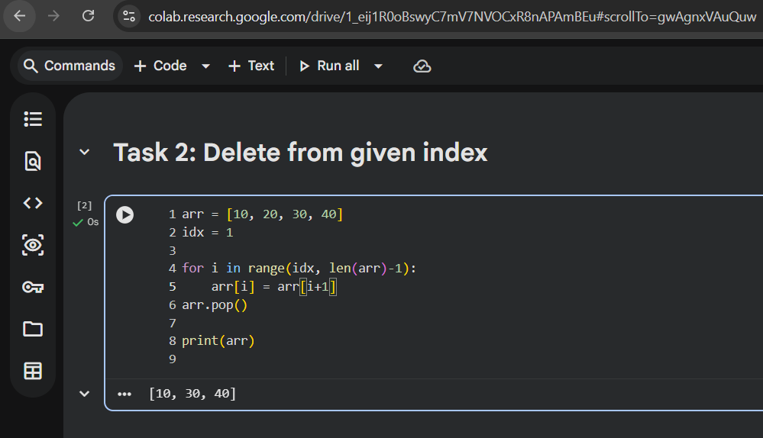
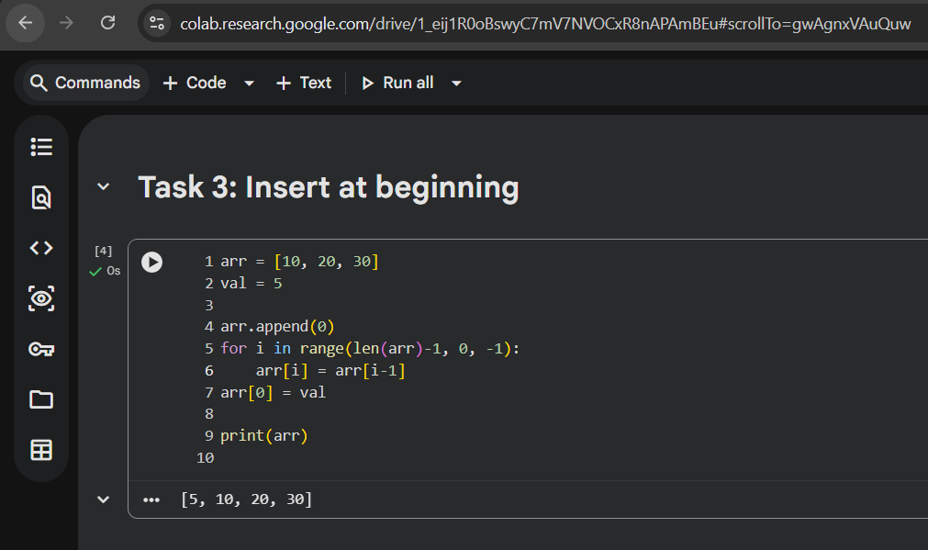

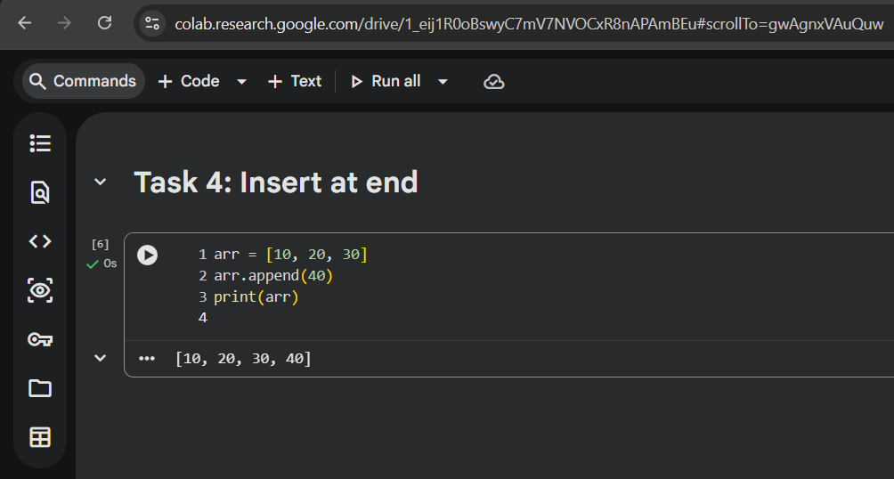

PROOF OF WORK

Why shifting is unavoidable?
Shifting is unavoidable because arrays store elements in continuous memory locations.
To maintain order during insertion or deletion, existing elements must be moved either left or right.

Why insertion and deletion are O(n)?
In the worst case (insertion or deletion at the beginning), all elements need to be shifted once.
Since the number of shifts depends on the size of the array, the time complexity becomes O(n).

What happens if the index is invalid?
If an invalid index is used, the program tries to access memory outside the array range.
This causes an index out of bounds error or program crash.

