DSA DAY-5

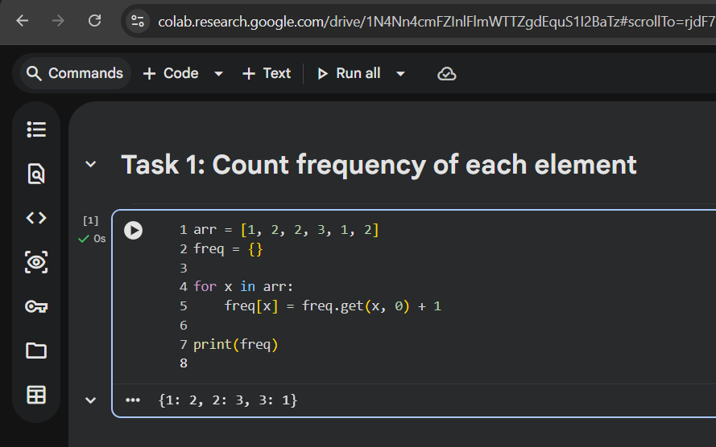

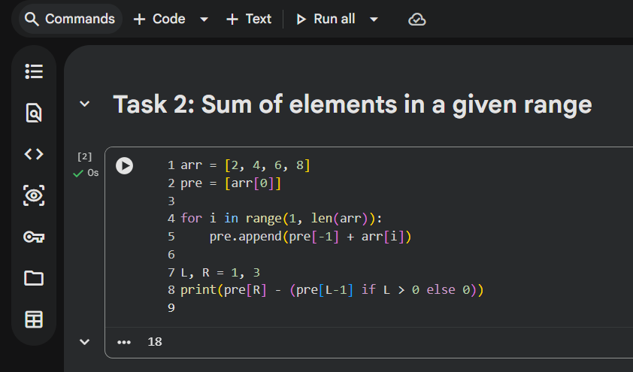
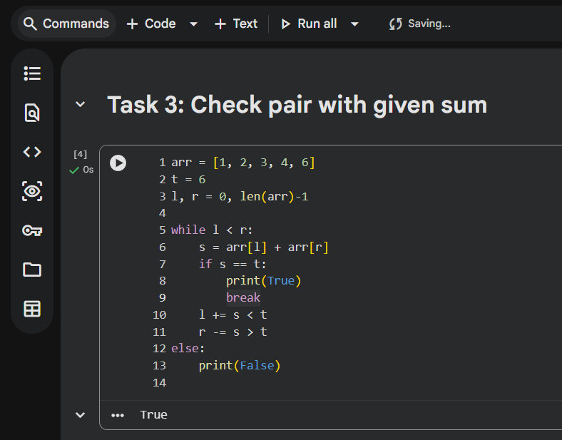

Which pattern you used and why?
- Frequency counting for counting occurrences
- Prefix sum for fast range sum queries
- Two-pointer to avoid checking all pairs

Brute-force approach?
- Nested loops or repeated traversal

Time complexity?
- Brute force: O(n²)
- Optimized patterns: O(n) or O(1)

