DSA DAY-6

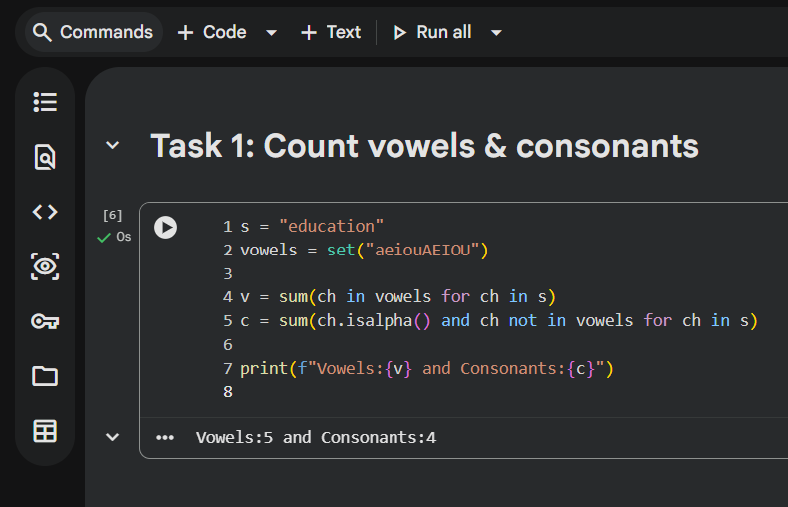

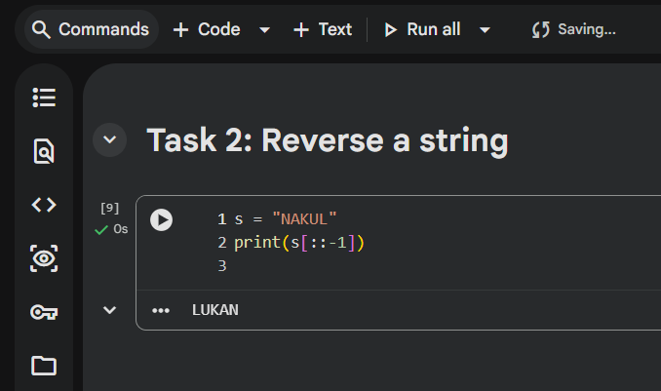

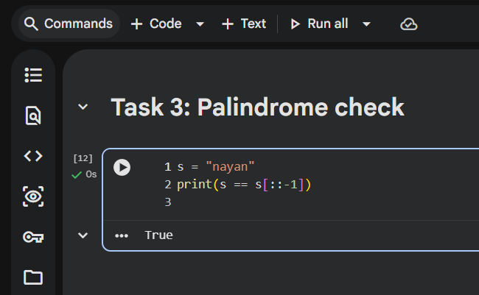

PROOF OF WORK

Step-by-step logic for palindrome check
I reversed the string using Python slicing and then compared it with the original string.
If both strings are the same, the string is a palindrome; otherwise, it is not.

How many times does the loop run?
In the slicing approach, Python internally traverses the string once to create the reversed copy.
So string is processed one time.

Time complexity (in simple words)
The time taken increases linearly with the length of the string because each character is visited once.
So the time complexity is O(n).

