DSA DAY-7

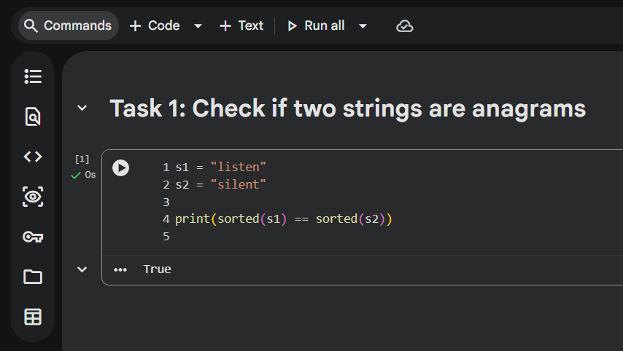

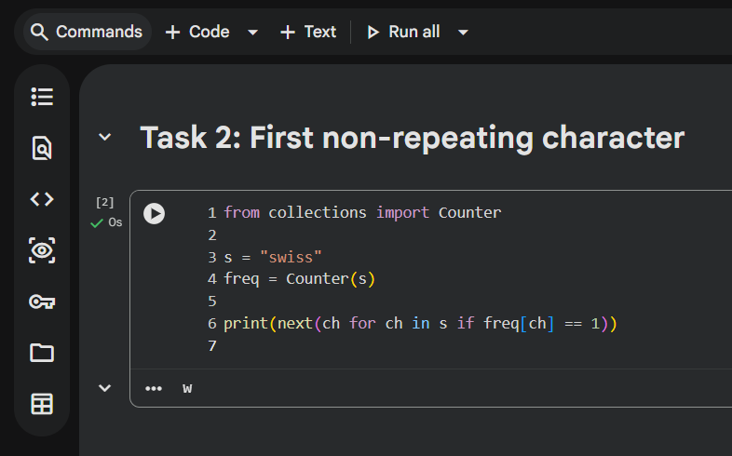
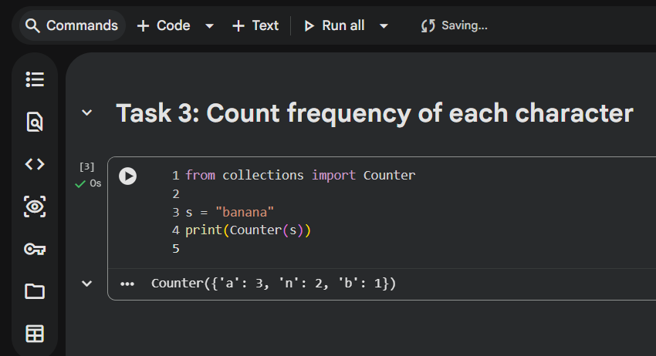

PROOF OF WORK — HOW YOU SHOULD EXPLAIN

Data structure used for counting
I used a hash-based frequency map (Counter) to store the count of each character efficiently.

Time complexity (simple words)
The string is scanned once to count characters, so time increases linearly with string length → O(n).

One edge case handled
Case sensitivity was handled by converting strings to the same case before counting.

