**Deepinder Goyal : Story of Zomato**

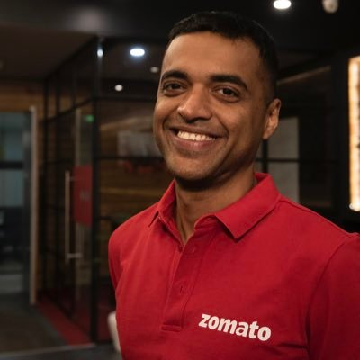

Deepinder Goyal, the co-founder and CEO of Zomato, a prominent online food delivery and restaurant discovery platform based in India. However, I can provide you with some information about Deepinder Goyal and his role in building Zomato, which could be used to create a case study.

Deepinder Goyal, along with his co-founder Pankaj Chaddah, started Zomato in 2008 as "Foodiebay," primarily as a platform to provide menu information for restaurants in Delhi NCR, India. Over the years, the company expanded its services to cover restaurant discovery, food delivery, reviews, and ratings, becoming one of the largest food aggregators globally.

1. **Entrepreneurial Journey**: Detail the journey of Deepinder Goyal from his early days as a management consultant to co-founding Zomato. Highlight his motivations, challenges faced, and key decisions made during the company's growth.
2. **Business Model Evolution**: Discuss how Zomato's business model evolved over time. Initially starting as a restaurant discovery platform, it later ventured into food delivery, cloud kitchens, table reservations, and other related services.
3. **Market Expansion**: Analyze Zomato's expansion strategies both within India and internationally. This could include market entry decisions, competition analysis, and adaptation to local cultures and preferences.
4. **Technological Innovation**: Explore the role of technology in Zomato's success. This could involve discussing the development of the platform, features such as recommendation algorithms, user interface improvements, and efforts in improving delivery logistics.
5. **Monetization Strategies**: Examine how Zomato monetizes its platform. This could include revenue streams such as advertising, subscription services, delivery fees, and partnerships with restaurants.
6. **Challenges Faced**: Identify key challenges and obstacles encountered by Zomato during its growth. This could include regulatory hurdles, competition with other food delivery platforms, managing relationships with restaurant partners, and dealing with crises such as the COVID-19 pandemic.
7. **Corporate Culture and Leadership**: Discuss the corporate culture fostered by Deepinder Goyal and its impact on Zomato's growth. Highlight leadership qualities and management strategies employed by Goyal in steering the company.
8. **Future Outlook**: Provide insights into Zomato's future prospects and potential challenges it might face in an evolving market landscape.