COMMAND LINE INTERFACE

If you're operating system is a Pistachio, then the actual nut is the Kernel. And in computing, the Kernel refers to the actual program that interfaces with the hardware. So it's the core of your operating system. Now the Shell in computing refers to the user interface for you as a human to be able to interact with the kernel and in turn with the hardware of your computer. And there's two variants to the shell. There are Graphical User Interface Shells, so for example, when you open up Finder, you're using a graphical user interface to access and find your files, but there's also a Command Line Interface, which is what we're going to be talking about and what we're going to be learning about in this module. So this is an alternative way of interfacing with the kernel.

**BASH SHELL** Bash, short for Bourne-Again SHell, is a shell program and command language supported by the Free Software Foundation and first developed for the GNU Project by Brian Fox. Designed as a 100% free software alternative for the Bourne shell, it was initially released in 1989.

It is available on **nearly all modern operating systems**, making it a versatile tool in various computing environments. As a command processor, Bash operates within a text window where users input commands to execute various tasks.

mkdir: mkdir filename. makes up a new directory.

ls: list all the items inside a particular directory.

~: tilde shows me that I’m in my user directory.

The root or the highest level in the hierarchy is your Macintosh hard drive.

cd: change directory.

use up button to use the last command that you typed.

Rather it is advisable to use ls command to go through your entire history of previous commands and you hit enter to execute it.

Use cd ~ to go back to your user directory. To go back to parent folder (Ex: if doc1 is inside documents then documents is the parent folder of doc1) type cd .. i.e. cd and two dots and we can keep doing this until we are back in our root directory.

If we want to go backward we have to give entire path of the directory but for going forward we just need to type the folder name.

If you want to edit your command, you can do this with left and right arrow keys but there is a trick you can do this by holding alt and then move you mouse pointer.

If I wanted to go to the beginning of this line, then I can simply hold down Ctrl and press A.

If I wanted to go to the end of this line, then I can simply hold down Ctrl and press E.

To clear the current command without executing it you can hold down Ctrl and hit the U button and that clears your entire line.

**USING TOUCH, OPEN, START AND RM.**

pwd: print working directory command it tells your current folder location.

rm to remove file. To remove all files in the folder we can use rm * and hit enter it will remove all the files inside my current directory. Here we used askterisks * as a wildcard which matches everything that has every single name.

rm –r this allows you to remove a directory.

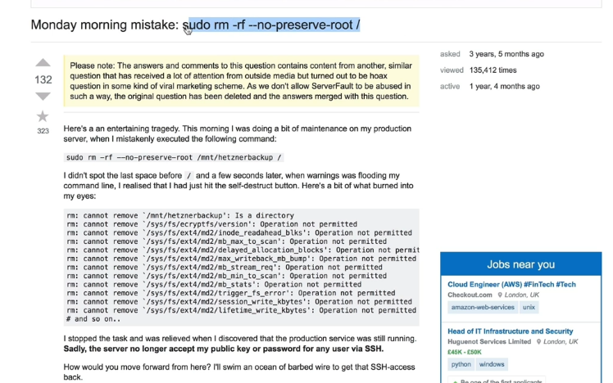

it basically wipes your hard disk to the point where you cannot recover it.

https://www.learnenough.com/command-line-tutorial