MARKET BASKET INSIGHTS

Phase- 5 Submission Document

**Project:** Market basket Insights

**Phase** 5: Project Documentation And Submission

**Topic**: Finial project submission

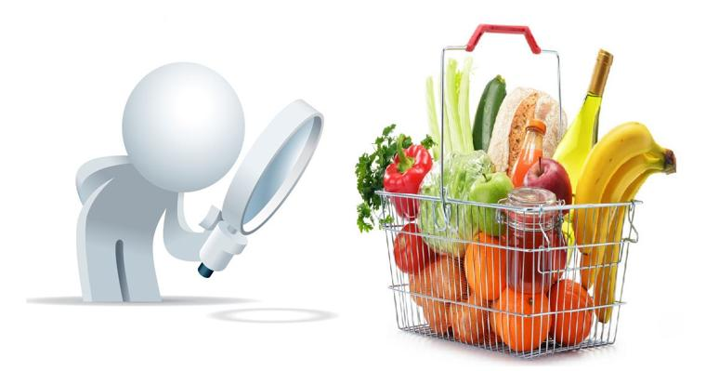

Market Basket Insights

**Introduction:**

* Market Basket Analysis is a analysis technique which identifies the strength of association between pairs of products purchased together and identify patterns of co-occurrence.
* Market Basket Analysis creates If-Then scenario rules (association rules), for example, if item A is purchased then item B is likely to be purchased. The rules are probabilistic in nature or, in other words, they are derived from the frequencies of co-occurrence in the observations. Frequency is the proportion of baskets that contain the items of interest. The rules can be used in pricing strategies, product placement, and various types of cross-selling strategies.

**How association rules work**

* Association rule mining, at a basic level, involves the use of machine learning models to analyze data for patterns, or co-occurrences, in a database. It identifies frequent if-then associations, which themselves are the association rules.
* An association rule has two parts: an antecedent (if) and a consequent (then). An antecedent is an item found within the data. A consequent is an item found in combination with the antecedent.
* Association rules are created by searching data for frequent if-then patterns and using the criteria support and confidence to identify the most important relationships. Support is an indication of how frequently the items appear in the data. Confidence indicates the number of times the if-then statements are found true. A third metric, called lift, can be used to compare confidence with expected confidence, or how many times an if-then statement is expected to be found true.
* Association rules are calculated from itemsets, which are made up of two or more items. If rules are built from analyzing all the possible itemsets, there could be so many rules that the rules hold little meaning. With that, association rules are typically created from rules well-represented in data.

Dataset Link: (<https://www.kaggle.com/datasets/robikscube/hourly-energy-consumption>)

**Given dataset**

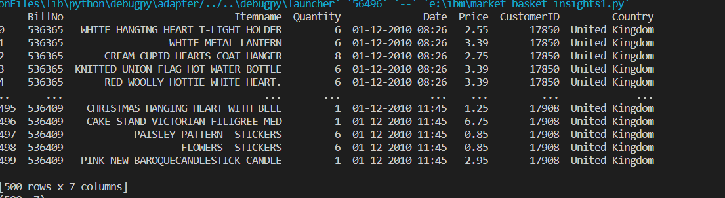

Data set loading:

* Data set loading is the process of importing data from various sources into a data structure, such as a table, a matrix, or an array. Data sets can be loaded from files, databases, web services, or other sources. Data set loading is often used for data analysis, machine learning, or visualization purposes.
* There are different ways to load data sets in different programming languages and frameworks. For example, in Python, you can use the pandas library to read data from CSV or Excel files into a DataFrame object. In R, you can use the read.csv or read.xlsx functions to load data from files into a data frame.
* Depending on the format and structure of the data source, you may need to specify some parameters or options when loading data sets, such as the delimiter, the encoding, the header, the index, or the columns to use.

**Types:**

**Numpy.loadtxt function:**

* This is a built-in function in Numpy, a famous numerical library in Python. It is a really simple function to load the data. It is very useful for reading data which is of the same datatype.
* When data is more complex, it is hard to read using this function, but when files are easy and simple, this function is really powerful.

**Pandas.read_csv():**

* Pandas is a very popular data manipulation library, and it is very commonly used. One of it’s very important and mature functions is *read_csv()* which can read any .csv file very easily and help us manipulate it. Let’s do it on our 100-Sales-Record dataset.
* This function is very popular due to its ease of use. You can compare it with our previous codes, and you can check it.

**Pickle:**

* When your data is not in a good, human-readable format, you can use pickle to save it in a binary format. Then you can easily reload it using the pickle library.

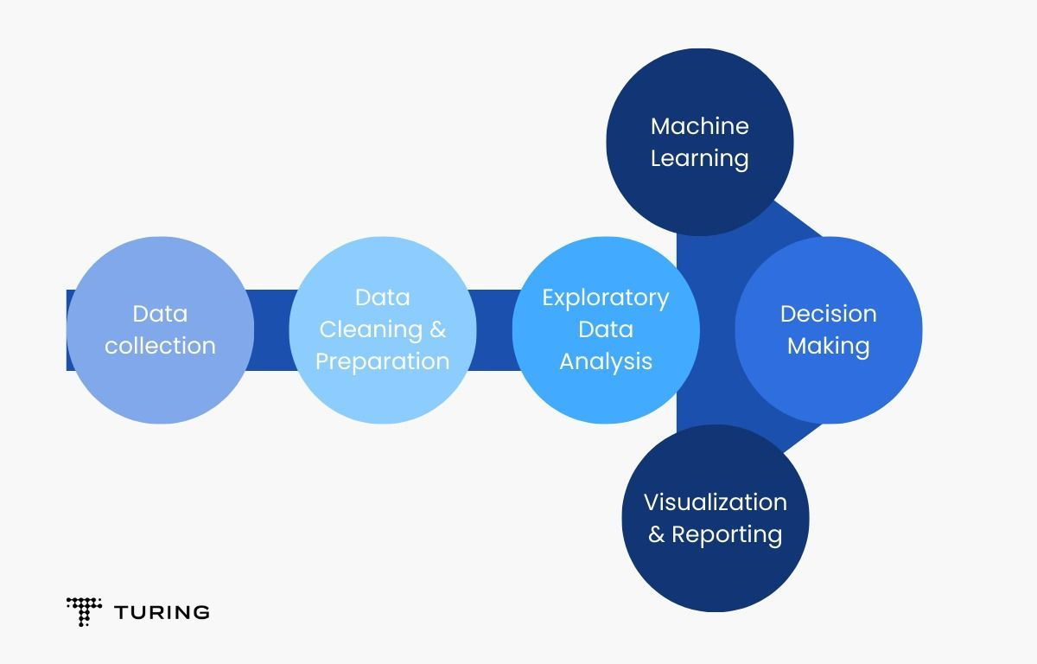

**Machine Learning algorithm:**

The Apriori algorithm is a classic data mining and machine learning technique used for discovering association rules in large datasets

It is commonly applied to market basket insights to find relationships between items that customers frequently purchase together optimize store layouts, and enhance sales strategies.

* Data Preparation:
* Start with a dataset where each row represents a transaction, and each column represents an item (product or service).
* Encode the data, typically using binary values (1 for item presence, 0 for absence) for each item in each transaction.
* **Apriori Principle**:
* The Apriori algorithm relies on the Apriori principle, which states that if an itemset is frequent (has high support), then all of its subsets must also be frequent.
* **Algorithm Steps**:
* Initialize with frequent itemsets of size 1 (single items).
* While there are frequent itemsets of size k, generate candidates of size k+1.
* Prune candidates that do not meet minimum support.
* Calculate confidence for the remaining candidates.
* Repeat the process until no more candidates can be generated.

**Training the model:**

Choose a machine learning algorithm: such as Apriori, FP-Growth, AIS, and SETM. These algorithms differ in their efficiency, scalability, and complexity. To perform market basket insights in Python, one can use libraries such as mlxtend or Orange3-Associate.

**Import apriori:**

import numpy as np

import pandas as pd

from mlxtend.frequent_patterns import apriori

from mlxtend.frequent_patterns import association_rules

**Design thinking:**

Design thinking is a way of solving problems that focuses on the needs and experiences of the users. It involves a series of steps that help designers understand the problem, generate ideas, create prototypes, and test solutions. Design thinking can be applied to any field or industry, and it can lead to innovative and creative outcomes.

**PREPROCESSING:**

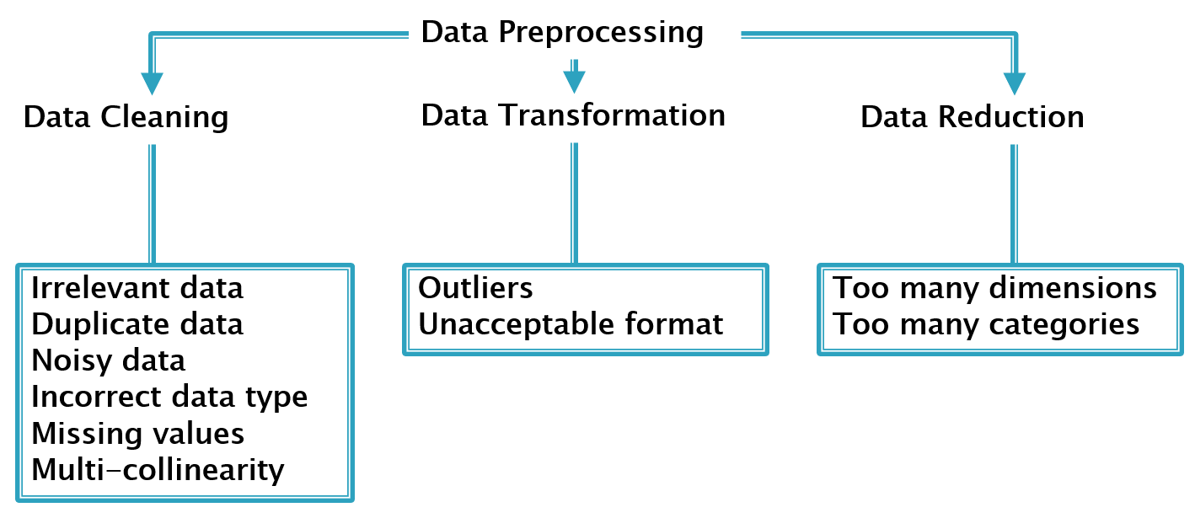

Market basket analysis is a technique that helps to discover patterns and relationships among items purchased by customers. It can provide valuable insights for businesses to optimize their marketing, sales, and inventory strategies. To perform market basket analysis, you need to follow some steps:

* Clean and preprocess the data, removing any irrelevant information, handling missing values, and converting the data into a suitable format for analysis. For example, you can use one-hot encoding to transform the data into a binary matrix, where each row represents a transaction and each column represents an item
* Use association rules mining algorithms such as Apriori or FP-Growth to identify frequent item sets, sets of items often appearing together in a transaction. These algorithms use a minimum support threshold to filter out rare item sets.
* Generate association rules from the frequent item sets, using a minimum confidence threshold to filter out weak rules
* Evaluate and interpret the association rules, using metrics such as lift, leverage, and conviction to measure the strength and significance of the rules. Lift is the ratio of the observed support of an item set to the expected support if the items were independent. Leverage is the difference between the observed support and the expected support.
* Apply the association rules to business problems, such as inventory management, cross-selling opportunities, customer segmentation, and pricing strategies.

1.Calculate the null values:

dataset.isnull().sum()

Output:

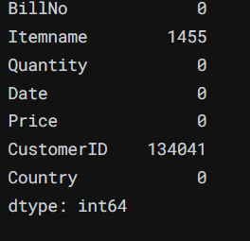

2.Remove null values:

dataset.dropna(axis=0, subset=['Itemname'], inplace = True)

dataset = dataset.drop(columns= ['CustomerID'])

dataset.isnull().sum()

Output:

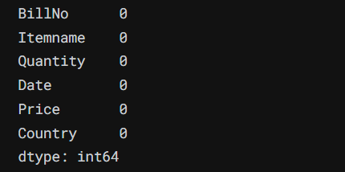

3.Datatypes:

dataset.dtypes

Output:

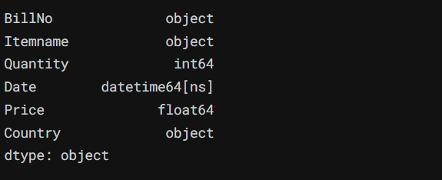

4.Find best quality of data:

data[data['Quantity']<=0]

data[data['Price']<=0]

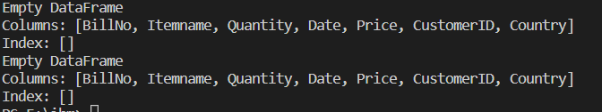

remove the rows which has the buyed quality is small or equal to zero:

data=data[data['Quantity']>0]

data=data[data['Price']>0]

data.shape

output:

(500,8)

Program:

plt.figure(figsize=(22,7))

plt.subplot(1,2,1)

a.Price.plot()

plt.title("Price")

plt.subplot(1,2,2)

a.Quantity.plot()

plt.title("Quantity")

Output:

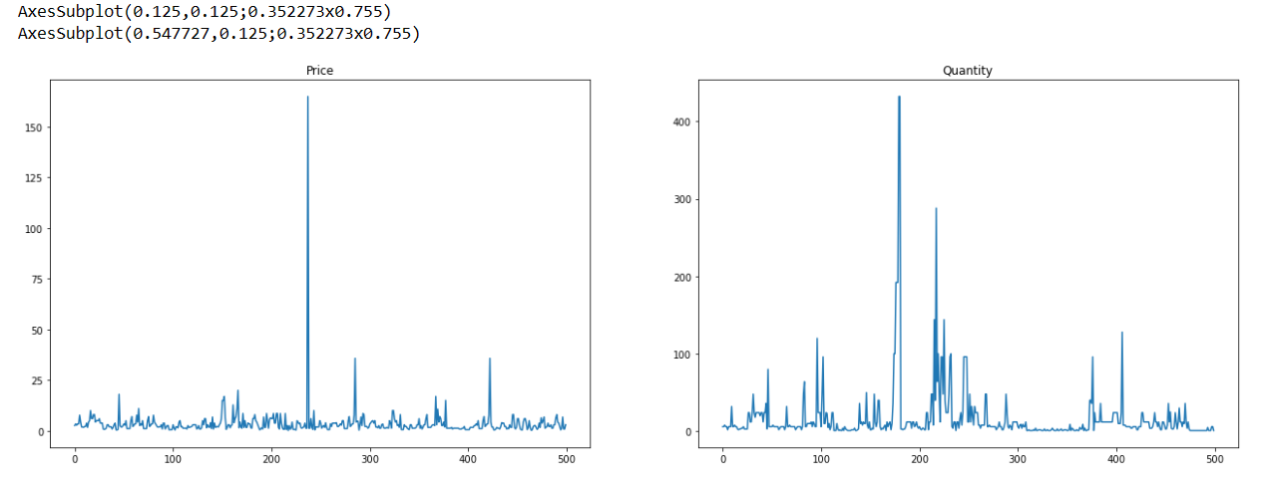

Program:

a.Country.value_counts().head(10)

Output:

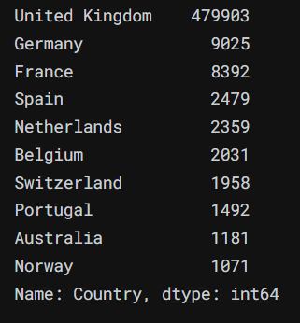

Filter the DataFrame to exclude rows where 'Itemname' is missing (not NaN):

Program:

data = data[data['Itemname'].notna()]

print("Number of unique items:", data['Itemname'].nunique())

'Itemname' column

print(data['Itemname'].value_counts(normalize=True)[:5])

output:

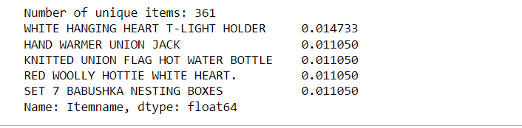

Program:

mybasket= (a[a['Country'] =="Germany"]

.groupby(['BillNo', 'Itemname'])['Quantity']

.sum().unstack().reset_index().fillna(0)

.set_index('BillNo'))

Output:

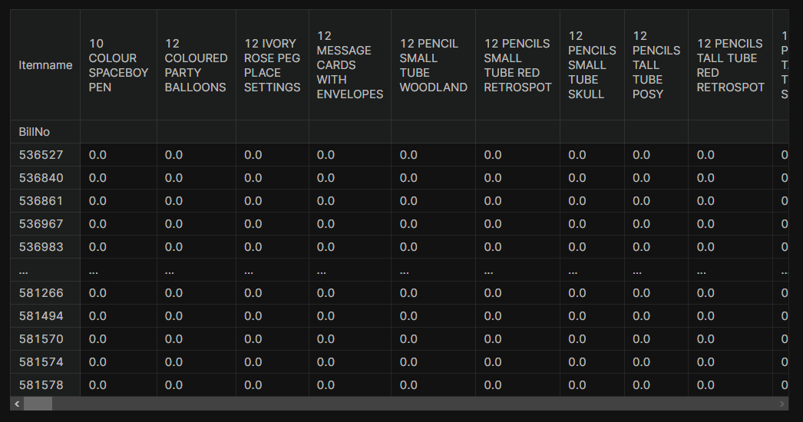

***Plotting the top 10 most sold products by quantity:***

***Program:***

data.groupby('Itemname')['Quantity'].sum().sort_values(ascending=False)[:10].plot(kind='barh', title='Number of Quantity Sold')

plt.ylabel('Item Name')

plt.xlim(20000, 82000)

plt.show()

data['Itemname'].value_counts(ascending=False)[:10].plot(kind='barh', title='Number of Sales')

plt.ylabel('Item Name')

plt.xlim(0, 10)

plt.show()

output:

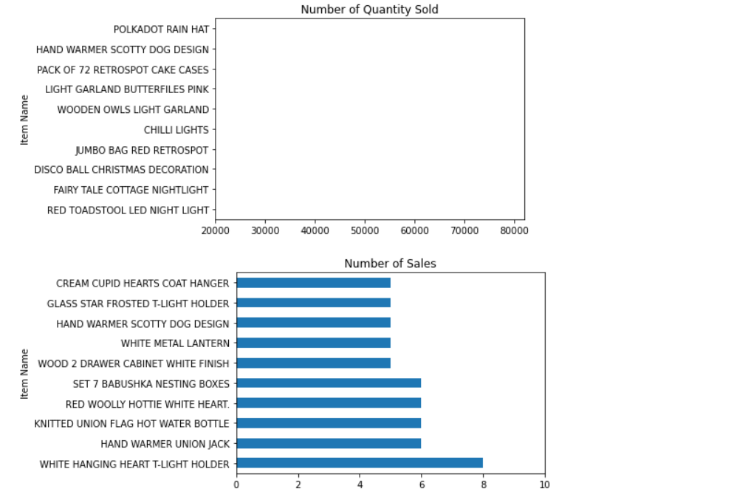

Program:

a.columns

output:

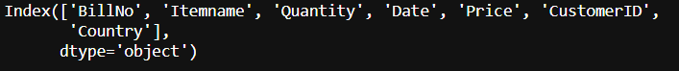

a.describe()

Output:

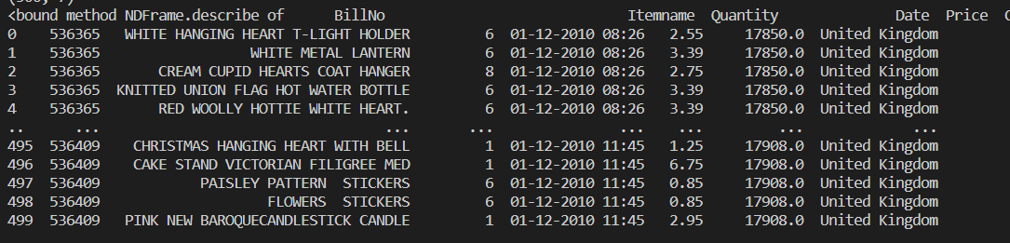

**Program:**

**best_selling_items = data.groupby(['Country', 'Itemname']).agg({'Quantity': 'sum'}).reset_index()**

**best_selling_items = best_selling_items.groupby('Country').apply(lambda x: x[x['Quantity'] == x['Quantity'].max()]).reset_index(drop=True)**

**best_selling_items.sort_values("Quantity",ascending=False)**

output:

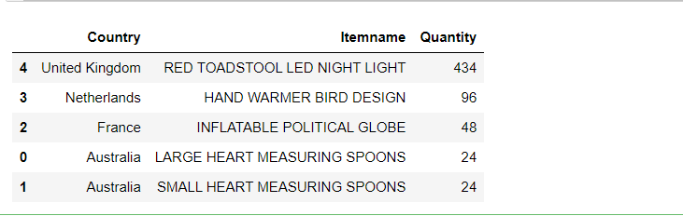

**Program:**

from matplotlib import pyplot as plt

plt.bar(best_selling_items['Country'],best_selling_items['Itemname'])

plt.yscale('log')

plt.ylabel('Quantity')

plt.xticks(rotation=90)

plt.show()

output:

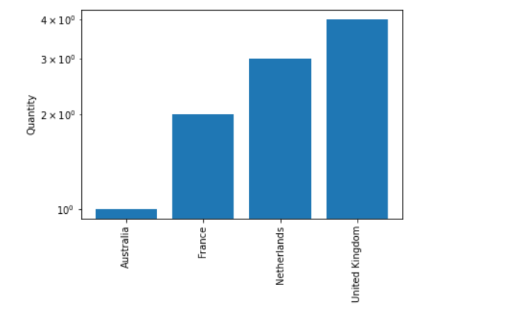

Program:

import seaborn as sns

sns.heatmap(data.isnull())

output:

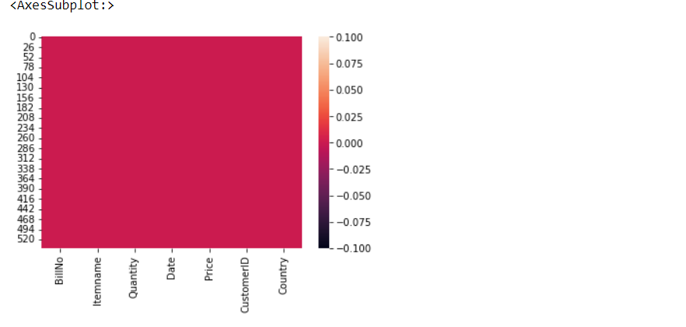

Filter the DataFrame to include only the top 10 item names:

Program:

top_10_items = data['Itemname'].value_counts().nlargest(10).index

df_top_10 = data[data['Itemname'].isin(top_10_items)]

ax=sns.countplot(data=df_top_10, x='Itemname')

plt.xticks(rotation=90)

output:

(array([0, 1, 2, 3, 4, 5, 6, 7, 8, 9]),

[Text(0, 0, 'WHITE HANGING HEART T-LIGHT HOLDER'),

Text(1, 0, 'WHITE METAL LANTERN'),

Text(2, 0, 'CREAM CUPID HEARTS COAT HANGER'),

Text(3, 0, 'KNITTED UNION FLAG HOT WATER BOTTLE'),

Text(4, 0, 'RED WOOLLY HOTTIE WHITE HEART.'),

Text(5, 0, 'SET 7 BABUSHKA NESTING BOXES'),

Text(6, 0, 'GLASS STAR FROSTED T-LIGHT HOLDER'),

Text(7, 0, 'HAND WARMER UNION JACK'),

Text(8, 0, 'WOOD 2 DRAWER CABINET WHITE FINISH'),

Text(9, 0, 'HAND WARMER SCOTTY DOG DESIGN')])

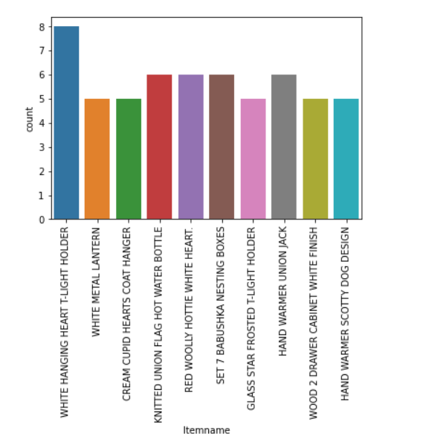

**Exploring data analysis:**

Exploratory analysis, also known as exploratory data analysis (EDA), is a crucial step in market basket insights and data analysis in general. EDA is the process of visually and statistically exploring a dataset to understand its main characteristics, identify patterns, and generate hypotheses before applying more advanced analytical techniques, such as association rules or predictive modeling. In the context of market basket analysis, EDA can help uncover initial insights and guide subsequent data mining and modeling efforts.

Here are some common steps and techniques involved in exploring analysis in the context of market basket insights:

1. **Data Summary:** Begin by summarizing and describing the dataset. This includes understanding the structure of the data, the number of transactions, and the items within each transaction.
2. **Data Visualization:** Visualize the data to get an initial sense of item frequencies, associations, and patterns. Common visualizations include bar charts, scatter plots, and heatmaps to represent item sets' occurrence and relationships.
3. **Frequency Analysis:** Calculate item frequencies and the distribution of item sets to identify frequently purchased products. This can help in understanding popular items and potential associations.
4. **Correlation Analysis:** Explore correlations between items or item sets using techniques like correlation matrices or association rule metrics like lift, confidence, and support.
5. **Basket Metrics:** Calculate various market basket metrics to gain insights into customer behavior. Metrics like average basket size, frequent item pairs, and item-set distribution can reveal valuable patterns.
6. **Segmentation:** Divide the dataset into different customer segments based on demographics, purchase history, or other relevant factors. EDA can help identify distinctive behaviors within these segments.
7. **Outlier Detection:** Identify unusual or unexpected patterns, such as rare item combinations or anomalies in the data.
8. **Pattern Discovery:** Explore frequent itemsets or association rules to identify interesting item combinations and potential recommendations. EDA can help refine the rule generation process by setting appropriate thresholds for support and confidence.
9. **Visualization of Association Rules:** Visualize discovered association rules to provide a clearer understanding of the relationships between items and their associated metrics.
10. **Hypothesis Generation:** EDA often leads to the generation of hypotheses that can be tested in subsequent analyses or experiments.

**Program:**

sales=data.groupby(['Year','Month'])['Total price','Quantity'].sum()

sales.to_csv('sales.csv')

sales=pd.read_csv(' D:/IBM/market basket insights1.csv")')

sales=sales.pivot_table(sales,index=['Year','Month'],aggfunc=np.sum,fill_value=0)

sales.plot(kind='bar',cmap='Set1')

plt.show()

output:

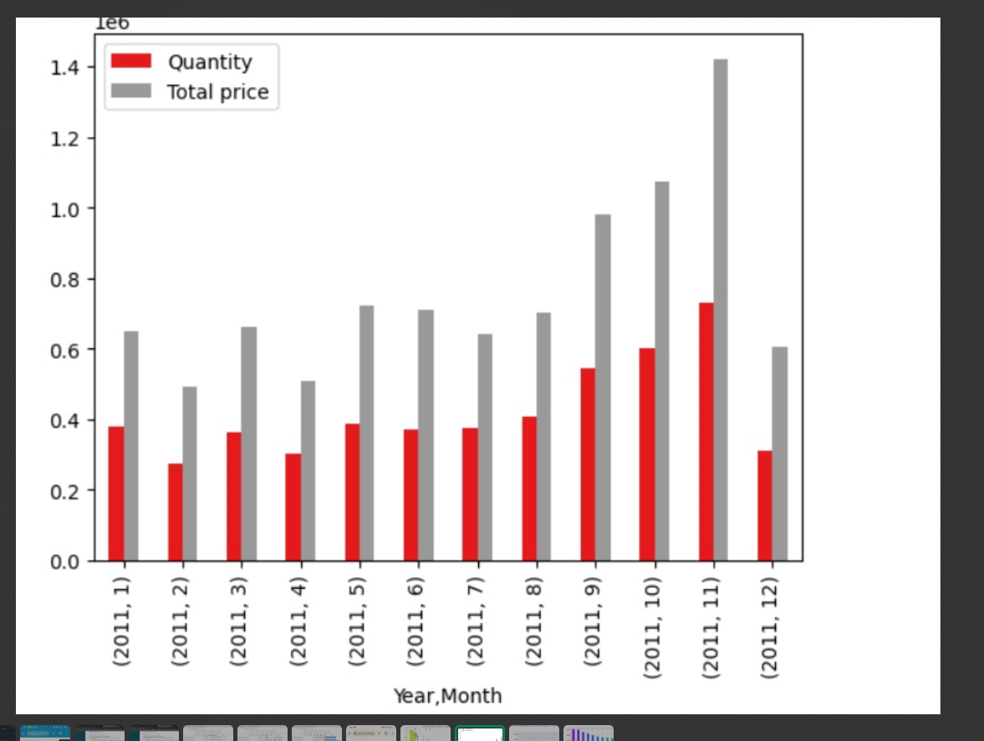

Program:

sales_country=data.groupby(['Year','Month','Country'])['Total price'].sum()

sales_country.to_csv('sales_country.csv')

sales_country=pd.read_csv('sales_country.csv')

fig=plt.bar(sales_country,x=['Month'],y='Total price',color='Country',title='Monthly sales amount in each country in 2021')

fig.update_layout(xaxis_title='Month',yaxis_title='Sales amount')

fig.show()

output:

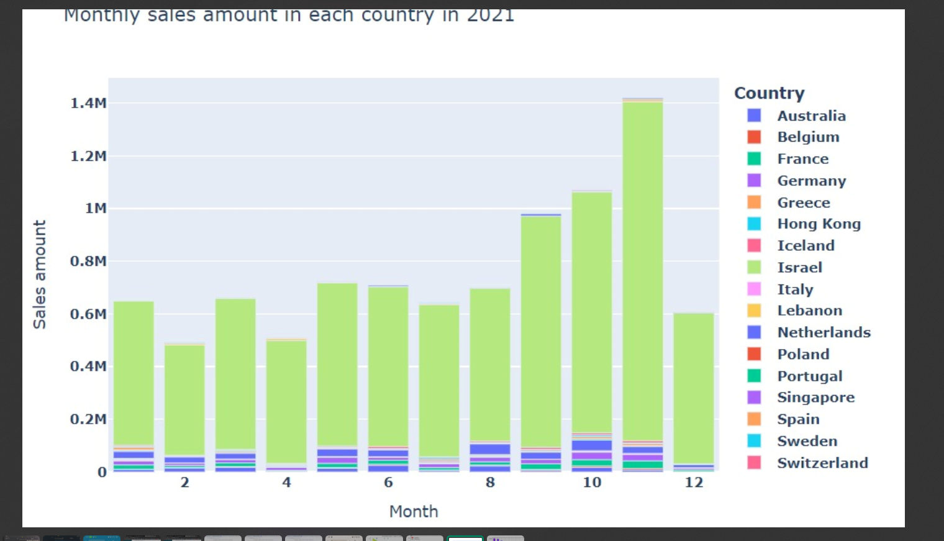

Program:

color=plt.cm.rainbow(np.linspace(0,1,30))

df['Itemname'].value_counts().head(10).plot.bar(color=color,figsize=(6,3))

plt.title('Frequency of Most popular items',fontsize=14)

plt.xticks(rotation=90,fontsize=8)

plt.grid()

plt.show()

output:

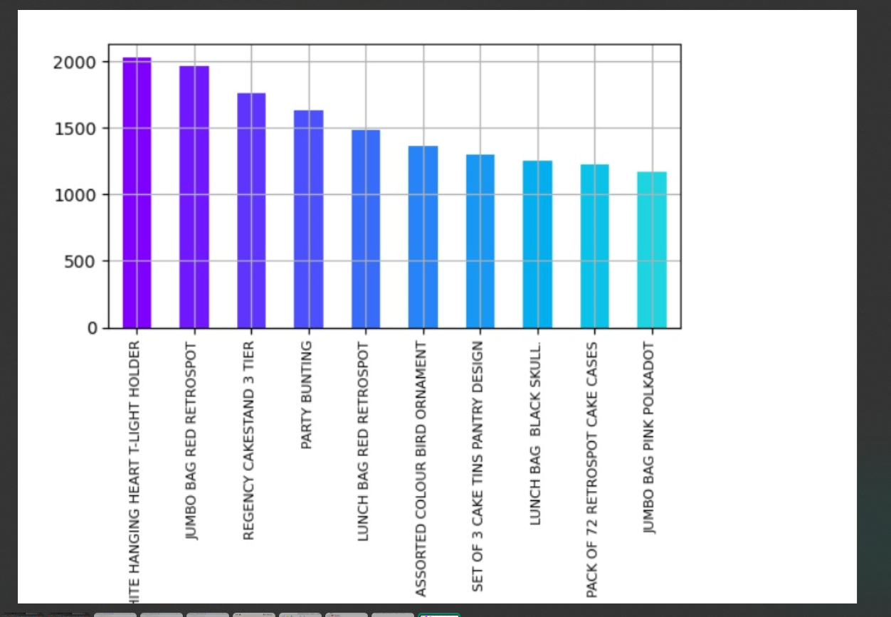

Performing Association Analysis:

Association analysis, often referred to as market basket insights, is a data mining technique used to discover interesting relationships or associations between items in a transactional dataset.

* **Association Rules:**
* Association rules are generated by identifying itemsets with high support and confidence values.
* Rules typically take the form of "If {A}, then {B}," indicating that when customers buy item A, they are also likely to purchase item B.
* Support: This measures the frequency or popularity of an itemset (a collection of items) in the dataset. It indicates how often a particular combination of products is purchased. High support values suggest that the itemset is frequently occurring.
* **Confidence:** This measures the likelihood that a customer who buys one item from an itemset will also buy the other items in the same itemset. It's a conditional probability. High confidence values indicate a strong relationship between items.
* **Lift**: Lift measures the degree of association between two items in an itemset. It is the ratio of the observed support to the expected support if the two items were independent. A lift greater than 1 suggests a positive association, while a lift less than 1 suggests a negative association.

**Businesses can use these association rules to:**

* Improve cross-selling and upselling strategies.
* Optimize product placement within physical stores.
* Enhance online product recommendations.
* Manage inventory more effectively by stocking related products together.
* Understand customer preferences and behaviors.
* **Setting Thresholds:**

You can set minimum support and confidence thresholds to filter out rules. This allows you to focus on the most interesting and relevant associations.

* **Interpreting and Using Results**:
  + Analyze the generated rules to gain insights into customer behavior.
  + Use the insights to make business decisions, such as product placement, cross-selling, upselling, marketing campaigns, and inventory management.
* **A/B Testing:**

Implement A/B tests based on the insights from association analysis to validate the impact of changes

in marketing or product placement on customer behavior.

Support: This measures the frequency or popularity of an itemset (a collection of items) in the dataset. It indicates how often a particular combination of products is purchased. High support values suggest that the itemset is frequently occurring.

Confidence: This measures the likelihood that a customer who buys one item from an itemset will also buy the other items in the same itemset. It's a conditional probability. High confidence values indicate a strong relationship between items.

Lift: Lift measures the degree of association between two items in an itemset. It is the ratio of the observed support to the expected support if the two items were independent. A lift greater than 1 suggests a positive association, while a lift less than 1 suggests a negative association.

**Program:**

**import numpy as np # linear algebra**

**import pandas as pd # data processing, CSV file I/O (e.g. pd.read_csv)**

**from matplotlib import pyplot as plt**

**from mlxtend.frequent_patterns import apriori, association_rules**

**from mlxtend.preprocessing import TransactionEncoder**

**df = pd.read_csv("D:/IBM/market basket insights1.csv",names=['itemname'**

**],sep=',')**

**a=df.head(500)**

**print(a)**

**data = list(a["itemname"].apply(lambda x:x.split(",") ))**

**print(data)**

**b = TransactionEncoder()**

**b_data = b.fit(data).transform(data)**

**df = pd.DataFrame(b_data,columns=b.columns_)**

**df = df.replace(False,0)**

**print(df)**

**df = apriori(df, min_support = 0.2, use_colnames = True, verbose = 1)**

**print(df)**

output:

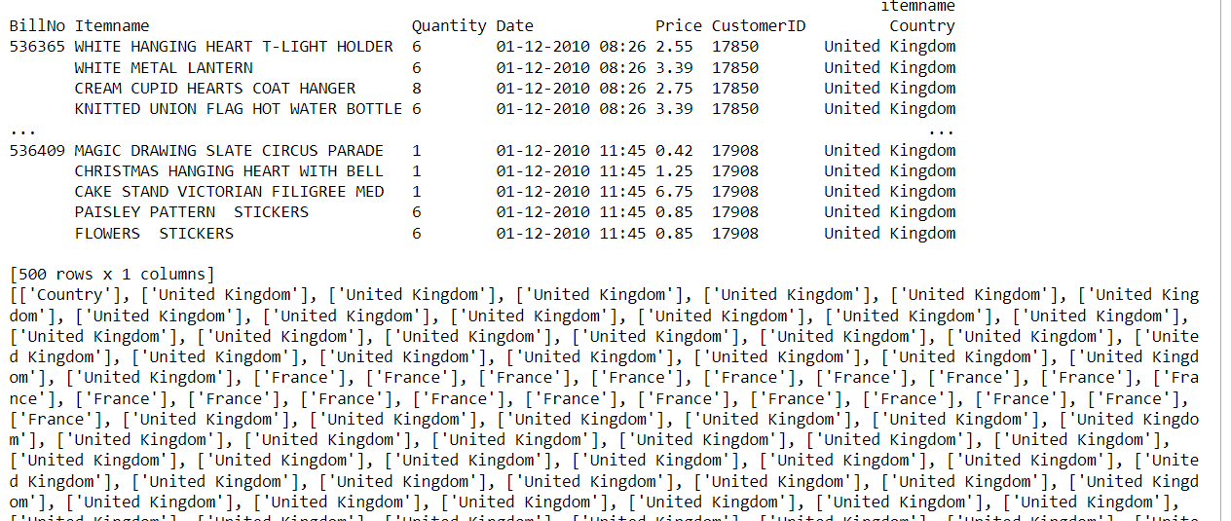

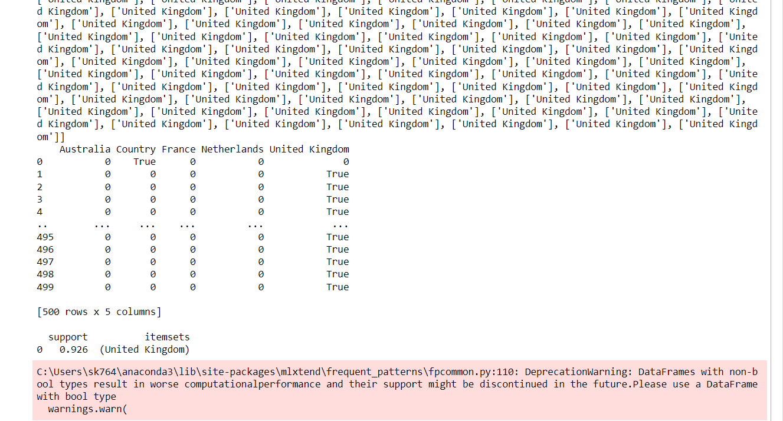

**Program**:

import matplotlib.pyplot as plt

import seaborn as sns

plt.figure(figsize=(12, 8))

sns.scatterplot(x="support", y="confidence", size="lift", data=rules, hue="lift", palette="viridis", sizes=(20, 200))

plt.title('Market Basket Analysis - Support vs. Confidence (Size = Lift)')

plt.xlabel('Support')

plt.ylabel('Confidence')

plt.legend(title='Lift', loc='upper right', bbox_to_anchor=(1.2, 1))

plt.show()

output:

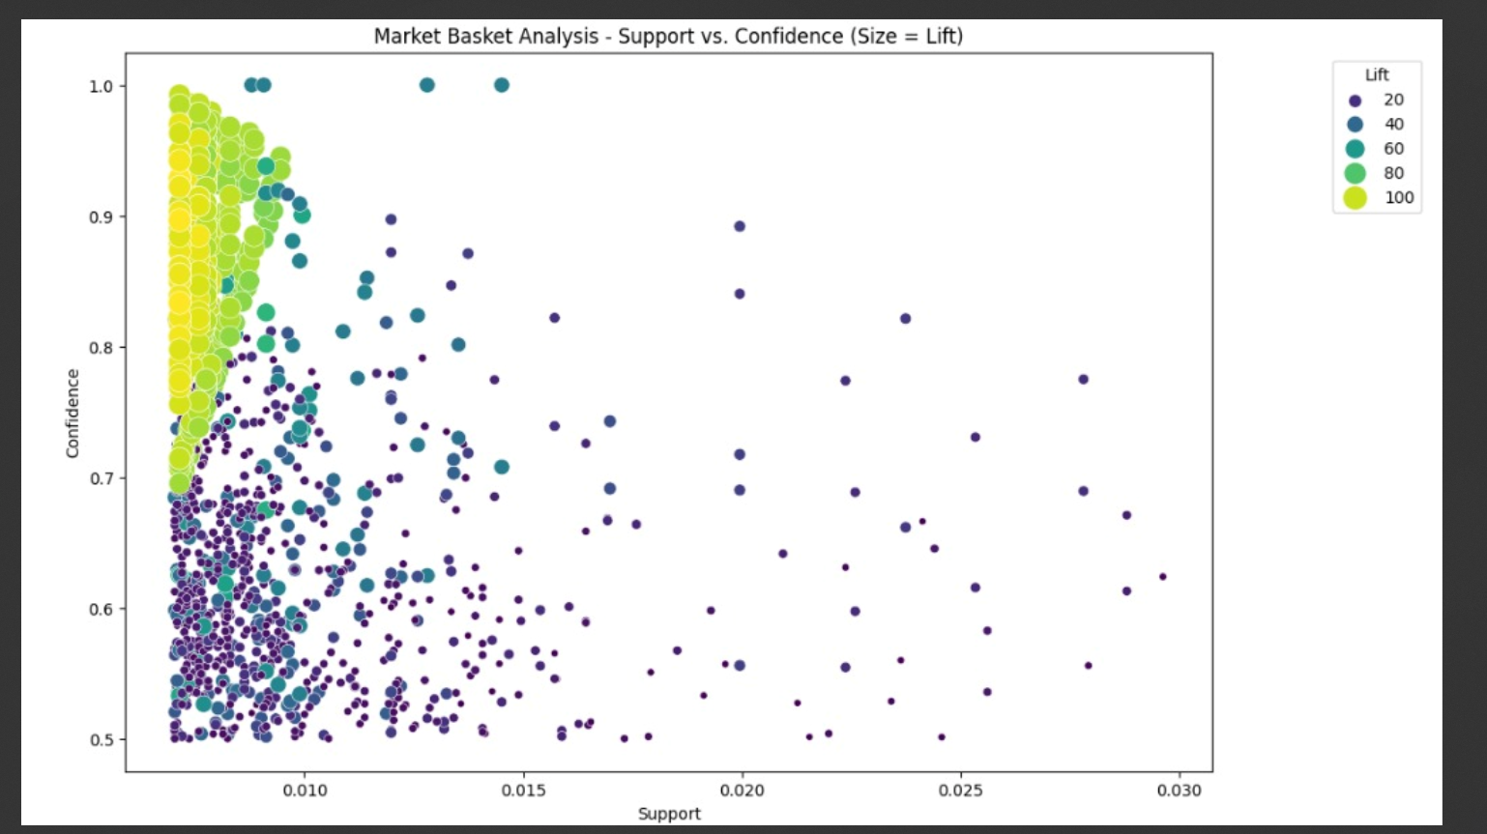

**Data Analysis:**

Data analysis in the context of market basket insights, also known as market basket analysis or association analysis, involves examining transactional data to uncover patterns, relationships, and associations between items that customers purchase together

* There are different types of market basket analysis, such as descriptive, predictive, or prescriptive. Descriptive market basket analysis only derives insights from past data and does not make any predictions.
* Predictive market basket analysis uses supervised learning models to forecast future customer behavior based on past data. Prescriptive market basket analysis uses optimization techniques to suggest the best actions to take based on the analysis results.
* Market basket analysis is based on association rule mining, which is a data mining technique that finds rules of the form {IF} -> {THEN}. The IF part is called the antecedent and the THEN part is called the consequent
* **Exploratory Data Analysis (EDA)**:

EDA involves visualizing and summarizing data to understand its characteristics and uncover patterns, trends, and anomalies. This step often includes data visualization techniques such as histograms, scatter plots, and summary statistics.

* **Statistical Analysis**:

Data analysts often use statistical methods to gain insights from the data. This can involve hypothesis testing, regression analysis, and other statistical techniques to test relationships and make predictions.

* **Data Visualization**:

Visualizing data through charts, graphs, and plots is a powerful way to communicate findings and insights effectively. Visualization can make complex data more understandable and compelling.

**Program:**

total_sales = data

total_sales["Total_Price"] = total_sales["Price"] * total_sales["Quantity"]

*#total_sales.columns*

total_sales_per_customer = total_sales.groupby(["CustomerID", "Country"]).agg({"Total_Price": "sum"})

total_sales_per_customer.head(10)

**output:**

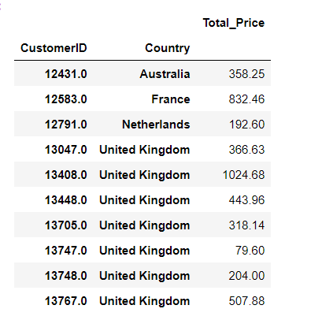

**Program:**

**total_sales_per_customer.reset_index(inplace=True)**

**total_sales_per_customer.sort_values(by = "Total_Price", ascending = False).head(10)**

**output:**

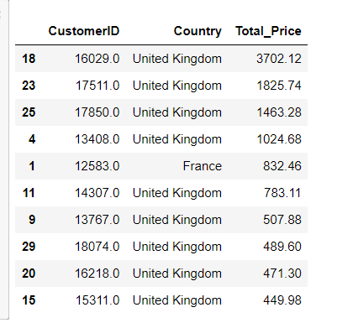

**Program:**

Total_sales_per_customer.groupby(["Country"]).agg({"Total_Price":"sum"}).reset_index().sort_values(by="Total_Price", ascending=False )

output:

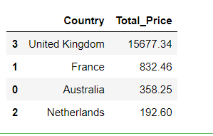

Program:

df_market.createOrReplaceTempView("df")

itemname_by_country = sqlCtx.sql("""SELECT Country, Itemname, SUM(Quantity) as Quantity, SUM(TotPrice) as TotPrice FROM df GROUP BY Country, Itemname""")

itemname_by_country.createOrReplaceTempView("itemname_by_country")

top_product_country = sqlCtx.sql("""SELECT Country, Itemname, Quantity FROM

(SELECT Country, Itemname, Quantity, MAX(Quantity) OVER(PARTITION BY Country) AS Max_Quant FROM itemname_by_country)

WHERE Quantity=MAX_QUANT

""")

print("Best sellers by country")

top_product_country.orderBy('Quantity', ascending=False).show(40, truncate=False)

output:

Best sellers by country

[Stage 19:=============================> (2 + 2) / 4]

+--------------------+-----------------------------------+--------+

|Country |Itemname |Quantity|

+--------------------+-----------------------------------+--------+

|United Kingdom |PAPER CRAFT , LITTLE BIRDIE |80995 |

|Netherlands |RABBIT NIGHT LIGHT |4801 |

|France |RABBIT NIGHT LIGHT |4024 |

|Japan |RABBIT NIGHT LIGHT |3408 |

|Australia |MINI PAINT SET VINTAGE |2952 |

|Sweden |MINI PAINT SET VINTAGE |2916 |

|Germany |ROUND SNACK BOXES SET OF4 WOODLAND |1233 |

|Spain |CHILDRENS CUTLERY POLKADOT PINK |729 |

|Switzerland |PLASTERS IN TIN WOODLAND ANIMALS |639 |

|Norway |SMALL FOLDING SCISSOR(POINTED EDGE)|576 |

|Belgium |PACK OF 72 RETROSPOT CAKE CASES |480 |

|Singapore |CHRISTMAS TREE PAINTED ZINC |384 |

|Austria |SET 12 KIDS COLOUR CHALK STICKS |288 |

|Italy |FEATHER PEN,HOT PINK |240 |

|Iceland |ICE CREAM SUNDAE LIP GLOSS |240 |

|Portugal |POLKADOT PEN |240 |

|Hong Kong |ROUND SNACK BOXES SET OF4 WOODLAND |150 ||Greece |4 LAVENDER BOTANICAL DINNER CANDLES|48 |

|Greece |4 PEAR BOTANICAL DINNER CANDLES |48 |

|Lithuania |FELTCRAFT DOLL ROSIE |48 |

|Lithuania |RED HARMONICA IN BOX |48 |

|Brazil |ROSES REGENCY TEACUP AND SAUCER |24 |

|Brazil |SET OF 4 PANTRY JELLY MOULDS |24 |

|Brazil |DOLLY GIRL LUNCH BOX |24 |

|Brazil |SMALL HEART FLOWERS HOOK |24 |

|Brazil |GREEN REGENCY TEACUP AND SAUCER |24 |

|Brazil |PINK REGENCY TEACUP AND SAUCER |24 |

|Brazil |SET OF 6 SPICE TINS PANTRY DESIGN |24 |

|Brazil |SET/3 RED GINGHAM ROSE STORAGE BOX |24 |

|Lebanon |ASSTD FRUIT+FLOWERS FRIDGE MAGNETS |24 |

|RSA |PACK OF 6 BIRDY GIFT TAGS |12 |

+--------------------+-----------------------------------+--------+

only showing top 40 rows

program:

tot_price_by_country = sqlCtx.sql("""SELECT Country, ROUND(SUM(TotPrice), 2) AS TotPrice FROM itemname_by_country GROUP BY Country""")

print("Total gain by country")

tot_price_by_country_pd = tot_price_by_country.orderBy('TotPrice', ascending=False).toPandas()

tot_price_by_country_pd.head(40)

output:

|  |  |  |
| --- | --- | --- |
| 0 | United Kingdom | 9003097.96 |
| 1 | Netherlands | 285446.34 |
| 2 | Germany | 228867.14 |
| 3 | France | 209715.11 |
| 4 | Australia | 138521.31 |
| 5 | Spain | 61577.11 |
| 6 | Switzerland | 57089.90 |
| 7 | Belgium | 41196.34 |
| 8 | Sweden | 38378.33 |
| 9 | Japan | 37416.37 |
| 10 | Norway | 36165.44 |
| 11 | Portugal | 33747.10 |
| 12 | Singapore | 21279.29 |
| 13 | Italy | 17483.24 |
| 14 | Hong Kong | 15691.80 |
| 15 | Austria | 10198.68 |
| 16 | Israel | 8135.26 |
| 17 | Poland | 7334.65 |
| 18 | Greece | 4760.52 |
| 19 | Unspecified | 4749.79 |
| 20 | Iceland | 4310.00 |
| 21 | USA | 3580.39 |
| 22 | Malta | 2725.59 |
| 23 | United Arab Emirates | 1902.28 |
| 24 | Lebanon | 1693.88 |
| 25 | Lithuania | 1661.06 |
| 26 | Brazil | 1143.60 |
| 27 | RSA | 1002.31 |
| 28 | Bahrai | 754.789 |

**Program:**

x = tot_price_by_country_pd['Country']

y = tot_price_by_country_pd['TotPrice']

plt.bar(x, y)

plt.yscale('log')

plt.ylabel('Quantity')

plt.xticks(rotation=90)

plt.show()

**output:**

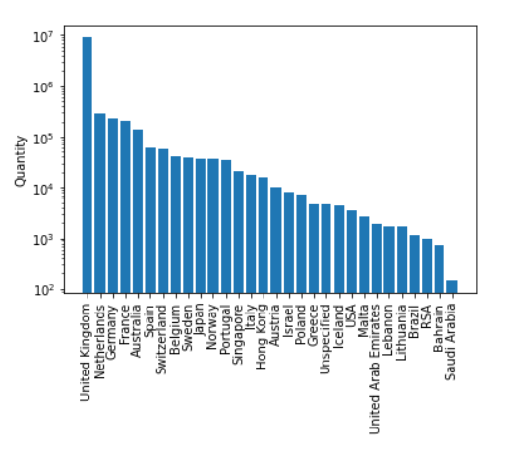

**Generating insights:**

Generating insights in the context of market basket insights involves extracting valuable information and knowledge from transactional data to make informed decisions and improvements in various aspects of a business, particularly in retail and e-commerce.

* **Support, Confidence, and Lift Metrics:**
* Support, confidence, and lift are important metrics for assessing the strength and significance of association rules.
* Insights are derived by examining the values of these metrics. High confidence and lift suggest strong relationships, while high support indicates popularity
* **Identifying Product Associations**:
* By analyzing association rules and frequent itemsets, businesses can identify which products are often bought together. This information can be used for cross-selling and upselling strategies.
* For example, if customers frequently buy cameras with memory cards, insights can lead to bundling these items for promotions.
* **Marketing and Promotion Strategies**:
* Insights can be used to design marketing campaigns and promotions that are more likely to resonate with customers.
* For instance, businesses can create personalized recommendations based on the associations discovered in the data.
* **Customer Segmentation:**
* Insights can be used to segment customers based on their purchase behaviours. Different customer groups may exhibit distinct purchase patterns.
* Tailoring marketing and product recommendations to each segment can lead to more effective strategies.
* **Data-Driven Decision-Making:**
* Insights from market basket analysis provide a data-driven foundation for making decisions that aim to enhance customer satisfaction, increase revenue, and optimize business operations.

**Conclusion:**

In conclusion, market basket insights are a valuable asset for businesses, particularly those in retail and e-commerce, seeking to understand and leverage customer purchase patterns. By analyzing transactional data, companies can uncover associations and relationships between items that provide numerous benefits.

* **Enhanced Customer Experiences**: Market basket insights enable businesses to offer customers more relevant product recommendations. By understanding which items are frequently purchased together, businesses can improve the shopping experience and increase customer satisfaction.
* **Optimized Business Operations:** Insights from market basket analysis can lead to more effective inventory management. Businesses can adjust stock levels based on anticipated demand for associated items, reducing costs and minimizing stockouts or overstocking.
* **Strategic Marketing:** With knowledge of product associations, companies can design marketing campaigns and promotions that resonate with customers. Personalized recommendations and targeted marketing strategies are more likely to boost sales.