Hospital Management System — Insurance Module Documentation
Version: 1.0
Author: Siddhant Sangram Shinde
Date: 14 May 2026
Branch: `feature/insurance-module`
____________________________________________________________

Table of Contents
1. [Introduction](#1-introduction)
2. [Objectives](#2-objectives)
3. [Scope](#3-scope)
4. [Features](#4-features)
5. [User Roles & Permissions](#5-user-roles--permissions)
6. [System Architecture](#6-system-architecture)
7. [Database Schema](#7-database-schema)
8. [Entity Relationship Diagram](#8-entity-relationship-diagram)
9. [API Endpoints](#9-api-endpoints)
10. [Frontend Components](#10-frontend-components)
11. [Workflows](#11-workflows)
12. [Diagrams](#12-diagrams)
13. [Integration Points](#13-integration-points)
14. [Technology Stack](#14-technology-stack)
15. [Setup & Configuration](#15-setup--configuration)
16. [Conclusion](#16-conclusion)
____________________________________________________________

1. Introduction
The Insurance Module is a core component of the Hospital Management System (HMS) that manages the complete insurance lifecycle for hospital patients. It handles both private insurance policies (linked to Third Party Administrators and Insurance Companies) and government health schemes (PM-JAY/Ayushman Bharat, CGHS, ESIC, MJPJAY).
The module automates the entire insurance workflow from policy registration and verification through pre-authorization requests, cashless/reimbursement claims processing, document management, and integration with the hospital's Billing Module for insurance-billing splits.
It supports dynamic provider-specific forms through a flexible form rendering engine, allowing the system to generate insurer-specific pre-authorization and claim forms (IRDAI Standard, PM-JAY, CGHS) without schema changes.
____________________________________________________________

2. Objectives
- Automate insurance policy registration and verification for patients
- Support both private insurance (via TPAs) and government health schemes
- Streamline pre-authorization requests for planned admissions/procedures
- Enable cashless and reimbursement claim processing with full audit trails
- Manage medical document uploads and retrieval for claims
- Integrate insurance deductions into the hospital billing system
- Maintain master data for TPAs, insurance companies, and official forms
- Provide real-time dashboard analytics (claims stats, settlement amounts)
- Support role-based access control for different hospital staff
- Reduce manual paperwork and improve claim turnaround time
____________________________________________________________

3. Scope

In Scope
- Private insurance policy management (registration, verification, updates)
- Government scheme enrollment (PM-JAY, CGHS, ESIC, MJPJAY)
- Pre-authorization request lifecycle management
- Cashless claim processing
- Reimbursement claim processing
- Medical document upload and management
- Insurance-billing split calculation and mapping
- TPA master data management
- Insurance company master data management
- Official insurer forms registry
- Provider-specific dynamic form rendering
- Dashboard statistics and reporting
- Cross-module integration (Reception, Billing, Admin)

Out of Scope
- Direct integration with insurer/TPA portals (manual entry supported)
- Real-time claim status updates from insurers
- Insurance premium payment collection
- Patient insurance eligibility verification via external APIs
- Policy renewal automation
- IRDAI regulatory reporting
- Insurance fraud detection
- Patient-facing insurance portal
____________________________________________________________

4. Features

4.1 Policy Management (Private Insurance)
Register and manage private health insurance policies linked to patients.
- Register new insurance policy with patient association
- Support plan types: Individual, Family Floater, Group
- Capture sub-limits (room rent cap, ICU cap, procedure cap)
- Track co-pay percentage, deductibles, and waiting periods
- Policy verification workflow (Not Verified → Verified — Active / Expired)
- Soft-delete with audit trail
- Link policies to TPAs and Insurance Companies
API: `POST /api/insurance/policies`, `GET /:patientId`, `PUT /:policyId`, `PATCH /:policyId/verify`, `DELETE /:policyId`

4.2 Government Scheme Management
Enroll patients under government health schemes with scheme-specific data.
- Support 4 schemes: PM-JAY, CGHS, ESIC, MJPJAY
- Capture scheme-specific identifiers (ABHA number, Ayushman card, CGHS beneficiary ID, ESIC IP number)
- Ration card validation for PM-JAY eligibility
- Dual-scheme support (primary scheme flag)
- Verification workflow matching policy verification
API: `POST /api/insurance/schemes`, `GET /:patientId`, `PUT /:schemeId`, `PATCH /:schemeId/verify`

4.3 Pre-Authorization Management
Request and track pre-authorization for planned procedures and admissions.
- Submit pre-auth requests with diagnosis (ICD-10), proposed treatment, estimated cost
- Status lifecycle: Draft → Submitted → Under Review → Query Raised → Approved → Rejected → Expired
- Query/response tracking between hospital and insurer
- Authorization number and validity date management
- Support for dynamic provider-specific forms (IRDAI, PM-JAY, CGHS)
- Status history audit trail
API: `POST /api/insurance/pre-auth`, `GET /`, `GET /:id`, `PATCH /:id/status`

4.4 Cashless Claims Management
Process cashless claims where the insurer settles directly with the hospital.
- Auto-generate unique claim numbers (CLM-YYYYMMDD-NNNN)
- Link claims to policies, schemes, and pre-auth requests
- 11-stage status lifecycle from Draft to Settled
- Document checklist tracking (9 document types)
- Settlement details (UTR number, date, bank reference)
- Financial breakdown: total bill, claimed amount, approved amount, settled amount
- Co-pay, deductible, and non-covered amount tracking
- Status history with full audit trail
API: `POST /api/insurance/claims`, `GET /`, `GET /:id`, `PATCH /:id/status`, `GET /dashboard-stats`

4.5 Reimbursement Claims
Handle reimbursement claims where the patient pays first and claims later.
- Distinct claim type (Reimbursement vs Cashless)
- Same 11-stage status lifecycle
- Supports all document types for claim submission
- Tracks settlement details for bank transfers

4.6 TPA Management
Manage Third Party Administrator master data.
- CRUD operations for TPA records
- Track IRDAI license numbers and portal URLs
- Pre-auth TAT and claim TAT tracking
- Link TPAs to insurance companies (many-to-many)
API: `GET/POST /api/insurance/master-data/tpas`

4.7 Billing Integration
Calculate and track insurance-billing splits for the Billing Module.
- Insurance deduction calculation (co-pay, deductible, non-covered items)
- Patient payable amount computation
- Manual override support with audit trail
- Summary API for Billing Module consumption
API: `GET /api/insurance/billing/summary/:patientId`, `POST /api/insurance/billing/mapping`

4.8 Document Management
Upload and manage medical documents for claims and pre-auth requests.
- Support PDF, JPEG, PNG files (max 5MB)
- 11 document categories (Admission Form, Discharge Summary, Investigation Reports, etc.)
- Soft-delete with audit trail
- Link documents to claims or pre-auth requests
API: `POST /api/insurance/documents/upload`, `GET /claim/:claimId`, `GET /pre-auth/:preAuthId`, `DELETE /:docId`

4.9 Official Forms Registry
Maintain a directory of official insurer/TPA claim forms.
- Form types: Pre-Auth, Claim, Reimbursement, Discharge
- Track form versions and deprecation
- Store download URLs (forms not hosted in-system)
API: `GET/POST /api/insurance/master-data/forms`

4.10 Insurance Dashboard
Real-time analytics for the insurance desk.
- Total Claims count
- Approved Claims count
- Pending Claims count
- Total Settled Amount
- Claims list with status filtering and pagination
API: `GET /api/insurance/claims/dashboard-stats`

4.11 Provider-Specific Dynamic Forms
Render insurer-specific official forms without schema changes.
- 3 form templates: IRDAI Standard, PM-JAY, CGHS
- Dynamic field rendering (text, number, select, textarea, checkbox, file)
- Auto-fill patient data from system
- Print-to-PDF support
- Form data stored in flexible Map fields
Frontend: `ProviderFormRenderer.jsx`, `insuranceFormTemplates.js`

4.12 Notifications
Notify insurance desk officers about claim updates and pending tasks.
- Notification bell with unread count badge
- Polling every 30 seconds
- Mark-as-read functionality
- Currently mock data (real triggers planned)
API: `GET /api/insurance/notifications`, `PUT /:id/read`

4.13 Cross-Module Integration
The Insurance Module integrates with multiple hospital departments.
- Reception → Insurance: Auto-creates Draft pre-auth when patient has insurance
- Insurance → Billing: Provides insurance split data (InsuranceSplitCard)
- Admin → Insurance: Manages TPA and Insurance Company master data
____________________________________________________________

5. User Roles & Permissions
| Role | View Policies | Register Policy | Verify Policy | File Pre-Auth | Process Claims | Upload Documents | Manage TPA/Insurer | View Dashboard | Manage Schemes |
|---|---|---|---|---|---|---|---|---|---|
| **Insurance Desk Officer** | ✅ | ✅ | ✅ | ✅ | ✅ | ✅ | ❌ | ✅ | ✅ |
| **Admin** | ✅ | ❌ | ✅ | ❌ | ❌ | ❌ | ✅ | ✅ | ❌ |
| **Receptionist** | ✅ | ❌ | ❌ | ✅ (auto) | ❌ | ❌ | ❌ | ❌ | ❌ |
| **Billing Officer** | ✅ (read) | ❌ | ❌ | ❌ | ❌ | ❌ | ❌ | ❌ | ❌ |
| **Doctor** | ✅ (read) | ❌ | ❌ | ✅ (initiate) | ❌ | ✅ (clinical docs) | ❌ | ❌ | ❌ |
| **Patient** | ✅ (own only) | ❌ | ❌ | ❌ | ❌ | ❌ | ❌ | ❌ | ❌ |
**Note:** Role-Based Access Control (RBAC) middleware is planned but not yet enforced. All endpoints are currently open.
____________________________________________________________

6. System Architecture

6.1 HMS Full System Architecture
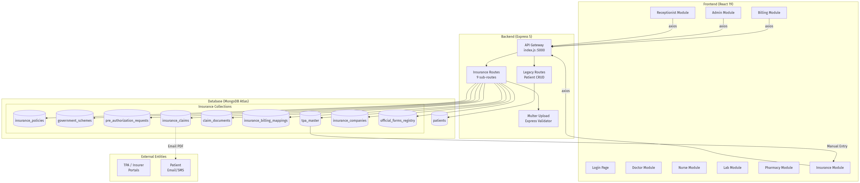
Figure: HMS Full System Architecture

6.2 Insurance Module Architecture
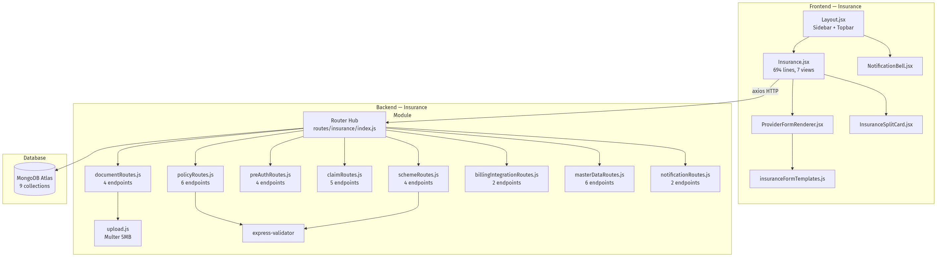
Figure: Insurance Module Architecture
____________________________________________________________

7. Database Schema
The Insurance Module uses 9 MongoDB collections stored in a MongoDB Atlas sharded cluster.

7.1 InsurancePolicy (`insurance_policies`)
| Field | Type | Required | Description |
|---|---|---|---|
| `patientId` | ObjectId (ref: Patient) | ✅ | Link to patient |
| `insuranceType` | Enum: `Private`, `Government` | ✅ | Type of insurance |
| `providerName` | String | ✅ | Insurer name |
| `policyNumber` | String | ✅ | Unique policy number |
| `planType` | Enum: `Individual`, `Family Floater`, `Group` | ✅ | Plan category |
| `sumInsured` | Number | ✅ | Maximum coverage amount |
| `subLimits.roomRentCap` | Number | | Room rent limit per day |
| `subLimits.icuCap` | Number | | ICU charge limit per day |
| `subLimits.procedureCap` | Number | | Per-procedure limit |
| `coPayPercentage` | Number | | Patient co-pay % (default: 0) |
| `deductible` | Number | | Deductible amount (default: 0) |
| `tpaId` | ObjectId (ref: TPAMaster) | | Linked TPA |
| `insurerCompanyId` | ObjectId (ref: InsuranceCompany) | | Linked insurer |
| `policyStartDate` | Date | ✅ | Coverage start |
| `policyEndDate` | Date | ✅ | Coverage end |
| `isNetworkHospital` | Boolean | | Hospital in insurer network? |
| `waitingPeriodNotes` | String | | Waiting period details |
| `verificationStatus` | Enum | | `Not Verified`, `Verified — Active`, `Verified — Expired`, `Verification Failed` |
| `verifiedBy` | ObjectId (ref: User) | | Verifying officer |
| `verifiedAt` | Date | | Verification timestamp |
| `isActive` | Boolean | | Soft-delete flag |

7.2 GovernmentScheme (`government_schemes`)
| Field | Type | Required | Description |
|---|---|---|---|
| `patientId` | ObjectId (ref: Patient) | ✅ | Link to patient |
| `schemeName` | Enum: `PM-JAY`, `CGHS`, `ESIC`, `MJPJAY`, `Other` | ✅ | Scheme identifier |
| `schemeSpecificData.abhaNumber` | String | | ABHA Health ID |
| `schemeSpecificData.ayushmanCardNumber` | String | | PM-JAY card number |
| `schemeSpecificData.familyId` | String | | Family identifier |
| `schemeSpecificData.hbpCode` | String | | Health Benefit Package code |
| `schemeSpecificData.cghsBeneficiaryId` | String | | CGHS beneficiary ID |
| `schemeSpecificData.cghsCardType` | Enum | | `Serving`, `Pensioner`, `Dependent` |
| `schemeSpecificData.referralReference` | String | | CGHS referral number |
| `schemeSpecificData.esicIpNumber` | String | | ESIC IP number |
| `schemeSpecificData.employerName` | String | | ESIC employer |
| `schemeSpecificData.dispensaryName` | String | | ESIC dispensary |
| `schemeSpecificData.rationCardNumber` | String | | PM-JAY eligibility |
| `schemeSpecificData.rationCardCategory` | Enum | | `Yellow`, `Orange`, `AAY`, `Annapurna` |
| `schemeSpecificData.sevenTwelveExtract` | String | | Land record reference |
| `schemeSpecificData.arogyamitraVerified` | Boolean | | Arogya Mitra verified? |
| `verificationStatus` | Enum | | Same as Policy |
| `primaryScheme` | Boolean | | For dual-eligible patients |
| `isActive` | Boolean | | Soft-delete flag |

7.3 PreAuthRequest (`pre_authorization_requests`)
| Field | Type | Required | Description |
|---|---|---|---|
| `patientId` | ObjectId (ref: Patient) | ✅ | Link to patient |
| `policyId` | ObjectId (ref: InsurancePolicy) | | Private policy reference |
| `schemeId` | ObjectId (ref: GovernmentScheme) | | Govt scheme reference |
| `admittingDoctor` | String | ✅ | Treating doctor name |
| `expectedAdmissionDate` | Date | | Planned admission |
| `expectedDischargeDate` | Date | | Planned discharge |
| `diagnosis` | String | ✅ | Medical diagnosis |
| `icd10Code` | String | | ICD-10 classification |
| `proposedTreatment` | String | ✅ | Planned procedure |
| `estimatedCost` | Number | ✅ | Estimated treatment cost |
| `status` | Enum | ✅ | `Draft`, `Submitted`, `Under Review`, `Query Raised`, `Approved`, `Enhancement Requested`, `Rejected`, `Expired` |
| `approvedAmount` | Number | | Insurer approved amount |
| `authorizationNumber` | String | | Auth reference number |
| `validityDate` | Date | | Auth expiry date |
| `queryDetails` | Array | | Query/response tracking |
| `statusHistory` | Array | | Full status audit trail |
| `documents` | [ObjectId] (ref: ClaimDocument) | | Attached documents |
| `providerTemplateUsed` | String | | e.g. `IRDAI_STANDARD`, `PM_JAY` |
| `providerSpecificData` | Map of Mixed | | Dynamic form field values |

7.4 InsuranceClaim (`insurance_claims`)
| Field | Type | Required | Description |
|---|---|---|---|
| `claimNumber` | String (unique) | ✅ | Auto-generated: CLM-YYYYMMDD-NNNN |
| `patientId` | ObjectId (ref: Patient) | ✅ | Link to patient |
| `policyId` | ObjectId (ref: InsurancePolicy) | | Policy reference |
| `schemeId` | ObjectId (ref: GovernmentScheme) | | Scheme reference |
| `preAuthId` | ObjectId (ref: PreAuthRequest) | | Pre-auth reference |
| `claimType` | Enum: `Cashless`, `Reimbursement` | ✅ | Claim category |
| `admissionDate` | Date | ✅ | Admission date |
| `dischargeDate` | Date | | Discharge date |
| `diagnosis` | String | ✅ | Diagnosis |
| `icd10Code` | String | | ICD-10 code |
| `proceduresPerformed` | String | | Procedures done |
| `treatingDoctor` | String | | Doctor name |
| `totalBillAmount` | Number | | Gross hospital bill |
| `claimedAmount` | Number | | Amount claimed |
| `approvedAmount` | Number | | Insurer approved |
| `settledAmount` | Number | | Actual amount received |
| `coPayAmount` | Number | | Patient co-pay |
| `deductibleAmount` | Number | | Deductible applied |
| `nonCoveredAmount` | Number | | Non-covered charges |
| `patientPayable` | Number | | Net patient liability |
| `status` | Enum | ✅ | 11-stage lifecycle |
| `settlementDetails` | Subdocument | | UTR, date, bank reference |
| `rejectionReason` | String | | Rejection explanation |
| `statusHistory` | Array | | Full audit trail |
| `documents` | [ObjectId] (ref: ClaimDocument) | | Attached documents |
| `documentChecklist` | Subdocument | | 9 boolean flags |
| `providerTemplateUsed` | String | | Dynamic form template |
| `providerSpecificData` | Map of Mixed | | Dynamic form values |

7.5 InsuranceBillingMapping (`insurance_billing_mappings`)
| Field | Type | Required | Description |
|---|---|---|---|
| `patientId` | ObjectId (ref: Patient) | ✅ | Patient link |
| `billId` | ObjectId (ref: Bill) | | Billing module bill |
| `claimId` | ObjectId (ref: InsuranceClaim) | | Insurance claim |
| `policyId` | ObjectId (ref: InsurancePolicy) | | Policy reference |
| `totalBillAmount` | Number | ✅ | Gross bill |
| `approvedAmount` | Number | | Insurer approved |
| `coPayAmount` | Number | | Co-pay deduction |
| `deductibleAmount` | Number | | Deductible |
| `nonCoveredItems` | Array | | Itemized non-covered |
| `insuranceDeduction` | Number | ✅ | What insurance pays |
| `patientPayable` | Number | ✅ | What patient pays |
| `isManualOverride` | Boolean | | Manual adjustment? |
| `overrideReason` | String | | Override justification |
| `overrideBy` | ObjectId (ref: User) | | Override officer |

7.6 ClaimDocument (`claim_documents`)
| Field | Type | Required | Description |
|---|---|---|---|
| `claimId` | ObjectId (ref: InsuranceClaim) | | Linked claim |
| `preAuthId` | ObjectId (ref: PreAuthRequest) | | Linked pre-auth |
| `category` | Enum (11 types) | ✅ | Document type |
| `filename` | String | ✅ | Stored filename |
| `originalName` | String | ✅ | Upload filename |
| `filePath` | String | ✅ | Storage path |
| `fileSize` | Number | | File size |
| `mimeType` | Enum | | `application/pdf`, `image/jpeg`, `image/png` |
| `uploadedBy` | ObjectId (ref: User) | ✅ | Uploader |
| `isDeleted` | Boolean | | Soft-delete |
| `deletedBy` | ObjectId (ref: User) | | Delete audit |
| `deletedAt` | Date | | Delete timestamp |

7.7 TPAMaster (`tpa_master`)
| Field | Type | Required | Description |
|---|---|---|---|
| `name` | String (unique) | ✅ | TPA name |
| `irdaiLicenseNumber` | String | | IRDAI license |
| `portalUrl` | String | | TPA portal URL |
| `helpdeskPhone` | String | | Contact phone |
| `helpdeskEmail` | String | | Contact email |
| `preAuthTAT` | String | | Pre-auth turnaround |
| `claimTAT` | String | | Claim turnaround |
| `linkedInsurers` | [ObjectId] (ref: InsuranceCompany) | | Linked insurers |
| `isActive` | Boolean | | Active flag |

7.8 InsuranceCompany (`insurance_companies`)
| Field | Type | Required | Description |
|---|---|---|---|
| `name` | String (unique) | ✅ | Company name |
| `type` | Enum: `Private`, `PSU`, `Government` | ✅ | Company type |
| `irdaiRegistrationNumber` | String | | IRDAI reg number |
| `claimPortalUrl` | String | | Claim portal |
| `contactPhone` | String | | Phone |
| `contactEmail` | String | | Email |
| `networkHospitalStatus` | Boolean | | In-network? |
| `defaultTpaId` | ObjectId (ref: TPAMaster) | | Default TPA |
| `isActive` | Boolean | | Active flag |

7.9 OfficialFormsRegistry (`official_forms_registry`)
| Field | Type | Required | Description |
|---|---|---|---|
| `insurerOrTpaName` | String | ✅ | Entity name |
| `formName` | String | ✅ | Form name |
| `formType` | Enum | ✅ | `Pre-Auth`, `Claim`, `Reimbursement`, `Discharge`, `Other` |
| `downloadUrl` | String | ✅ | Form download URL |
| `formVersion` | String | | Version |
| `lastVerifiedDate` | Date | | Last verification |
| `lastVerifiedBy` | ObjectId (ref: User) | | Verifier |
| `isDeprecated` | Boolean | | Deprecated? |
| `notes` | String | | Notes |
____________________________________________________________

8. Entity Relationship Diagram
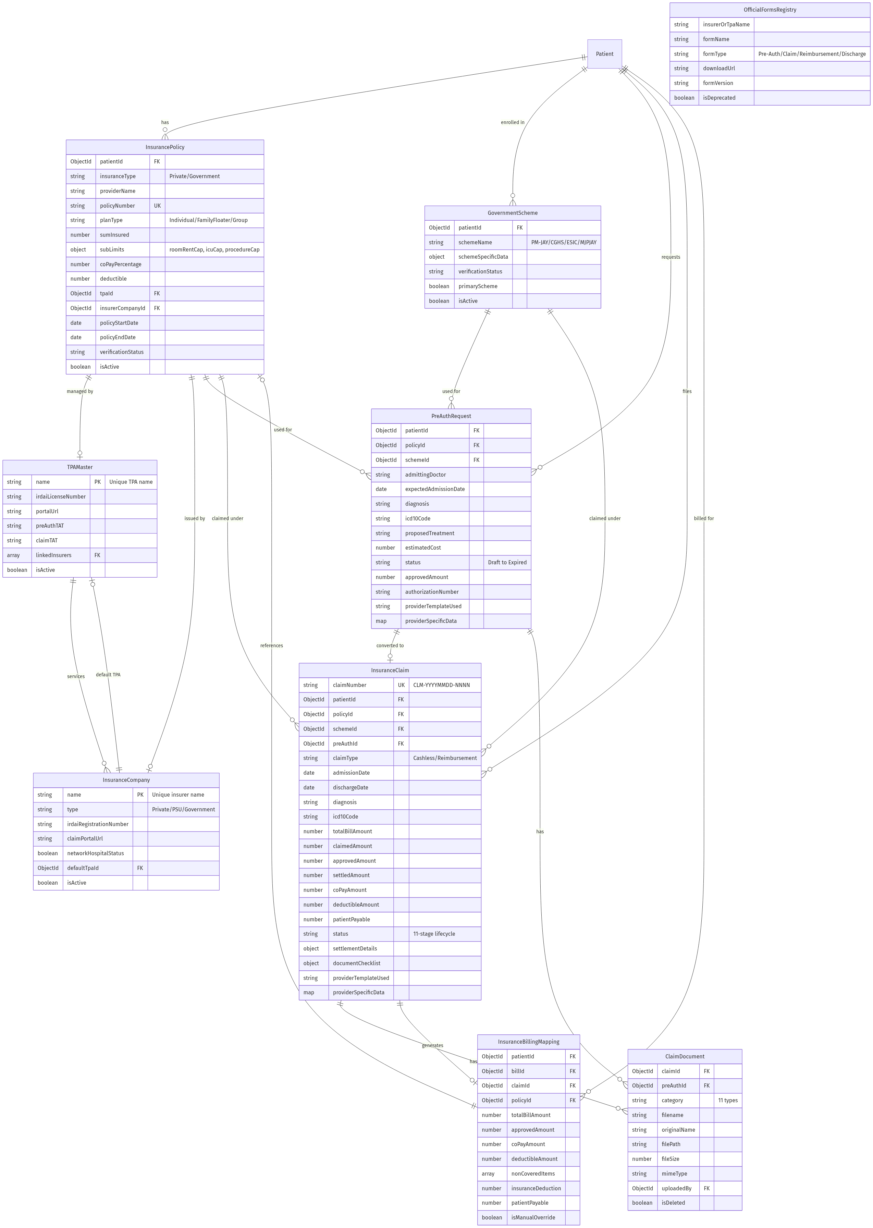
Figure: Entity Relationship Diagram
____________________________________________________________

9. API Endpoints
All endpoints are mounted under `/api/insurance`.

9.1 Health Check
| Method | Endpoint | Description |
|---|---|---|
| `GET` | `/health` | Server health check (returns timestamp) |

9.2 Policy Routes (`/policies`)
| Method | Endpoint | Validation | Description |
|---|---|---|---|
| `POST` | `/` | `policyValidationRules` | Register new insurance policy |
| `GET` | `/:patientId` | — | Get all policies for a patient |
| `GET` | `/detail/:policyId` | — | Get single policy with TPA + insurer populated |
| `PUT` | `/:policyId` | `policyValidationRules` | Update policy details |
| `PATCH` | `/:policyId/verify` | — | Update verification status only |
| `DELETE` | `/:policyId` | — | Soft-delete policy (isActive = false) |

9.3 Scheme Routes (`/schemes`)
| Method | Endpoint | Validation | Description |
|---|---|---|---|
| `POST` | `/` | `schemeValidationRules` | Enroll patient in government scheme |
| `GET` | `/:patientId` | — | Get all scheme enrollments for a patient |
| `PUT` | `/:schemeId` | `schemeValidationRules` | Update scheme details |
| `PATCH` | `/:schemeId/verify` | — | Update verification status |

9.4 Pre-Auth Routes (`/pre-auth`)
| Method | Endpoint | Description |
|---|---|---|
| `POST` | `/` | Create pre-auth request (supports provider-specific forms) |
| `GET` | `/` | List all pre-auth requests (populated with patient + policy) |
| `GET` | `/:id` | Get single pre-auth detail |
| `PATCH` | `/:id/status` | Update status + approved amount + authorization number |

9.5 Claim Routes (`/claims`)
| Method | Endpoint | Description |
|---|---|---|
| `POST` | `/` | Create claim (auto-generates claim number, supports dynamic forms) |
| `GET` | `/` | List claims with pagination (`?status&page&limit`) |
| `GET` | `/dashboard-stats` | Aggregated dashboard statistics |
| `GET` | `/:id` | Get single claim (populated with patient, policy, scheme, documents) |
| `PATCH` | `/:id/status` | Update claim status with history tracking |

9.6 Document Routes (`/documents`)
| Method | Endpoint | Description |
|---|---|---|
| `POST` | `/upload` | Upload document (multipart, links to claim or pre-auth) |
| `GET` | `/claim/:claimId` | Get documents for a claim (non-deleted only) |
| `GET` | `/pre-auth/:preAuthId` | Get documents for a pre-auth (non-deleted only) |
| `DELETE` | `/:docId` | Soft-delete document |

9.7 Billing Integration Routes (`/billing`)
| Method | Endpoint | Description |
|---|---|---|
| `GET` | `/summary/:patientId` | Get insurance deduction summary for billing |
| `POST` | `/mapping` | Create billing-insurance mapping record |

9.8 Master Data Routes (`/master-data`)
| Method | Endpoint | Description |
|---|---|---|
| `GET` | `/tpas` | List all TPAs |
| `POST` | `/tpas` | Create new TPA |
| `GET` | `/companies` | List all insurance companies |
| `POST` | `/companies` | Create new insurance company |
| `GET` | `/forms` | List all official forms |
| `POST` | `/forms` | Create new official form |

9.9 Notification Routes (`/notifications`)
| Method | Endpoint | Description |
|---|---|---|
| `GET` | `/` | Get all notifications (currently mock data) |
| `PUT` | `/:id/read` | Mark notification as read |
Total: 33 API endpoints across 9 sub-routes.
____________________________________________________________

10. Frontend Components

10.1 Main Insurance Page (`Insurance.jsx`)
The main Insurance Desk interface is a single-page application with 7 internal views managed by a `step` state variable.
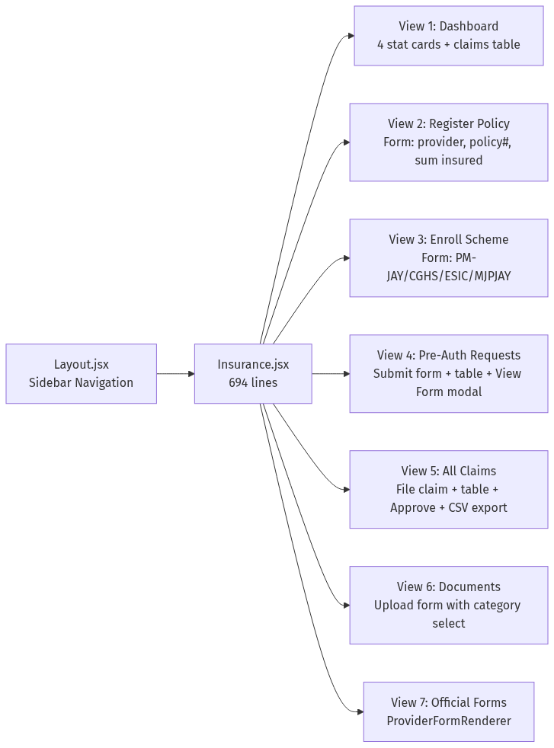
Figure: Main Insurance Page
Sidebar Navigation Buttons:
- Dashboard
- Register Policy
- Enroll Scheme
- Pre-Auth Requests
- All Claims
- Documents
- Official Provider Forms

10.2 ProviderFormRenderer (`ProviderFormRenderer.jsx`)
A dynamic form engine that renders insurer-specific official forms based on template configuration.
- Dropdown to select template: IRDAI Standard, PM-JAY, CGHS
- Auto-fills fields from patient data
- Handles all field types: text, number, select, textarea, checkbox, file
- Submits to pre-auth or claim endpoints depending on mode
- Print-to-PDF support via `window.print()`

10.3 InsuranceSplitCard (`InsuranceSplitCard.jsx`)
Reusable billing integration component used by the Billing Module.
- Fetches `GET /api/insurance/billing/summary/:patientId`
- Displays breakdown: Gross Hospital Bill → Insurance Deduction → Co-Pay → Net Patient Payable

10.4 NotificationBell (`NotificationBell.jsx`)
- Polls `GET /api/insurance/notifications` every 30 seconds
- Dropdown with unread count badge
- Click marks notification as read

10.5 Form Templates (`insuranceFormTemplates.js`)
Three provider templates defined as configuration objects:
| Template ID | Name | Sections |
|---|---|---|
| `IRDAI_STANDARD` | IRDAI Standard Private Insurance | Patient Details, Policy Details, Medical Information, Financial Estimates |
| `PM_JAY` | Ayushman Bharat (PM-JAY) | Beneficiary Verification, Admission & Clinical Status, Package Selection & Evidence |
| `CGHS` | Central Government Health Scheme | Beneficiary Information, Medical & Billing Details |
____________________________________________________________

11. Workflows

11.1 Policy & Scheme Registration Flow
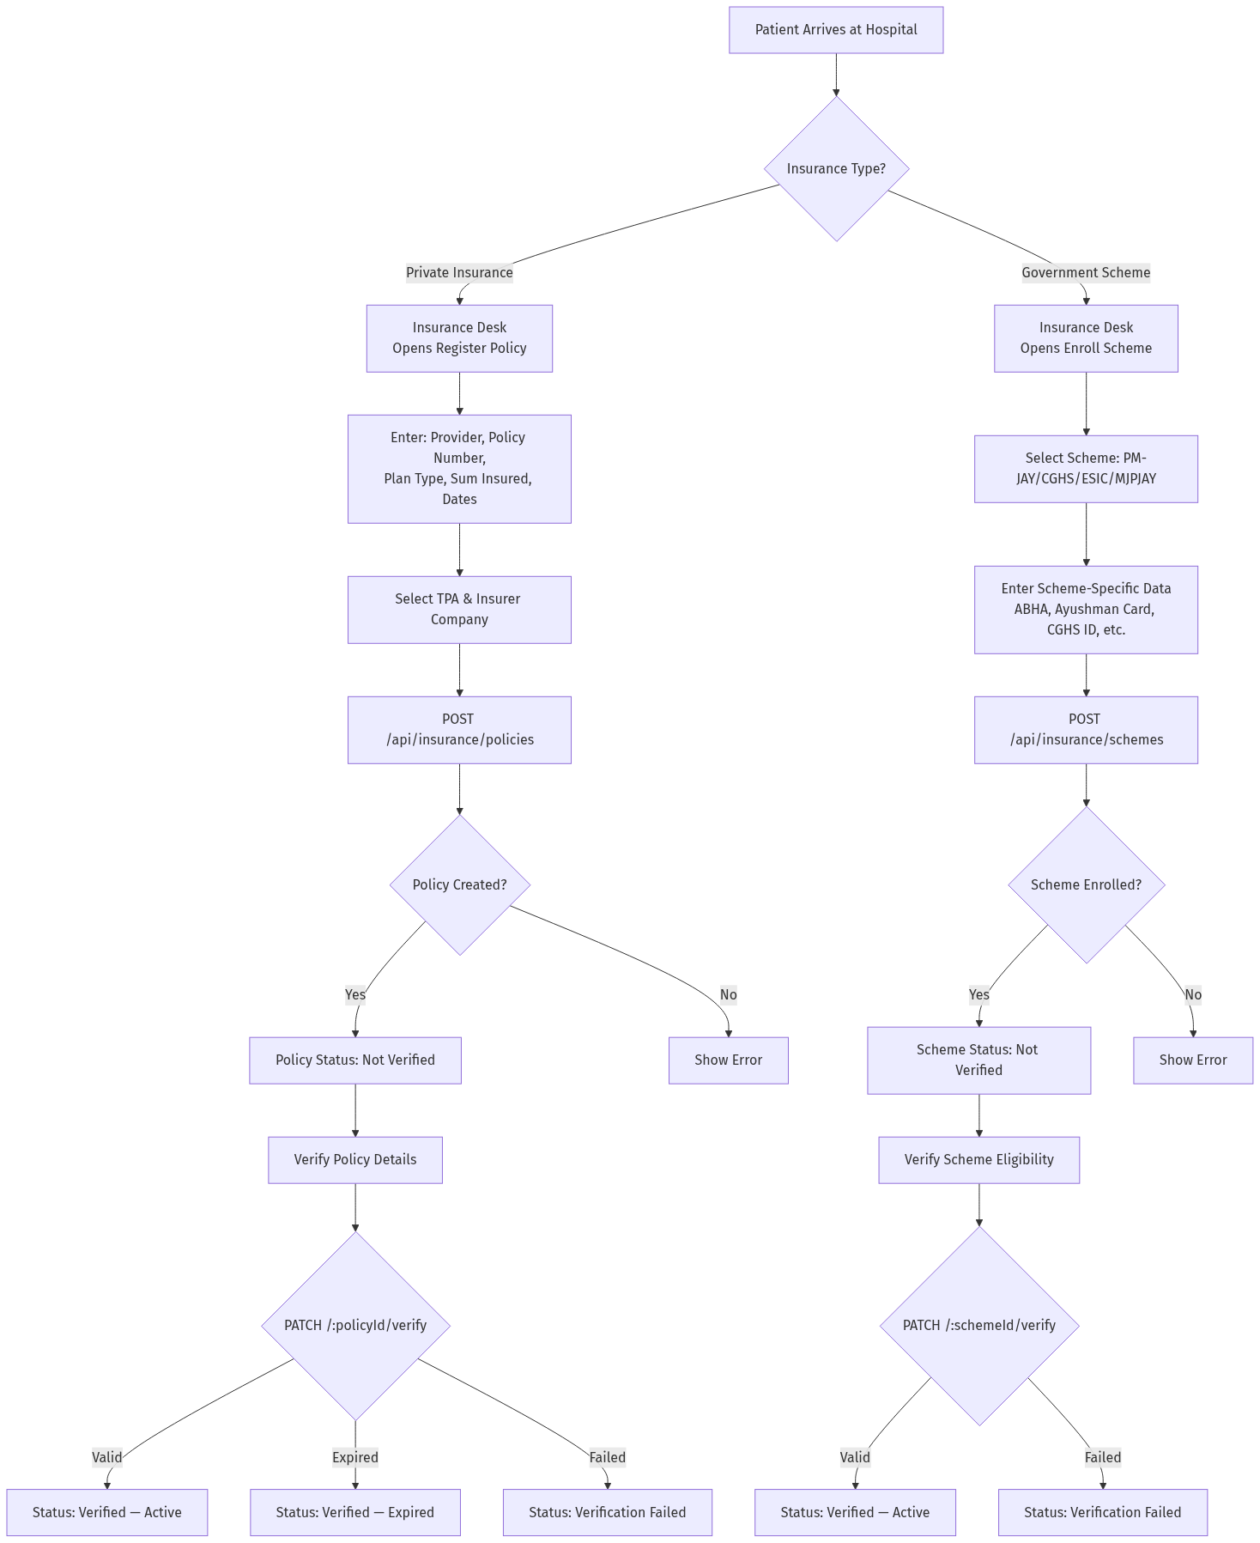
Figure: Policy & Scheme Registration Flow

11.2 Pre-Authorization Workflow
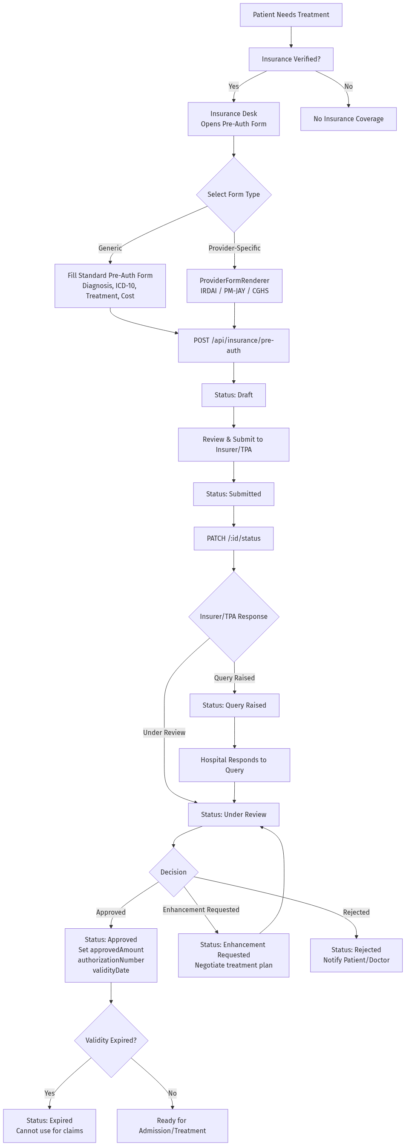
Figure: Pre-Authorization Workflow

11.3 Claims Workflow
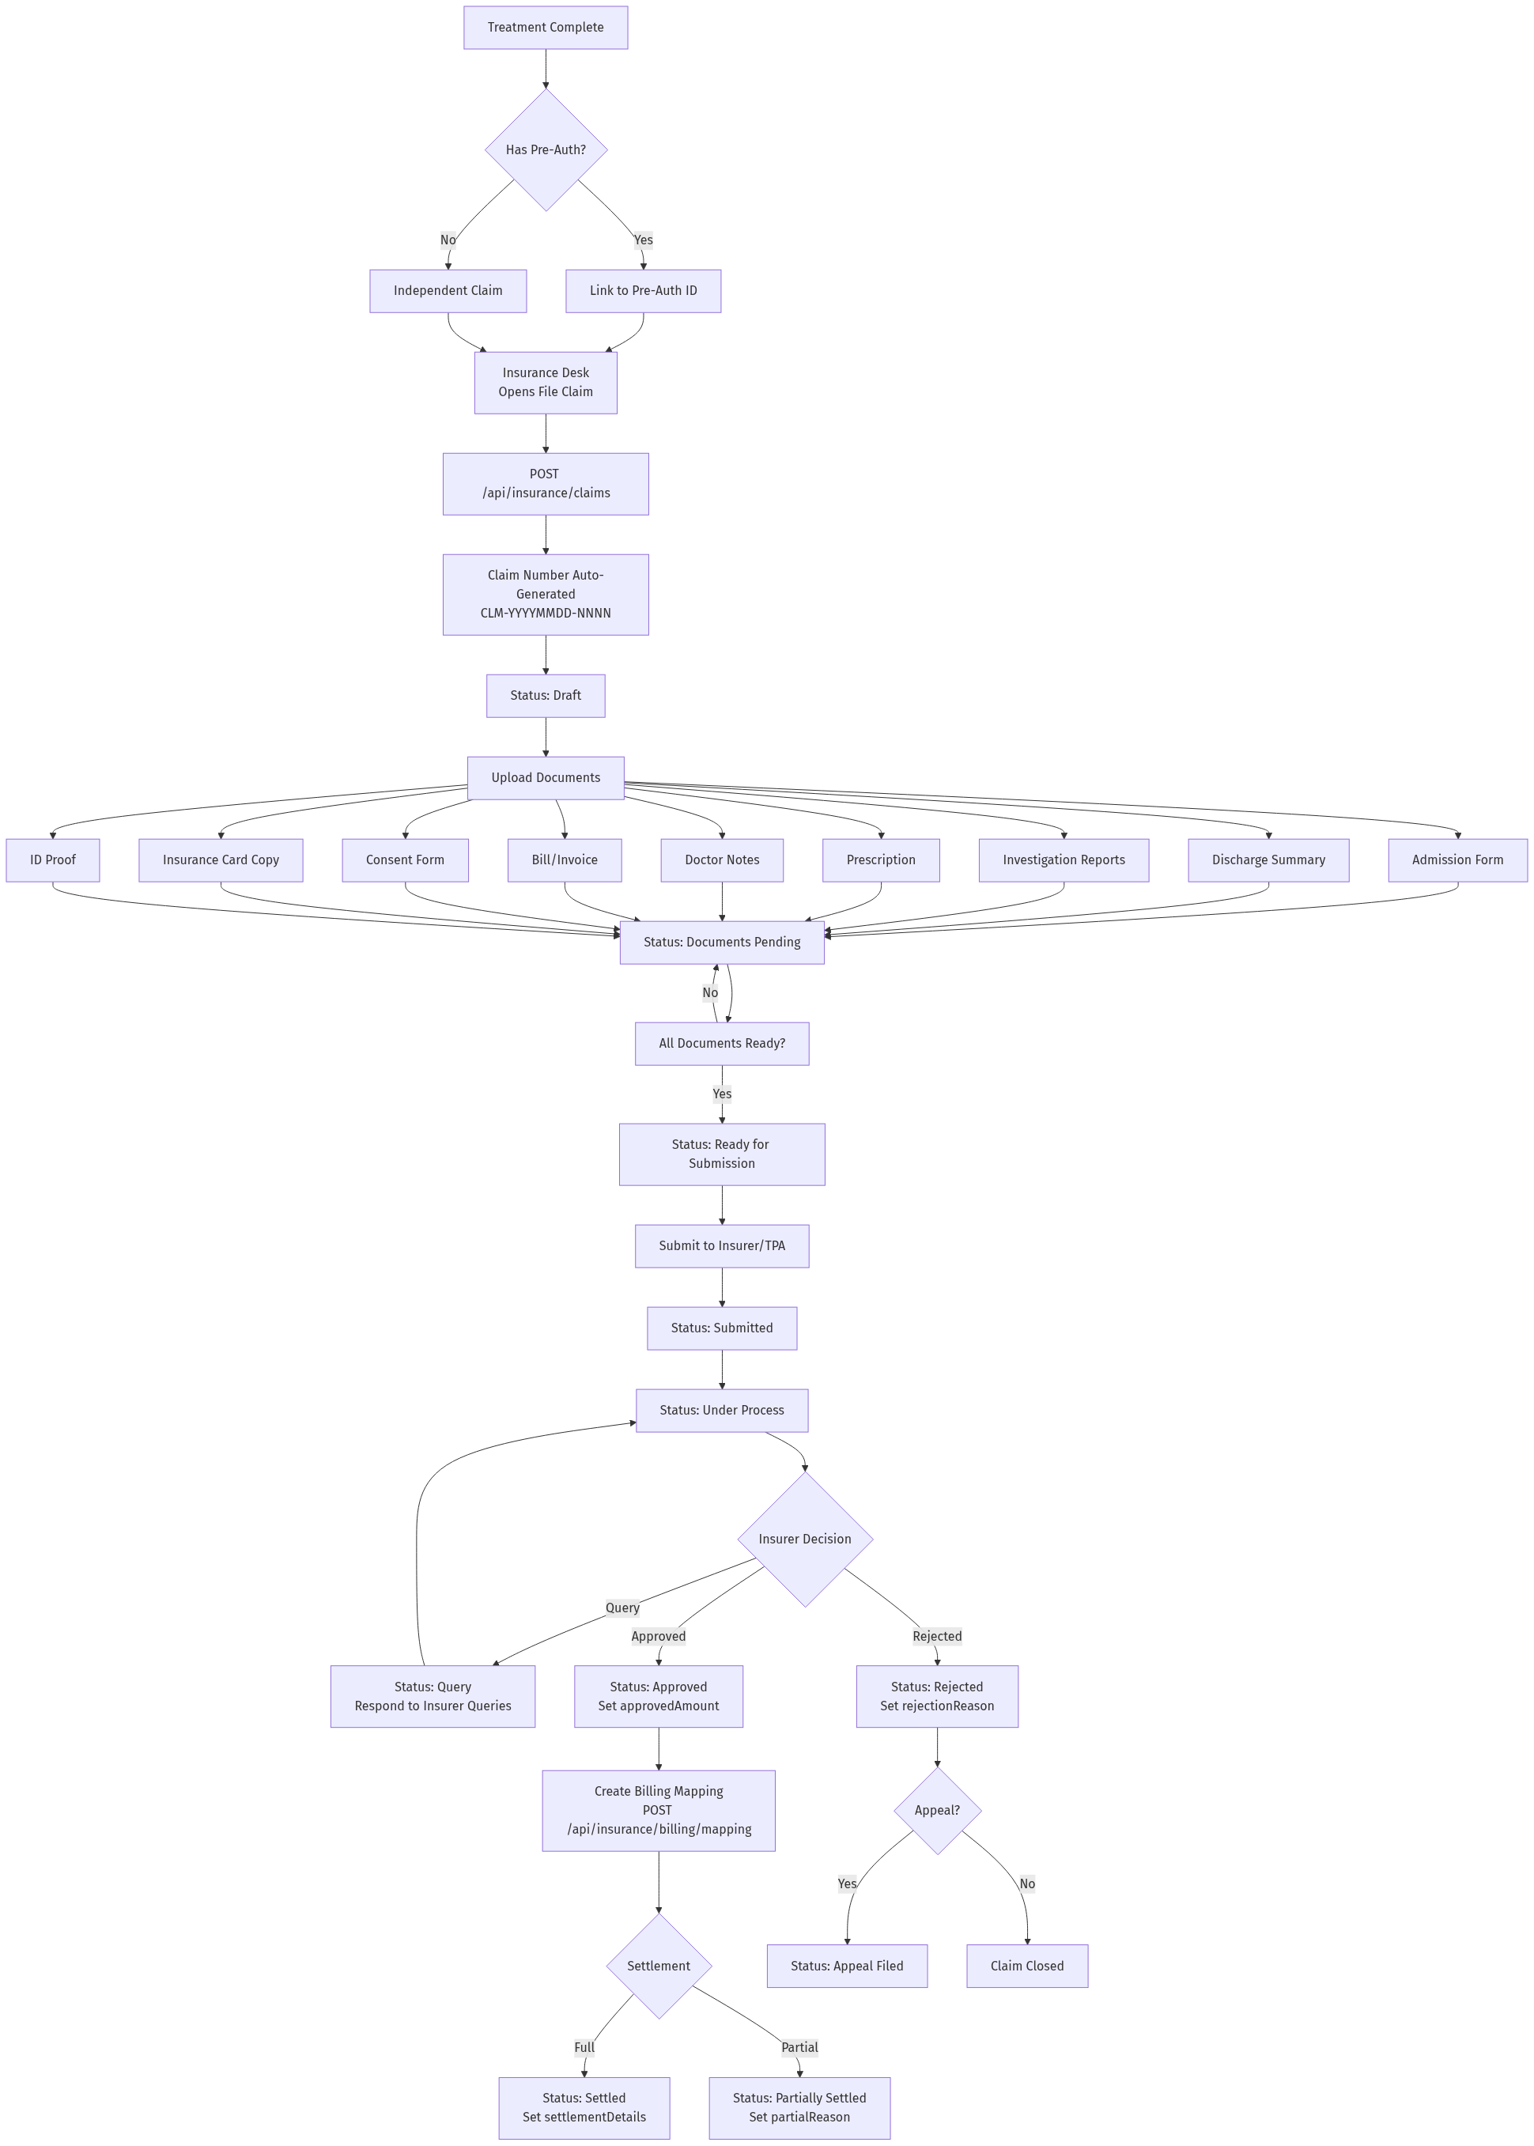
Figure: Claims Workflow

11.4 Billing Integration Flow
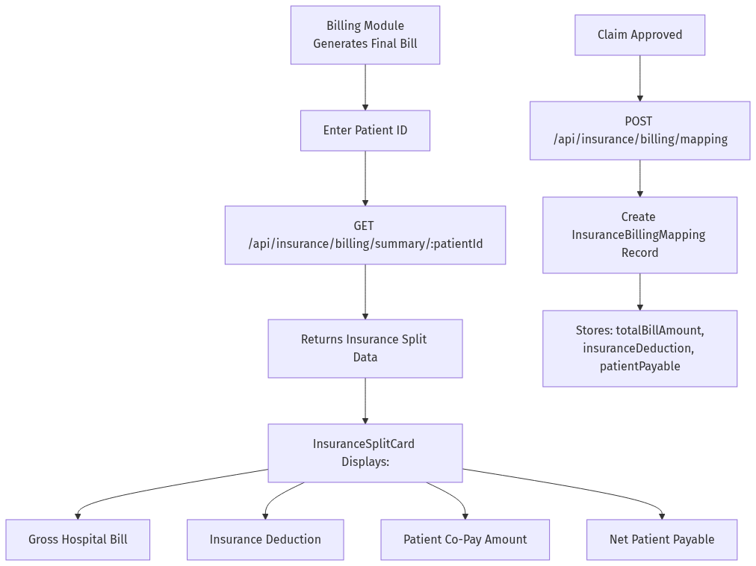
Figure: Billing Integration Flow
____________________________________________________________

12. Diagrams

12.1 Flowchart Diagram
*The complete workflow flowcharts are documented in Section 11 above:*
- Policy & Scheme Registration Flow
- Pre-Authorization Workflow
- Claims Workflow
- Billing Integration Flow

12.2 Data Flow Diagram (DFD)
#### DFD Level 0 — Insurance System Context

Figure: Policy & Scheme Registration Flow
#### DFD Level 1 — Insurance Internal Processes

Figure: Pre-Authorization Workflow

12.3 Use Case Diagram

Figure: Claims Workflow

12.4 Sequence Diagram — Pre-Authorization Flow
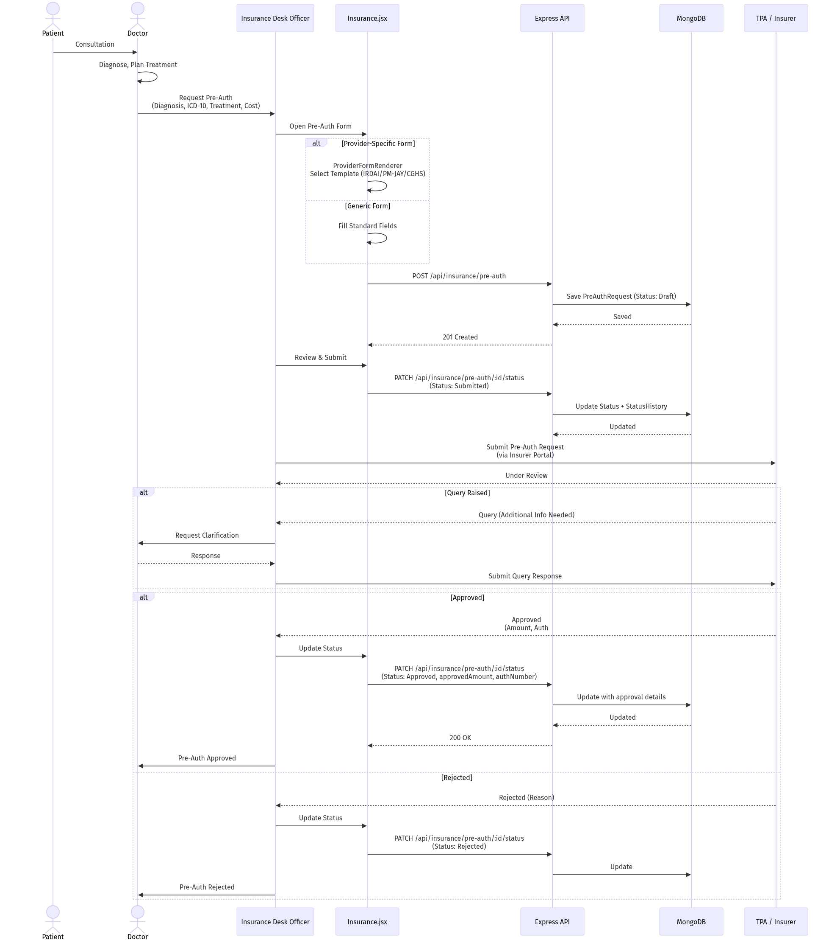
Figure: Pre-Authorization Flow

12.5 Sequence Diagram — Claim Processing Flow
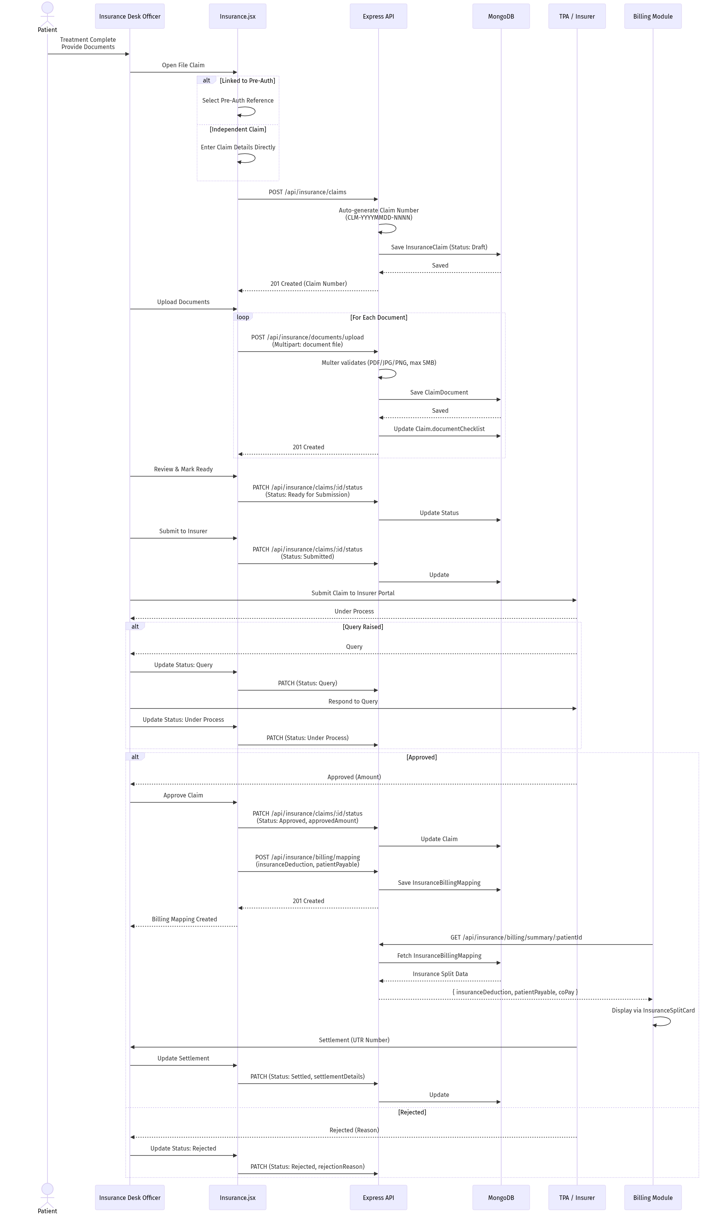
Figure: Claim Processing Flow

12.6 Module Interaction Diagram
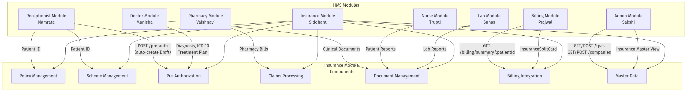
Figure: Module Interaction Diagram
____________________________________________________________

13. Integration Points

13.1 Reception ↔ Insurance
When a receptionist registers a patient with insurance, the system automatically creates a Draft pre-authorization request.
Trigger: Patient registration with `insurance: true` flag
API: `POST /api/insurance/pre-auth`
Result: PreAuthRequest saved with status "Draft" for insurance desk to process

13.2 Insurance ↔ Billing
When a claim is approved, the insurance module creates a billing mapping record. The billing module fetches this data to display insurance coverage splits.
Trigger: Claim status changed to "Approved"
API: `POST /api/insurance/billing/mapping`
Consumer: Billing Module via `GET /api/insurance/billing/summary/:patientId`
Frontend: `InsuranceSplitCard.jsx` displays the breakdown

13.3 Admin ↔ Insurance
The Admin Module manages the master data that the Insurance Module depends on.
API: `GET /api/insurance/master-data/tpas`, `GET /api/insurance/master-data/companies`
Frontend: Admin Dashboard → "Insurance Master" view

13.4 Doctor ↔ Insurance
Doctors initiate pre-auth requests and upload clinical documents.
Flow: Doctor Dashboard → Diagnosis → Request Pre-Auth → Insurance Module
Documents: Clinical reports, prescriptions, investigation results

13.5 Pharmacy ↔ Insurance
Pharmacy bills are included in claim totals for insurance reimbursement.
Flow: Pharmacy generates bill → Bill included in claim total → Insurance processes
____________________________________________________________

14. Technology Stack
| Layer | Technology | Version |
|---|---|---|
| **Frontend Framework** | React | 19.2.5 |
| **Routing** | React Router DOM | 7.15.0 |
| **HTTP Client** | Axios | 1.15.0 |
| **Backend Runtime** | Node.js | — |
| **Backend Framework** | Express | 5.2.1 |
| **Database** | MongoDB (Atlas) | — |
| **ODM** | Mongoose | 9.4.1 |
| **Validation** | express-validator | 7.3.2 |
| **File Upload** | Multer | 2.1.1 |
| **Authentication** | bcryptjs, jsonwebtoken | 3.0.3, 9.0.3 |
| **Environment** | dotenv | 17.4.1 |
| **CORS** | cors | 2.8.6 |
| **Dev Tools** | nodemon | 3.1.14 |
____________________________________________________________

15. Setup & Configuration

15.1 Prerequisites
- Node.js (v18+)
- MongoDB Atlas account (or local MongoDB instance)
- npm or yarn

15.2 Backend Setup

Navigate to backend
cd Backend

Install dependencies
npm install

Seed insurance master data (TPAs + Companies)
node seeds/insuranceSeed.js

Start development server
npm run dev
Server runs on `http://localhost:5000`.

15.3 Frontend Setup

Navigate to frontend
cd frontend

Install dependencies
npm install

Start development server
npm start
Frontend runs on `http://localhost:3000`.

15.4 MongoDB Collections
The insurance module uses these collections in the `hospitalDB` database:
| Collection | Purpose |
|---|---|
| `insurance_policies` | Private insurance policies |
| `government_schemes` | Government scheme enrollments |
| `pre_authorization_requests` | Pre-auth requests |
| `insurance_claims` | Cashless & reimbursement claims |
| `claim_documents` | Uploaded medical documents |
| `insurance_billing_mappings` | Insurance-billing split records |
| `tpa_master` | TPA registry |
| `insurance_companies` | Insurer registry |
| `official_forms_registry` | Official form directory |

15.5 Postman Collection
A pre-built Postman collection is available at:
`Backend/insurance-api.postman_collection.json`
____________________________________________________________

16. Conclusion
The Insurance Module provides a comprehensive solution for managing hospital insurance operations. It handles the complete lifecycle from policy registration through pre-authorization, claims processing, and billing integration.
Key Accomplishments:
- 9 MongoDB collections fully implemented with proper relationships
- 33 API endpoints across 9 sub-routes
- Dynamic provider-specific form rendering (IRDAI, PM-JAY, CGHS)
- Full status lifecycle tracking with audit trails
- Cross-module integration with Reception, Billing, and Admin modules
- Insurance dashboard with real-time statistics
Pending Items:
- JWT authentication and RBAC middleware enforcement
- Real notification triggers (currently mock data)
- Analytics and reports module (6 planned report types)
- Dedicated reimbursement workflow enhancements
- Patient-facing insurance portal
____________________________________________________________
Document Version: 1.0
Last Updated: 14 May 2026
Author: Siddhant Sangram Shinde
Module: Insurance Module — Hospital Management System

