INSTRUCTIVE FOR THE REVIEW AND APPROVAL FIRE AND SAFETY CONTROL PLAN

 | POSITION | DATE | SIGNATURE
PREPARED BY
REVISED BY
APPROVED BY

- OBJECTIVE

To establish an appropriate mechanism to accomplish and control systematically the surveys and completion of the corresponding reports and certificates.

- SCOPE

The content of this instructive applies to all ships depending on their gross tonnage and the regulation that applies.

- RESPONSIBILITIES

  - It is responsibility of the personnel of Technical Manager to assure that all procedures contained in this instructive are fulfilled for the surveys and issuance of respective certificate.

  - It is responsibility of the personnel of Technical Department to support in the monitoring for the compliance of the mechanisms for the surveys and issuance of the technical certificate.

  - It is the responsibility of the Naval Architect and/or the Engineer to conduct the plan approval according to the provisions of this instructive.

- DEFINITIONS

GR CLASS | Gr Class-Classified For Standard is an Recognised Organization and Recognised Security Organisation to perform inspection and certification work on ships registered under a Flag Administration.
Classification Rules | They are referred to those issued by a classification society with which GR CLASS has signed contractual agreement for sharing such rules in ship surveys and certification activities.
Stand by | to be waiting and ready to do something.
IMO | International Maritime Organization: It is a specialized agency of the United Nations devoted to maritime matters.
Maritime Administration | is the Authority responsible to regulate all aspects related to the marine requirements of the flag.
National Regulations | Are those established by each Maritime Administration to implement IMO Regulations or to adopt standards not envisaged in International Conventions.
Types of Certificates
Interim Certificate of approval | with maximum validity of (3) months, counted from the date of the preliminary review is issued by the Naval Architect / Engineer after satisfactory verification.
Statutory certificate of approval | with no expiration date is issued exclusively by the Technical Manager to plans, manuals and booklets found with satisfactory results.

- ACTIVITIES

  - GENERAL

    - For the proper document review , the following should be provided to GR CLASS Technical Staff:
- Patent
- Pre-certification
- Inspector's Pate Checklist
- Respective naval documentation (plans, manuals and respective books)

    - The Naval Architect / Engineer should take into consideration the following rules:
- ISO 128-20:1996 (Technical drawings)
- COMDTINST M9000.6 (USCG Naval Engineering Manual, Chapter 085)
- ANSI/ASME Y14.2-2005 (Line Conventions and Lettering)
- ANSI/ASME Y14.5-2009 (Dimensions and Tolerancing)
- ANSI/ASME Y14.35M (Revision of Engineering Drawings and Associated Documents)
- MIL-STD-25 (Ship Structural Symbols for Use on Ship Drawings (See Note))
- Note: Ship drawings shall comply with MIL-STD-25 except that steel symbol designations may conform to the current American Institute of Steel Construction (AISC) “Manual of Steel Construction.”
- Resolutions A.654 (16)
- Resolutions A. 952 (23)
- SOLAS 74, Chapter II-2, Regulation 15.2.4
- FSS code – Fire Safety Systems – Resolution MSC. 98 (73)

    - The Naval Architect / Engineer should check the below points to check for the drawings:
- Verify the generalities of the ship which can be obtained from the checklist filled out by the inspector with the respective competence (length, beam, prop, etc.)
- Consistency of the views (consistency of the view from above, with lashings)
- Verify the length and location of the different accommodations which have to be congruent with those established in the certificate.
- Scale of the plan.
- Type of load, accommodations, superstructure, bulkheads, forecastle, engine room.
- Format of the plan which has to be in accordance with the norms mentioned in point 2 (Applied norms when revising or making a naval plan)
- Last revision of the corresponding plan.
- Verify if there are no structural modifications, which are not reflected in it, which will be taken from the checklist provided by the inspector with the relevant competence.

    - The Naval Architect / Engineer should check the below points, against fire:
- Verify that the location of the tanks (position according to the bulkheads)
- Verify that the plan is under Resolutions A.654 (16)
- Verify that the plan is under Resolutions A. 952 (23)
- Verify that the plane is under SOLAS 74, Chapter II-2, Regulation 15.2.4
- Verify that the plane is under the FSS code - Fire Safety Systems - Resolution MSC. 98 (73)
- Check the location, and quantities of the equipment on the fire plan.

    - The following steps are stipulated when verifying the tonnage calculations of a vessel, in order to verify its accuracy.

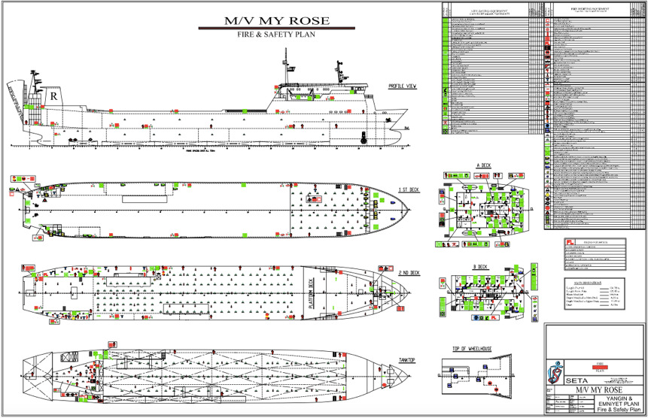
Step #1

Export the PDF drawing (supplied by the shipowner) to the AutoCad program, which will allow us to take the measurements more accurately and quickly.

After exporting the plan, it must be scaled according to the generality of the ship.

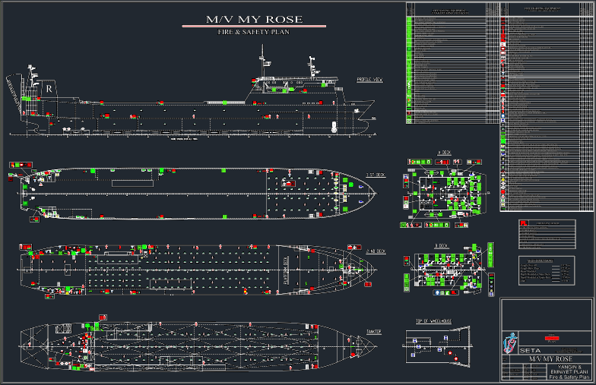

At the moment of scaling the corresponding plane it will allow us to measure in a more precise way the generalities highlighted in point 4 (Verification of the plane), a very relevant characteristic of this tool is its speed and pressure because it allows us to have the exact dimensions of the plane which have to be in accordance with the reality of the boat.

This step is the first one that must be done when verifying a naval document (tonnage, load line, stability book, capacity plan, fire plan.

Step #2

Check the quantities, symbols, requirements according to the following resolutions: Resolutions A.654 (16), Resolutions A. 952 (23), SOLAS 74, Chapter II-2, Regulation 15.2.4, FSS Code - Fire Safety Systems - Resolution MSC. 98 (73); in order that the system implemented is suitable for the type of ship and activity it performs.

    - In case the competent staff has no knowledge of the computer tools, they have the option to carry out the revision manually. For this the Naval Architect / Engineer will need the help of a scale, which will allow to approximate the measurements to reality, in this case the Naval Architect / Engineer has to use special use of the ANSI/ASME Y14.5-2009 standard (Dimensions and Tolerancing).

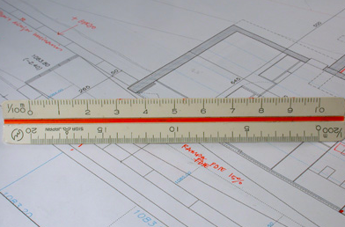

    - The following tables and formats are relevant to verifying a general arrangement plan, which will assist the Naval Architect / Engineer in performing this activity.
Note: This manual may be a first impression of how to perform a plan review, but much depends on the skill of the respective Naval Architect / Engineer.

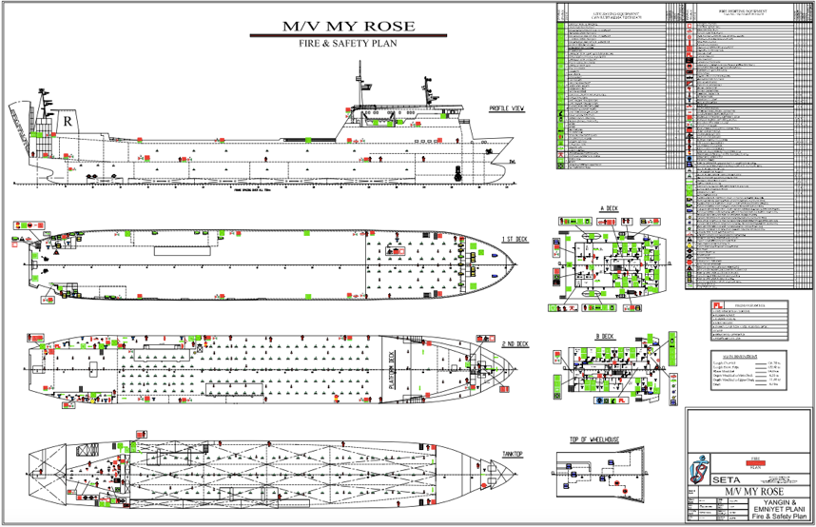
Presentation format of a fire and safety plan

    - Drawing area requirements

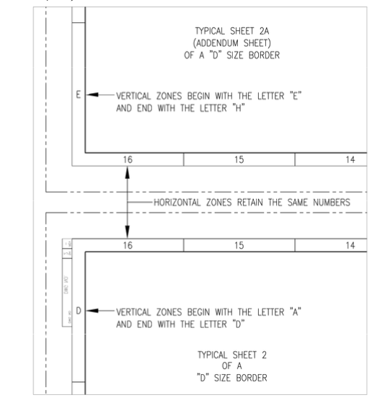

    - All drawing sheets, except size A and B drawings, must include vertical (alphabetical) and horizontal (numerical) areas for reference purposes.

    - The alphabetical (vertical) letters shall begin with "A" with the exception that the appendix sheets shall have alphabetical (vertical) zone designators which shall continue with the lettering scheme of the sheet inserted next (e.g. if sheet 2 of a size D border is divided into 9-A to 16-D zones, then sheet 2A shall be divided into 9-E to 16-H zones).

    - Numerical (horizontal) entries will begin with "1" in the lower right-hand corner of the first sheet and continue with consecutive numbering throughout the drawing (e.g. in an H panel drawing size 8, sheet one will begin with 1 and move to 8, sheet two 9 to 16, sheet three 17 to 24, etc.).

    - Mandatory and conditional blocks or tables

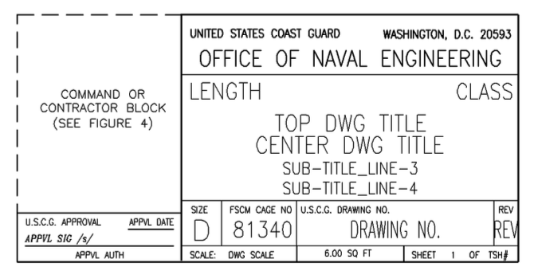

    - Mandatory blocks or tables can be found in the drawing edge templates.
- Coast Guard Title Block
- Drawing number block
- Class Approval Block
- Command or contractor block
- Scientific technical information block
- Revision History Table
- Applicability table
- Leaf revision status table
- Table of Special Annotations
- Weight control table
- Reference plane table

    - The linear reduction scaling block is mandatory for every graphic window with scalable geometry. Only one scale is required for a sheet containing multiple graphic windows with the same scale. The block is not required for geometry drawn on a 1:1 scale.

The Naval Architect issues coordinates with technical department for the issue ofa permanent certificate of approval for plans, manuals and booklets that demonstrate compliance with applicable IMO guidelines and national requirements, according to GR-PM-TD28.

- RELATED DOCUMENTATION

Certificate Of Approval (Interim) APR-FSC-IC
Certificate Of Approval APR-FSC
Checklist For Fire And Safety Control Plan Approval CHKL-FSC
Control of Documentation CONTROL LIST-FSC

- REFERENCES

Procedure for the Control of Documents and Records GR-PM-QD01
Request for survey GR-PM-TD03
Service Procedure GR-PM-TD07
Plan approval Procedure GR-PM-TD28
IMO Resolution A.654 (16)
IMO Resolution A. 952 (23)

