INSTRUCTIVE FOR THE SURVEY AND ISSUANCE OF THE INTERNATIONAL TONNAGE CERTIFICATE

 | POSITION | DATE | SIGNATURE
PREPARED BY
REVISED BY
APPROVED BY

- OBJECTIVE

To establish an appropriate mechanism to accomplish and control systematically the surveys and completion of the corresponding reports and certificates.

GR Class undertakes to give effect to the provisions of the Convention and its Annexes which shall constitute an integral part of the Convention. Every reference to the Convention constitutes at the same time a reference to the Annexes.

This procedure takes into consideration IMO Resolution A.1157(32).

- SCOPE

The content of this instructive will be applied to all ships of 24 meters (79 feet) length and above, on international, national or coastal voyages:
- Ships registered in countries the Governments of which are Contracting Governments.
- Ships registered in territories to which the present Convention is extended under Article 20.
- Unregistered ships flying the flag of a State, the Government of which is a Contracting Government.
- Existing ships which undergo alterations or modifications which the Administration deems to be a substantial variation in their existing gross tonnage; according to Article 2(7) of the Convention.
- Existing ships if the owner so requests.

- RESPONSIBILITIES

  - It is responsibility of the staff of Technical Department to assure that all procedures contained in this INSTRUCTIVE are fulfilled for the surveys and issuance of the International Tonnage Certificate.

  - It is responsibility of the staff of Technical Department to support in the monitoring for the compliance of the mechanisms for the surveys and issuance of the International Tonnage Certificate.

  - It is responsibility of the surveyors to comply with the procedure contained in this instructive when carrying out the surveys for the International Tonnage Certificate.

- DEFINITIONS

GR Class | GR Class- Classifed For Standard , is an Recognised Organization and Recognised Security Organisation to perform inspection and certification work on ships registered under a Flag Administration.
Classification Rules | They are referred to those issued by a classification society with which GR CLASS has signed contractual agreement for sharing such rules in ship surveys and certification activities.
Stand by | to be waiting and ready to do something.
IMO | International Maritime Organization: It is a specialized agency of the United Nations devoted to maritime matters.
ITC-69 | International Convention on Tonnage Measurement of Ships, 1969.
Maritime Administration | is the Authority responsible to regulate all aspects related to the marine requirements of the flag.
National Regulations | Are those established by each Maritime Administration to implement IMO Regulations or to adopt standards not envisaged in International Conventions.
Length (L) | means 96 per cent of the total length on a waterline at 85 per cent of the least moulded depth measured from the top of the keel, or the length from the fore side of the stem to the axis of the rudder stock on that waterline, if that be greater. In ships designed with a rake of keel the waterline on which this length is measured shall be parallel to the designed waterline.
Applicable Regulations
 | The determination of Gross Tonnage and Net Tonnage will be carried out according to Regulations 3 and 4 of the ITC-69 Convention, the calculation of volumes according to Regulation 6 and the measurements and calculation of volumes according to Regulation 7 of the ITC-69 Convention.
 | To the Surveys for the issuance of the International Tonnage Certificate that reflects compliance with the requirements of ITC-69, GR CLASS will produce an International Tonnage Certificate according to Article 7(1).
 | The validity of the statutory Full Term International Tonnage Certificate, for ships under Panama will be permanent.
Types of Certificates
Interim Certificate | with maximum validity of five (5) months counted from the date of renewal survey, it is issued by the surveyor to ship whose survey for the issuance of International Tonnage Certificate to his criteria, complies with all the requirements.
Full Term Certificate | is issued exclusively by the Head Office of GR CLASS, to ship whose survey demonstrates a satisfactory result.

- ACTIVITIES

  - GENERAL

    - Force Majeure

      - In applying the provisions of the Convention, GR Class shall give due consideration to any deviation or delay caused to any ship owing to stress of weather or any other cause of force majeure.

    - Determination of Tonnages.

      - The determination of gross and net tonnages shall be carried out by GR Class. In every case the Administration concerned shall accept full responsibility for the determination of gross and net tonnages.

    - The Surveyor carries out review documentation provided by GR Class Technical Staff as:
- Patent
- Pre-certification
- Inspector's Pate Checklist
- Respective naval documentation (plans, manuals and respective books)

    - Below is the information provided by GR Class's technical staff; where the information needed to perform the review in the correct manner is shown.

    - Check the consistency of all the information in all the respective documents corresponding to the type of certificate.

    - The rules that apply when reviewing or developing a naval plan are according to:
- ISO 128-20:1996 (Technical drawings)
- COMDTINST M9000.6 (USCG Naval Engineering Manual, Chapter 085)
- ANSI/ASME Y14.2-2005 (Line Conventions and Lettering)
- ANSI/ASME Y14.5-2009 (Dimensions and Tolerancing)
- ANSI/ASME Y14.35M (Revision of Engineering Drawings and Associated Documents)
- MIL-STD-25 (Ship Structural Symbols for Use on Ship Drawings (See Note))
- Note: Ship drawings shall comply with MIL-STD-25 except that steel symbol designations may conform to the current American Institute of Steel Construction (AISC) “Manual of Steel Construction.”
- International Convention on Tonnage Measurement of Ships 1969

    - Calculation for the issuance of International Tonnage Certificate could be carried out in any of following cases:
- Existing ship, the first time attended by GR Class for the issuance of International Tonnage Certificate
- Existing ships which undergo modifications or alterations deemed a significant variation in their existing Gross Tonnage.
- Existing ships if the owner so request due to change of name of the ship, flag, port of registry, call signs, or date in which the ship undergo significant alterations or modifications or by change of Recognized Organization

  - VERIFICATION OF THE PLAN

    - Points to check:
- Generalities (length, sleeve, prop, etc.)
- Consistency of the view (consistency of the upper view, with lasterals)
- Verify the length and location of the different accommodations which have to be congruent with those established in the certificate.
- Verify that the plan is made according to the generalities and principles of the naval drawing, which is applied to all the types of corresponding plans in the different certificates.

  - REVISION OF THE CALCULATIONS

    - When reviewing the calculations provided by the shipowner in accordance with the International Convention on Tonnage Measurement of Ships 1969, the shipowner must comply with the generalities, restrictions and applicability established by the Convention.

    - Example of the tonnage calculation provided by the shipowner to the corresponding company (GR CLASS), this must contain sufficient information to ensure that it was performed in the correct manner according to the guidelines established by the International Convention on Tonnage Measurement of Ships 1969.

    - The following guidelines should be checked in the document:
- General information on the ship (Article 3 /application and Article 4 /exceptions)
- Corresponding Modules (draft, registration length, length between perpendiculars, etc.)
- Draught (You must be in accordance with the draught shown on the tonnage certificate)/ annex 1 - rule 2 (Definitions of terms).
- Corresponding volumes according to what is established by the agreement when calculating the gross and net tonnage of the vessel (These volumes delivered by the shipowner can be checked and the calculation can be correct; but it must be verified according to the corresponding methods).
- Accommodations must be sectioned according to the corresponding certificate.

  - CALCULATIONS

    - The calculations must be verified according to Annex I / regal 3 and 4 of the Convention.

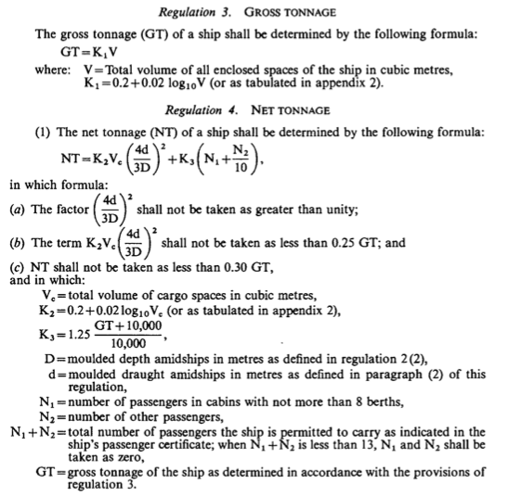

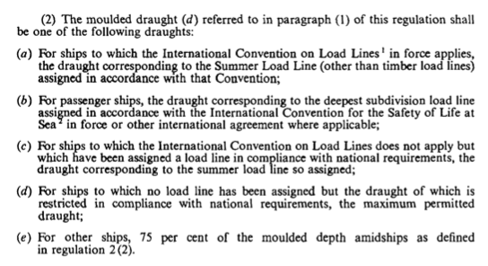
    - These calculations have to be in accordance with the generalities of the Convention, in which the different parameters established by the same must be verified, after verifying the restrictions, definitions and regulations corresponding to the rule 3 (annex I), the veracity of the corresponding values can be given.

    - The corresponding calculations must be verified by more consistent methods than just relying on the information provided by the shipowner.

    - Verification of the certificate according to the agreement

      - The format of the certificate has to be in accordance with the stipulations of the convention (Annex II), and the information given must be verified according to all the information mentioned above.

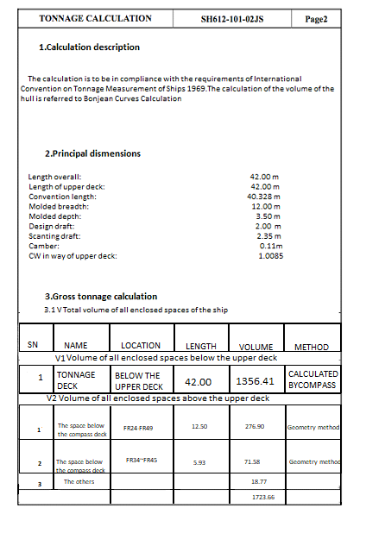

  - VERIFICATION

    - The following steps are stipulated when verifying the tonnage calculations of a vessel, in order to verify its accuracy.

      - Step #1

        - Export the PDF drawing (provided by the shipowner) corresponding to the AutoCad Program, which will allow us to take the measurements in a more precise and fast way.

        - After exporting the plan, it must be scaled according to the generality of the ship.

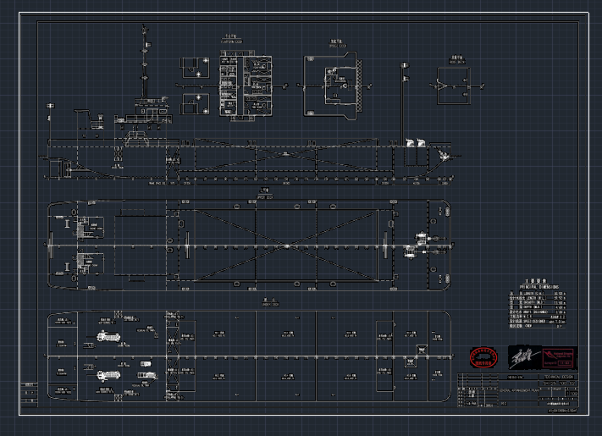

      - Step #2

        - After clarifying the measurements of the ship to its real dimensions, they must be exported to the MaxSurf naval program, which will allow us to verify the volumes of the lower part of the main deck, which represents the most complicated part when verifying the corresponding calculation.

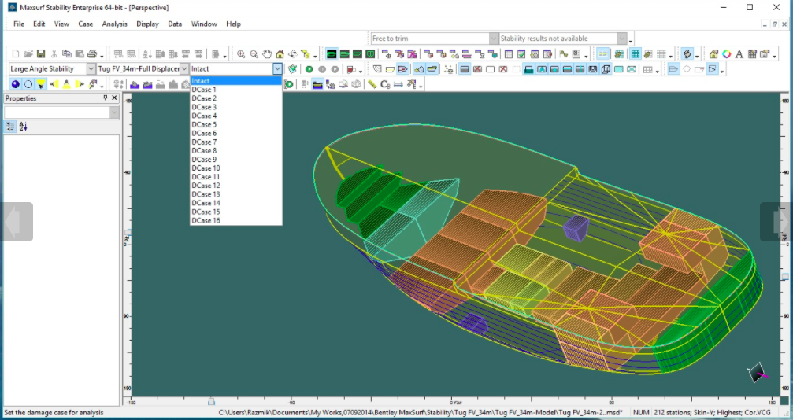

      - Step #3

        - After modelling the ship in the Maxsurf program, the analysis of the reports delivered by the program is carried out in order to compare the data obtained.

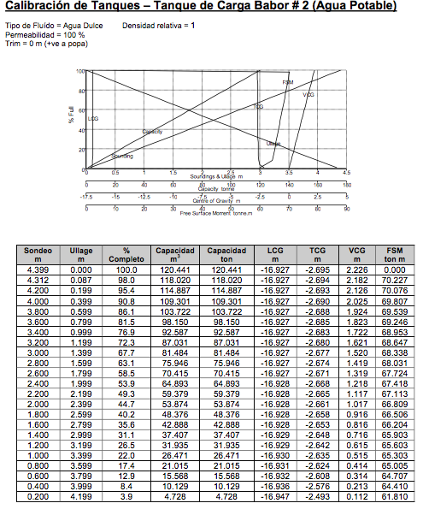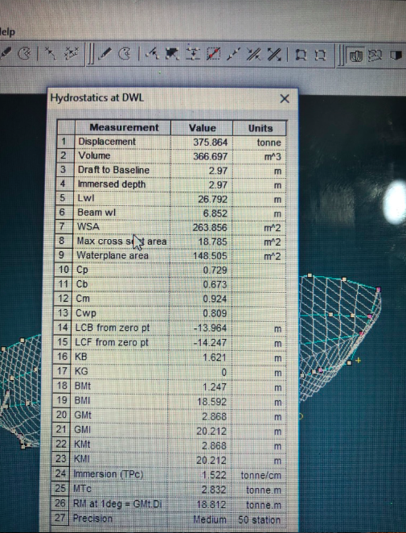

        - The results obtained will allow us to know the corresponding volumes of all the parts of the ship in order to corroborate that the values given in the calculation of tonnage supplied by the ship owner are correct.

      - Step # 4

        - After obtaining the volume data (MaxSurf), proceed to perform the cycle stipulated in point 5 (Calculation) of this manual.

  - EXPLANATION

    - The principle of this point is to explain Annex I / regal 3 and 4 of the Convention which is used to verify the result obtained through the equations and restrictions shown in it.

    - Rule 3

      - This rule tells us about the gross tonnage of the vessel, which we know is the volume of all accommodations such as; cargo holds, cabins, cabins, rooms, etc; except the excluded spaces (which are explained in Annex I, rule 1, point 5 .

      - These excluded spaces have ways of being taken which are set out in Appendix 1 to the Convention.
Nomenclature: O = Excluded space
C = Closed Space
I = Space to be considered

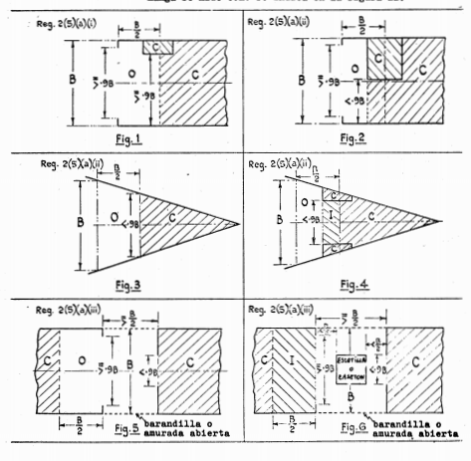
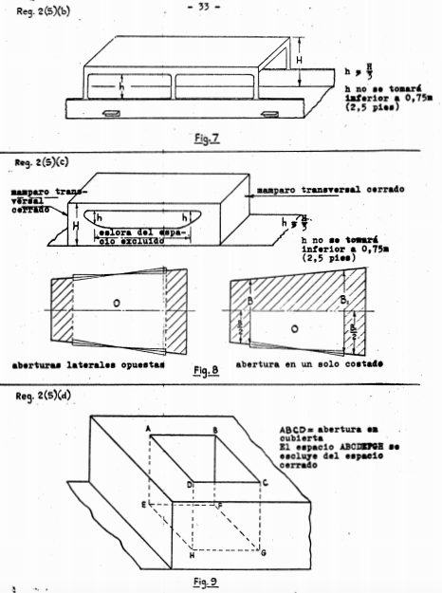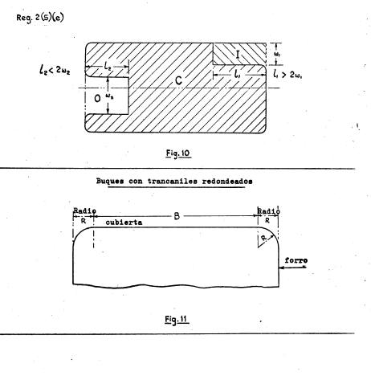

    - Rule 4

      - This rule tells us about the gross tonnage of the vessel, which we know is the volume of all accommodations such as; cargo holds; excluded (which are explained in Annex I, rule 1, point 7.

      - It is important to emphasize that the cargo spaces have to be the ones stipulated for that activity, the volume of the capacity that includes: oil tanks, fuel (for the use of the boat), provisions, etc. is not included.

N= refers to all persons who are considered passengers of the vessel with exceptions such as: children, crew members, or persons providing continuous or established service to the vessel.

      - The factors or restrictions set out in Annex I / Regulation 4 point i (must be respected when checking the calculation)

      - The factors or restrictions set out in Annex I/Rule 4 point ii (must be respected when checking the calculation)

      - The factors or restrictions set out in Annex I / Regulation 4 point iii (must be respected when comparing the calculation), this point states that the net tonnage cannot be less than one third of the gross tonnage (0.3Gt=Nt).

      - For example, if a ship has a gross tonnage of 1000 tons, when calculating the net tonnage of 200 tons, the certificate will include the minimum established by the agreement, which is 300 tons (0.3Gt=Nt); however, the net tonnage must be calculated.

    - Regulation 7 - MEASUREMENT AND CALCULATION

      - All measurement used in the calculation of volumes shall be taken to the nearest centimeter or one-twentieth of a foot.

      - The volumes shall be calculated by generally accepted methods for the space concerned and with an accuracy acceptable to the Flag Administration.

      - The calculation shall be sufficiently detailed to permit easy checking.

  - PROCEDURE FOR CERTIFICATION OF INTERNATIONAL TONNAGE CERTIFICATE

    - The Surveyor follows the Service Procedure (GR-PM-TD07) for the issuance of interim certification and issues an interim certificate ITC-IC whose validity in no case will exceed five (5) months counted from the date of concluding the survey for the issuance of International Tonnage Certificate and satisfies the requirements of the ITC-69 Convention and its amendments, otherwise if there is not available tonnage calculation and shall not issue any interim certificate.

    - The Surveyor shall make sure to complete the form ITC-SR to confirm type of survey if initial or change of name, flag or ship’s particulars.

    - An interim ITC certificate shall be issued by GR Class, whereas in the cases of a Panama flying vessels, the Administration shall issue the Certificate. For any other Flag, GR Class issues the Full Term ITC Certificate. In every case, the Administration shall assume full responsibility for the certificate.

    - The certificate shall be drawn up in the official language or languages of the issuing country. If the language used is neither English nor French, the text shall include a translation into one of these languages. The form of the certificate shall correspond to that of the model given in Annex II of the Convention.

    - The Technical Manager coordinates with concerned Maritime Administration, the issuance of a Full Term International Tonnage Certificate ITC, whose validity will not expiry to all ITC-69 surveys that satisfies the general procedures and what is indicated in this instructive.

    - The Surveyor complies with the established Service Procedure (GR-PM-TD07), concerning the notification via e-mail to the Technical Department of GR Class Head Office for the surveys carried out and the mailing of copies of the documentation that supports the survey and the issued or endorsed certificates to the ship.

  - ISSUE OF CERTIFICATE BY ANOTHER GOVERNMENT

    - A Flag Administration may, at the request of another Flag Administration, determine the gross and net tonnages of a ship and issue or authorize the issue of an International Tonnage Certificate (1969) to the ship in accordance with the Convention.

    - A copy of the certificate and a copy of the calculations of the tonnages shall be transmitted as early as possible to the requesting Flag Administration.

    - A certificate so issued shall contain a statement to the effect that it has been issued at the request of the Flag Administration whose flag the ship is or will be flying and it shall have the same validity and receive the same recognition as a certificate issued.

    - No International Tonnage Certificate (1969) shall be issued to a Ship which is flying the flag of a State the Government of which is not a Flag Administration.

  - CANCELLATION OF CERTIFICATE

    - Subject to any exceptions provided in the Regulations, an International Tonnage Certificate (1969) shall cease to be valid and shall be cancelled by the Administration if alterations have taken place in the arrangement, construction, capacity, use of spaces, total number of passengers the ship is permitted to carry as indicated in the ship's passenger certificate, assigned load line or permitted draught of the ship, such as would necessitate an increase in gross tonnage or net tonnage.

    - A certificate issued to a ship by an Administration shall cease to be valid upon transfer of such a ship to the flag of another State.

    - Upon transfer of a ship to the flag of another State the Government of which is a Contracting Government, the International Tonnage Certificate (1969) shall remain in force for a period not exceeding three (3) months, or until the Administration issues another International Tonnage Certificate (1969) to replace it, whichever is the earlier. The Contracting Government of the State whose flag the ship was flying hitherto shall transmit to the Administration as soon as possible after the transfer takes place a copy of the certificate carried by the ship at the time of transfer and a copy of the relevant tonnage calculations.

  - ACCEPTANCE OF CERTIFICATE

    - The certificate issued under the authority of a Contracting Government in accordance with the present Convention shall be accepted by the other Contracting Governments and regarded for all purposes covered by the Convention as having the same validity as certificates issued by them.

  - COMMUNICATION OF INFORMATION

    - The Flag Administrations undertake to communicate to and deposit with the Organization:
- a sufficient number of specimens of their certificates issued under the provisions of the Convention for circulation to the Flag Administrations;
- the text of the laws, orders, decrees, regulations and other instruments which shall have been promulgated on the various matters within the scope of the Convention; and
- a list of non-governmental agencies which are authorized to act in their behalf in matters relating to tonnages for circulation to the Flag Administrations.

  - PROCEDURE FOR TONNAGE CALCULATION

    - The gross tonnage and the net tonnage of novel types of craft whose constructional features are such as to render the application of the provisions of the Regulations unreasonable or impracticable shall be as determined by the Administration. Where the tonnage is so determined, the Flag Administration shall communicate to IMO details of the method used for that purpose, for circulation to the Contacting Governments for their information.

    - In case of calculate the tonnage is necessary the following documents:
- Copy of General Arrangement Plan
- Line plan
- Capacity plan (if applicable)

    - This document will be evaluated and approved by a Naval Architect / Head office.

  - PROCEDURE FOR INCREASE DEADWEIGHT / DRAFT

    - In case of increase deadweight / draft is necessary approved the following documents:
- Stability booklet
- Freeboard calculation
- ITC certificate
- LL certificate
- Tonnage calculation
- Grain booklet

    - This document will be evaluated and approved by a Naval Architect / Head office.

  - PROCEDURE FOR CHANGE OF TONNAGE

    - When the characteristics of a ship such as V, Vc , d, N1, or N2 are altered or when the appropriate assigned load line is altered due to the change of the trade in which the ship is engaged, and where such an alteration results in a decrease in its net tonnage as determined in accordance with the provisions of Regulation 4 of the Convention, a new International Tonnage Certificate (1969) incorporating the net tonnage so determined shall not be issued until twelve months have elapsed from the date on which the current Certificate was issued; provided that this requirement shall not apply:
- if the ship undergoes alterations or modifications which are deemed by the Administration to be of a major character, such as the removal of a superstructure which requires an alteration of the assigned load line.

    - In case of change the tonnage is necessary approved the following documents:
- General arrangement plan
- Capacity plan
- Freeboard calculation
- Tonnage calculation

    - This document will be evaluated and approved by a Naval Architect / Head office.

  - Flag Administration requirements

    - The Flag Administration requirements should also be taken into consideration when carrying out any type of survey on board no matter the scope. The Flag Administration requirements are listed through GR-PM-TD12.

- RELATED DOCUMENTATION

International Tonnage Certificate (1969) (Interim) ITC-IC
International Tonnage Certificate (1969) (FT) ITC
International Tonnage Certificate (1969) (Interim) (Panama) ITC-IC-PA
International Tonnage Certificate (1969) (Panama) ITC-PA
Tonnage survey checklist ITC-SR
Control of Documentation CONTROL LIST-ITC
Control of Documentation (Tonnage Measurement) CONTROL LIST-TC
Control of Documentation (Non Conventional Vessel) CONTROL LIST-NTC

- REFERENCES

Procedure for the Control of Documents and Records GR-PM-QD01
Flag Administration requirements GR-PM-TD12
Request for survey GR-PM-TD03
Service Procedure GR-PM-TD07
Instruments Relevant To The IMO Instruments
Implementation Code (III Code) IMO Res. A.1157(32)

