INSTRUCTIONS FOR THE REVIEW OF THE SHIP ENERGY EFFICIENCY MANAGEMENT PLAN (SEEMP PART I)
&
THE IMO DATA COLLECTION SYSTEM (DCS) FOR FUEL OIL CONSUMPTION OF SHIPS (SEEMP PART II)
&
SHIP OPERATIONAL CARBON INTENSITY PLAN (SEEMP III)

 | POSITION | DATE | SIGNATURE
PREPARED BY | TECHNICAL MANAGER
REVISED BY | QUALITY MANAGER
APPROVED BY | GENERAL MANAGER

- OBJECTIVE

To establish an appropriate mechanism to accomplish and control systematically the review and completion of the corresponding reports and certificates.

- SCOPE

SEEMP Part I is required by Regulation 22 of Annex VI to MARPOL 73/78 and is applicable to all ships above 400 gross tonnages.

SEEMP Part II provides the methodologies ships of 5,000 gross tonnage and above should use to collect the data required pursuant to regulation 22A of MARPOL Annex VI and the processes that the ship should use to report the data to the ship's Administration.

SEEMP Part III applies to any ship on international voyages of 5,000GT and above should document how the vessel plans to achieve its Carbon Intensity Indicator (CII) as required by Regulation 26.3.1 of MARPOL Annex VI.

- RESPONSIBILITIES

2.1 It is responsibility of the personnel of Technical Manager to assure that all procedures contained in this INSTRUCTIVE are fulfilled for the review and approval of the Ship Energy Efficiency Management Plan (SEEMP Part I), the IMO Data Collection System (DCS) for Fuel Oil Consumption of Ships (SEEMP PART II), for the verification of ship fuel oil consumption data and review and approval of SEEMP III.

2.2 It is responsibility of the personnel of Technical Department to support in the monitoring for the compliance of the mechanisms for the review, approval and verification and issuance of the applicable Review Letters and the Statement of Compliance for Fuel Oil Consumption Reporting.

2.3 It is responsibility of the Naval Architect and/or the Engineer to comply with the procedure contained in this instructive when carrying out the review, approval and verification and issuance of the applicable Review Letters and the Statement of Compliance for Fuel Oil Consumption Reporting.

- DEFINITIONS

GR Class | GR Class Classified For Standard, is a Maritime Organization authorized to carry out surveys and Certification on behalf of Maritime Administration of Flag State. In some cases, also it is identified as a Recognized Organization (RO) or Recognized Security Organization (RSO).
Company | The owner of the ship or any other organization of person such as the manager, or the bareboat charter, who has assumed the responsibility for operation of the ship form the shipowner.
Safety Management System | A structured and documented system enabling company personnel to implement effectively the company safety and environmental protection policy, as defined in paragraph 1.1 of International Safety Management Code.
Calendar year | Means the period from 1 January until 31 December inclusive.
Company | Means the owner of the ship or any other organization or person such as the manager, or the bareboat charterer, who has assumed the responsibility for operation of the ship from the owner of the ship and who on assuming such responsibility has agreed to take over all the duties and responsibilities imposed by the International Management Code for the Safe Operation of Ships and for Pollution Prevention, as amended.
Distance travelled | Means distance travelled over ground.
IMO DCS | Means the IMO Data Collection System as adopted by amendments to Annex VI to MARPOL through IMO Resolution MEPC 346(78).
Ship’s Data Collection Plan | Ship Energy Efficiency Management Plan (SEEMP) Part II as per the IMO Resolution MEPC 346(78).
Ship Operational Carbon Intensity Plan | Ship Operational Carbon Intensity Plan (SEEMP Part III) as per as per the IMO Resolution MEPC 346(78).
Applicable Regulations
The Administration shall ensure that for each ship to which regulation 27 applies, the SEEMP complies with regulation 26.2 of MARPOL Annex VI. This shall be done prior to collecting data under regulation 27 of this Annex in order to ensure the methodology and processes are in place prior to the beginning of the ship’s first reporting period. Confirmation of compliance shall be provided to and retained on board the ship;
The Administration shall ensure that, for each ship to which regulation 28 applies, the SEEMP complies with regulation 26.3.1 of MARPOL Annex VI. This shall be done prior to 1 January 2023. Confirmation of compliance shall be provided to, and retained on board, the ship.
 | Under the data collection system for fuel oil consumption and the operational carbon intensity rating of ships, as specified in MARPOL Annex VI, an Administration may authorize an organization to receive the data from a ship, verify the data for compliance with the requirements, verify the attained annual operational CII against the required annual operational CII, determine the operational carbon intensity rating, issue the Statement of Compliance, and submit the data to the Organization. In every case, the Administration assumes full responsibility for all tasks conducted by the Administration or any organization duly authorized by it.
Types of Certificates
Interim Certificate of approval | with maximum validity of (3) months, counted from the date of the preliminary review is issued by the Naval Architect / Engineer after satisfactory verification.
Statutory certificate of approval | with no expiration date is issued exclusively by the Technical Manager to plans, manuals and booklets found with satisfactory results.

- ACTIVITIES

  - The Ship Energy Efficiency Management Plan

    - SEEMP is divided in three parts.

    - SEEMP Part I provides a possible approach for monitoring ship and fleet efficiency performance over time and some options to be considered when seeking to optimize the performance of the ship.

    - SEEMP Part II provides the methodologies ships of 5,000 gross tonnage and above should use to collect the data required pursuant to regulation 22 of MARPOL Annex VI and the processes that the ship should use to report the data to the ship's Administration.

    - SEEMP Part III documents how the vessel plans to achieve its Carbon Intensity Indicator (CII) as required by Regulation 26.3.1 of MARPOL Annex VI.

  - SEEMP PART I: Ship Management Plan to improve Energy Efficiency

    - Application

      - SEEMP Part I is required by Regulation 22 of Annex VI to MARPOL 73/78 and is applicable to all ships above 400 gross tonnage.

      - SEEMP Part I provides a possible approach for monitoring ship and fleet efficiency performance over time and some options to be considered when seeking to optimize the performance of the ship.

      - In global terms it should be recognized that operational efficiencies delivered by a large number of ship operators will make an invaluable contribution to reducing global carbon emissions.

      - The purpose of Part I of a SEEMP is to establish a mechanism for a company and/or a ship to improve the energy efficiency of a ship's operation. Preferably, the ship-specific SEEMP is linked to a broader corporate energy management policy for the company that owns, operates or controls the ship, recognizing that no two shipping companies are the same, and that ships operate under a wide range of different conditions.

      - Many companies already develop, implement and maintain a Safety Management System. In such case, Part I of the SEEMP may form part of the ship's Safety Management System.

      - SEEMP Part I should be developed as a ship-specific plan by the company. The SEEMP Part I seeks to improve a ship's energy efficiency through four steps:
- Planning;
- Implementation;
- Monitoring; and
- self-evaluation and improvement.

    - Review and approval of SEEMP Part I

      - Below listed plans shall be submitted to GR Class:
- General Arrangement Plan;
- Any procedures of the Company related a broader corporate energy management policy, if implemented and applicable.

      - The submitted plans and procedures shall be verified using the checklist as per CHKL-SEEMP I.

      - The SEEMP Part I must be written in one or more working languages of the ship.

      - If review is not satisfactory, the Technical Manager shall make recommendations for revision and request resubmission, by sending an electronic message to the Company, explaining the discrepancies and requesting re-submittal with necessary changes.

      - If review is satisfactory, the SEEMP Part I first page is to be stamped and the Technical Manager shall issue a review letter as per APR-SEEMP-IC.

      - The Technical Manager shall send the approved plan to the Owners/Managers by electronic means, where it shall be the latter’s responsibility to place on board the vessel.

  - SEEMP PART II: IMO Data Collection Plan

    - Application

      - Regulation 22 of Annex VI to MARPOL applies to ships of 5,000 GT and above, except for:
- ships engaged on domestic voyages;
- ships not propelled by mechanical means; and
- platforms, including FPSOs, FSUs and drilling rigs.

      - From the allowable data collection methods, IMO DCS requires the collection of data on the total annual fuel oil consumption. Apart from berthing and travelling at sea, this data consists of fuel consumption due to activities including but not limited to anchoring, drifting, bunkering/de-bunkering, supply stops, maintenance, cargo loading/offloading, ballast and commercial purposes.

    - Approval of ship’s Data Collection Plan

      - On or before 31 December 2018, the ship’s Data Collection Plan need to include a description of the methodology that will be used to collect the data required by Regulation 22A.1 of Annex VI to MARPOL and the processes that will be used to report the data to the ship's Administration.

      - The ship’s Data Collection Plan must be prepared by the company in line with the IMO Resolution MEPC 346(78).

      - For the approval of the ship’s Data Collection Plan, the Company need to submit to the Technical Manager the below supporting information via electronic means:
- Ship's Data Collection Plan (SEEMP Part II)
- Relevant information or description of the ship’s installations, including emissions sources certificates outlined in Table 3 of the Data Collection Plan
- Machinery space drawing
- Classification Certificate
- Registration Certificate
- International Air Pollution Prevention Certificate and Supplement
- Capacity or any other plan showing all fuel oil tanks on board the ship
- In the event the ship’s Data Collection Plan refers to existing procedures (from the Safety Management System (SMS) of the Ship/ Company or any other document) copies of these procedures
- Flow meters used and installation diagram-piping diagrams

      - The Technical Manager shall review and approve the ship’s Data Collection Plan using CHKL-SEEMP II.

      - The Technical Manager shall ensure that:
- the company used the appropriate Data Collection Plan template and that information is provided for all mandatory items referred to in the IMO Resolution MEPC 346(78);
- the information in the ship’s Data Collection Plan accurately and completely describes the emission sources and measurement equipment installed on board the ship and the systems and procedures in place to monitor and report relevant information pursuant to the IMO DCS;
- where applicable, review whether the information submitted by the company regarding elements, procedures or controls implemented as part of the ship’s existing management systems or covered by relevant quality, environmental or management harmonized standards is relevant for monitoring CO2 emissions and other relevant information and reporting pursuant to IMO DCS.

      - In case discrepancies have been raised the Technical Manager shall inform the company by recording and submitting the relevant section of CHKL-SEEMP II and request corrective action. The Technical Manager should deal with the discrepancies in a structured way:
- Timely communication of discrepancies;
- Request companies to correct all discrepancies identified;
- Keep track on discrepancies identified to:
- Estimate the impact;
- Evaluate whether discrepancies have been corrected appropriately by the company;
- Evaluate uncorrected discrepancies and the impact on approval of ship’s Data Collection Plan (obtain an understanding of the reason for not correcting these and evaluate the impact).

When the company has submitted a revised ship’s Data Collection Plan, and/or any other requested documentation, the Technical Manager shall indicate in the relevant section of CHKL-SEEMP II of this document the corrective action and confirm that the impose discrepancy has been rectified.

      - If, based on the assessment the Technical Manager concludes that the ship’s Data Collection Plan is in conformity with the IMO Resolution MEPC 346(78),the Technical Manager shall issue a Confirmation of Compliance as per SEEMP/COC.

      - Upon completion of the review and if the Technical Manager is satisfied that the ship’s Data Collection Plan is in accordance with the relevant documents, the first page shall be stamped.

      - The Technical Manager shall submit to the company the Confirmation of Compliance as per SEEMP/COC to be placed on board the ship and with the final ship’s Data Collection Plan shall be submitted in electronic copy.

    - Verification of the ship’s fuel oil consumption data

      - To facilitate data verification, companies shall submit to GR Class the below documentation via electronic means:
- Ship's Data Collection Plan (SEEMP Part II)
- Summaries of bunker delivery notes (BDNs), in sufficient detail to show that all fuel oil consumed by the ship is accounted for
- Summaries of disaggregated data of fuel oil consumption, distance travelled and hours underway
- Information to demonstrate that the ship followed the Data Collection Plan set out in its SEEMP Part II, including information on data gaps and how they were filled as well as how the event that caused the data gap was resolved

      - Once the Technical Manager has identified which voyages will be sampled for the purpose of its verification, the specific section(s) or document(s) deemed relevant shall be submitted by the company. The Technical Manager shall request the below mentioned documents from the company for the chosen sampled voyages:
- Copies of the ship’s official logbook and of the oil record book (if separate)
- Copies of bunkering documents. For e.g. paper or electronic documents may include BDNs, bunkering survey reports or bunkering invoices, if available.
- Copies of documents containing information on distance travelled and time spent at sea for the ship’s voyages during the reporting period.

      - Additionally, and if applicable on the basis of the monitoring method applied, the Technical Manager may ask the company to provide the following additional information via electronic means:
- An overview of the IT landscape showing the data-flow for the relevant ship
- Evidence of the maintenance and accuracy/uncertainty of measurement equipment/flow meters (e.g. calibration certificates). For e.g. evidence indicated may include calibration certificates, instructions from manufacturers, relevant entries from the PMS, procedures from the SMS for maintenance/ zeroing/ calibration etc.
- An extract of fuel consumption activity data from flow meters.
- For e.g. data could be provided in a format that is compatible with spreadsheet or via “Verifier access” (read-only) to the tool that monitoring and analyses data from flow meters. For ships which use the same flow meters to monitor the consumption rates of various fuels (HFO, LFO, MDO/ MGO), sample fuel change-over events in the engine logbook to compare with the raw data and reported date.
- Copies of evidence of fuel tank meter readings. For e.g. for ships using the first method (i.e. Bunker Delivery Notes) or the second method (i.e. flow meters) for a sample period indicated by the Verifier at the time of the elaboration of the sampling plan or the voyages identified by the Verifier.
- An extract of activity data from direct emissions measurement systems.
- Any other information relevant to the verification of the emissions report.

      - In the event of a change of company, the companies involved shall exercise due diligence to provide the Technical Manager with the above-mentioned supporting documents or information relating to the voyages performed under their respective responsibilities.

      - Companies shall retain the above-mentioned information for the periods set under the 1973 International Convention for the Prevention of Pollution from Ships (the MARPOL Convention) and the 1988 International Convention for the Safety of Life at Sea (the SOLAS Convention).

      - Strategic Analysis

        - At the start of verification, the Technical Manager shall carry out a strategic analysis of all relevant activities of the company. This analysis enables the Technical Manager to understand the company’s activities and assess the likely nature, scale and complexity of the verification activities to be performed. The objective of the strategic analysis is to obtain an understanding of the company’s business.

        - If the Technical Manager has carried out the prior year(s) verifications for the same company, the information from those earlier verification(s) must be considered. Major deviations compared to previous verifications should attract attention by the Technical Manager. Although the strategic analysis will take less time in a situation where, because of earlier verifications, the Technical Manager is already familiar with the company this does not negate the Technical Manager from carrying out that analysis for the present verification engagement.

        - As part of the strategic analysis the Technical Manager shall check:
- whether the ship’s Data Collection Plan has been approved; and
- whether changes have occurred to the Data Collection Plan and whether these changes have been approved (if these changes are significant and require a re-approval).

        - If (part of) the ship’s Data Collection Plan is not approved or if significant changes to the Data Collection Plan have not been approved, the Technical Manager directs the company to rectify the situation. In principle the Technical Manager should not continue the verification until such approval has been obtained. Once the ship’s Data Collection Plan has been approved and found in conformity the company shall submit the approved Data Collection Plan to the Technical Manager to continue the verification process.

        - However, in some cases the Technical Manager may continue to carry out the verification activities so long as the company is fully aware that some activities may need to be repeated based on the final response for the approval of the ship’s Data Collection Plan and that the response could impact the opinion of the Technical Manager as the verification progresses. Following approval, the Technical Manager continues, repeats or adapts the verification activities.

      - Sampling size and selection

        - The Technical Manager shall specify the sample size and selection with statistical sampling, where sample items are selected in a way that each sampling unit has a known probability of being selected. The Technical Manager will use probability sampling and selection methods, i.e. random, systematic or stratified sampling, to select the items to be reviewed during verification.

        - Example of statistical sampling based on sampling in scope voyages data:
Data could be verified based on the approach below:
- If the number of voyages for significant emissions (accounting for more than 3.3% of the total emissions reported) is less than 30, 100% sampling should be carried out.
- If the number of voyages for significant emissions is more than one per month and is more than 30 per year, and if verification is possible for more than 50% of the time in the total number of voyages, then voyages for six months out of a year shall be selected in the descending order of reported emissions and 100% sampling of these shall be carried out.
- If no voyages contribute to the significant emission (less than 3.3%) or if even selection and verification of the 50% mentioned above is difficult due to time consideration, then the following table for the minimum sample size should be taken.

Number of voyages | % of the total voyages
0 – 12 | 100
13 – 30 | 50
31 – 50 | 34
51 – 90 | 21
91 – 150 | 14
151 – 280 | 9
281 – 500 | 5
501 – 1200 | 3
1200 – 1500 | 2

        - Example of statistical sampling based on sampling the numbers of Bunker Delivery Notes (BDNs) used in the reporting period or another data set such as tank sounding readings:
Data could be verified based on the approach below:
- If detection risk is low then divide by 2 the sampling size
- If detection risk is medium then use the sampling size
- If detection risk is high then multiply by 2 the sampling size

Size of dataset | Sampling size
2 to 8 | 3
9 to 15 | 3
16 to 25 | 5
26 to 50 | 8
51 to 90 | 13
91 to 150 | 20
151 to 280 | 32
281 to 500 | 50
501 to 1200 | 80
1201 to 3200 | 125
3201 to 10000 | 200
10001 to 35000 | 315
35001 to 150000 | 500

      - Verification of reported data

        - The Technical Manager shall verify whether the ship followed the methodology specified in its Data Collection Plan, with a view to confirm:
- the consistency of reported data and calculated values, including with previous reporting periods (if applicable), through recalculating the annual reported values using the underlying data, etc.;
- completeness of data (e.g. perform substantive testing based on reconciliation, recalculations, and document cross-check, for example with official logbook and/or arrival/noon/departure reports, recalculate hours underway and total quantities of fuel oil used and distance travelled); and
- reliability and accuracy of the data (e.g. test that the data quality procedures as described in the Data Collection Plan) have been properly implemented, carry out site visits (typically to the Company's offices rather to the ship) to test the systems, processes and the control activities) through corroborating fuel oil consumption data with distance travelled and hours underway, comparing reported fuel oil consumption with that which is expected for the ship size, operational profile, and technical characteristics, and/or comparing reported fuel oil consumption total fuel bunkered, etc.

        - The verification of the reported data shall be carried out as per VR-SEEMP II.

        - Where the Technical Manager identifies non-conformities during the verification of the reported data, it shall inform the company thereof without undue delay and request relevant corrections within a reasonable deadline.

      - Exceptions and exemptions

        - A permit issued under Regulation 22A of Annex VI to MARPOL shall not exempt a ship from the reporting requirement under this regulation and shall not alter the type and scope of data required to be reported.

        - In the case that a ship diverts from its scheduled passage to engage in search and rescue operations, it may be exempted.

        - In the case of a ship which is normally engaged on domestic voyages but which, in exceptional circumstances, is required to undertake a single international voyage, an exemption from any of the requirements in Chapter 4 of Annex VI to MARPOL may be sought from the Administration. Refer to MEPC.1/Circ.863 for guidance. In such a case the Technical Manager shall coordinate with the company and request by the Administration for an exemption to be issued.

      - Issuance of Statement of Compliance

        - Upon successful verification of the reported data, the Technical Manager shall review and issue a Statement of Compliance related to fuel oil consumption to the ship no later than five months from the beginning of the calendar year.

        - A Statement of Compliance shall be issued as per SEEMP/SOC-IC.

        - For Panama flagged ships, the Technical Manager shall submit to the Administration the VR-SEEMP II confirming that the reported data have been verified and a Statement of Compliance can be issued by the Administration.

        - The Statement of Compliance pursuant to Regulation 6.6 of Annex VI to MARPOL shall be valid for the calendar year in which it is issued and for the first five months of the following calendar year. The Statement of Compliance pursuant to Regulation 6.7 of Annex VI to MARPOL shall be valid for the calendar year in which it is issued, for the following calendar year, and for the first five months of the subsequent calendar year.

  - SEEMP PART III: Ship Operational Carbon Intensity Plan

    - Application

      - The SEEMP Part III applies to any ship on international voyages of 5,000GT and above, and is one of the following ship types defined in MARPOL Annex VI, Regulation 2:
- Bulk carrier;
- Combination carrier;
- Containership;
- Cruise passenger ship;
- Gas Carrier;
- General cargo ship; and
- LNG carrier.

      - SEEMP Part III on or before 01 January 2023 shall include:
- a description of the methodology that will be used to calculate the ship's attained annual operational CII
- required by regulation 28 of MARPOL Annex VI and the processes that will be used to report this value to the ship's Administration;
- the required annual operational CIIs, as specified in regulation 28 of MARPOL Annex VI, for the next three years;
- an implementation plan documenting how the required annual operational CIIs will be achieved during the next three years; and
- a procedure for self-evaluation and improvement.

      - The required annual operational CII is to be calculated in accordance with regulation 28 and taking into account the guidelines developed by IMO.

      - In addition, pursuant to regulation 28 of MARPOL Annex VI, part III of the SEEMP is further to include calculation methodologies and a plan of corrective actions for ships that are rated D for three consecutive years or rated as E.

      - The ship's attained annual operational carbon intensity is to be calculated taking into account the guidelines developed by IMO.

      - Ships of 5,000 gross tonnage and above that are subject to regulations 26.3 and 28 of MARPOL Annex VI are strongly encouraged to review part I of their SEEMP to revise it as needed to reflect the actions taken to achieve the ship's CII requirements.

      - The goal setting, as referred to in paragraph 4.1.7 in part I, should be consistent with the requirements of regulation 28 of MARPOL Annex VI and should include the ship's required annual operational CII for the next three years following the updating of the SEEMP.

      - In addition, while ships subject to regulation 28 of MARPOL Annex VI may relay on the CII requirements when defining goals under part I of the SEEMP, they are encouraged to consider setting additional ship-specific goals that go beyond the applicable CII requirements and strive for energy efficiency improvements and carbon intensity reductions beyond such requirements.

      - Ships subject to regulation 28 of MARPOL Annex VI may consider voluntarily using one or more of the trial CIIs (EEPI, cbDIST, clDIST or EEOI), where applicable, for the purpose of providing supporting data for decision-making to support the review clause set out in regulation 28.11 of MARPOL Annex VI. A description of the methodology that should be used to calculate the trial CII should be included in the SEEMP.

      - Part III of the ship's SEEMP should be updated in case of voluntary modifications or necessary corrective actions are involved (every three years).

    - ATTAINED ANNUAL OPERATIONAL CII CALCULATION METHODOLOGY; DATA COLLECTION PLAN AND DATA QUALITY

      - Taking into account the guidelines developed by IMO, part III of the SEEMP provides detailed information on how the ship's attained annual operational CII should be calculated. Regulation 28 of MARPOL Annex VI states that the attained annual operational CII shall be calculated, using the data collected in accordance with regulation 27 (Fuel Oil Data Collection System).

      - In describing the calculation methodology, part III of the SEEMP should include a detailed description of the data required for the calculation of the attained annual operational CII. The data collection should follow the relevant methodology and requirements on the Fuel Oil Data Collection System pursuant to regulation 27 of MARPOL Annex VI.

      - In case of transfer of the ship from one company to another according to regulation 27.5 or 27.6 of MARPOL Annex VI, all relevant data necessary for the calculation of the attained annual operational CII should be submitted by the former company to the receiving company within one month after the date of transfer. The data should have been verified by GR Class according to regulation 6.7 of MARPOL Annex VI before they are transferred to the receiving company.

      - In case the former company does not transfer the required data, GR Class may make relevant data submitted to the IMO Fuel Oil Consumption Database available to the receiving company. In case of a transfer of both company and Administration concurrently, the incoming Administration may make a request to the Organization for access to the data according to regulation 27.11. If no such data is available, the attained annual operational CII can be calculated and verified using the available data covering a period of the preceding calendar year as long as practically possible.

      - In case of transfer of a ship from one Administration to another according to regulation 27.4 of MARPOL Annex VI the data needed for calculating the annual attained CII is already in the possession of the relevant company and no further exchange of data is needed.

    - REQUIRED ANNUAL OPERATIONAL CII FOR NEXT THREE YEARS

      - Part III of the SEEMP describes the required annual operational CII values for the ship for each of the next three years, calculated in accordance with regulation 28 of MARPOL Annex VI and taking into account the guidelines developed by IMO, as the basis for those calculations.

    - REVIEW AND UPDATE OF PART III OF THE SEEMP

      - Regulation 26.1 of MARPOL Annex VI provides: "Each ship shall keep on board a ship-specific Ship Energy Efficiency Management Plan (SEEMP). This may form part of the ship's safety management system. The SEEMP shall be developed and reviewed, taking into account guidelines adopted by the Organization". Regulation 26.3.2 of MARPOL Annex VI provides: "For ships rated as D for three consecutive years or rated as E, in accordance with regulation 28 of this Annex, the SEEMP shall be reviewed in accordance with regulation 28.8 of this Annex to include a plan of corrective actions to achieve the required annual operational CII".

      - The company should ensure that the SEEMP is reviewed and updated, when necessary, as per paragraph 9.10.

      - The SEEMP should include a log for when it has been reviewed and updated and identify which parts have been changed.

    - VERIFICATION OF THE REPORTED DATA

      - To facilitate data verification, GR Class may request the following documentation:
.1 a copy of the verified ship's Data Collection Plan (SEEMP Part II);
.2 summaries of bunker delivery notes (BDNs), in sufficient detail to show that all fuel oil consumed by the ship is accounted for (see sample form of BDN summary set out in appendix 1);
.3 summaries of disaggregated data of fuel oil consumption, distance travelled and hours under way, in a format specified by the Administration (see sample form of data summary set out in appendix 2);
.4 information to demonstrate that the ship followed the Data Collection Plan set out in its SEEMP, including information on data gaps and how they were filled as well as how the event that caused the data gap was resolved;
.5 copies of documents containing information on the amount of fuel oil consumption, distance travelled and hours under way for the ship's voyages during the reporting period (e.g. the ship's official logbook, oil record book, BDNs, arrival/noon/departure reports, and from auto-log data files); and
.6 supported by documentary evidence, copies of the fuel oil mass to CO2 mass conversion factor provided by fuel supplier in case the type of fuel is not covered by the guidelines developed by IMO.

      - GR Class may request a ship to submit such documentation needed to perform a comprehensive review of a ship's annual fuel oil consumption, distance travelled, and hours under way. GR Class may request that this documentation be submitted by all ships or a subset of the ships under its jurisdiction. This documentation may be used by GR Class to verify whether the ship followed the methodology specified in its Data Collection Plan, with a view to confirming:
.1 consistency of reported data and calculated values, including with previous reporting periods (if applicable), through recalculating the annual reported values using the underlying data, etc.;
.2 completeness of data (e.g. perform substantive testing based on reconciliation, recalculations, and document cross-check, for example with official logbook and/or arrival/noon/departure reports, auto-log report files; recalculate total quantities of fuel oil used, distance travelled and hours under way); and
.3 reliability and accuracy of the data (e.g. test that the data quality procedures as described in the Data Collection Plan have been properly implemented, carry out site visits (typically to the company's offices rather than to the ship) to test the systems, processes and the control activities) through corroborating fuel oil consumption data with distance travelled and hours under way, comparing reported fuel oil consumption with that which is expected for the ship size, operational profile, and technical characteristics, and/or comparing reported fuel oil consumption total fuel bunkered, etc.

      - For a ship which has undergone a transfer addressed in regulations 27.4, 27.5 or 27.6 of MARPOL Annex VI, the losing Administration needs to verify the data before the transfer.

    - VERIFICATION OF THE ATTAINED ANNUAL OPERATIONAL CII AND DETERMINATION OF THE CII RATING

      - To facilitate the verification of the attained annual operational CII, GR Class shall request the following documentation:
.1 a copy of the verified ship's Operational Carbon Intensity Plan (SEEMP part III);
.2 documents (IEE certificate, Stability Booklet or International Tonnage Certificate) evidencing the capacity parameter of the ship in the metric relevant for the calculation of its operational carbon intensity (deadweight or gross tonnage);
.3 aggregated data of fuel oil consumption and distance travelled covering the entire calendar year to calculate the attained annual operational CII (AER or cgDIST) (see sample form of data summary set out in appendix 2);
.4 the aggregated values of the parameters and associated calculation methods to determine the annual metric value of the trial CIIs on voluntary basis, if any (see sample form of data summary set out in appendix 2 –Add.1);
.5 supported by documentary evidence, the correction factors and voyage adjustments applied in the attained annual operational CII calculation, if any, during the reporting period (see sample form of data summary set out in appendix 2); and
.6 statements of compliance for previous two calendar years, where applicable.

      - The attained annual operational CII should be verified using the data over a 12-month period from 1 January to 31 December for the preceding calendar year, by GR Class. In cases where the calculation of the attained annual operational CII is not possible due to the unavailability of some data, such as where a new ship is delivered after 1 January in the preceding year, the attained annual operational CII should be verified using the available data covering the corresponding period of the preceding calendar year.

      - In case of a ship with multiple load line certificates or with a load line certificate containing multiple load lines, the highest deadweight value should be used to calculate and verify the required and attained annual operational CII.

      - For a ship which permanently changes its deadweight (DWT) and/or its gross tonnage (GT) during the year, which the SEEMP or a corrective action plan identifies as being undertaken to improve the ship's operational carbon intensity performance:
.1 the required annual operational CII should always be calculated and verified using the original DWT or GT value before conversion; however, the attained CII which is used to assess compliance should be calculated and verified using the new DWT or GT value after conversion; and
.2 for the year when the conversion is made, the attained annual operational CII should be calculated and verified for the entire calendar year on the average DWT or GT value weighted on distance travelled before and after conversion.

      - For a ship which is regarded by the Administration as a newly constructed ship as per regulation 5.4.3 of MARPOL Annex VI due to major conversion, including extensive changes of carrying capacity and/or ship type during the year, the required and attained annual operational CII should be calculated and verified as per a newly constructed ship for the period after conversion. For the year when the major conversion is made, the data for partial year before conversion should still be reported for verification but will not be included in the calculation and verification of the attained annual operational CII.

      - For a ship which has undergone a transfer addressed in regulations 27.4, 27.5 or 27.6 of MARPOL Annex VI, the losing Administration neither needs to verify the attained annual operational CII nor to determine the annual CII rating of the ship for partial year. The attained annual operational CII should be verified by the receiving Administration using the data over an entire calendar year. In such cases, the aggregated data necessary to calculate the attained annual operational CII before transfer, which should have already been verified by the losing Administration, can be directly used by the receiving Administration without further verification (see sample form set out in appendix 3 and appendix 3 – Add.1).

      - The administration should determine the operational carbon intensity rating for the ship, taking into account the guidelines developed by IMO. The attained and required annual operational CII, as well as the rating boundaries, should be all given with three decimal places. If the attained annual operational CII happens to land on a rating boundary, the ship should be rated as the better of the two ratings.

      - The trial CIIs (e.g. EEPI, cbDIST, clDIST or EEOI), if voluntarily calculated and reported, should be verified by GR Class following the same procedure as for the attained annual operational CII (AER or cgDIST). GR Class does not need to assign a rating to a ship based on trial CIIs.

    - ISSUE OF A STATEMENT OF COMPLIANCE

      - In accordance with regulation 6.6 of MARPOL Annex VI, upon receipt of reported data pursuant to regulation 27 of MARPOL Annex VI and attained annual operational CII pursuant to regulation 28 of MARPOL Annex VI and satisfactory completion of the verification, the Statement of Compliance should be issued by GR Class.

      - GR Class may consider whether a corrective action plan is required according to regulation 6.8 of MARPOL Annex VI. In the case of a corrective actions plan being required but not submitted together with the attained annual operational CII, GR Class Technical Department should inform the company in a timely manner that a revised SEEMP including a plan of corrective actions, must be submitted for verification no later than one month after reporting the attained annual operational CII. The Statement of Compliance should not be issued in such a case unless a corrective action plan is duly developed and reflected in the SEEMP and verified by GR Class Technical Department, taking into account the guidelines developed by IMO.

      - Should any material discrepancy be identified by GR Class in the reported data and/or the calculation of required/attained annual operational CII, it should be communicated to the company on a timely basis for clarification or correction. A discrepancy is considered material if the discrepancy or aggregation of discrepancies could influence the reported total by more than ±5%. The Statement of Compliance should not be issued in such a case unless the material discrepancy is clarified or corrected.

    - VERIFICATION OF THE SEEMP AND DOCUMENTATION

      - An Administration may authorize an organization to carry out verifications of, and company audits related to, the SEEMP, and issue the Confirmation of Compliance, submit the data to the Organization and perform other actions authorized by the Administration. In every case, the Administration assumes full responsibility for all tasks conducted by the Administration, or any organization duly authorized by it.

      - Verification of, and company audits related to, the SEEMP do not relieve the company, management, those undertaking delegated SEEMP tasks, officers or seafarers of their obligations as to compliance with those requirements in regulation 28 of MARPOL Annex VI.

      - The company is responsible for:
.1 informing relevant personnel and those undertaking the delegated SEEMP tasks about the content of the SEEMP;
.2 appointing responsible members of staff to accompany the verifier; and
.3 providing access and evidential materials as requested by the verifier.

      - To facilitate the verification, GR Class shall indicate what documentation, if any, the company should submit along with its SEEMP.

    - INITIAL, PERIODICAL, ADDITIONAL VERIFICATIONS AND COMPANY AUDITS

      - The verification and audit process for the SEEMP according to regulation 26.3.3 of MARPOL Annex VI should normally involve the following:
- initial verification;
- periodical verifications;
- additional verifications; and
- company audits.

      - The initial, periodical, additional verifications and company audits should be based on documentary evidence.

      - Initial verification (regulation 5.4.6 of MARPOL Annex VI)

        - GR Class should perform an initial verification to ensure that for each ship to which regulation 26.3 of MARPOL Annex VI applies, the SEEMP complies with regulation 26.3.1 of MARPOL Annex VI. In accordance with regulation 5.4.6 of MARPOL Annex VI, this process must be done prior to 1 January 2023 for existing ships or before a new ship is put in service.

        - On satisfactory assessment of the SEEMP part III, GR Class Technical Department can issue the Confirmation of Compliance as per SEEMP III-COC.

      - Periodical verification (regulation 5.4.6 of MARPOL Annex VI)

        - If any of the elements in regulation 26.3.1 is updated, and in any case every three years, GR Class Technical Department should perform a periodical verification to ensure the SEEMP complies with regulation 26.3.1 of MARPOL Annex VI in accordance with regulation 5.4.6 of MARPOL Annex VI.

        - On satisfactory assessment of SEEMP part III, the Technical Manager should issue the Confirmation of Compliance as per SEEMP III-COC.

      - Additional verifications (regulation 6.8 of MARPOL Annex VI)

        - GR Class Technical Department should, in the case of a ship rated as D for three consecutive years or a ship rated as E, perform an additional verification to ensure that a plan of corrective actions has been established in accordance with regulations 28.7 and 28.8.

        - On satisfactory verification of the plan of corrective actions, the Technical Manager can issue the Statement of Compliance as per SEEMP III-SOC.

      - Company audits

        - GR Class Technical Department should perform periodical company audits to:
- verify that the SEEMP for which the Confirmation of Compliance has previously been issued complies with regulation 26.3.1 and, in the case of non-compliance, require remedial action;
- confirm that the ship is being operated in accordance with SEEMP part III, regardless of its rating;
- verify the progress made in the (corrective) actions to be taken in the execution of the three-year implementation plan and the plan of corrective actions;
- verify self-assessment and improvement of actions taken; and
- verify the assignment of responsibilities related to the implementation and monitoring of measures.

        - The periodical company audits may include annual audits of the company (company audits) and verifications on board the ship (shipboard audits).

        - These additional shipboard verifications and company audits, if undertaken, should be six months after the issuance of the Statement of Compliance at the latest.

    - 6 ELEMENTS OF VERIFICATION

      - Verification could consist of, but not be limited to, the following elements:
- verification of the method of calculations of the CII and that there is a proper description of the method to report ship data to the Administration;
- assessment of the effectiveness (of the combination) of measures, so that when implemented the ship will with reasonable assurance achieve the required annual operational CII, including the goal as set in accordance with paragraph 4.1.7 and 9.7 of the SEEMP Guidelines; and
- robustness of the three-year implementation plan and, where applicable, the plan of corrective actions, including whether realistic timelines for implementation of actions have been included.

    - COMBINATION WITH ISM AUDITS

      - Verification of implementation aspects of the SEEMP on board (monitoring, self-evaluation and improvements, etc.) could be combined with the ISM audits.

      - The verifications may be carried out in accordance with guidelines on implementation of the ISM Code referred to in Chapter 15 of the ISM Code.

  - Flag Administration requirements

    - The Flag Administration requirements should also be taken into consideration when carrying out any type of survey on board no matter the scope. The Flag Administration requirements are listed through GR-PM-TD12.

    - For Panama flying vessels GR Class shall:
- Verify that each ship shall keep on board a ship specific Ship Energy Efficiency Management Plan (SEEMP), and verify in case of ships of 5,000 gross tonnage and above keeps on board a Ship Energy Efficiency Management Plan (including SEEMP-Part III) as required by MARPOL Annex VI regulation 26.3.
- Issue a “Confirmation of Compliance” stating that the ship complies with the previous paragraph, using the sample format shown on the Annex of the Guidelines for the Verification and Company Audits by the Administration of Part III of the Ship Energy Efficiency Management Plan (SEEMP) adopted by the IMO through Resolution MEPC.347(78).
- Determine upon receipt the fuel oil consumption data if, this data reported by the ship has been collected and complies with MARPOL Annex VI regulation 27.
- Verify that the Attained Annual Operational CII reported (regulation 28.1) is based on the fuel oil consumption data reported, as per MARPOL Annex VI regulation 27.
- Determine the operational carbon intensity rating according to MARPOL Annex VI regulation 28.6.
- Recommends to the Administration the issuance of a “Statement of Compliance – Fuel Oil Consumption Reporting and Operational Carbon Intensity Rating” upon completion of verification, providing the following information:
- SEEMP Confirmation of Compliance,
- Data Reporting Form specified in appendix 3 of the 2022 Guidelines for the Development of a Ship Energy Efficiency Management Plan (SEEMP) adopted by the IMO through Resolution MEPC.346(78).
- Submit to the International Maritime Organization the reported data noted in appendix IX, MARPOL Annex VI, by accessing to IMO-GISIS Ship Fuel Oil Consumption Database Module.
- Verify in case of ships rated as D for three (3) consecutive years or rated as E (MARPOL Annex VI regulation 28.7) that the SEEMP has been revised and includes the plan of corrective actions to achieve the required annual operational CII, following the 2022 Guidelines for the Development of a Ship Energy Efficiency Management Plan (SEEMP) Resolution MEPC.346(78).
- Carry out the periodical company audits may include annual audits of the company and verifications on board the ship (shipboard audits).
- Carry out additional shipboard verifications and company audits should be conducted six (6) months after the issuance of the Statement of Compliance at the latest for ships rated as D for three (3) consecutive years or rated as E.

- RELATED DOCUMENTS

SEEMP Part I:
SEEMP I Review Letter (Interim) APR-SEEMP I-IC
SEEMP I Review Letter APR-SEEMP I
SEEMP I Checklist CHKL-SEEMP I
Control of Documentation CONTROL LIST-SEEMP I

SEEMP Part II:
SEEMP II Statement of Compliance SEEMP-SOC
SEEMP II Verification Checklist VR-SEEMP II
SEEMP II Confirmation of Compliance SEEMP-COC
SEEMP II Checklist for CoC CHKL-SEEMP II
Control of Documentation CONTROL LIST-SEEMP II

SEEMP Part III:
SEEMP III Statement of Compliance SEEMP-SOC
SEEMP III Verification Checklist VR-SEEMP III
SEEMP III Confirmation of Compliance SEEMP-COC
SEEMP III Checklist for CoC CHKL-SEEMP III
Control of Documentation CONTROL LIST-SEEMP III

- REFERENCES

Procedure for the Control of Documents and Records GR-PM-QD01
Flag Administration requirements GR-PM-TD12
Request for survey GR-PM-TD03
Service Procedure GR-PM-TD07
Plan approval Procedure GR-PM-TD28
Instruments Relevant To The IMO Instruments
Implementation Code (III Code) IMO Res. A.1157(32)

APPENDIX 1 – SAMPLE OF THE BDN SUMMARIES

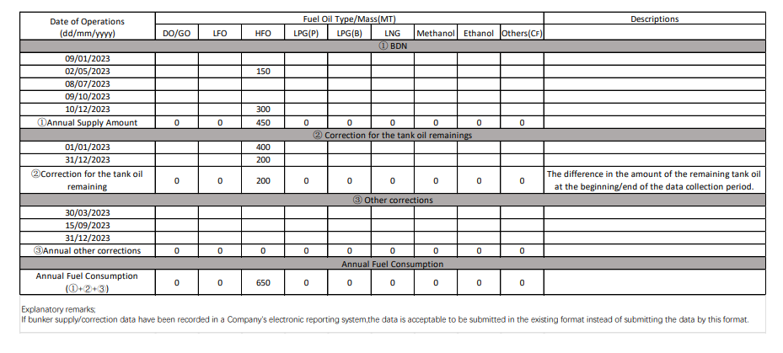

APPENDIX 2 – SAMPLE OF THE COLLECTED DATA SUMMARIES

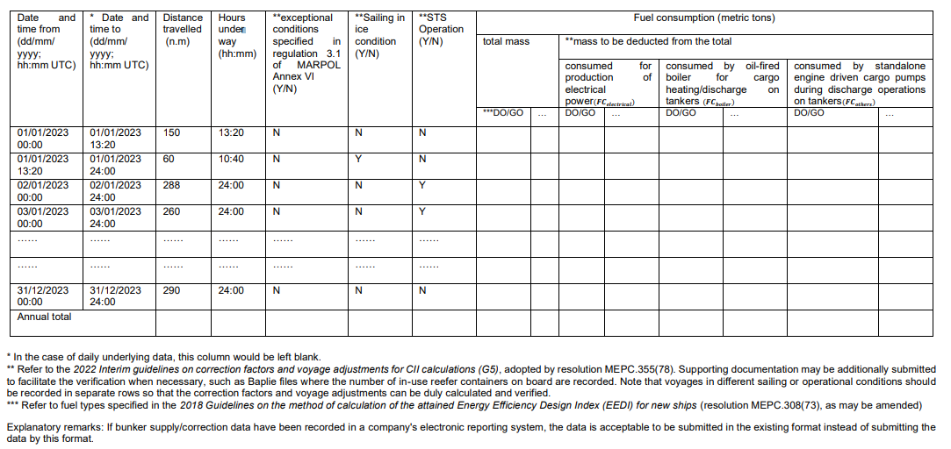

APPENDIX 2 – ADD.1 - SAMPLE OF THE COLLECTED DATA SUMMARIES TO CALCULATE TRIAL CII ON A VOLUNTARY BASIS

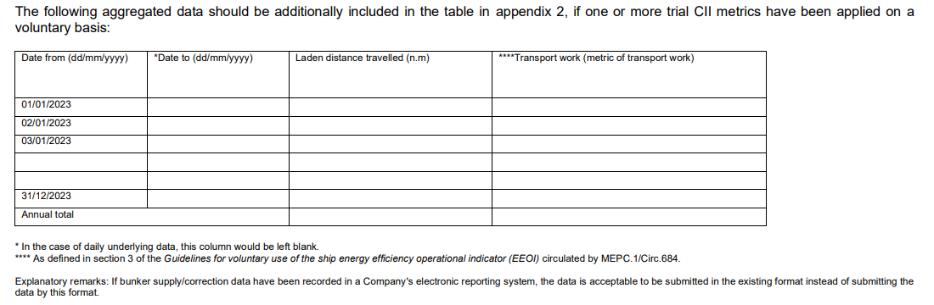

APPENDIX 3 – SAMPLE OF THE AGGREGATED DATA BEFORE A TRANSFER OF FLAG/COMPANY ADDRESSED IN REGULATIONS 27.4, 27.5 OR 27.6 OF MARPOL ANNEX VI

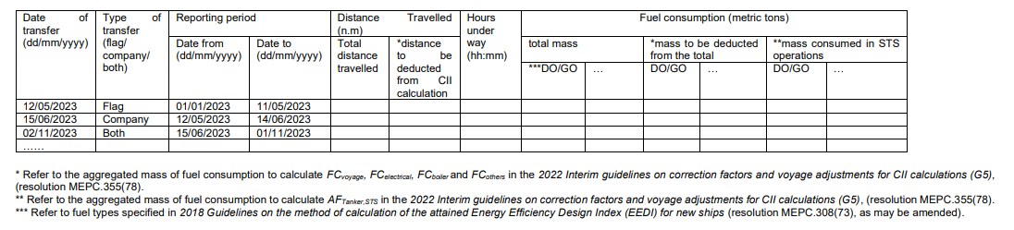

APPENDIX 3 – ADD.1 - SAMPLE OF THE AGGREGATED DATA BEFORE A TRANSFER OF FLAG/COMPANY ADDRESSED IN REGULATIONS 27.4, 27.5 OR 27.6 OF MARPOL ANNEX VI TO CALCULATE TRIAL CII METRICS ON A VOLUNTARY BASIS

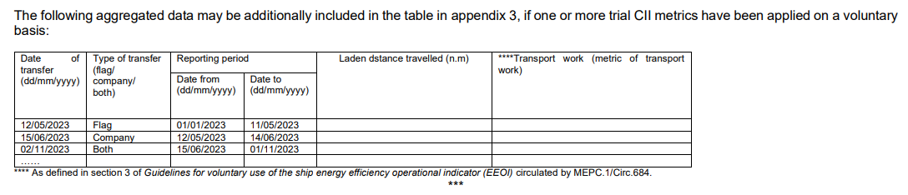

Refer to the 2022 Guidelines on the reference lines for use with operational carbon intensity indicators (CII reference lines guidelines, G2) (Resolution MEPC.353(78) and the 2021 Guidelines on the operational carbon intensity reduction factors relative to reference lines (CII reduction factors guidelines, G3) (Resolution MEPC.338(76).
Refer to the 2022 Guidelines on operational carbon intensity indicators and calculation methods (CII Guidelines, G1) (Resolution MEPC.352(78)) and the 2022 Interim guidelines on correction factors and voyage adjustments for CII calculations (G5) (Resolution MEPC.355(78)).
Refer to the 2025 Guidelines on operational carbon intensity indicators and calculation methods (CII Guidelines, G1) (Resolution MEPC.352(78)) and the 2025 Interim guidelines on correction factors and voyage adjustments for CII calculations (G5) (Resolution MEPC.355(78)).
Refer to the 2025 Guidelines on the reference lines for use with operational carbon intensity indicators (CII reference lines guidelines, G2) (Resolution MEPC.353(78)) and the 2021 Guidelines on the operational carbon intensity reduction factors relative to reference lines (CII reduction factors guidelines, G3) (Resolution MEPC.338(76)).
Refer to the 2025 Guidelines on the method of calculation of the attained Energy Efficiency Design Index (EEDI) for new ships (resolution MEPC.308(73)), as may be amended.
Refer to the 2025 Interim guidelines on correction factors and voyage adjustments for CII calculations (G5), adopted by resolution MEPC.355(78).
Refer to the 2025 Guidelines on the operational carbon intensity rating of ships (CII Rating Guidelines, G4) adopted by resolution MEPC.354(78).
Refer to the 2022 Guidelines on operational carbon intensity indicators and the calculation methods (CII Guidelines, G1) adopted by resolution MEPC.352(78).
Refer to the Guidelines for the verification and company audits by the Administration of part III of the Ship Energy Efficiency Management Plan (SEEMP) adopted by resolution MEPC.347(78).

