CAMPUS ELECTRICITY
CONSUMPTION FORECASTING
Mini Project Report
M.Sc. (Data Science), Semester III — Activity 2
Predictive Analysis Theory
Project Topic: Campus Electricity Consumption Forecasting
Roll Number: 11
Academic Year: 2026–27
Department of Computer Science
Dr. D. Y. Patil Arts, Commerce & Science College, Pimpri

Abstract
This project demonstrates a time-series workflow for forecasting daily campus electricity consumption. Hourly observations are aggregated into daily kWh totals, explored through visualisation, and modelled using simple baselines and a Random Forest regressor with calendar and lag-based features. The supplied dataset is synthetic and was generated for demonstration; it is not measured electricity usage from the college. Therefore, the numerical results illustrate a reproducible methodology and must not be represented as real campus findings. For final submission, replace the demo data with authorised meter readings and rerun the notebook/script.

1. Introduction
Educational campuses use electricity for classrooms, computer laboratories, libraries, offices, lighting, cooling, and other facilities. Consumption varies by hour, day of week, academic calendar, weather, occupancy, and equipment use. Forecasting can support energy budgeting, operational planning, anomaly detection, and energy-efficiency initiatives.

2. Problem Statement
The project investigates how historical electricity consumption can be used to estimate future daily energy demand. The immediate demonstration task is to compare baseline forecasts with a feature-based machine-learning model using a chronological holdout period. Real deployment requires actual meter data and contextual variables.

3. Objectives
- Prepare a time-indexed electricity dataset and check its quality.
- Explore hourly and daily consumption patterns using plots and summary statistics.
- Create lag, rolling-average, and calendar features.
- Compare persistence, seasonal-naive, moving-average, and Random Forest forecasts.
- Evaluate the models with MAE, RMSE, and MAPE on a chronological test set.
- Produce an illustrative 14-day forecast and discuss limitations and practical use.

4. Dataset Description and Data Provenance
IMPORTANT DATA NOTE: All values in the included CSV are synthetic, generated with a fixed random seed for this academic demonstration. They do not come from a real college meter, utility bill, or public dataset. The time span is 1 January–31 December 2025, with 8,760 hourly rows. The columns are timestamp and consumption_kwh. The synthetic pattern includes a daily load shape, lower weekend use, smooth seasonal variation, and random noise.
Field | Description
timestamp | Hourly timestamp (synthetic)
consumption_kwh | Simulated electricity consumption during the hour, in kWh
Daily kWh | Sum of hourly kWh readings for each calendar day
Hourly mean: 4.67 kWh per hour. Mean daily total: 112.18 kWh/day. Daily standard deviation: 17.94 kWh/day. Highest synthetic daily total: 140.32 kWh on 2025-06-12. These are demo-data statistics, not real campus measurements.

5. Methodology

5.1 Data preprocessing
Parse timestamps, sort chronologically, check duplicate timestamps and missing values, set timestamp as the index, and resample hourly readings to daily sums. In real data, investigate missing intervals and meter resets before imputation; do not silently treat missing readings as zero.

5.2 Exploratory analysis
Plot daily consumption over the year and compare weekdays with weekends. Inspect daily/weekly cycles and seasonal changes. Use hourly profiles and calendar annotations in the final real-data analysis.

5.3 Feature engineering
Use day of week, day of year, month, weekend indicator, previous-day consumption (lag 1), same-weekday previous-week consumption (lag 7), and a trailing 7-day mean. Lag and rolling features use only past values.

5.4 Train/test split
Use a chronological 80/20 split after feature creation. The test period is held out in time; random shuffling is avoided because it can leak future information into training.

5.5 Forecasting models
Compare persistence (yesterday), seasonal naive (same weekday last week), trailing 7-day moving average, and Random Forest regression. The Random Forest is a nonlinear tree-ensemble model using calendar and lag features.

5.6 Evaluation
Report MAE and RMSE in kWh/day and MAPE in percent. Lower values indicate better average forecast accuracy. MAPE can become unstable when actual values are near zero; here simulated daily totals are positive.

6. Results and Discussion (Synthetic Demonstration)
The model evaluation uses 72 test days from 2025-10-21 to 2025-12-31. Each test-day prediction uses observed lag values from the preceding days, so this is a one-step-ahead rolling evaluation, not a fully independent 14-day evaluation.
Model | MAE (kWh/day) | RMSE (kWh/day) | MAPE (%)
Persistence (yesterday) | 10.68 | 16.96 | 11.55
Seasonal naive (7 days) | 2.95 | 3.86 | 3.01
7-day moving average | 12.63 | 14.33 | 13.84
Random Forest | 3.78 | 4.43 | 3.99
Lowest test MAE in this run: Seasonal naive (7 days). This ranking is specific to the synthetic series and should not be assumed to hold for actual campus data.

Figure 1. Daily consumption time series
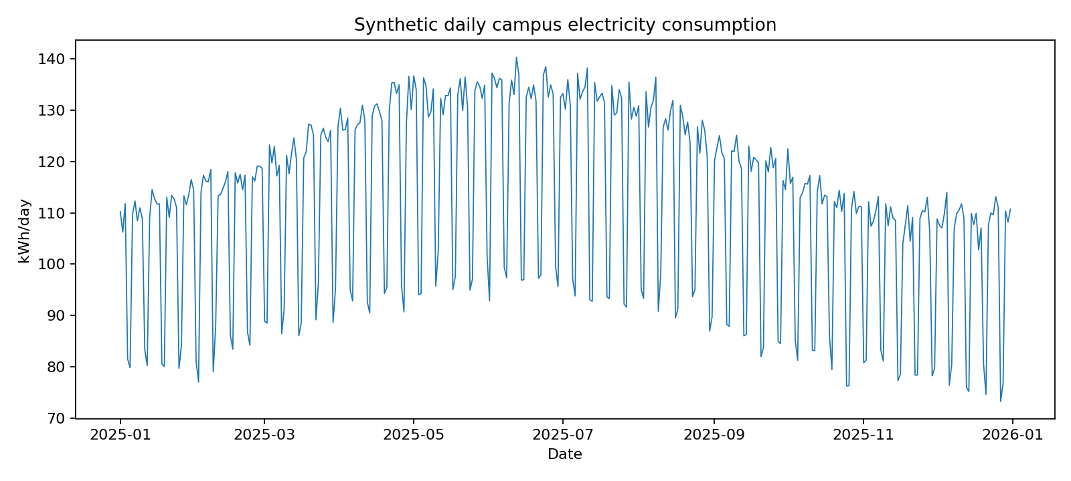
Synthetic daily kWh totals across the demonstration year.

Figure 2. Model comparison by MAE
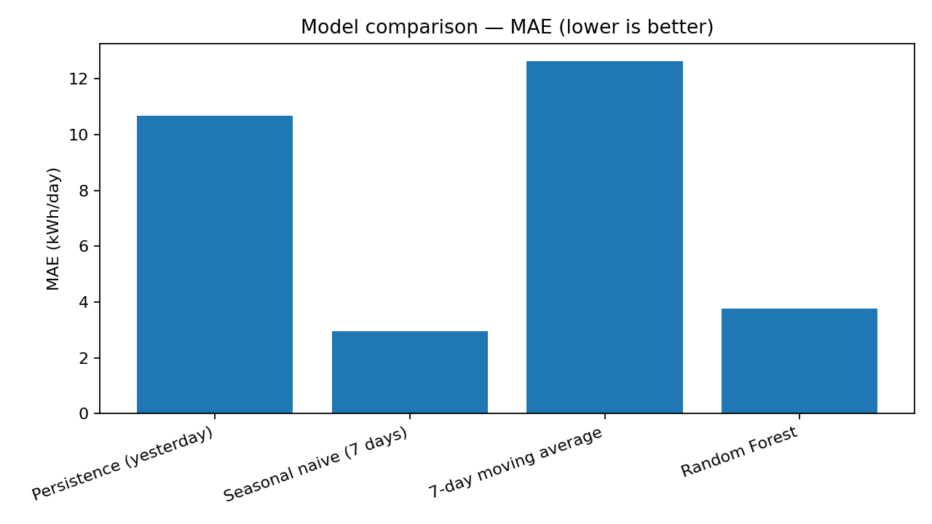
Lower MAE is better; values are from the synthetic chronological test set.

Figure 3. Actual versus predicted
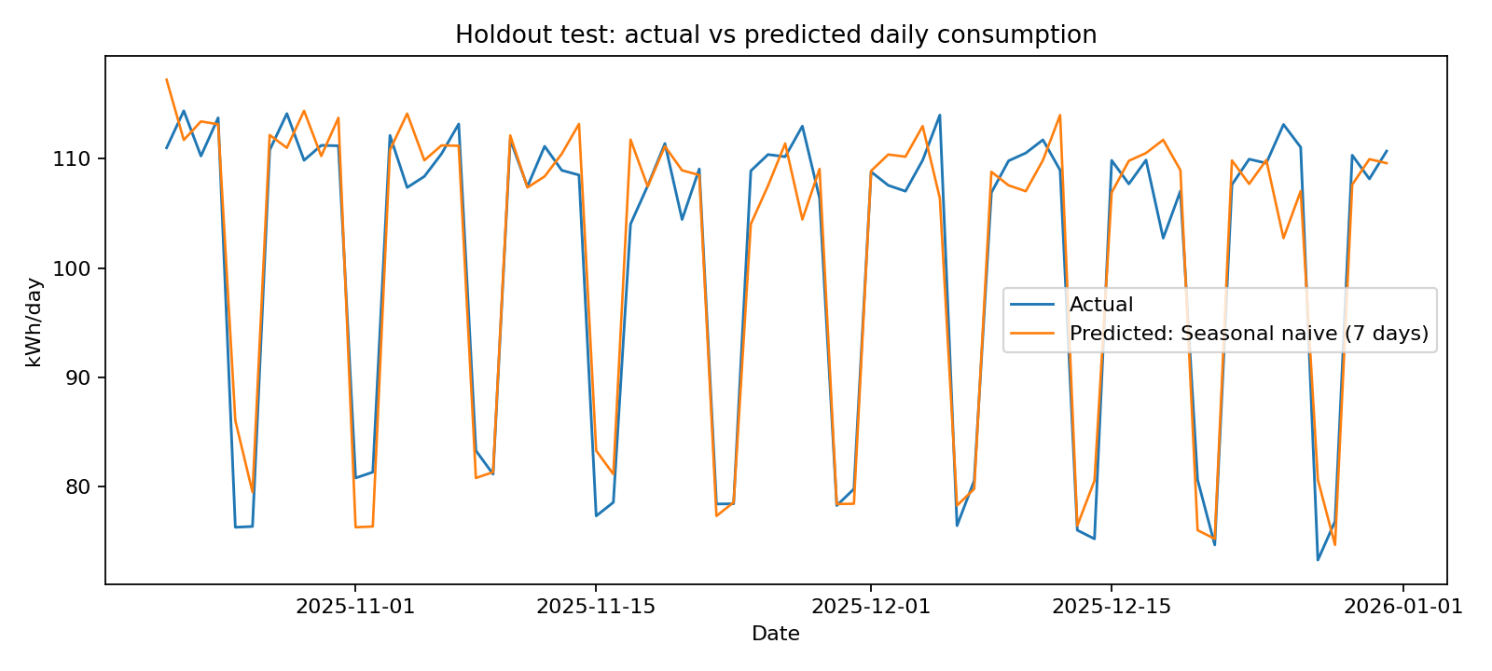
Holdout-period actual and predicted values for the model with lowest MAE.

Figure 4. Fourteen-day forecast
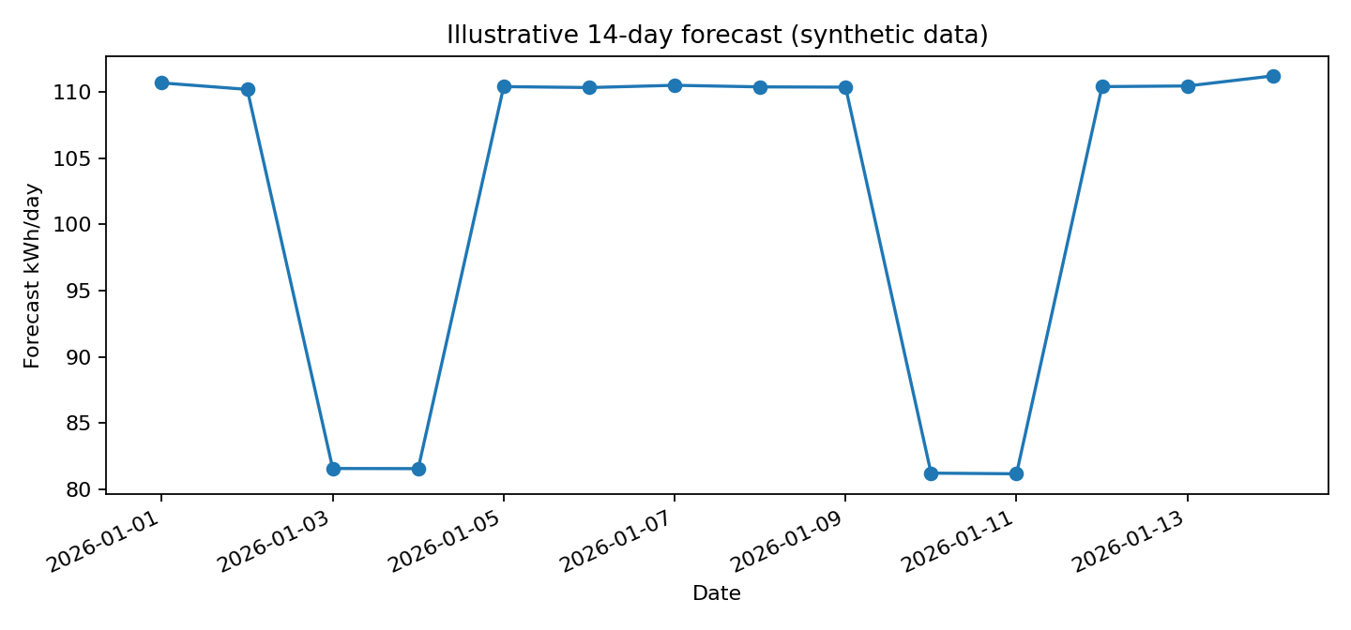
Illustrative recursive forecast produced by the Random Forest using synthetic data.

7. Implementation
The companion CSV files provide the synthetic hourly input, model metrics, and 14-day forecast. The modelling workflow uses Python, pandas, NumPy, Matplotlib, and scikit-learn. To reproduce the analysis, install these packages, load the hourly CSV, aggregate to daily totals, create lag/calendar features, split chronologically, fit the models, and calculate the metrics. The accompanying implementation script is included separately.

8. Practical Recommendations
- Obtain at least 12–24 months of authorised meter readings, ideally hourly or 15-minute intervals.
- Record academic holidays, examination periods, occupancy, weather, and major equipment schedules where available.
- Keep a final chronological test period untouched while tuning models on earlier validation periods.
- Compare against simple seasonal baselines before adopting a complex model.
- Use forecast intervals or scenario ranges for operational decisions; point forecasts alone do not express uncertainty.
- Protect facility-level data and document sensor outages, meter changes, and preprocessing decisions.

9. Limitations
The largest limitation is that the demonstration data are synthetic, not real college measurements. The simulation does not capture actual holidays, weather extremes, occupancy, tariffs, campus expansion, outages, or equipment-specific behaviour. The model comparison is illustrative and not evidence that Random Forest is best for the real campus. The 14-day output is recursively generated and uncertainty is not quantified.

10. Conclusion
This mini-project demonstrates a complete baseline time-series forecasting workflow: timestamp validation, daily aggregation, visualisation, lag and calendar features, chronological evaluation, comparison of multiple models, and a short-horizon forecast. For a valid campus-specific conclusion, replace synthetic values with real authorised meter data and rerun the same workflow. The best operational model should be selected from real-data test results, not from this demonstration.

References
- Hyndman, R. J., & Athanasopoulos, G. (2021). Forecasting: Principles and Practice (3rd ed.). OTexts. https://otexts.com/fpp3/
- Pedregosa, F., et al. (2011). Scikit-learn: Machine Learning in Python. Journal of Machine Learning Research, 12, 2825–2830. https://jmlr.org/papers/v12/pedregosa11a.html
- McKinney, W. (2010). Data Structures for Statistical Computing in Python. Proceedings of the 9th Python in Science Conference, 51–56. https://doi.org/10.25080/Majora-92bf1922-00a
- Matplotlib Development Team. Matplotlib documentation. https://matplotlib.org/stable/
- Project dataset: Synthetic hourly electricity series generated for this demonstration; no external empirical dataset was used.
Submission note: Replace this note with the real dataset source and collection details if authorised campus meter data are obtained. Do not label synthetic results as observed campus consumption.

