**DOCUMENTATION**

|  |  |
| --- | --- |
| NAME | ANAND KUMAR |
| DESIGNATION | STUDENT |
| COLLEGE | YSM RANCHI |
| PROJECT TITLE | LIBRARY MANAGEMENT SYSTEM |
| CLIENT | SELF |

**PLANNING**

# PURPOSE

The purpose of the project is to achieve the basic understanding of Library Management System of a School or College.

# Target Audience

Parents, Teachers, Students

# Description

Project should be able to login an administrator user who can be a librarian. It should be able to create, update and delete book entries. It should also be able to issue and return books as students issue and return books.

Site Map

**Wireframes**

**Design**

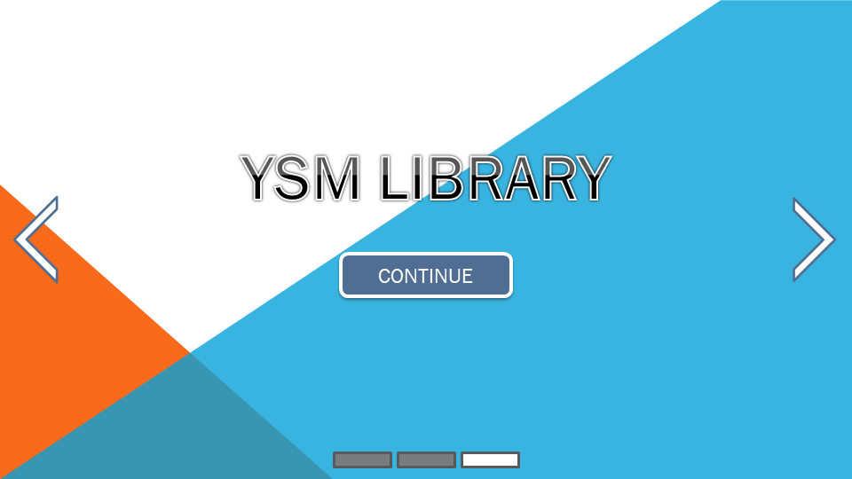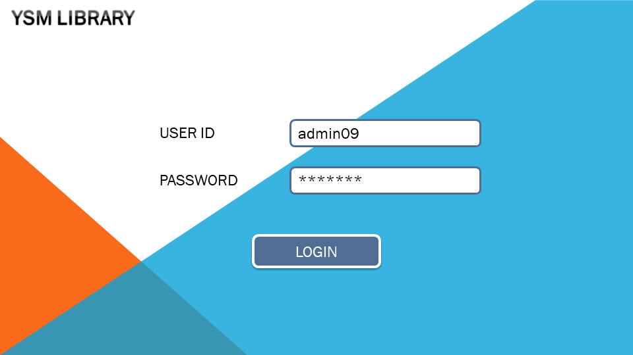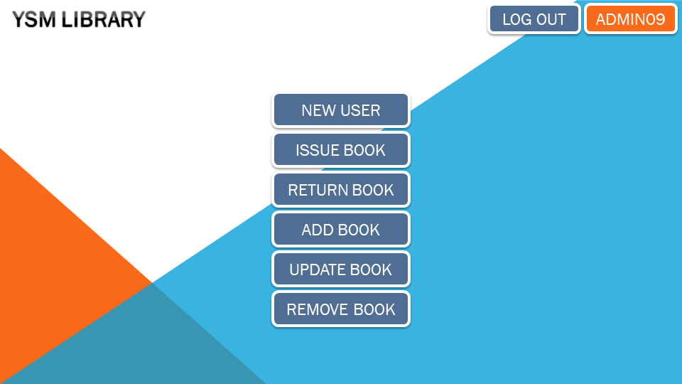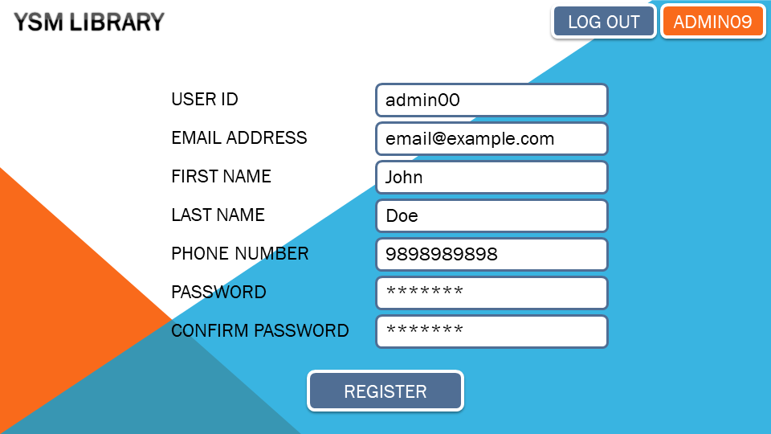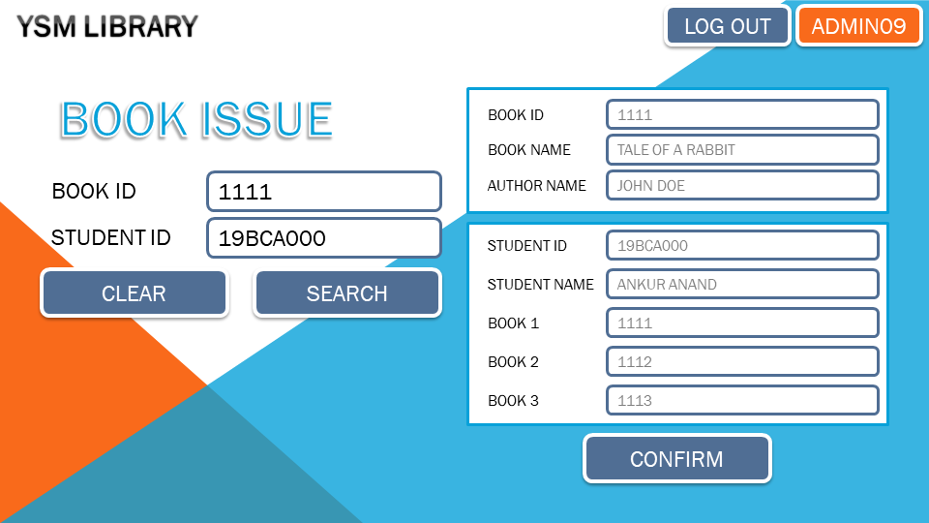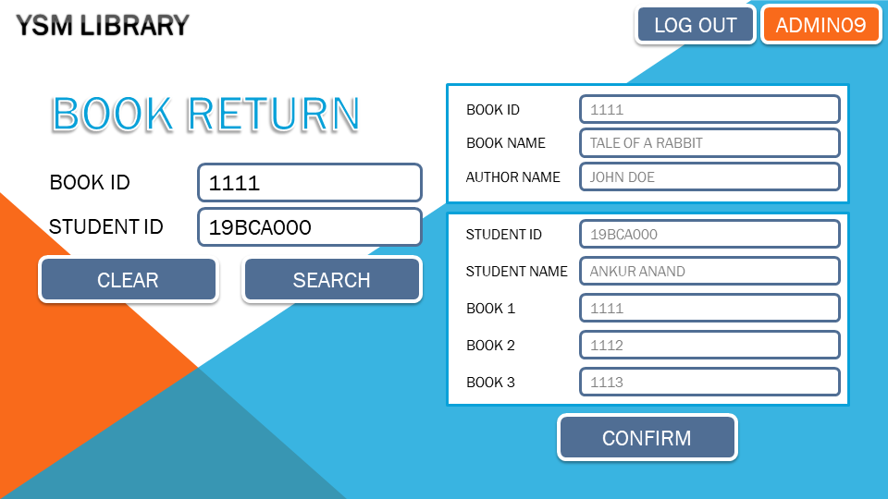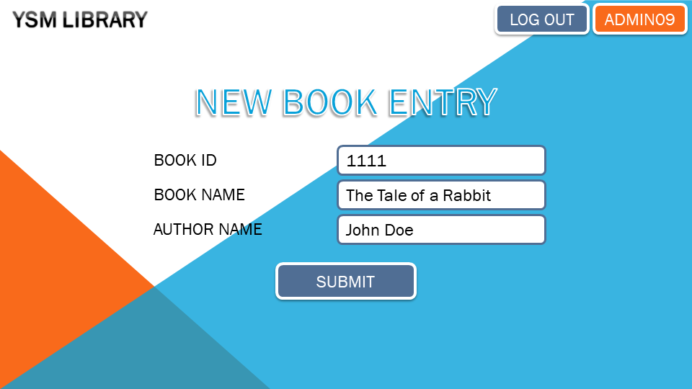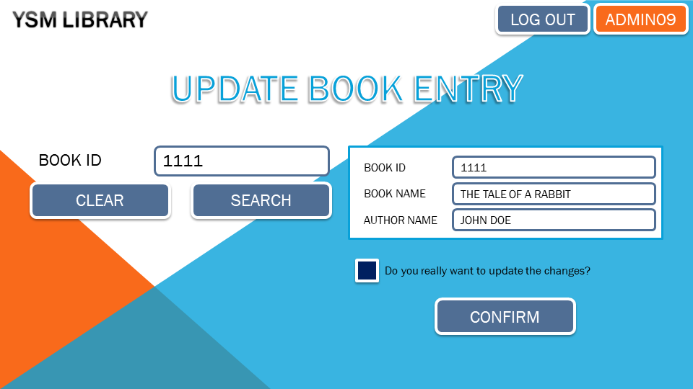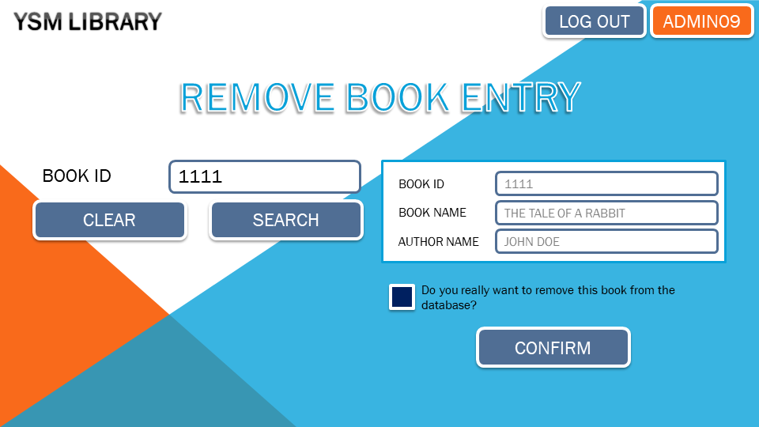

**Colors**

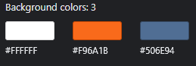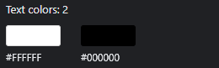

**Font Family**

# Times New Roman

# Open Sans, Sans-Serif

**DATABASE**

# Book_details Schema

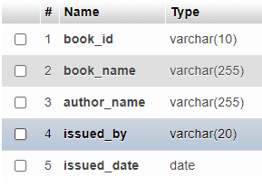

# Student_book Schema

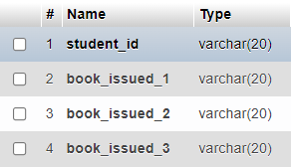

# Student_details Schema

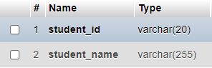

# User_data Schema

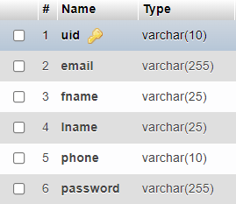

**Stylesheet**

*@import* url('https://fonts.googleapis.com/css2?family=Open+Sans:wght@300;400;500;600;700;800&display=swap');

*/* width */*

*::-webkit-scrollbar* {

    width: 10px;

}

*/* Track */*

*::-webkit-scrollbar-track* {

    background: #f1f1f1;

}

*/* Handle */*

*::-webkit-scrollbar-thumb* {

    background: rgb(80, 110, 148);

}

*/* Handle on hover */*

*::-webkit-scrollbar-thumb:hover* {

    background: rgb(55, 80, 112);

}

*{

    padding: 0;

    margin: 0;

    box-sizing: border-box;

}

body{

    width: 100vw;

    height: 100vh;

    font-family: 'Open Sans', sans-serif;

    background-image: url('./img/background.png');

    background-position: center;

    background-attachment: fixed;

    background-repeat: no-repeat;

    background-size: cover;

    overflow-x: hidden;

    overflow-y: auto;

}

h1{

    font-size: 60px;

    -webkit-text-stroke: 2px white;

    text-shadow: 0 0 2px black;

    text-align: center;

}

h2{

    font-size: 28px;

}

a{

    text-decoration: none;

}

a*:active*,

a*:link*,

a*:visited*,

a*:hover*{

    color: white;

}

*.btn*{

    border: none;

    display: inline-block;

    background: rgb(80, 110, 148);

    box-shadow: 0 0 0 5px white,

                2px 2px 10px 3px black;

    color: white;

    font-size: 18px;

    font-weight: 500;

    padding: 8px 20px;

    border-radius: 5px;

    cursor: pointer;

    text-transform: uppercase;

    margin: 10px;

*/* min-width: 220px; */*

    text-align: center;

}

*.btn-sm*{

    width: 150px;

}

*.btn-lg*{

    width: 350px;

}

*.btn:hover*{

    background: rgb(55, 80, 112);

}

*.sec*{

    background: rgb(249, 106, 27);

}

*.sec:hover*{

    background: rgb(219, 92, 24);

}

*.navbar*{

    display: flex;

    flex-direction: row;

    align-items: center;

    padding: 10px;

}

*.navbar* *.nav-logo*{

    flex: 1;

}

*.main*{

    margin: auto;

    width: 90%;

    height: 90%;

    display: flex;

    flex-direction: column;

    justify-content: center;

    align-items: center;

}

*.container*{

    display: flex;

    padding: 10px;

    gap: 10px;

}

*.w-500*{

    width: 500px;

}

*.w-700*{

    width: 700px

}

*.bg-wb*{

    background: white;

    border: 5px solid rgb(8, 161, 217);

}

*.w-sm*{

    flex: 3 / 1;

}

*.md-row*{

    flex-direction: row;

    align-items: center;

    justify-content: space-between;

}

*.md-col*{

    flex-direction: column;

}

*.row*{

    display: flex;

    flex-direction: row;

    justify-content: space-between;

    align-items: center;

}

*.row-cen*{

    justify-content: center;

}

*.col*{

    display: inline-block;

}

label,

input{

    font-weight: 400;

}

input{

    border: 5px solid rgb(80, 110, 148);

    padding: 8px;

    border-radius: 10px;

    min-width: 300px;

}

input*:disabled*{

    border: 5px solid rgb(105, 105, 105);

}

*:not*(input[*type*="chekbox"]){

    min-width: fit-content;

}

*.lb-sm*{

    font-size: 18px;

}

*.lb-lg*{

    font-size: 24px;

}