To be a preferred hub for nurturing computer engineering aspirants through innovative, ethical, value-based technical education, impactful research, and industry collaboration, to become successful professionals contributing for the betterment of society.
Mission Statement of the Department.
To nurture computer engineering professionals by offering Dynamic learning environment that encourages problem-solving using emerging technology, National Education Policy aligned evidence-based technical education, fostering ,innovation, research, and industry–institute collaboration & Holistic, ethical and sustainable development for lifelong success.

Session 2026-2027

Vision:Dream of where you want. | Mission: Means to achieve Vision

Program Educational Objectives of the program (PEO): (broad statements that describe the professional and career accomplishments)
PEO1 | Preparation | P: Preparation | Pep-CL abbreviation pronounce as Pep-si-lL easy to recall
PEO2 | Core Competence | E: Environment  (Learning Environment) | Pep-CL abbreviation pronounce as Pep-si-lL easy to recall
PEO3 | Breadth | P: Professionalism | Pep-CL abbreviation pronounce as Pep-si-lL easy to recall
PEO4 | Professionalism | C: Core Competence | Pep-CL abbreviation pronounce as Pep-si-lL easy to recall
PEO5 | Learning  Environment | L: Breadth (Learning in diverse areas) | Pep-CL abbreviation pronounce as Pep-si-lL easy to recall

Program Outcomes (PO): (statements that describe what a student should be able to do and know by the end of a program)
Keywords of POs:
Engineering knowledge,Problem analysis, Design/development of solutions,Conduct Investigations of Complex Problems, Engineering Tool Usage, The Engineer and The World,Ethics, Individual and Collaborative Team work,Communication, Project Management and Finance, Life-Long Learning

PSO Keywords: Cutting edge technologies, Research

“I am an engineer, and I know how to apply engineering knowledge to investigate, analyse and design solutions to complex problems using tools for entire world following all ethics in a collaborative way with proper management skills throughout my life.” to contribute to the development of cutting-edge technologies and Research.

Integrity: I will adhere to the Laboratory Code of Conduct and ethics in its entirety.

Name and Signature of Student and Date
(Signature and Date in Handwritten)

Name: Ashish Shriram Waghare
Date: 11/08/2026

To be a preferred hub for nurturing computer engineering aspirants through innovative, ethical, value-based technical education, impactful research, and industry collaboration, to become successful professionals contributing for the betterment of society.
Mission Statement of the Department.
To nurture computer engineering professionals by offering Dynamic learning environment that encourages problem-solving using emerging technology, National Education Policy aligned evidence-based technical education, fostering ,innovation, research, and industry–institute collaboration & Holistic, ethical and sustainable development for lifelong success.

Session | 2024-25 (ODD) | Course Name | Web Technology Lab
Semester | 3 | Course Code | 23CT1301
Roll No | 45 | Name of Student | Ashish Shriram Waghare

Practical Number | 2
Course Outcome | - Understand various internet technologies.  - Design the web pages using HTML and CSS.  - Implement the XML technology to store the data.  - Develop the interactive web pages using JavaScript.
Aim | Build a registration form (name, email, password, phone number) and write JavaScript to validate all fields on submit, displaying inline error messages
Problem Definition | Design and implement a registration form containing fields such as name, email, password and phone number. Write JavaScript code to validate all input fields when the user submits the form. The program should check whether the entered data satisfies the required conditions and display appropriate inline error messages for invalid or empty fields. Conditional  statements and JavaScript validation techniques are used to process the input and provide immediate feedback to the user.
Theory  (100 words) | Form validation is the process of checking whether the data entered by a user is correct and complete before submitting a form. In this practical, HTML is used to create a registration form containing fields for name, email, password, and phone number. CSS is used to style the form and display validation error messages. JavaScript is used to perform client-side validation. The submit event is handled using an event listener, and preventDefault() prevents the form from being submitted when invalid data is entered. JavaScript checks whether the name is entered, email contains @, password has at least 6 characters, and phone number contains exactly 10 digits. Error messages are displayed for invalid inputs.
Procedure and Execution  (100 Words) | Procedure and Execution — Step for Implementation  - Create a project folder for the registration form.  - Create index.html, style.css, and script.js files.  - Design the registration form using HTML.  - Add fields for name, email, password, and phone number.  - Link the CSS file to the HTML document.  - Apply styling to the form using CSS.  - Link the JavaScript file to the HTML page.  - Add validation conditions using JavaScript.  - Display error messages for invalid inputs.  - Run the form in a browser and verify successful registration.
To be a preferred hub for nurturing computer engineering aspirants through innovative, ethical, value-based technical education, impactful research, and industry collaboration, to become successful professionals contributing for the betterment of society.
Mission Statement of the Department.
To nurture computer engineering professionals by offering Dynamic learning environment that encourages problem-solving using emerging technology, National Education Policy aligned evidence-based technical education, fostering ,innovation, research, and industry–institute collaboration & Holistic, ethical and sustainable development for lifelong success.
Code:
index.html :
<!DOCTYPE html>
<html>
<head>
<title>Registration Form</title>
<link rel="stylesheet" href="style.css">
</head>
<body>
<h2>Registration Form</h2>
<form id="registrationForm">
<label>Name:</label>
<input type="text" id="name">
<span id="nameError" class="error"></span>
<label>Email:</label>
<input type="text" id="email">
<span id="emailError" class="error"></span>
<label>Password:</label>
<input type="password" id="password">
<span id="passwordError" class="error"></span>
<label>Phone Number:</label>
<input type="text" id="phone">
<span id="phoneError" class="error"></span>
<input type="submit" value="Register">
</form>
<script src="script.js"></script>
</body>
</html>
style.css :
body {
font-family: Arial; width: 400px; margin: 50px auto;
}
h2 {
text-align: center;
}
label {
display: block; margin-top: 15px;
}
input {
width: 100%; padding: 8px; margin-top: 5px;
box-sizing: border-box;
}
input[type="submit"] { margin-top: 20px; cursor: pointer;
}
.error {
color: red;
font-size: 13px; display: block; margin-top: 3px;
}
script.js : document.getElementById("registrationForm").addEventListener("submit", function(event) {
event.preventDefault();
let name = document.getElementById("name").value.trim(); let email = document.getElementById("email").value.trim(); let password = document.getElementById("password").value; let phone = document.getElementById("phone").value.trim();
let valid = true;
// Clear previous errors using loop
let errors = document.querySelectorAll(".error");
for (let i = 0; i < errors.length; i++) { errors[i].innerHTML = "";
}
// Name validation if (name == "") {
document.getElementById("nameError").innerHTML = "Name is required";
valid = false;
}
// Email validation
if (email == "" || !email.includes("@")) { document.getElementById("emailError").innerHTML =
"Enter a valid email"; valid = false;
}
// Password validation
if (password.length < 6) { document.getElementById("passwordError").innerHTML =
"Password must contain at least 6 characters"; valid = false;
}
// Phone validation
if (phone.length != 10 || isNaN(phone)) { document.getElementById("phoneError").innerHTML =
"Enter a valid 10-digit phone number"; valid = false;
}
// Final condition if (valid) {
alert("Registration Successful!");
}
});

Output:

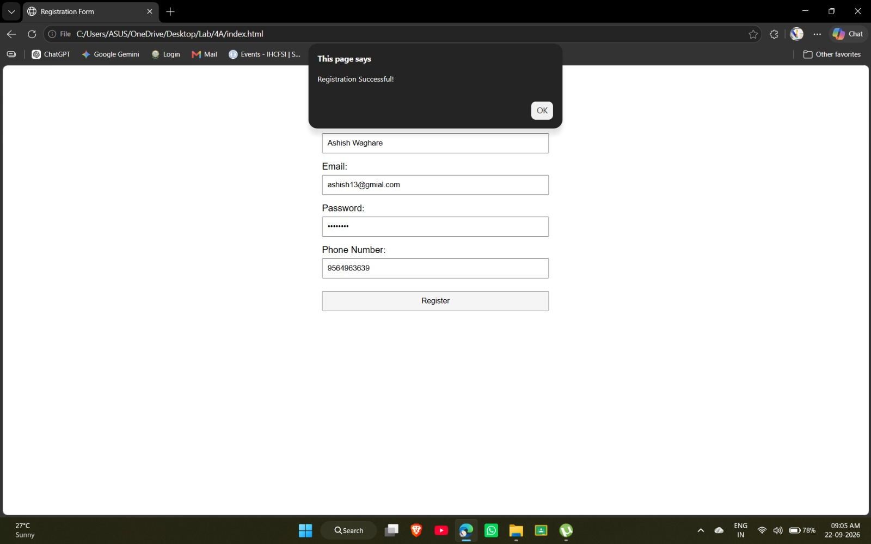

Output Analysis | The registration form is displayed successfully with fields for Name, Email, Password, and Phone Number. The entered details are validated using JavaScript. Since all the entered values satisfy the specified validation conditions, the message “Registration Successful!” is displayed in an alert box. This confirms that the HTML form, CSS styling, and JavaScript validation are functioning correctly.
Link of student Github profile where lab assignment has been uploaded | https://github.com/codewithashish-byte
Conclusion | Thus, a registration form was successfully designed using HTML and CSS, and client-side form validation was implemented using JavaScript. The form successfully validates the user inputs and displays an appropriate success message when valid data is entered.
Plag Report (Similarity index < 12%) | The assignment was prepared by referring to the concepts and practical instructions provided for this experiment. The code was written and implemented for the practical, and the content was presented in my own words. The plagiarism/similarity check was considered while preparing the assignment.
Date | 11/08/2026

