To be a preferred hub for nurturing computer engineering aspirants through innovative, ethical, value-based technical education, impactful research, and industry collaboration, to become successful professionals contributing for the betterment of society.
Mission Statement of the Department.
To nurture computer engineering professionals by offering Dynamic learning environment that encourages problem-solving using emerging technology, National Education Policy aligned evidence-based technical education, fostering ,innovation, research, and industry–institute collaboration & Holistic, ethical and sustainable development for lifelong success.

Session 2026-2027

Vision:Dream of where you want. | Mission: Means to achieve Vision

Program Educational Objectives of the program (PEO): (broad statements that describe the professional and career accomplishments)
PEO1 | Preparation | P: Preparation | Pep-CL abbreviation pronounce as Pep-si-lL easy to recall
PEO2 | Core Competence | E: Environment  (Learning Environment) | Pep-CL abbreviation pronounce as Pep-si-lL easy to recall
PEO3 | Breadth | P: Professionalism | Pep-CL abbreviation pronounce as Pep-si-lL easy to recall
PEO4 | Professionalism | C: Core Competence | Pep-CL abbreviation pronounce as Pep-si-lL easy to recall
PEO5 | Learning  Environment | L: Breadth (Learning in diverse areas) | Pep-CL abbreviation pronounce as Pep-si-lL easy to recall

Program Outcomes (PO): (statements that describe what a student should be able to do and know by the end of a program)
Keywords of POs:
Engineering knowledge,Problem analysis, Design/development of solutions,Conduct Investigations of Complex Problems, Engineering Tool Usage, The Engineer and The World,Ethics, Individual and Collaborative Team work,Communication, Project Management and Finance, Life-Long Learning

PSO Keywords: Cutting edge technologies, Research

“I am an engineer, and I know how to apply engineering knowledge to investigate, analyse and design solutions to complex problems using tools for entire world following all ethics in a collaborative way with proper management skills throughout my life.” to contribute to the development of cutting-edge technologies and Research.

Integrity: I will adhere to the Laboratory Code of Conduct and ethics in its entirety.

Name and Signature of Student and Date
(Signature and Date in Handwritten)

Name: Ashish Shriram Waghare
Date: 29/09/2026

To be a preferred hub for nurturing computer engineering aspirants through innovative, ethical, value-based technical education, impactful research, and industry collaboration, to become successful professionals contributing for the betterment of society.
Mission Statement of the Department.
To nurture computer engineering professionals by offering Dynamic learning environment that encourages problem-solving using emerging technology, National Education Policy aligned evidence-based technical education, fostering ,innovation, research, and industry–institute collaboration & Holistic, ethical and sustainable development for lifelong success.

Session | 2024-25 (ODD) | Course Name | Web Technology Lab
Semester | 3 | Course Code | 23CT1301
Roll No | 45 | Name of Student | Ashish Shriram Waghare

Practical Number | 7
Course Outcome | - Understand various internet technologies.  - Design the web pages using HTML and CSS.  - Implement the XML technology to store the data.  - Develop the interactive web pages using JavaScript.
Aim | To develop a weather application using JavaScript and the Fetch API to retrieve weather data asynchronously from a public API and display the information dynamically on a webpage.
Problem Definition | To develop a web-based weather application that accepts a city name from the user, obtains its geographical coordinates, requests current weather information from a weather API, processes the JSON response, and displays the weather details on the webpage. The application should also handle empty input, invalid city names, and API/network errors appropriately.
Theory  (100 words) | Asynchronous programming allows JavaScript to perform tasks such as API requests without blocking the webpage. An API (Application Programming Interface) provides a way for one application to request data or services from another application. The Fetch API is used to send HTTP requests and receive data from a server. A Promise represents the eventual completion or failure of an asynchronous operation. The async and await keywords make asynchronous code easier to write and understand. API responses are commonly received in JSON (JavaScript Object Notation) format, which can be converted into JavaScript objects using response.json(). The try...catch block is used to handle errors during API communication.
Procedure and Execution  (100 Words) | Step for Implementation:  - Create a folder named weather-app.  - Create index.html, style.css, and script.js.  - Design the webpage with a city input box.  - Add a Search button and weather result container.  - Link the CSS and JavaScript files.  - Access the input and result elements using JavaScript.  - Add a click event to the Search button.  - Use fetch() to request city coordinates and weather data.  - Use async/await and JSON to process the API response.  - Display weather details and handle invalid input or errors.
To be a preferred hub for nurturing computer engineering aspirants through innovative, ethical, value-based technical education, impactful research, and industry collaboration, to become successful professionals contributing for the betterment of society.
Mission Statement of the Department.
To nurture computer engineering professionals by offering Dynamic learning environment that encourages problem-solving using emerging technology, National Education Policy aligned evidence-based technical education, fostering ,innovation, research, and industry–institute collaboration & Holistic, ethical and sustainable development for lifelong success.
Code:
index.html:-
<!DOCTYPE html>
<html>

<head>
<title>Weather App</title>
<link rel="stylesheet" href="style.css">
</head>

<body>

<h1>Weather App</h1>

<input type="text" id="cityInput"
placeholder="Enter city name">

<button id="searchButton">Search</button>

<div id="weatherResult"></div>

<script src="script.js"></script>

</body>

</html>

Style.css:-
body {
font-family: Arial;
text-align: center;
margin-top: 50px;
}

input {
padding: 10px;
width: 250px;
}

button {
padding: 10px 20px;
cursor: pointer;
}

#weatherResult {
margin-top: 30px;
}
script.js:-
let cityInput = document.getElementById("cityInput");
let searchButton = document.getElementById("searchButton");
let weatherResult = document.getElementById("weatherResult");

searchButton.addEventListener("click", function()
{
let city = cityInput.value.trim();

if(city == "")
{
weatherResult.innerHTML = "<p>Please enter a city.</p>";
return;
}

getWeather(city);
});

async function getWeather(city)
{
weatherResult.innerHTML = "<p>Loading...</p>";

try
{
let geoUrl = "https://geocoding-api.open-meteo.com/v1/search?name="
+ encodeURIComponent(city) + "&count=1";

let geoResponse = await fetch(geoUrl);

let geoData = await geoResponse.json();

if(!geoData.results)
{
weatherResult.innerHTML = "<p>City not found.</p>";
return;
}

let location = geoData.results[0];

let latitude = location.latitude;
let longitude = location.longitude;

let weatherUrl = "https://api.open-meteo.com/v1/forecast"
+ "?latitude=" + latitude
+ "&longitude=" + longitude
+ "&current=temperature_2m,relative_humidity_2m,"
+ "weather_code,wind_speed_10m";

let weatherResponse = await fetch(weatherUrl);

let weatherData = await weatherResponse.json();

let current = weatherData.current;

let temperature = current.temperature_2m;
let humidity = current.relative_humidity_2m;
let windSpeed = current.wind_speed_10m;
let weatherCode = current.weather_code;

weatherResult.innerHTML =
"<h2>" + location.name + "</h2>" +
"<p>Country: " + location.country + "</p>" +
"<p>Temperature: " + temperature + " °C</p>" +
"<p>Humidity: " + humidity + " %</p>" +
"<p>Wind Speed: " + windSpeed + " km/h</p>" +
"<p>Weather Code: " + weatherCode + "</p>";
}

catch(error)
{
weatherResult.innerHTML =
"<p>Unable to fetch weather data.</p>";

console.log(error);
}
}

Output:
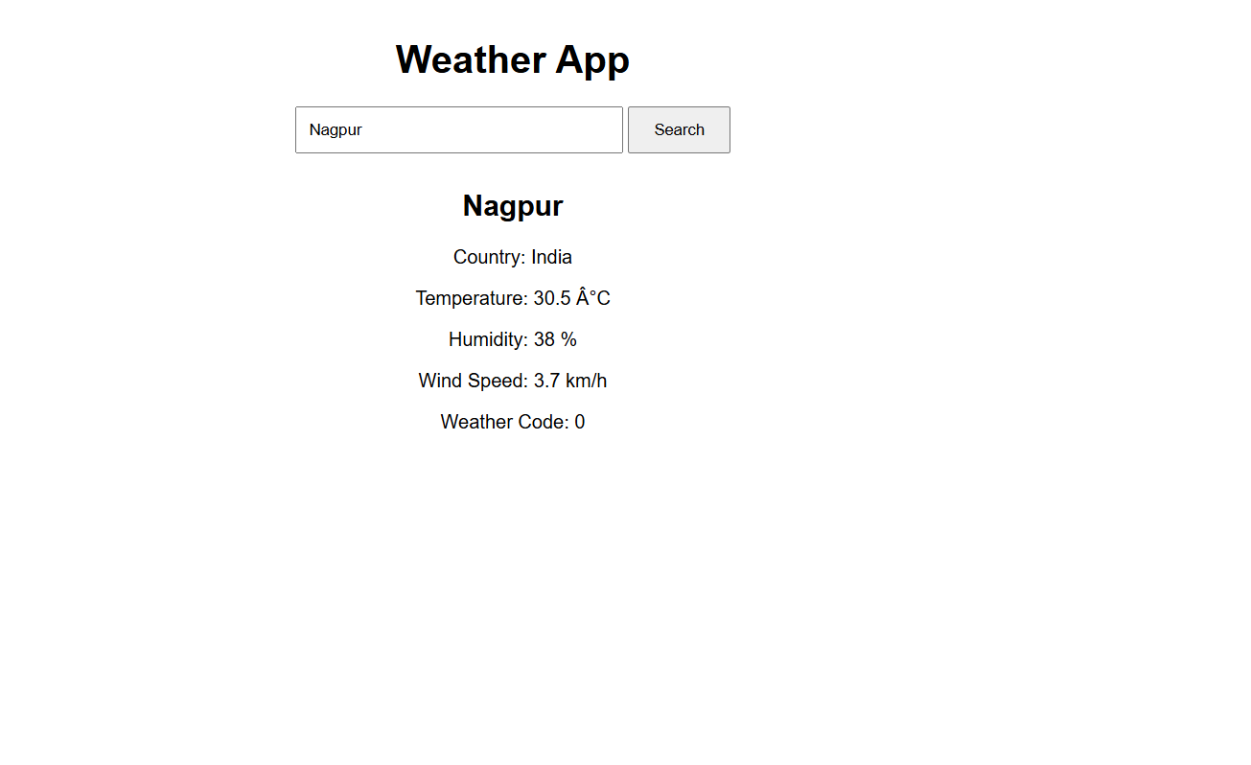

Output Analysis | The Weather App is displayed successfully in the browser. The user enters Nagpur in the search field, and the application fetches and displays the weather information. The output shows India as the country, a temperature of 30.5 °C, humidity of 38%, wind speed of 3.7 km/h, and weather code 0. This confirms that the Fetch API successfully retrieves the weather data and JavaScript displays the received information dynamically.
Link of student Github profile where lab assignment has been uploaded | https://github.com/codewithashish-byte
Conclusion | Thus, a weather application was successfully developed using HTML, CSS, JavaScript, and the Fetch API. The application accepts a city name, retrieves weather data asynchronously from an external API, processes the JSON response, and displays the required weather information on the webpage.
Plag Report (Similarity index < 12%) | The practical was prepared using the concepts and implementation instructions provided for the experiment. The code and written content were implemented in the required format, and the theory and explanations were presented appropriately. The work was reviewed to avoid unnecessary copying from external sources.
Date | 29/09/2026

