To be a preferred hub for nurturing computer engineering aspirants through innovative, ethical, value-based technical education, impactful research, and industry collaboration, to become successful professionals contributing for the betterment of society.
Mission Statement of the Department.
To nurture computer engineering professionals by offering Dynamic learning environment that encourages problem-solving using emerging technology, National Education Policy aligned evidence-based technical education, fostering ,innovation, research, and industry–institute collaboration & Holistic, ethical and sustainable development for lifelong success.

Session 2026-2027

Vision:Dream of where you want. | Mission: Means to achieve Vision

Program Educational Objectives of the program (PEO): (broad statements that describe the professional and career accomplishments)
PEO1 | Preparation | P: Preparation | Pep-CL abbreviation pronounce as Pep-si-lL easy to recall
PEO2 | Core Competence | E: Environment  (Learning Environment) | Pep-CL abbreviation pronounce as Pep-si-lL easy to recall
PEO3 | Breadth | P: Professionalism | Pep-CL abbreviation pronounce as Pep-si-lL easy to recall
PEO4 | Professionalism | C: Core Competence | Pep-CL abbreviation pronounce as Pep-si-lL easy to recall
PEO5 | Learning  Environment | L: Breadth (Learning in diverse areas) | Pep-CL abbreviation pronounce as Pep-si-lL easy to recall

Program Outcomes (PO): (statements that describe what a student should be able to do and know by the end of a program)
Keywords of POs:
Engineering knowledge,Problem analysis, Design/development of solutions,Conduct Investigations of Complex Problems, Engineering Tool Usage, The Engineer and The World,Ethics, Individual and Collaborative Team work,Communication, Project Management and Finance, Life-Long Learning

PSO Keywords: Cutting edge technologies, Research

“I am an engineer, and I know how to apply engineering knowledge to investigate, analyse and design solutions to complex problems using tools for entire world following all ethics in a collaborative way with proper management skills throughout my life.” to contribute to the development of cutting-edge technologies and Research.

Integrity: I will adhere to the Laboratory Code of Conduct and ethics in its entirety.

Name and Signature of Student and Date
(Signature and Date in Handwritten)

Name: Ashish Shriram Waghare
Date: 06/10/2026

To be a preferred hub for nurturing computer engineering aspirants through innovative, ethical, value-based technical education, impactful research, and industry collaboration, to become successful professionals contributing for the betterment of society.
Mission Statement of the Department.
To nurture computer engineering professionals by offering Dynamic learning environment that encourages problem-solving using emerging technology, National Education Policy aligned evidence-based technical education, fostering ,innovation, research, and industry–institute collaboration & Holistic, ethical and sustainable development for lifelong success.

Session | 2024-25 (ODD) | Course Name | Web Technology Lab
Semester | 3 | Course Code | 23CT1301
Roll No | 45 | Name of Student | Ashish Shriram Waghare

Practical Number | 8A
Course Outcome | - Understand various internet technologies.  - Design the web pages using HTML and CSS.  - Implement the XML technology to store the data.  - Develop the interactive web pages using JavaScript.
Aim | To implement a To-Do List logic using TypeScript by defining an interface and typed functions for adding, completing, and deleting tasks.
Problem Definition | To develop a TypeScript-based To-Do List logic in which tasks are represented using a common Task interface. Each task should contain an ID, title, and completion status. The program should provide typed functions to add a new task, toggle its completion status, and delete a task using TypeScript array methods.
Theory  (100 words) | TypeScript is a superset of JavaScript that provides static typing and helps detect errors before program execution. An interface is used to define the structure of an object. In this practical, the Task interface contains three properties: id of type number, title of type string, and completed of type boolean. The task list is declared as Task[], which allows only Task objects. Typed functions are used to add, toggle, and delete tasks. The push() method adds a new task, map() changes the completion status of a selected task, and filter() removes a task based on its ID.
Procedure and Execution  (100 Words) | Step for Implementation:  - Create a TypeScript project folder.  - Create types.ts and todoLogic.ts.  - Define the Task interface.  - Specify id, title, and completed types.  - Create a Task[] array for storing tasks.  - Create a typed addTask() function.  - Use push() to add a new task.  - Create toggleTask() using map().  - Create deleteTask() using filter().  - Compile or execute the TypeScript code and check for type errors.
To be a preferred hub for nurturing computer engineering aspirants through innovative, ethical, value-based technical education, impactful research, and industry collaboration, to become successful professionals contributing for the betterment of society.
Mission Statement of the Department.
To nurture computer engineering professionals by offering Dynamic learning environment that encourages problem-solving using emerging technology, National Education Policy aligned evidence-based technical education, fostering ,innovation, research, and industry–institute collaboration & Holistic, ethical and sustainable development for lifelong success.
Code:-
src/types.ts:-
export interface Task
{
id: number;
title: string;
completed: boolean;
}

src/todoLogic.ts:-
import { Task } from "./types";

let tasks: Task[] = [];

function addTask(title: string): void
{
const newTask: Task =
{
id: Date.now(),
title: title,
completed: false
};

tasks.push(newTask);
}

function toggleTask(id: number): void
{
tasks = tasks.map((task: Task) =>
{
if(task.id === id)
{
return {
...task,
completed: !task.completed
};
}

return task;
});
}

function deleteTask(id: number): void
{
tasks =
tasks.filter((task: Task) =>
task.id !== id
);
}

Output:
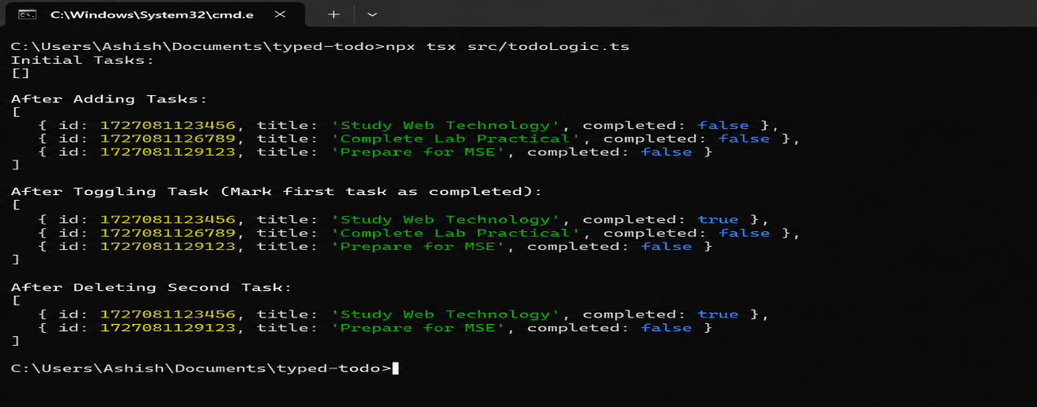

Output Analysis | The output shows the successful execution of the TypeScript To-Do List logic. Initially, the task list is empty. Three tasks are added successfully with their IDs, titles, and completion status set to false. The first task is then toggled, changing its completion status to true. Finally, the second task is deleted using its ID, and only the remaining two tasks are displayed. This confirms that the addTask(), toggleTask(), and deleteTask() functions work correctly.
Link of student Github profile where lab assignment has been uploaded | https://github.com/codewithashish-byte
Conclusion | Thus, the TypeScript To-Do List logic was implemented successfully using an interface, typed functions, and array methods such as push(), map(), and filter(). The program correctly performs task addition, completion status toggling, and task deletion.
Plag Report (Similarity index < 12%) | The practical was implemented using TypeScript concepts and the required problem statement. The code and explanations were written in the prescribed format, with the implementation kept simple and relevant to the practical requirements. No unnecessary external code was copied.
Date | 06/10/2026

