To be a preferred hub for nurturing computer engineering aspirants through innovative, ethical, value-based technical education, impactful research, and industry collaboration, to become successful professionals contributing for the betterment of society.
Mission Statement of the Department.
To nurture computer engineering professionals by offering Dynamic learning environment that encourages problem-solving using emerging technology, National Education Policy aligned evidence-based technical education, fostering ,innovation, research, and industry–institute collaboration & Holistic, ethical and sustainable development for lifelong success.

Session 2026-2027

Vision:Dream of where you want. | Mission: Means to achieve Vision

Program Educational Objectives of the program (PEO): (broad statements that describe the professional and career accomplishments)
PEO1 | Preparation | P: Preparation | Pep-CL abbreviation pronounce as Pep-si-lL easy to recall
PEO2 | Core Competence | E: Environment  (Learning Environment) | Pep-CL abbreviation pronounce as Pep-si-lL easy to recall
PEO3 | Breadth | P: Professionalism | Pep-CL abbreviation pronounce as Pep-si-lL easy to recall
PEO4 | Professionalism | C: Core Competence | Pep-CL abbreviation pronounce as Pep-si-lL easy to recall
PEO5 | Learning  Environment | L: Breadth (Learning in diverse areas) | Pep-CL abbreviation pronounce as Pep-si-lL easy to recall

Program Outcomes (PO): (statements that describe what a student should be able to do and know by the end of a program)
Keywords of POs:
Engineering knowledge,Problem analysis, Design/development of solutions,Conduct Investigations of Complex Problems, Engineering Tool Usage, The Engineer and The World,Ethics, Individual and Collaborative Team work,Communication, Project Management and Finance, Life-Long Learning

PSO Keywords: Cutting edge technologies, Research

“I am an engineer, and I know how to apply engineering knowledge to investigate, analyse and design solutions to complex problems using tools for entire world following all ethics in a collaborative way with proper management skills throughout my life.” to contribute to the development of cutting-edge technologies and Research.

Integrity: I will adhere to the Laboratory Code of Conduct and ethics in its entirety.

Name and Signature of Student and Date
(Signature and Date in Handwritten)

Name: Ashish Shriram Waghare
Date: 06/10/2026

To be a preferred hub for nurturing computer engineering aspirants through innovative, ethical, value-based technical education, impactful research, and industry collaboration, to become successful professionals contributing for the betterment of society.
Mission Statement of the Department.
To nurture computer engineering professionals by offering Dynamic learning environment that encourages problem-solving using emerging technology, National Education Policy aligned evidence-based technical education, fostering ,innovation, research, and industry–institute collaboration & Holistic, ethical and sustainable development for lifelong success.

Session | 2024-25 (ODD) | Course Name | Web Technology Lab
Semester | 3 | Course Code | 23CT1301
Roll No | 45 | Name of Student | Ashish Shriram Waghare

Practical Number | 8B
Course Outcome | - Understand various internet technologies.  - Design the web pages using HTML and CSS.  - Implement the XML technology to store the data.  - Develop the interactive web pages using JavaScript.
Aim | To develop a To-Do List application using React and TypeScript by implementing functional components, props, and useState for managing and displaying typed task objects.
Problem Definition | To create a small React + TypeScript To-Do List application where users can add, complete, and delete tasks. The application should use the Task interface, React functional components, props, and state management using useState.
Theory  (100 words) | React is a library used to build user interfaces using reusable components. TypeScript adds static typing to JavaScript and helps detect type-related errors before execution.  In this practical:  - Components are used to divide the application into reusable parts.  - Props are used to pass data and functions from a parent component to child components.  - State stores task data inside the React component.  - useState<Task[]>([]) maintains an array of typed Task objects.  - TaskInput accepts a task title and sends it to the parent using the onAdd prop.  - TaskItem displays an individual task and provides Toggle and Delete operations.  - map() is used to update task completion status.  - filter() is used to remove a task.  - React automatically updates the UI whenever the state changes.
Procedure and Execution  (100 Words) | Step for Implementation:  - Create a React + TypeScript project using Vite.  - Open the project folder in VS Code.  - Install the required packages using npm install.  - Create the components folder inside src.  - Create TaskInput.tsx and TaskItem.tsx.  - Create types.ts containing the Task interface.  - Implement App.tsx using React useState.  - Pass task data and functions using props.  - Add CSS styling in index.css.  - Run the application using npm run dev and open the localhost URL in the browser.
To be a preferred hub for nurturing computer engineering aspirants through innovative, ethical, value-based technical education, impactful research, and industry collaboration, to become successful professionals contributing for the betterment of society.
Mission Statement of the Department.
To nurture computer engineering professionals by offering Dynamic learning environment that encourages problem-solving using emerging technology, National Education Policy aligned evidence-based technical education, fostering ,innovation, research, and industry–institute collaboration & Holistic, ethical and sustainable development for lifelong success.
Code:
types.ts:-
export interface Task
{
id: number;
title: string;
completed: boolean;
}

TaskInput.tsx:-
import { useState } from "react";

interface TaskInputProps
{
onAdd: (title: string) => void;
}

function TaskInput(
{ onAdd }: TaskInputProps
)
{
const [title, setTitle] =
useState<string>("");

function handleAdd(): void
{
if(title.trim() === "")
{
return;
}

onAdd(title);
setTitle("");
}

return (
<div>
<input
value={title}
onChange={(event) =>
setTitle(event.target.value)
}
placeholder="Enter task"
/>

<button onClick={handleAdd}>
Add Task
</button>
</div>
);
}

export default TaskInput;

TaskItem.tsx:-
import type { Task } from "../types";

interface TaskItemProps
{
task: Task;
onToggle: (id: number) => void;
onDelete: (id: number) => void;
}

function TaskItem(
{
task,
onToggle,
onDelete
}: TaskItemProps
)
{
return (
<li>

<span
style={{
textDecoration:
task.completed
? "line-through"
: "none"
}}
>
{task.title}
</span>

<button
onClick={() =>
onToggle(task.id)
}
>
Complete
</button>

<button
onClick={() =>
onDelete(task.id)
}
>
Delete
</button>

</li>
);
}

export default TaskItem;

App.tsx:-
import { useState } from "react";
import TaskInput from "./components/TaskInput";
import TaskItem from "./components/TaskItem";
import type { Task } from "./types";

function App()
{
const [tasks, setTasks] =
useState<Task[]>([]);

function addTask(title: string): void
{
const newTask: Task =
{
id: Date.now(),
title: title,
completed: false
};

setTasks([
...tasks,
newTask
]);
}

function toggleTask(id: number): void
{
setTasks(
tasks.map((task) =>
task.id === id
? {
...task,
completed:
!task.completed
}
: task
)
);
}

function deleteTask(id: number): void
{
setTasks(
tasks.filter(
(task) => task.id !== id
)
);
}

return (
<div>

<h1>Typed To-Do List</h1>

<TaskInput
onAdd={addTask}
/>

<ul>
{tasks.map((task) => (
<TaskItem
key={task.id}
task={task}
onToggle={toggleTask}
onDelete={deleteTask}
/>
))}
</ul>

</div>
);
}

export default App;

main.tsx:-
import React from "react";
import ReactDOM from "react-dom/client";
import App from "./App";
import "./index.css";

ReactDOM.createRoot(
document.getElementById("root")!
).render(
<React.StrictMode>
<App />
</React.StrictMode>
);

index.css:-
body
{
font-family: Arial;
text-align: center;
margin-top: 40px;
}

h1
{
color: darkblue;
}

input
{
padding: 8px;
width: 220px;
}

button
{
padding: 8px 14px;
margin-left: 8px;
cursor: pointer;
}

ul
{
list-style: none;
padding: 0;
}

li
{
margin: 12px 0;
}
Output:
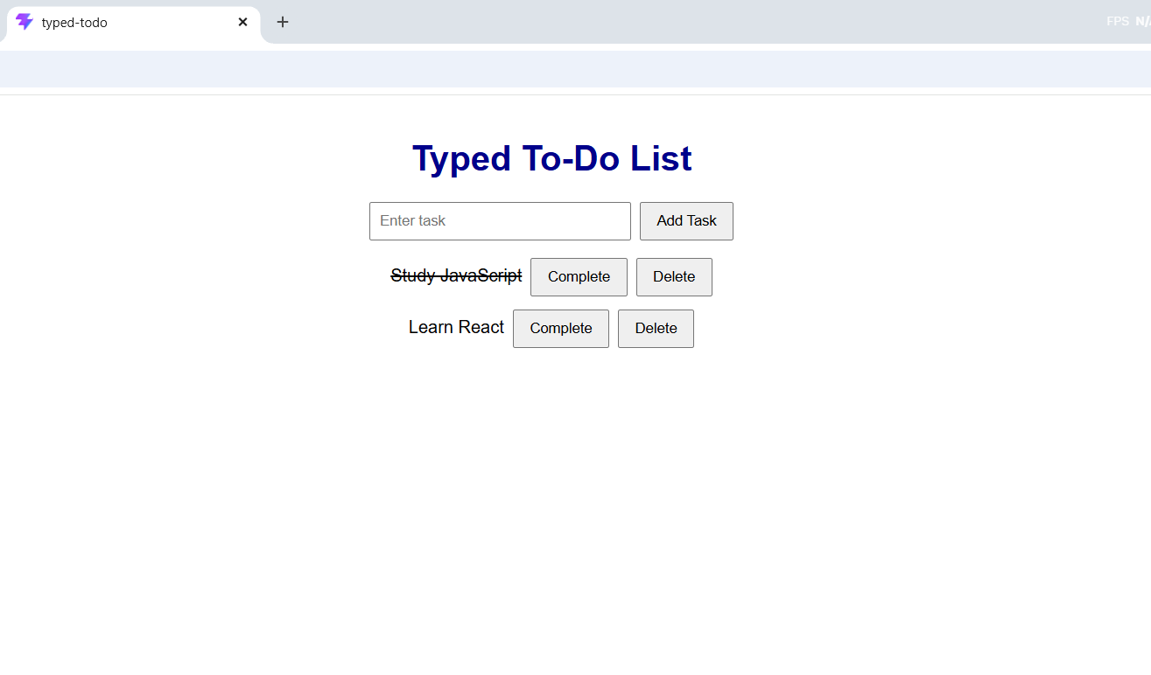

Output Analysis | The output shows a successfully running React + TypeScript To-Do List application. The application displays the “Typed To-Do List” heading along with a task input field and an Add Task button. Two tasks, “Study JavaScript” and “Learn React”, are displayed. The “Study JavaScript” task is crossed out, indicating that the task has been marked as completed. Each task also provides Complete and Delete buttons. Thus, the output demonstrates that the To-Do List UI and its basic task management functionality are working correctly.
Link of student Github profile where lab assignment has been uploaded | https://github.com/codewithashish-byte
Conclusion | Thus, the React + TypeScript To-Do List application was successfully implemented. The application uses React components, props, and state to display and manage tasks. The output confirms that tasks can be displayed, completed, and deleted through the provided controls.
Plag Report (Similarity index < 12%) | The practical was implemented according to the given React + TypeScript To-Do List requirements. The code and documentation were prepared in the prescribed practical format, using the required concepts such as components, props, state, and typed task objects. No unnecessary external code was copied.
Date | 06/10/2026

