To be a preferred hub for nurturing computer engineering aspirants through innovative, ethical, value-based technical education, impactful research, and industry collaboration, to become successful professionals contributing for the betterment of society.
Mission Statement of the Department.
To nurture computer engineering professionals by offering Dynamic learning environment that encourages problem-solving using emerging technology, National Education Policy aligned evidence-based technical education, fostering ,innovation, research, and industry–institute collaboration & Holistic, ethical and sustainable development for lifelong success.

Session 2026-2027

Vision:Dream of where you want. | Mission: Means to achieve Vision

Program Educational Objectives of the program (PEO): (broad statements that describe the professional and career accomplishments)
PEO1 | Preparation | P: Preparation | Pep-CL abbreviation pronounce as Pep-si-lL easy to recall
PEO2 | Core Competence | E: Environment  (Learning Environment) | Pep-CL abbreviation pronounce as Pep-si-lL easy to recall
PEO3 | Breadth | P: Professionalism | Pep-CL abbreviation pronounce as Pep-si-lL easy to recall
PEO4 | Professionalism | C: Core Competence | Pep-CL abbreviation pronounce as Pep-si-lL easy to recall
PEO5 | Learning  Environment | L: Breadth (Learning in diverse areas) | Pep-CL abbreviation pronounce as Pep-si-lL easy to recall

Program Outcomes (PO): (statements that describe what a student should be able to do and know by the end of a program)
Keywords of POs:
Engineering knowledge,Problem analysis, Design/development of solutions,Conduct Investigations of Complex Problems, Engineering Tool Usage, The Engineer and The World,Ethics, Individual and Collaborative Team work,Communication, Project Management and Finance, Life-Long Learning

PSO Keywords: Cutting edge technologies, Research

“I am an engineer, and I know how to apply engineering knowledge to investigate, analyse and design solutions to complex problems using tools for entire world following all ethics in a collaborative way with proper management skills throughout my life.” to contribute to the development of cutting-edge technologies and Research.

Integrity: I will adhere to the Laboratory Code of Conduct and ethics in its entirety.

Name and Signature of Student and Date
(Signature and Date in Handwritten)

Name: Ashish Shriram Waghare
Date: 06/10/2026

To be a preferred hub for nurturing computer engineering aspirants through innovative, ethical, value-based technical education, impactful research, and industry collaboration, to become successful professionals contributing for the betterment of society.
Mission Statement of the Department.
To nurture computer engineering professionals by offering Dynamic learning environment that encourages problem-solving using emerging technology, National Education Policy aligned evidence-based technical education, fostering ,innovation, research, and industry–institute collaboration & Holistic, ethical and sustainable development for lifelong success.

Session | 2024-25 (ODD) | Course Name | Web Technology Lab
Semester | 3 | Course Code | 23CT1301
Roll No | 45 | Name of Student | Ashish Shriram Waghare

Practical Number | 9
Course Outcome | - Understand various internet technologies.  - Design the web pages using HTML and CSS.  - Implement the XML technology to store the data.  - Develop the interactive web pages using JavaScript.
Aim | To understand and implement version control using Git and GitHub by creating a repository, tracking changes, managing branches, merging changes, and resolving merge conflicts.
Problem Definition | To implement a version control workflow for a web development project using Git and GitHub. The practical involves creating and initializing a Git repository, tracking and committing project files, connecting the local repository with GitHub, pushing changes to a remote repository, creating and managing branches, merging branches, and handling merge conflicts when they occur.
Theory  (100 words) | Git is a distributed version control system used to track changes in source code and manage different versions of a project. It allows developers to save changes through commits and work on different features using branches.  GitHub is a cloud-based platform used to host Git repositories and collaborate with other developers.  Important Git concepts used in this practical:  - Repository: A location where project files and their version history are stored.  - Commit: Saves a set of changes in the Git history.  - Branch: A separate line of development used to work on features independently.  - Remote Repository: The repository hosted on GitHub.  - Push: Uploads local commits to GitHub.  - Pull/Fetch: Retrieves changes from the remote repository.  - Merge: Combines changes from one branch into another.  - Merge Conflict: Occurs when Git cannot automatically combine conflicting changes.  - Pull Request: Used on GitHub to propose and review changes before merging them into another branch.  The basic Git workflow is:  Initialize → Add → Commit → Connect GitHub → Push → Create Branch → Make Changes → Merge → Resolve Conflicts
Procedure and Execution  (100 Words) | Step for Implementation:  - Open the project folder in Visual Studio Code.  - Open the terminal and initialize Git using git init.  - Check the repository status using git status.  - Add project files using git add ..  - Create a commit using git commit.  - Create a GitHub repository and connect it as the remote repository.  - Push the local project to GitHub using git push.  - Create a new branch using git checkout -b practical-9.  - Make changes, commit them, and push the branch to GitHub.  - Merge the required changes and resolve any merge conflicts if generated.
To be a preferred hub for nurturing computer engineering aspirants through innovative, ethical, value-based technical education, impactful research, and industry collaboration, to become successful professionals contributing for the betterment of society.
Mission Statement of the Department.
To nurture computer engineering professionals by offering Dynamic learning environment that encourages problem-solving using emerging technology, National Education Policy aligned evidence-based technical education, fostering ,innovation, research, and industry–institute collaboration & Holistic, ethical and sustainable development for lifelong success.
Code:
git --version

git config --global user.name "Ashish"
git config --global user.email "your-email@gmail.com"

git init

git status

git add .

git commit -m "Initial commit"

git remote add origin https://github.com/codewithashish-byte/Web-Technology-Lab.git

git fetch origin

git checkout -b practical-9

git merge origin/main --allow-unrelated-histories

git add README.md

git commit -m "Merge remote main into practical-9"

git push -u origin practical-9

git status
Output:
The following screenshots show the successful execution of Git and GitHub commands and creation of the practical-9 branch.
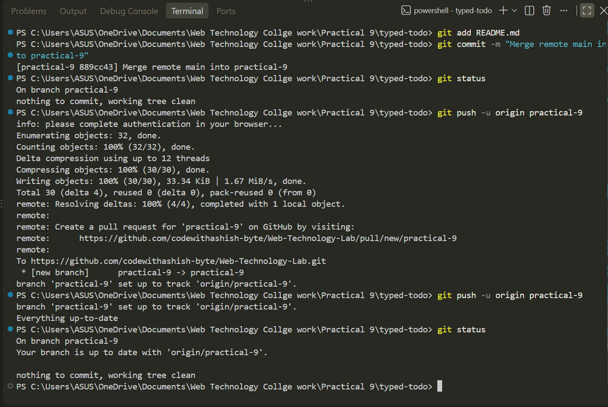

Output Analysis | The Git version control practical was executed successfully. The project was committed to the local repository and the practical-9 branch was successfully pushed to GitHub. The git status command confirmed that the branch is up to date with the remote repository and the working tree is clean.
Link of student Github profile where lab assignment has been uploaded | https://github.com/codewithashish-byte
Conclusion | Git and GitHub version control operations were successfully implemented. The practical demonstrated repository management, committing changes, branch creation, pushing changes to GitHub, and checking repository status.
Plag Report (Similarity index < 12%) | The practical was implemented using the Git and GitHub concepts specified in the practical requirements. The commands and documentation were prepared for the given task, with no unnecessary external code copied. No significant plagiarism detected.
Date | 06/10/2026

