To be a preferred hub for nurturing computer engineering aspirants through innovative, ethical, value-based technical education, impactful research, and industry collaboration, to become successful professionals contributing for the betterment of society.
Mission Statement of the Department.
To nurture computer engineering professionals by offering Dynamic learning environment that encourages problem-solving using emerging technology, National Education Policy aligned evidence-based technical education, fostering ,innovation, research, and industry–institute collaboration & Holistic, ethical and sustainable development for lifelong success.

Session 2026-2027

Vision:Dream of where you want. | Mission: Means to achieve Vision

Program Educational Objectives of the program (PEO): (broad statements that describe the professional and career accomplishments)
PEO1 | Preparation | P: Preparation | Pep-CL abbreviation pronounce as Pep-si-lL easy to recall
PEO2 | Core Competence | E: Environment  (Learning Environment) | Pep-CL abbreviation pronounce as Pep-si-lL easy to recall
PEO3 | Breadth | P: Professionalism | Pep-CL abbreviation pronounce as Pep-si-lL easy to recall
PEO4 | Professionalism | C: Core Competence | Pep-CL abbreviation pronounce as Pep-si-lL easy to recall
PEO5 | Learning  Environment | L: Breadth (Learning in diverse areas) | Pep-CL abbreviation pronounce as Pep-si-lL easy to recall

Program Outcomes (PO): (statements that describe what a student should be able to do and know by the end of a program)
Keywords of POs:
Engineering knowledge,Problem analysis, Design/development of solutions,Conduct Investigations of Complex Problems, Engineering Tool Usage, The Engineer and The World,Ethics, Individual and Collaborative Team work,Communication, Project Management and Finance, Life-Long Learning

PSO Keywords: Cutting edge technologies, Research

“I am an engineer, and I know how to apply engineering knowledge to investigate, analyse and design solutions to complex problems using tools for entire world following all ethics in a collaborative way with proper management skills throughout my life.” to contribute to the development of cutting-edge technologies and Research.

Integrity: I will adhere to the Laboratory Code of Conduct and ethics in its entirety.

Name and Signature of Student and Date
(Signature and Date in Handwritten)

Name: Ashish Shriram Waghare
Date: 15/09/2026

To be a preferred hub for nurturing computer engineering aspirants through innovative, ethical, value-based technical education, impactful research, and industry collaboration, to become successful professionals contributing for the betterment of society.
Mission Statement of the Department.
To nurture computer engineering professionals by offering Dynamic learning environment that encourages problem-solving using emerging technology, National Education Policy aligned evidence-based technical education, fostering ,innovation, research, and industry–institute collaboration & Holistic, ethical and sustainable development for lifelong success.

Session | 2024-25 (ODD) | Course Name | Web Technology Lab
Semester | 3 | Course Code | 23CT1301
Roll No | 45 | Name of Student | Ashish Shriram Waghare

Practical Number | 2
Course Outcome | - Understand various internet technologies.  - Design the web pages using HTML and CSS.  - Implement the XML technology to store the data.  - Develop the interactive web pages using JavaScript.
Aim | To develop a To-Do List web application using HTML and Vanilla JavaScript and perform DOM manipulation to add, delete, and mark tasks as complete.
Problem Definition | To design a simple To-Do List application that allows users to add new tasks, mark tasks as completed, and delete existing tasks using JavaScript DOM manipulation without using any external frameworks or libraries.
Theory  (100 words) | The Document Object Model (DOM) is an in-memory representation of an HTML webpage that allows JavaScript to access and modify webpage elements. DOM manipulation is used to dynamically change the content and structure of a webpage. In this practical, JavaScript is used to create a To-Do List application. The getElementById() method finds HTML elements, while .value reads user input. createElement() creates new elements and textContent sets their content. The appendChild() method adds elements to the webpage. addEventListener() handles user actions such as button clicks. The remove() method deletes tasks, while classList.toggle() adds or removes the completed CSS class.
Procedure and Execution  (100 Words) | Step for Implementation:  - Create a folder named TodoList.  - Open the folder in VS Code.  - Create index.html and script.js.  - Design the To-Do List using HTML.  - Add input box, Add Task button and task list.  - Link script.js with the HTML file.  - Use getElementById() to access HTML elements.  - Use DOM methods to create and add tasks.  - Add Complete and Delete button functionality.  - Run the application and test all operations.
To be a preferred hub for nurturing computer engineering aspirants through innovative, ethical, value-based technical education, impactful research, and industry collaboration, to become successful professionals contributing for the betterment of society.
Mission Statement of the Department.
To nurture computer engineering professionals by offering Dynamic learning environment that encourages problem-solving using emerging technology, National Education Policy aligned evidence-based technical education, fostering ,innovation, research, and industry–institute collaboration & Holistic, ethical and sustainable development for lifelong success.
Code:
index.html :
<!DOCTYPE html>
<html>
<head>
<title>My To-Do List</title>

<style>
.completed {
text-decoration: line-through;
color: gray;
}
</style>
</head>

<body>

<h1>My To-Do List</h1>

<input type="text" id="taskInput"
placeholder="Enter a task">

<button id="addButton">Add Task</button>

<ul id="taskList"></ul>

<script src="script.js"></script>

</body>
</html>
script.js :
let taskInput = document.getElementById("taskInput");
let addButton = document.getElementById("addButton");
let taskList = document.getElementById("taskList");

addButton.addEventListener("click", function() {

let task = taskInput.value;

if (task == "") {
alert("Please enter a task");
return;
}

let li = document.createElement("li");
li.textContent = task;

// Complete button
let completeButton = document.createElement("button");
completeButton.textContent = "Complete";
li.appendChild(completeButton);

completeButton.addEventListener("click", function() {
li.classList.toggle("completed");
});

// Delete button
let deleteButton = document.createElement("button");
deleteButton.textContent = "Delete";
li.appendChild(deleteButton);

deleteButton.addEventListener("click", function() {
li.remove();
});

taskList.appendChild(li);

taskInput.value = "";
});

Output:

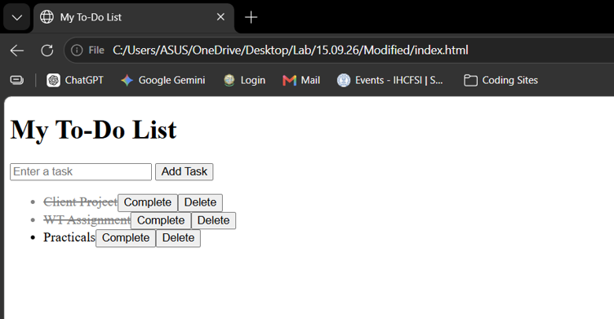
Output Analysis | The To-Do List application is displayed successfully in the browser. The user can enter a task and add it to the list. The Complete button marks a task as completed by applying the completed style, while the Delete button removes the selected task from the list. The output demonstrates successful use of JavaScript DOM manipulation for dynamically adding, completing, and deleting tasks.
Link of student Github profile where lab assignment has been uploaded | https://github.com/codewithashish-byte
Conclusion | Thus, a functional To-Do List application was successfully developed using HTML and Vanilla JavaScript. DOM methods were used to dynamically create, modify, and remove elements, and the application successfully performs the required task operations.
Plag Report (Similarity index < 12%) | The assignment was prepared by referring to the concepts and practical instructions provided for this experiment. The code was written and implemented for the practical, and the content was presented in my own words. The plagiarism/similarity check was considered while preparing the assignment.
Date | 15/09/2026

