To be a preferred hub for nurturing computer engineering aspirants through innovative, ethical, value-based technical education, impactful research, and industry collaboration, to become successful professionals contributing for the betterment of society.
Mission Statement of the Department.
To nurture computer engineering professionals by offering Dynamic learning environment that encourages problem-solving using emerging technology, National Education Policy aligned evidence-based technical education, fostering ,innovation, research, and industry–institute collaboration & Holistic, ethical and sustainable development for lifelong success.

Session 2026-2027

Vision:Dream of where you want. | Mission: Means to achieve Vision

Program Educational Objectives of the program (PEO): (broad statements that describe the professional and career accomplishments)
PEO1 | Preparation | P: Preparation | Pep-CL abbreviation pronounce as Pep-si-lL easy to recall
PEO2 | Core Competence | E: Environment  (Learning Environment) | Pep-CL abbreviation pronounce as Pep-si-lL easy to recall
PEO3 | Breadth | P: Professionalism | Pep-CL abbreviation pronounce as Pep-si-lL easy to recall
PEO4 | Professionalism | C: Core Competence | Pep-CL abbreviation pronounce as Pep-si-lL easy to recall
PEO5 | Learning  Environment | L: Breadth (Learning in diverse areas) | Pep-CL abbreviation pronounce as Pep-si-lL easy to recall

Program Outcomes (PO): (statements that describe what a student should be able to do and know by the end of a program)
Keywords of POs:
Engineering knowledge,Problem analysis, Design/development of solutions,Conduct Investigations of Complex Problems, Engineering Tool Usage, The Engineer and The World,Ethics, Individual and Collaborative Team work,Communication, Project Management and Finance, Life-Long Learning

PSO Keywords: Cutting edge technologies, Research

“I am an engineer, and I know how to apply engineering knowledge to investigate, analyse and design solutions to complex problems using tools for entire world following all ethics in a collaborative way with proper management skills throughout my life.” to contribute to the development of cutting-edge technologies and Research.

Integrity: I will adhere to the Laboratory Code of Conduct and ethics in its entirety.

Name and Signature of Student and Date
(Signature and Date in Handwritten)

Name: Ashish Shriram Waghare
Date: 22/09/2026

To be a preferred hub for nurturing computer engineering aspirants through innovative, ethical, value-based technical education, impactful research, and industry collaboration, to become successful professionals contributing for the betterment of society.
Mission Statement of the Department.
To nurture computer engineering professionals by offering Dynamic learning environment that encourages problem-solving using emerging technology, National Education Policy aligned evidence-based technical education, fostering ,innovation, research, and industry–institute collaboration & Holistic, ethical and sustainable development for lifelong success.

Session | 2024-25 (ODD) | Course Name | Web Technology Lab
Semester | 3 | Course Code | 23CT1301
Roll No | 45 | Name of Student | Ashish Shriram Waghare

Practical Number | 5
Course Outcome | - Understand various internet technologies.  - Design the web pages using HTML and CSS.  - Implement the XML technology to store the data.  - Develop the interactive web pages using JavaScript.
Aim | To develop an interactive calculator using HTML, CSS, and JavaScript and implement event handling for button clicks and keyboard input to perform basic arithmetic operations.
Problem Definition | To build an interactive calculator that accepts numbers through buttons and keyboard input, performs addition, subtraction, multiplication, and division, dynamically displays the result, and provides a Clear function using JavaScript event handling and DOM manipulation.
Theory  (100 words) | An event in JavaScript is an action that occurs on a webpage, such as a mouse click or keyboard key press. Event handling allows JavaScript to respond to these actions and perform specific operations. In this practical, addEventListener() is used to detect click and keyboard events. The calculator uses DOM methods such as getElementById() to access elements and .value to update the display. Functions are used to perform reusable operations such as adding numbers, setting operators, calculating results, and clearing the display. Conditional statements select the required arithmetic operation, while Number() converts input text into numerical values.
Procedure and Execution  (100 Words) | Step for Implementation  - Create a project folder named Calculator.  - Create index.html, style.css, and script.js.  - Design the calculator layout using HTML.  - Add buttons for numbers and arithmetic operators.  - Create a display box using an input element.  - Style the calculator using CSS.  - Access calculator elements using getElementById().  - Add click events using addEventListener().  - Implement calculations using JavaScript functions and operators.  - Add keyboard input and Clear functionality, then test the calculator.
To be a preferred hub for nurturing computer engineering aspirants through innovative, ethical, value-based technical education, impactful research, and industry collaboration, to become successful professionals contributing for the betterment of society.
Mission Statement of the Department.
To nurture computer engineering professionals by offering Dynamic learning environment that encourages problem-solving using emerging technology, National Education Policy aligned evidence-based technical education, fostering ,innovation, research, and industry–institute collaboration & Holistic, ethical and sustainable development for lifelong success.
Code:
Index.html:-
<!DOCTYPE html>
<html lang="en">

<head>
<title>My Calculator</title>
<link rel="stylesheet" href="style.css">
</head>

<body>

<h1>My Calculator</h1>

<!-- Expression shown above the answer -->
<div id="expression"></div>

<!-- Calculator display -->
<input type="text" id="display" readonly>

<div>
<button id="seven">7</button>
<button id="eight">8</button>
<button id="nine">9</button>
<button id="divide">/</button>
</div>

<div>
<button id="four">4</button>
<button id="five">5</button>
<button id="six">6</button>
<button id="multiply">*</button>
</div>

<div>
<button id="one">1</button>
<button id="two">2</button>
<button id="three">3</button>
<button id="subtract">-</button>
</div>

<div>
<button id="clear">C</button>
<button id="zero">0</button>
<button id="equals">=</button>
<button id="add">+</button>
</div>

<script src="script.js"></script>

</body>

</html>
style.css:-
body {
text-align: center;
font-family: Arial;
}

h1 {
margin-bottom: 20px;
}

#expression {
width: 220px;
height: 25px;
font-size: 18px;
text-align: right;
margin: 0 auto;
}

#display {
width: 220px;
height: 40px;
font-size: 25px;
text-align: right;
margin-bottom: 10px;
}

button {
width: 50px;
height: 50px;
margin: 3px;
font-size: 20px;
}
script.js:-
let display = document.getElementById("display");
let expression = document.getElementById("expression");

let firstNumber = "";
let operator = "";

/* Add numbers to display */

function addNumber(number) {
display.value += number;
}

/* Store operator */

function setOperator(op) {

firstNumber = display.value;
operator = op;

expression.textContent = firstNumber + " " + operator;

display.value = "";
}

/* Calculate result */

function calculate() {

let secondNumber = display.value;
let result;

if (operator == "+") {
result = Number(firstNumber) + Number(secondNumber);
}

else if (operator == "-") {
result = Number(firstNumber) - Number(secondNumber);
}

else if (operator == "*") {
result = Number(firstNumber) * Number(secondNumber);
}

else if (operator == "/") {
result = Number(firstNumber) / Number(secondNumber);
}

expression.textContent =
firstNumber + " " + operator + " " + secondNumber + " =";

display.value = result;
}

/* Clear calculator */

function clearDisplay() {

display.value = "";
expression.textContent = "";
firstNumber = "";
operator = "";
}

/* Number buttons */

document.getElementById("seven").addEventListener("click", function() {
addNumber(7);
});

document.getElementById("eight").addEventListener("click", function() {
addNumber(8);
});

document.getElementById("nine").addEventListener("click", function() {
addNumber(9);
});

document.getElementById("four").addEventListener("click", function() {
addNumber(4);
});

document.getElementById("five").addEventListener("click", function() {
addNumber(5);
});

document.getElementById("six").addEventListener("click", function() {
addNumber(6);
});

document.getElementById("one").addEventListener("click", function() {
addNumber(1);
});

document.getElementById("two").addEventListener("click", function() {
addNumber(2);
});

document.getElementById("three").addEventListener("click", function() {
addNumber(3);
});

document.getElementById("zero").addEventListener("click", function() {
addNumber(0);
});

/* Operator buttons */

document.getElementById("add").addEventListener("click", function() {
setOperator("+");
});

document.getElementById("subtract").addEventListener("click", function() {
setOperator("-");
});

document.getElementById("multiply").addEventListener("click", function() {
setOperator("*");
});

document.getElementById("divide").addEventListener("click", function() {
setOperator("/");
});

/* Equal button */

document.getElementById("equals").addEventListener("click", function() {
calculate();
});

/* Clear button */

document.getElementById("clear").addEventListener("click", function() {
clearDisplay();
});

/* Keyboard events */

document.addEventListener("keydown", function(event) {

if (event.key >= "0" && event.key <= "9") {
addNumber(event.key);
}

if (event.key == "Enter") {
calculate();
}

if (event.key == "Escape") {
clearDisplay();
}

if (event.key == "+") {
setOperator("+");
}

if (event.key == "-") {
setOperator("-");
}

if (event.key == "*") {
setOperator("*");
}

if (event.key == "/") {
setOperator("/");
}

});
Output:
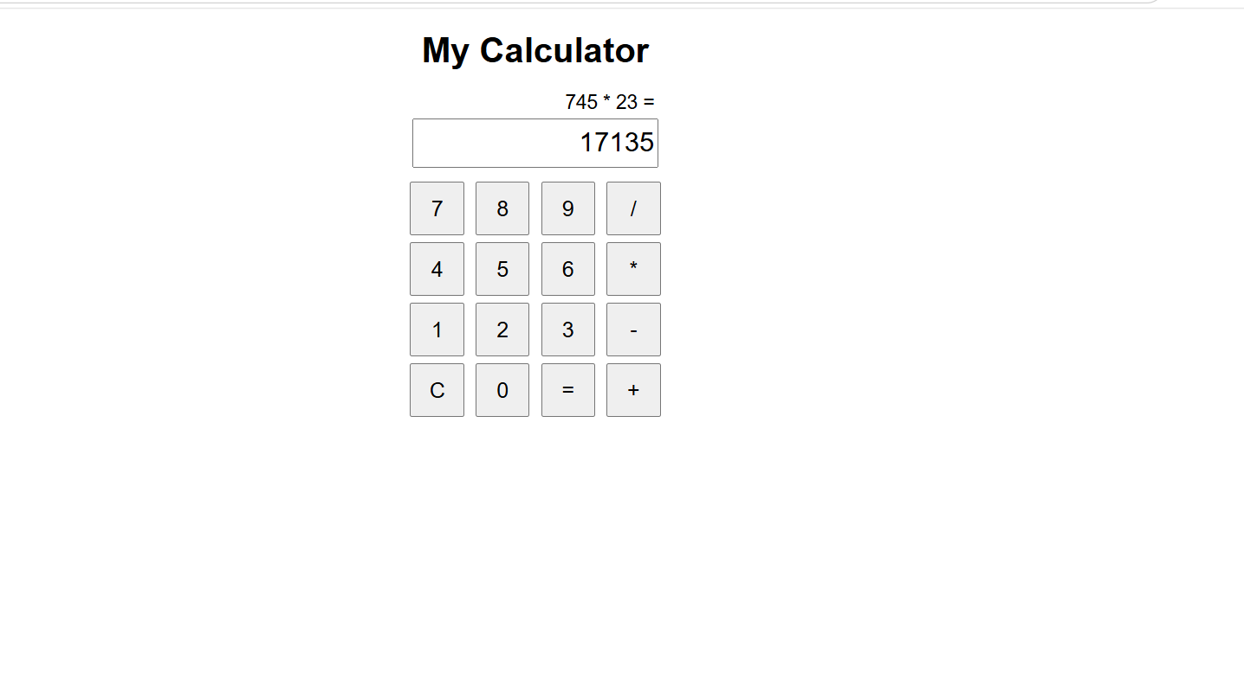

Output Analysis | The calculator is displayed successfully with number buttons, arithmetic operators, a Clear button, and an output display. In the shown output, the expression 745 × 23 is entered and the calculator correctly displays the result 17135. This confirms that the calculator performs arithmetic operations and updates the display correctly.
Link of student Github profile where lab assignment has been uploaded | https://github.com/codewithashish-byte
Conclusion | Thus, an interactive calculator was successfully developed using HTML, CSS, and JavaScript. JavaScript event handling was used to process user inputs, perform arithmetic calculations, and display the result dynamically.
Plag Report (Similarity index < 12%) | The practical was prepared using the concepts and implementation instructions provided for the experiment. The code and written content were implemented and presented in the required format. The work was reviewed to avoid unnecessary copying from external sources.
Date | 22/09/2026

