To be a preferred hub for nurturing computer engineering aspirants through innovative, ethical, value-based technical education, impactful research, and industry collaboration, to become successful professionals contributing for the betterment of society.
Mission Statement of the Department.
To nurture computer engineering professionals by offering Dynamic learning environment that encourages problem-solving using emerging technology, National Education Policy aligned evidence-based technical education, fostering ,innovation, research, and industry–institute collaboration & Holistic, ethical and sustainable development for lifelong success.

Session 2026-2027

Vision:Dream of where you want. | Mission: Means to achieve Vision

Program Educational Objectives of the program (PEO): (broad statements that describe the professional and career accomplishments)
PEO1 | Preparation | P: Preparation | Pep-CL abbreviation pronounce as Pep-si-lL easy to recall
PEO2 | Core Competence | E: Environment  (Learning Environment) | Pep-CL abbreviation pronounce as Pep-si-lL easy to recall
PEO3 | Breadth | P: Professionalism | Pep-CL abbreviation pronounce as Pep-si-lL easy to recall
PEO4 | Professionalism | C: Core Competence | Pep-CL abbreviation pronounce as Pep-si-lL easy to recall
PEO5 | Learning  Environment | L: Breadth (Learning in diverse areas) | Pep-CL abbreviation pronounce as Pep-si-lL easy to recall

Program Outcomes (PO): (statements that describe what a student should be able to do and know by the end of a program)
Keywords of POs:
Engineering knowledge,Problem analysis, Design/development of solutions,Conduct Investigations of Complex Problems, Engineering Tool Usage, The Engineer and The World,Ethics, Individual and Collaborative Team work,Communication, Project Management and Finance, Life-Long Learning

PSO Keywords: Cutting edge technologies, Research

“I am an engineer, and I know how to apply engineering knowledge to investigate, analyse and design solutions to complex problems using tools for entire world following all ethics in a collaborative way with proper management skills throughout my life.” to contribute to the development of cutting-edge technologies and Research.

Integrity: I will adhere to the Laboratory Code of Conduct and ethics in its entirety.

Name and Signature of Student and Date
(Signature and Date in Handwritten)

Name: Ashish Shriram Waghare
Date: 14/07/2026

To be a preferred hub for nurturing computer engineering aspirants through innovative, ethical, value-based technical education, impactful research, and industry collaboration, to become successful professionals contributing for the betterment of society.
Mission Statement of the Department.
To nurture computer engineering professionals by offering Dynamic learning environment that encourages problem-solving using emerging technology, National Education Policy aligned evidence-based technical education, fostering ,innovation, research, and industry–institute collaboration & Holistic, ethical and sustainable development for lifelong success.

Session | 2024-25 (ODD) | Course Name | Web Technology Lab
Semester | 3 | Course Code | 23CT1301
Roll No | 45 | Name of Student | Ashish Shriram Waghare

Practical Number | 1(B )
Course Outcome | - Understand various internet technologies.  - Design the web pages using HTML and CSS.  - Implement the XML technology to store the data.  - Develop the interactive web pages using JavaScript.
Aim | To study important HTML tags and implement a simple web page using the basic HTML document structure, including the DOCTYPE declaration, html, head, title, body, heading, and paragraph elements.
Problem Definition | To understand the role of fundamental HTML elements and use them to create a basic, properly structured web page that can be interpreted and displayed by a web browser.
Theory  (100 words) | HTML stands for HyperText Markup Language and is used to structure web pages. A basic HTML document contains a DOCTYPE declaration, the html root element, a head section, a title, and a body section. The head stores document information that is not directly displayed, while the body contains visible webpage content. Heading and paragraph tags present text in a browser. HTML5 extends HTML with semantic elements, improved forms, canvas, audio and video, geolocation, and drag-and-drop. HTML5 also supports a simple DOCTYPE declaration and UTF-8 character encoding.
Procedure and Execution  (100 Words) | Step for Implementation:  1. Open a text editor and create a file with the .html extension.  2. Add the DOCTYPE declaration and html root element.  3. Create the head section and specify a title.  4. Add the body section with a heading and paragraph.  5. Save the file and open it in a web browser.  6. Observe the rendered content and verify the HTML structure.
To be a preferred hub for nurturing computer engineering aspirants through innovative, ethical, value-based technical education, impactful research, and industry collaboration, to become successful professionals contributing for the betterment of society.
Mission Statement of the Department.
To nurture computer engineering professionals by offering Dynamic learning environment that encourages problem-solving using emerging technology, National Education Policy aligned evidence-based technical education, fostering ,innovation, research, and industry–institute collaboration & Holistic, ethical and sustainable development for lifelong success.
Code:
<!DOCTYPE html>
<html>
<head>
<meta charset="UTF-8">
<title>My Web Page</title>
</head>
<body>
<h1>Welcome to Web Technology</h1>
<p>This is a basic HTML web page.</p>
</body>
</html>
Output:

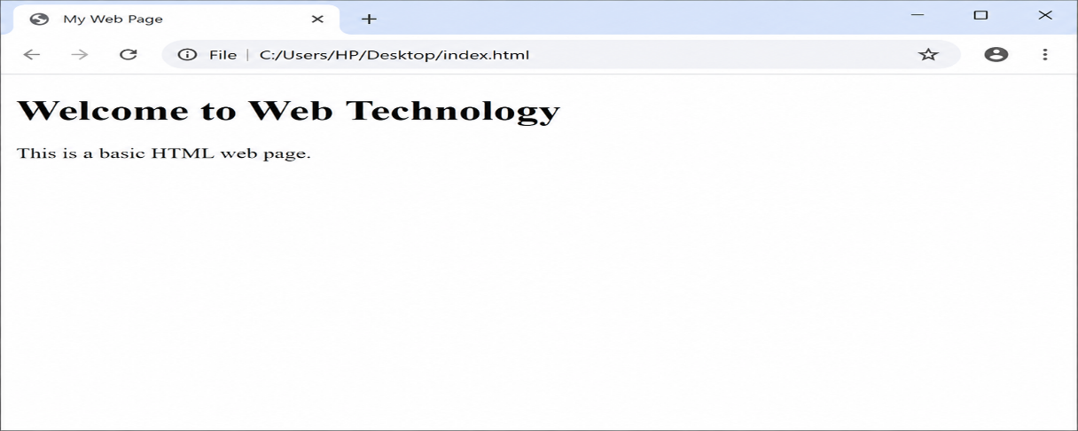
Output Analysis | - The implemented page demonstrates the basic HTML structure described in the theory.  - The DOCTYPE identifies the document as HTML, the html element forms the root, the head contains metadata and the page title, and the body holds visible content.  - The h1 and p elements render the heading and paragraph in the browser.
Link of student Github profile where lab assignment has been uploaded | https://github.com/codewithashish-byte
Conclusion | A basic HTML web page was successfully implemented using the essential document structure and fundamental tags. The practical helped in understanding how HTML elements organize content for display in a web browser.
Plag Report (Similarity index < 12%) | Not generated / not supplied
Date | 14/08/2026

