To be a preferred hub for nurturing computer engineering aspirants through innovative, ethical, value-based technical education, impactful research, and industry collaboration, to become successful professionals contributing for the betterment of society.
Mission Statement of the Department.
To nurture computer engineering professionals by offering Dynamic learning environment that encourages problem-solving using emerging technology, National Education Policy aligned evidence-based technical education, fostering ,innovation, research, and industry–institute collaboration & Holistic, ethical and sustainable development for lifelong success.

Session 2026-2027

Vision:Dream of where you want. | Mission: Means to achieve Vision

Program Educational Objectives of the program (PEO): (broad statements that describe the professional and career accomplishments)
PEO1 | Preparation | P: Preparation | Pep-CL abbreviation pronounce as Pep-si-lL easy to recall
PEO2 | Core Competence | E: Environment  (Learning Environment) | Pep-CL abbreviation pronounce as Pep-si-lL easy to recall
PEO3 | Breadth | P: Professionalism | Pep-CL abbreviation pronounce as Pep-si-lL easy to recall
PEO4 | Professionalism | C: Core Competence | Pep-CL abbreviation pronounce as Pep-si-lL easy to recall
PEO5 | Learning  Environment | L: Breadth (Learning in diverse areas) | Pep-CL abbreviation pronounce as Pep-si-lL easy to recall

Program Outcomes (PO): (statements that describe what a student should be able to do and know by the end of a program)
Keywords of POs:
Engineering knowledge,Problem analysis, Design/development of solutions,Conduct Investigations of Complex Problems, Engineering Tool Usage, The Engineer and The World,Ethics, Individual and Collaborative Team work,Communication, Project Management and Finance, Life-Long Learning

PSO Keywords: Cutting edge technologies, Research

“I am an engineer, and I know how to apply engineering knowledge to investigate, analyse and design solutions to complex problems using tools for entire world following all ethics in a collaborative way with proper management skills throughout my life.” to contribute to the development of cutting-edge technologies and Research.

Integrity: I will adhere to the Laboratory Code of Conduct and ethics in its entirety.

Name and Signature of Student and Date
(Signature and Date in Handwritten)

Name: Ashish Shriram Waghare
Date: 21/07/2026

To be a preferred hub for nurturing computer engineering aspirants through innovative, ethical, value-based technical education, impactful research, and industry collaboration, to become successful professionals contributing for the betterment of society.
Mission Statement of the Department.
To nurture computer engineering professionals by offering Dynamic learning environment that encourages problem-solving using emerging technology, National Education Policy aligned evidence-based technical education, fostering ,innovation, research, and industry–institute collaboration & Holistic, ethical and sustainable development for lifelong success.

Session | 2024-25 (ODD) | Course Name | Web Technology Lab
Semester | 3 | Course Code | 23CT1301
Roll No | 45 | Name of Student | Ashish Shriram Waghare

Practical Number | 2
Course Outcome | - Understand various internet technologies.  - Design the web pages using HTML and CSS.  - Implement the XML technology to store the data.  - Develop the interactive web pages using JavaScript.
Aim | To create a student registration form using HTML tags and different form controls for collecting student information such as personal details, contact information, course, hobbies, photograph, and password.
Problem Definition | To design a simple and user-friendly HTML registration form that uses suitable form elements such as text fields, date input, radio buttons, checkboxes, a drop-down list, file upload, textarea, and submit/reset controls.
Theory  (100 words) | An HTML form provides a structured way to collect information from a user. The form can contain labels and input controls for different types of data. Text inputs can collect names, email and mobile details, while a date control can collect date of birth. Radio buttons allow one gender choice, and checkboxes allow hobbies or skills to be selected. A textarea is used for an address, while select and option create a course list. A file input can be used for a photograph.  Password input provides a password field, and submit and reset controls complete the form interaction described in the practical.
Procedure and Execution  (100 Words) | Step for Implementation:  1. Open a text editor such as Visual Studio Code and create an HTML file. 2. Write the basic html, head, title and body structure.  3. Add a heading and form element.  4. Insert labels and controls for name, date of birth, gender,  email, mobile, address and password.  5. Add radio buttons, checkboxes and a course drop-down list.  6. Add a photo upload control and Register/Clear buttons.  7. Save the file and open it in a browser.  8. Verify that all form elements are displayed correctly.
To be a preferred hub for nurturing computer engineering aspirants through innovative, ethical, value-based technical education, impactful research, and industry collaboration, to become successful professionals contributing for the betterment of society.
Mission Statement of the Department.
To nurture computer engineering professionals by offering Dynamic learning environment that encourages problem-solving using emerging technology, National Education Policy aligned evidence-based technical education, fostering ,innovation, research, and industry–institute collaboration & Holistic, ethical and sustainable development for lifelong success.
Code:
<!DOCTYPE html>
<html>
<head>
<title>Student Registration Form</title>
</head>
<body>
<h1>Student Registration Form</h1>
<form>

Name: <br>
<input type="text" id="fname">
<br><br>

LastName: <br>
<input type="text" id="lname">
<br><br>

Email: <br>
<input type="email" id="email">
<br><br>

Password: <br>
<input type="password" id="password">
<br><br>

Phone Number: <br>
<input type="text" id="phone">
<br><br>

<button type="submit">Submit</button>
<button type="reset">Reset</button>

</form>

</body>
</html>
Output:
A centered “Student Registration Form” heading is displayed with fields for student details. The form contains text/date/email/mobile inputs, gender radio buttons, an address textarea, course drop-down, hobby checkboxes, photo upload, password field, and Register/Clear buttons.

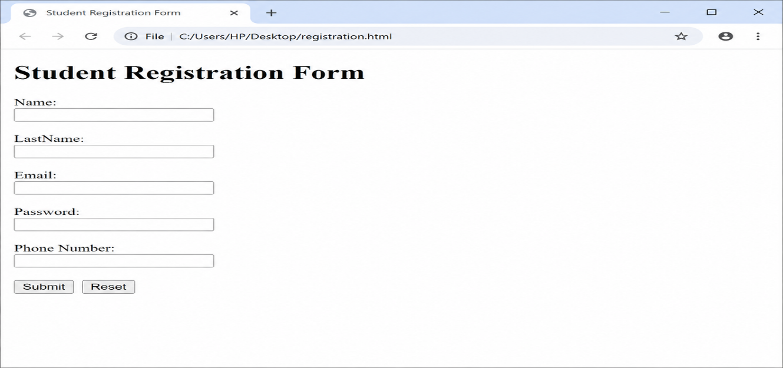
Output Analysis | The form uses multiple HTML controls for different types of student information. Radio buttons provide a single gender selection, checkboxes allow multiple hobbies, and the select element provides a course choice. The file, password, textarea, submit and reset controls demonstrate the different form elements specified in the practical.
Link of student Github profile where lab assignment has been uploaded | https://github.com/codewithashish-byte
Conclusion | The student registration form was successfully designed using HTML tags and form controls. The practical demonstrated how different input elements can be combined to collect student information.
Plag Report (Similarity index < 12%) | Not generated / not supplied
Date | 21/07/2026

