TEST CASE REPORT
Module Name: Zepto login
Test Case ID: TC_ZEP_001
Webpage URL: Zepto app/website
Tester Name: Ashish
· Scenario ID: SC001
Scenario: User Login with Valid Mobile Number
Test Steps:
1. Open Zepto app/website
2. Click 'Login'
3. Enter registered mobile number
4. Enter valid OTP
Screenshots:
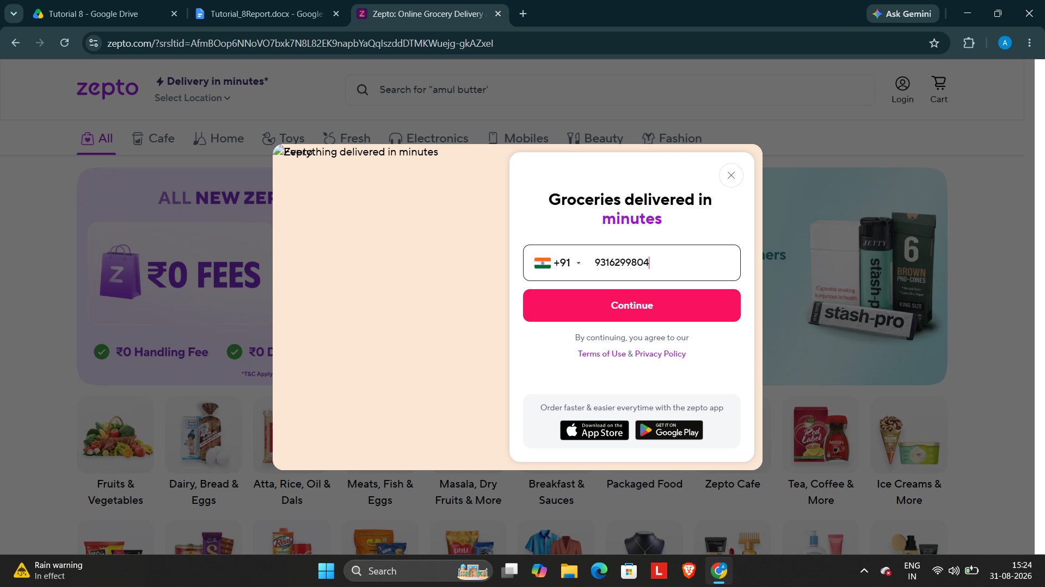

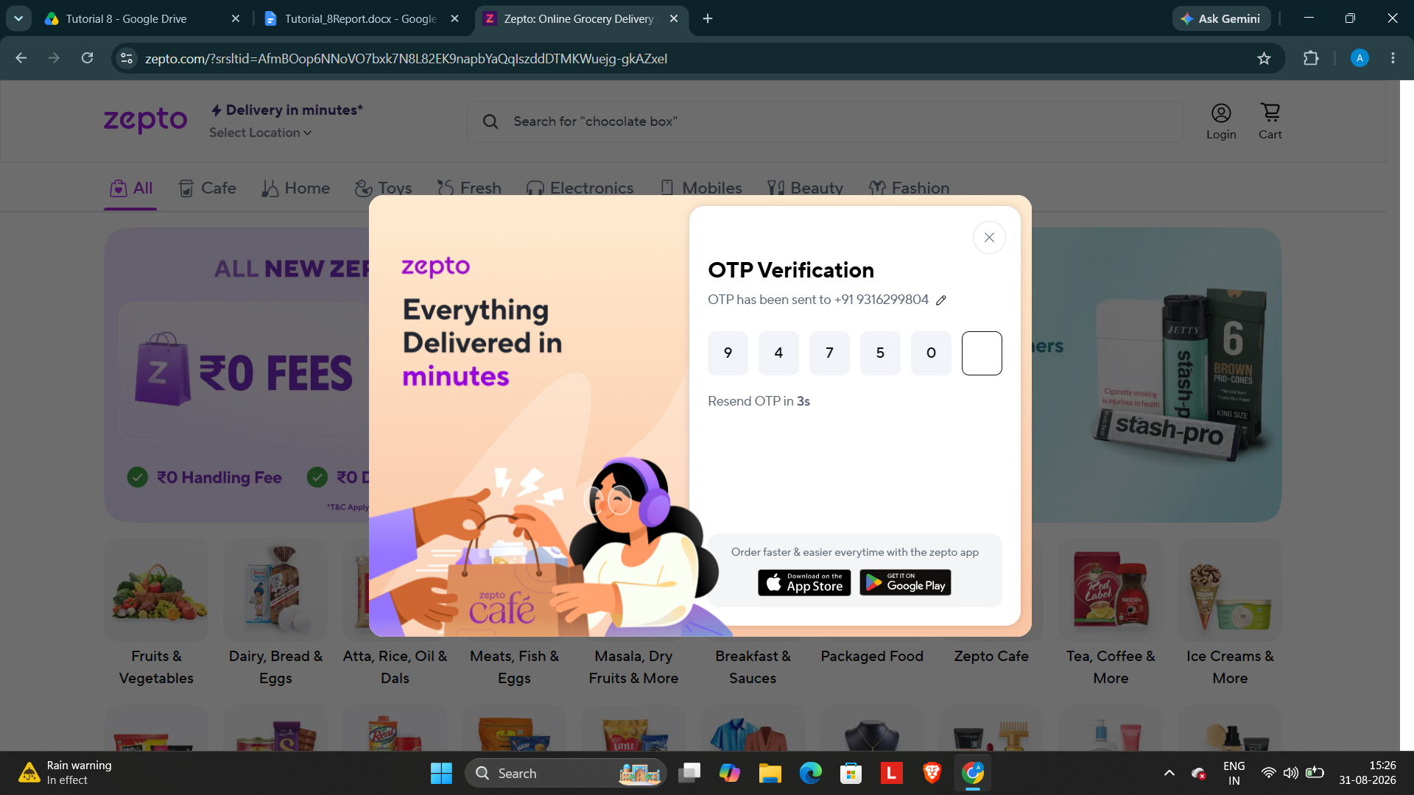

· Scenario ID: SC002
Scenario: Search for a charger
Test Steps:
1. Tap the search bar
2. Enter 'Charger'
3. Tap Search
Screenshots:

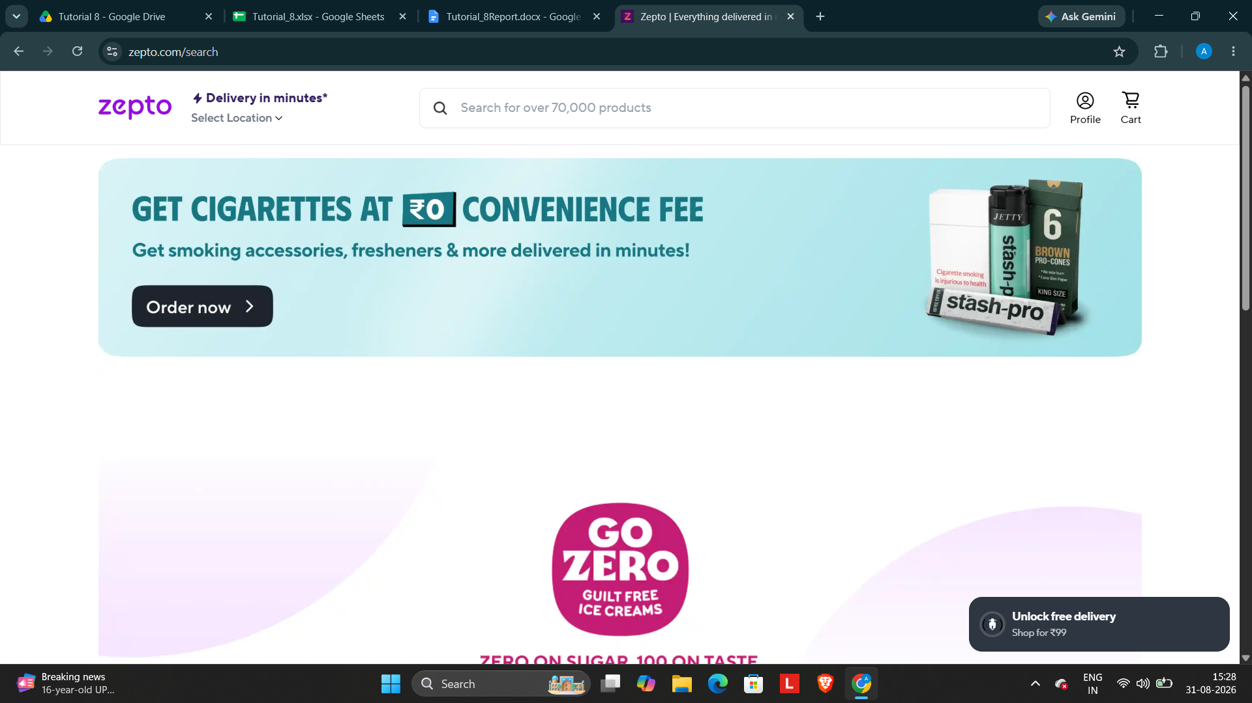

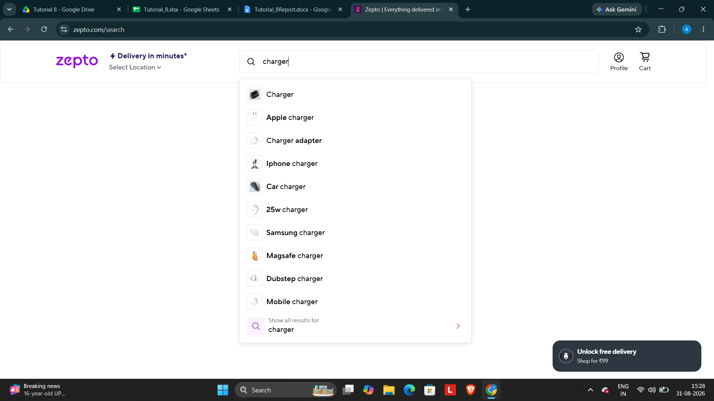

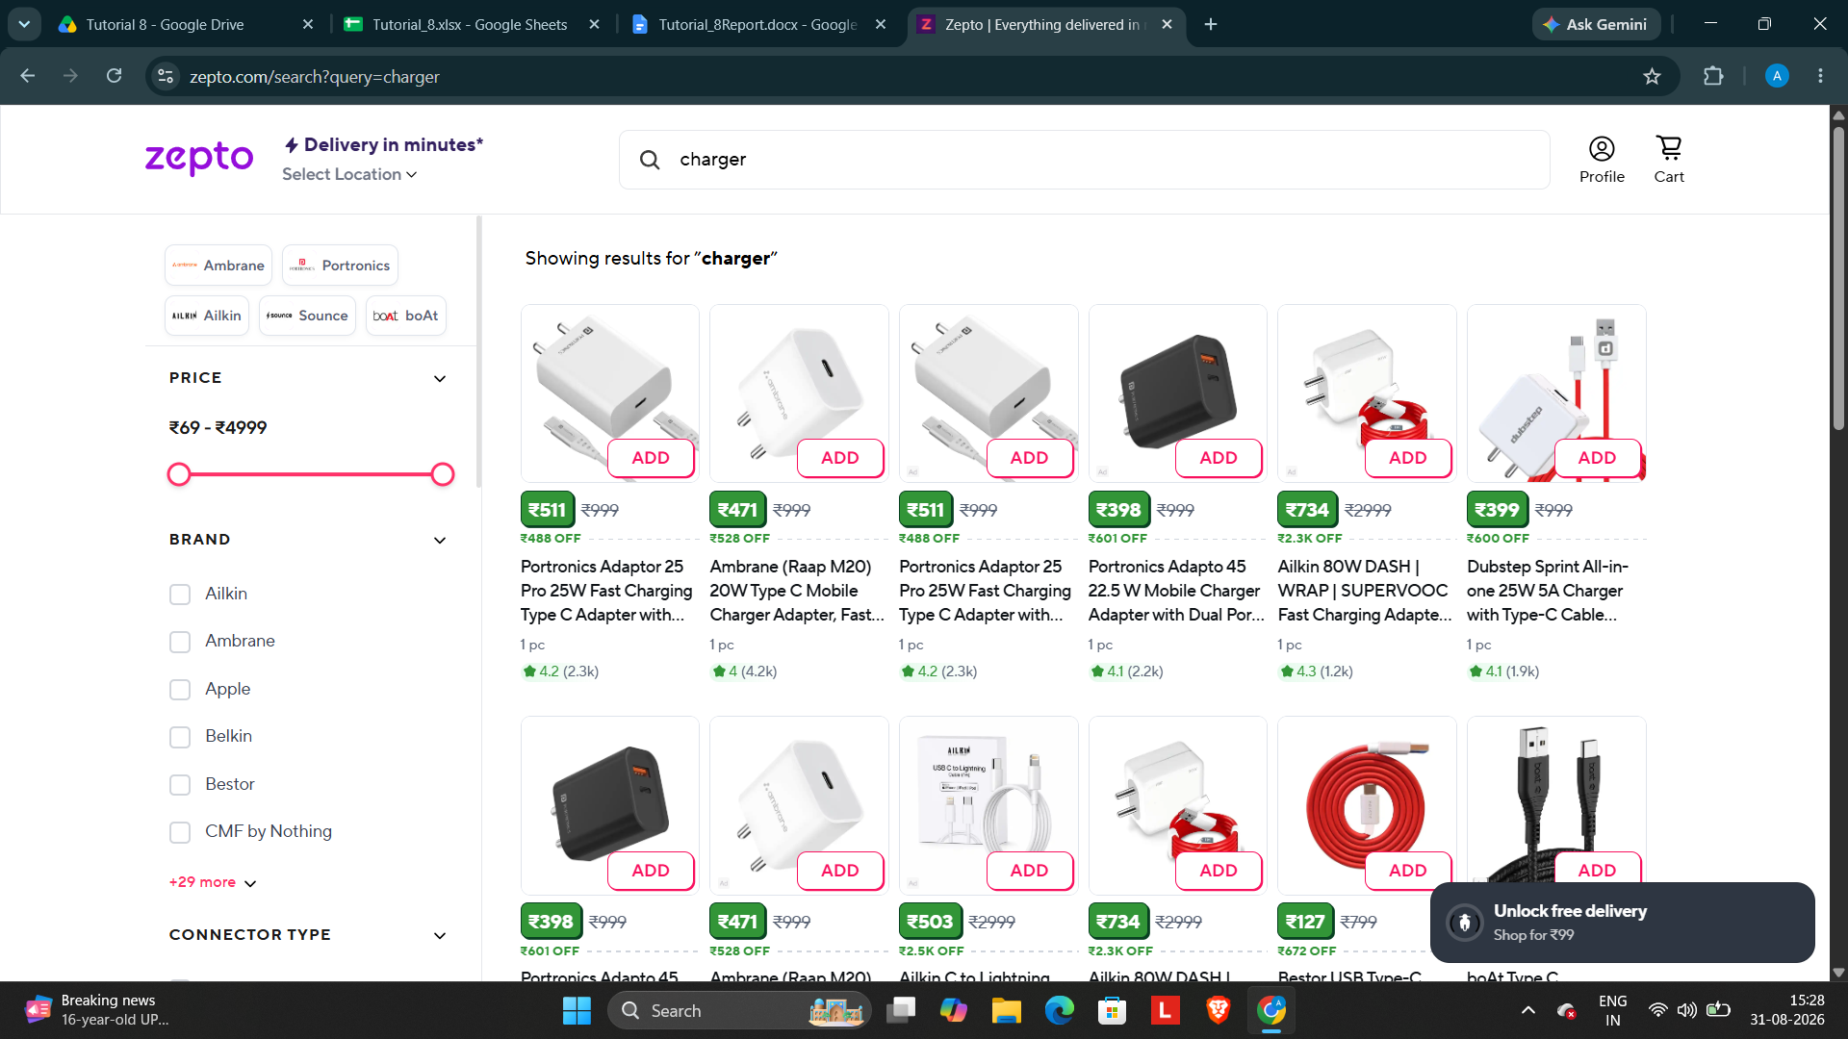

· Scenario ID: SC003
Scenario: Apply Brand Filter
Test Steps:
1. Search for charger
2. Tap 'Filter'
3. Select Brand: Samsung
4. Tap 'Apply'
Screenshots:

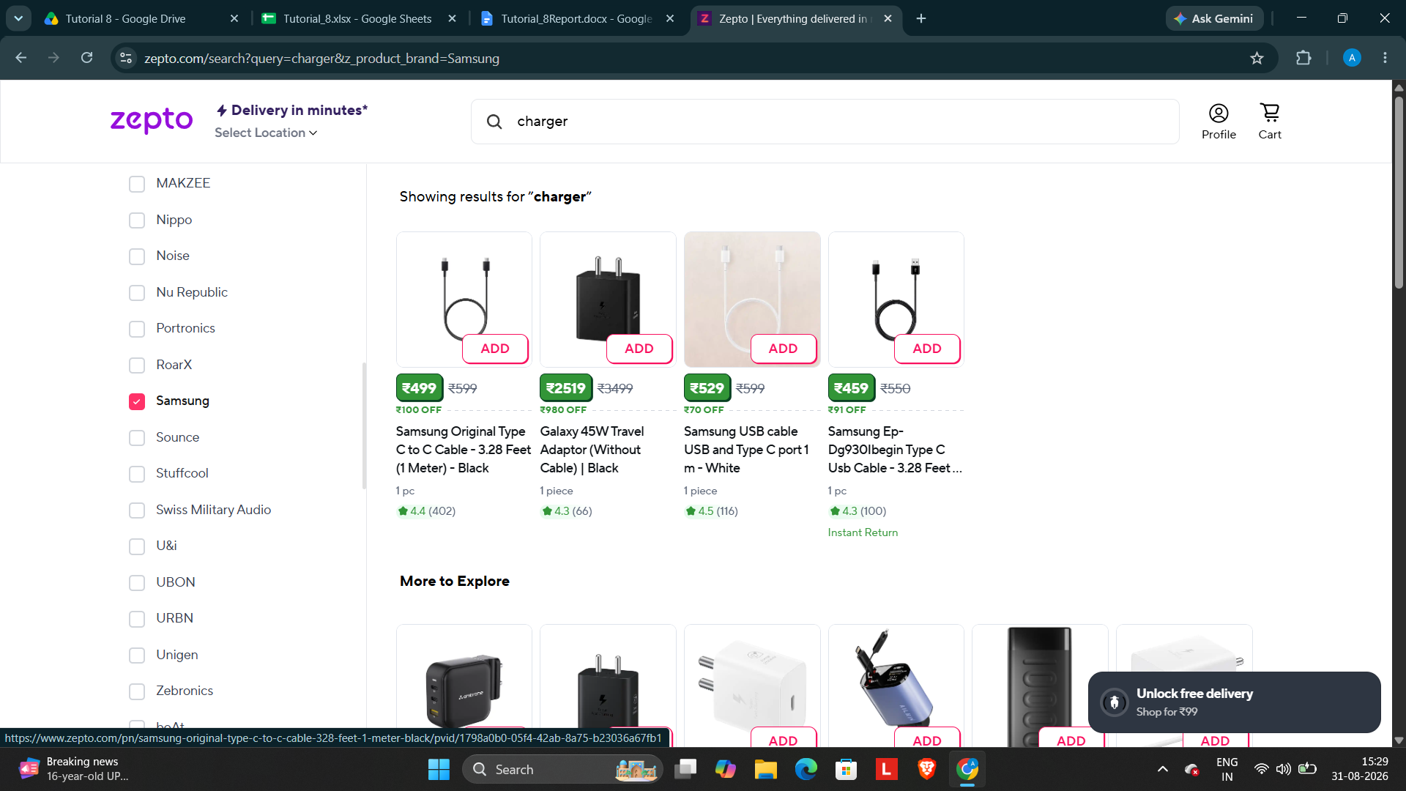

· Scenario ID: SC004
Scenario: View Product Details
Test Steps:
1. Open a product from search results
2. Verify product name, image, price and description
3. Check product details
Screenshots:

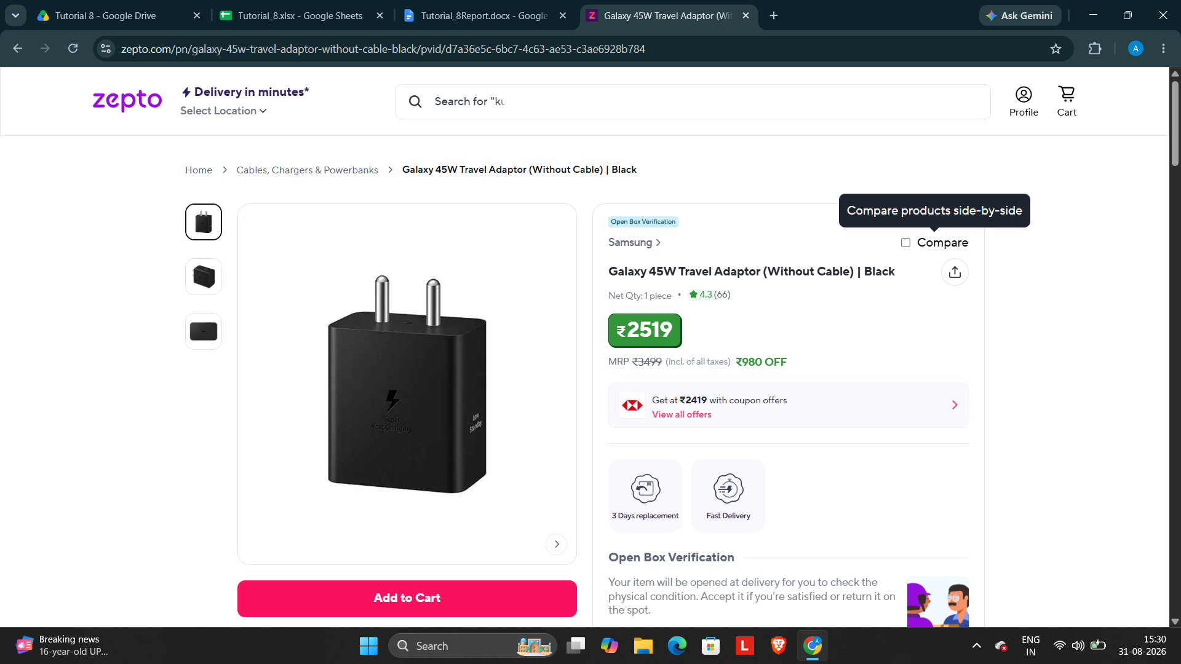

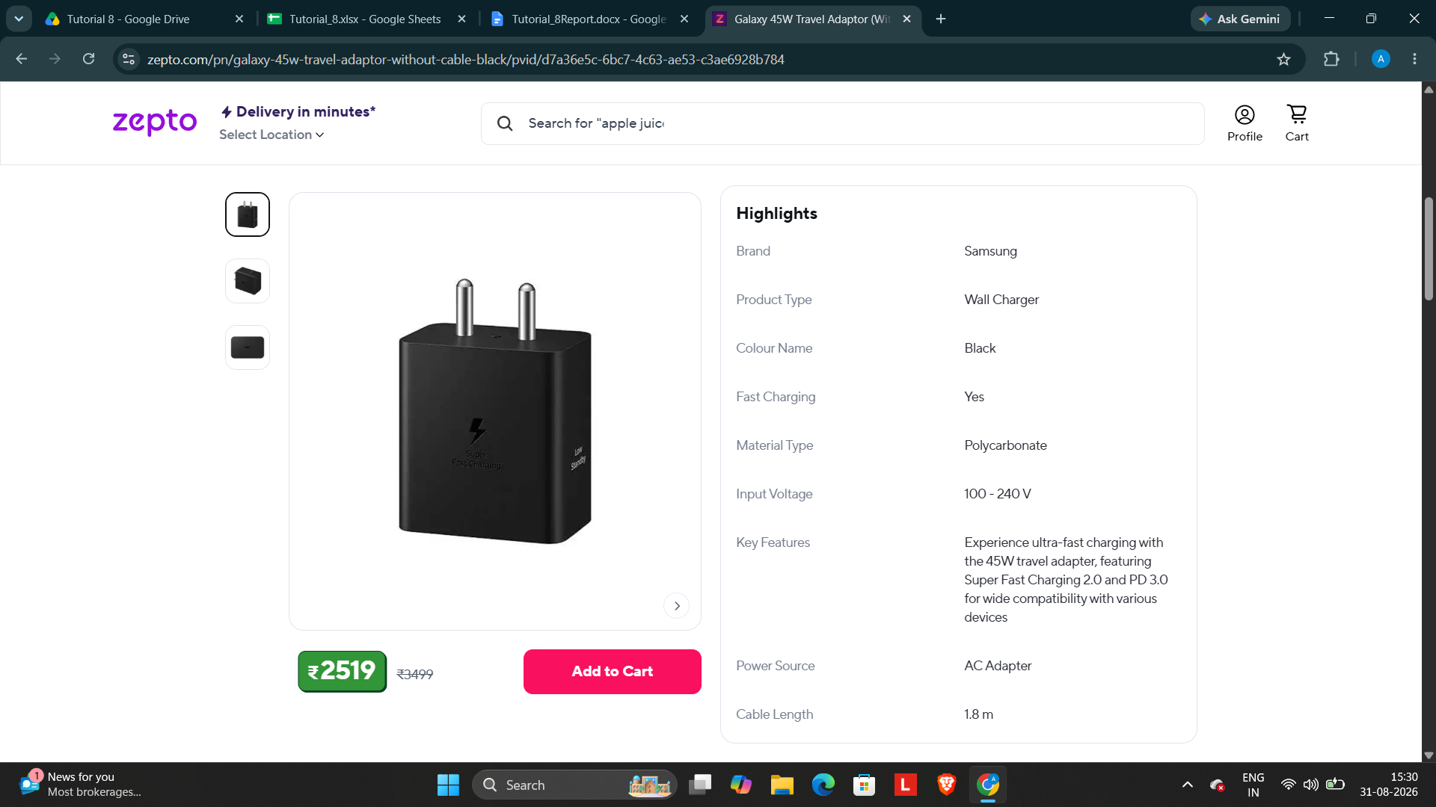

· Scenario ID: SC005
Scenario: Add Product to Cart
Test Steps:
1. Open a product
2. Click 'Add to Cart'
3. Open Cart
Screenshots:
