Lexi
AI-Powered English Vocabulary Learning Through Reading
Technical design, requirements and evaluation plan
Deliverables: technology comparison, requirements, system context, use cases, component architecture, UX prototype scope, verification and evaluation plan.
Prepared by: Student 2
Project: Lexi (Akbota Karimolda and Kamila Melsova)
Version: draft for Pre-Defense , October 12, 2026

1. Introduction and scope
Lexi is an AI-powered mobile application for learning English vocabulary through reading. The user reads articles from a built-in library or adds their own material by pasting text or uploading a PDF, highlights unknown words and phrases, and receives AI-generated notes: translation, a simple explanation, the meaning in the context of the text, and two example sentences. Saved words are practised with flashcards, fill-in-the-blank tasks and word matching, scheduled by spaced repetition.
This document contains the technical design deliverables of the project: technology comparison, functional and non-functional requirements with acceptance criteria, the architecture (system context, use cases and components), the UX prototype scope, and the verification and evaluation plan. The prototype screens are provided in a Lexi_app_screens.pdf.

1.1 Key design decisions and system limits
The following limits were derived from technical constraints (device performance, free-tier quotas, privacy). They are initial values and will be tuned after pilot testing.
Parameter | Value and reason
PDF input | Up to 10 MB and up to 30 pages. Both limits apply, because a long document can be very small in size. Larger files are rejected and not stored.
Text per lesson | Up to 100,000 characters after extraction or pasting. Excess text is marked red and must be removed by the user.
Reader part size | About 5,000 characters per part ("Part 2 of 14"), for smooth reading and highlighting.
Selected items per lesson | Up to 50 words or phrases. The AI receives items in batches of 10.
Daily AI limit | 150 words or phrases per user per day (protects the free AI quota).
Data sent to the AI | Only the selected items and one surrounding sentence for each. The full text and the PDF are never sent.
PDF storage | Temporary only: the file is deleted after text extraction. Scanned PDFs without text layer are not supported (no OCR).
Languages | Interface and translation language: Kazakh (KZ), English (EN), Russian (RU), selected separately.
Highlight colours | Five colours (yellow by default), selectable before highlighting.

2. Technology comparison
Each area is evaluated with a weighted scoring matrix (scores 1–5, 5 is best). The scores are the team's assessment based on the project constraints: a team with limited programming experience, a zero-cost prototype, a short development time, and the need to test on real phones. Facts about free tiers change often and must be re-checked on the provider's website before submission.

2.1 Mobile framework
Criterion | Weight | React Native + Expo | Flutter | Native (Kotlin + Swift)
Learning curve for beginners | 20 | 4 | 3 | 2
Testing on a real phone without emulator or Mac | 20 | 5 | 3 | 2
One codebase for Android and iOS | 15 | 5 | 5 | 1
WebView and text selection support | 15 | 4 | 4 | 4
Ecosystem and AI-coding assistance | 15 | 5 | 4 | 4
Runtime performance | 10 | 4 | 5 | 5
Cost | 5 | 5 | 5 | 5
Weighted score (max 5.00) | 100 | 4.55 | 3.90 | 2.90
Decision: React Native with Expo. Expo Go lets the team run the app on a phone by scanning a QR code, including iPhones without a Mac. Flutter is a strong alternative with slightly better rendering performance; it was rejected mainly because of heavier setup (Android Studio, and a Mac for iOS builds). Risk: some libraries are not available in Expo Go; mitigation is a development build if needed.

2.2 Backend
Criterion | Weight | Supabase | Firebase | Custom Node.js server
Free tier suitable for a prototype | 20 | 4 | 3 | 3
Built-in auth, storage and server functions | 20 | 5 | 4 | 1
Relational data and SQL queries | 20 | 5 | 2 | 4
Setup time and low maintenance | 15 | 4 | 5 | 2
Per-user data protection model | 10 | 5 | 4 | 3
Portability / low vendor lock-in | 10 | 4 | 2 | 5
Documentation and community | 5 | 4 | 5 | 5
Weighted score (max 5.00) | 100 | 4.50 | 3.40 | 2.95
Decision: Supabase. It provides authentication, a PostgreSQL database, file storage and Edge Functions in one service. Free plan limits at the time of writing: 500 MB database, 50,000 monthly active users, 5 GB egress, and automatic pausing of projects after one week of inactivity. Firebase would require a billing plan for server functions (to be verified) and uses a non-relational model that fits spaced-repetition queries less well.

2.3 Database
Criterion | Weight | PostgreSQL (Supabase) | Cloud Firestore | SQLite on device only
Relational integrity and queries (lessons, words, review schedule) | 25 | 5 | 2 | 4
Cloud storage and multi-device access | 20 | 5 | 5 | 1
Row-level access control per user | 20 | 5 | 3 | 1
Free capacity for a prototype | 15 | 4 | 4 | 5
Offline use | 10 | 2 | 4 | 5
Simplicity for beginners | 10 | 4 | 4 | 5
Weighted score (max 5.00) | 100 | 4.45 | 3.50 | 3.15
Decision: PostgreSQL in Supabase with Row Level Security. Offline mode is not a requirement of the prototype; a local cache can be added later.

2.4 AI integration
Criterion | Weight | Gemini API (Flash / Flash-Lite) | OpenAI API | Claude API (Anthropic) | Self-hosted open model
Free tier for the prototype | 25 | 5 | 1 | 1 | 3
Structured JSON output | 15 | 5 | 5 | 4 | 3
Quality in KZ / RU / EN (to be validated) | 20 | 4 | 4 | 4 | 2
Latency and cost per request | 15 | 5 | 4 | 3 | 2
Privacy terms on paid tier | 10 | 3 | 4 | 4 | 5
Ease of integration | 15 | 5 | 5 | 4 | 1
Weighted score (max 5.00) | 100 | 4.60 | 3.55 | 3.10 | 2.55
Decision: Gemini API (Flash or Flash-Lite model) accessed only from a server function, so the API key is never stored in the app. No model training is needed: the AI is given a role and a strict JSON schema in the prompt. Caveats: (1) free-tier rate limits are small and change often; (2) on the free tier, submitted content may be used by the provider to improve its products, so the prototype must be tested with non-sensitive texts only; (3) Kazakh quality must be validated in a pilot test of at least 30 words. For a real release, the plan is to switch to a paid tier or provider whose terms exclude using customer data for training; the terms must be checked at that time. The AI provider is isolated behind one server function, so it can be replaced without changing the app.

2.5 Other technical decisions
Area | Chosen | Alternatives | Reason
PDF text extraction | unpdf (pdf.js-based) in an Edge Function | pdf-parse; PyMuPDF on own server; sending the PDF to the AI | Free, runs in the same backend. Sending whole PDFs to an external AI was rejected for privacy.
Reader and selection | WebView with native text selection and own toolbar | A separate pressable element for every word | Handles long text well and allows phrases (phrasal verbs, idioms) without extra code.
Highlight storage | Character offsets (start, end) + colour | Storing highlighted HTML | Compact and independent from rendering. Text is locked after confirmation so offsets stay valid.
Spaced repetition | SM-2 algorithm | Leitner boxes; FSRS | Simple, well documented, about 30 lines of code, easy to unit-test.
Localisation and theme | i18next, device colour scheme + own theme provider | Hard-coded strings | Required for KZ / EN / RU and day/night mode.
Navigation | Expo Router | React Navigation (manual) | File-based routing, less setup.
Source control and tasks | GitHub, YouTrack | — | Required by the course.
Diagrams | draw.io (.drawio + PNG) | PlantUML | Editable and easy for non-developers.

3. Requirements
Priority uses MoSCoW: Must (the prototype is not acceptable without it), Should (important, implemented if time allows), Could (optional improvement).

3.1 Functional requirements
ID | Requirement | Priority | Acceptance criteria
FR-01 | User can register and log in with email and password. | Must | A new user can register and log in; a wrong password shows an error; the session persists after restarting the app.
FR-02 | Library shows articles grouped by category, with level (CEFR) and reading time. | Must | At least 30 articles in at least 8 categories; each card shows title, level and reading time.
FR-03 | User can filter by category and sort (Newest, Oldest, Difficulty, Reading time). | Should | A chosen category shows only its articles; each sort option reorders the list correctly.
FR-04 | User can search articles by title and text. | Must | Search returns matching articles within 1 s after typing stops; no result shows an empty-state message.
FR-05 | A floating "+" button offers "Upload PDF" and "Paste text". | Must | Tapping "+" shows both options; tapping outside closes the menu.
FR-06 | User can paste text and enter a lesson title. | Must | Title is required (default: first words of the text); a character counter is shown; text above 100,000 characters is marked red.
FR-07 | User can upload a PDF; files over 10 MB or over 30 pages are rejected and not stored. | Should | A 10.1 MB file is rejected on the device; a 75-page 75 KB file is rejected by the server and nothing is stored; a 30-page file is accepted.
FR-08 | System extracts text from text-based PDFs; scanned PDFs show a clear error. | Should | Readable text for text-based test PDFs (see M4); a scanned PDF shows "We couldn't read text from this PDF" and no lesson is created.
FR-09 | Likely unwanted text (repeated headers/footers, page numbers, URLs, reference lists) is marked red; user can keep or remove each item or remove all. | Should | On a test PDF, at least 90% of repeated header/footer lines are flagged; "Remove all suggested" removes them in one tap.
FR-10 | Long text is split into parts of about 5,000 characters with Part x of y navigation. | Must | A 60,000-character text gives at least 12 parts; navigation works; highlights persist across parts.
FR-11 | After the user confirms the text, it becomes read-only. | Should | Editing is disabled after "Confirm text"; existing highlight offsets remain valid.
FR-12 | User can highlight a word or a phrase by selection, choose one of 5 colours, and remove a highlight. | Must | Single words and multi-word phrases can be highlighted; tapping a highlight allows removal; highlights are restored when the lesson is reopened.
FR-13 | A counter shows selected items against the limit of 50. | Must | The 51st item is blocked with an explanatory message.
FR-14 | "Prepare study notes" sends the selected items to the AI and returns, for each item: base form, part of speech, translation, simple explanation, meaning in context, two examples with translation, and distractors for exercises. | Must | For 10 items, a valid response with all fields is returned in at least 95% of requests; phrasal verbs and idioms are labelled as such.
FR-15 | Items are processed in batches of 10 with a progress indicator. | Should | 37 items produce 4 requests and the progress "20 / 37" is shown.
FR-16 | System enforces the daily limit (150 items per user per day). | Must | After 150 items the next request is refused with a message; the limit resets the next day.
FR-17 | Study notes screen shows one card per item with "Add to dictionary" and "Add all to dictionary". | Must | Saved items appear in the lesson in Dictionary; the button changes to "Added".
FR-18 | Dictionary lists lessons with title, date, word count and an icon by source (PDF = book, text = text icon, article = article icon). | Must | Each lesson shows the correct icon; newest lessons first by default.
FR-19 | User can search and sort lessons in Dictionary. | Should | Searching by title returns matching lessons; sorting works.
FR-20 | Opening a lesson shows its words with translation and examples; a word can be removed. | Must | Lesson content matches the saved notes; a removed word disappears from practice.
FR-21 | Practice offers Flashcards, Insert a word and Match words; the user selects which lessons to practise. | Must | Practice uses words only from the selected lessons; "Start" is disabled when none is selected.
FR-22 | Flashcards show a word in the learner's language; tapping flips the card; the user rates Don't know / Hard / Know. | Must | The card flips; each rating updates the review schedule.
FR-23 | Insert a word shows a sentence with a gap and 4 options (1 correct, 3 distractors in the same word form). | Should | Correct and incorrect answers are indicated; the correct answer is shown after an error.
FR-24 | Match words shows 5 English words and 5 translations to connect. | Should | A correct pair is fixed; a wrong pair resets after a short delay; a new round starts when all pairs are matched.
FR-25 | System schedules reviews with spaced repetition (SM-2) and shows how many words are due. | Should | Interval and ease factor follow SM-2 in unit tests; the due count is correct.
FR-26 | Practice ends with a result summary. | Could | The summary shows correct answers and difficult words.
FR-27 | Profile lets the user choose interface language and translation language (KZ / EN / RU). | Must | All screens are translated; no raw translation keys are visible.
FR-28 | Profile lets the user choose Day or Night mode. | Should | The theme changes immediately, including the reader.
FR-29 | Profile contains daily goal, reminders and reading text size. | Could | Settings persist; a reminder is delivered at the chosen time.
FR-30 | Profile shows statistics: words, lessons, day streak. | Could | Values match the stored data.
FR-31 | User can delete the account and all personal data. | Should | After deletion no lessons, words or highlights of the user remain.
FR-32 | Before the first AI request the app shows a consent notice about the data sent to the AI. | Must | Without consent the AI feature is blocked, but reading remains available.
FR-33 | Administrator can import articles with category and level. | Should | An imported article appears in Library in the correct category.

3.2 Non-functional requirements
ID | Category | Requirement and measure
NFR-01 | Performance | A reader part of 5,000 characters opens in at most 1 s on a mid-range Android phone.
NFR-02 | Performance | Highlighting responds in at most 200 ms.
NFR-03 | Performance | Study notes for 10 items are ready in at most 15 s (95th percentile), with a progress indicator.
NFR-04 | Performance | Text extraction from a 30-page text-based PDF takes at most 30 s.
NFR-05 | Reliability | At least 99% crash-free sessions in testing; invalid AI responses are retried up to 2 times; the user sees a clear error with a Retry button.
NFR-06 | Usability | A first-time user completes the core scenario (paste text, highlight, notes, save) without help in at most 5 minutes; SUS score at least 68.
NFR-07 | Security | All tables use Row Level Security; a user cannot read another user's data (tested with two accounts); the AI key exists only on the server; all traffic uses HTTPS.
NFR-08 | Privacy | Only selected items and one sentence each are sent to the AI; PDFs are deleted after extraction; the user can delete all data; consent is recorded.
NFR-09 | Localisation | UI available in KZ, EN and RU without hard-coded strings; Kazakh texts are reviewed by a native speaker.
NFR-10 | Compatibility | Runs on Android and iOS versions supported by the current Expo SDK (exact versions are listed in the repository README).
NFR-11 | Cost | The prototype uses only free tiers (monthly cost 0). The limits of free tiers and the plan for a paid tier are documented.
NFR-12 | Maintainability | TypeScript, linting, README; unit tests for text cleaning, SM-2 and AI response validation with at least 70% coverage of these modules.
NFR-13 | Accessibility | Body text contrast at least 4.5:1 in both themes; touch targets at least 44 px; three text sizes.

4. Architecture

4.1 System context
Lexi is treated as one system (mobile app plus backend). Its external parties are the learner, the content administrator, the Gemini API, the device (files, clipboard, notification service) and the open-licence sources of articles.
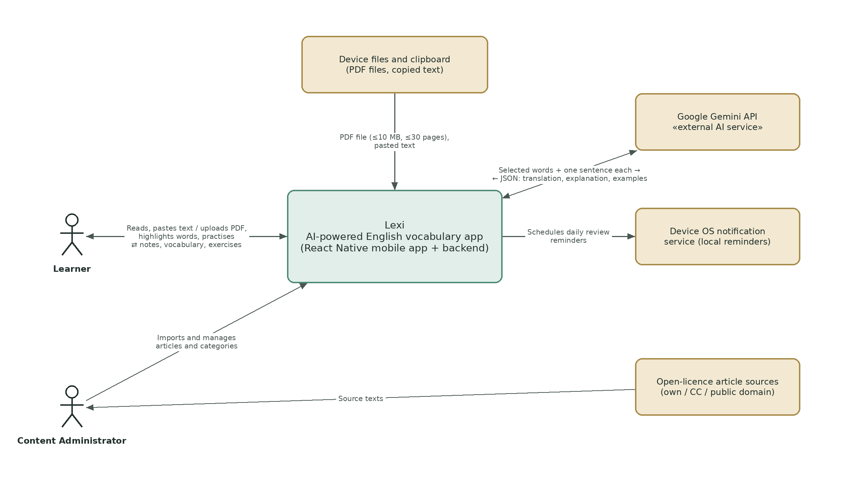
Figure 1. System context diagram

4.2 Use cases
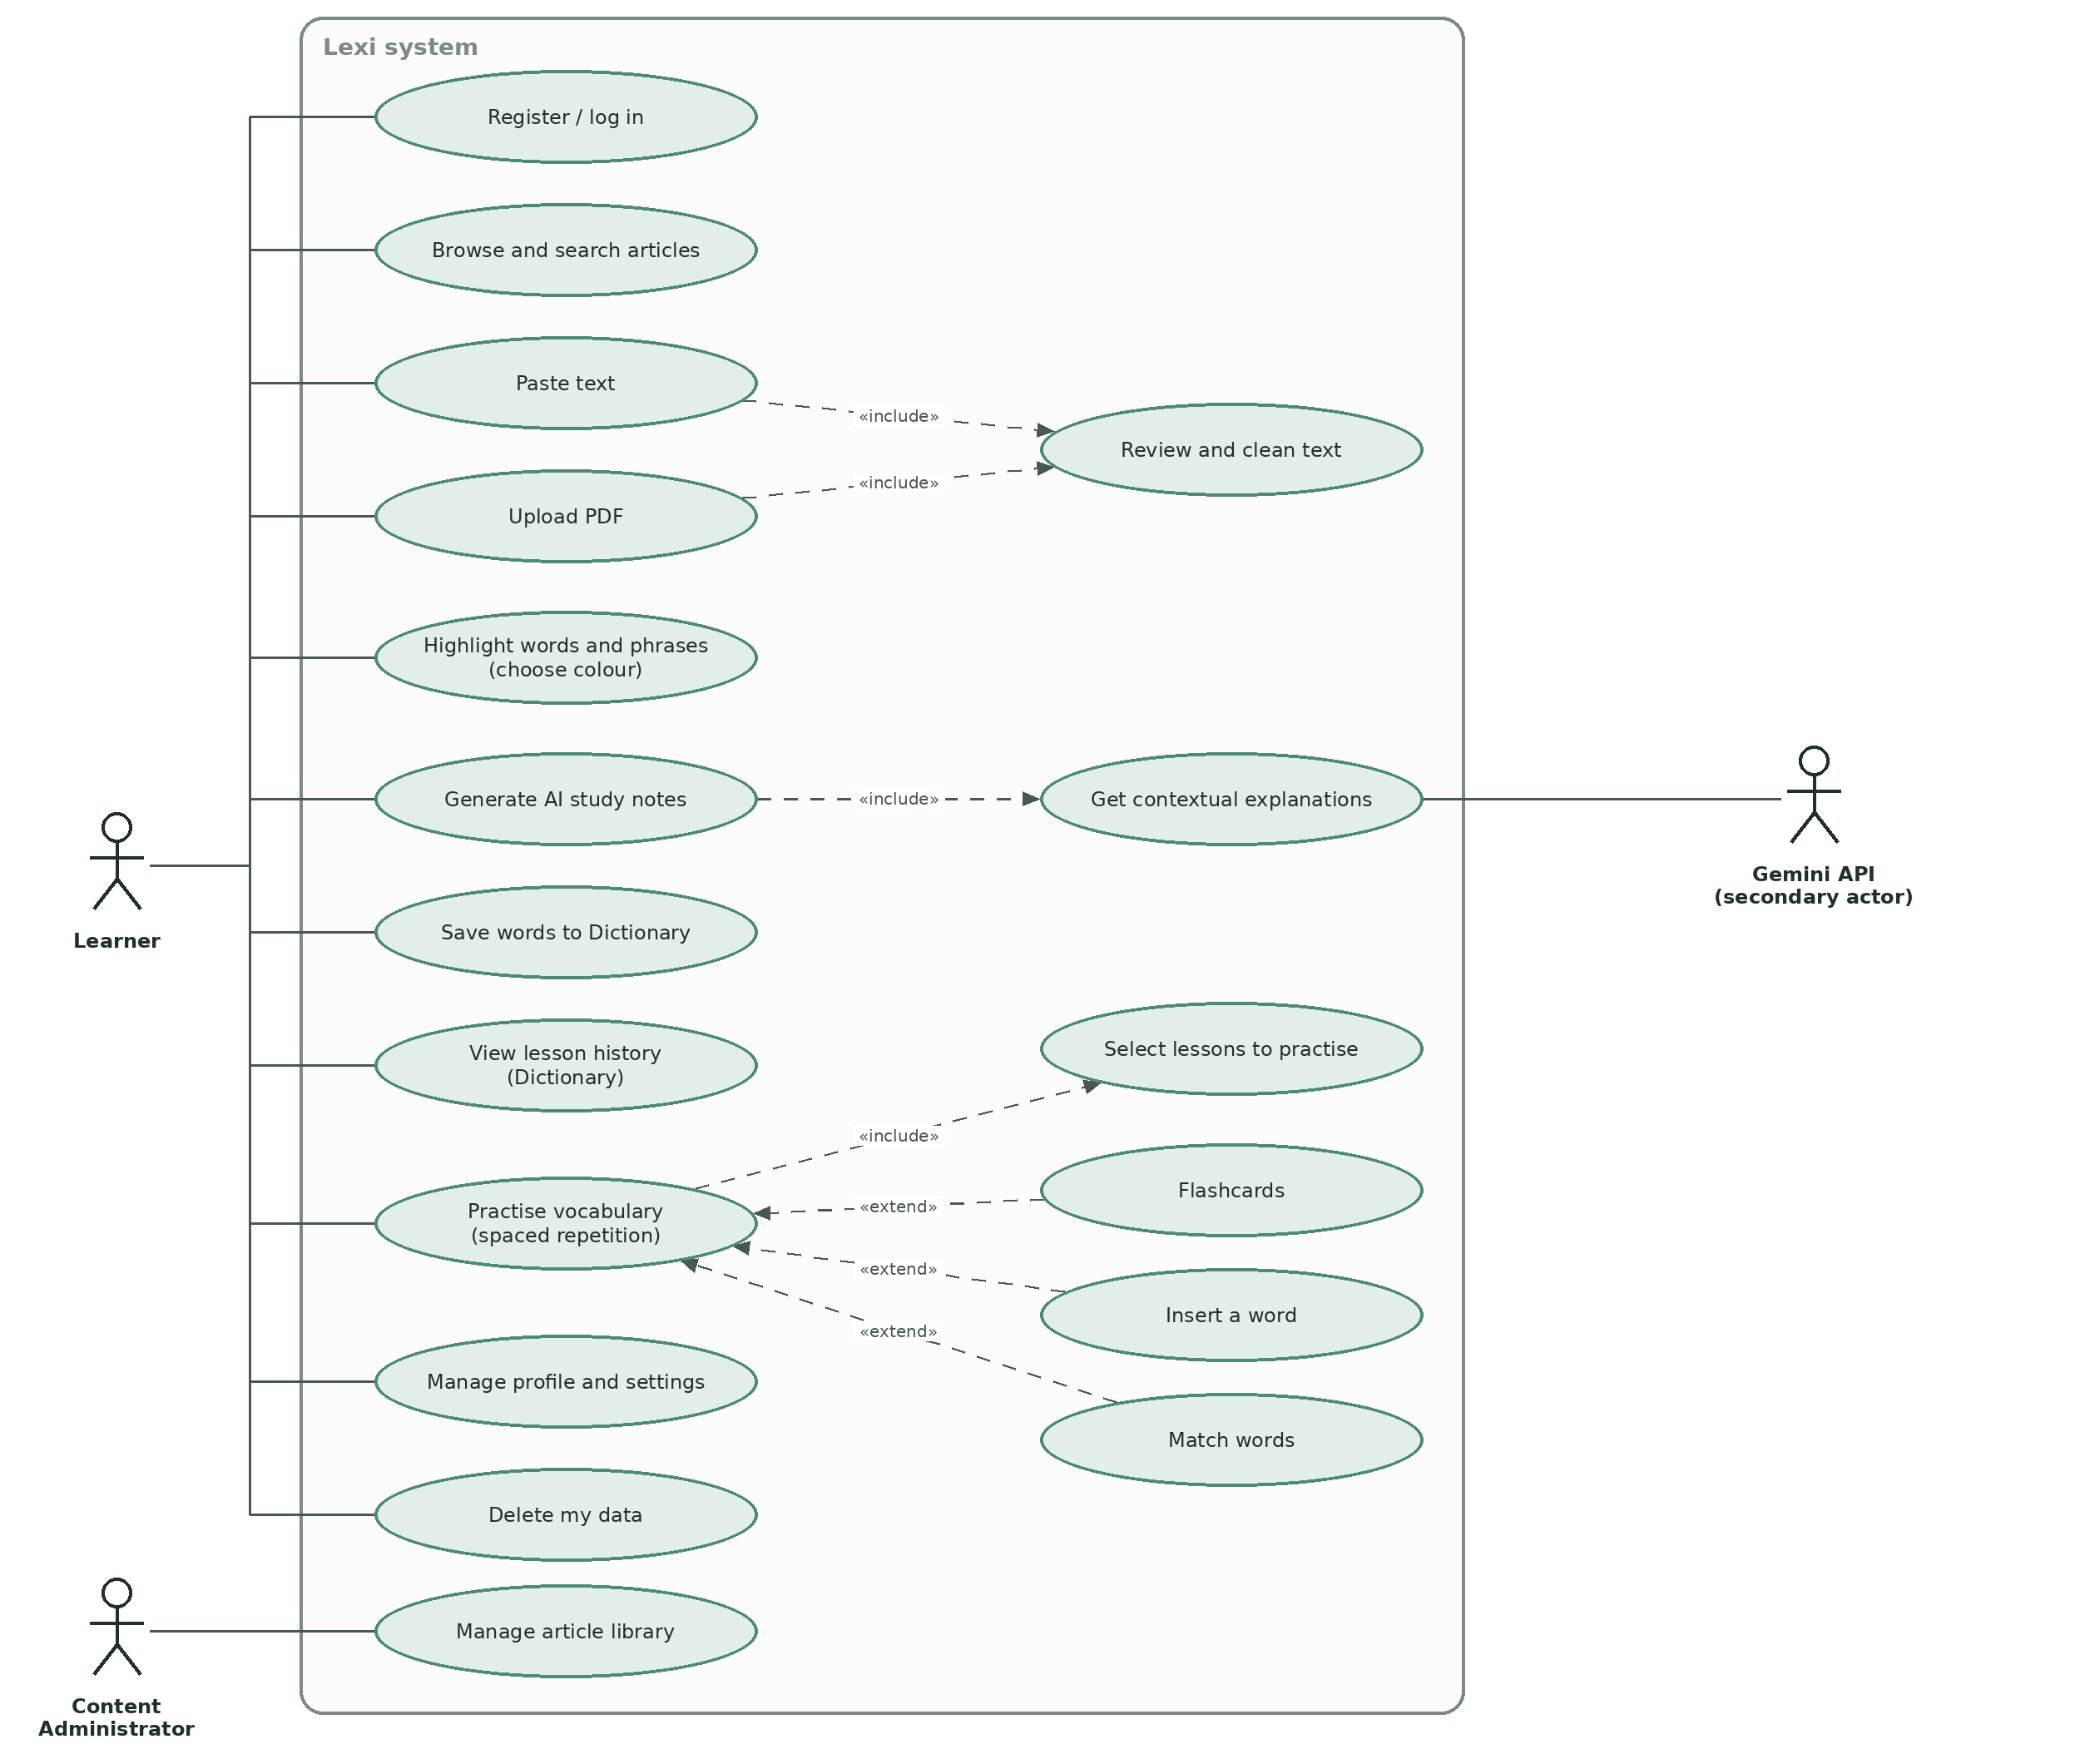
Figure 2. Use case diagram
ID | Use case | Actor | Description and related requirements
UC-01 | Register / log in | Learner | Creates an account or signs in (FR-01).
UC-02 | Browse and search articles | Learner | Finds an article by category, sorting or search (FR-02 to FR-04).
UC-03 | Paste text | Learner | Enters text and a lesson title (FR-06). Includes UC-05.
UC-04 | Upload PDF | Learner | Selects a PDF; the system checks size and pages and extracts text (FR-07, FR-08). Includes UC-05.
UC-05 | Review and clean text | Learner | Reviews red-marked unwanted text, removes it, confirms the text (FR-09 to FR-11).
UC-06 | Highlight words and phrases | Learner | Selects words or phrases and chooses a colour (FR-12, FR-13).
UC-07 | Generate AI study notes | Learner, Gemini API | Sends selected items for explanation (FR-14 to FR-16). Includes UC-07b.
UC-07b | Get contextual explanations | Gemini API | The AI returns translation, explanation, context meaning, examples, distractors in JSON.
UC-08 | Save words to Dictionary | Learner | Adds one or all words of the lesson (FR-17).
UC-09 | View lesson history | Learner | Lists lessons and opens a lesson (FR-18 to FR-20).
UC-10 | Practise vocabulary | Learner | Chooses a mode (extended by Flashcards, Insert a word, Match words) and lessons (included: select lessons); results update the review schedule (FR-21 to FR-26).
UC-16 | Manage profile and settings | Learner | Languages, theme, goals, reminders, statistics (FR-27 to FR-30).
UC-17 | Delete my data | Learner | Removes the account and all data (FR-31).
UC-18 | Manage article library | Content Administrator | Imports and edits articles and categories (FR-33).

4.3 Components
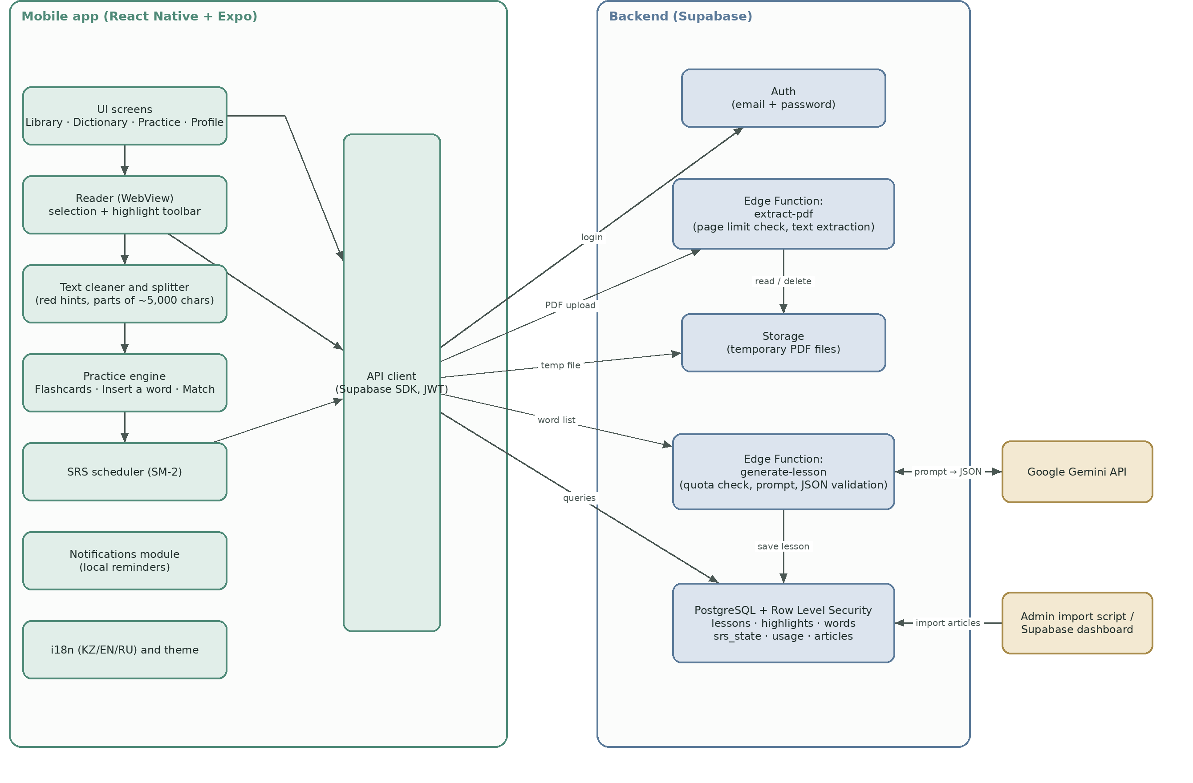
Figure 3. Component diagram
Component | Responsibility | Technology
UI screens | Library, Dictionary, Practice, Profile and navigation. | React Native, Expo Router
Reader | Shows text parts in a WebView, handles selection, colour toolbar and highlight offsets. | react-native-webview
Text cleaner and splitter | Marks unwanted text red, splits text into parts of about 5,000 characters. | TypeScript (rule-based)
Practice engine | Builds Flashcards, Insert a word and Match words from saved data (no AI call). | TypeScript
SRS scheduler | Computes next review date with SM-2. | TypeScript
Notifications, i18n and theme | Local reminders; KZ / EN / RU texts; day/night mode. | expo-notifications, i18next
API client | Single access point to the backend with the user's token. | Supabase SDK
Auth | Registration, login, sessions. | Supabase Auth
extract-pdf | Checks page count, extracts text, deletes the file. | Edge Function, unpdf
generate-lesson | Checks daily quota, builds the prompt, calls Gemini in batches, validates JSON, saves the lesson. | Edge Function, Gemini API
Database | Stores lessons, highlights, words, review state, usage, articles with Row Level Security. | PostgreSQL (Supabase)
Storage | Temporary PDF files. | Supabase Storage

4.4 Main flows

Flow A: importing a PDF
- The app checks that the file is at most 10 MB and sends it to temporary storage.
- extract-pdf reads the page count; if it exceeds 30, it rejects the file and deletes it.
- The text is extracted, the file is deleted, and the text is returned to the app.
- The cleaner marks unwanted text red; the user reviews and confirms; the text is split into parts.

Flow B: generating study notes
- The user highlights up to 50 items and taps "Prepare study notes".
- The app sends the items and one sentence each to generate-lesson.
- The function checks the daily quota, sends batches of 10 to Gemini with a role prompt and a JSON schema, validates the answers (up to 2 retries), and saves the lesson and words.
- The app shows the notes screen; the user adds words to the dictionary.

Flow C: practice and spaced repetition
- The user selects a mode and lessons; the app builds the exercises from saved words and examples without calling the AI.
- Each answer produces a rating (Know = 5, Hard = 3, Don't know = 1; correct = 5, wrong = 1).
- SM-2 updates the interval and ease factor; ratings below 3 reset the repetition count and the word returns after 1 day.

4.5 Data model (main tables)
Table | Main fields
profiles | id, display name, interface language, translation language, theme, daily goal, reminder settings
articles | id, title, category, level (CEFR), reading time, text, source and licence
lessons | id, user_id, title, source_type (pdf / text / article), text, created_at
highlights | id, lesson_id, start, end, text, colour
words | id, lesson_id, base form, part of speech, item type (word / phrasal verb / idiom), translation, simple explanation, meaning in context, example 1, example 2 (with translations), distractors
srs_state | word_id, user_id, interval (days), ease factor, repetitions, next review date
usage | user_id, date, number of items processed

4.6 Risks and mitigations
Risk | Mitigation
AI free-tier limits change or the service is unavailable | Own daily limits, caching of repeated words, batch processing, provider isolated behind one function.
AI returns an invalid or low-quality answer (especially Kazakh) | Strict JSON schema, validation with retries, pilot test of 30 words per language, native-speaker review.
Text selection behaves differently on Android and iOS | Early prototype on both platforms; CSS and message handling tested on real phones.
PDF layout (columns, tables, scans) gives poor text | Red hints and manual cleaning; scans rejected with a clear message; limits documented.
User data sent to a third-party AI | Minimal data, consent notice, no PDFs or full texts sent, deletion on request; paid privacy-preserving tier planned for release.
Supabase free project pauses after inactivity | Weekly activity and a check before demonstrations.
Team inexperience and short time | MoSCoW priorities, iterative development, risky parts prototyped first.

5. UX prototype
The clickable prototype covers the screens listed below and is delivered as an interactive HTML page together with instructions for recreating it in Figma. All screens use one visual style: a calm green-grey palette, white rounded cards, one accent colour and the Manrope font.
No. | Screen | Content
1 | Library | Search, category chips, sorting, articles by category, floating "+" button, bottom navigation (Library, Dictionary, Practice, Profile).
2 | Add material menu | Dimmed background with "Upload PDF" and "Paste text".
3 | Paste text / reader | Lesson title, highlight tools (colours, erase, undo), text part navigation, "Prepare study notes" button.
4 | Study notes | Word cards with translation and two examples, "Add to dictionary", "Add all to dictionary".
5 | Dictionary | Search and history of lessons with title, date, word count and source icon.
6 | Practice | Three modes and the "Select dictionary to practice" screen.
7 | Flashcards, Insert a word, Match words | One screen for each exercise type.
8 | Profile | Statistics, languages (KZ / EN / RU), Day/Night mode, daily goal, reminders, text size.

6. Verification and evaluation plan

6.1 Objectives
- Verify that every Must requirement is implemented and meets its acceptance criteria.
- Evaluate the quality and reliability of the AI-generated notes.
- Evaluate usability and the perceived usefulness of the application with real users.
- Compare the application with a baseline (the learner's usual method) and report the results honestly, including limitations.

6.2 Test levels and tools
Level | What is tested | Tools
Unit tests | Text cleaning rules, text splitting, SM-2, AI response validation, limit checks. | Jest, TypeScript
Integration tests | Edge functions with a mocked Gemini API; database access rules (Row Level Security); PDF page-limit logic. | Supabase dev project, Jest, mock responses
System tests (manual) | End-to-end scenarios on real Android and iOS devices. | Expo Go, test checklist
Security tests | A user cannot access another user's data; the AI key is not in the app; limits cannot be bypassed. | Two test accounts, API client
Performance checks | Reader opening time, highlight response, AI and PDF processing time. | Device timer, function logs
AI quality evaluation | Correctness of translations and context meanings on a fixed item set. | Rating sheet, 2 evaluators
Usability study | Task success, time and SUS questionnaire. | Task script, Google Forms

6.3 Test data
- 20 PDF files: articles, book chapters, two-column papers, files with headers and footers, a scanned PDF, a 75-page file of about 75 KB, a 30-page file, a file just above 10 MB.
- 10 texts from 500 to 100,000 characters.
- 100 test items: 60 single words, 25 phrasal verbs, 15 idioms, in sentences of different difficulty.
- Test accounts: two regular users and one administrator.

6.4 Metrics
Targets are hypotheses for a prototype and will be reported as measured results, even if a target is not met.
ID | Metric | How it is measured | Target
M1 | Valid AI responses | Share of requests returning valid JSON with all fields, over at least 100 requests | At least 95% (after retries)
M2 | AI correctness in context | Two evaluators rate whether the translation and context meaning fit the sentence (0/1) for 60 items (20 per language) | At least 85%, higher than the baseline
M3 | AI response time | 95th percentile for 10 items | At most 15 s
M4 | PDF extraction success | Share of text-based test PDFs with readable text (judged by a rater); scans must be rejected with a message | At least 90%; 100% of scans rejected
M5 | Cleaning hints quality | Recall and precision of flagged header/footer/page-number lines on 10 PDFs | Recall at least 90%, precision at least 80%
M6 | Reader responsiveness | Opening time of a 5,000-character part; highlight response | At most 1 s; at most 200 ms
M7 | Task success rate | Share of core tasks completed without help in the usability study | At least 90%
M8 | Time on core scenario | Time from pasting text to saved words for first-time users | At most 5 min
M9 | SUS score | System Usability Scale questionnaire | At least 68
M10 | Vocabulary retention | Pre-test and post-test (after 7 days) on target words; application group vs control group | Application group not lower than control; effect reported with limitations
M11 | Stability | Crash-free sessions during testing | At least 99%
M12 | Data isolation | Cross-user access attempts in security tests | 0 successful attempts

6.5 Baseline
Two baselines are used:
- Learning baseline (for M7–M10): the participant's usual method of reading English texts, i.e. reading with an online translator or dictionary and keeping their own notes. The control group works with the same texts and the same pre/post tests using this method.
- AI quality baseline (for M2): the first translation or dictionary entry for each item without context, evaluated by the same raters on the same items.
With 10–15 participants the study is exploratory: results show tendencies and usability problems, not statistical proof. This limitation will be stated in the final report.

6.6 Usability study design
- Participants: 10–15 learners of English (B1–B2), voluntary, informed consent, anonymised data, no personal documents.
- Session 1: pre-test, short tasks on the prototype (paste text, highlight, notes, save, one practice mode), SUS questionnaire, short interview.
- Seven days of use with five prepared texts (control group: usual method with the same texts).
- Session 2: post-test on the same target words, follow-up questions.

6.7 Test cases
ID | Requirement | Steps | Expected result | Type
TC-01 | FR-01 | Register, log out, log in; restart the app. | Login succeeds; the session persists. | Manual
TC-02 | FR-01 | Log in with a wrong password. | Error is shown; no access. | Manual
TC-03 | FR-04 | Search "sleep", then "zzzz". | Matching article found; empty-state message for the second query. | Manual
TC-04 | FR-06 | Paste 100,001 characters. | Counter and excess text are red; generation is blocked until reduced. | Manual
TC-05 | FR-07 | Select a 10.1 MB PDF. | Rejected on the device with a message. | Manual
TC-06 | FR-07 | Upload a 75-page PDF of about 75 KB. | Rejected by the server after page count; no file or text stored. | Integration
TC-07 | FR-07 | Upload a 30-page PDF under 10 MB. | Accepted and processed. | Integration
TC-08 | FR-08 | Upload a scanned PDF without a text layer. | Message "We couldn't read text"; no lesson created. | Integration
TC-09 | FR-09 | Upload a PDF with the same header on 20 pages; tap "Remove all suggested". | At least 90% of header lines are flagged and removed. | Manual
TC-10 | FR-10 | Open a 60,000-character text; highlight in part 1; go to part 3 and back. | At least 12 parts; the highlight is preserved. | Manual
TC-11 | FR-11 | Confirm the text, then try to edit it. | Editing is disabled; offsets unchanged. | Manual
TC-12 | FR-12 | Highlight one word in two colours; reopen the lesson. | Colours applied and restored. | Manual
TC-13 | FR-12 | Highlight "give up" and "take into account"; remove one highlight. | Each phrase counts as one item; removal updates the counter. | Manual
TC-14 | FR-13 | Add a 51st item. | Blocked with a message. | Manual
TC-15 | FR-14 | Generate notes for 10 items with a mocked AI. | All fields saved; phrases labelled as phrasal verb or idiom. | Integration
TC-16 | FR-14, NFR-05 | Mocked AI returns invalid JSON. | Up to 2 retries; then an error with Retry; no partial lesson saved. | Integration
TC-17 | FR-15 | Generate notes for 37 items. | 4 batch requests; progress shown. | Integration
TC-18 | FR-16 | Process 150 items, then 1 more; repeat on the next simulated day. | The extra item is refused; allowed on the next day. | Integration
TC-19 | FR-18 | Create lessons from PDF, pasted text and an article. | Book, text and article icons shown; sorted by date. | Manual
TC-20 | FR-21 | Select two lessons and start practice. | Only words from these lessons appear; Start disabled with no selection. | Manual
TC-21 | FR-22, FR-25 | Rate a card "Don't know" and another "Know". | Next review dates differ as defined by SM-2. | Unit
TC-22 | FR-23 | Open Insert a word. | Gap in the first example, 1 correct and 3 distractors in the same form. | Manual
TC-23 | FR-24 | Match 5 pairs with one mistake. | Wrong pair resets; correct pairs stay fixed. | Manual
TC-24 | FR-25 | Feed SM-2 with ratings 5, 5, 5, 1, 4. | Intervals 1, 6, then multiplied by the ease factor; reset to 1 after the rating 1. | Unit
TC-25 | FR-27 | Switch the interface language KZ, EN, RU. | All screens translated; no raw keys. | Manual
TC-26 | FR-28, NFR-13 | Switch to Night mode and open the reader. | Theme applied; contrast at least 4.5:1. | Manual
TC-27 | NFR-07 | User A requests lessons of user B through the API. | Empty or denied response. | Security
TC-28 | FR-31 | Delete the account. | All user rows are removed. | Integration
TC-29 | FR-32 | Open the AI feature for the first time; decline consent. | AI blocked; reading still works. | Manual
TC-30 | NFR-01 | Open a 5,000-character part on a mid-range Android phone. | Opens in at most 1 s. | Performance

6.8 Schedule, roles and exit criteria
Item | Definition
Responsibilities | Akbota drafts the plan, test cases and metrics; Kamila reviews. Both run the usability sessions. Each person records results in YouTrack.
Order of work | Unit tests during development; integration tests after each backend feature; system tests after each milestone; AI quality evaluation after the AI function is stable; usability study in the last stage.
Exit criteria | All Must test cases pass; no open critical defects; M1, M4, M11 and M12 reach their targets; results of all metrics are documented.
Threats to validity | Small sample, short study period, familiarity of participants with the team, changing AI free-tier behaviour. Each is described in the final report.

6.9 Assumptions
- The values of limits (file size, pages, characters, items per lesson, daily limit) are initial and may change after pilot testing.
- The free tiers of Supabase and Gemini remain available during development; their current conditions will be re-checked before submission.
- Scanned PDFs and OCR are out of scope for the prototype.

