1. I have created a user “Edward James”.
2. When I logged in with Edward James, I am able to see a default dashboard selected and created for the user.  
   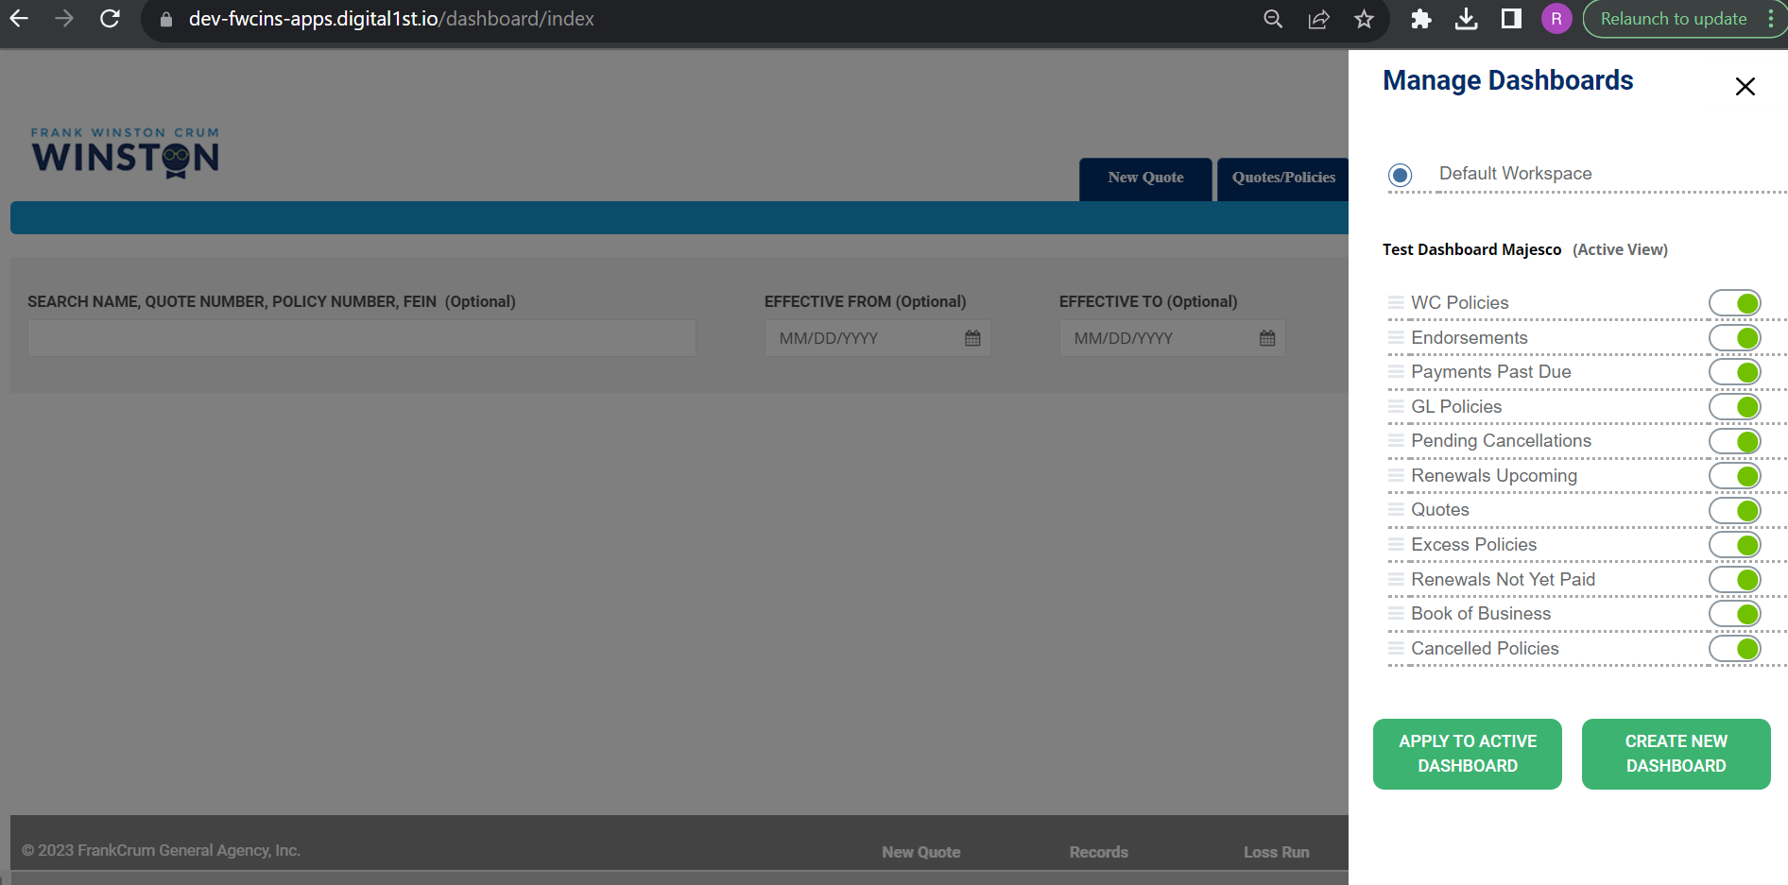
3. I click on create new Dashboard  
   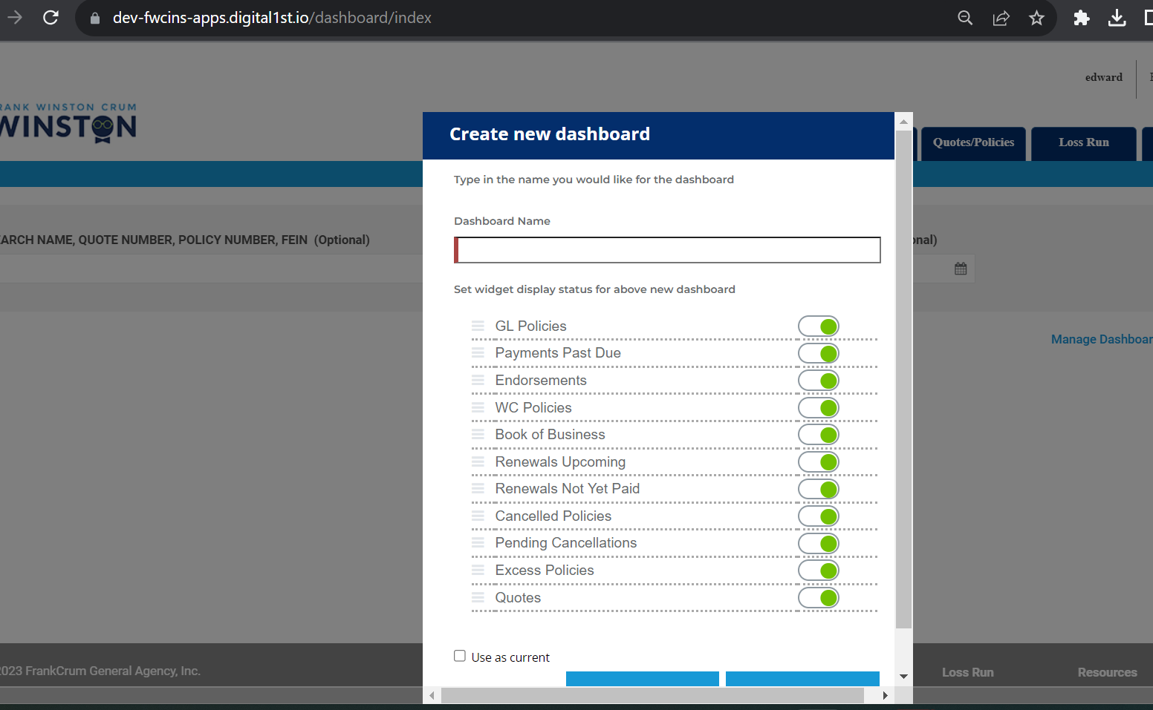
4. Added Dashboard 1 for the user  
   