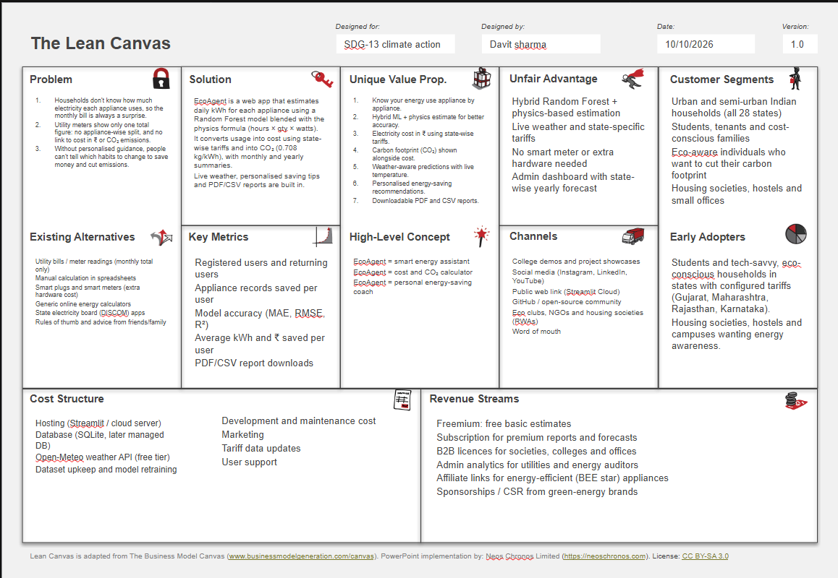

Link:-https://docs.google.com/presentation/d/1UC7dzbxJ1f-PsjNQ4DOMiDJeHofgR4D2/edit?usp=sharing&ouid=103166235661740134270&rtpof=true&sd=true

EcoAgent – Concept Notes
Smart Energy Assistant: key concepts behind the project, for study, report writing and viva preparation.

Project in One Paragraph
EcoAgent is a Streamlit web application that estimates a household's electricity use appliance by appliance, converts it into cost (₹) and CO2 emissions, and gives energy-saving suggestions. A user registers with a state, adds appliances (hours per day, quantity, watts, outdoor temperature), and the app predicts daily kWh, stores it in a SQLite database, and builds monthly and yearly summaries and downloadable PDF/CSV reports. An admin can see all users and a state-wise yearly cost forecast.
Tech stack: Python, Streamlit (UI), pandas (data), scikit-learn (Random Forest), joblib (model saving), SQLite (database), ReportLab (PDF), Open-Meteo API (live weather).

Energy Basics

Term | Meaning
Watt (W) | Rate at which an appliance uses power
Kilowatt (kW) | 1000 W
Kilowatt-hour (kWh) | Energy used by a 1 kW load running for 1 hour; this is the "unit" on an electricity bill
Tariff | Price per kWh charged by the state (₹/kWh)
Emission factor | kg of CO2 produced per kWh of grid electricity

Core formula (physics-based estimate):
k W h p e r d a y = h o u r s × q u a n t i t y × w a t t s ÷ 1 0 0 0
Example: 2 fans, 75 W each, 10 hours/day → 10 × 2 × 75 ÷ 1000 = 1.5 kWh/day. Cost: c o s t = k W h × t a r i f f . At ₹7/kWh, 1.5 kWh costs ₹10.50 per day.
CO2: C O 2 ( k g ) = k W h × 0 . 7 0 8 . The project uses 0.708 kg/kWh, a simplified average grid factor for India.

Machine Learning Concepts Used

Regression
The model predicts a continuous number (kWh), so this is a regression problem, not classification.

Features and target
    - Features (inputs): hours, quantity, watts, temperature

Target (output): kwh
Temperature matters because appliances such as air conditioners and fridges work harder in hot weather.

Random Forest Regressor
    - A Random Forest is an ensemble of many decision trees (here 150, n _ e s t i m a t o r s = 1 5 0 ).
    - Each tree is trained on a random sample of the data (bagging) and a random subset of features.
    - For regression, the final prediction is the average of all trees' predictions.
    - Why it fits: it handles non-linear relationships, needs little scaling, resists overfitting better than a single tree, and works well on tabular data.
    - Weakness: it cannot predict outside the range it saw in training, which is one reason the project blends it with a formula.

  - Training pipeline (train_model.py)
- Load the CSV dataset (s m a r t _ h o m e _ e n e r g y _ c o n s u m p t i o n _ l a r g e . c s v ).
- Check that the required columns exist.
- Convert to numbers and drop rows with missing values (data cleaning).

- Remove invalid rows (negative hours, zero watts, and so on).
- Split the data 80% train / 20% test (t e s t _ s i z e = 0 . 2 , r a n d o m _ s t a t e = 4 2 for reproducibility).
- Fit the model, predict on the test set and compute metrics.
- Save the model with joblib as e n e r g y _ r f . j o b l i b .
If the model file is missing, t o o l s . l o a d _ m o d e l ( ) trains it automatically on first use.

Evaluation metrics

Metric | Meaning | Better when
MAE | Average absolute error, in kWh | Lower
RMSE | Square root of mean squared error; penalises large errors more | Lower
R2 | Share of variance in the data explained by the model (1.0 is perfect) | Closer to 1

  - Hybrid estimate (ML + physics)
In the app, the final value is a 50/50 blend:
k w h = 0 . 5 × M L p r e d i c t i o n + 0 . 5 × ( h o u r s × q u a n t i t y × w a t t s ÷ 1 0 0 0 )
Reason: the physics formula is always consistent and explainable, while the ML model captures real-world effects such as temperature and duty cycles. Averaging the two reduces the risk of either being badly wrong. The result is clamped at 0 so it can never be negative.

Live Weather (Open-Meteo)
- g e t _ l i v e _ w e a t h e r ( s t a t e ) maps the user's state to its capital city.
- Step 1: the Geocoding API converts the city name into latitude and longitude.
- Step 2: the Forecast API returns t e m p e r a t u r e _ 2 m for the current time.
- No API key is needed, and a t i m e o u t = 8 prevents the app hanging.
- Errors are caught and shown as a warning so the app keeps working.

Cost, Summary and Score Logic
- State tariff: S T A T E _ T A R I F F is a dictionary (for example Gujarat 7.0, Maharashtra 8.0). States not listed use a default of ₹7.0/kWh.
- Summary extrapolation: each saved record is a typical daily value, so the app sums them and computes
m o n t h l y = d a i l y × 3 0 and y e a r l y = d a i l y × 3 6 5 .
- Monthly CO2: m o n t h l y k W h × 0 . 7 0 8 .
- Efficiency score: s c o r e = 1 0 0 − m o n t h l y _ k W h ÷ 2 0 , limited to the range 0 to 100. Higher usage lowers the score.
- Recommendations are rule-based: find the appliance with the highest kWh, flag any appliance running more than 6 hours/day, and add general tips (LED lighting, switch off standby).

Software Architecture

Streamlit concepts
    - Script rerun model: Streamlit re-executes the whole script on every interaction.
    - s t . s e s s i o n _ s t a t e : stores values across reruns (logged-in user, weather temperature).
    - s t . f o r m : groups inputs so they are submitted together (login and register).
    - s t . t a b s , s t . c o l u m n s , s t . m e t r i c , s t . b a r _ c h a r t , s t . d a t a f r a m e : layout and display components.
    - s t . r e r u n ( ) : forces a refresh after saving data or logging in.
    - s t . s t o p ( ) : halts the script so later sections do not run (used in the older a d m i n . p y -style flow).

Application flow
Login or register → role check → user dashboard (Energy Usage, Summary, Recommendations, Report) or
admin dashboard (Overview, All Users & Records, State-wise Forecast).

Files

File | Purpose
a p p . p y | Streamlit UI and routing
d b . p y | Database layer, authentication, state tariffs
t o o l s . p y | Prediction, cost, summary, recommendations, weather
t r a i n _ m o d e l . p y | Trains and saves the Random Forest
e c o a g e n t . d b | SQLite database file
e n e r g y _ r f . j o b l i b | Saved trained model

Database Concepts (SQLite)

Tables
- u s e r s (id, username UNIQUE, password_hash, state, role, created_at)
- u s a g e (id, user_id, appliance, hours, quantity, watts, kwh, cost, created_at)
- s u m m a r y (user_id PRIMARY KEY, monthly and yearly kWh and cost, co2_kg, score, updated_at)

Key ideas
- Primary key and AUTOINCREMENT: a unique id for every row.
- UNIQUE constraint: prevents duplicate usernames (caught as I n t e g r i t y E r r o r ).
- Foreign key with O N D E L E T E C A S C A D E : deleting a user automatically deletes their usage and summary rows. P R A G M A f o r e i g n _ k e y s = O N is required in SQLite to enforce this.
- Parameterised queries (? ): prevent SQL injection.
- UPSERT (I N S E R T . . . O N C O N F L I C T D O U P D A T E ): s a v e _ s u m m a r y inserts a summary or updates it if one already exists.
- JOIN and LEFT JOIN: the admin view joins u s a g e and u s e r s ; L E F T J O I N plus C O A L E S C E shows users with zero usage as 0.
- GROUP BY: counts users per state.
- c l o s i n g ( ) context manager: guarantees each connection is closed.

Security Concepts
- Password hashing: passwords are stored as SHA-256 hashes, never as plain text.
- h m a c . c o m p a r e _ d i g e s t : compares hashes in constant time, which protects against timing attacks.
- Role-based access control (RBAC): r o l e is u s e r or a d m i n , and the app re-reads the role from the database on each run.
- Admin protection: d e l e t e _ u s e r refuses to delete admin accounts (r o l e ! = ' a d m i n ' ).
- Input validation: a password must have at least 6 characters, and number inputs have min and max limits.

Known limitations to mention honestly
- Plain SHA-256 has no salt and is fast to brute-force; production systems should use bcrypt, scrypt or PBKDF2.
- The demo admin login (admin / admin123) must be changed before real deployment.

Admin Dashboard and State-wise Forecast
- Metrics: registered users, states represented, estimated yearly cost.
- The forecast groups users' summaries by state, sums yearly kWh, multiplies by that state's tariff and sorts by cost.
- It is an estimate based on registered users only, not the real total demand of a state. This caveat is shown in the app.
- Admin can filter records by state, download CSV and delete users with a confirmation checkbox.

Reports
- CSV: D a t a F r a m e . t o _ c s v ( ) encoded to UTF-8 and offered through s t . d o w n l o a d _ b u t t o n .
- PDF: ReportLab (S i m p l e D o c T e m p l a t e , P a r a g r a p h , T a b l e ) builds the report in memory with B y t e s I O , with no temporary file on disk.
- If ReportLab is not installed, the app catches I m p o r t E r r o r and shows a warning.

Limitations and Future Scope

Limitations
- Estimates depend on user-entered watts and hours, not real meter readings.
- Tariffs are simplified flat rates; real bills use slabs, fixed charges and taxes.
- A single temperature value is used, not hourly weather.
- Records are treated as a typical day; seasonal change is ignored.
- The state list in the code does not include Delhi, even though a Delhi tariff exists.

Future scope
- Slab-wise tariff calculation and live tariff data.
- Smart-meter or IoT sensor integration for real readings.
- Salted password hashing, plus email verification.
- Time-series forecasting for seasonal usage.
- Appliance-level benchmarks (BEE star ratings) and cost-saving what-if scenarios.

Quick Viva Questions
- Why Random Forest? It models non-linear patterns in tabular data, is robust to noise and overfitting, and needs little preprocessing.
- Why blend ML with a formula? The formula is exact and explainable while the ML model adds real-world effects; the blend is more reliable than either alone.
- What does R2 mean? The proportion of variation in kWh that the model explains.
- Why r a n d o m _ s t a t e = 4 2 ? To get the same train/test split and results every run.
- How is CO2 calculated? kWh multiplied by an emission factor of 0.708 kg/kWh.
- How is SQL injection prevented? By using parameterised queries instead of building SQL strings.
- What does ON DELETE CASCADE do? It removes child rows automatically when the parent user is deleted.
- Why use s t . s e s s i o n _ s t a t e ? Streamlit reruns the script on each action, so state must be stored to persist across reruns.
- What is a weakness of your authentication? Unsalted SHA-256; it should be upgraded to bcrypt or PBKDF2.
- Is the state forecast the real state demand? No, it only extrapolates the data of registered users.

Worked Example: End-to-End Calculation
Input: 1 air conditioner, 1500 W, used 8 hours/day, user in Gujarat (tariff ₹7.0/kWh), outdoor temperature 35
°C.

Step | Calculation | Result
Physics estimate | 8 × 1 × 1500 ÷ 1000 | 12.0 kWh/day
ML prediction (illustrative value) | Random Forest output | 13.2 kWh/day
Blended estimate | 0.5 × 13.2 + 0.5 × 12.0 | 12.6 kWh/day
Daily cost | 12.6 × 7.0 | ₹88.20
Monthly energy and cost | 12.6 × 30 and 378 × 7.0 | 378 kWh, ₹2,646

Step | Calculation | Result
Yearly energy and cost | 12.6 × 365 and 4,599 × 7.0 | 4,599 kWh, ₹32,193
Monthly CO2 | 378 × 0.708 | about 267.6 kg
Efficiency score | 100 − 378 ÷ 20 | 81.1
The ML value above is only an example; the real number depends on the trained model and dataset.

Data Flow Step by Step
- The user logs in; d b . a u t h e n t i c a t e ( ) checks the hashed password and returns the user record.
- The user enters appliance, hours, quantity, watts and temperature (optionally filled by the live weather button).
- t o o l s . p r e d i c t _ k w h ( ) builds a one-row DataFrame with the four features and asks the Random Forest for a prediction.
- The app blends that prediction with the physics formula.
- t o o l s . c a l c u l a t e _ c o s t ( ) multiplies kWh by the user's state tariff.
- d b . s a v e _ u s a g e ( ) inserts the record into the u s a g e table.
- s t . r e r u n ( ) refreshes the page, and d b . g e t _ u s a g e ( ) reloads all of the user's records.
- t o o l s . c a l c u l a t e _ s u m m a r y ( ) totals the records, and d b . s a v e _ s u m m a r y ( ) upserts the result so the admin can see it.
- The tabs display metrics, recommendations and report downloads.

Library and Python Concepts

Library / feature | Used for in EcoAgent
pandas D a t a F r a m e | Holds usage tables; g r o u p b y , a g g , t o _ c s v , r e a d _ s q l _ q u e r y
numpy | Square root for RMSE
scikit-learn | R a n d o m F o r e s t R e g r e s s o r , t r a i n _ t e s t _ s p l i t , MAE, MSE and R2 metrics
joblib | d u m p and l o a d to save and reuse the trained model
pathlib P a t h | Builds file paths that work on any operating system
requests | Calls the Open-Meteo APIs; r a i s e _ f o r _ s t a t u s ( ) turns HTTP errors into exceptions
sqlite3 | Built-in database; r o w _ f a c t o r y = s q l i t e 3 . R o w lets rows behave like dictionaries
contextlib c l o s i n g | Closes the database connection automatically
hashlib and hmac | Password hashing and safe comparison
reportlab | Generates the PDF report

Good practices visible in the code
- Separation of concerns: UI in a p p . p y , data in d b . p y , logic in t o o l s . p y , training in t r a i n _ m o d e l . p y .
- Lazy imports (r e p o r t l a b , r e q u e s t s ) so the app starts even if an optional package is missing.
- t r y / e x c e p t around the model, weather and PDF steps so failures show a message instead of crashing.
- A model that trains itself on first run if the . j o b l i b file is absent.

Glossary

Term | Simple meaning
Ensemble | A model made by combining many smaller models
Bagging | Training each model on a random sample of the data
Overfitting | Memorising training data so well that new data is predicted badly
Hyperparameter | A setting chosen before training, such as the number of trees
Feature | An input column used for prediction
Target | The value the model learns to predict
Standby power | Electricity used by a device that is plugged in but switched off
Duty cycle | The fraction of time an appliance (such as a fridge compressor) is actually running
Tariff slab | Price bands where the rate per unit rises as usage increases
Emission factor | kg of CO2 released per kWh of grid electricity
Salt | Random data added to a password before hashing so equal passwords give different hashes
CRUD | Create, Read, Update, Delete: the four basic database operations
RBAC | Role-based access control: permissions depend on the user's role

Testing and Deployment Notes

Test cases worth showing in a demo or report
- Hours set to 0 gives 0 kWh and ₹0 cost.
- Registering with a username that already exists shows an error.
- A password shorter than 6 characters is rejected.
- Wrong password shows "Invalid username or password".
- Deleting a user also removes their usage and summary rows (cascade).
- Removing e n e r g y _ r f . j o b l i b makes the app retrain the model automatically.
- Turning off the internet makes the weather button show a warning, while manual temperature entry still works.

Running the project
- Install packages: p i p i n s t a l l - r r e q u i r e m e n t s . t x t .
- Train the model (optional, it also happens automatically): p y t h o n t r a i n _ m o d e l . p y .
- Start the app: s t r e a m l i t r u n a p p . p y .

Deployment points
- Streamlit Community Cloud can host the app directly from GitHub.
- SQLite is a single file and handles few simultaneous writers; use PostgreSQL or MySQL for many users.
- On some free hosts the file system resets, so the database must be kept on persistent storage.
- Change the default admin password and avoid committing the database file to a public repository.

Exam and Report Tips
- Explain the hybrid estimate clearly; it is the most original idea in the project.
- Always state that results are estimates, not meter readings.
- Be ready to name the limitations (flat tariffs, simple password hashing, single temperature) before the examiner does.
- Know the three formulas by heart: kWh, cost and CO2.
- Be able to draw the flow: user input → prediction → cost and CO2 → database → summary → report.

