1. What are the JavaScript data types give example?

* JavaScript is a **dynamic type language** means you don't need to specify type of the variable because it is dynamically used by JavaScript engine.
* JavaScript provides different **data types** to hold different types of values. There are two types of data types in JavaScript.
* Non-primitive (reference) data type
* Primitive data type

primitive data types-

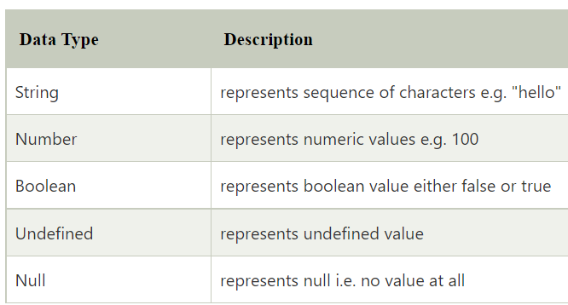

non-primitive data types-

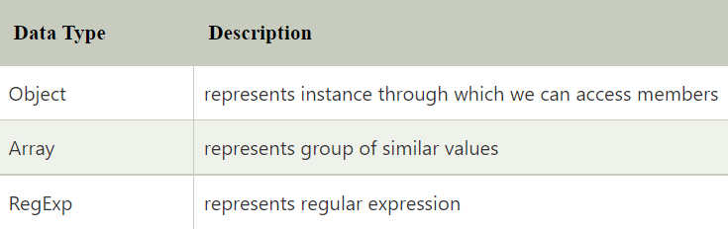

Que2. What is complex data type?

* Complex Data Type in JavaScript includes the typeof operator.
* The*typeof*operator is a unary operator that is placed before its single operand, which can be of any type. Its value is a string indicating the data type of the operand.
* The *typeof* operator evaluates to "number", "string", or "boolean" if its operand is a number, string, or boolean value and returns true or false based on the evaluation.

Que3.  What is typeof undefined?

The typeof undefined is undefined since undefined itself is a datatype.

Que4. What is typeof null?

The typeof null is an object since null is an empty object pointer

Que5. What is Boolean, number and string? Explore in detail?

* **Strings** are useful for holding data that can be represented in text form. Some of the most-used operations on strings are to check their [length](https://developer.mozilla.org/en-US/docs/Web/JavaScript/Reference/Global_Objects/String/length), to build and concatenate them using the [+ and += string operators](https://developer.mozilla.org/en-US/docs/Web/JavaScript/Guide/Expressions_and_Operators#string_operators), checking for the existence or location of substrings with the [indexOf()](https://developer.mozilla.org/en-US/docs/Web/JavaScript/Reference/Global_Objects/String/indexOf) method, or extracting substrings with the [substring()](https://developer.mozilla.org/en-US/docs/Web/JavaScript/Reference/Global_Objects/String/substring) method.
* **Boolean** is a logical data type that can have only the values true or false. For example, in JavaScript, Boolean conditionals are often used to decide which sections of code to execute (such as in [if statements](https://developer.mozilla.org/en-US/docs/Web/JavaScript/Reference/Statements/if...else)) or repeat (such as in [for loops](https://developer.mozilla.org/en-US/docs/Web/JavaScript/Reference/Statements/for)).
* **Number** represents numeric values.

When adding a number and a string, JavaScript will treat the number as a string.

Que6. What is operating system and kernel means?

* An operating system (OS) is the program that, after being initially loaded into the computer by a boot program, manages all of the other application programs in a computer. The application programs make use of the operating system by making requests for services through a defined application program interface ([API](https://searchapparchitecture.techtarget.com/definition/application-program-interface-API)). In addition, users can interact directly with the operating system through a user interface, such as a command-line interface (CLI) or a graphical UI (GUI).

### Why use an operating system?

* An operating system brings powerful benefits to computer software and software development. Without an operating system, every application would need to include its own UI, as well as the comprehensive code needed to handle all low-level functionality of the underlying computer, such as disk storage, network interfaces and so on. Considering the vast array of underlying hardware available, this would vastly bloat the size of every application and make software development impractical.
* Instead, many common tasks, such as sending a network packet or displaying text on a standard output device, such as a display, can be offloaded to [system software](https://whatis.techtarget.com/definition/system-software) that serves as an intermediary between the applications and the hardware. The system software provides a consistent and repeatable way for applications to interact with the hardware without the applications needing to know any details about the hardware.
* As long as each application accesses the same resources and services in the same way, that system software -- the operating system -- can service almost any number of applications. This vastly reduces the amount of time and coding required to develop and debug an application, while ensuring that users can control, configure and manage the system hardware through a common and well-understood interface

What is kernel?

* [Kernel](https://www.geeksforgeeks.org/kernel-i-o-subsystem-in-operating-system/) is central component of an operating system that manages operations of computer and hardware. It basically manages operations of memory and CPU time. It is core component of an operating system. Kernel acts as a bridge between applications and data processing performed at hardware level using inter-process communication and system calls.
* Kernel loads first into memory when an operating system is loaded and remains into memory until operating system is shut down again. It is responsible for various tasks such as disk management, task management, and memory management.
* It decides which process should be allocated to processor to execute and which process should be kept in main memory to execute. It basically acts as an interface between user applications and hardware. The major aim of kernel is to manage communication between software i.e. user-level applications and hardware i.e., CPU and disk memory.

**Objectives of Kernel :**

* To establish communication between user level application and hardware.
* To decide state of incoming processes.
* To control disk management.
* To control memory management.
* To control task management.

Que7. What is a memory in computer science?

A memory is just like a human brain. It is used to store data and instructions. Computer memory is the storage space in the computer, where data is to be processed and instructions required for processing are stored. The memory is divided into large number of small parts called cells. Each location or cell has a unique address, which varies from zero to memory size minus one. For example, if the computer has 64k words, then this memory unit has 64 * 1024 = 65536 memory locations. The address of these locations varies from 0 to 65535.

Memory is primarily of three types −

* Cache Memory
* Primary Memory/Main Memory
* Secondary Memory

## Cache Memory

Cache memory is a very high speed semiconductor memory which can speed up the CPU. It acts as a buffer between the CPU and the main memory. It is used to hold those parts of data and program which are most frequently used by the CPU. The parts of data and programs are transferred from the disk to cache memory by the operating system, from where the CPU can access them.

## Primary Memory (Main Memory)

Primary memory holds only those data and instructions on which the computer is currently working. It has a limited capacity and data is lost when power is switched off. It is generally made up of semiconductor device. These memories are not as fast as registers. The data and instruction required to be processed resides in the main memory. It is divided into two subcategories RAM and ROM.

## Secondary Memory

This type of memory is also known as external memory or non-volatile. It is slower than the main memory. These are used for storing data/information permanently. CPU directly does not access these memories, instead they are accessed via input-output routines. The contents of secondary memories are first transferred to the main memory, and then the CPU can access it. For example, disk, CD-ROM, DVD, etc.