Safety Investigation Report
Boeing 737-800 PK-GMP struck by an unattended lavatory service truck at parking stand W29, Kualanamu (WIMM)
Report: NAVRAP-ORLIO-KNKT.24.10.22.04
Project: DEMO-07 — Case study: KNKT.24.10.22.04
Status: Example (not an official report)
Prepared by: NAVRAP worked example — ORLIO analysis using the ATSB method, based on the KNKT final report
Source: KNKT final report KNKT.24.10.22.04 (Komite Nasional Keselamatan Transportasi). Facts are taken from the report; the ORLIO/ATSB analysis, risk ratings and actions marked 'proposed (NAVRAP example)' are illustrative.
Generated: 2026-10-01
NAVRAP inv-report-1.0.0 · analysis engine atsb-1.1.0

1. Executive summary

1.1 Synopsis
What | Boeing 737-800 PK-GMP struck by an unattended lavatory service truck at parking stand W29, Kualanamu (WIMM)
Occurrence type | Ground collision — GSE with aircraft (serious incident)
When | 2024-10-16 about 2126 LT (UTC+7)
Where | Kualanamu International Airport (WIMM), Deli Serdang, North Sumatra, Indonesia
Who | PT Garuda Indonesia (aircraft); PT Gapura Angkasa (ground handling); PT Angkasa Pura Aviasi (airport)
Reference | KNKT.24.10.22.04

After a scheduled flight from Jakarta, PK-GMP was taxiing onto parking stand W29 when the lavatory service truck, parked unattended with its engine running in the adjacent staging area, began to roll and struck the aircraft's tail as it stopped. The truck's parking brake had no brake shoes or linings and the wheel chock was not in contact with the tyre.

1.2 Consequences
No injuries to the 109 persons on board (2 pilots, 5 flight attendants, 102 passengers) or to ground staff. The tail section of PK-GMP and the lavatory service truck were damaged. No environmental impact was reported.

1.3 Core finding
The ORLIO analysis identified 11 contributing safety factors and 6 other factors that increased risk. 7 safety issues were identified (7 significant). The primary safety breakdowns, traced from the occurrence back to the organisational level, were:
- Occurrence: The unattended lavatory service truck moved unaided and struck the tail section of PK-GMP at parking stand W29; The LST parking brake drum had no brake shoes or linings installed, so the parking brake could not hold the vehicle.
- Individual actions: GSE Operator 1 placed the wheel chock at the right aft tyre in a position that did not restrain the wheel; The morning-shift GSE operator recorded the LST brakes as unserviceable but released the vehicle as serviceable.
- Local conditions: The equipment staging area between W28 and W29 sloped down 0.57 % toward the impact point.
- Risk controls that were absent, failed or were bypassed: There was no means to verify that a wheel chock had been placed in contact with the tyre other than the operator's own action; Ground handler practice assessed GSE with an unserviceable parking brake as serviceable, on the assumption that wheel chocks could replace the parking brake; The airport operator's GSE supervision checklist had no items for parking brakes or wheel chocks.
- Organisational influences: Regulation KP 635 of 2015 required a functional parking brake yet allowed wheel chocks alone as the holding device; Since 2020 the DGCA has had no safety oversight programme for the operation of motorized GSE; The aircraft operator's Station Safety Audits did not lead to effective correction of unserviceable GSE parking brakes.
Findings are stated to identify safety factors, not to apportion blame or liability.

2. Factual information

2.1 Occurrence timeline
Time | Event | Source
2023-05 | Garuda Indonesia's Station Safety Audit found a baggage towing tractor operating with an unserviceable parking brake; the tractor was sent to the workshop and the finding closed | Station Safety Audit May 2023
2023-09-13 | Maintenance removed the LST parking brake shoes and linings for an unrecorded reason; they were not reinstalled because parts were unavailable | LST maintenance report
2024-04 | The next Station Safety Audit of the ground handler recorded no finding on the LST parking brake | Station Safety Audit April 2024
2024-10-16 06:00 | The morning-shift GSE operator marked the LST service and parking brakes 'X' but recorded the vehicle serviceable (S/B) | Daily Check Sheet, October 2024
2024-10-16 19:10 | PK-GMP departed Soekarno-Hatta (WIII) for Kualanamu (WIMM); the flight was uneventful | Report §1.1
2024-10-16 21:13 | PK-GMP landed on runway 23 and taxied via G, A, A2 and U toward parking stand W29 | Report §1.1; FDR
2024-10-16 21:24 | GSE Operator 1 parked the LST in the equipment staging area between W28 and W29, facing northeast, with the engine running and the transmission in neutral | CCTV; interview
2024-10-16 21:24 | GSE Operator 1 placed a wheel chock at the right aft tyre, closed the cab door and walked to W30 to operate an aircraft towing tractor | CCTV; interview
2024-10-16 21:26 | PK-GMP turned onto the W29 lead-in line at about 5 kt ground speed with N1 about 21 % | FDR; CCTV
2024-10-16 21:26 | The LST began to move unaided while PK-GMP was about 46 m from the parking position | CCTV; FDR
2024-10-16 21:26 | PK-GMP stopped at the parking position and the LST struck its tail section | CCTV
2024-10-16 21:27 | The engines were shut down; maintenance personnel told the pilot about the collision; the passengers disembarked | Report §1.1
2024-10-17 | The LST cab was documented with the parking brake handle not set; disassembly found no shoes or linings in the parking brake drum | Report §1.6, §1.16

2.2 Personnel and assets involved
Personnel | Experience, qualifications and duty
GSE Operator 1 (drove and parked the LST) | 30 years; 12 years as GSE operator; valid airside driving permit and competency for several GSE but not the lavatory service system; afternoon shift 1500–2300 LT; about 6 h 30 min on duty; seven aircraft handled.
GSE Operator 2 (standby) | 29 years; 10 years as GSE operator; valid airside driving permit and competency including the lavatory service system; waiting in the staging area to chock the nose wheel and operate the lavatory system.
Maintenance personnel | On standby at W29 for the arrival; informed the pilot of the collision after engine shutdown.
Morning-shift GSE operator | Performed the LST daily check on 16 October 2024.
Flight crew | Two pilots; no flight crew factor identified. Five flight attendants.

Asset / equipment | Type and configuration
Aircraft | Boeing 737-800 PK-GMP, PT Garuda Indonesia; valid C of A and C of R; no system malfunction. FDR: ground speed about 5 kt, N1 about 21 % (ground idle) during the turn-in. CVR overwritten.
Lavatory service truck (LST) | Lavatory service system on a Mitsubishi truck built in 1986, reconditioned without documentation. Parking brake: ratchet-bar handle and cable to a drum on the propeller shaft; shoes and linings removed 13 September 2023. Two triangle wheel chocks chained to the aft right fender. Low-battery starter problem recorded.
Aerodrome | Kualanamu International Airport (WIMM), PT Angkasa Pura Aviasi; Apron W, parking stand W29; equipment staging area between W28 and W29 with a 0.57 % downslope toward the impact point.

Environmental configuration | Night (about 2126 LT). The LST was parked facing northeast, opposite to the aircraft's parking manoeuvre. Weather was not reported as a factor.

2.3 Immediate actions taken
- 2127 LT: engines shut down; maintenance personnel informed the pilot that the aircraft had collided with the LST.
- Passengers disembarked normally; no injuries.
- The LST cab was documented (parking brake handle not set) and the vehicle retained for inspection; the parking brake drum was later disassembled.
- Airport CCTV and FDR data were secured. The CVR had been overwritten — preserving the CVR after a ground occurrence is a lesson for operators.
- Site survey of the slope between the LST position and the impact point (theodolite).

3. ORLIO analysis framework
Evidence is mapped against the ORLIO layers to trace the causal flow from the occurrence back to organisational influences. Each factor was tested for existence, and for influence on the occurrence or on another factor (or for importance), to the standard of proof 'likely' (≥66 %), following the ATSB safety investigation analysis method.

3.1 Occurrence events (O)
Definition: The final physical outcomes and the specific technical failure mechanisms that triggered the accident.
Control was lost when the unattended LST began to roll while PK-GMP was about 46 m from its parking position; the LST struck the tail as the aircraft stopped.

F1 · The unattended lavatory service truck moved unaided and struck the tail section of PK-GMP at parking stand W29
Classification | Occurrence event
Finding | Contributing safety factor
Description | The LST started to roll from the equipment staging area as the aircraft approached along the lead-in line, and struck the tail when the aircraft had stopped. No one was in the LST cab.
Existence | supported (Virtually certain)
Influence | supported (Virtually certain) — on the occurrence: the occurrence
Explained by | F2 The LST parking brake drum had no brake shoes or linings installed, so the parking brake could not hold the vehicle, F3 The equipment staging area between W28 and W29 sloped down 0.57 % toward the impact point, F4 GSE Operator 1 placed the wheel chock at the right aft tyre in a position that did not restrain the wheel, F6 Vibration from the running LST engine and the approaching aircraft, with engine suction, may have started the LST moving, F19 The morning-shift GSE operator recorded the LST brakes as unserviceable but released the vehicle as serviceable

- [supports] CCTV shows the LST moving from the staging area and striking the tail section — Airport CCTV
- [supports] Damage to the aircraft tail section and to the LST — Damage inspection
- [supports] The contact is the occurrence — Airport CCTV

F2 · The LST parking brake drum had no brake shoes or linings installed, so the parking brake could not hold the vehicle
Classification | Technical failure mechanism · T8
Finding | Contributing safety factor
Description | Shoes and linings were removed on 13 September 2023 and not reinstalled because replacement parts were unavailable. With the handle fully applied the truck could be pushed freely.
Existence | supported (Virtually certain)
Influence | supported (Very likely) — on F1 (Occurrence event): The unattended lavatory service truck moved unaided and struck the tail section of PK-GMP at parking stand W29 — Without brake shoes the parking brake could not hold the LST whether or not the handle was set.
Explained by | F11 The lavatory service truck, built in 1986, was reconditioned without the documentation required by the GSE Maintenance & Technical Support Manual

- [supports] Disassembly found no shoes, linings or other components in the drum — Post-occurrence inspection
- [supports] With the parking brake fully applied the truck was pushed and moved freely — Functional test
- [supports] Maintenance report of 13 September 2023 records the removal — LST maintenance report
- [supports] A functioning parking brake is designed to hold the vehicle on the measured 0.57 % slope — Regulation KP 635/2015 (holding on 7 % slope)
- [opposes] The handle was found not set after the occurrence, so a serviceable brake might not have been applied either — Cab documentation

3.2 Individual actions (I)
Definition: The direct actions, omissions or decisions made by frontline operators (pilots, controllers, drivers, technicians).
The actions are analysed for why they made sense at the time; none involved disregard of a rule the individuals knew to apply.

F4 · GSE Operator 1 placed the wheel chock at the right aft tyre in a position that did not restrain the wheel
Classification | Individual action · I4.3
Finding | Contributing safety factor
Role / error type | Ground crew · action
Why it made sense at the time | Placing a chock was a routine task he had done many times; he was already planning to go to W30 to tow another aircraft; it was late evening, 6 h 30 min into his shift after seven aircraft; nothing in the procedure or the equipment showed whether the chock was in contact with the tyre.
Existence | supported (Likely) — The absence of a bump indicates that the chock was not in contact with the tyre.
Influence | supported (Very likely) — on F1 (Occurrence event): The unattended lavatory service truck moved unaided and struck the tail section of PK-GMP at parking stand W29
Explained by | F7 GSE Operator 1 was 6 h 30 min into an 8-hour shift, had handled seven aircraft and was working at about 2130 local time, F8 GSE Operator 1 was planning his next task at W30 while placing the wheel chock, F9 There was no means to verify that a wheel chock had been placed in contact with the tyre other than the operator's own action

- [supports] CCTV shows him placing the chock and leaving — Airport CCTV
- [supports] No bump at the start of the movement, as would be expected if the tyre had rolled over a chock in contact — Airport CCTV
- [supports] The triangle chocks were dimensioned to hold the LST — Chock dimensions
- [supports] A chock in contact would have held the LST against the measured slope — Chock dimensions; site survey

F19 · The morning-shift GSE operator recorded the LST brakes as unserviceable but released the vehicle as serviceable
Classification | Individual action · I4.3
Finding | Contributing safety factor
Role / error type | Ground crew · decision
Why it made sense at the time | The practice at the station, and the regulation the manual referred to, treated wheel chocks as an acceptable substitute for the parking brake; the same entry had been made daily for weeks.
Existence | supported (Virtually certain)
Influence | supported (Very likely) — on F1 (Occurrence event): The unattended lavatory service truck moved unaided and struck the tail section of PK-GMP at parking stand W29
Explained by | F10 Ground handler practice assessed GSE with an unserviceable parking brake as serviceable, on the assumption that wheel chocks could replace the parking brake, F12 The Daily Check Sheet recorded parking brake and service brake results in a single column

- [supports] Daily Check Sheet 16 October 2024: brakes 'X', final status 'S/B' — Daily Check Sheet
- [supports] Had the LST been labelled unserviceable it would not have been used that evening — GOM 6.1.2

F5 · GSE Operator 1 left the LST unattended with the engine running and the transmission in neutral
Classification | Individual action · I4.3
Finding | Other factor that increased risk
Role / error type | Ground crew · decision
Why it made sense at the time | The engine had been hard to restart (a low-battery starter problem was recorded); the Ground Operation Manual allowed an engine-running unattended GSE in extremely cold weather if the parking brake was set and a chock placed; he was needed at W30 to tow another departing aircraft.
Existence | supported (Virtually certain)
Influence | supported (Likely) — on F6 (Local condition): Vibration from the running LST engine and the approaching aircraft, with engine suction, may have started the LST moving

- [supports] Operator 1 stated he kept the engine running — Interview
- [supports] Daily Check Sheet records a low-battery starter problem 1–5 September 2024 — Daily Check Sheet
- [supports] Engine vibration is one of the candidate forces that started the movement — Report analysis §2.1

3.3 Local conditions (L)
Definition: Environmental, situational or task-specific variables affecting human performance at the time of the event.

F3 · The equipment staging area between W28 and W29 sloped down 0.57 % toward the impact point
Classification | Local condition · L6.3
Finding | Contributing safety factor
Existence | supported (Virtually certain)
Influence | supported (Likely) — on F1 (Occurrence event): The unattended lavatory service truck moved unaided and struck the tail section of PK-GMP at parking stand W29 — The slope combined with the unrestrained wheels let the LST keep rolling.
Further explanation | The slope is a design feature of the apron drainage; no further explanation is needed for the analysis (KNKT finding 13).

- [supports] Theodolite measurement between the LST position and the impact point: 0.57 % downslope — Site survey
- [supports] The LST rolled in the downslope direction once moving — CCTV

F6 · Vibration from the running LST engine and the approaching aircraft, with engine suction, may have started the LST moving
Classification | Local condition · L6.3
Finding | Other factor that increased risk
Description | The investigation could not identify the force that started the movement. The aircraft was at ground idle (N1 about 21 %) and the LST was outside the 3.1 m engine inlet hazard area.
Existence | supported (Virtually certain)
Influence | not_supported (About as likely as not) — on F1 (Occurrence event): The unattended lavatory service truck moved unaided and struck the tail section of PK-GMP at parking stand W29 — KNKT lists this as a contributing factor ('might have triggered'). Under the ATSB standard of proof (likely, ≥ 66 %) NAVRAP records it as an other safety factor.
Importance | Unattended running GSE close to arriving aircraft is a recurring exposure; the triggering mechanism matters for staging-area design.
Explained by | F5 GSE Operator 1 left the LST unattended with the engine running and the transmission in neutral

- [supports] The LST engine was running — Interview
- [supports] The aircraft was taxiing 46 m away at ground idle when the LST started to move — FDR; CCTV
- [opposes] The LST was outside the 3.1 m inlet hazard area of the engine — Boeing inlet hazard data

F7 · GSE Operator 1 was 6 h 30 min into an 8-hour shift, had handled seven aircraft and was working at about 2130 local time
Classification | Local condition · L1.3, L3.1
Finding | Other factor that increased risk
Description | Afternoon shift 1500–2300 LT. Around 2100 LT the circadian rhythm starts preparing the body for rest; vigilance and thoroughness of routine checks can decline without the person noticing.
Existence | supported (Virtually certain)
Influence | not_supported (About as likely as not) — on F4 (Individual action): GSE Operator 1 placed the wheel chock at the right aft tyre in a position that did not restrain the wheel — KNKT: 'might have influenced' the improper placement. Recorded as an other safety factor under the ATSB standard of proof.
Importance | Late-evening shifts and back-to-back turnarounds recur every day; fatigue risk for ground staff is not managed.

- [supports] Shift 1500–2300 LT; seven aircraft handled — Roster; interview
- [supports] Occurrence at about 2126 LT — CCTV
- [supports] Fatigue and time-of-day effects reduce thoroughness of routine tasks — ICAO Doc 9966

F8 · GSE Operator 1 was planning his next task at W30 while placing the wheel chock
Classification | Local condition · L1.7, L3.2
Finding | Other factor that increased risk
Existence | supported (Likely)
Influence | not_supported (About as likely as not) — on F4 (Individual action): GSE Operator 1 placed the wheel chock at the right aft tyre in a position that did not restrain the wheel
Importance | Single operators covering consecutive tasks on adjacent stands is a normal staffing pattern.

- [supports] He left the LST to operate the towing tractor at W30 for a departing aircraft — CCTV; interview
- [supports] Preoccupation with the next task is a plausible reason for a routine action done less thoroughly — Report analysis §2.2

3.4 Risk controls (R)
Definition: Existing safeguards, defences, barriers or safety procedures meant to intercept errors or break the accident chain.
Three layers of defence were weak at the same time: the parking brake (removed and not reinstated), the wheel chock (placed without verification) and the serviceability checks (which accepted the chock as a substitute).

F9 · There was no means to verify that a wheel chock had been placed in contact with the tyre other than the operator's own action
Classification | Risk control · R3, R1.3
Finding | Contributing safety factor
Control function | preventive
Existence | supported (Very likely)
Influence | supported (Likely) — on F4 (Individual action): GSE Operator 1 placed the wheel chock at the right aft tyre in a position that did not restrain the wheel
Further explanation | Chock placement is a single-person task by design under the ground handler's SOP; the absence of verification is explained by the procedure design itself (see F12 and the recommendation 04-G-2024-22.03).
Safety issue | Significant safety issue — risk 4D (ATSB 6×6); owner PT Gapura Angkasa

- [supports] The Ground Operation Manual only requires the chock to be 'positioned properly'; no check or second person — GOM 6.1.2
- [supports] Investigation found no other means of verification — Report §1.17
- [supports] An independent check or a visible chock-contact cue would probably have revealed the gap before he left — Investigation team judgement

F10 · Ground handler practice assessed GSE with an unserviceable parking brake as serviceable, on the assumption that wheel chocks could replace the parking brake
Classification | Risk control · R6.3, R3
Finding | Contributing safety factor
Description | After September 2023 every PMI left the parking brake unmarked and recorded the braking system 'OK'; daily checks from August to October 2024 marked the brakes 'X' yet the final status 'S/B'. GOM 6.1.2 required an inoperative parking brake to make the GSE unserviceable.
Control function | preventive
Existence | supported (Virtually certain)
Influence | supported (Very likely) — on F19 (Individual action): The morning-shift GSE operator recorded the LST brakes as unserviceable but released the vehicle as serviceable
Explained by | F13 Regulation KP 635 of 2015 required a functional parking brake yet allowed wheel chocks alone as the holding device, F14 Since 2020 the DGCA has had no safety oversight programme for the operation of motorized GSE, F15 The aircraft operator's Station Safety Audits did not lead to effective correction of unserviceable GSE parking brakes, F16 The airport operator's GSE supervision checklist had no items for parking brakes or wheel chocks
Safety issue | Tolerable (upper) — risk 4C (AirNav 5×5); owner PT Gapura Angkasa

- [supports] PMI records after removal: parking brake not marked, braking system 'OK' — PMI checklists
- [supports] Daily Check Sheets: brakes 'X' with final status 'S/B' on the day — Daily Check Sheet October 2024
- [supports] GOM 6.1.2 prohibits use of GSE with an inoperative parking brake — GOM 6.1.2
- [supports] The morning-shift operator released the LST as serviceable on this basis — Daily Check Sheet

F16 · The airport operator's GSE supervision checklist had no items for parking brakes or wheel chocks
Classification | Risk control · R3
Finding | Contributing safety factor
Description | The SOP required Airside Operation Officers to check hand brakes, parking brakes and chocks during five daily patrols and CCTV monitoring, but the checklist had no such items and the logbook recorded no brake findings from September 2023 to the occurrence.
Control function | recovery
Existence | supported (Virtually certain)
Influence | supported (Likely) — on F10 (Risk control): Ground handler practice assessed GSE with an unserviceable parking brake as serviceable, on the assumption that wheel chocks could replace the parking brake
Further explanation | The checklist content reflects the airport operator's interpretation of KP 635/2015 (F13); no further organisational factor was established.
Safety issue | Significant safety issue — risk 4D (ATSB 6×6); owner PT Angkasa Pura Aviasi

- [supports] Checklist content — Airside Operation Officer checklist
- [supports] No brake findings in the daily logbook since September 2023 — Daily logbook
- [supports] Supervision without a brake item could not detect GSE operated with unserviceable brakes — Report analysis §2.3.2

F12 · The Daily Check Sheet recorded parking brake and service brake results in a single column
Classification | Risk control · R3
Finding | Other factor that increased risk
Control function | preventive
Existence | supported (Virtually certain)
Influence | not_supported (About as likely as not) — on F19 (Individual action): The morning-shift GSE operator recorded the LST brakes as unserviceable but released the vehicle as serviceable
Importance | Check-sheet design affects every daily check; the ground handler has already changed it.

- [supports] Daily Check Sheet layout — Daily Check Sheet

3.5 Organisational influences (O)
Definition: Latent systemic, corporate or policy-level choices that fostered unsafe local conditions or weakened risk controls.
The assumption that chocks can replace a parking brake traces to an ambiguous regulation, an oversight gap since 2020, and audit and supervision that did not look at GSE braking.

F13 · Regulation KP 635 of 2015 required a functional parking brake yet allowed wheel chocks alone as the holding device
Classification | Organisational influence · O3
Finding | Contributing safety factor
Existence | supported (Virtually certain)
Influence | supported (Likely) — on F10 (Risk control): Ground handler practice assessed GSE with an unserviceable parking brake as serviceable, on the assumption that wheel chocks could replace the parking brake
Safety issue | Significant safety issue — risk 3C (ATSB 6×6); owner DGCA

- [supports] Article 2 text: parking brake as safety feature; 'parking brakes and/or wheel chocks' as safety device holding on a 7 % slope — DG Regulation KP 635/2015
- [supports] The ground handler's manual referenced KP 635/2015; personnel assumed chocks could replace the parking brake — GOM; interviews

F14 · Since 2020 the DGCA has had no safety oversight programme for the operation of motorized GSE
Classification | Organisational influence · O3
Finding | Contributing safety factor
Description | The amendment of Aviation Law Article 219 abolished certification of airport facilities, and PM 36/2021 excluded motorized GSE from the facilities to be standardised.
Existence | supported (Virtually certain)
Influence | supported (Likely) — on F10 (Risk control): Ground handler practice assessed GSE with an unserviceable parking brake as serviceable, on the assumption that wheel chocks could replace the parking brake
Safety issue | Significant safety issue — risk 3C (ATSB 6×6); owner DGCA

- [supports] Aviation Law Art. 219 amended 2020; PM 77/2015 repealed by PM 36/2021 — Regulations
- [supports] No external check existed to stop GSE with unserviceable brakes being operated — Report analysis §2.3.2

F15 · The aircraft operator's Station Safety Audits did not lead to effective correction of unserviceable GSE parking brakes
Classification | Organisational influence · O4
Finding | Contributing safety factor
Existence | supported (Virtually certain)
Influence | supported (Likely) — on F10 (Risk control): Ground handler practice assessed GSE with an unserviceable parking brake as serviceable, on the assumption that wheel chocks could replace the parking brake
Safety issue | Significant safety issue — risk 4D (ATSB 6×6); owner PT Garuda Indonesia

- [supports] May 2023 SSA closed by sending one tractor to the workshop — SSA May 2023
- [supports] April 2024 SSA: no finding on the LST, the only LST at the station — SSA April 2024
- [supports] An effective audit would probably have found the LST brake defect in April 2024 — Investigation team judgement

F11 · The lavatory service truck, built in 1986, was reconditioned without the documentation required by the GSE Maintenance & Technical Support Manual
Classification | Organisational influence · O1
Finding | Other factor that increased risk
Description | Its technical specification and applicable maintenance manuals could not be identified. Regulation KP 635/2015 sets a maximum age of 15 years for this GSE.
Existence | supported (Virtually certain)
Influence | not_supported (About as likely as not) — on F2 (Technical failure): The LST parking brake drum had no brake shoes or linings installed, so the parking brake could not hold the vehicle
Importance | Undocumented reconditioning leaves maintenance of all such GSE without a technical basis.
Safety issue | Significant safety issue — risk 3D (ATSB 6×6); owner PT Gapura Angkasa

- [supports] No reconditioning documentation found — Report §1.6
- [supports] Manual 3.6 requires formal documentation of reconditioning — GSE Maintenance & Technical Support Manual

4. Findings and contributing factors
Contributing safety factors are listed in priority order — safety issues by risk level first, then from the organisational level down to the occurrence. Each entry shows the chain through which it contributed (→ influenced).

4.1 Contributing factors (chain of events and conditions)
Occurrence: F1 The unattended lavatory service truck moved unaided and struck the tail section of PK-GMP at parking stand W29; F2 The LST parking brake drum had no brake shoes or linings installed, so the parking brake could not hold the vehicle.
- Contributing factor 1 — Organisational influence: Regulation KP 635 of 2015 required a functional parking brake yet allowed wheel chocks alone as the holding device. [Safety issue · Significant safety issue 3C] Chain: F13 (Organisational influence) → F10 (Risk control) → F19 (Individual action) → F1 (Occurrence event) → the occurrence.
- Contributing factor 2 — Organisational influence: Since 2020 the DGCA has had no safety oversight programme for the operation of motorized GSE. [Safety issue · Significant safety issue 3C] Chain: F14 (Organisational influence) → F10 (Risk control) → F19 (Individual action) → F1 (Occurrence event) → the occurrence.
- Contributing factor 3 — Organisational influence: The aircraft operator's Station Safety Audits did not lead to effective correction of unserviceable GSE parking brakes. [Safety issue · Significant safety issue 4D] Chain: F15 (Organisational influence) → F10 (Risk control) → F19 (Individual action) → F1 (Occurrence event) → the occurrence.
- Contributing factor 4 — Risk control: There was no means to verify that a wheel chock had been placed in contact with the tyre other than the operator's own action. [Safety issue · Significant safety issue 4D] Chain: F9 (Risk control) → F4 (Individual action) → F1 (Occurrence event) → the occurrence.
- Contributing factor 5 — Risk control: Ground handler practice assessed GSE with an unserviceable parking brake as serviceable, on the assumption that wheel chocks could replace the parking brake. [Safety issue · Tolerable (upper) 4C] Chain: F10 (Risk control) → F19 (Individual action) → F1 (Occurrence event) → the occurrence.
- Contributing factor 6 — Risk control: The airport operator's GSE supervision checklist had no items for parking brakes or wheel chocks. [Safety issue · Significant safety issue 4D] Chain: F16 (Risk control) → F10 (Risk control) → F19 (Individual action) → F1 (Occurrence event) → the occurrence.
- Contributing factor 7 — Local condition: The equipment staging area between W28 and W29 sloped down 0.57 % toward the impact point. Chain: F3 (Local condition) → F1 (Occurrence event) → the occurrence.
- Contributing factor 8 — Individual action: GSE Operator 1 placed the wheel chock at the right aft tyre in a position that did not restrain the wheel. Chain: F4 (Individual action) → F1 (Occurrence event) → the occurrence.
- Contributing factor 9 — Individual action: The morning-shift GSE operator recorded the LST brakes as unserviceable but released the vehicle as serviceable. Chain: F19 (Individual action) → F1 (Occurrence event) → the occurrence.
- Contributing factor 10 — Technical failure: The LST parking brake drum had no brake shoes or linings installed, so the parking brake could not hold the vehicle. Chain: F2 (Technical failure) → F1 (Occurrence event) → the occurrence.

4.2 Other factors that increased risk
- Organisational influence: The lavatory service truck, built in 1986, was reconditioned without the documentation required by the GSE Maintenance & Technical Support Manual. [Safety issue]
- Risk control: The Daily Check Sheet recorded parking brake and service brake results in a single column.
- Local condition: Vibration from the running LST engine and the approaching aircraft, with engine suction, may have started the LST moving.
- Local condition: GSE Operator 1 was 6 h 30 min into an 8-hour shift, had handled seven aircraft and was working at about 2130 local time.
- Local condition: GSE Operator 1 was planning his next task at W30 while placing the wheel chock.
- Individual action: GSE Operator 1 left the LST unattended with the engine running and the transmission in neutral.

4.4 Other key findings
- The parking brake handle was found not set after the occurrence; without shoes or linings the parking brake would not have held the LST either way
- The aircraft was serviceable and its engine inlet hazard area (3.1 m) did not reach the LST
- The cockpit voice recorder had been overwritten and provided no data

4.5 Safety issues
Ref | Safety issue | Owner | Risk | Status
F9 | There was no means to verify that a wheel chock had been placed in contact with the tyre other than the operator's own action | PT Gapura Angkasa | 4D Significant safety issue | Safety action pending
F10 | Ground handler practice assessed GSE with an unserviceable parking brake as serviceable, on the assumption that wheel chocks could replace the parking brake | PT Gapura Angkasa | 4C Tolerable (upper) | Safety action pending
F11 | The lavatory service truck, built in 1986, was reconditioned without the documentation required by the GSE Maintenance & Technical Support Manual | PT Gapura Angkasa | 3D Significant safety issue | Safety action pending
F13 | Regulation KP 635 of 2015 required a functional parking brake yet allowed wheel chocks alone as the holding device | DGCA | 3C Significant safety issue | Safety action pending
F14 | Since 2020 the DGCA has had no safety oversight programme for the operation of motorized GSE | DGCA | 3C Significant safety issue | Safety action pending
F15 | The aircraft operator's Station Safety Audits did not lead to effective correction of unserviceable GSE parking brakes | PT Garuda Indonesia | 4D Significant safety issue | Partially addressed
F16 | The airport operator's GSE supervision checklist had no items for parking brakes or wheel chocks | PT Angkasa Pura Aviasi | 4D Significant safety issue | Safety action pending

4.6 Factors considered and not included
Ref | Factor considered | Reason
F17 | GSE Operator 1 drove the LST without a lavatory service system competency certificate | Not a safety factor (trivial risk) — He held a valid airside driving permit; the lavatory system was to be operated by GSE Operator 2, who held that competency. Driving and parking were within his permit.
F18 | The GSE operator lost awareness of the LST | Restates the problem (e.g. 'loss of situation awareness') — Restates F4–F5; the reasons are analysed as F7–F9.

5. Safety recommendations and corrective actions
Every identified contributing factor is resolved with corrective action, ranked by the hierarchy of controls: Elimination > Substitution > Engineering controls > Administrative controls > Personal protective equipment. Formal safety recommendations state the safety issue; the addressee determines the means. [Date] marks a target date still to be agreed.
ORLIO layer | Identified deficiency | Corrective action required | Action owner | Target date
Organisational | F11 The lavatory service truck, built in 1986, was reconditioned without the documentation required by the GSE Maintenance & Technical Support Manual | [Administrative controls] Safety recommendation: KNKT 04-G-2024-22.01: ensure that the reconditioning of all GSE is implemented in accordance with the applicable procedures (KNKT 04-G-2024-22.01; Proposed) | PT Gapura Angkasa | [Date]
Organisational | F13 Regulation KP 635 of 2015 required a functional parking brake yet allowed wheel chocks alone as the holding device | [Administrative controls] Safety recommendation: KNKT 04-R-2024-22.06: review Regulation KP 635 of 2015 to prevent confusion about the minimum requirements of the GSE (KNKT 04-R-2024-22.06; Proposed) | DGCA | [Date]
Organisational | F14 Since 2020 the DGCA has had no safety oversight programme for the operation of motorized GSE | [Administrative controls] Safety recommendation: KNKT 04-R-2024-22.07: include the GSE operations in the safety oversight program (KNKT 04-R-2024-22.07; Proposed) | DGCA | [Date]
Organisational | F15 The aircraft operator's Station Safety Audits did not lead to effective correction of unserviceable GSE parking brakes | [Administrative controls] Safety recommendation: KNKT 04-O-2024-22.05: improve the Station Safety Audit to ensure that the operation of unserviceable motorized GSE can be prevented (KNKT 04-O-2024-22.05; Proposed) | PT Garuda Indonesia | [Date]
Organisational | F15 The aircraft operator's Station Safety Audits did not lead to effective correction of unserviceable GSE parking brakes | [Administrative controls] Notice to Auditor (pre-audit reminder to check GSE maintenance programme implementation); Special Audit at Kualanamu 13–15 Nov 2024; audit of the ground handler's head office (PMI in AMTISS) with weekly follow-up (safety action taken (KNKT report §4); Monitor) | PT Garuda Indonesia | [Date]
Risk controls | F9 There was no means to verify that a wheel chock had been placed in contact with the tyre other than the operator's own action | [Engineering controls] Use chocks with a high-visibility contact indicator and a 'chocks in contact' call-out confirmed by a second person before leaving the vehicle (proposed (NAVRAP example); Proposed) | PT Gapura Angkasa | [Date]
Risk controls | F9 There was no means to verify that a wheel chock had been placed in contact with the tyre other than the operator's own action | [Administrative controls] Safety recommendation: KNKT 04-G-2024-22.03: develop a mechanism to verify the proper placement of the wheel chock (KNKT 04-G-2024-22.03; Proposed) | PT Gapura Angkasa | [Date]
Risk controls | F10 Ground handler practice assessed GSE with an unserviceable parking brake as serviceable, on the assumption that wheel chocks could replace the parking brake | [Elimination] Safety recommendation: KNKT 04-G-2024-22.02: ensure the serviceability of the parking brake of the GSE to prevent the risk of collision (KNKT 04-G-2024-22.02; Proposed) | PT Gapura Angkasa | [Date]
Risk controls | F10 Ground handler practice assessed GSE with an unserviceable parking brake as serviceable, on the assumption that wheel chocks could replace the parking brake | [Administrative controls] Amended the Daily Check Sheet so that parking brake and service brake results are recorded separately (safety action taken (KNKT report §4); Closed) | PT Gapura Angkasa | Completed
Risk controls | F12 The Daily Check Sheet recorded parking brake and service brake results in a single column | [Administrative controls] Separate check-result columns for parking brake and service brake (done) (safety action taken (KNKT report §4); Closed) | PT Gapura Angkasa | Completed
Risk controls | F16 The airport operator's GSE supervision checklist had no items for parking brakes or wheel chocks | [Administrative controls] Safety recommendation: KNKT 04-B-2024-22.04: ensure the supervision of motorized GSE is able to detect the operation of GSE with an unserviceable parking brake (KNKT 04-B-2024-22.04; Proposed) | PT Angkasa Pura Aviasi | [Date]
Local conditions | F3 The equipment staging area between W28 and W29 sloped down 0.57 % toward the impact point | [Engineering controls] Mark level GSE parking positions in staging areas and require GSE to park perpendicular to, or facing away from, the aircraft path (proposed (NAVRAP example); Proposed) | PT Angkasa Pura Aviasi | [Date]
Local conditions | F6 Vibration from the running LST engine and the approaching aircraft, with engine suction, may have started the LST moving | [Administrative controls] Keep the staging area beside an arrival stand clear of unattended running GSE from block-in minus 5 minutes until chocks-on (proposed (NAVRAP example); Proposed) | PT Angkasa Pura Aviasi | [Date]
Local conditions | F7 GSE Operator 1 was 6 h 30 min into an 8-hour shift, had handled seven aircraft and was working at about 2130 local time | [Administrative controls] Introduce fatigue risk management for GSE operators: task allocation that avoids one operator covering two stands at the same time late in the shift (proposed (NAVRAP example); Proposed) | PT Gapura Angkasa | [Date]
Individual actions | F4 GSE Operator 1 placed the wheel chock at the right aft tyre in a position that did not restrain the wheel | [Administrative controls] Include chock placement (chock in contact with the tyre, front and rear of the wheel) in recurrent GSE operator training with a practical assessment (proposed (NAVRAP example); Proposed) | PT Gapura Angkasa | [Date]
Individual actions | F5 GSE Operator 1 left the LST unattended with the engine running and the transmission in neutral | [Engineering controls] Repair the LST starting system so the engine can be shut down when the vehicle is left (proposed (NAVRAP example); Proposed) | PT Gapura Angkasa — GSE maintenance | [Date]
Individual actions | F19 The morning-shift GSE operator recorded the LST brakes as unserviceable but released the vehicle as serviceable | [Elimination] Lock-out/tag-out: any brake defect on the daily check makes the GSE unserviceable and physically tagged, with the key returned to maintenance (proposed (NAVRAP example); Proposed) | PT Gapura Angkasa | [Date]
Occurrence events | F1 The unattended lavatory service truck moved unaided and struck the tail section of PK-GMP at parking stand W29 | [Elimination] Prohibit leaving motorized GSE unattended with the engine running in the equipment staging area while an aircraft is arriving at the adjacent stand (proposed (NAVRAP example); Proposed) | PT Gapura Angkasa / PT Angkasa Pura Aviasi | [Date]
Occurrence events | F2 The LST parking brake drum had no brake shoes or linings installed, so the parking brake could not hold the vehicle | [Engineering controls] Reinstall parking brake shoes and linings and remove the LST from service until the parking brake passes a holding test (proposed (NAVRAP example); Proposed) | PT Gapura Angkasa — GSE maintenance | [Date]

Actions by hierarchy level: Elimination 3, Engineering controls 4, Administrative controls 12. Every contributing factor has at least one corrective action.

6. Appendices and supporting evidence

Appendix A — Photographs and diagrams of the scene and asset damage
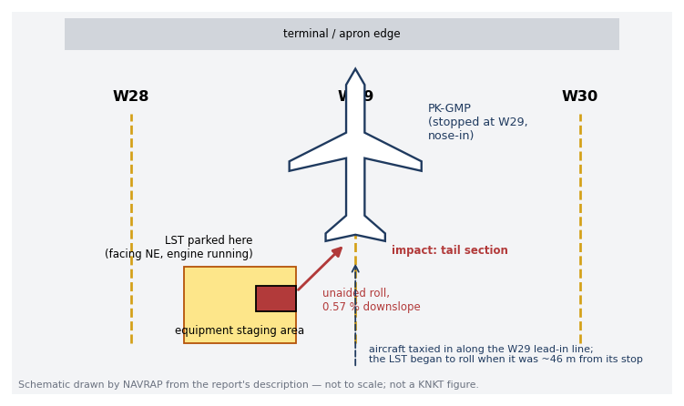
Figure A1. Schematic of the occurrence site at Apron W, parking stand W29 (not to scale)
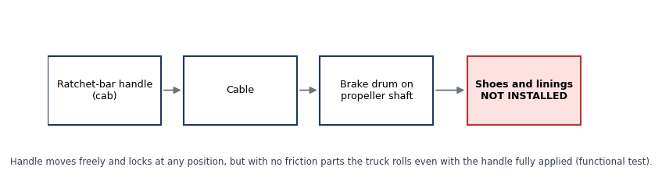
Figure A2. LST parking brake chain and the missing components (schematic)
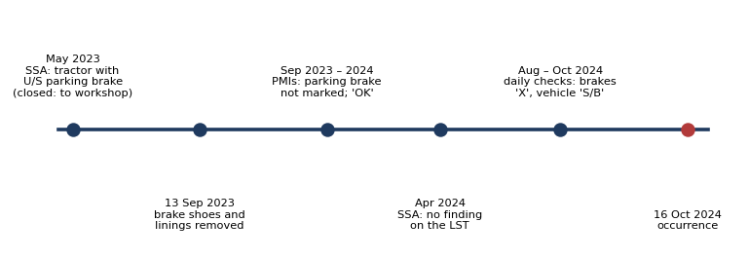
Figure A3. How the unserviceable parking brake stayed in service, September 2023 – October 2024

Appendix B — Interview summaries and witness accounts
GSE Operator 1 | Recalled setting the parking brake and placing the chock at the right aft tyre. Kept the engine running because it had been difficult to start. Went to W30 to operate the towing tractor for a departure and did not see the LST move.

GSE Operator 2 | Was in the staging area between W29 and W30, ready to chock the nose wheel and operate the lavatory service. Was watching the aircraft and could not prevent the collision.

Maintenance personnel | On standby at W29 watching the aircraft; informed the pilot after engine shutdown.

Morning-shift GSE operator | Found the parking brake unserviceable during the daily check and marked it 'X'; marked the vehicle serviceable on the understanding that wheel chocks could replace the parking brake.

Appendix C — ORLIO factor map
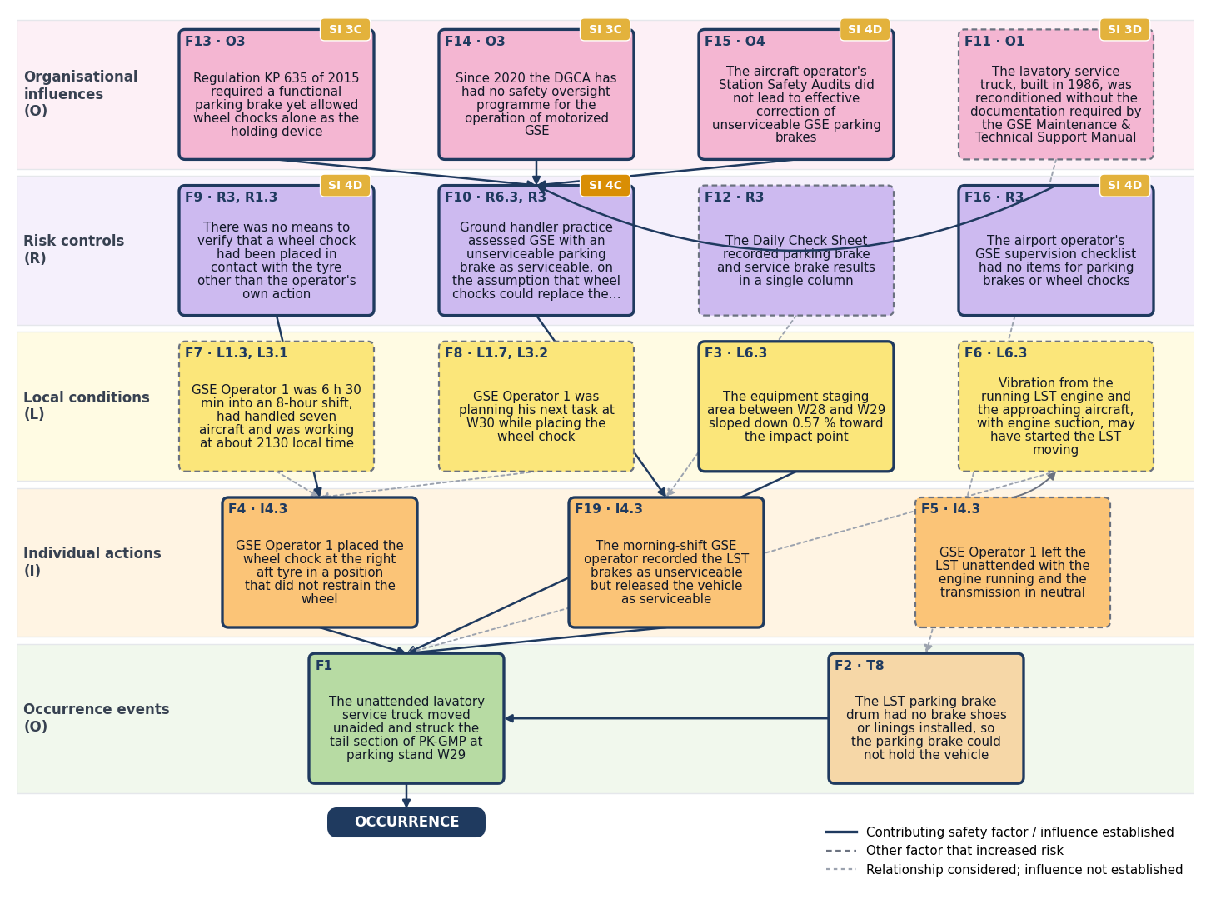
Figure C1. ORLIO factor map — solid borders are contributing safety factors, dashed borders other factors that increased risk; solid arrows show an established influence, dotted arrows a relationship considered but not established; SI badges mark safety issues with their risk index.

