Supermarket_DB Output Screenshots

This is the homepage for our supermarket where both the Customer and Admin can interact with the database.

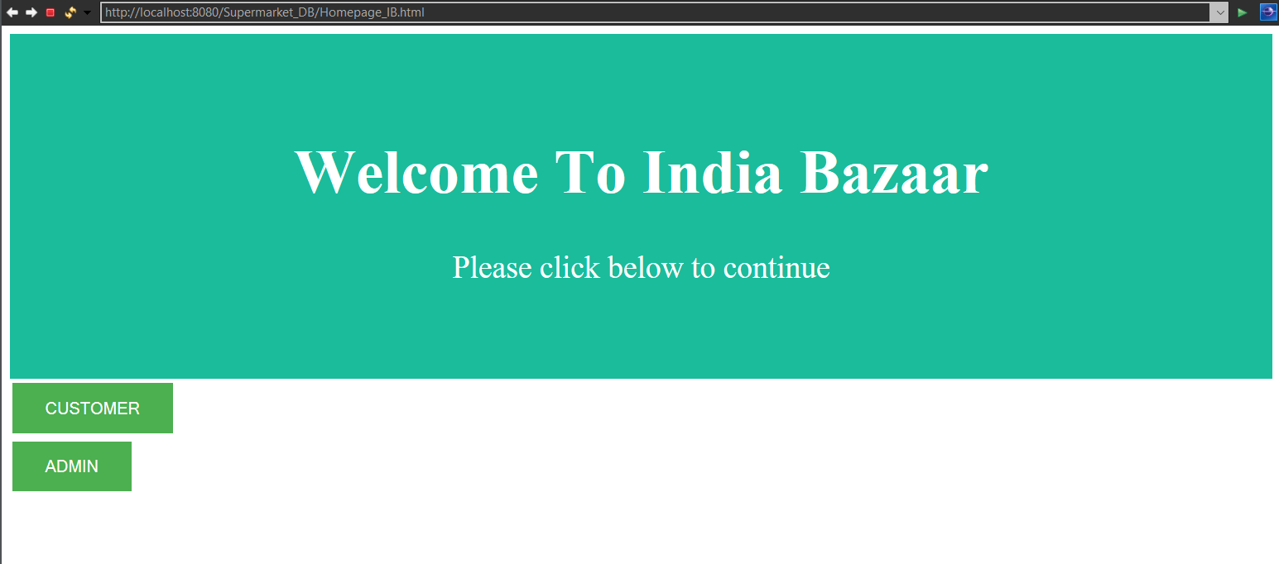

On clicking the ‘Customer’ button, the page will redirect to the ‘Customer Registration’ page where a new Customer can register by providing their Customer ID, Name and Email. Existing Customers can enter their Customer ID to view their order history.

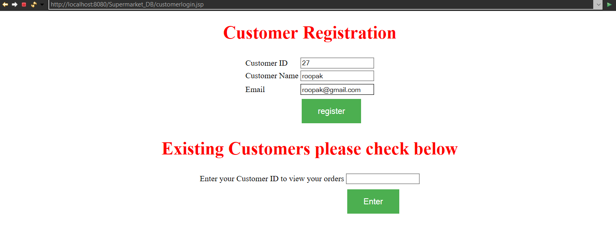

Once the data is given by the Customer, the Customer must click the ‘register’ button where they get a pop up, displaying that the registration is confirmed and the data is stored successfully.

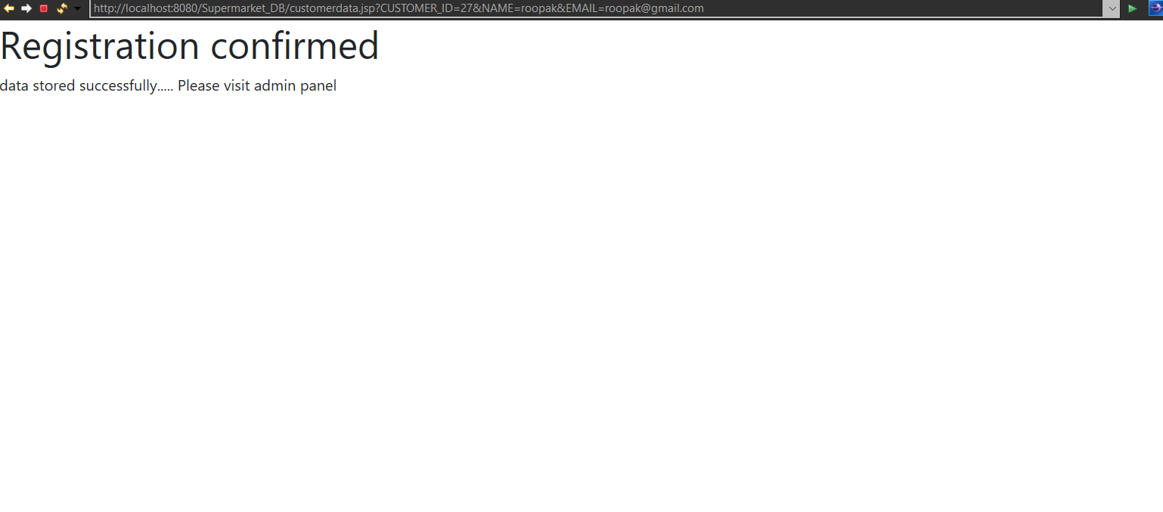

We can see that the new customer ‘roopak’ got added to the database with Customer ID ‘27’.

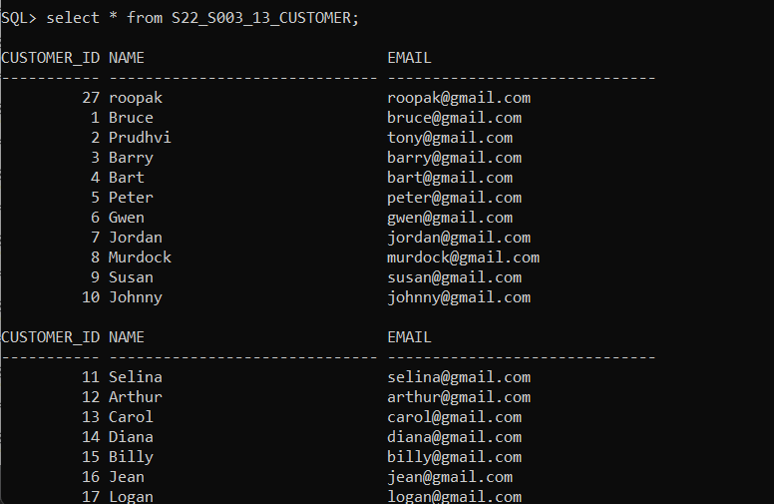

If an existing Customer enters their Customer ID, then the orders placed, earlier, by the Customer gets displayed.

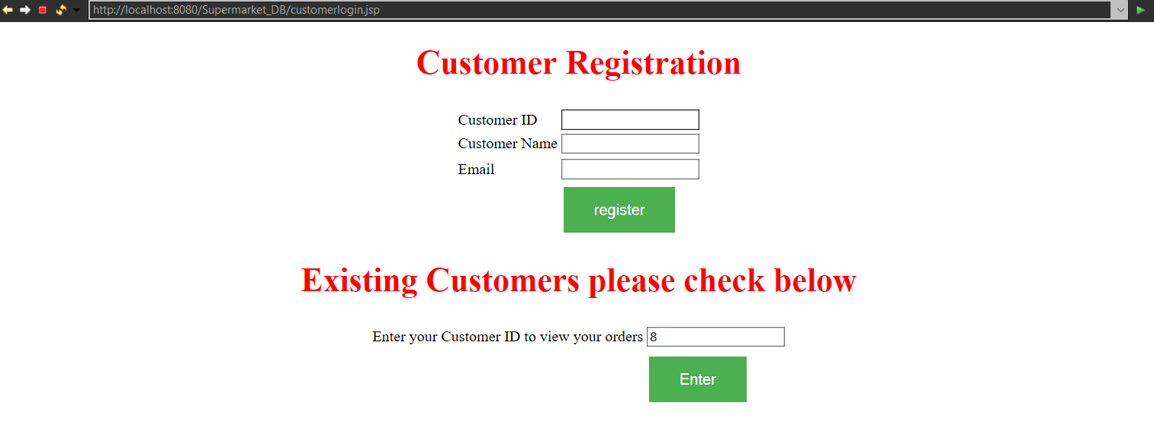

Below is the output displaying orders place by Customer with Customer ID =’8’

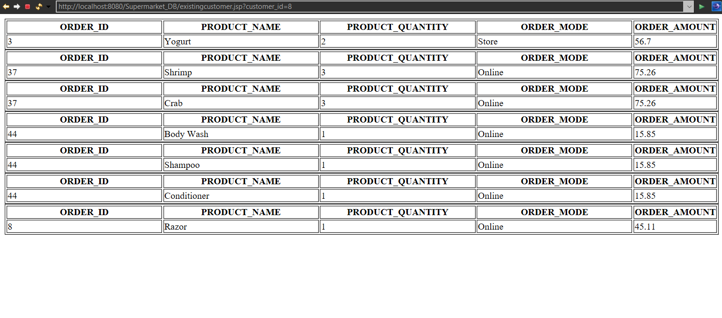

Now the Admin can access the Database by clicking on the ‘Admin’ button



Here the admin can delete the existing customer record, provide discount on a particular order, manage employee records, add new products to the database & view the reports

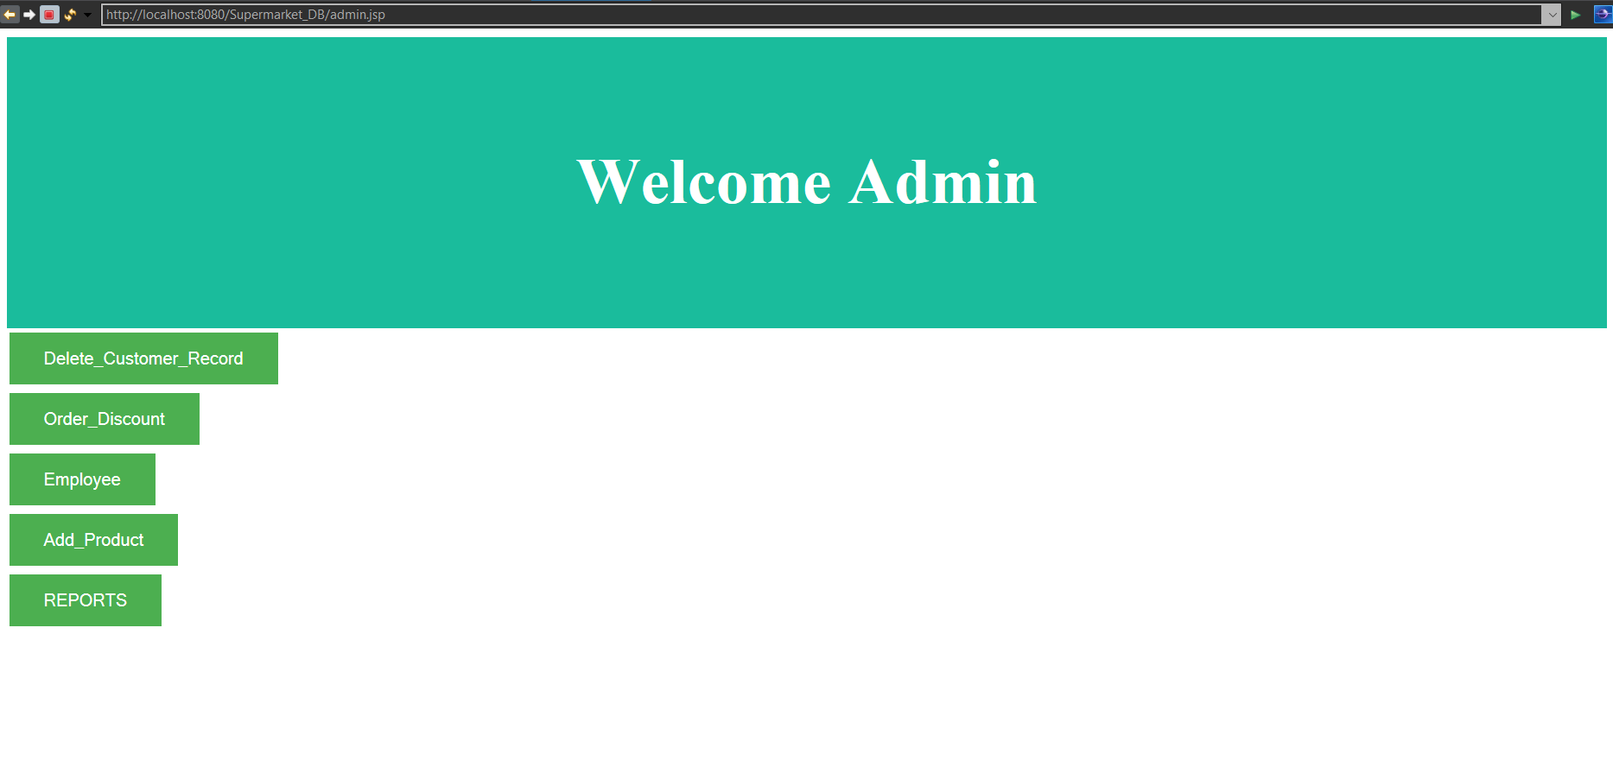

Here, the admin can enter the Customer ID to delete the customer record and then click on ‘Proceed’

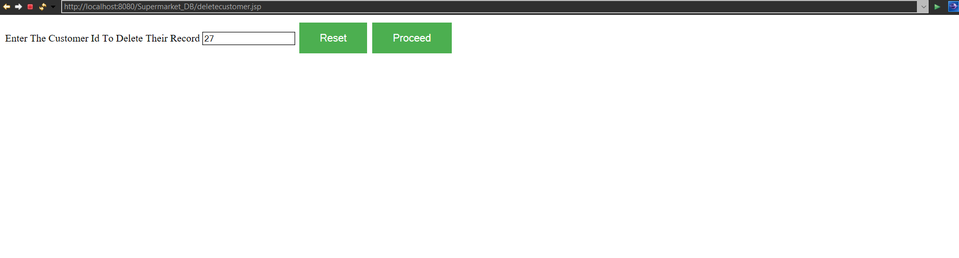

The Customer record gets removed from the database

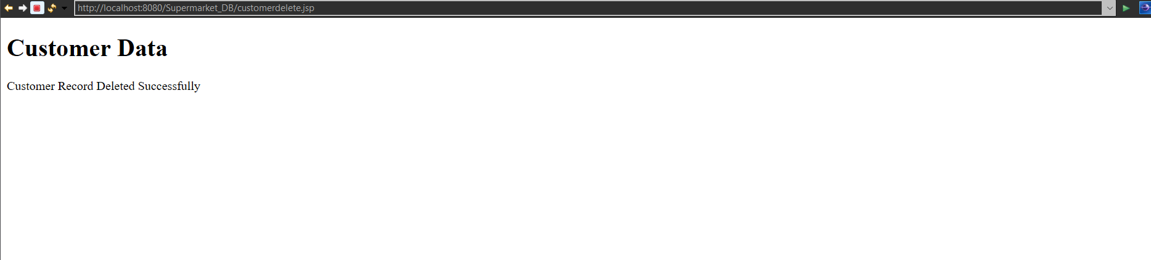

Here, the Admin can give a 25% discount on a particular Order’s Amount by entering the respective Order_ID.

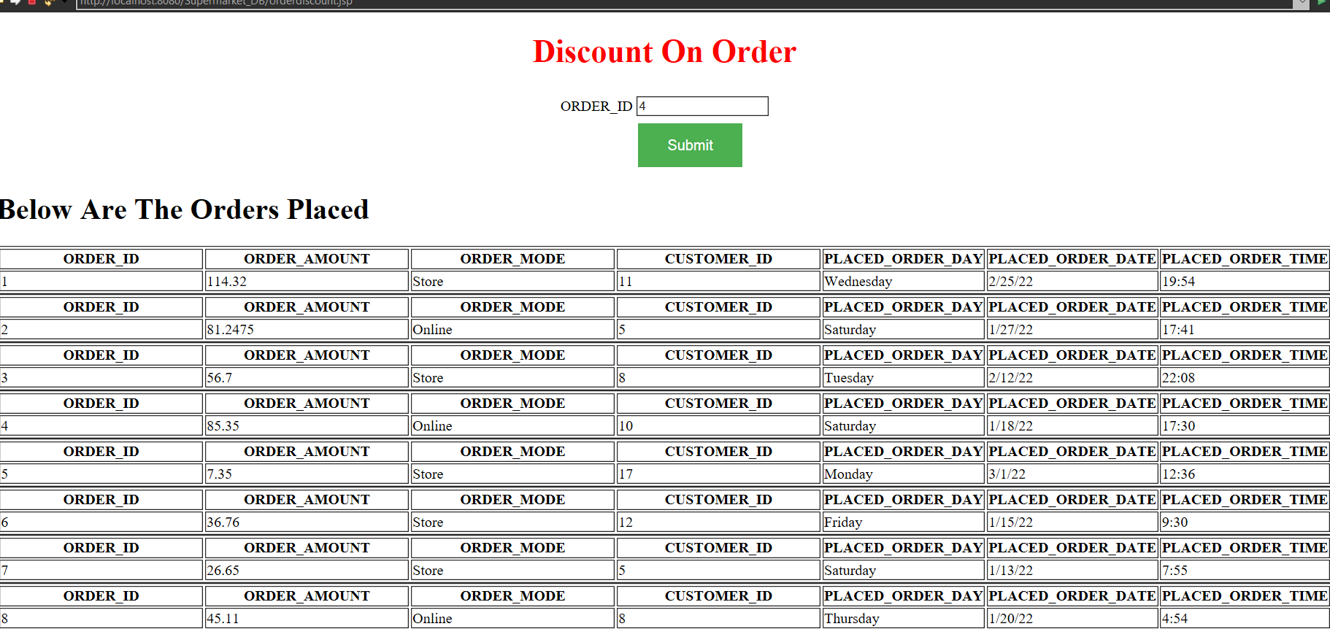

This page displays the Order Details after the Discount.

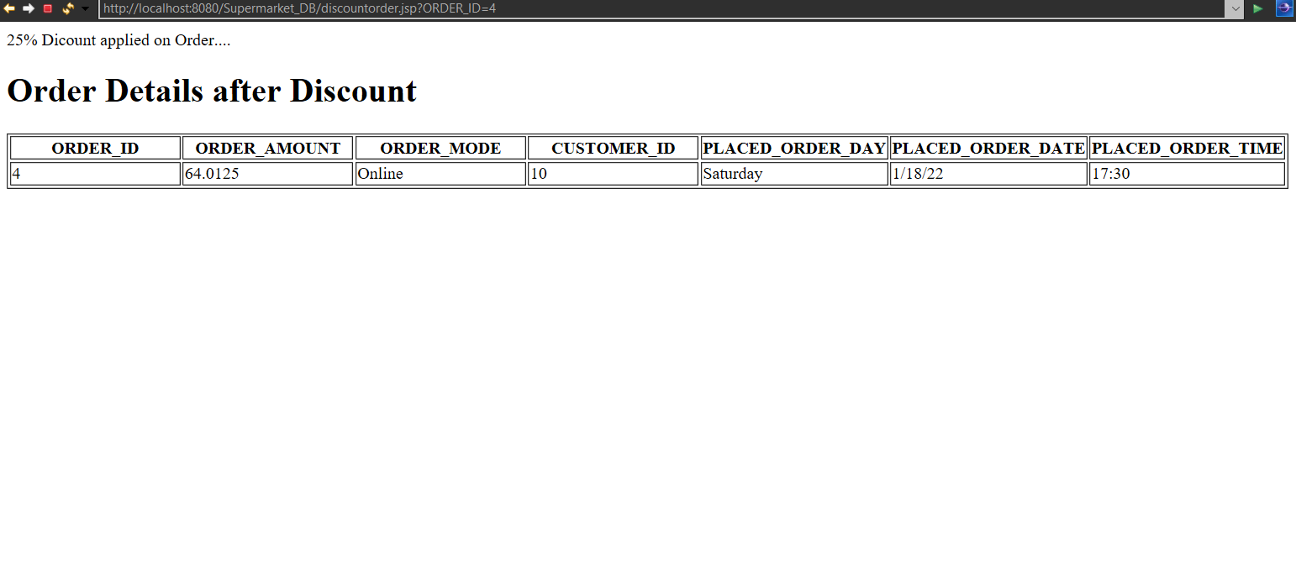

The admin can promote a particular employee by clicking the ‘Promote_Employee’ button to give a salary increment to the employee.

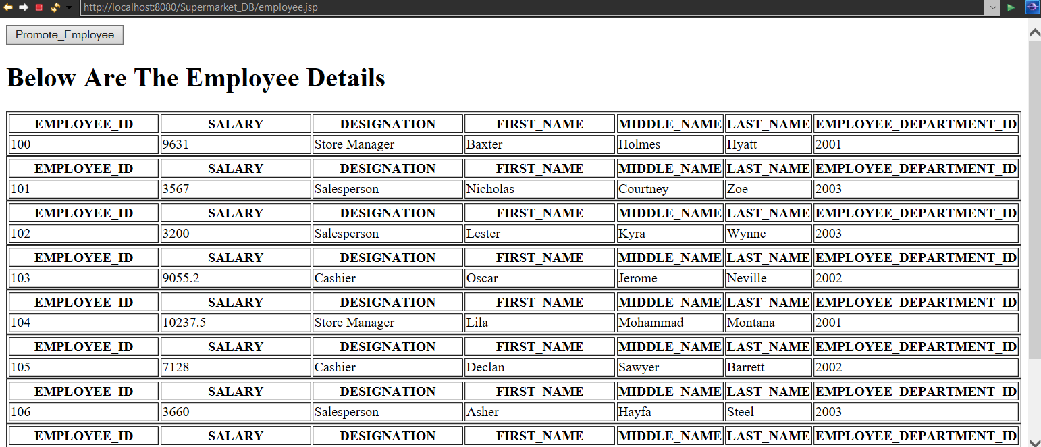

Here, the Admin should enter the ID of the Employee, to whom he/she wishes to give a salary increment, and then click on ‘Submit’ button

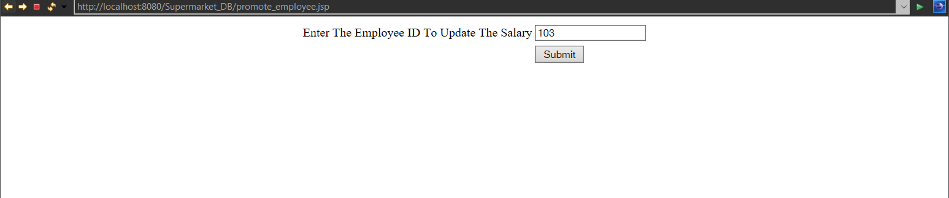

This page displays a text stating that the salary of the employee has been updated

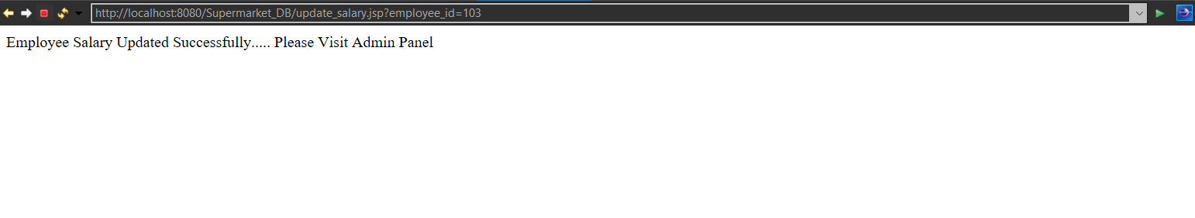

Upon clicking the ‘Add_Product’ button in the Admin page, the Admin can enter the product details to add the new product to the database.

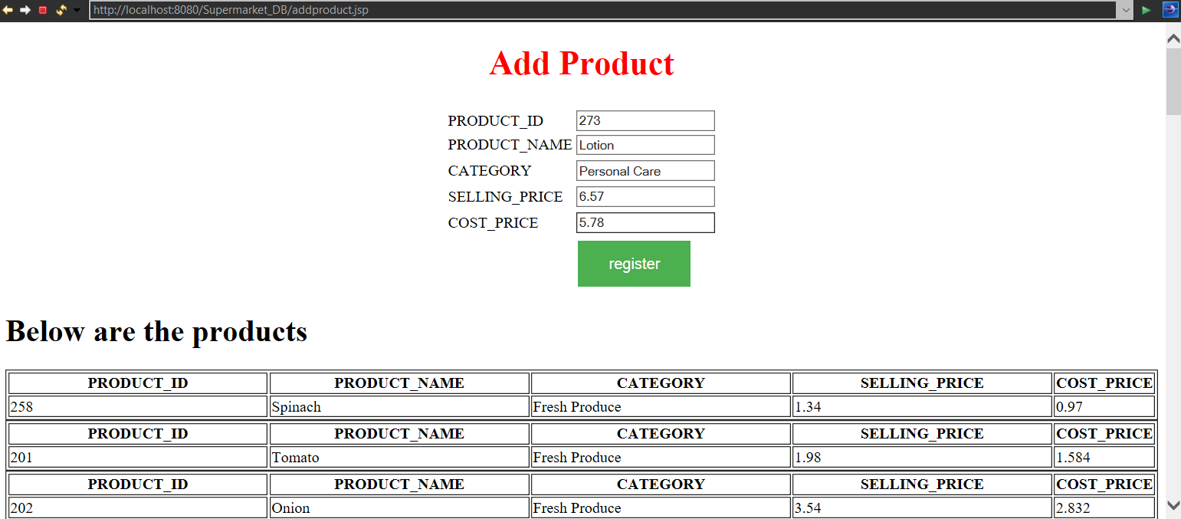

This page displays a message showing that the product is added to the database. To view the updated product table, the Admin can click on the ‘View_Product’ button.

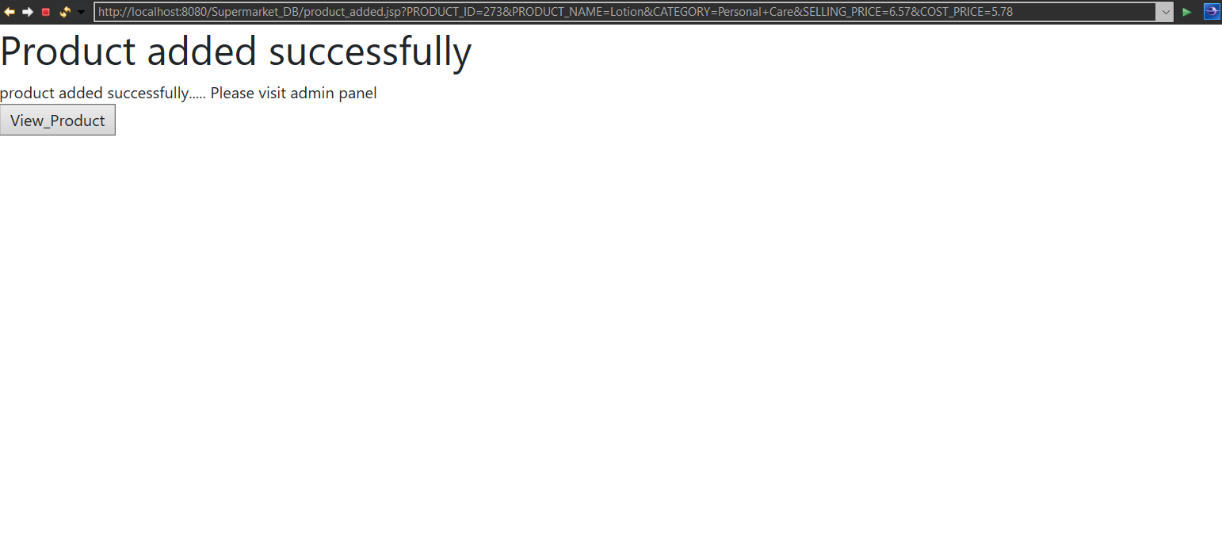

Upon clicking the ‘View_Product’ button, the product table contents get displayed. We can see that that Product ‘Lotion’ has been added to the database.

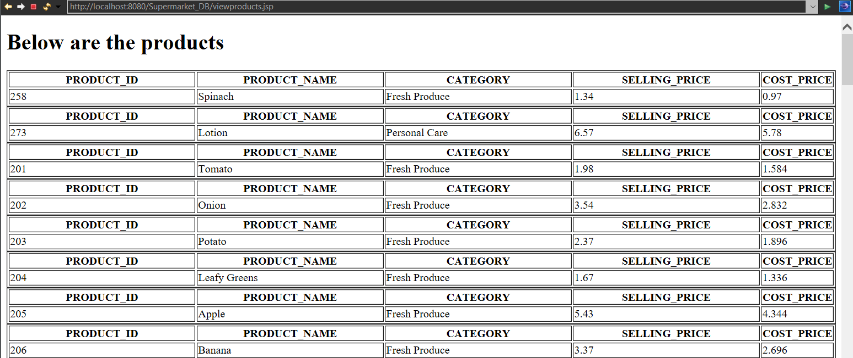

*Reports Homepage*

Upon clicking the ‘REPORTS’ button in the Admin page, the Admin can now generate the reports for every business goal by clicking on the respective ‘retrieve’ buttons

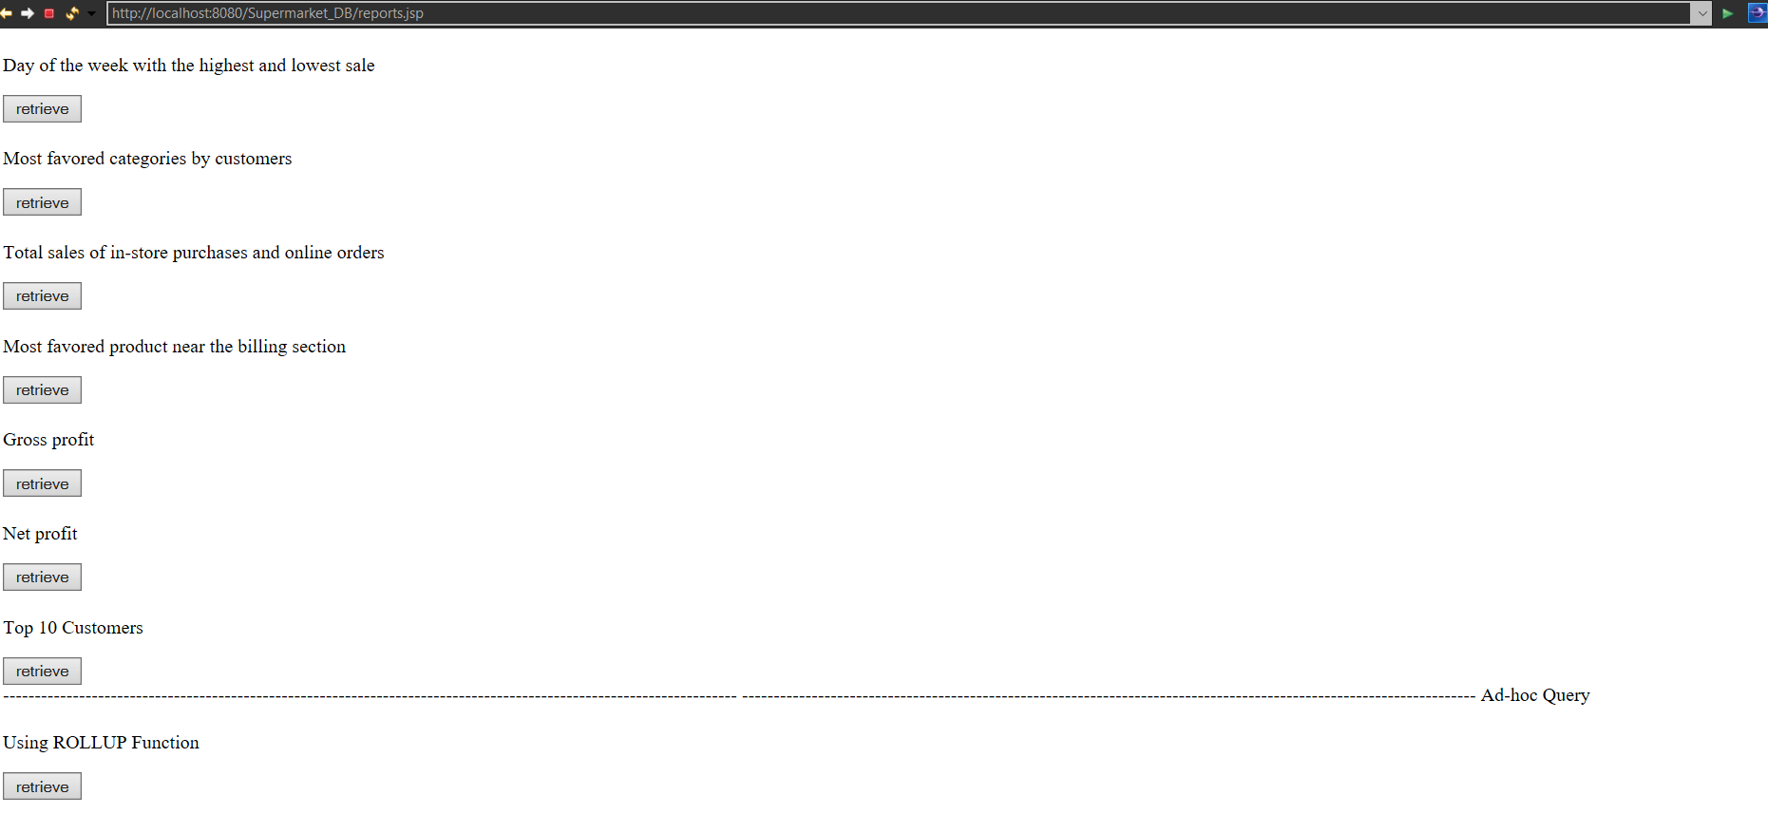

In this page, the day of the week with the highest and lowest sales is displayed along with the total amount. GROUP BY and UNION Clause was used in the query

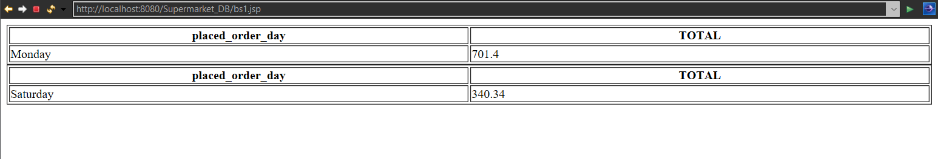

In this page, the most favoured category is displayed based on the number of purchases made for each category of products.

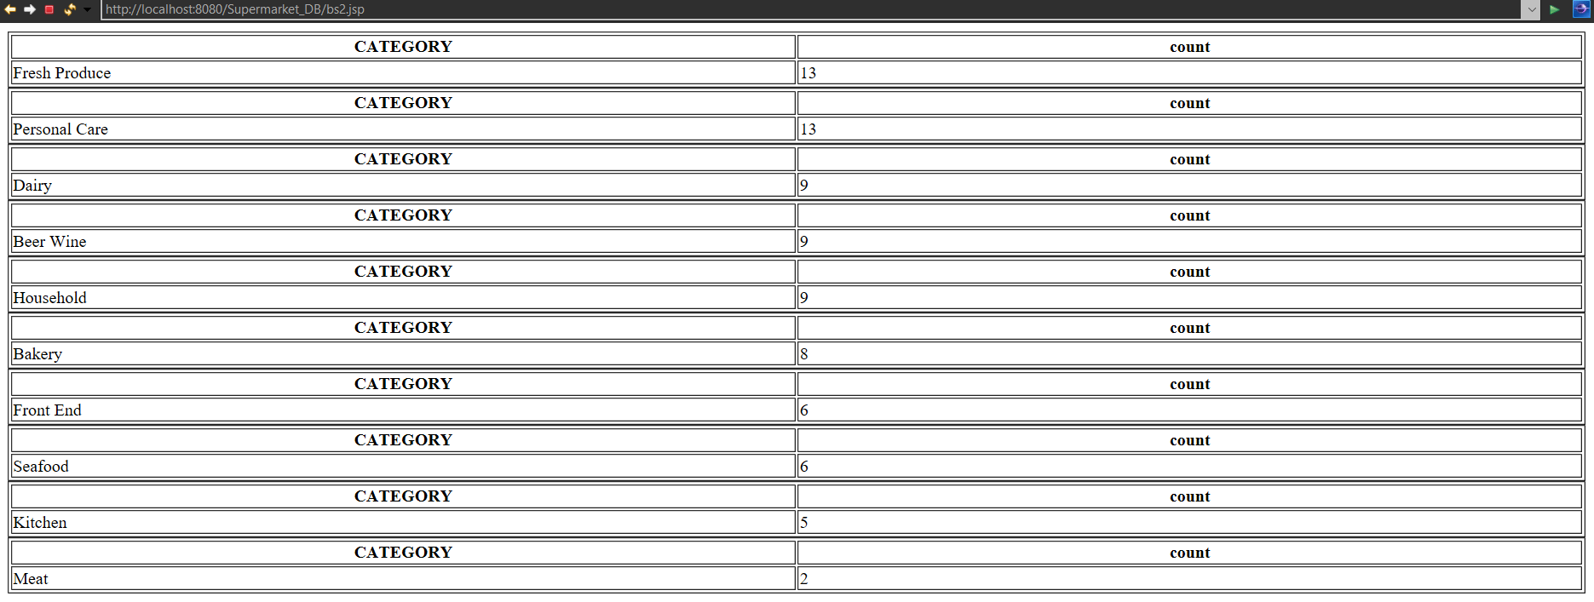

In this page, the total sales of in-store purchases and online sales is displayed.

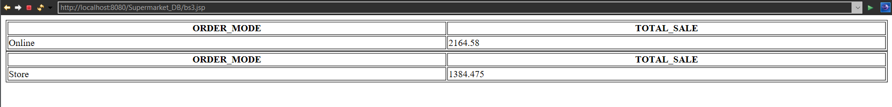

In this page, the most favoured product near the billing section is displayed. FETCH clause is used in this query.



In this page, the gross profit amount is displayed.

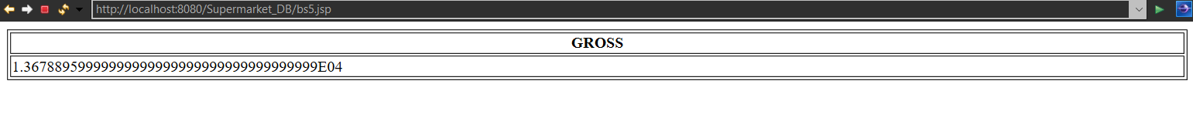

In this page, the net profit is displayed.

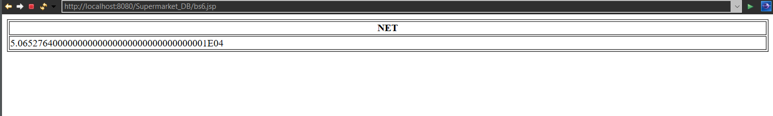

In this page, top 10 customers who’ve made the maximum number of purchases is displayed. GROUP BY & HAVING clauses are used in this query

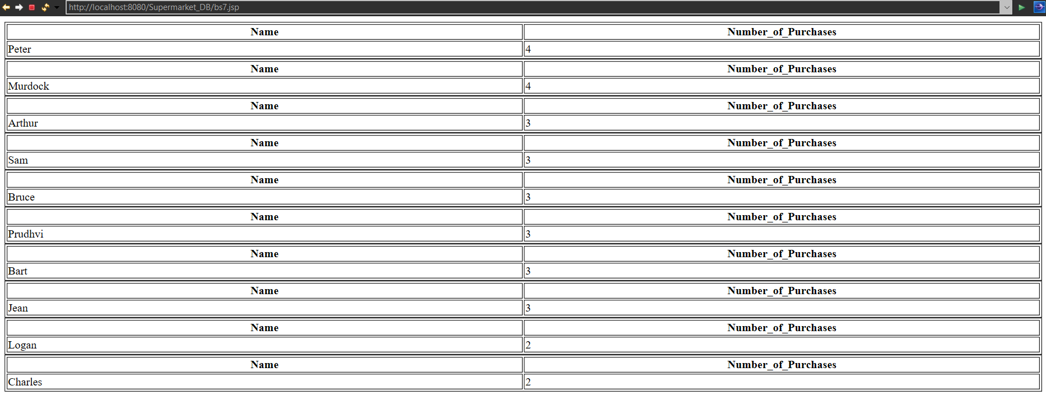

Ad-Hoc Query – Using GROUP BY ROLLUP query on Product_Name & Selling_Price

