**Skill Review I**

**Filename: average.c**

Code:

Result:

**Skill Review II**

**Filename: pag21A.c**

Code: Output:

**Filename: pag21B.c**

Code: Output:

**Filename: Mod2Sk2**

Output:

**Filename: Mod2Sk5**

Output:

**Practice Exercises:**

**Filename: posNeg.c**

**

**Filename: age.c**

Code: Output:

**Filename: switchProg.c**

Code: Output

**Skill Review III**

**Filename: assignment.c**

Code: Output:

**Filename: dayWeek.c**

Code: Output:

**Skill Review IV**

**Filename: bonus.c**

Code:

Output:

**Filename: parking.c**

Code:

Output:

**Concept Review I**

**Problem 1**

Code: Output:

**Problem 2**

Code: Output:

**Problem 3**

Code: Output:

**Concept Review 2**

**Problem 1**

Code: Output:

**Problem 1**

Code: Output:

**Practice Exercises:**

**Filename: forProg.c**

Code: Out:

**Filename: nested.c**

Code:

Out:

**Filename: multiples.c**

Code: Out:

**Filename: reverse.c**

Code: Out:

**Filename: yorn.c**

Code:

Out:

**Skill Review IV**

**Filename: doubles.c**

Code:

Output:

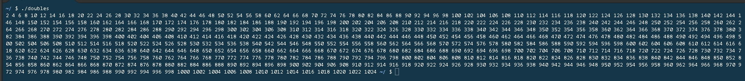

**Filename: factorial.c**

Code: Output:

**Filename: score.c**

Code: Output:

**Practice Exercises:**

**Filename: function1.c**

Code: Output:

**Filename: function2.c**

Code: Output:

