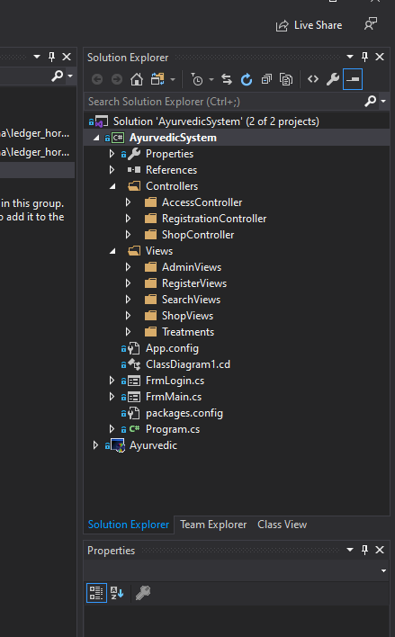

fu ol=kq me;af;ka ;sfhk solution explorer tfla ;uhs yeu interface tllau " class tllau ;sfhkafk .

fïfl fï views lsh, folder tl we;=f, ;sfhkafk interface ú;rhs' controllers tfla ;uhs ;sfhkafk database tlal jev lrk functions.