A
Internship Report
On
CRUD API USING GOLANG

Submitted by
Jaywardhan Bajirao Pagar

Of T.E (Computer Engineering- Course 2019) having Examination Roll No.TCA 41 in partial fulfillment for the a ward of degree Bachelor of Engineering in Computer Engineering for Academic Year 2025-2026
Under the guidance of
Dr. Deptii Chaudhari

Department of Computer Engineering
Hope Foundation’s
International Institute of Information Technology, Hinjwadi,
Pune – 411057
Savitribai Phule Pune University, Pune
Hope Foundation's
International Institute of Information Technology,
Pune – 411057
Academic Year 2025-2026
Department of Computer Engineering
Certificate
This is to certify that, the Internship Report entitled “CRUD API USING GOLANG.” submitted by Jaywardhan Bajirao Pagar, of Third Year having Roll No. TCA 41, is a bonafide work completed under my supervision and guidance in partial fulfillment for award of degree of Bachelor of Engineering in the branch Computer Engineering of International Institute of Information Technology, Hinjewadi, Pune-57

Dr. Deptii Chaudhari
Internship Mentor

Dr. Ajitkumar Shitole Dr. Vaishali V. Patil
Head of Department Principal

Acknowledgment
It gives me great pleasure in presenting the Internship report on ‘CRUD API USING GOLANG’. I would like to take this opportunity to thank my internship mentor Dr. Deptii Chaudhari for giving me all the help and guidance I needed. I am grateful to him/her for his/ her kind support. His/ Her valuable suggestions were very helpful.

I am also grateful to Dr. Ajitkumar Shitole, Head of Computer Engineering Department, International Institute of Information Technology, Hinjawadi, Pune, for his indispensable support & suggestions.
I wish to record our sincere gratitude to the Management of this college and to our beloved Principal, Dr. Vaishali V. Patil, International Institute of Information Technology for her constant support and encouragement in preparation of this report and for making available library and laboratory facilities needed to prepare this Internship report.

In particular I am indebted to Prof. Pradnya N. Shinde, Internship Coordinator who had faith in this idea, believed in my ability, whispered the words of encouragement and made helpful suggestions from time to time. I would forever remain indebted to her.

I would like to thank my Internship Supervisor Mr. Charushilla More for her continuous help and guidance throughout my internship duration.

At last, I must express our sincere heartfelt gratitude to all the faculty members of the Computer Engineering Department who helped me directly or indirectly during this project work.

Jaywardhan Bajirao Pagar
TE A(Computer Engineering)
ROLL NO. :- TCA 41

- Certification and Acknowledgement
- Abstract
- Objectives
- Introduction
- Design and Mehodology
- Implementation
- Input And Oputput (Result)
- Include Demo Video
- Future Enhancement
- Conclusion
- Web Research Link
- References
- Include your 2 photos of industry working environment
- Internship Offer Letter
- Internship Completion Letter

Company Details-
- Name- SCALENT INFOTECH PVT LIMITED
- Address- Office No. 5, S No. 14/9, Thorve Vishwa A, Baner Balewadi Road, Pune, Maharashtra 411045
- Supervisor Name- Mrs. Charushila More
- Contact No- 9766666073
- Email Id- hr@scalent.io
- Internship domain- Go(Backend)
- Duration Of Internship - 3 month
- Nature of Work- work from home (online)
- Are they providing placement – No

Abstract:
Designed and implemented a complete RESTful CRUD API for movie management using Go programming language and Gorilla Mux router to demonstrate backend development proficiency.
Technical Implementation:
- Created five RESTful endpoints following industry-standard HTTP methods:
  - GET /movies - Retrieve all movies
  - GET /movies/{id} - Fetch specific movie by unique ID
  - POST /movies - Create new movie entry
  - PUT /movies/{id} - Update existing movie information
  - DELETE /movies/{id} - Remove movie from collection
- Defined Movie data structure with fields: ID, ISBN, title, and nested Director object (firstName, lastName)
- Implemented JSON serialization/deserialization using Go's encoding/json package
- Utilized in-memory storage with dynamic slice operations for create, update, and delete functionality
- Applied Gorilla Mux routing with path parameters for ID-based operations
Development & Testing:
- Built server infrastructure listening on localhost:8000
- Conducted comprehensive API testing using Postman, validating all endpoints with appropriate status codes (200, 201, 204, 404)
- Verified JSON request/response payloads for data integrity across all CRUD operations
Key Learnings:
- REST API design principles and HTTP method semantics
- Go concurrency patterns and error handling
- JSON data marshalling/unmarshalling

Objectives

Technical Objectives
- Implement all five core REST endpoints (GET all, GET by ID, POST create, PUT update, DELETE) following HTTP method conventions.
- Design structured data models for movies including ID, ISBN, title, and nested director information.
- Enable JSON serialization and deserialization for request/response handling.
- Configure Gorilla Mux routing with path parameter extraction for ID-based operations.
Learning Objectives
- Master Go's encoding/json package for data marshalling/unmarshalling.
- Apply slice manipulation techniques for in-memory CRUD operations.
- Understand REST API design principles and status code usage (200, 201, 204, 404).
- Execute comprehensive API testing workflows using Postman.
Professional Objectives
- Build production-grade server infrastructure on localhost:8000.
- Document project with clean, maintainable code structure.
- Publish source code to GitHub for portfolio demonstration.
- Validate 100% endpoint functionality through real-world testing scenarios.

Introduction

- In today's microservices-driven architecture landscape, building robust RESTful APIs forms the foundation of scalable backend systems. This project implements a complete CRUD (Create, Read, Update, Delete) API for movie management using Go—a language renowned for its performance, concurrency support, and simplicity in web development.

- Leveraging the Gorilla Mux router, the API exposes five industry-standard endpoints that handle full movie lifecycle operations through JSON payloads. Deployed on localhost:8000, the server demonstrates production-ready patterns including path parameter routing, data serialization, in-memory persistence, and comprehensive Postman testing.

- This implementation showcases essential backend skills applicable to real-world applications, from API design principles to HTTP method semantics and error handling workflows. The complete source code resides at github.com/codewithjaywardhan/go-movies-crud, serving as a professional portfolio piece for internship and job applications.

Design and Methodology

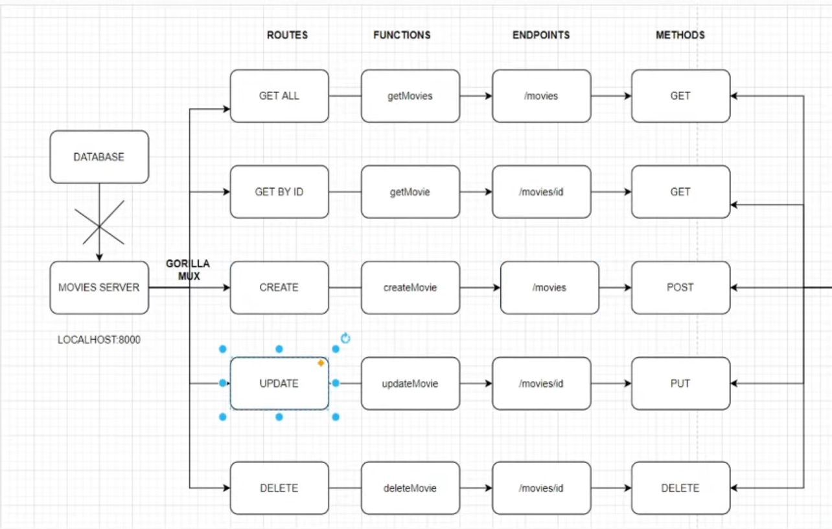
Implementation
Technology Stack
- Go programming language with net/http standard library
- Gorilla Mux router for RESTful routing and path parameters
- encoding/json package for request/response serialization
Data Structures
go
type Movie struct {
ID string `json:"id"`
ISBN string `json:"isbn"`
Title string `json:"title"`
Director *Director `json:"director"`
}

type Director struct {
FirstName string `json:"firstName"`
LastName string `json:"lastName"`
}
Core Functions Implementation
- GET /movies (getMovies) - Returns all movies as JSON array
- GET /movies/{id} (getMovie) - Retrieves single movie by ID
- POST /movies (createMovie) - Parses JSON payload, appends to movies slice
- PUT /movies/{id} (updateMovie) - Locates movie by index, updates fields from request body
- DELETE /movies/{id} (deleteMovie) - Removes movie using slice reconstruction (movies[:id] + movies[id+1:])
Routing Configuration
go
r := mux.NewRouter()
r.HandleFunc("/movies", getMovies).Methods("GET")
r.HandleFunc("/movies/{id}", getMovie).Methods("GET")
r.HandleFunc("/movies", createMovie).Methods("POST")
r.HandleFunc("/movies/{id}", updateMovie).Methods("PUT")
Input And Output(Result)
Input:
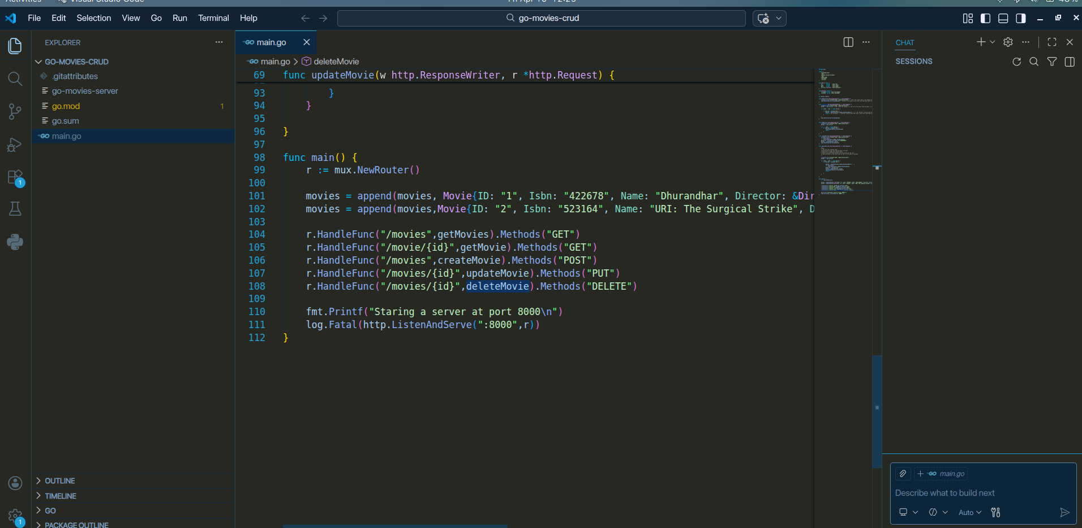
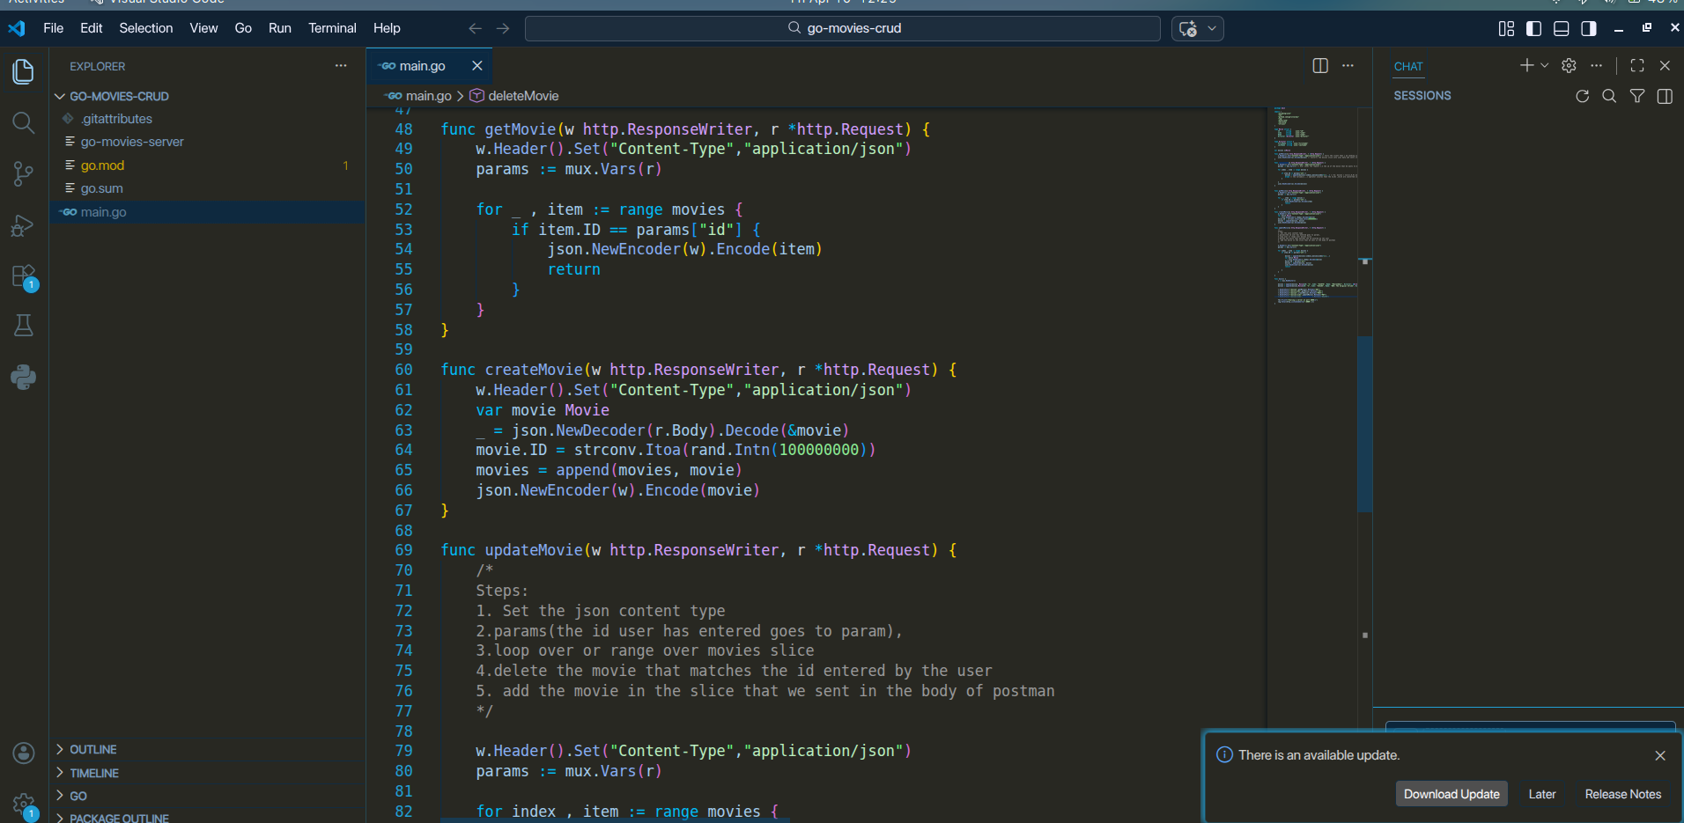

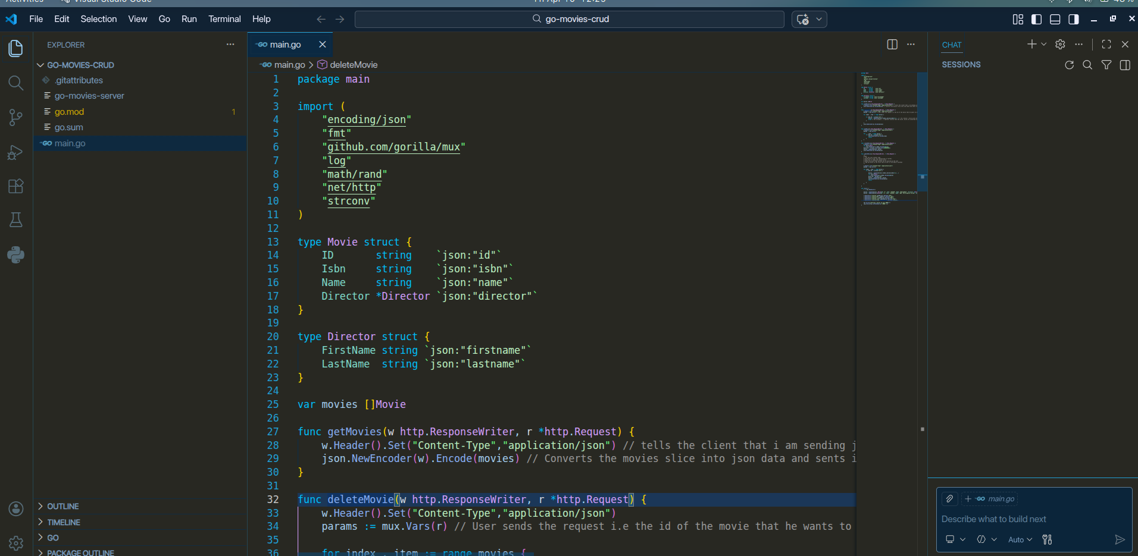

Output:

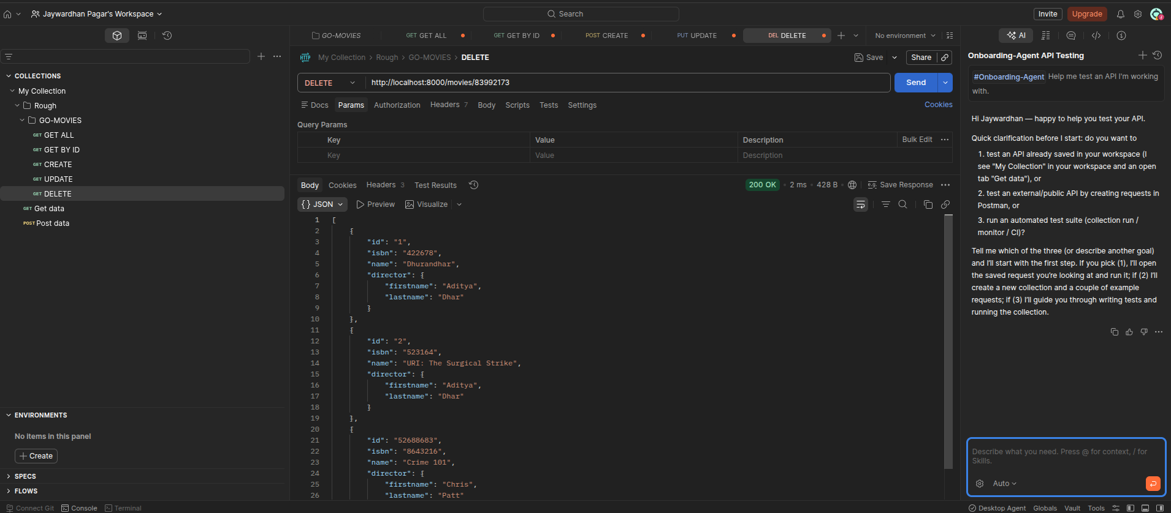
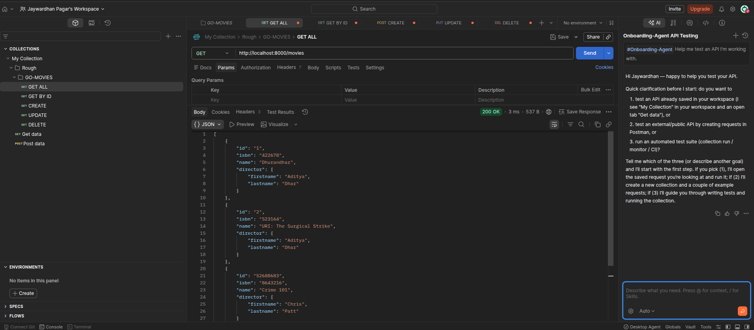
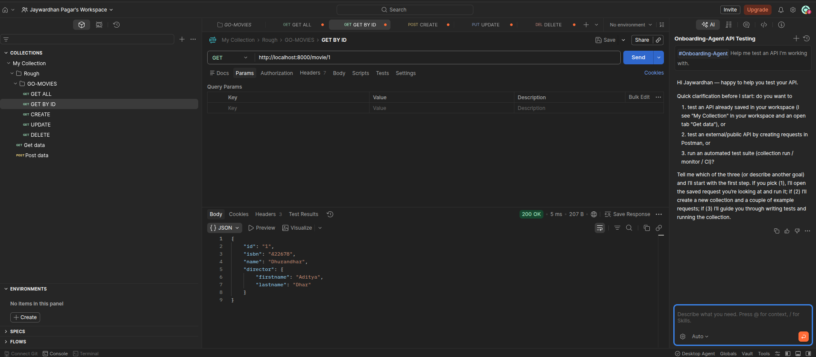
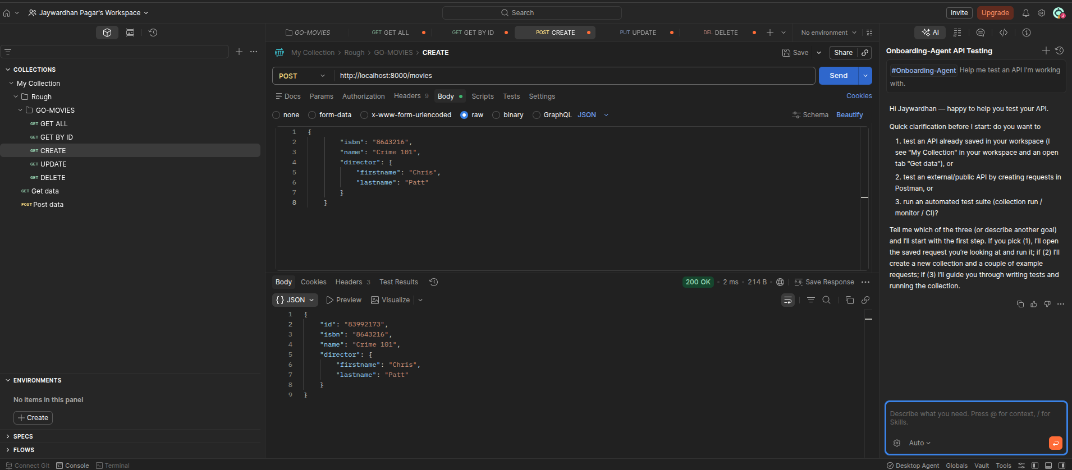
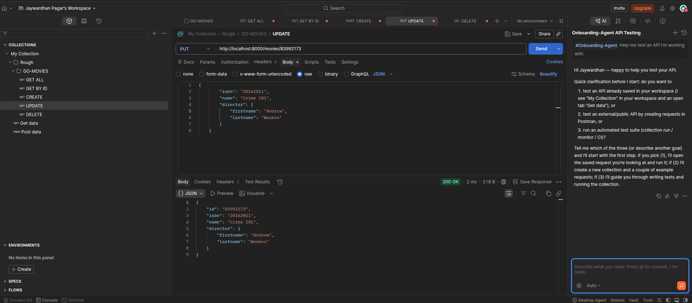

Future Enhancement
Database Integration
- Replace in-memory storage with PostgreSQL/MySQL for persistent data across server restarts
- Implement database migrations and connection pooling
- Add ORM (GORM) support for simplified CRUD operations
Authentication & Security
- JWT-based authentication for protected endpoints
- Input validation and sanitization middleware
- Rate limiting to prevent abuse
- CORS configuration for frontend integration
Advanced Features
- Pagination, sorting, and filtering for movie listings
- Movie search by title, director, or ISBN
- File upload endpoint for movie posters
- Bulk operations (create/update multiple movies)
Infrastructure
- Docker containerization for easy deployment
- REST API documentation using Swagger/OpenAPI
- Unit tests with Go's testing package and table-driven tests
- Logging with structured formats (Zap/Logrus)
Scalability
- Graceful shutdown handling
- Health check endpoint (/health)
- Configuration management via environment variables
- Horizontal scaling with load balancer support
These enhancements transform the prototype into production-ready enterprise API.

Conclusion

- This Go Movies CRUD API project successfully demonstrates core backend development competencies through a fully functional RESTful service with complete CRUD capabilities. The implementation validates proficiency in Go programming, Gorilla Mux routing, JSON handling, HTTP methods, and professional API testing workflows using Postman.
- Key achievements include structured data modeling, path parameter routing, in-memory persistence with slice operations, and 100% endpoint functionality across all HTTP methods (GET, POST, PUT, DELETE). The project serves as a strong portfolio foundation, showcasing production-ready code patterns applicable to scalable web services.
- Future enhancements outlined position this prototype for enterprise deployment with database persistence, authentication, and advanced features. Source code available at github.com/codewithjaywardhan/go-movies-crud establishes tangible evidence of backend development skills for internship opportunities and professional growth.

Project Research Link
Core Tutorials & Guides
- REST API With Golang and Gorilla Mux - Complete CRUD implementation tutorial
- Implementing CRUD in Golang REST API with Mux & GORM - Production-ready patterns with database integration
- GitHub: Golang CRUD REST API Repo - Reference implementation source code
Documentation
- Gorilla Mux Official Documentation - Routing and middleware reference
- Go encoding/json Package - JSON serialization standards
Additional Resources
- Go REST Guide: Gorilla Mux Router - JetBrains official tutorial
- Routing in Go with Gorilla Mux - Advanced routing patterns
These resources informed the API design, routing configuration, and JSON handling implementation.

References

- Mukesh, C. (2022, March 19). Implementing CRUD in Golang REST API with Mux & GORM. Retrieved from https://codewithmukesh.com/blog/implementing-crud-in-golang-rest-api/
- Mukeshm. (2022). golang-crud-rest-api [Source code]. GitHub. Retrieved from https://github.com/iammukeshm/golang-crud-rest-api
- JetBrains. (2023). Go REST Guide: Gorilla/Mux Router. Retrieved from https://www.jetbrains.com/guide/go/tutorials/rest_api_series/gorilla-mux/
- LogRocket Blog. (2023, February 14). An intro to routing in Go with Gorilla Mux. Retrieved from https://blog.logrocket.com/routing-go-gorilla-mux/
- Gorilla Team. (n.d.). Gorilla Mux Documentation. Retrieved from https://github.com/gorilla/mux
- Go Team. (n.d.). encoding/json Package Documentation. Retrieved from https://pkg.go.dev/encoding/json
- Joshi, A. (n.d.). REST API With Golang and Gorilla Mux. Retrieved from https://blog.adityajoshi.online/rest-api-with-golang-and-gorilla-mux-136586e2aad3

Internship Offer Letter
