Banking Risk Analysis Report
1. Project Overview
This project focuses on risk analysis in the banking domain using a structured customer-level dataset. The objective is to understand customer risk profiles, identify key drivers of financial risk, and extract actionable insights that can support credit risk management, customer segmentation, and strategic decision-making.
The analysis is aligned with real-world banking use cases such as loan approval, portfolio risk monitoring, and customer value assessment.

2. Dataset Description
- Total Records: 3,000 customers
- Total Features: 25
- Data Type: Structured (Numerical + Categorical)
- Granularity: Individual banking customers
Key Feature Groups
Customer Demographics
- Client ID, Name, Age, GenderId, Nationality, Occupation, Location ID
Banking Relationship Information
- Joined Bank (tenure)
- Banking Contact
- Fee Structure
- Loyalty Classification
Financial Attributes
- Estimated Income
- Superannuation Savings
- Credit Card Balance
- Bank Loans
- Bank Deposits
- Checking Accounts
- Saving Accounts
- Foreign Currency Account
- Business Lending
Risk Indicators
- Properties Owned
- Amount of Credit Cards
- Risk Weighting (Target variable for risk analysis)

3. Business Problem Statement
Banks face continuous exposure to credit and financial risk due to customer borrowing behavior, asset distribution, and income stability. The key challenge is to:
- Identify high-risk customers
- Understand financial patterns linked to higher risk
- Support risk-based customer segmentation
This analysis aims to answer:
- What type of customers carry higher risk weightings?
- How do income, loans, and deposits influence risk?
- Are loyal or premium customers less risky?

4. Data Quality & Preprocessing
Data Quality Checks
- No missing values across all columns
- Correct data types for numerical and categorical variables
- Unique Client IDs ensure no duplicate customer records
Preprocessing Steps
- Converted date-related fields (Joined Bank) into tenure-based insights
- Encoded categorical variables for analysis where required
- Checked numerical distributions for skewness and outliers
The dataset was found to be clean and analysis-ready.

5. Exploratory Data Analysis (EDA)
5.1 Demographic Insights
- Majority of customers fall within the young-to-middle age group, indicating an active working population
- Certain occupations show higher exposure to loans and credit usage
- Property ownership is unevenly distributed and strongly linked to risk
5.2 Financial Behavior Analysis
Income vs Risk
- Customers with lower estimated income and higher loan amounts tend to have higher risk weighting
- Higher income alone does not guarantee lower risk unless supported by strong savings and deposits
Loans & Credit Cards
- Risk increases with:
  - Higher number of credit cards
  - Large outstanding credit card balances
  - Heavy dependence on bank loans
Assets & Savings
- Customers with:
  - Higher bank deposits
  - Strong saving account balances
  - Multiple owned properties
generally exhibit lower risk profiles

6. Risk Weighting Analysis
Risk Weighting acts as the core dependent variable in this project.
Observed Patterns
- High Risk Customers:
  - High loan exposure
  - Low savings-to-loan ratio
  - Multiple credit cards with high balances
- Low Risk Customers:
  - Strong deposit and savings base
  - Long-term banking relationship
  - Higher loyalty classifications (Gold, Platinum)
Risk is not driven by a single factor but by a combination of income stability, liabilities, and asset ownership.

7. Customer Segmentation from Risk Perspective
Based on EDA, customers can be grouped into:
- Low-Risk / High-Value Customers
  - High income
  - High deposits & savings
  - Low loan dependency
- Medium-Risk Customers
  - Balanced income and loans
  - Moderate savings
- High-Risk Customers
  - High loan-to-income ratio
  - High credit card utilization
  - Low asset ownership
This segmentation can directly support risk-based pricing and credit decisions.

8. Business Insights & Recommendations
Key Insights
- Loan exposure is the strongest driver of customer risk
- Asset ownership significantly reduces risk weighting
- Loyalty classification can be used as a proxy for financial stability
Recommendations
- Introduce stricter credit policies for customers with high loan-to-savings ratios
- Offer financial planning products to medium-risk customers to reduce future risk
- Prioritize low-risk, high-value customers for premium banking services

9. Conclusion
This risk analysis project demonstrates how customer-level banking data can be leveraged to identify risk patterns, segment customers, and improve financial decision-making. By combining demographic, financial, and behavioral indicators, banks can move toward a more proactive and data-driven risk management approach.
The insights derived from this analysis are highly applicable to real-world banking scenarios such as credit scoring, portfolio monitoring, and customer lifetime value assessment.

10. Tools & Technologies
- Python (Pandas, NumPy, Matplotlib, Seaborn)
- Jupyter Notebook
- Exploratory Data Analysis (EDA)
- Statistical Analysis
- Power BI

======================================================================
BANK RISK ANALYSIS - KEY INSIGHTS SUMMARY
======================================================================

1. RISK DISTRIBUTION:
- Total Clients: 3000
- High Risk Clients: 942 (31.40%)
- Medium Risk Clients: 2058 (68.60%)
- Low Risk Clients: 0 (0.00%)

2. AGE ANALYSIS:
- Risk Level 1: Average Age = 50.9 years
- Risk Level 2: Average Age = 51.2 years
- Risk Level 3: Average Age = 51.0 years
- Risk Level 4: Average Age = 51.0 years
- Risk Level 5: Average Age = 50.7 years

3. INCOME ANALYSIS:
- Risk Level 1: Average Income = $77,539.98
- Risk Level 2: Average Income = $159,256.78
- Risk Level 3: Average Income = $246,057.65
- Risk Level 4: Average Income = $284,741.65
- Risk Level 5: Average Income = $310,040.98

4. CREDIT CARD EXPOSURE:
- Average Credit Cards per Client: 1.46
- Clients with 3 or + Credit Cards: 313 (10.43%)

5. LOAN TO DEPOSIT RATIO:
- Risk Level 1: Average Ratio = 4162.86
- Risk Level 2: Average Ratio = 10074.68
- Risk Level 3: Average Ratio = 6143.58
- Risk Level 4: Average Ratio = 24581.33
- Risk Level 5: Average Ratio = 6614.36

6. CUSTOMER TENURE:
- Risk Level 1: Average Tenure = 13.7 years
- Risk Level 2: Average Tenure = 13.4 years
- Risk Level 3: Average Tenure = 13.2 years
- Risk Level 4: Average Tenure = 14.2 years
- Risk Level 5: Average Tenure = 12.1 years

7. TOP RISK FACTORS (Correlation with Risk):
- Risk Weighting: 1.0000
- Estimated Income: 0.6647
- Bank Loans: 0.4218
- Credit Card Balance: 0.3997
- Risk_Score: 0.0823

======================================================================

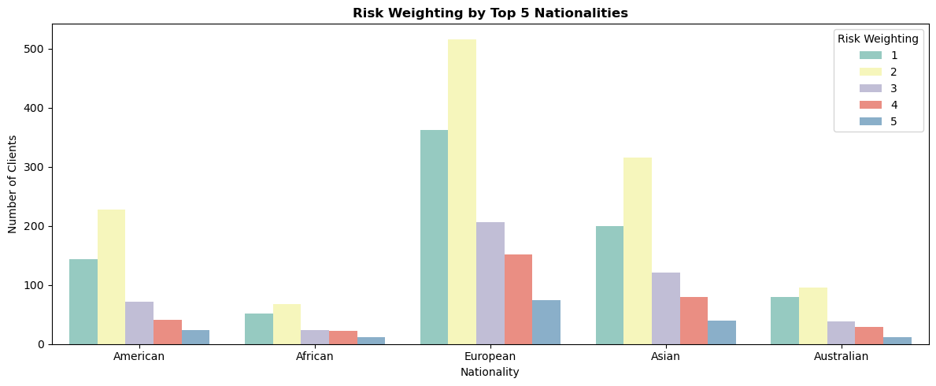
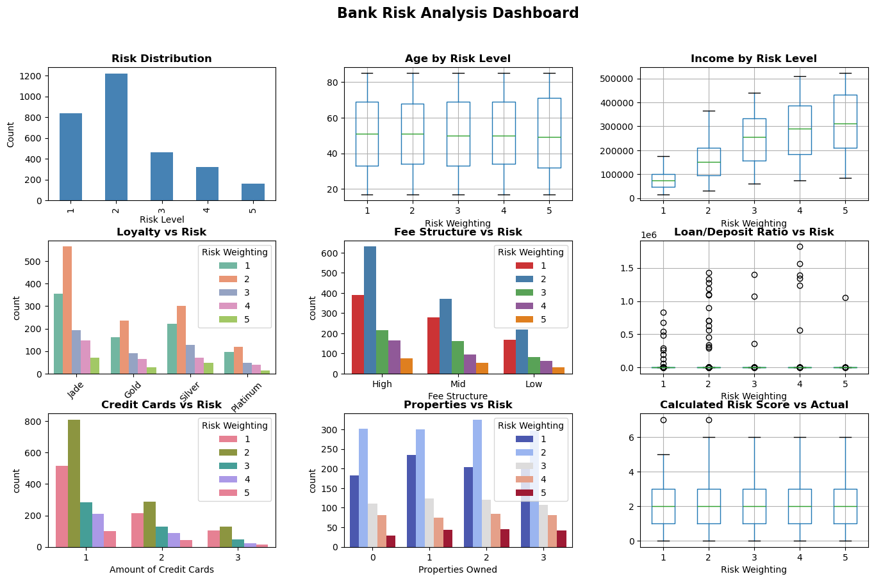

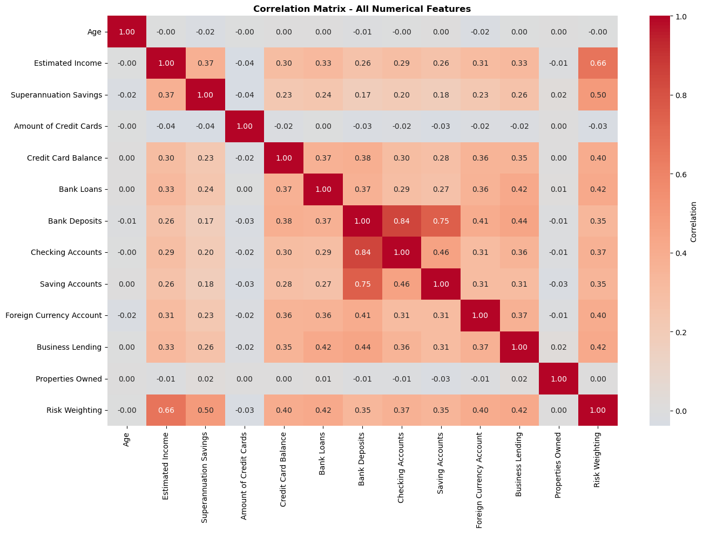
Correlation Matrix – All Numerical Features
======================================================================
RISK MANAGEMENT RECOMMENDATIONS
======================================================================

1. HIGH RISK CLIENTS (Risk Level 3+):
- Total: 942 clients (31.4%)
- Average Loan Amount: $839,877.77
- Average Income: $270,148.50
- ACTION: Implement stricter credit policies and frequent monitoring

2. CREDIT CARD RISK:
- Clients with High CC Balance: 750 (25.0%)
- ACTION: Review credit card limits and repayment terms

3. NEW CUSTOMERS (Tenure < 3 years):
- Total: 184 (6.1%)
- High Risk %: 35.9%
- ACTION: Implement probation period with higher monitoring

4. AGE-BASED RISK:
- Young Customers (<30): 564 - High Risk %: 32.3%
- Senior Customers (>70): 663 - High Risk %: 32.6%
- ACTION: Develop targeted risk profiles for age groups

