Министерство науки и высшего образования Российской Федерации

Федеральное государственное бюджетное образовательное учреждение высшего образования «Алтайский государственный технический университет им. И. И. Ползунова»

Министерство науки и высшего образования Российской Федерации

Федеральное государственное бюджетное образовательное учреждение  
высшего образования   
«Алтайский государственный технический университет им. И. И. Ползунова»

Факультет информационных технологий

Кафедра прикладной математики

Отчет защищен с оценкой _____

Преподаватель _____________

(подпись)

«___» ____________ 2022 г.

Отчет

По лабораторной работе № 7

**«Классы и объекты»**

по дисциплине «Программирование»

Студент группы ПИ-03 Абукар А. А.

Преподаватель доцент, к.т.н. Троицкий В.С.

Барнаул 2022

**Задание**: Разработка программного модуля, описывающего работу с объектом типа Auto_show.

Текст программы:

С++

#include <stdio.h>

#include <string.h>

#include <locale.h>

#include <malloc.h>

#include <iostream>

#include <string>

#pragma warning (disable:4996)

#define SIZE 25

class Engine {

public:

Engine()

{

}

Engine(int cylinders, int capacity, int power)

{

this->cylinders = cylinders;

this->capacity = capacity;

this->power = power;

}

std::string GetInfo()

{

return "Двигатель: кол-во целинтров = " + std::to_string(cylinders) + " объем = " + std::to_string(capacity) + " мощность = " + std::to_string(power);

}

void Read()

{

puts("Введите кол-во целиндров в двигателе:");

scanf("%d", &this->cylinders);

fflush(stdin);

puts("Введите объем двигателя:");

scanf("%d", &this->capacity);

fflush(stdin);

puts("Введите мощность двигателя:");

scanf("%d", &this->power);

fflush(stdin);

}

private:

int cylinders;

int capacity;

int power;

};

class Auto_show

{

public:

Auto_show()

{

}

~Auto_show()

{

}

void init(std::string brend, std::string name, int cost, int max_speed, int year, Engine eng1)

{

this->autoBrend = brend;

this->autoName = name;

this->autoCost = cost;

this->autoMax_speed = max_speed;

this->autoYear = year;

this->autoeng1 = eng1;

}

friend void contest(Auto_show* a);

void Display()

{

std::cout << "Марка: " << this->autoBrend << std::endl;

std::cout << "Название: " << this->autoName << std::endl;

std::cout << "Стоимость: " << this->autoCost << std::endl;

std::cout << "Максимальная скорость: " << this->autoMax_speed << std::endl;

std::cout << "Год выпуска: " << this->autoYear << std::endl;

std::cout << autoeng1.GetInfo() << std::endl << std::endl;

}

void Read()

{

puts("Введите марку автомобиля:");

std::cin >> this->autoBrend;

puts("Введите название автомобиля:");

std::cin >> this->autoName;

puts("Введите стоимость автомобиля:");

scanf("%d", &this->autoCost);

fflush(stdin);

puts("Введите максимальную скорость автомобиля:");

scanf("%d", &this->autoMax_speed);

fflush(stdin);

puts("Введите год выпуска автомобиля:");

scanf("%d", &this->autoYear);

fflush(stdin);

autoeng1.Read();

}

int Add(Auto_show second)

{

return this->autoCost + second.autoCost;

}

int operator+ (Auto_show& dif)

{

return autoCost + dif.autoCost;

}

int operator++()

{

return ++autoCost;

}

int operator++(int)

{

return ++autoYear;

}

void CostAddr(int& autoCost)

{

autoCost = this->autoCost;

return;

}

void SpeedPtr(int* autoMax_speed)

{

*autoMax_speed = this->autoMax_speed;

return;

}

private:

std::string autoBrend;

std::string autoName;

int autoCost;

int autoMax_speed;

int autoYear;

Engine autoeng1;

};

void contest(Auto_show* a) {

a->autoCost = 0;

}

int main()

{

setlocale(LC_ALL, "ru");

puts("Первый автомобиль");

Auto_show first_auto;

Engine autoeng(4, 2, 100);

first_auto.init("lada", "granta", 300, 150, 2017, autoeng);

first_auto.Display();

puts("Второй автомобиль");

Auto_show second_auto;

second_auto.Read();

second_auto.Display();

contest(&first_auto);

first_auto.Display();

std::cout << "Cost sum: " << first_auto + second_auto << std::endl;

std::cout << "++Cost: " << ++first_auto << std::endl;

std::cout << "Year++: " << first_auto++ << std::endl;

int cost;

first_auto.CostAddr(cost);

std::cout << "Cost:" << cost << std::endl;

first_auto.SpeedPtr(&cost);

std::cout << "Speed:" << cost << std::endl;

return 0;

}

Тест программы:

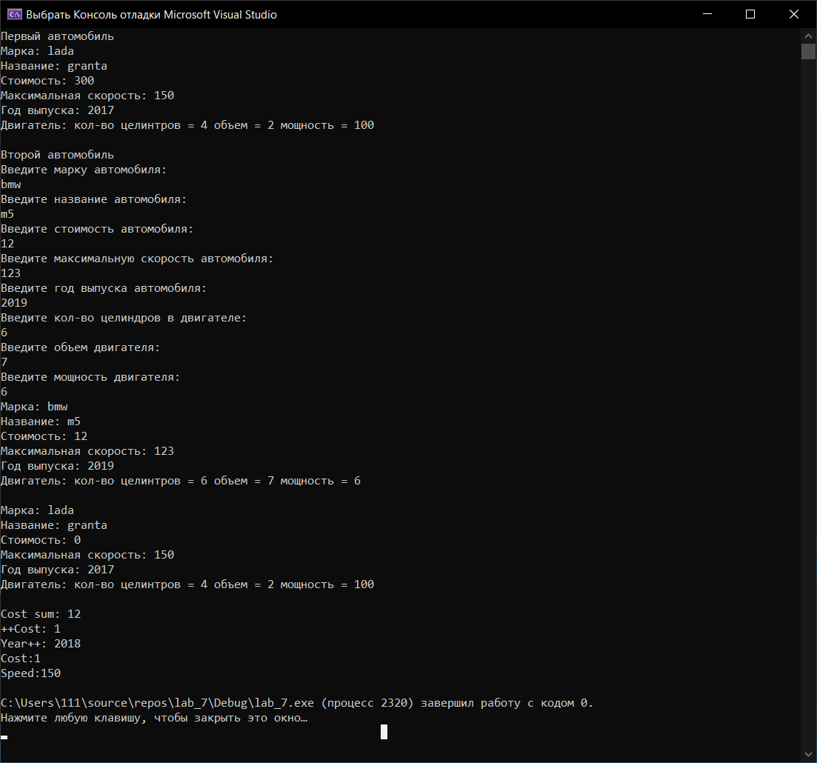

**С#**

using System;

namespace laba_6

{

class Auto_show

{

private String autoBrand;

private String autoName;

private int autoCost;

private int autoMax_speed;

private int autoYear;

private Engine autoeng1 = new Engine();

public Auto_show()

{

}

public Auto_show(string brend, string name, int cost, int max_speed, int year)

{

this.autoBrand = brend;

this.autoName = name;

this.autoCost = cost;

this.autoMax_speed = max_speed;

this.autoYear = year;

}

public void init(String brend, String name, int cost, int max_speed, int year, Engine eng1)

{

this.autoBrand = brend;

this.autoName = name;

this.autoCost = cost;

this.autoMax_speed = max_speed;

this.autoYear = year;

this.autoeng1 = eng1;

}

public void init_not_eng(String brend, String name, int cost, int max_speed, int year)

{

this.autoBrand = brend;

this.autoName = name;

this.autoCost = cost;

this.autoMax_speed = max_speed;

this.autoYear = year;

}

public void display()

{

Console.WriteLine("Brand: " + autoBrand);

Console.WriteLine("Name: " + autoName);

Console.WriteLine("Cost: " + autoCost);

Console.WriteLine("Max speed: " + autoMax_speed);

Console.WriteLine("Year: " + autoYear);

Console.WriteLine(autoeng1.GetInfo());

}

public void read()

{

Console.WriteLine("Enter brand: ");

this.autoBrand = System.Console.ReadLine();

Console.WriteLine("Enter name: ");

this.autoName = System.Console.ReadLine();

Console.Write("Cost: ");

this.autoCost = Convert.ToInt32(Console.ReadLine());

Console.Write("Max speed: ");

this.autoMax_speed = Convert.ToInt32(Console.ReadLine());

Console.Write("Year: ");

this.autoYear = Convert.ToInt32(Console.ReadLine());

autoeng1.Read();

}

public void CostRef(ref int autoCost)

{

autoCost = this.autoCost;

}

public void CostOut(out int autoCost)

{

autoCost = this.autoCost;

}

public static Auto_show operator +(Auto_show a, Auto_show b)

{

return new Auto_show(a.autoBrand, a.autoName, a.autoCost + b.autoCost

, a.autoMax_speed + b.autoMax_speed,

a.autoYear + b.autoYear);

}

public static Auto_show operator ++(Auto_show a)

{

return new Auto_show(a.autoBrand, a.autoName, a.autoCost + a.autoCost,

a.autoMax_speed + a.autoMax_speed,

a.autoYear + a.autoYear);

}

}

class Engine

{

private int cylinders;

private int capacity;

public int power;

public Engine()

{

}

public Engine(int cylinders, int capacity, int power)

{

this.cylinders = cylinders;

this.capacity = capacity;

this.power = power;

}

public String GetInfo()

{

return ("Engine: cylinders = " + cylinders + " capacity = " + capacity + " power = " + power);

}

public void Read()

{

Console.Write("Enter the number of cylinders:");

this.cylinders = Convert.ToInt32(Console.ReadLine());

Console.Write("Enter capacity:");

this.capacity = Convert.ToInt32(Console.ReadLine());

Console.Write("Enter power:");

this.power = Convert.ToInt32(Console.ReadLine());

}

}

struct Engine_st

{

private int cylinders;

private int capacity;

public int power;

public Engine_st(int cylinders, int capacity, int power)

{

this.cylinders = cylinders;

this.capacity = capacity;

this.power = power;

}

public String GetInfo()

{

return ("Engine: cylinders = " + cylinders + " capacity = " + capacity + " power = " + power);

}

public void Read()

{

Console.Write("Enter the number of cylinders:");

this.cylinders = Convert.ToInt32(Console.ReadLine());

Console.Write("Enter capacity:");

this.capacity = Convert.ToInt32(Console.ReadLine());

Console.Write("Enter power:");

this.power = Convert.ToInt32(Console.ReadLine());

}

}

class Program

{

static void Main()

{

Console.WriteLine("Первое auto");

Auto_show first_auto = new Auto_show();

Engine autoeng = new Engine(4, 2, 100);

first_auto.init("Lada", "granta", 300, 150, 2017, autoeng);

first_auto.display();

Console.WriteLine("Second auto");

Auto_show second_auto = new Auto_show();

second_auto.read();

second_auto.display();

Auto_show[] array = new Auto_show[10];

for (int i = 0; i < 10; i++)

{

array[i] = new Auto_show();

array[i].init_not_eng("Lada", "preora", 300, 150, 2012); ;

}

System.Console.WriteLine("Array[0]::");

array[0].display();

int cost_1 = 0;

array[1].CostRef(ref cost_1);

System.Console.WriteLine("reference::Cost: {0}", cost_1);

int cost_2;

array[1].CostOut(out cost_2);

System.Console.WriteLine("out::Cost: {0}", cost_2);

System.Console.WriteLine("Sum array[2] and array[3]:");

array[1] = array[2] + array[3];

array[1].display();

System.Console.WriteLine("Array[2].Auto++::");

array[1] = array[2]++;

array[1].display();

//Класс & струтура

Engine eng_class = new Engine(4, 2, 100);

SuperPower(eng_class);

System.Console.WriteLine("class:: power: {0}", eng_class.power);

Engine_st eng_struct = new Engine_st(4, 2, 100);

SuperPower(eng_struct);

System.Console.WriteLine("struct:: power: {0}", eng_struct.power);

}

public static void SuperPower(Engine e)

{

e.power++;

}

public static void SuperPower(Engine_st e)

{

e.power++;

}

}

}

Тест программы:

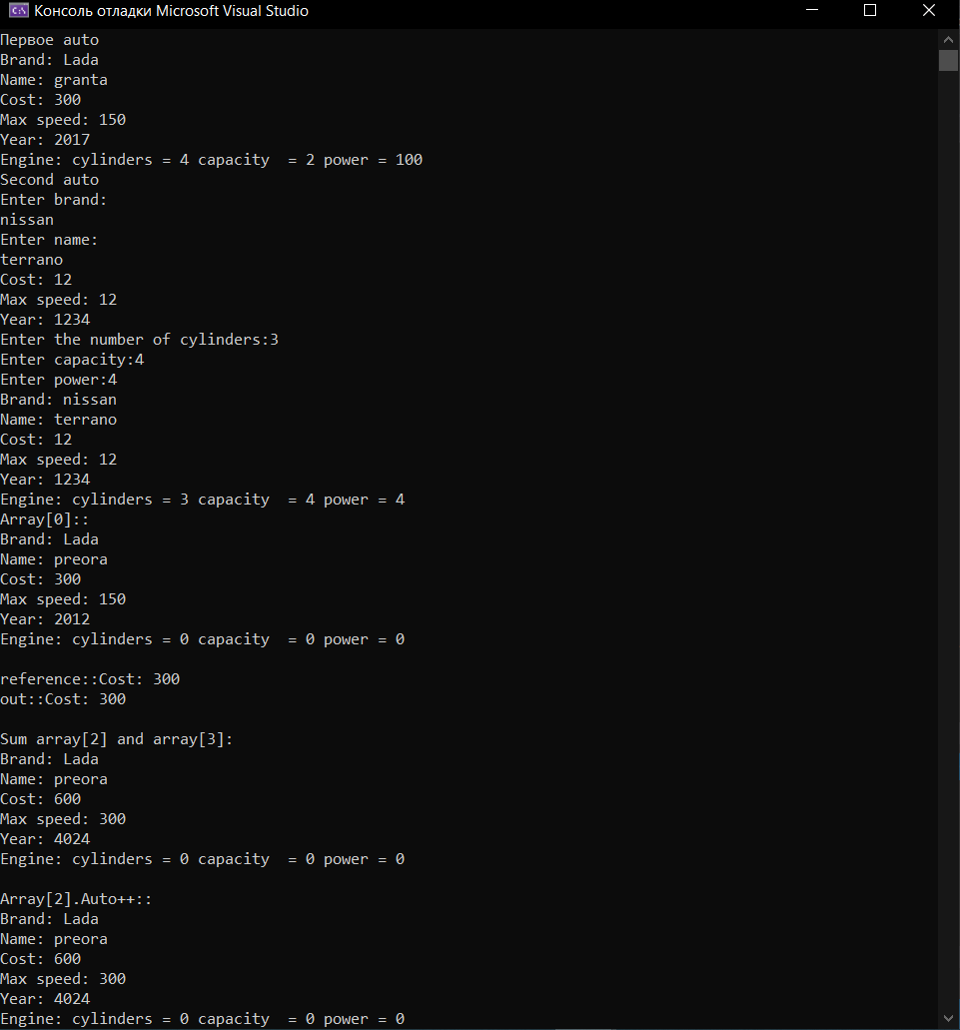

**Java**

**Main.java**

public class Main {

public static void main (String[] args) {

//Scanner in = new Scanner(System.in);

System.out.println("пїЅпїЅпїЅпїЅпїЅпїЅ auto");

Auto_show[] first_auto = new Auto_show[10];

Engine autoeng = new Engine(4, 2, 100);

for(int i = 0; i < 10; i++)

{

first_auto[i] = new Auto_show();

first_auto[i].init("lada", "priora", 100, 100, 2018, autoeng);

}

first_auto[1].display();

System.out.println("Cost: " + first_auto[1].CostAndSpeed().add1());

System.out.println("Speed: " + first_auto[1].CostAndSpeed().add2());

}

}**Auto_show.java**

import java.util.Scanner;  
public class Auto_show {  
 private String autoBrand;  
 private String autoName;  
 private int autoCost;  
 private int autoMax_speed;  
 private int autoYear;  
 private Engine autoeng1 = new Engine();  
  
 void init(String brend, String name, int cost, int max_speed, int year, Engine eng1)  
 {  
 this.autoBrand = brend;  
 this.autoName = name;  
 this.autoCost = cost;  
 this.autoMax_speed = max_speed;  
 this.autoYear = year;  
 this.autoeng1 = eng1;  
 }  
  
 void display()  
 {  
 System.*out*.println("Brand: " + autoBrand);  
 System.*out*.println("Name: " + autoName);  
 System.*out*.println("Cost: " + autoCost);  
 System.*out*.println("Max speed: " + autoMax_speed);  
 System.*out*.println("Year: " + autoYear);  
 System.*out*.println(autoeng1.GetInfo());  
 }  
 Scanner in = new Scanner(System.*in*);  
 void read(){  
  
 System.*out*.println("Enter brand: ");  
 this.autoBrand = in.nextLine();  
 System.*out*.println("Enter name: ");  
 this.autoName = in.nextLine();  
 System.*out*.println("Cost: ");  
 this.autoCost = in.nextInt();  
 System.*out*.println("Max speed: ");  
 this.autoMax_speed = in.nextInt();  
 System.*out*.println("Year: ");  
 this.autoYear = in.nextInt();  
 autoeng1.Read();  
 }  
}

**Engine.java**

import java.util.Scanner;  
public class Engine {  
 private int cylinders;  
 private int capacity;  
 private int power;  
 Engine(){  
  
 }  
  
 Engine(int cylinders, int capacity, int power){  
 this.cylinders = cylinders;  
 this.capacity = capacity;  
 this.power = power;  
 }  
  
 public String GetInfo(){  
 return ("Engine: cylinders = " + cylinders + " capacity = " + capacity + " power = " + power);  
 }  
 Scanner in = new Scanner(System.*in*);  
 public void Read(){  
 System.*out*.println("Enter the number of cylinders:");  
 this.cylinders = in.nextInt();  
 System.*out*.println("Enter capacity:");  
 this.capacity = in.nextInt();  
 System.*out*.println("Enter power:");  
 this.power = in.nextInt();  
 }  
}

**add.java**

public class add {

private int add1;

private int add2;

add(int add1, int add2)

{

this.add1 = add1;

this.add2 = add2;

}

int add1() {return add1;}

int add2() {return add2;}

**}**

