2018

Ed2Pro

A

Project Report

On

**Learn Code Online**



**Developed By**

1. Manoranjan Dash

2. Riddhi Bhuva

3. Subham Patel

1. Krunal khatra

**Guided By**

CHRIST POLYTECHNIC INSTITUTE, RAJKOT

DEPARTMENT: c.e.

ed2pro.com |

**Christ Polytechnic Institute, Rajkot**



**CERTIFICATE**

This is to certify that Mr. Manoranjan Dash from Christ Polytechnic Institute having Enrolment No: 156100307046 has completed. **Report on the Problem Definition/Semester V Project Report** having title Learn Code Online in a group consisting of 3 persons under the guidance of the faculty guide **Krunal Khatra.**

The mentor from the industry for the project:

Name : Malay Ghedia

Industry : Vector Software

Contact Details : +91 7990292194

Institute Guide-IDP/Industry Guide-IDP Head of Department

**Christ Polytechnic Institute, Rajkot**



**CERTIFICATE**

This is to certify that Miss. Riddhi Bhuva from Christ Polytechnic Institute having Enrolment No: 156100307013 has completed. **Report on the Problem Definition/Semester V Project Report** having title Learn Code Online in a group consisting of 3 persons under the guidance of the faculty guide **Krunal Khatra.**

The mentor from the industry for the project:

Name : Malay Ghedia

Industry : Vector Software

Contact Details : +91 7990292194

Institute Guide-IDP/Industry Guide-IDP Head of Department

**Christ Polytechnic Institute, Rajkot**



**CERTIFICATE**

This is to certify that Mr. Shubham Patel from Christ Polytechnic Institute having Enrolment No: 156100307066 has completed. **Report on the Problem Definition/Semester V Project Report** having title Learn Code Online in a group consisting of 3 persons under the guidance of the faculty guide **Krunal Khatra.**

The mentor from the industry for the project:

Name : Malay Ghedia

Industry : Vector Software

Contact Details : +91 7990292194

Institute Guide-IDP/Industry Guide-IDP Head of Department

Candidate Declaration

I declare that last semester report entitled “Learn Code Online” is our own work.

I further declare that to the best of our knowledge the report for DIPLOMA last semester doesn’t contain part of the work, which has been submitted for the award of DIPLOMA either in this or any other university without proper citation.

|  |
| --- |
| **Candidate ‘s Signature** |
| Student Name: Manoranjan Dash  Roll No.: 156100307046  Branch: CE |

|  |
| --- |
| **Candidate ‘s Signature** |
| Student Name: Riddhi Bhuva  Roll No.: 156100307013  Branch: CE |

|  |
| --- |
| **Candidate ‘s Signature** |
| Student Name: Subham Patel  Roll No.: 156100307066  Branch: CE |

Acknowledgement

I take this pleasure in presenting my project with work done for the **Ed2Pro (Learn Code Online Project).** This four months’ period was a good platform for getting to know how to deal with live projects and the websites. It also helps me to enhanced my Technical as well as Programming skill.

I wish to express my thanks to all my dear faculty members and also who helped me and supported me during my project work. Special thanks to Google for the all such information and knowledge that I have putted here. I would love to thank to **Krunal Khatra** for introducing me to this project and being my mentors.

I would love to express my gratitude to the entire department of C.E. for this invaluable help to provide support in lab.

Project Abstract

This is an Online Learning Project. Now In these days, there is no such places where we can learn Programming in free of cost. We all learn programming in our college or any institutes, but I think there is something missing in all these places. I have seen many students who have completed their study but they do not have a job. The problem is not that they have come from a village or any poor college. The problem is they could not get such platform where they can explore their knowledge.

The situation in all engineering colleges and universities are not going well in India. There is something wrong whether that is the way the syllabus was designed or the syllabus are going on are out dated. We all have to agree with it and we all need to address it.

Okay, you got a degree in computer science and have plenty of coding skills. So, other million programmers out there have these qualities. That’s why having a degree or coding skills doesn’t convey that you are a perfect programmer. To be a top in the game, you required adopting some extra traits in your personality. Traits that make you better than other programmers.

Problem Statement

Users

Application has three kinds of users

1. Unregister users
2. Register users
3. Admin

Functionalities

Unregister users

1. He can view Index page containing introduction and elements of the application. (static page)
2. He/she can register by giving small piece of information.

Register users

1. He can view Index page containing introduction and elements of the application. (static page)
2. He can login to explore the features of website.
3. He can manage his account.
4. He can view the available objective question.
5. He can test his knowledge by attempting the test.
6. He can view his score after attempting the test.
7. He can logout from the website.

Admin

1. Admin can login.
2. Admin can manage test questions.
3. Admin can logout.

Index

No. Subject Page Number

|  |  |  |
| --- | --- | --- |
|  |  |  |
| 1 | Acknowledgement | 2 |
| 2 | Introduction  2.1 Project summary  2.2 Project profile  2.3 Purpose  2.4 Scope  2.5 Technology used |  |
| 3 | System Requirement Study  3.1 User and administrator characteristics  3.2 Software and hardware requirement |  |
| 4 | System Analysis  4.1 Study of current system  4.2 Demerits of the current system  4.3 Requirement of new system  4.4 Feasibility study |  |
| 5 | Database and tables  5.1 Screenshots |  |
| 6 | Diagrams  6.1 Data flow diagram  6.2 Entity Relationship diagram |  |
| 7 | Application layouts  7.1 Screenshots |  |
| 8 | Pros |  |
| 9 | Limitation & future enhancement  9.1 Limitation  9.2 Future Enhancement |  |
| 10 | Bibliography |  |

Industry Information

* This company was established in the year 2004.
* This company is the one of the popular developers in the city.
* The owner of the Malay Ghedia.

|  |
| --- |
| **Industry Information** |
| Project Name :- Learn code online  Owner Name:- Malay Ghedia.  Contact Number:- +91 7990292194  Email ID:-vectorsoftware@gmail.com |

Introduction

2.1 Project summary:

Learn Code Online Project is an application to learn programming online where we can also register user, manage content of the application. This can help you to enhance your programming skills by attempting such objective questions.

2.2 Project Profile:

Front End : PHP, CSS (Bootstrap Framework), Html 5

Back End : MySQL

Documentation tools : Microsoft Office

Project duration : 4 Months

Project Guide : Krunal Khatra

Institute Name : Christ Polytechnic Institute, Rajkot

2.3 Purpose:

Main purpose of this application is to provide such facility to the students to enhance their programming skills.

The main objective of project is for candidate to appear for an online test in an effective way and there is no loss of time to check the paper.

2.4 Scope:

Every application development project should begin with an analysis of the requirement and clear list of the goals.

The problem is broken into successively manageable parts for individual study.

The basic aim of analysis is to obtain a clear understanding of user’s need and exactly is desired from the requirement of required information for our practice training. We ride my best for the practical study and presentation of this project.

2.5 Technology used:

The languages we have used to accomplish our project are Programming Language PHP & MySQL database.

HTML:

HTML is a language for structuring and presenting content for the [World Wide Web](http://en.wikipedia.org/wiki/World_Wide_Web), a core technology of the [Internet](http://en.wikipedia.org/wiki/Internet). It is the fifth revision of the [HTML](http://en.wikipedia.org/wiki/HTML) standard its only provide new feature for design page

Limitation:

* Not provide Dynamic page generation
* Cross browser support not available

JavaScript:

JavaScript is a scripting language. JavaScript was designed to add interactivity to HTML pages. JavaScript is to add additional interaction between the website and its visitors with just a little extra work by the web developer. JavaScript is a client-side scripting language. This means the web surfer's browser will be running the script.

CSS:

Cascading Style Sheets (CSS) is a [style sheet language](http://en.wikipedia.org/wiki/Style_sheet_language) used for describing the presentation semantics (the look and formatting) of a document written in a markup language. Its most common application is to style [web pages](http://en.wikipedia.org/wiki/Web_page) written in [HTML](http://en.wikipedia.org/wiki/HTML).

PHP:

PHP is a server-side scripting language designed for web development but also used as a general-purpose programming language.  PHP originally stood for Personal Home Page. PHP processor module, which generates the resulting web page: PHP commands can be embedded directly into an HTML source document rather than calling an external file to process data. The PHP language was originally implemented as an interpreter, and this is still the most popular implementation.

XAMP-Server:

A Stack of programs that are designed to run HTTP server which understand PHP.

* Windows - The Operating System
* Apache - HTTP Server
* MySQL - A database server and client
* PHP - A plug-in for Apache so it can run (interpret) PHP Scripts.

My-SQL:

MySQL, the most popular Open Source SQL database management system, is developed, distributed, and supported by Oracle Corporation. MySQL is a database management system. A database is a structured collection of data. The MySQL Database Server is very fast, reliable, scalable, and easy to use. If that is what you are looking for, you should give it a try. MySQL Server can run comfortably on a desktop or laptop, alongside your other applications, web servers, and so on, requiring little or no attention.

MySQL Server works in client/server or embedded systems. The MySQL Database Software is a client/server system that consists of a multi-threaded SQL server that supports different backbends, several different client programs and libraries, administrative tools, and a wide range of application programming interfaces (APIs).

System Requirement Study

It studies the current business system to find out how it work and where improvement should be made? This study considered both manually and computer method.

Requirement is a feature that must be include in new system it may be include a way capturing or processing data, producing information.

3.1 User and administrator characteristics

User Characteristics

* User characteristics means different type of user can check his/her programming skills by giving such tests.
* Learn Code Online System would allow user to access his account so that following characteristics should be maintained:

Administrator Characteristics

* Administrator of the Learn Code Online has fully right of the controlling the whole system.
* He/she will be safely responsible for maintaining of all function.

3.2 Software and Hardware Requirement

Software Requirement

1. Front End : PHP
2. Back End : MySQL

Hardware Requirement

Processor : Celeron 500 MHZ Or Any Pentium Processor Or Above

Ram : 64mb Or Above

HDD : Minimum Requirement Is 1.2 GB

Display : Standard VGA Or SVGA Card

System Analysis

A system analysis is responsible for researching, planning, and recommending software and system choices to meet an organizations business requirement.

System analysis may act as liaisons between vendors and the organization they represent. They may be responsible for developing cost analysis, design consideration, and implementation timelines. They may also be responsible for feasibility studies of a computer system before making recommendation to senior management.

Basically a system analyst performs the following tasks:

1. Interact with students to know their requirements.
2. Interact with designers to convey the possible interface of the software.
3. Interact the users to keep track of system development.
4. Perform system testing with live data with the help of testers.
5. Successfully implement the new system.

4.1 Study of Current System:

Current Auction System is fully manual. Administrator is managing all documents papers. They are having problem in retrieving all data like current price, time remaining for product etc.

4.2 Demerits of Current System:

According to the system there are many obstacles for students to enhance their knowledge.

4.3 Requirement of the New System:

It is necessary to automatic management of the system of such management system by using automatic & computerized system of management it is easy for administrator to manage records related to materials user details etc.

4.4 Feasibility Study

One of the most important decisions of the preliminary investigation is the determination that the system required is feasible.

Feasibility study the test of system proposed regarding its workability, impact on the organization, ability to meet user needs, and effective use of resources.

There are two type of feasibility study:

1. Technical
2. Operational

Database and Table

5.1 Screenshot

1. Database: edpro

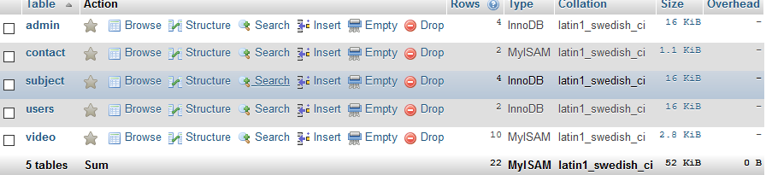

2. Admin Table: admin

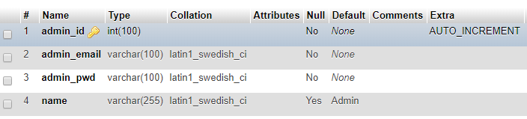

3. User Information Table: user

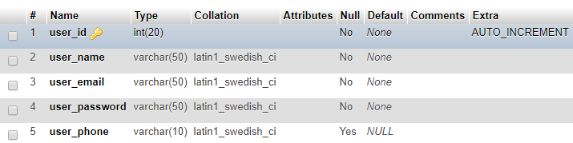

4. Contact US : contact

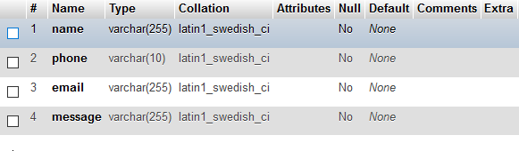

5. Subject Table: subject

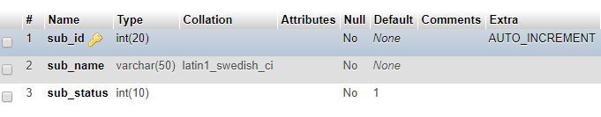

6. Video: video

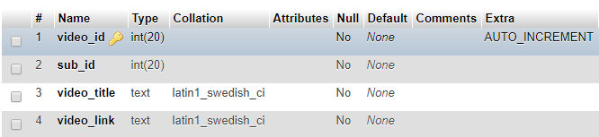

Diagrams

6.1 Data Flow Diagrams:

Level-0

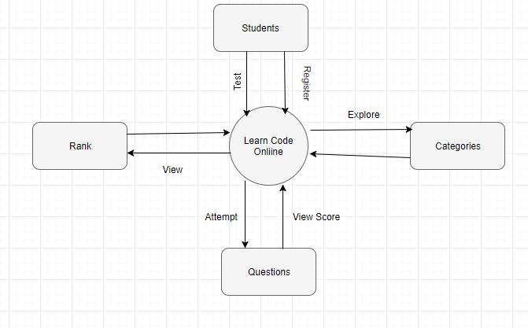

Level-1

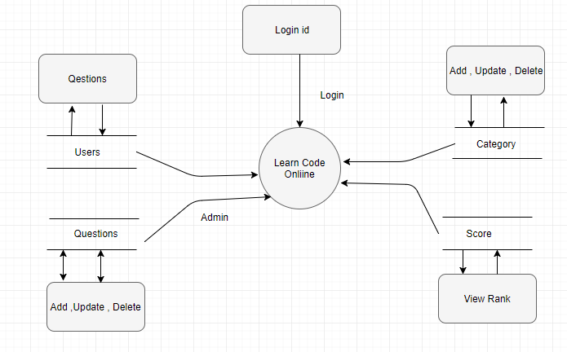

6.2 ER Diagrams:

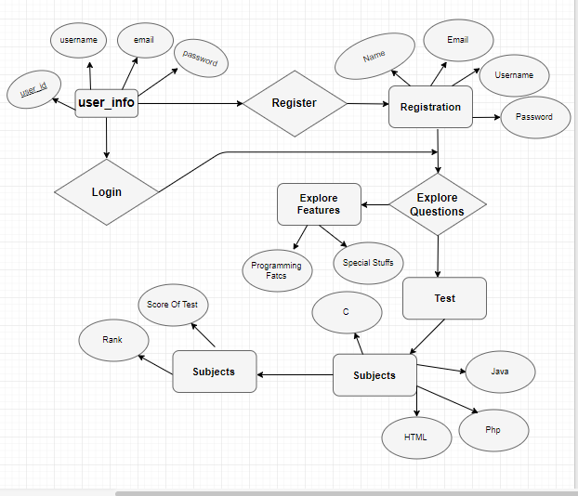

Application Layouts

Index page for Unregistered users

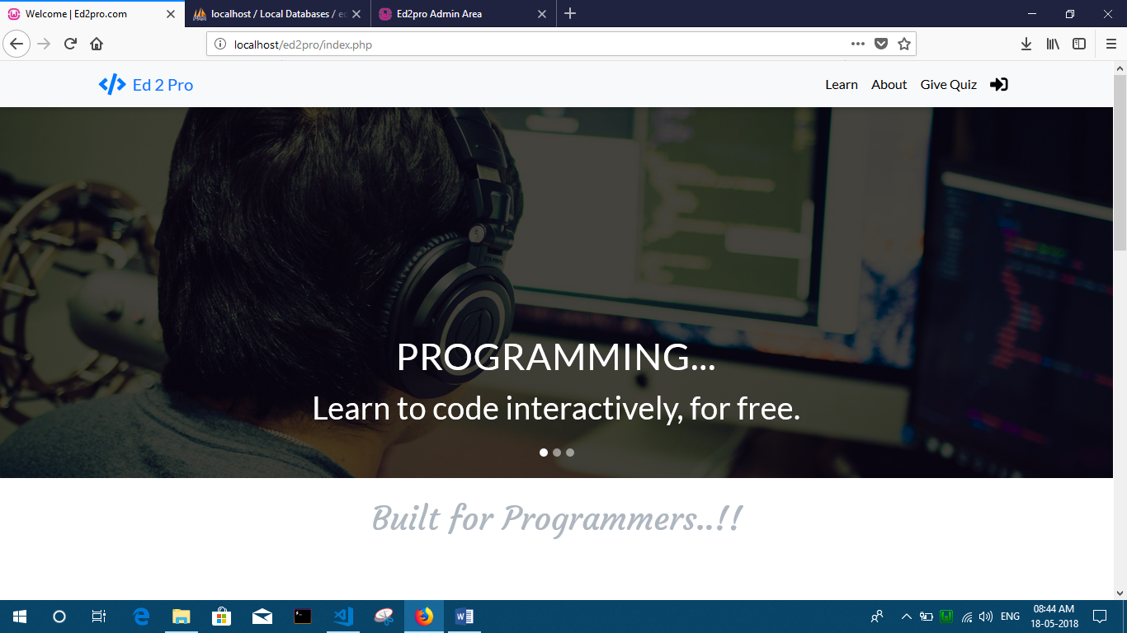

Contents

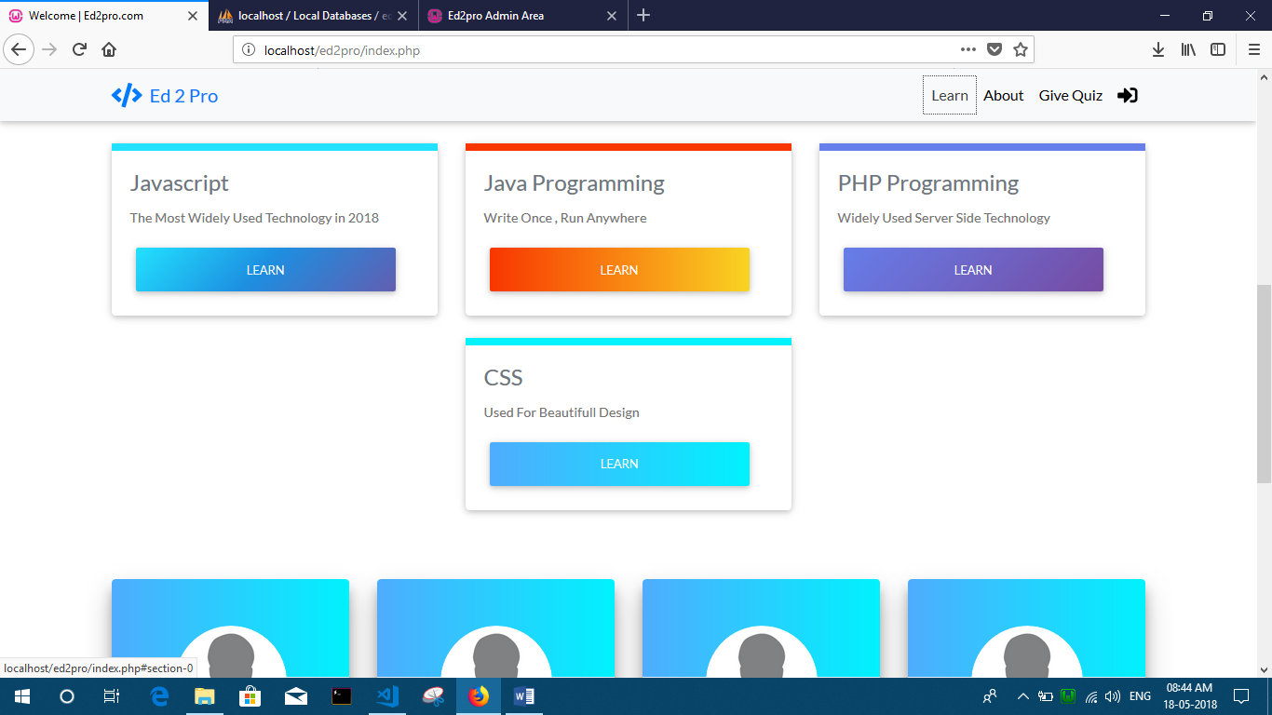

Application Layouts

About

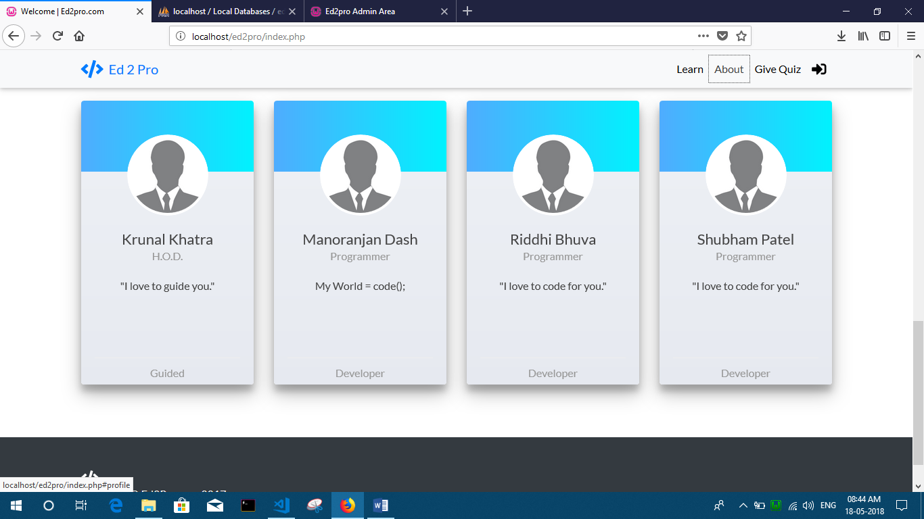

Contact Form

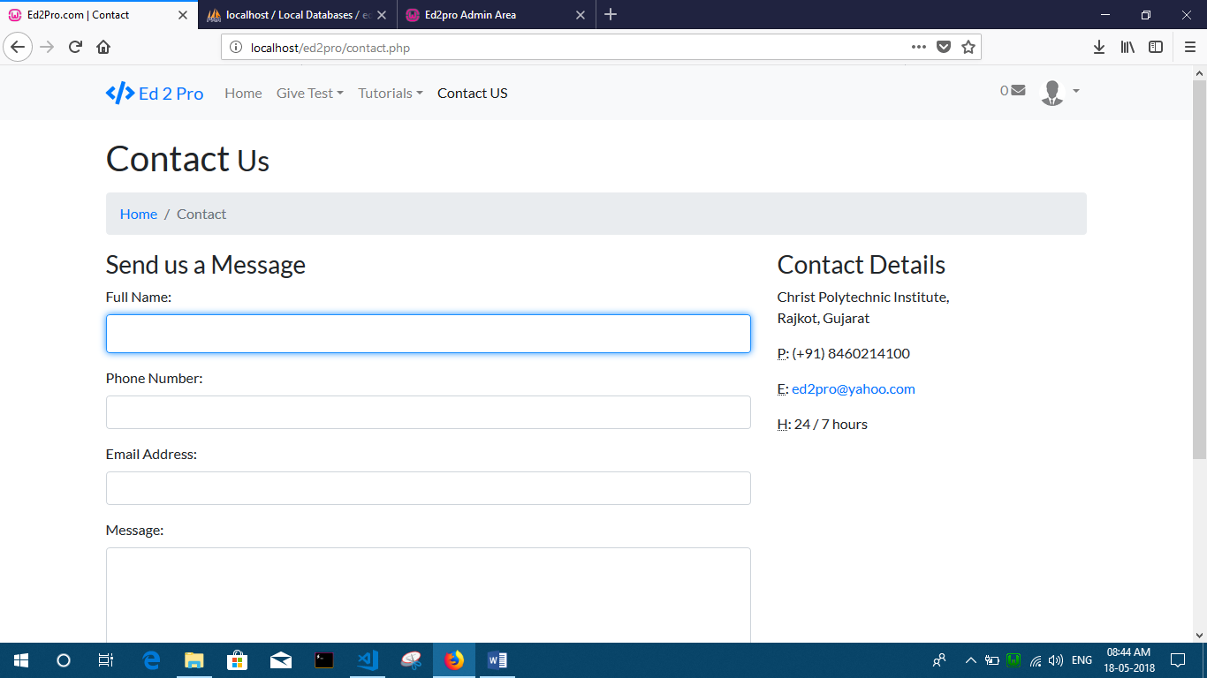

Application Layouts

User login form

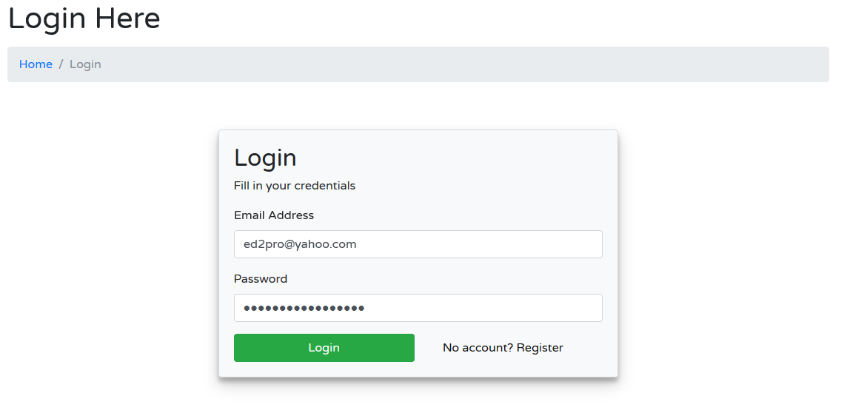

User register form

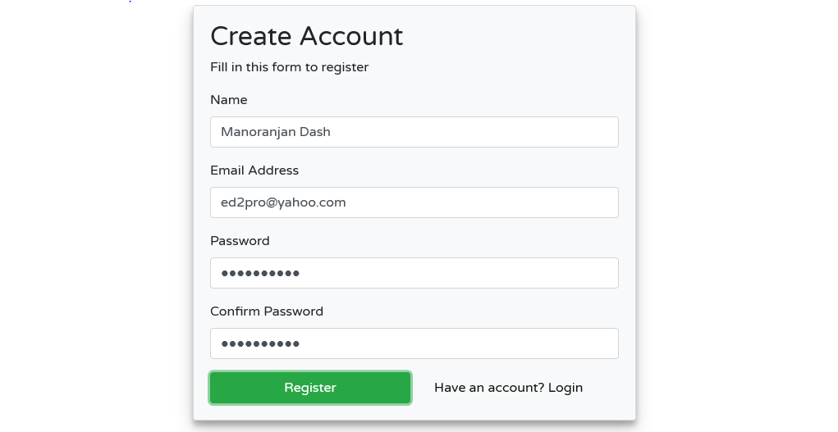

Application Layouts

Admin Login Form

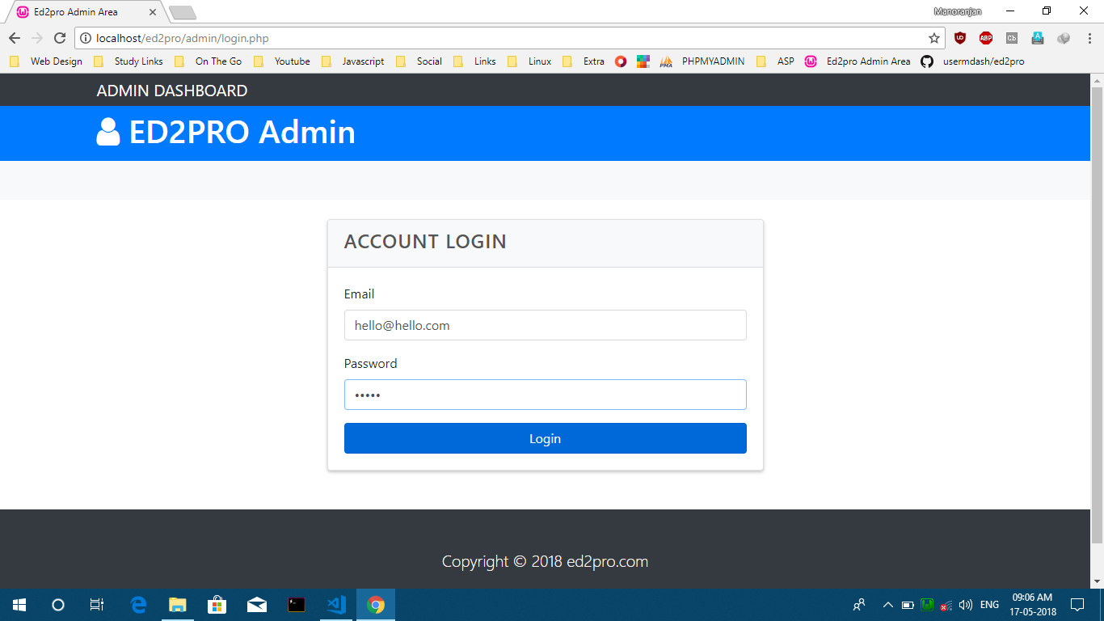

Admin Dashboard

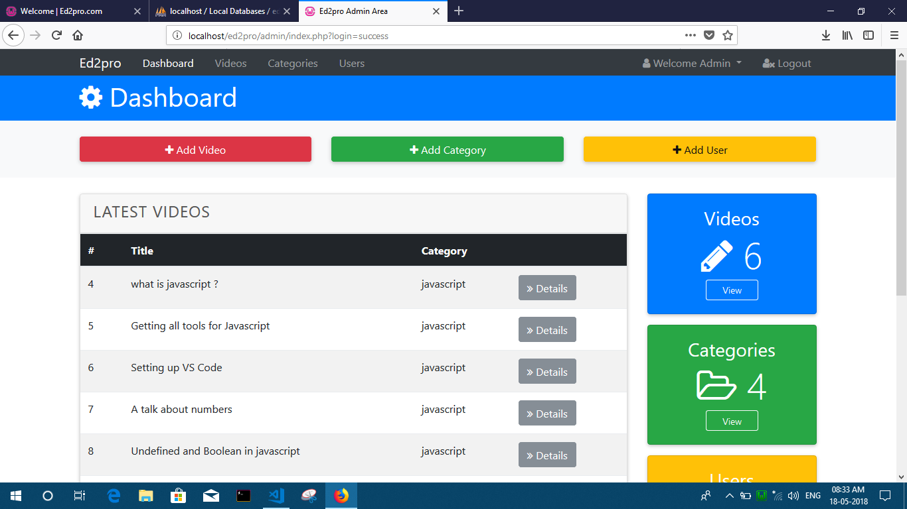

Application Layouts

Videos :

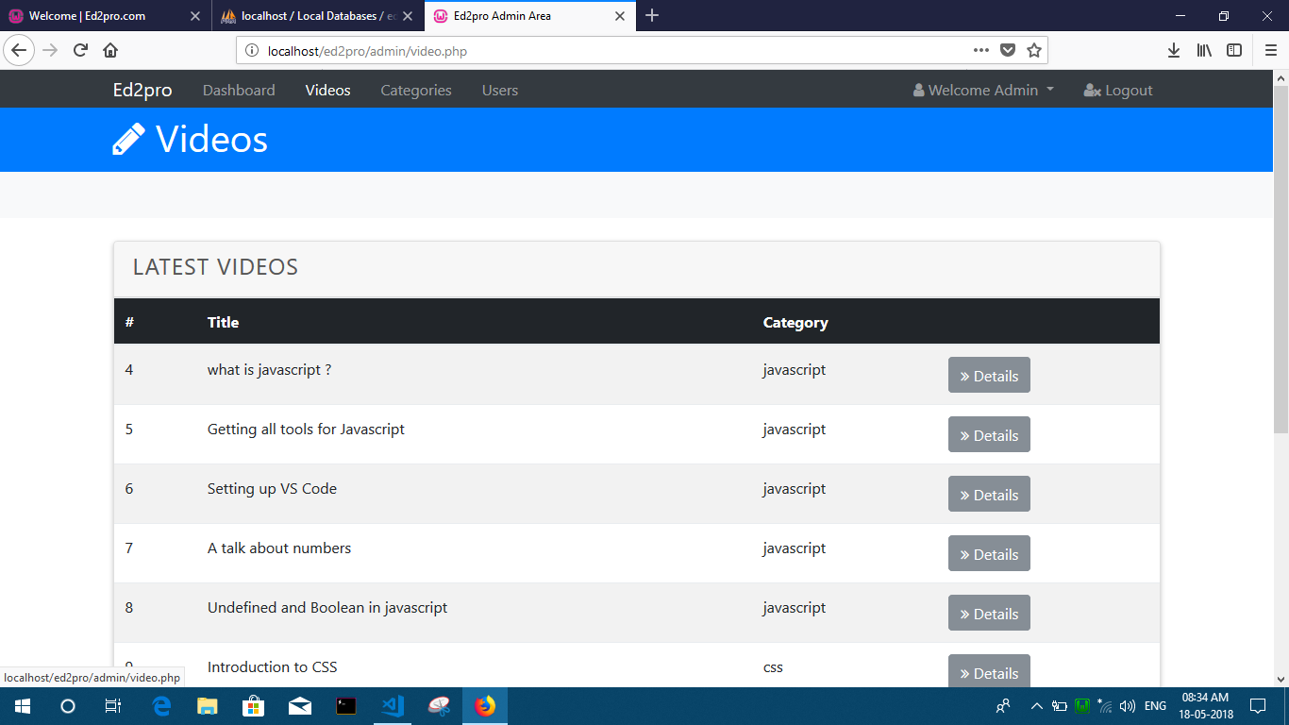

Categories

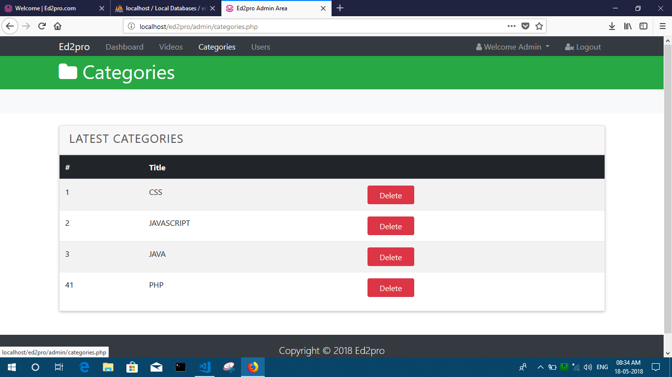

Application Layouts

Users

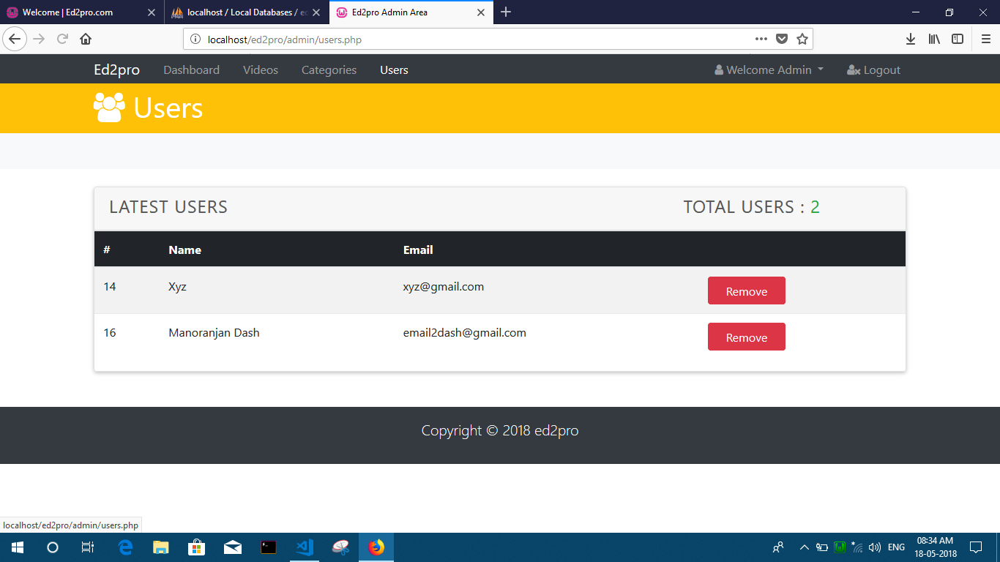

Add User:

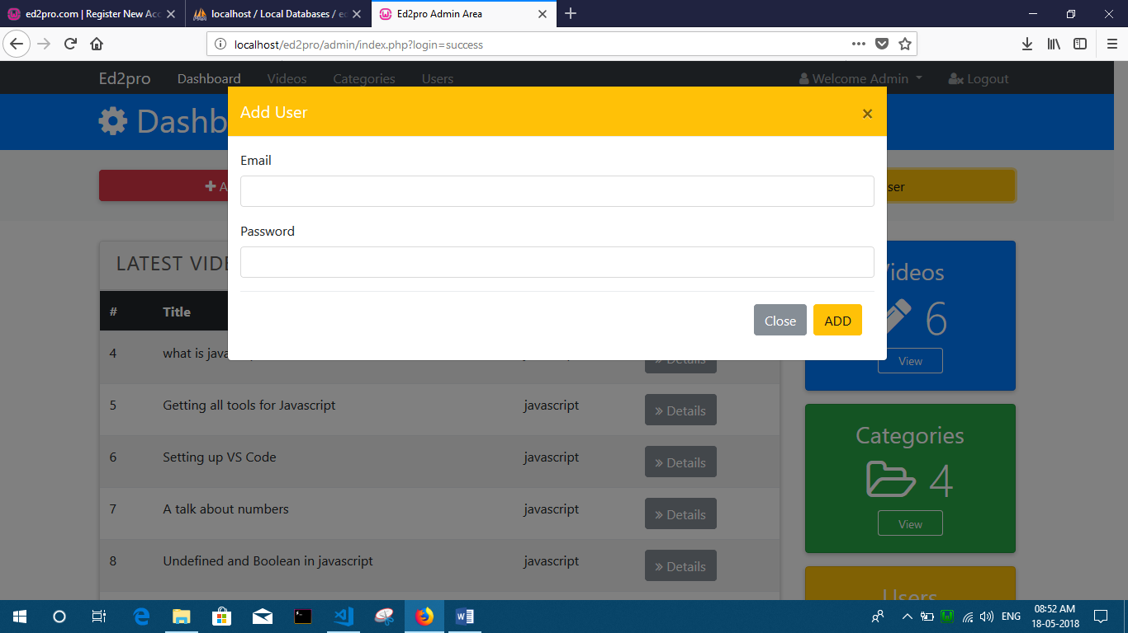

Add Categories

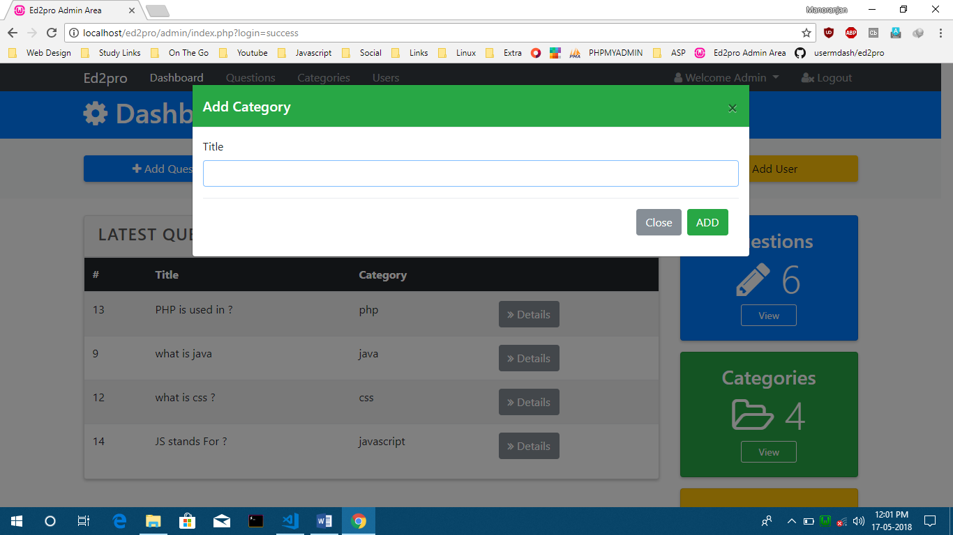

Change Passsword:

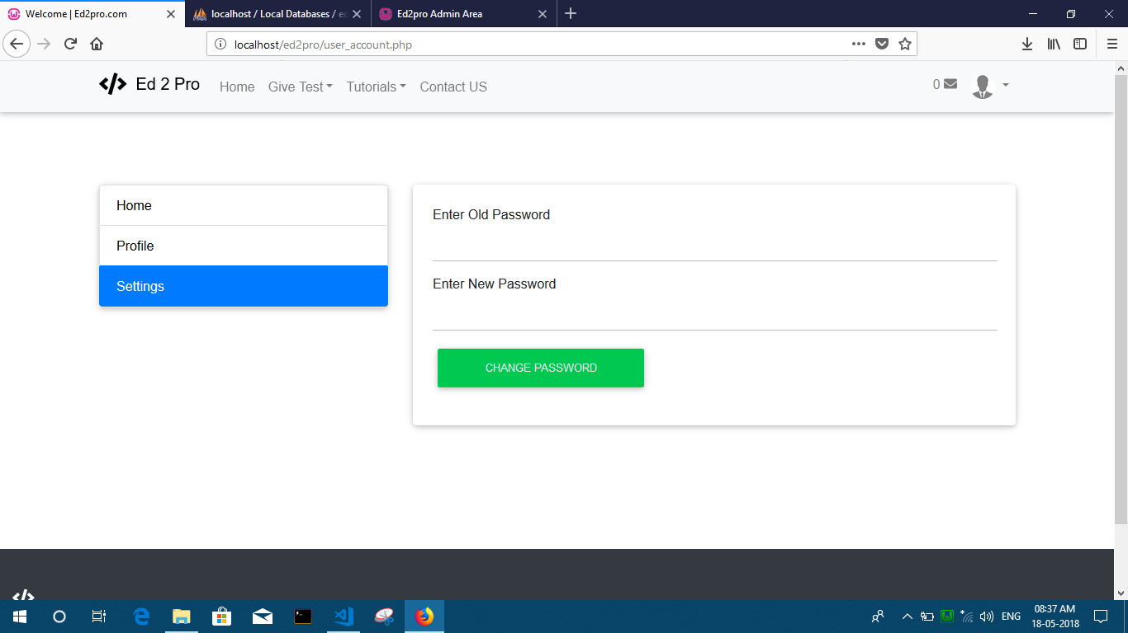

Application Layouts

Manage Account

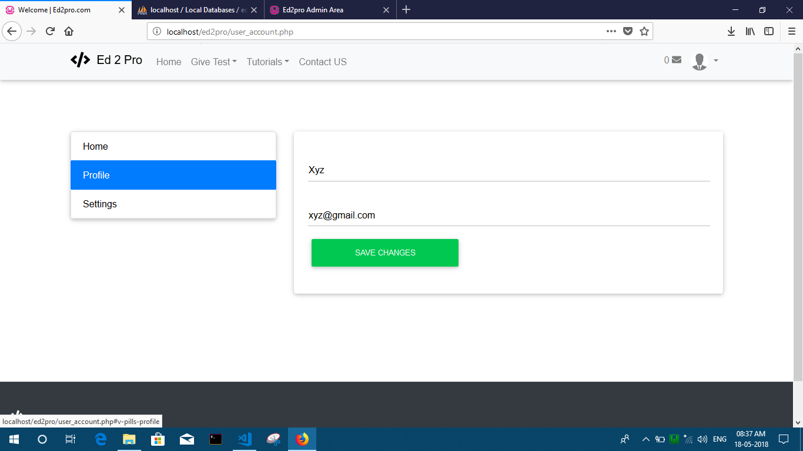

Watch Tutorials

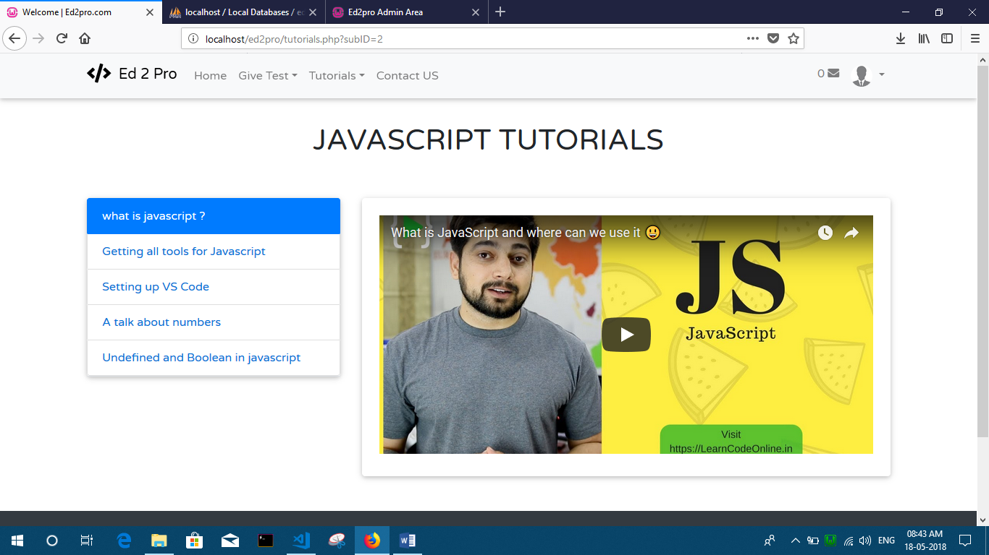

Test Page

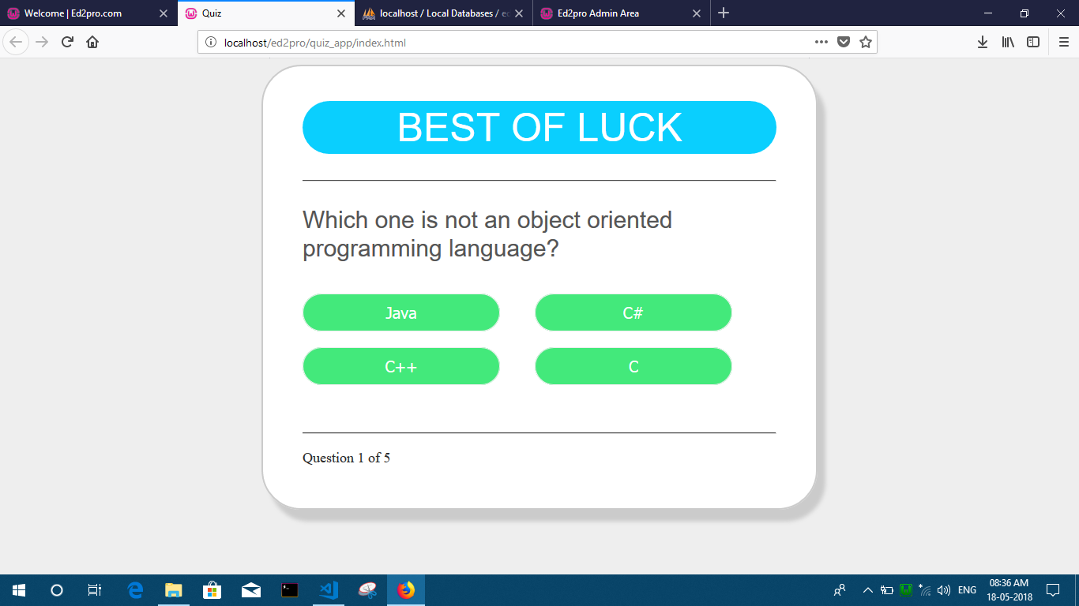

Result Page :

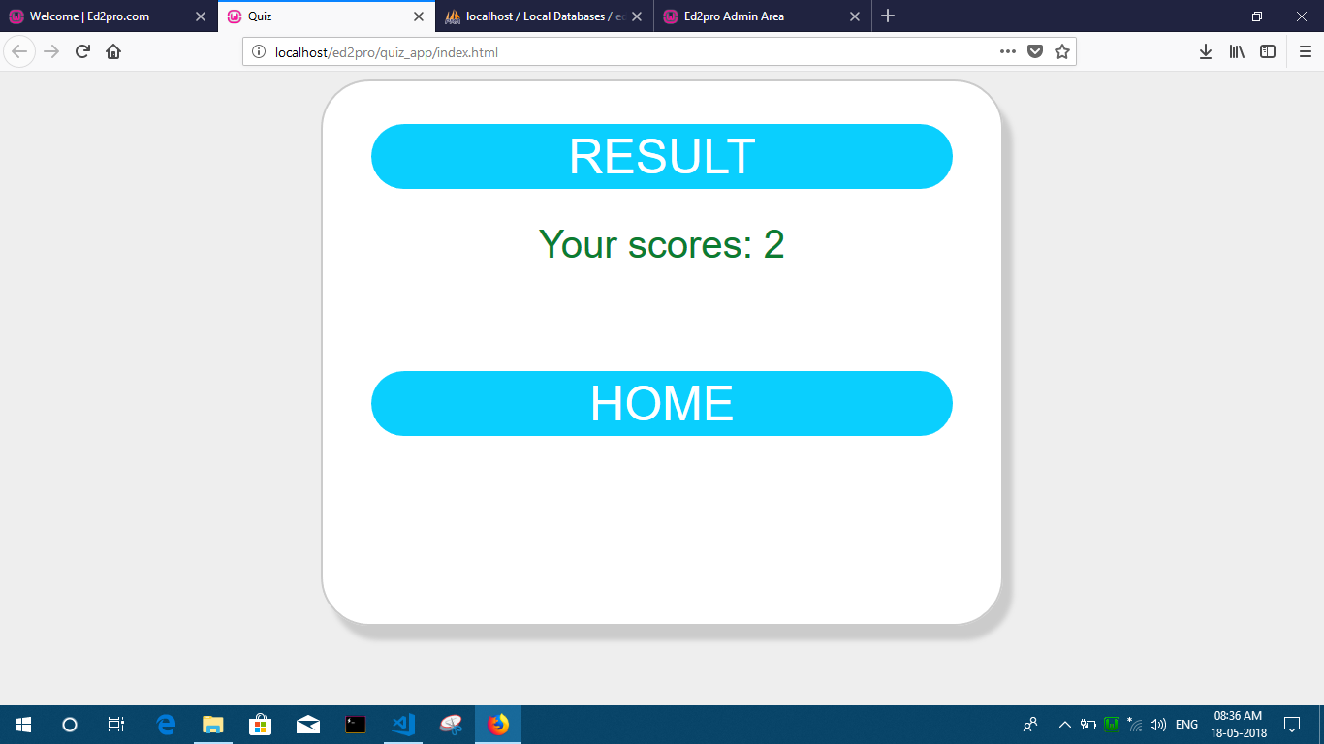

Pros

* Students can get a platform where they can explore their knowledge by Learning from our Website.
* Learn by Watching Lectures from Famous Teachers
* They can give a test to check themselves.
* There is a ranking page where all students can view their position among all.
* These ranking feature helps the students to work hard in order to get first rank.
* Easy to attempt questions.
* Data can be stored for a longer time period.

Limitation and future enhancement

9.1 Limitation

Here we are not considering that our is so perfect but also some limitation or need for future enhancement are there which are also ignorable for user.

We have kept fully attention towered as this project put there is necessary to know about the limitation of this project.

The system cannot work under DOS based environment.

We have to install it in standalone PC to use it on that particular PC.

9.2 Future enhancement

In future we can develop the website and add more features as much as possible.

We will make the system to work in larger system.

Bibliography

Here we make this system by take reference form many websites and applications.

Websites:

* [www.github.com](http://www.github.com)
* [www.codeacademy.com](http://www.codeacademy.com)
* [www.w3schools.com](http://www.w3schools.com)
* [www.hackerrank.com](http://www.hackerrank.com)
* [www.mysirg.com](http://www.mysirg.com)
* www.learncodeonline.in