**Attendance Management System**

## CONTENTS OF THIS FILE

* Introduction
* Features
* Installation
* Usage
* Credits
* FAQ
* Contact us

## INTRODUCTION

Attendance is a task which is done at the start of class which can consume quite a time, to manage the time efficiently teacher needs toolSo we came up with this particular solution which can reduce the burden in the said scenarioThe attendance management system can help to reduce the manual and paper workSince it'd be completely online and automated. It can also be useful for maintaining accurate records and generate reports

## THE KEY FEATURES OF OUR SOFTWARE IS INSTALLATION

* It’s a simple online attendance system designed for attendance requirements. It simply requires an internet connection to run smoothly
* Connects teachers and students on-the-go
* Its can store unlimited student records
* User friendly and simple to access

## INSTALLATION

**The Steps to install the project on local computer are**

1. Clone the project in your computer using following link and command

**Git clone** [**https://github.com/codewithnick/attendance-management-system.git**](https://github.com/codewithnick/attendance-management-system.git)

1. Open NetBeans and access the cloned folders to work on
2. Set up SQL connection
3. Then press shift+F6 tom run the project

## USAGE

1. Visit the website of the attendance management system and select the respective choice.

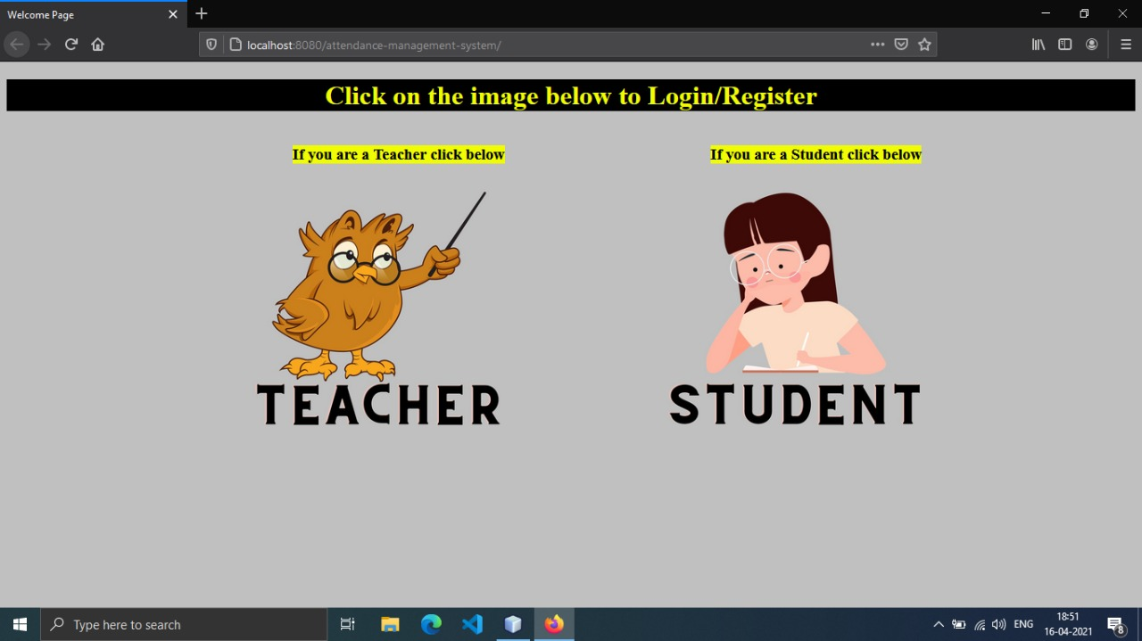

2. Both, teacher and student will be directed to Login/Register page. If you are a new user, Register otherwise Login.

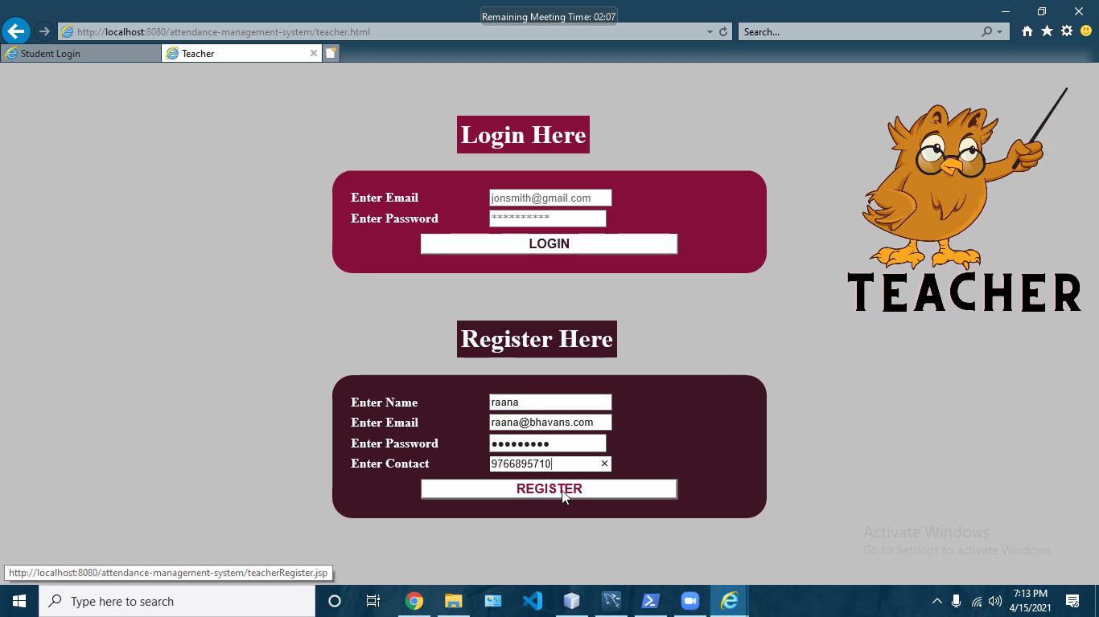

A similar page will be shown to the student as well for login/register.

**For Students**

3. After login student will be directed to Student Dashboard from where, they’d be able to **mark their attendance** for the day and they’ll also be able to **Update their Profiles**.

**Mark Attendance**

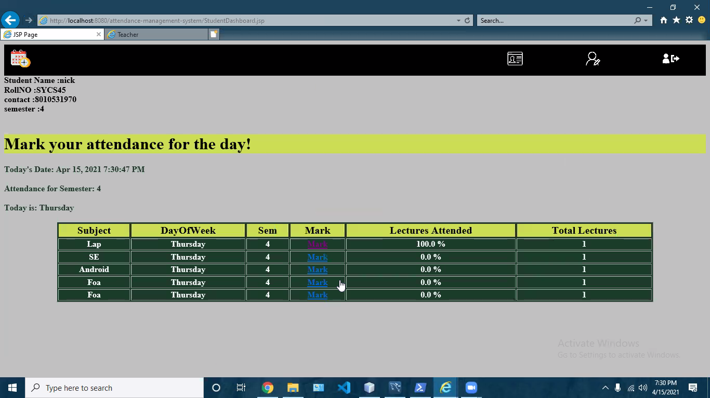

After clicking on mark, the students will be directed to a new page where they can mark their attendance.

**For Teachers**

1. After login, the teachers will be directed to the page where subjects and its info are visible.

From this page they’d be able **to Delete, Edit** the subject for the respective day or can **view the attendance mark by students**

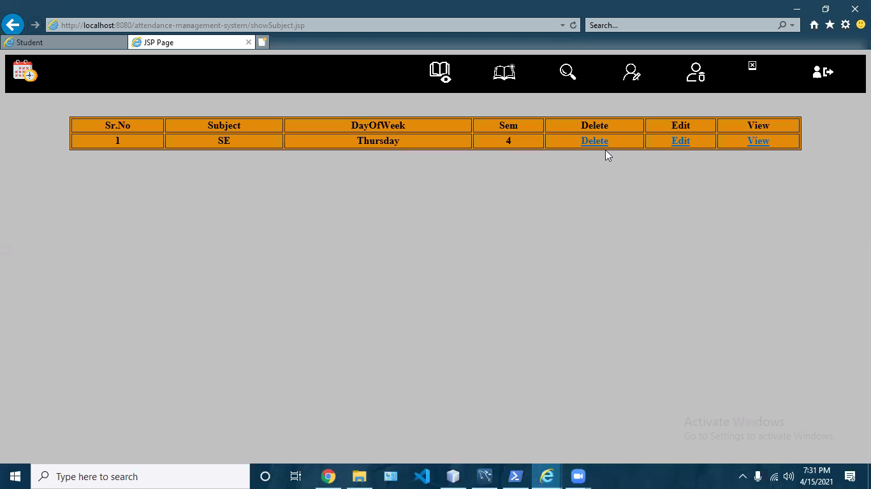

2. The teacher can **add, edit, search subject or update their profiles** by clicking respective icons on the menu bar

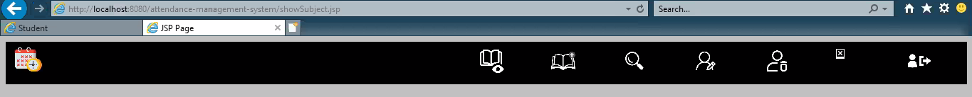

3. The menu bar also provides options to **Delete Student or Teacher** record from the database

**CREDITS**

Anand Chaudhary

Shivam Chaudhary

Gaurav Prajapati

Sahil Raorane

Nikhil Singh

Sophia Philip Dcruz

**FAQ**

**Q:** What are the requirements to use this software?

**A:** You need a device and proper Internet connectivity

**Q:** Can I use the system without Registration/login?

**A:** No, you cannot use this system without Registration/Login. You have to first register followed by login to use the system

**Q:** Are Student and Teacher Dashboard different?

**A:** Yes, the Teacher and Student will be redirected to the respective dashboards

**Contact Info**

Please feel free to contact us for more information

[nikhilsingh892710@gmail.com](mailto:nikhilsingh892710@gmail.com)