**Practical 8**

**aim- Add validations name should be not null, age should be within (18 to 100) and email should be in specific format, password field should not be empty, retype password should be same as password field.**

**Webform1.aspx**

<%@ Page Language="C#" AutoEventWireup="true" CodeBehind="WebForm1.aspx.cs" Inherits="practical5.WebForm1" %>

<!DOCTYPE html>

<html xmlns="http://www.w3.org/1999/xhtml">

<head runat="server">

<title></title>

</head>

<body>

<form id="form1" runat="server">

<div>

&nbsp;&nbsp;&nbsp;&nbsp;&nbsp;&nbsp;&nbsp;&nbsp;&nbsp;&nbsp;&nbsp;&nbsp;&nbsp;&nbsp;&nbsp;&nbsp;&nbsp;&nbsp;&nbsp;&nbsp;

<asp:Label ID="Label1" runat="server" Text="REGISTRATION FORM"></asp:Label>

<br />

<br />

<asp:Label ID="Label2" runat="server" Text="username"></asp:Label>

&nbsp;&nbsp;&nbsp;&nbsp;&nbsp;&nbsp;&nbsp;&nbsp;&nbsp;&nbsp;&nbsp;

<asp:TextBox ID="TextBox1" runat="server"></asp:TextBox>

&nbsp;&nbsp;&nbsp;

<asp:RequiredFieldValidator ID="RequiredFieldValidator1" runat="server" ControlToValidate="TextBox1" ErrorMessage="enter username" ForeColor="Red"></asp:RequiredFieldValidator>

<br />

<br />

<asp:Label ID="Label3" runat="server" Text="email id"></asp:Label>

&nbsp;&nbsp;&nbsp;&nbsp;&nbsp;&nbsp;&nbsp;&nbsp;&nbsp;&nbsp;&nbsp;&nbsp;&nbsp;

<asp:TextBox ID="TextBox2" runat="server"></asp:TextBox>

&nbsp;&nbsp;&nbsp;

<asp:RequiredFieldValidator ID="txtemail" runat="server" ControlToValidate="TextBox2" ErrorMessage="email is empty" ForeColor="Red"></asp:RequiredFieldValidator>

&nbsp;&nbsp;&nbsp;

<asp:RegularExpressionValidator ID="RegularExpressionValidator1" runat="server" ControlToValidate="TextBox2" ErrorMessage="invalid email" ForeColor="Red" ValidationExpression="\w+([-+.']\w+)*@\w+([-.]\w+)*\.\w+([-.]\w+)*"></asp:RegularExpressionValidator>

<br />

<br />

<asp:Label ID="Label4" runat="server" Text="password"></asp:Label>

&nbsp;&nbsp;&nbsp;&nbsp;&nbsp;&nbsp;&nbsp;&nbsp;&nbsp;&nbsp;

<asp:TextBox ID="TextBox3" runat="server" TextMode="Password"></asp:TextBox>

&nbsp;&nbsp;&nbsp;

<asp:RequiredFieldValidator ID="txtpass" runat="server" ControlToValidate="TextBox3" ErrorMessage="enter password" ForeColor="Red"></asp:RequiredFieldValidator>

<br />

<br />

Retype pass&nbsp;&nbsp;&nbsp;&nbsp;&nbsp;&nbsp;&nbsp;

<asp:TextBox ID="TextBox4" runat="server" TextMode="Password"></asp:TextBox>

&nbsp;&nbsp;&nbsp;

<asp:RequiredFieldValidator ID="txtpassrep" runat="server" ControlToValidate="TextBox4" ErrorMessage="retype-pass" ForeColor="Red"></asp:RequiredFieldValidator>

&nbsp;&nbsp;&nbsp;

<asp:CompareValidator ID="CompareValidator1" runat="server" ControlToCompare="TextBox3" ControlToValidate="TextBox4" ErrorMessage="not same" ForeColor="Red"></asp:CompareValidator>

<br />

<br />

age&nbsp;&nbsp;&nbsp;&nbsp;&nbsp;&nbsp;&nbsp;&nbsp;&nbsp;&nbsp;&nbsp;&nbsp;&nbsp;&nbsp;&nbsp;&nbsp;&nbsp;&nbsp;&nbsp;&nbsp;&nbsp;

<asp:TextBox ID="TextBox5" runat="server" TextMode="Number"></asp:TextBox>

&nbsp;&nbsp;&nbsp;&nbsp;

<asp:RequiredFieldValidator ID="txtage" runat="server" ControlToValidate="TextBox5" ErrorMessage="enter age" ForeColor="Red"></asp:RequiredFieldValidator>

&nbsp;&nbsp;&nbsp;

<asp:RangeValidator ID="RangeValidator1" runat="server" ControlToValidate="TextBox5" ErrorMessage="enter valid age 18-99" ForeColor="Red" MaximumValue="99" MinimumValue="18" Type="Integer"></asp:RangeValidator>

<br />

<br />

&nbsp;&nbsp;&nbsp;&nbsp;&nbsp;&nbsp;&nbsp;&nbsp;&nbsp;&nbsp;&nbsp;&nbsp;&nbsp;&nbsp;&nbsp;&nbsp;&nbsp;&nbsp;&nbsp;&nbsp;&nbsp;&nbsp;&nbsp;

<asp:Button ID="Button1" runat="server" OnClick="Button1_Click" Text="Button" />

</div>

</form>

</body>

</html>

**Webform1.aspx.cs**

using System;

using System.Collections.Generic;

using System.Linq;

using System.Web;

using System.Web.UI;

using System.Web.UI.WebControls;

namespace practical5

{

public partial class WebForm1 : System.Web.UI.Page

{

protected void Page_Load(object sender, EventArgs e)

{

}

protected void Button1_Click(object sender, EventArgs e)

{

Response.Write("sucess");

}

}

}

**OUTPUT:**

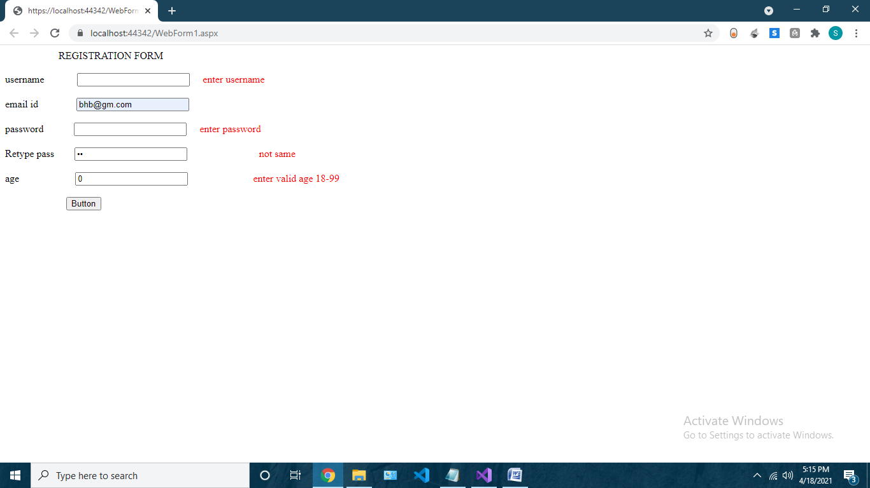

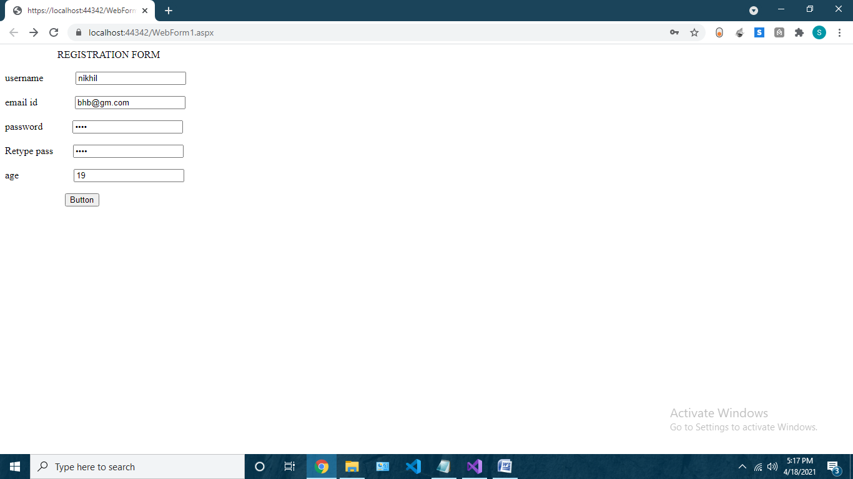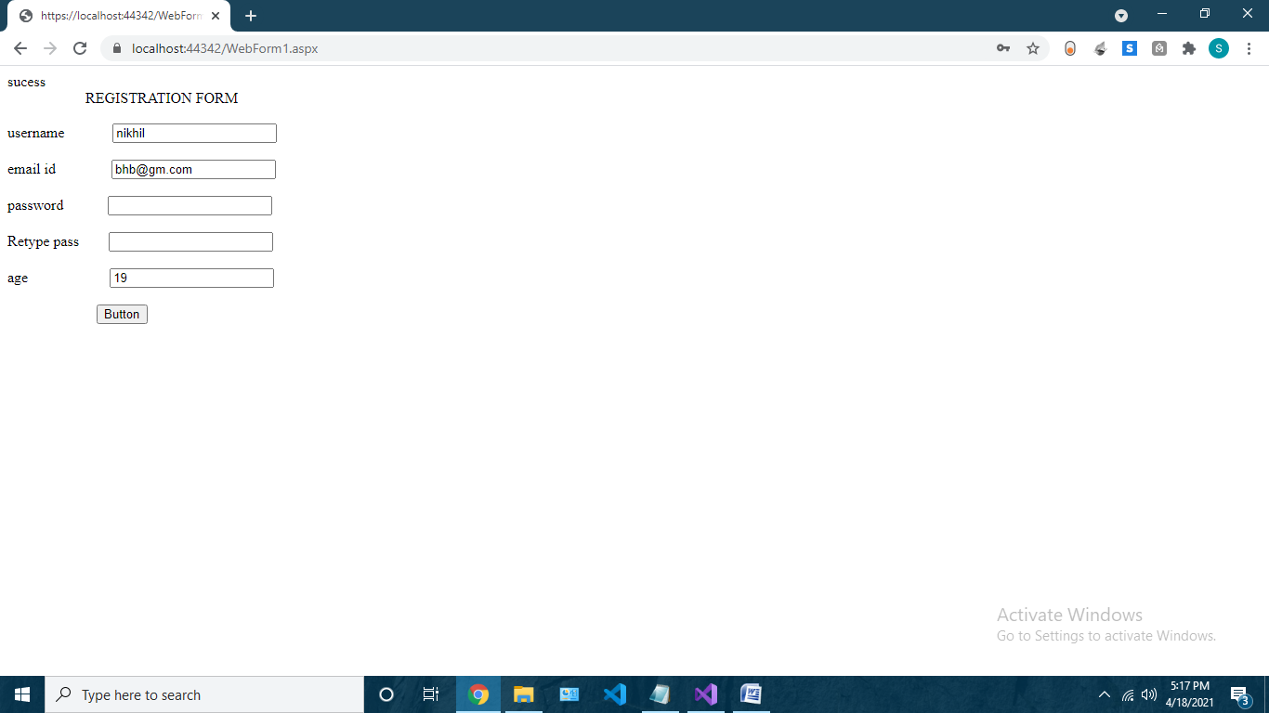

**Practical 9**

**(I have used calendar and adrotator in multiview in detail please refer)**

**AIM- Design ASP.Net pages for state management using:**

**a) Calendar**

<asp:Calendar ID="Calendar1" runat="server" BackColor="#009933" Caption="Calender" CaptionAlign="Bottom" Font-Names="Comic Sans MS" Font-Underline="True" ForeColor="#6600FF" NextMonthText="=&gt;" PrevMonthText="&lt;=" ShowGridLines="True"></asp:Calendar>

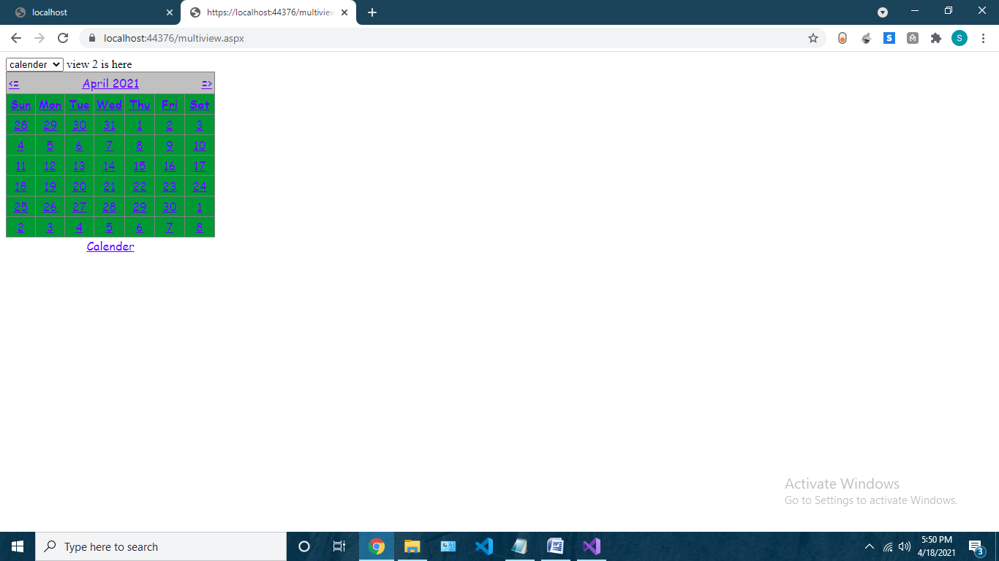

**b) Ad. Rotator**

<asp:XmlDataSource ID="XmlDataSource1" runat="server"></asp:XmlDataSource>

<asp:AdRotator runat="server" AdvertisementFile="adfile.xml" Target="_blank" />

**Adfile.xml**

<?xml version="1.0" encoding="utf-8" ?>

<Advertisements>

<Ad>

<ImageUrl>./images/download.png</ImageUrl>

<AlternateText>

picture

</AlternateText>

<Impressions>1</Impressions>

<Keyword>flowers</Keyword>

</Ad>

<Ad>

<ImageUrl>./images/download 1.png</ImageUrl>

<AlternateText>

picture

</AlternateText>

<Impressions>1</Impressions>

<Keyword>flowers</Keyword>

</Ad>

<Ad>

<ImageUrl>./images/download 2.png</ImageUrl>

<AlternateText>

picture

</AlternateText>

<Impressions>1</Impressions>

<Keyword>flowers</Keyword>

</Ad>

</Advertisements>

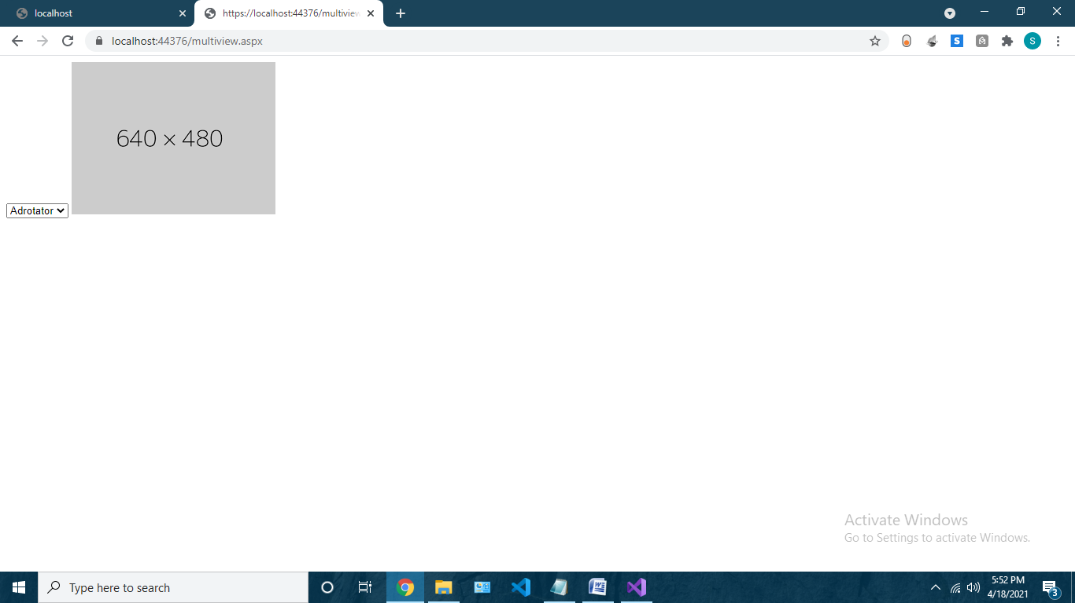 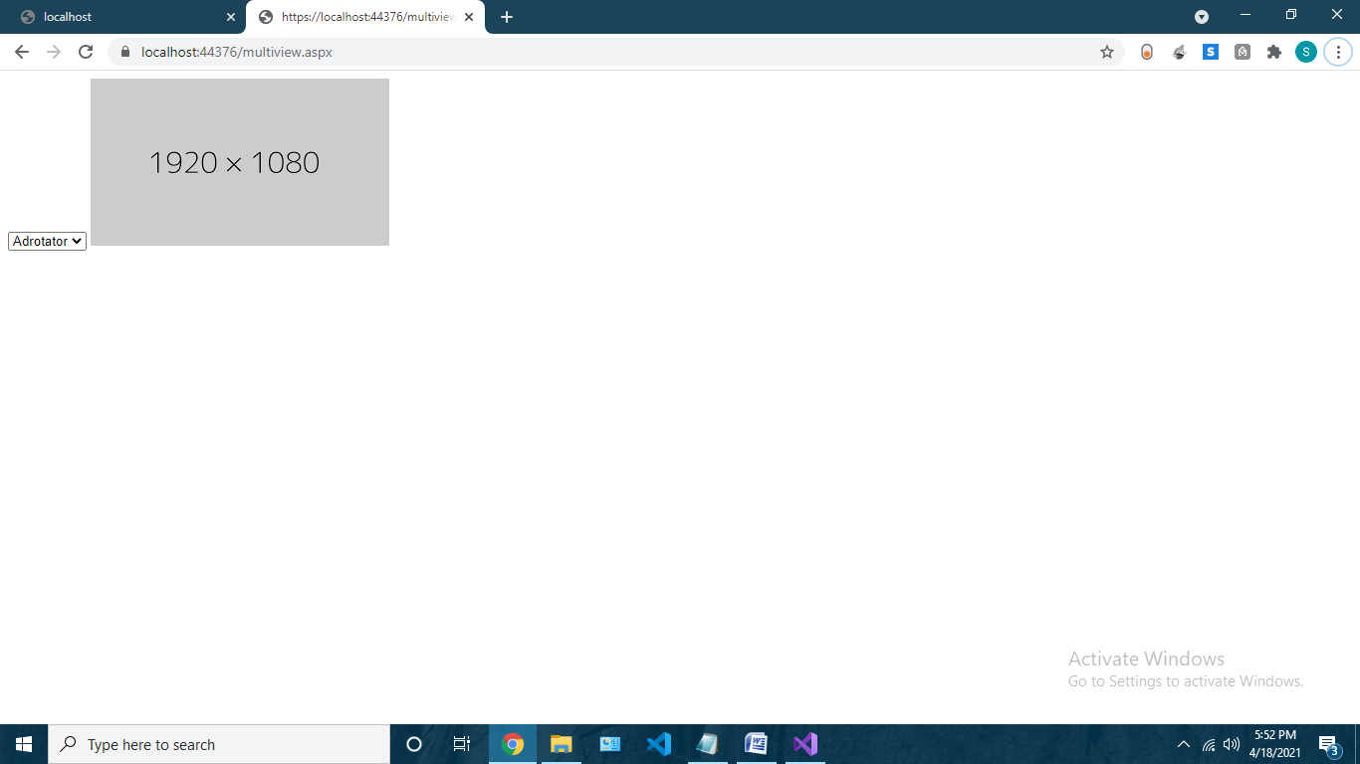 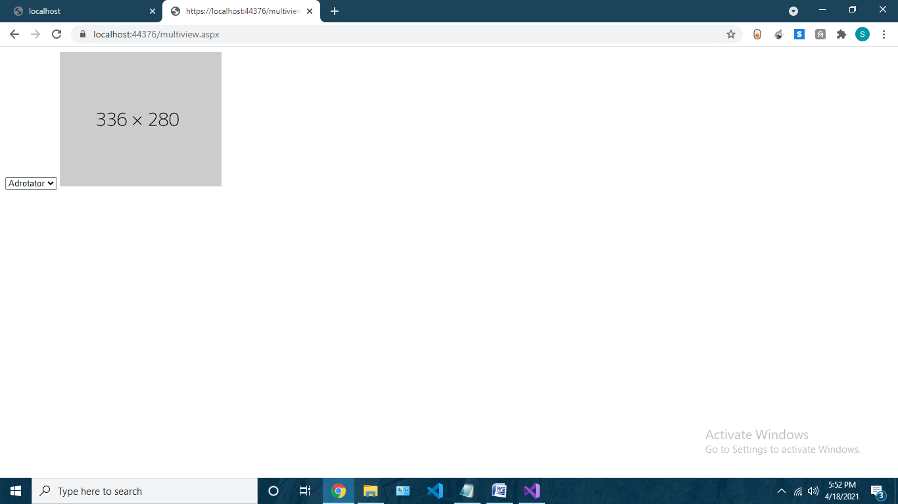

**c)MultiView Control**

**multiview.aspx**

<%@ Page Language="C#" AutoEventWireup="true" CodeBehind="multiview.aspx.cs" Inherits="practical6.WebForm1" %>

<!DOCTYPE html>

<html xmlns="http://www.w3.org/1999/xhtml">

<head runat="server">

<title></title>

</head>

<body>

<form id="form1" runat="server">

<div>

<asp:DropDownList ID="DropDownList1" runat="server" OnSelectedIndexChanged="DropDownList1_SelectedIndexChanged" AutoPostBack="True" >

<asp:ListItem Value="0">Adrotator</asp:ListItem>

<asp:ListItem Value="1">calender</asp:ListItem>

<asp:ListItem Value="2">loginform</asp:ListItem>

</asp:DropDownList>

<asp:MultiView ID="MultiView1" runat="server" ActiveViewIndex="0">

<asp:View ID="View1" runat="server">

<asp:XmlDataSource ID="XmlDataSource1" runat="server"></asp:XmlDataSource>

<asp:AdRotator runat="server" AdvertisementFile="adfile.xml" Target="_blank" />

</asp:View>

<br />

<asp:View ID="View2" runat="server">

<asp:Label ID="Label1" runat="server" Text="view 2 is here"></asp:Label>

<asp:Calendar ID="Calendar1" runat="server" BackColor="#009933" Caption="Calender" CaptionAlign="Bottom" Font-Names="Comic Sans MS" Font-Underline="True" ForeColor="#6600FF" NextMonthText="=&gt;" PrevMonthText="&lt;=" ShowGridLines="True"></asp:Calendar>

</asp:View>

<br />

<asp:View ID="View3" runat="server">

<asp:Label ID="Label2" runat="server" Text="I am view 3"></asp:Label>

<asp:Login ID="Login1" runat="server">

</asp:Login>

</asp:View>

</asp:MultiView>

</div>

</form>

</body>

</html>

**Multiview.aspx.cs**

using System;

using System.Collections.Generic;

using System.Linq;

using System.Web;

using System.Web.UI;

using System.Web.UI.WebControls;

namespace practical6

{

public partial class WebForm1 : System.Web.UI.Page

{

protected void Page_Load(object sender, EventArgs e)

{

}

protected void DropDownList1_SelectedIndexChanged(object sender, EventArgs e)

{

MultiView1.ActiveViewIndex = Int32.Parse(DropDownList1.SelectedValue);

}

}

}

OUTPUT

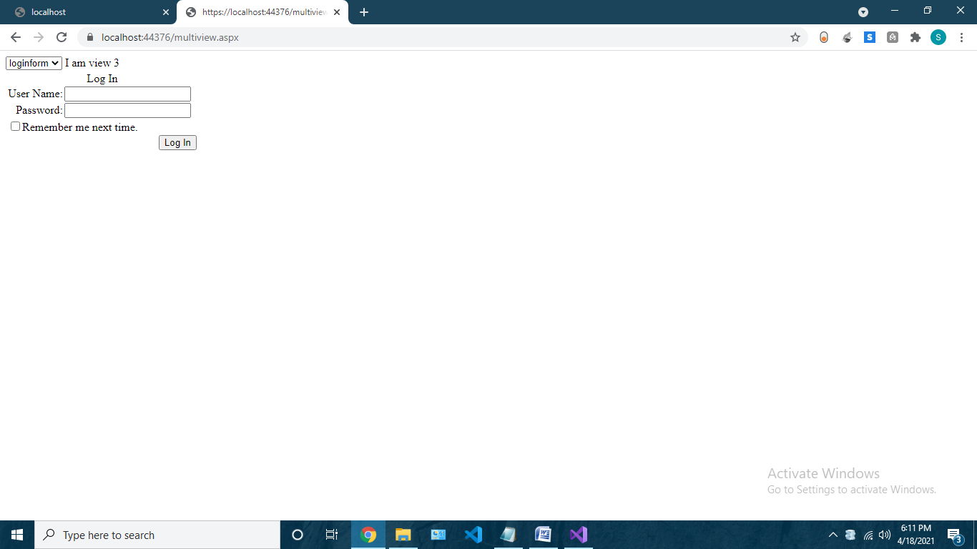

**Practical 10**

**Create a page in asp.net using session variable and display a message on label**

Webform1.aspx

<%@ Page Language="C#" AutoEventWireup="true" CodeBehind="WebForm1.aspx.cs" Inherits="Practical10.WebForm1" %>

<!DOCTYPE html>

<html xmlns="http://www.w3.org/1999/xhtml">

<head runat="server">

<title></title>

</head>

<body>

<form id="form1" runat="server">

<div>

<asp:Label ID="Label1" runat="server" Text="name"></asp:Label>

&nbsp;&nbsp;&nbsp;

<asp:TextBox ID="TextBox1" runat="server"></asp:TextBox>

<br />

<asp:Label ID="Label2" runat="server" Text="session"></asp:Label>

&nbsp;&nbsp;&nbsp;

<asp:Label ID="Label3" runat="server" Text="Label"></asp:Label>

<br />

<asp:Button ID="Button1" runat="server" OnClick="Button1_Click" Text="Button" />

</div>

</form>

</body>

</html>

Webform1.aspx.cs

using System;

using System.Collections.Generic;

using System.Linq;

using System.Web;

using System.Web.UI;

using System.Web.UI.WebControls;

namespace Practical10

{

public partial class WebForm1 : System.Web.UI.Page

{

protected void Page_Load(object sender, EventArgs e)

{

}

protected void Button1_Click(object sender, EventArgs e)

{

Session["name"] = TextBox1.Text;

Label3.Text = (string)Session["name"];

}

}

}

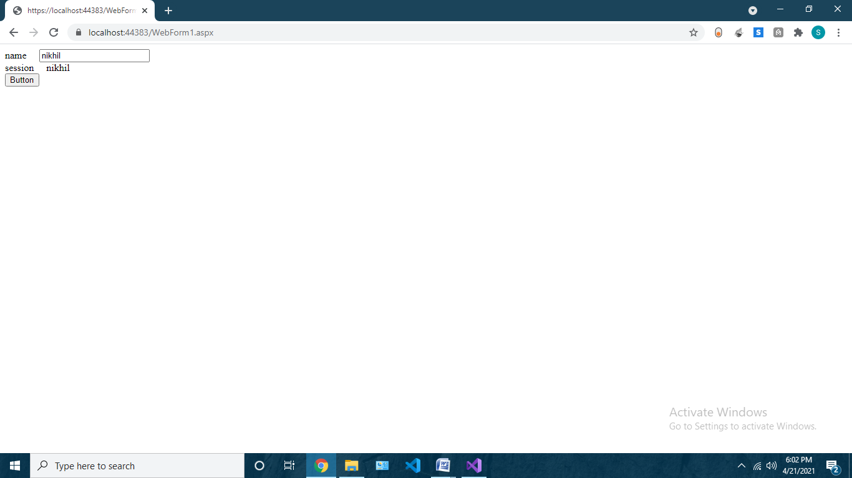

**Practical 12**

**- Design an ASP.net Master web page and use it other (at least 2-3 ) content pages.**

Site1.master

<%@ Master Language="C#" AutoEventWireup="true" CodeBehind="Site1.master.cs" Inherits="Tree.Site1" %>

<!DOCTYPE html>

<html>

<head runat="server">

<title></title>

<asp:ContentPlaceHolder ID="head" runat="server">

</asp:ContentPlaceHolder>

</head>

<body>

<form id="form1" runat="server">

<div>

<p>No Candidates shall be admitted to enter the First Year of the B.Com. Degree Course

(Revised Structure) unless he/she has passed the Higher Secondary School Certificate

Examination of the Maharashtra State Board of Higher Secondary Education Board or

University with English as a passing subject.

2) No candidate shall be admitted to the annual examination of the First year B.Com. (Revised

Structure ) unless he/ she has satisfactorily kept two terms for the course at the college at the

college affiliated to this University.

3) No candidate shall be admitted to the annual examination of the Second Year unless he/she

has kept two terms satisfactorily for the course at the college affiliated to this University.

4) No candidate shall be admitted to the Third year of the B.Com. Degree Course (Revised

Structure) unless he/she has passed in all the papers at the First Year B.Com. Examination

and has passed in all the papers at the first Year B.Com. Examination and has satisfactorily

kept terms for the second year and also two terms for the third year of B.Com. satisfactorily

in a college affiliated to this University. </p>

<asp:TreeView ID="TreeView1" runat="server">

<Nodes>

<asp:TreeNode Text="Graduation" Value="Graduation">

<asp:TreeNode NavigateUrl="~/WebForm2.aspx" Text="FYCS" Value="FYCS"></asp:TreeNode>

<asp:TreeNode Text="SYCS" Value="SYCS" NavigateUrl="~/WebForm1.aspx"></asp:TreeNode>

<asp:TreeNode NavigateUrl="~/WebForm3.aspx" Text="TYCS" Value="TYCS"></asp:TreeNode>

</asp:TreeNode>

</Nodes>

</asp:TreeView>

<asp:ContentPlaceHolder ID="ContentPlaceHolder1" runat="server">

</asp:ContentPlaceHolder>

</div>

</form>

</body>

</html>

Webform1.aspx

<%@ Page Title="" Language="C#" MasterPageFile="~/Site1.Master" AutoEventWireup="true" CodeBehind="WebForm2.aspx.cs" Inherits="Tree.WebForm2" %>

<asp:Content ID="Content1" ContentPlaceHolderID="head" runat="server">

</asp:Content>

<asp:Content ID="Content2" ContentPlaceHolderID="ContentPlaceHolder1" runat="server">

sycs

</asp:Content>

Webform2.aspx

<%@ Page Title="" Language="C#" MasterPageFile="~/Site1.Master" AutoEventWireup="true" CodeBehind="WebForm2.aspx.cs" Inherits="Tree.WebForm2" %>

<asp:Content ID="Content1" ContentPlaceHolderID="head" runat="server">

</asp:Content>

<asp:Content ID="Content2" ContentPlaceHolderID="ContentPlaceHolder1" runat="server">

fycs

</asp:Content>

Webform3.aspx

<%@ Page Title="" Language="C#" MasterPageFile="~/Site1.Master" AutoEventWireup="true" CodeBehind="WebForm3.aspx.cs" Inherits="Tree.WebForm3" %>

<asp:Content ID="Content1" ContentPlaceHolderID="head" runat="server">

</asp:Content>

<asp:Content ID="Content2" ContentPlaceHolderID="ContentPlaceHolder1" runat="server">

tycs

</asp:Content>

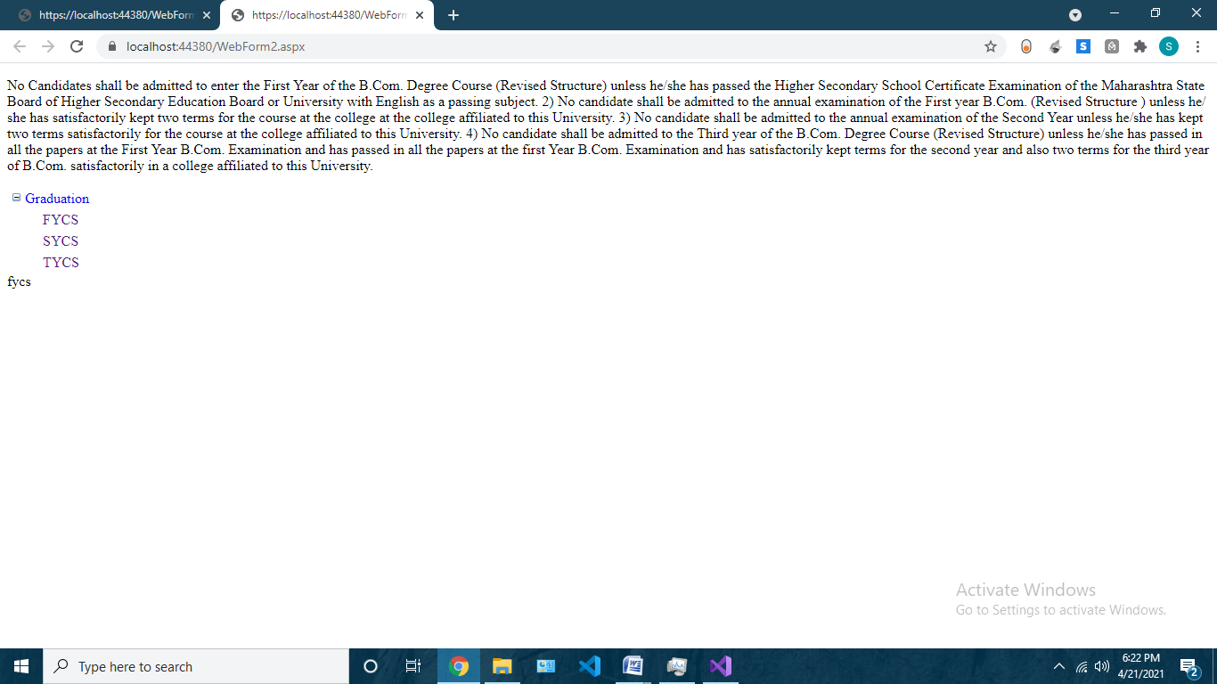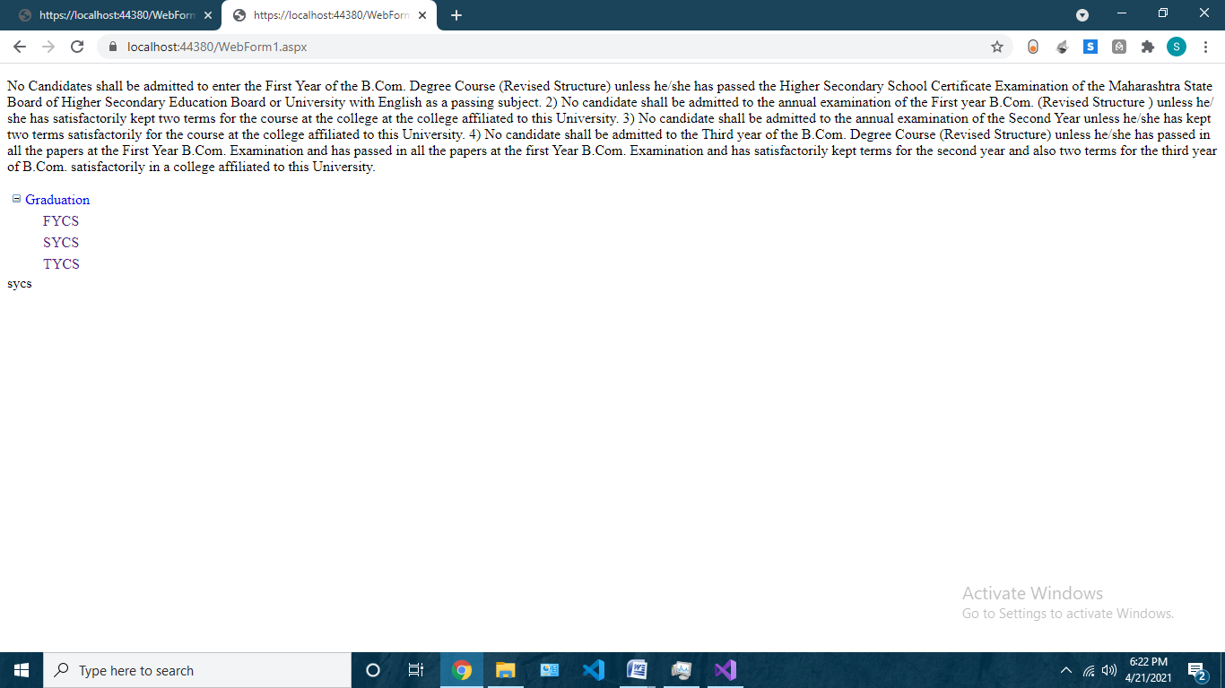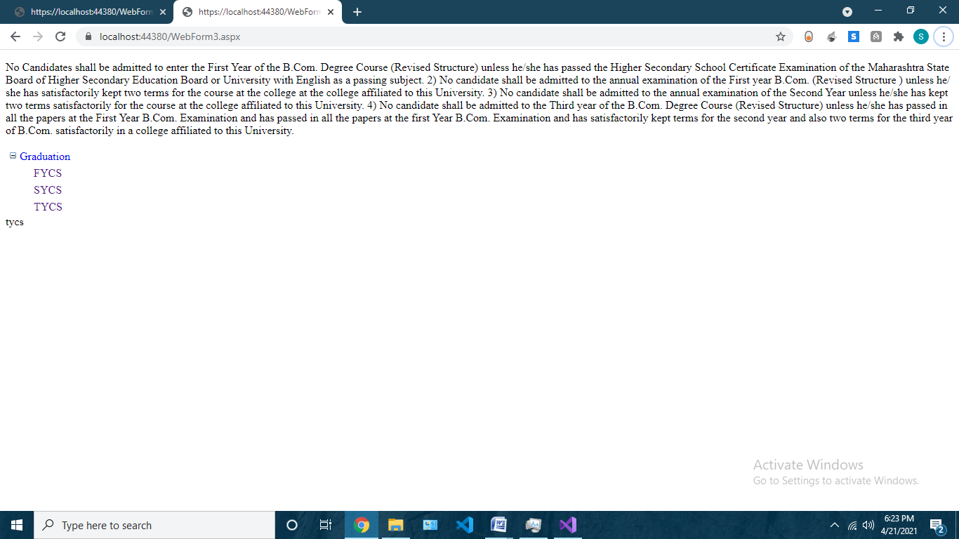

**Practical 15: Design an ASP.NET application for interacting(Creating and Reading) with XML file.**

**And**

**Practical16: A Cable TV provider stores the list of channels in an XML File. For each Channel, there is an attribute “Name”. The Channel element consists of sub-elements such as Language (such as Hindi, English, Marathi etc), Category (Sports, Movies, Cartoon etc). Design an ASP.NET page that displays, the list of languages and categories in 2 combo boxes. When user clicks on a button, all the channels matching the selected criteria should be displayed**

**Webform1.aspx**

<%@ Page Language="C#" AutoEventWireup="true" CodeBehind="WebForm1.aspx.cs" Inherits="xml.WebForm1" %>

<!DOCTYPE html>

<html xmlns="http://www.w3.org/1999/xhtml">

<head runat="server">

<title></title>

</head>

<body>

<form id="form1" runat="server">

<div style="margin-left: 240px">

<asp:Button ID="Button1" runat="server" OnClick="Button1_Click" Text="create" />

&nbsp;&nbsp;&nbsp;

<asp:Button ID="Button2" runat="server" Text="read" />

<br />

<asp:Label ID="Label1" runat="server" Text="Label"></asp:Label>

&nbsp;&nbsp;&nbsp;&nbsp;&nbsp;&nbsp;&nbsp;&nbsp;&nbsp;&nbsp;&nbsp;

<asp:Label ID="Label2" runat="server" Text="Label"></asp:Label>

<br />

<asp:GridView ID="GridView1" runat="server" DataSourceID="XmlDataSource1">

</asp:GridView>

<br />

<asp:XmlDataSource ID="XmlDataSource1" runat="server" DataFile="~/XMLFile2.xml"></asp:XmlDataSource>

</div>

</form>

</body>

</html>

**Webform1.aspx.cs**

using System;

using System.Collections.Generic;

using System.Linq;

using System.Web;

using System.Web.UI;

using System.Web.UI.WebControls;

using System.Xml;

namespace xml

{

public partial class WebForm1 : System.Web.UI.Page

{

protected void Page_Load(object sender, EventArgs e)

{

}

protected void Button1_Click(object sender, EventArgs e)

{

String st = "<Students>" +

"<rollno>01 </rollno>" +

"<name>SYCS</name>" +

"</Students>";

XmlDocument doc = new XmlDocument();

doc.LoadXml(st);

doc.Save(Server.MapPath("XMLFile1.xml"));

Label1.Text = "XML DOC Created";

}

protected void Button2_Click(object sender, EventArgs e)

{

XmlDocument doc = new XmlDocument();

doc.Load(Server.MapPath("XMLFile1.xml"));

XmlNode rn = doc.SelectSingleNode("Students/rollno");

XmlNode nm = doc.SelectSingleNode("Students/name");

Label1.Text = rn.InnerText;

Label2.Text = nm.InnerText;

}

}

}

**XMLFILE1.xml**

<Students>

<rollno>01 </rollno>

<name>SYCS</name>

</Students>

XMLFIle2.xml

<?xml version="1.0" encoding="utf-8" ?>

<cableTv>

<channel name="SabTv">

<language>HINDI</language>

<category>ENTERTAINMENT</category>

</channel>

<channel name="Hungama">

<language>ENGLISH</language>

<category>KIDS</category>

</channel>

<channel name="news18">

<language>MARATHI</language>

<category>NEWS</category>

</channel>

<channel name="pogo">

<language>HINDI</language>

<category>KIDS</category>

</channel>

<channel name="FTV">

<language>ENGLISH</language>

<category>FASHION</category>

</channel>

</cableTv>

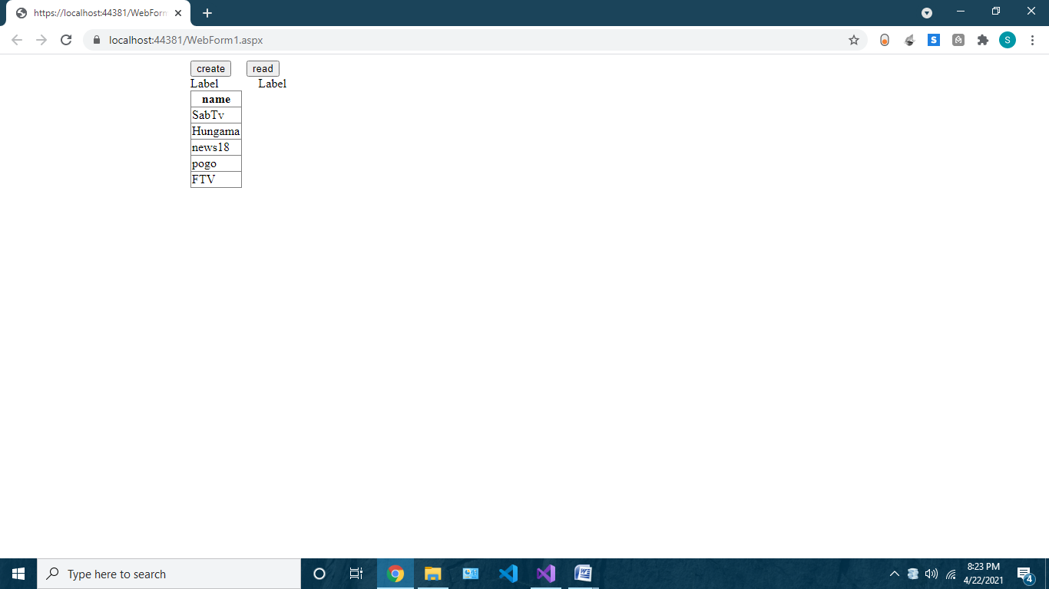

**Practical 19 : Create a database ‘SYCS’ and a table Student (id, name). Connect the front end with backend database.**

**And**

**practical 20: Design ASP.NET application to query a Database (External Data Source)**

**- Create a database ‘sycs’ and a table Student (id, name). Connect the front end with backend database. Create a table Student (id, name). Keep a ‘Show’ button to display the entire Student table on the webpage, a ‘Insert’ button to insert records in the table, a ‘Search’ button to look for student name with id as input, an ‘Edit’ button to edit student name for the given id, ’Delete’ button to delete a student record.**

**Table.aspx**

<%@ Page Title="" Language="C#" MasterPageFile="~/opertors.Master" AutoEventWireup="true" CodeBehind="table.aspx.cs" Inherits="DATABSE_OPERA.table" %>

<asp:Content ID="Content1" ContentPlaceHolderID="head" runat="server">

</asp:Content>

<asp:Content ID="Content2" ContentPlaceHolderID="ContentPlaceHolder1" runat="server">

<asp:GridView ID="GridView1" runat="server" BackColor="#00CC99" BorderColor="#FF66CC" BAutoGenerateColumns="False" DataSourceID="SqlDataSource1" ForeColor="#CC0000">

<Columns>

<asp:BoundField DataField="id" HeaderText="id" SortExpression="id" />

<asp:BoundField DataField="name" HeaderText="name" SortExpression="name" />

</Columns>

<FooterStyle />

<HeaderStyle />

<PagerStyle HorizontalAlign="Center" />

<RowStyle />

<SelectedRowStyle />

<SortedAscendingCellStyle />

<SortedAscendingHeaderStyle />

<SortedDescendingCellStyle />

<SortedDescendingHeaderStyle />

</asp:GridView>

<asp:SqlDataSource ID="SqlDataSource1" runat="server" ConnectionString="<%$ ConnectionStrings:rootConnectionString %>" SelectCommand="SELECT * FROM [Student]"></asp:SqlDataSource>

<br />

<br />

</asp:Content>

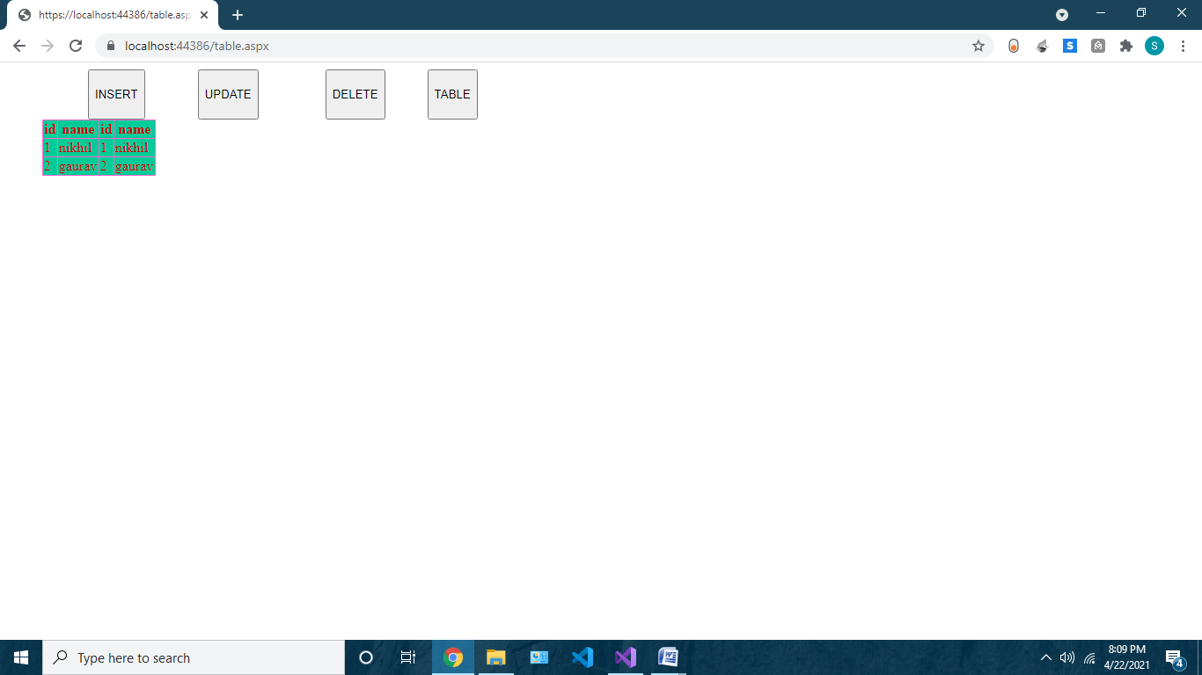

**Insert.aspx**

<%@ Page Title="" Language="C#" MasterPageFile="~/opertors.Master" AutoEventWireup="true" CodeBehind="ins.aspx.cs" Inherits="DATABSE_OPERA.ins" %>

<asp:Content ID="Content1" ContentPlaceHolderID="head" runat="server">

</asp:Content>

<asp:Content ID="Content2" ContentPlaceHolderID="ContentPlaceHolder1" runat="server">

<br />

&nbsp;&nbsp;&nbsp;&nbsp;&nbsp;&nbsp;&nbsp;&nbsp;&nbsp;&nbsp;&nbsp;&nbsp;&nbsp;&nbsp;&nbsp;

<br />

<br />

&nbsp;&nbsp;&nbsp;&nbsp;&nbsp;&nbsp;&nbsp;&nbsp;&nbsp;&nbsp;&nbsp; NAME:&nbsp;&nbsp;&nbsp;&nbsp;&nbsp;&nbsp;&nbsp;&nbsp;&nbsp;&nbsp;&nbsp;

<asp:TextBox ID="TextBox1" runat="server"></asp:TextBox>

<br />

<br />

&nbsp;&nbsp;&nbsp;&nbsp;&nbsp;&nbsp;&nbsp;&nbsp;&nbsp;&nbsp;&nbsp; ID:&nbsp;&nbsp;&nbsp;&nbsp;&nbsp;&nbsp;&nbsp;&nbsp;&nbsp;&nbsp;&nbsp;&nbsp;&nbsp;&nbsp;&nbsp;&nbsp;&nbsp;&nbsp;

<asp:TextBox ID="TextBox2" runat="server"></asp:TextBox>

<br />

<br />

&nbsp;&nbsp;&nbsp;&nbsp;&nbsp;&nbsp;&nbsp;&nbsp;&nbsp;&nbsp;&nbsp;&nbsp;&nbsp;&nbsp;&nbsp;&nbsp;&nbsp;&nbsp;&nbsp;&nbsp;&nbsp;&nbsp;&nbsp;&nbsp;&nbsp;&nbsp;&nbsp;&nbsp;&nbsp;&nbsp;&nbsp;&nbsp;&nbsp;&nbsp;&nbsp;

<asp:Button ID="Button6" runat="server" OnClick="Button6_Click" Text="ADD" Width="185px" />

<br />

<br />

<br />

&nbsp;&nbsp;&nbsp;&nbsp;&nbsp;&nbsp;&nbsp;&nbsp;&nbsp;&nbsp;&nbsp;&nbsp;&nbsp;&nbsp;&nbsp;&nbsp;&nbsp;&nbsp;&nbsp;&nbsp;&nbsp;&nbsp;&nbsp;&nbsp;&nbsp;&nbsp;&nbsp;

<asp:Label ID="Label1" runat="server"></asp:Label>

<br />

<br />

</asp:Content>

**Insert.aspx.cs**

using System;

using System.Collections.Generic;

using System.Linq;

using System.Web;

using System.Web.UI;

using System.Web.UI.WebControls;

using System.Data.SqlClient;

namespace DATABSE_OPERA

{

public partial class ins : System.Web.UI.Page

{

protected void Page_Load(object sender, EventArgs e)

{

}

public string cons = "Data Source=DESKTOP-1J3MI8F\\SQLEXPRESS;Initial Catalog=sycs;Integrated Security=True";

protected void Button6_Click(object sender, EventArgs e)

{

SqlConnection con = new SqlConnection(cons);

con.Open();

if(con.State==System.Data.ConnectionState.Open)

{

string q = "insert into student(name,id)values('"+TextBox1.Text.ToString()+"','"+ TextBox2.Text.ToString() +"')";

SqlCommand cmd = new SqlCommand(q, con);

cmd.ExecuteNonQuery();

Label1.Text = "insrted ";

}

}

}

}

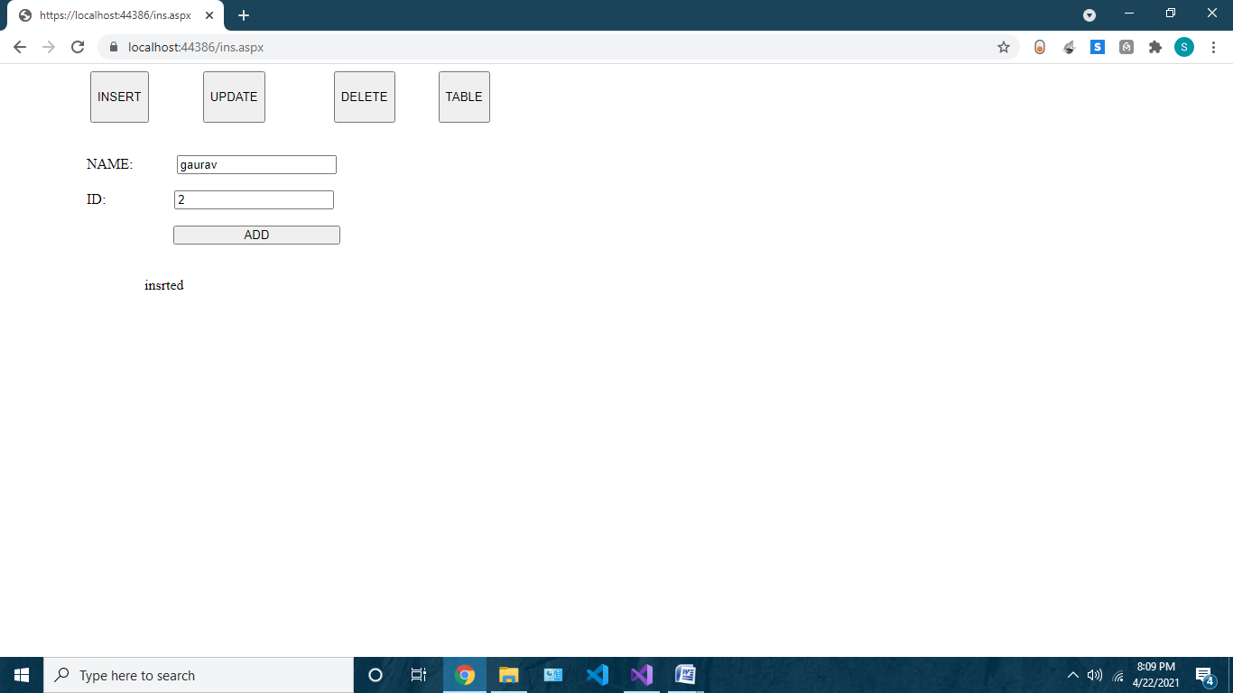

Update.aspx

<%@ Page Title="" Language="C#" MasterPageFile="~/opertors.Master" AutoEventWireup="true" CodeBehind="update.aspx.cs" Inherits="DATABSE_OPERA.update" %>

<asp:Content ID="Content1" ContentPlaceHolderID="head" runat="server">

</asp:Content>

<asp:Content ID="Content2" ContentPlaceHolderID="ContentPlaceHolder1" runat="server">

<br />

&nbsp;&nbsp;&nbsp;&nbsp;&nbsp;&nbsp;&nbsp;&nbsp;&nbsp;&nbsp;&nbsp;&nbsp;&nbsp;&nbsp;&nbsp;

<br />

<br />

&nbsp;&nbsp;&nbsp;&nbsp;&nbsp;&nbsp;&nbsp;&nbsp;&nbsp;&nbsp;&nbsp; NAME:&nbsp;&nbsp;&nbsp;&nbsp;&nbsp;&nbsp;&nbsp;&nbsp;&nbsp;&nbsp;&nbsp;

<asp:TextBox ID="TextBox1" runat="server"></asp:TextBox>

<br />

<br />

&nbsp;&nbsp;&nbsp;&nbsp;&nbsp;&nbsp;&nbsp;&nbsp;&nbsp;&nbsp;&nbsp; ID:&nbsp;&nbsp;&nbsp;&nbsp;&nbsp;&nbsp;&nbsp;&nbsp;&nbsp;&nbsp;&nbsp;&nbsp;&nbsp;&nbsp;&nbsp;&nbsp;&nbsp;&nbsp;

<asp:TextBox ID="TextBox2" runat="server"></asp:TextBox>

<br />

<br />

<br />

<br />

&nbsp;&nbsp;&nbsp;&nbsp;&nbsp;&nbsp;&nbsp;&nbsp;&nbsp;&nbsp;&nbsp;&nbsp;&nbsp;&nbsp;&nbsp;&nbsp;&nbsp;&nbsp;&nbsp;&nbsp;&nbsp;&nbsp;&nbsp;&nbsp;&nbsp;&nbsp;&nbsp;&nbsp;&nbsp;&nbsp;&nbsp;&nbsp;&nbsp;&nbsp;&nbsp;

<asp:Button ID="Button6" runat="server" OnClick="Button6_Click" Text="UPDATE" Width="185px" />

<br />

<br />

<br />

&nbsp;&nbsp;&nbsp;&nbsp;&nbsp;&nbsp;&nbsp;&nbsp;&nbsp;&nbsp;&nbsp;&nbsp;&nbsp;&nbsp;&nbsp;&nbsp;&nbsp;&nbsp;&nbsp;&nbsp;&nbsp;&nbsp;&nbsp;&nbsp;&nbsp;&nbsp;&nbsp;

<asp:Label ID="Label1" runat="server"></asp:Label>

<br />

<br />

</asp:Content>

**Update.aspx.cs**

using System;

using System.Collections.Generic;

using System.Linq;

using System.Web;

using System.Web.UI;

using System.Web.UI.WebControls;

using System.Data.SqlClient;

namespace DATABSE_OPERA

{

public partial class update : System.Web.UI.Page

{

protected void Page_Load(object sender, EventArgs e)

{

}

public string cons = "Data Source=DESKTOP-1J3MI8F\\SQLEXPRESS;Initial Catalog=sycs;Integrated Security=True";

protected void Button6_Click(object sender, EventArgs e)

{

SqlConnection con = new SqlConnection(cons);

con.Open();

if (con.State == System.Data.ConnectionState.Open)

{

string q = "Update student set id= " + TextBox2.Text + "where name='"+TextBox1.Text+"'";

SqlCommand cmd = new SqlCommand(q, con);

cmd.ExecuteNonQuery();

Label1.Text = "updated ";

}

else

{

Label1.Text = "Failed ";

}

}

}

}

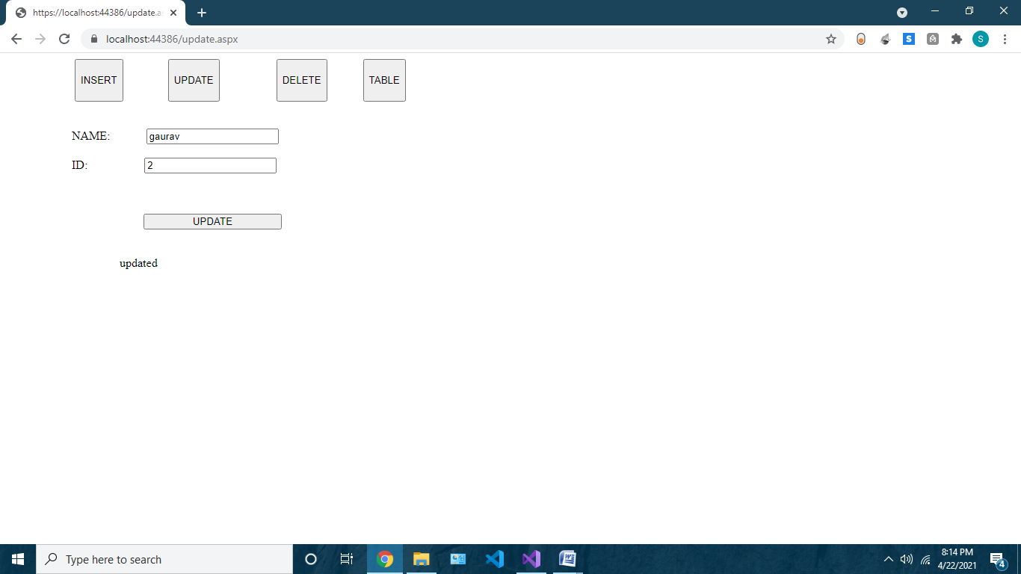

**Delete.aspx**

<%@ Page Title="" Language="C#" MasterPageFile="~/opertors.Master" AutoEventWireup="true" CodeBehind="delete.aspx.cs" Inherits="DATABSE_OPERA.delete" %>

<asp:Content ID="Content1" ContentPlaceHolderID="head" runat="server">

</asp:Content>

<asp:Content ID="Content2" ContentPlaceHolderID="ContentPlaceHolder1" runat="server">

<br />

&nbsp;<br />

<br />

ID :&nbsp;&nbsp;&nbsp;&nbsp;&nbsp;&nbsp;&nbsp;&nbsp;&nbsp;&nbsp;&nbsp;&nbsp;&nbsp;&nbsp;&nbsp;&nbsp;&nbsp;&nbsp;&nbsp;

<asp:TextBox ID="TextBox1" runat="server"></asp:TextBox>

<br />

<br />

<br />

&nbsp;&nbsp;&nbsp;&nbsp;&nbsp;&nbsp;&nbsp;&nbsp;&nbsp;&nbsp;&nbsp;&nbsp;&nbsp;&nbsp;&nbsp;&nbsp;&nbsp;

<asp:Button ID="Button6" runat="server" OnClick="Button6_Click" style="margin-left: 55px" Text="DELETE" Width="191px" />

<br />

<br />

&nbsp;&nbsp;&nbsp;&nbsp;&nbsp;&nbsp;&nbsp;&nbsp;&nbsp;&nbsp;&nbsp;&nbsp;&nbsp;&nbsp;&nbsp;&nbsp;&nbsp;&nbsp;&nbsp;&nbsp;&nbsp;&nbsp;&nbsp;&nbsp;&nbsp;&nbsp;&nbsp;&nbsp;&nbsp;&nbsp;&nbsp;&nbsp;&nbsp;&nbsp;&nbsp;&nbsp;&nbsp;&nbsp;&nbsp;&nbsp;&nbsp;&nbsp;&nbsp;&nbsp;

<br />

&nbsp;&nbsp;&nbsp;&nbsp;&nbsp;&nbsp;&nbsp;&nbsp;&nbsp;&nbsp;&nbsp;&nbsp;&nbsp;&nbsp;&nbsp;&nbsp;&nbsp;&nbsp;&nbsp;&nbsp;&nbsp;&nbsp;&nbsp;&nbsp;&nbsp;&nbsp;&nbsp;

<asp:Label ID="Label1" runat="server"></asp:Label>

<br />

<br />

<br />

</asp:Content>

**Delete.aspx.cs**

using System;

using System.Collections.Generic;

using System.Linq;

using System.Web;

using System.Web.UI;

using System.Web.UI.WebControls;

using System.Data.SqlClient;

namespace DATABSE_OPERA

{

public partial class delete : System.Web.UI.Page

{

protected void Page_Load(object sender, EventArgs e)

{

}

public string cons = "Data Source=DESKTOP-1J3MI8F\\SQLEXPRESS;Initial Catalog=sycs;Integrated Security=True";

protected void Button6_Click(object sender, EventArgs e)

{

SqlConnection con = new SqlConnection(cons);

con.Open();

if (con.State == System.Data.ConnectionState.Open)

{

string q = "delete from student where id='" + TextBox1.Text + "'";

SqlCommand cmd = new SqlCommand(q, con);

cmd.ExecuteNonQuery();

Label1.Text = "deleted";

}

else

{

Label1.Text = "Failed ";

}

}

}

}

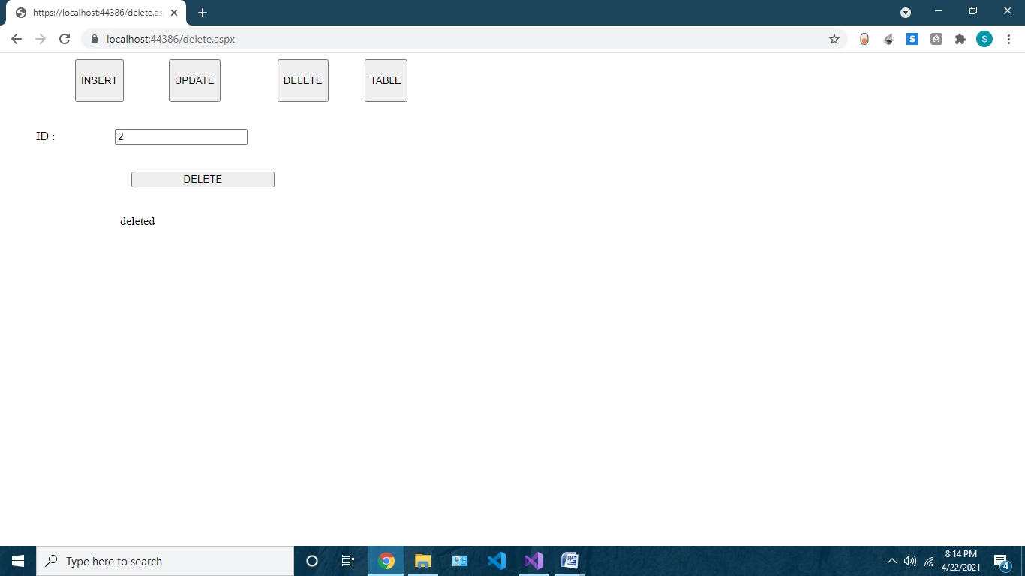

**Practical 21:output caching**

Webform1.aspx

<%@ Page Language="C#" AutoEventWireup="true" CodeBehind="WebForm1.aspx.cs" Inherits="caching.WebForm1" %>

<%@ OutputCache Duration="10" VaryByParam="none" %>

<!DOCTYPE html>

<html xmlns="http://www.w3.org/1999/xhtml">

<head runat="server">

<title></title>

</head>

<body>

<form id="form1" runat="server">

<div>

<asp:Label ID="Label1" runat="server" Text="Label"></asp:Label>

<br />

</div>

</form>

</body>

</html>

Webform1.aspx.cs

using System;

using System.Collections.Generic;

using System.Configuration;

using System.Data.SqlClient;

using System.Linq;

using System.Web;

using System.Web.UI;

using System.Web.UI.WebControls;

namespace caching

{

public partial class WebForm1 : System.Web.UI.Page

{

protected void Page_Load(object sender, EventArgs e)

{

Label1.Text = "Page Refreshed at: " + DateTime.Today.ToLongDateString() + " Time : " + DateTime.Now.ToLongTimeString();

}

protected void Timer1_Tick(object sender, EventArgs e)

{

}

}

}

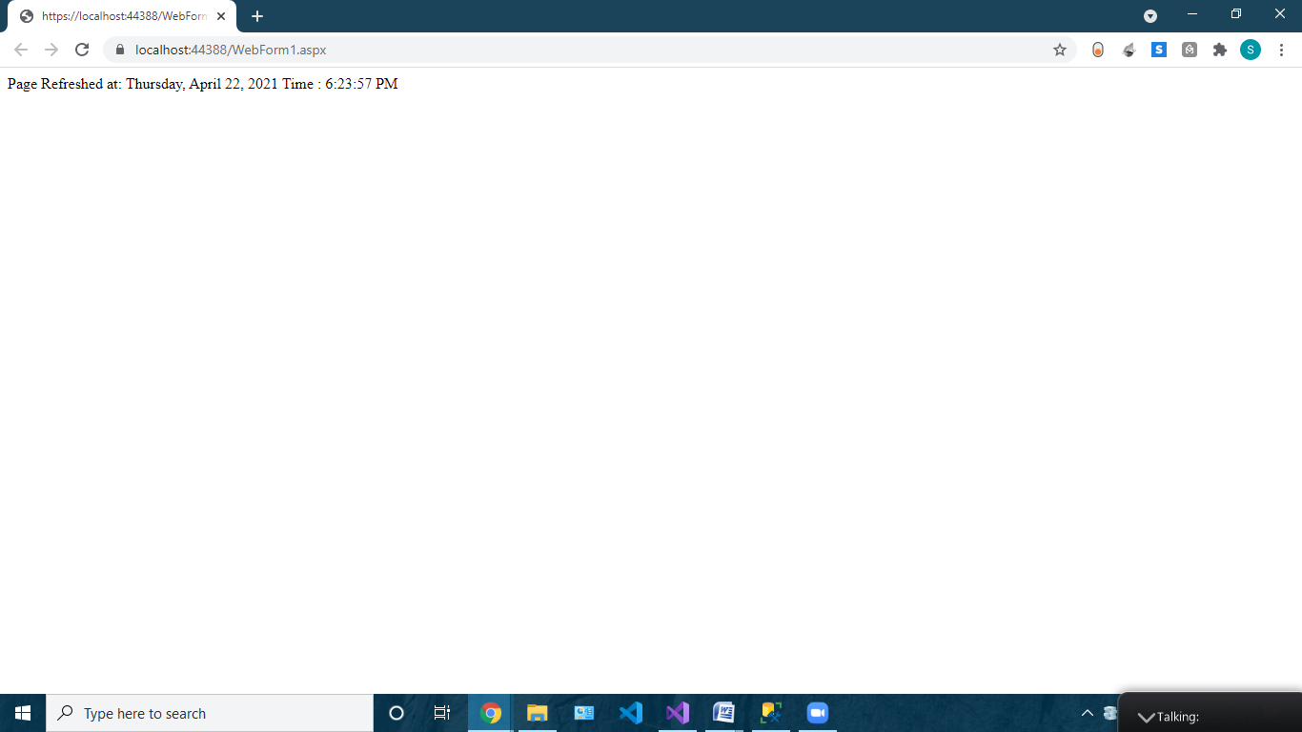

**Pratical 22: perform data binding**

Webform2.aspx

<%@ Page Language="C#" AutoEventWireup="true" CodeBehind="WebForm2.aspx.cs" Inherits="cashing.WebForm2" %>

<!DOCTYPE html>

<html xmlns="http://www.w3.org/1999/xhtml">

<head runat="server">

<title></title>

</head>

<body>

<form id="form1" runat="server">

<div class="auto-style2">

<br />

<br />

<br />

<br />

<br />

<br />

<br />

&nbsp;&nbsp; ENTER NAME

<asp:TextBox ID="tb1" runat="server" CssClass="auto-style1" Height="39px" Width="231px"></asp:TextBox>

<br />

<br />

&nbsp;&nbsp;&nbsp;&nbsp;&nbsp;

<asp:Button ID="Button1" runat="server" Height="41px" OnClick="Button1_Click" Text="GET ID" Width="173px" />

<br />

<br />

&nbsp;&nbsp;&nbsp;&nbsp;&nbsp;&nbsp;&nbsp;&nbsp;&nbsp;&nbsp;&nbsp;&nbsp;&nbsp;

<asp:Label ID="Label1" runat="server"></asp:Label>

<br />

&nbsp;&nbsp;&nbsp;&nbsp;&nbsp;&nbsp;&nbsp;&nbsp;&nbsp;&nbsp;&nbsp;&nbsp;&nbsp;&nbsp;

<asp:Label ID="l2" runat="server"></asp:Label>

</div>

</form>

</body>

</html>

Webform2.aspx.cs

using System;

using System.Collections.Generic;

using System.Linq;

using System.Web;

using System.Web.UI;

using System.Web.UI.WebControls;

using System.Data.SqlClient;

using System.Configuration;

namespace cashing

{

public partial class WebForm2 : System.Web.UI.Page

{

protected void Page_Load(object sender, EventArgs e)

{

}

protected void Button1_Click(object sender, EventArgs e)

{

String con = ConfigurationManager.ConnectionStrings["sycs"].ConnectionString;

SqlConnection sqlcon = new SqlConnection(con);

sqlcon.Open();

l2.Text="Connection done";

String s = "Select id from student where name='" + tb1.Text + "'";

SqlCommand cbm = new SqlCommand(s, sqlcon);

Label1.Text = "id of student is : " + cbm.ExecuteScalar().ToString();

}

}

}

Web.config

<connectionStrings>

<add name ="sycs" connectionString="Data Source=DESKTOP-1J3MI8F\SQLEXPRESS;Initial Catalog=sycs;Integrated Security=True"

providerName="System.Data.SqlClient" />

</connectionStrings>

