**Step 1:Setting up the envoirnment to run the program**

Just go to <https://www.python.org/downloads/> and download the required version ill be using version 3.7.4.

Do not forget to add python to PATH during installation so that you can run it from the cmd.

After the installation is complete, just go to your cmd and type

>pip install selenium

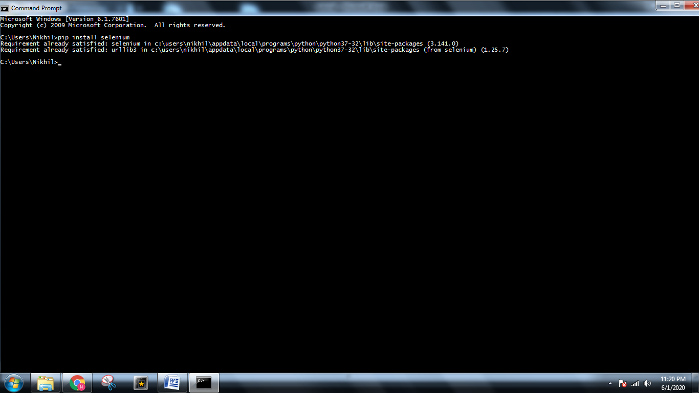

>pip install openpyxl

Now open your directory and download a chromedriver according to your os and chrom version from <https://chromedriver.chromium.org/downloads>

Store it in the same directory

Now you are setup with your envoirnment