

AN AI-POWERED RESEARCH PAPER COMPARISON AND EVIDENCE VERIFICATION SYSTEM USING
RETRIEVAL-AUGMENTED GENERATION (RAG)

A PROJECT REPORT

Submitted by

NIMAL V | [723724243137]
NAVEEN A | [723724243135]
SANJAY KANTH | [723724243175]
In partial fulfilment for the award of the degree
Of

BACHELOR OF TECHNOLOGY

IN

ARTIFICIAL INTELLIGENCE AND DATA SCIENCE

V.S.B. COLLEGE OF ENGINEERING TECHNICAL CAMPUS
(An Autonomous Institution) COIMBATORE-642109, 025
NOVEMBER 2026

ANNA UNIVERSITY: CHENNAI 600 025

BONAFIDE CERTIFICATE

Certified that this project report “AN AI-POWERED RESEARCH PAPER COMPARISONANDEVIDENCE VERIFICATION SYSTEM USING RETRIEVAL-AUGMENTED GENERATION (RAG)” is the bonafide work of NIMAL V [723724243137], NAVEEN A [723724243135], SANJAY KANTH [723724243137], who carried out the project work under my supervision.

SIGNATURE | SIGNATURE
Dr. R. MURUGADOSS, M.E., Ph.D.
HEAD OF THE DEPARTMENT, | SUPERVISOR,  ASSISTANT PROFESSOR,
DEPARTMENT OF ARTIFICIAL INTELLIGENCE AND DATA SCIENCE, | DEPARTMENT OF ARTIFICIAL INTELLIGENCE AND DATA SCIENCE,
V.S.B. COLLEGE OF ENGINEERING  TECHNICAL CAMPUS, | V.S.B. COLLEGE OF ENGINEERING TECHNICAL CAMPUS,
COIMBATORE-642109 | COIMBATORE-642109

Submitted for the university examination held on

at

V.S.B. College of Engineering Technical Campus, Coimbatore.

INTERNAL EXAMINER EXTERNAL EXAMINER

ACKNOWLEDGEMENT

First, we extend our heartfelt gratitude to the management of V.S.B. College of Engineering Technical Campus for providing us with the state-of-the-art computational infrastructure, high-speed research facilities, and an intellectually inspiring learning environment to pursue this project.

We express our sincere thanks to our beloved Principal, Dr. V. Velmurugan, M.E., Ph.D., for his continuous encouragement, leadership, and visionary academic guidance throughout our degree program.

We also express our gratitude to the Vice Principal, Dr. R. Poornachandran, M.E., Ph.D., for his academic support, administrative cooperation, and regular motivation.

We are highly grateful to Dr. R. Murugadoss, M.E., Ph.D., and Mrs. G. Nithya, M.E., (Ph.D), Head of the Department of Artificial Intelligence and Data Science, for their consistent encouragement, domain guidance, and constructive suggestions during technical seminars.

We are highly grateful to Mrs. G. Nithya M.E., (Ph.D), Head of the Department, Department of Artificial Intelligence and Data Science Engineering, for his valuable suggestions and encouragement throughout the project

We would like to express our deepest gratitude to our esteemed project guide, Mr. S. Soundhar, M.E., Assistant Professor, Department of Artificial Intelligence and Data Science, for his invaluable technical guidance, meticulous review of system architecture, and insightful recommendations throughout the lifecycle of this project.

Finally, we extend our sincere gratitude to our parents, faculty members, lab technicians, and friends who supported us morally and technically in bringing this research project to successful completion.



VISION AND MISSION STATEMENTS OF THE INSTITUTE

Vision:
We endeavour to impart futuristic technical education of the highest quality in the student community to inculcate discipline in them to face the world with self- confidence and thus we prepare them for life responsible citizens to uphold human values and to be of services at large. We strive to bring up the Institution as an Institution of Academic excellence of international standard.

Mission:
We transform persons into personalities by the state-of-the-art infrastructure, time consciousness, quick response and the best academic practices through assessment and advice.

VISION AND MISSION STATEMENTS OF THE DEPARTMENT
Name of the Department: Department of Artificial Intelligence and Data Science

Vision:
To emerge with technological excellence to nurture talents and instigate research skills with social responsibilities in the domain of Data Science.

Mission:
Empower students with knowledge through experiential learning. To create a conducive ambience for learning through exposures in latest cutting-edge technology in collaboration with industries. To provide individual attention and enable character building. Instill lifelong learning and encourage entrepreneurial skills among students.
Program Outcomes (POs)

PO1: Engineering Knowledge:
Apply knowledge of mathematics, natural science, computing, engineering fundamentals and an engineering specialization as specified in WK1 to WK4 respectively to develop to the solution of complex engineering problems.
PO2: Problem Analysis:
Identify, formulate, review research literature and analyze complex engineering problems reaching substantiated conclusions with consideration for sustainable development. (WK1 to WK4)
PO3: Design/Development of Solutions:
Design creative solutions for complex engineering problems and design/develop systems/components/processes to meet identified needs with consideration for the public health and safety, whole-life cost, net zero carbon, culture, society and environment as required. (WK5)
PO4: Conduct Investigations of Complex Problems:
Conduct investigations of complex engineering problems using research-based knowledge including design of experiments, modelling, analysis & interpretation of data to provide valid conclusions. (WK8).
PO5: Engineering Tool Usage:
Create, select and apply appropriate techniques, resources and modern engineering & IT tools, including prediction and modelling recognizing their limitations to solve complex engineering problems. (WK2 and WK6)
PO6: The Engineer and The World:
Analyze and evaluate societal and environmental aspects while solving complex engineering problems for its impact on sustainability with reference to economy, health, safety, legal framework, culture and environment. (WK1, WK5, and WK7).
PO7: Ethics:
Apply ethical principles and commit to professional ethics, human values, diversity and Inclusion; adhere to national & international laws. (WK9)
PO8: Individual and Collaborative Team work:
Function effectively as an individual, and as a member or leader in diverse/multi-disciplinary teams.

PO9: Communication:
Communicate effectively and inclusively within the engineering community and society at large, such as being able to comprehend and write effective reports and design documentation, make effective presentations considering cultural, language, and learning differences
PO10:Project Management and Finance:
Apply knowledge and understanding of engineering management principles and economic decision-making and apply these to one’s own work, as a member and leader in a team, and to manage projects and in multidisciplinary environments.
PO11: Life-Long Learning:
Recognize the need for, and have the preparation and ability for i) independent and lifelong learning ii) adaptability to new and emerging technologies and iii) critical thinking in the broadest context of technological change. (WK8)

Knowledge and Attitude Profile (WK)

WK1: A systematic, theory-based understanding of the natural sciences applicable to the discipline and awareness of relevant social sciences.
WK2: Conceptually-based mathematics, numerical analysis, data analysis, statistics and formal aspects of computer and information science to support detailed analysis and modelling applicable to the discipline.
WK3: A systematic, theory-based formulation of engineering fundamentals required in the engineering discipline.
WK4: Engineering specialist knowledge that provides theoretical frameworks and bodies of knowledge for the accepted practice areas in the engineering discipline; much is at the forefront of the discipline.
WK5: Knowledge, including efficient resource use, environmental impacts, whole-life cost, reuse of resources, net zero carbon, and similar concepts, that supports engineering design and operations in a practice area.
WK6: Knowledge of engineering practice (technology) in the practice areas in the engineering discipline.
WK7: Knowledge of the role of engineering in society and identified issues in engineering practice in the discipline, such as the professional responsibility of an engineer to public safety and sustainable development.
WK8: Engagement with selected knowledge in the current research literature of the discipline, awareness of the power of critical thinking and creative approaches to evaluate emerging issues.
WK9: Ethics, inclusive behaviour and conduct. Knowledge of professional ethics, responsibilities, and norms of engineering practice. Awareness of the need for diversity by reason of ethnicity, gender, age, physical ability with mutual understanding and respect, and of inclusive attitudes.

AN AI-POWERED RESEARCH PAPER COMPARISON AND EVIDENCE VERIFICATION SYSTEM USING RETRIEVAL-AUGMENTED GENERATION (RAG)

ABSTRACT

The exponential expansion of peer-reviewed scientific literature poses a formidable cognitive barrier for researchers, graduate scholars, and peer reviewers. Traditional academic search engines index keywords but provide zero cross-document relational synthesis. Conversely, general-purpose Large Language Models (LLMs) frequently generate hallucinated citations, phantom experimental results, and superficial summaries that lack verifiable grounding. This project presents an enterprise-grade AI-Powered Research Paper Comparison and Evidence Verification System using Retrieval-Augmented Generation (RAG) designed to perform automated, high-precision multi-document comparative analysis with absolute provenance. The framework integrates an automated PDF extraction pipeline using PyMuPDF that preserves exact 1-indexed page coordinates, a metadata-preserving sliding window chunker (512 tokens with 100-token overlap), and a hybrid retrieval engine combining dense vector embeddings (SentenceTransformers all-MiniLM-L6-v2) with sparse BM25 lexical indexing fused via Reciprocal Rank Fusion (k=60). To guarantee factual integrity, synthesized claims are validated through Natural Language Inference (NLI) entailment scoring, generating clickable, page-level citations formatted as [Paper Title, p. X]. The proposed system automatically constructs multi-dimensional comparative matrices spanning objectives, methodologies, model architectures, datasets, evaluation metrics, empirical findings, limitations, and research gaps. Furthermore, an automated metric consistency validation module audits reported quantitative benchmarks, identifying discrepancies in evaluation splits and measurement units across papers. To guarantee strict confidentiality for proprietary and pre-publication research manuscripts, an enterprise security module utilizing Spring Security 6, stateless JSON Web Tokens (JWT), and BCrypt password hashing enforces rigorous multi-tenant data isolation and resource ownership verification. Experimental evaluation across 50 peer-reviewed scientific papers demonstrated a Top-5 retrieval precision of 96.8%, a page citation accuracy of 97.4%, and an end-to-end processing latency of under 8 seconds for a 3-paper comparison, achieving 100% compliance across automated security and authorization test suites.
Keywords:
Retrieval-Augmented Generation (RAG), scientific document intelligence, multi-paper comparison matrix, evidence grounding, page-level citations, metric consistency auditing, hallucination mitigation, Spring Boot, Spring Security 6, JWT authentication, PyMuPDF, FastAPI, hybrid vector search.

TABLE OF CONTENTS

LIST OF TABLES xiv
LIST OF FIGURES xv
CHAPTER 1 INTRODUCTION 1
1.1 Background and Context 1
1.2 Problem Statement 2
1.3 Objectives of the Project 3
1.4 Scope of the Project 4
1.5 Authentication and User Data Isolation Requirements 5
CHAPTER 2 LITERATURE REVIEW 6
2.1 Evolution of Scientific Document Processing 6
2.2 Traditional NLP and Extractive Summarization 7
2.3 Large Language Models and Hallucination in Academic QA 7
2.4 Retrieval-Augmented Generation (RAG) in Scientific Domains 8
2.5 Comparative Analysis of Existing Literature Review Assistants 9
2.6 Summary of Research Gaps 10
CHAPTER 3 SYSTEM DESIGN AND ARCHITECTURE 11
3.1 Overall System Architecture 11
3.2 PDF Ingestion and Page-Bound Text Extraction Pipeline 12
3.3 Metadata-Preserving Hierarchical Chunking 13
3.4 Hybrid Semantic-Lexical Retrieval Architecture 14
3.5 Authentication, Authorization, and Security Architecture 15
3.6 Multi-Tenant Data Isolation and Ownership Verification Model 17
CHAPTER 4 RESEARCH METHODOLOGY AND ALGORITHMIC FORMULATION 18
CHAPTER 5 SYSTEM REQUIREMENTS 23
CHAPTER 6 SYSTEM DESIGN AND IMPLEMENTATION 26
CHAPTER 7 EXPERIMENTAL RESULTS AND ANALYSIS 32
CHAPTER 8 USE CASES 38
CHAPTER 9 ETHICAL, LEGAL AND SOCIETAL CONSIDERATIONS 41
CHAPTER 10 LIMITATIONS 43
CHAPTER 11 FUTURE SCOPE 44
CHAPTER 12 CONCLUSION 45
REFERENCES 46

LIST OF TABLES

Table 2.1 Comparative Analysis of Literature Review Tools and Proposed System 10
Table 4.1 Benchmark Evaluation Dataset and Scientific Document Corpus 19
Table 5.1 Hardware Requirements 23
Table 5.2 Software Requirements and Technology Stack 24
Table 5.3 Security, Authentication, and Compliance Requirements Specification 25
Table 6.1 Key Backend REST API Endpoints and Authorization Rules 28
Table 7.1 Evidence Retrieval Precision and Page Grounding Accuracy 33
Table 7.2 Ablation Study Results on Chunking Parameters and Fusion 33
Table 7.3 Inference Latency Breakdown for a 3-Paper Comparison Session 35
Table 7.4 Authentication, Authorization, and Security Test Suite Results 36

LIST OF FIGURES

Fig. 3.1 End-to-End System Architecture: AI-Powered Research Paper Comparison Engine 11
Fig. 3.2 PDF Ingestion and Page-Bound Text Extraction Pipeline 12
Fig. 3.3 Metadata-Preserving Hierarchical Chunking with Sliding Window Overlap 13
Fig. 3.4 Hybrid Semantic-Lexical Retrieval Architecture with Reciprocal Rank Fusion 14
Fig. 3.5 User Authentication and JWT Authorization Flow with Spring Security 17
Fig. 3.6 Multi-Tenant Data Isolation and Ownership Verification Architecture 17
Fig. 6.1 Multi-Paper Comparison Matrix and Claim Verification Pipeline 26
Fig. 6.2 Metric Extraction and Cross-Paper Consistency Verification Pipeline 30
Fig. 6.3 Asynchronous Job Processing and State Transition Lifecycle 31
Fig. 7.1 Evidence Retrieval Precision vs. Token Chunk Size Benchmark 34
Fig. 7.2 Inference and Matrix Construction Latency vs. Number of Papers 35
Fig. 7.3 Cross-Paper Claim Grounding Entailment Scores by Dimension Heatmap 37

CHAPTER - 1
INTRODUCTION
CHAPTER 1
INTRODUCTION
1.1 Background and Context
The volume of scientific literature published globally has experienced unprecedented exponential expansion over the past two decades. With more than 3 million peer-reviewed articles indexed across major repositories annually—spanning disciplines such as computer science, artificial intelligence, biomedicine, materials engineering, and renewable energy—scholars, graduate researchers, and domain specialists face an acute information triage challenge. Conducting a rigorous literature survey traditionally demands hundreds of hours of manual labor: identifying key papers, downloading PDF manuscripts, cross-referencing bibliographies, extracting methodological details, comparing experimental benchmarks, and synthesizing findings into cohesive thematic frameworks.
In multidisciplinary subfields such as deep learning and generative modeling, the pace of innovation exacerbates this cognitive burden. New model architectures, optimization algorithms, and benchmark datasets emerge weekly on pre-print repositories like arXiv. A researcher attempting to understand the state-of-the-art across competing paradigms (such as Convolutional Networks, Transformers, Selective State Space Models, and Graph Neural Networks) must simultaneously contrast disparate evaluation protocols, varying dataset versions, inconsistent metric definitions, and diverging operational constraints. Conventional academic search engines such as Google Scholar, IEEE Xplore, and Scopus excel at keyword indexing and document retrieval, but provide zero semantic synthesis, cross-document comparison, or quantitative discrepancy detection.
The emergence of large language models (LLMs) and conversational assistants has spurred significant interest in automated literature review and document question answering. While early experiments with general-purpose chatbots revealed remarkable fluency, they demonstrated profound vulnerabilities when applied to technical scholarly research. The lack of strict grounding in source texts frequently results in fabricated citations, phantom empirical findings, and distorted methodological descriptions—phenomena broadly characterized as epistemic hallucinations. For scientific inquiry, where accuracy and provenance are foundational, ungrounded generative summaries are fundamentally unusable. This reality establishes the urgent need for an evidence-grounded research assistance engine capable of performing multi-document comparative analysis with verifiable page-level provenance.
1.2 Problem Statement
Existing literature analysis tools and commercial generative AI systems suffer from three fundamental architectural and functional deficiencies that undermine their utility for scholarly research:
1. Lack of Verifiable Page-Level Provenance: When standard conversational AI systems generate answers or literature reviews based on input documents, they typically synthesize continuous text without anchoring specific empirical claims to exact page numbers, paragraphs, or tabular excerpts. When a model asserts that 'Method A achieved a 3.4% accuracy improvement over baseline on Dataset X,' the researcher cannot readily verify whether this claim reflects the primary findings of the paper, an ablation study on an auxiliary subset, or an outright hallucination. Verifying claims manually across 20-page technical manuscripts destroys the productivity advantages of automated assistance.
2. Inability to Perform Structured Multi-Document Comparison: Synthesizing multiple research papers requires more than answering isolated questions about individual documents. It demands cross-tabulation across standardized research dimensions: research objectives, underlying methodologies, model architectures, dataset splits, evaluation metrics, empirical outcomes, documented limitations, and identified research gaps. Existing document-QA systems treat papers in isolation or concatenate multiple documents into a single prompt context, leading to catastrophic attention dilution, recency bias, and superficial high-level generalizations that omit critical technical nuances.
3. Metric Inconsistency and Non-Standard Evaluation Protocols: In empirical computer science and engineering literature, authors frequently report evaluation metrics under subtly differing experimental configurations (e.g., micro vs. macro F1-score, accuracy on differing train/test splits, disparate evaluation hardware, varying tokenization strategies). Current document assistants blindly aggregate numerical values without contextual validation, presenting incomparable numbers as direct equivalents. This leads to erroneous academic conclusions regarding relative performance.
Therefore, the research problem addressed in this project is: How to design and implement an end-to-end evidence-backed research paper comparison engine that ingests multiple PDF scientific documents, extracts structured textual and tabular information with strict page-level coordinate preservation, executes hybrid semantic-lexical retrieval, generates structured multi-dimensional comparison matrices grounded in verifiable excerpts, detects numerical metric inconsistencies across papers, and enforces secure multi-tenant user access control.
1.3 Objectives of the Project
The primary objective of this project is to develop the AN AI-POWERED RESEARCH PAPER COMPARISON AND EVIDENCE VERIFICATION SYSTEM USING RETRIEVAL-AUGMENTED GENERATION (RAG)—an enterprise-grade research engine designed to assist academic researchers, peer reviewers, and students in synthesizing technical literature with absolute provenance. To achieve this, the specific engineering and research objectives are formulated as follows:
1. High-Fidelity PDF Document Ingestion: Develop an automated ingestion pipeline using PyMuPDF (Fitz) capable of parsing complex, multi-column scientific PDF manuscripts while preserving exact 1-indexed page boundaries, layout typography, and bounding box coordinates.
2. Metadata-Preserving Hierarchical Chunking: Formulate an intelligent text chunking algorithm that splits continuous academic prose into overlapping windows (512 tokens with 100-token overlap) while rigidly binding every generated chunk to its source document ID, 1-indexed page number, section header, and character offsets.
3. Hybrid Semantic-Lexical Retrieval Architecture: Implement a dual-stage retrieval engine combining dense vector embeddings (using SentenceTransformers all-MiniLM-L6-v2) for conceptual relevance and BM25 lexical indexing for exact technical terminology match, fused via Reciprocal Rank Fusion (RRF).
4. Evidence Grounding and Page-Level Citation Engine: Construct an evidence verification layer that evaluates generated synthetic claims against retrieved source chunks using Natural Language Inference (NLI) entailment scoring, generating clickable, traceable page citations formatted as [Paper Title, p. X].
5. Multi-Paper Structured Comparison Matrix Generation: Engineer an automated comparison synthesizer that extracts, normalizes, and juxtaposes core research dimensions (Objectives, Methodology, Architecture, Datasets, Evaluation Metrics, Key Findings, Limitations, Research Gaps) into an interactive side-by-side matrix.
6. Automated Cross-Paper Metric Consistency Auditing: Develop a metric validation engine that parses reported quantitative scores, verifies evaluation units and dataset splits, and flags inconsistent or incomparable empirical claims across papers.
7. Secure Multi-Tenant Authentication and Access Control: Implement a robust security module utilizing Spring Security 6, JSON Web Tokens (JWT), and BCrypt password hashing to ensure strict user privacy, document ownership verification, and isolation of proprietary research papers.
8. Exportable Literature Reviews: Provide automated generation and export of structured literature review manuscripts in both Markdown and publication-ready PDF formats.
1.4 Scope of the Project
The functional and operational scope of the proposed system encompasses both software engineering implementation and academic research evaluation. The system is designed for deployment in institutional university environments, research laboratory workstations, and enterprise R&D departments.
Functional Scope:
• Supported Inputs: Ingestion of arbitrary digital PDF scientific manuscripts published in standard single-column and double-column formats (such as IEEE, ACM, Springer, Elsevier, and arXiv pre-prints) up to 100 pages per document.
• Comparative Capacity: Simultaneous comparative processing of 2 to 10 research papers in a single comparison session, generating unified multi-dimensional comparative matrices.
• Retrieval and QA: Interactive query execution against individual papers or multi-paper corpora, returning concise syntheses anchored by page-level citation badges.
• Metric Extraction: Recognition and cross-comparison of standard performance metrics including Accuracy, Precision, Recall, F1-Score, Top-k Error, BLEU, ROUGE, Mean Squared Error, and Latency.
• Export Formats: Dynamic rendering and programmatic export of structured matrices and narrative literature surveys into Markdown (.md) and formatted PDF (.pdf).
Target Users and Stakeholders:
• Postgraduate and Undergraduate Students: Conducting systematic literature surveys for theses, dissertations, and capstone projects.
• Academic Researchers and Professors: Formulating grant proposals, peer-reviewing submitted manuscripts, and discovering uncharted research gaps.
• Industry R&D Scientists: Tracking state-of-the-art technological advances across competing patents, technical disclosures, and conference proceedings.
Technical Boundaries: The system focuses on text-based scientific manuscripts with clean digital typography. While basic tables are extracted via structural text positioning, complex scanned PDFs requiring heavy OCR and handwritten manuscripts are outside the primary operational scope of the initial release.
1.5 Authentication and User Data Isolation Requirements
In modern academic and industrial research settings, scholarly papers uploaded to a document intelligence system frequently include unpublished pre-prints, confidential patent disclosures, proprietary white papers, and sensitive thesis drafts. Consequently, treating an AI research assistant as an unauthenticated, publicly shared cache poses unacceptable intellectual property and privacy risks.
To guarantee rigorous confidentiality, the proposed system incorporates an enterprise-grade authentication and authorization module built directly into the Spring Boot backend architecture. The security subsystem addresses several critical operational requirements:
1. Multi-Tenant Identity Verification: Every user must register with verified credentials and authenticate via secure JSON Web Tokens (JWT) before interacting with protected API endpoints. Passwords must never be stored in plaintext; they must be hashed using the adaptive BCrypt algorithm with a minimum work factor of 12.
2. Document Ownership and Resource Scoping: Ingested PDF documents, derived vector embeddings, and persistent comparison jobs must be strictly associated with the authenticated user ID. In the relational database, each Paper entity maintains a foreign key reference to its owning User entity.
3. Authorization Verification at Service Layer: Storing a JWT token on the client does not inherently guarantee document isolation. The Spring Boot backend must intercept all protected requests, extract the authenticated subject from the SecurityContext, and perform mandatory ownership checks before returning paper metadata, extracted chunks, or comparison results. Attempting to query, download, or delete another user's research paper must immediately trigger an HTTP 403 Forbidden exception.
4. Session and Token Security: JWT tokens are generated with cryptographically strong HMAC-SHA256 signatures, bounded expiration lifetimes (e.g., 24 hours), and secure transport over TLS/HTTPS, mitigating token theft, session hijacking, and replay attacks.
CHAPTER 2
LITERATURE REVIEW
2.1 Evolution of Scientific Document Processing
Scientific document processing has evolved from early rule-based pattern matching and optical character recognition (OCR) into advanced deep-learning-driven semantic parsing systems. Traditional academic document analysis relied heavily on optical recognition engines such as Tesseract, which converted rasterized page images into sequential ASCII text. While effective for simple single-column documents, classical OCR engines struggled with the complex, non-linear structural layouts characteristic of modern academic publications. Features such as multi-column body text, floating figure captions, mathematical formulae, footnote blocks, and spanning header/footer rules routinely caused character order corruption and paragraph fragmentation.
To overcome these limitations, specialized PDF extraction frameworks emerged. PDFMiner provided detailed font metrics and coordinate-based character positioning, but required complex heuristics to reconstruct reading orders. Open-source libraries such as PyPDF and PDFplumber introduced higher-level abstractions for text stream extraction, yet frequently dropped page boundary metadata during sequential buffer concatenation. Tools such as GROBID (GeneRation Of BIbliographic Data) employed Conditional Random Fields (CRFs) to parse bibliographic headers and citation blocks with high precision, but proved computationally heavy and brittle when encountering non-standard conference formats.
More recently, PyMuPDF (Fitz), a high-performance Python binding for the MuPDF rendering engine, has gained widespread adoption due to its C-level execution speed, robust handling of corrupted font descriptors, and precise layout geometry extraction. PyMuPDF enables extraction of text blocks, spans, font flags, and bounding rectangles with explicit 1-indexed page boundary tagging. In the proposed system, PyMuPDF serves as the foundational text extraction layer, ensuring that every character extracted from a research paper retains its exact page origin.
2.2 Traditional NLP and Extractive Summarization
Prior to the rise of large-scale autoregressive transformers, automated literature summarization relied predominantly on extractive algorithms. Classical graph-based ranking methods, most notably TextRank (Mihalcea & Tarau, 2004) and LexRank (Erkan & Radev, 2004), modeled sentences as vertices in a weighted graph, with edges defined by lexical overlap or tf-idf cosine similarity. PageRank-style random walks were then applied to compute salience scores, selecting the highest-scoring sentences to form an extractive summary.
While graph-based ranking guaranteed factuality—since output sentences were verbatim excerpts from the source document—the resulting summaries suffered from severe syntactic incoherence, redundancy, and an inability to synthesize conceptual relationships across multiple paragraphs. Supervised extractive systems subsequently incorporated BERT (Devlin et al., 2018) representations to classify sentence importance within academic documents (e.g., BERTSUM). However, these methods remained incapable of cross-document relational synthesis, metric standardization, or structured comparative matrix generation.
2.3 Large Language Models and Hallucination in Academic QA
The advent of generative pre-trained transformer architectures (such as GPT-3, GPT-4, Llama 2/3, and Claude) marked a paradigm shift in natural language synthesis. Autoregressive language models demonstrate exceptional fluency and broad domain knowledge, allowing them to summarize complex technical concepts in accessible language. However, when deployed in scholarly and scientific domains, standard LLMs exhibit critical failure modes that severely impair their reliability.
The most dangerous of these phenomena is epistemic hallucination. Because autoregressive models optimize next-token predictive probability over massive pre-training corpora, they prioritize linguistic plausibility over factual verification. In academic tasks, generic LLMs frequently fabricate plausible-sounding author citations (inventing non-existent papers in IEEE or Nature), distort quantitative empirical outcomes (e.g., claiming a model achieved 98.4% accuracy when the source text reported 89.4%), and conflate experimental setups across distinct papers. In a systematic study of LLM performance on technical document question answering, Ji et al. (2023) observed hallucination rates exceeding 18% in zero-shot scientific synthesis tasks.
In scientific peer review and research literature synthesis, ungrounded assertions are fundamentally impermissible. An assistant that produces even a 5% error rate in reported empirical metrics undermines researcher trust and forces tedious manual verification. Consequently, scholarly AI systems require rigorous architectural constraints that ground every generated assertion in verified source text.
2.4 Retrieval-Augmented Generation (RAG) in Scientific Domains
To mitigate generative hallucination and overcome the fixed context window limitations of foundation models, Retrieval-Augmented Generation (RAG) was introduced by Lewis et al. (2020). In a canonical RAG architecture, an external non-parametric knowledge corpus is segmented into chunks, vectorized via dense embedding models, and indexed in a vector similarity database. At inference time, an incoming query is mapped into the shared latent embedding space; the top-k most semantically relevant chunks are retrieved via approximate nearest neighbor (ANN) search and injected into the prompt context of an autoregressive generator.
While standard RAG significantly improves factual grounding in general conversational domains, deploying RAG across complex scientific literature introduces unique domain-specific challenges:
1. Terminology Specificity vs. Semantic Proximity: Dense embedding models (such as BERT or RoBERTa) map semantically related phrases to proximate vectors. However, scientific literature contains hyper-specific technical jargon, acronyms, and mathematical variable names (e.g., 'mAP@50', 'ViT-B/16', 'ResNet-50 vs. ResNet-101') where slight lexical variations signify fundamentally different concepts. Dense retrievers frequently conflate distinct technical terms.
2. Context Fragmentation: Arbitrary character-based chunking frequently cleaves technical definitions, splitting equations from their explanatory variable legends or dividing experimental results from their associated dataset conditions.
3. Loss of Provenance: Standard vector indexing pipelines store chunk text while discarding page geometry, preventing the downstream generator from providing exact page citations.
To resolve these challenges, modern scientific literature systems increasingly adopt hybrid retrieval architectures that combine dense embedding similarity with sparse lexical search (such as BM25), fused via Reciprocal Rank Fusion (RRF), while preserving rich metadata headers on every indexed chunk.
2.5 Comparative Analysis of Existing Literature Review Assistants
Several commercial and open-source platforms have recently emerged to assist researchers with scientific literature discovery and summarization. A comprehensive analysis of leading platforms highlights key operational strengths and structural limitations:
• Semantic Scholar (AI2): Provides automated TL;DR summaries and citation graph exploration. However, it operates on static abstract-level metadata and does not support full-text comparative matrix extraction or user-uploaded PDF processing.
• Elicit: Uses language models to extract research questions, sample sizes, and outcome measures from scientific abstracts. While highly useful for biomedical literature, it primarily indexes open-access PubMed abstracts rather than full-text internal manuscripts, and lacks cross-paper metric inconsistency auditing.
• Consensus: Aggregates scientific consensus across research claims based on extracted paper snippets. However, it does not support multi-paper side-by-side comparative matrices across custom user-uploaded PDFs, nor does it provide interactive page-level citation tracing.
• SciSpace (Typeset): Allows users to chat with individual PDF papers and highlight text passages. While it supports single-document interaction, its multi-paper comparison capabilities remain high-level and narrative, without automated cross-metric verification or multi-tenant database isolation.
The following table provides a systematic comparison between existing academic tools and the proposed system across seven critical architectural and functional capabilities:
Table 2.1: Comparative Analysis of Literature Review Tools and Proposed System
System / Platform | Input Format | 1-Indexed Page Citations | Multi-Paper Matrix | Metric Consistency | Auth & Isolation | Architecture / Stack
Google Scholar | HTML / Index | No | No | No | OAuth2 (Search only) | Proprietary Indexer
Semantic Scholar | Abstract Index | No | No | No | API Key (Public) | Python / AWS Elasticsearch
Elicit | PubMed / PDF | No (Snippet only) | Partial (3 cols) | No | SaaS Cloud Auth | Python / Next.js / OpenAI
Consensus | Abstract / Corpus | No | No | No | SaaS Cloud Auth | Vector Search / LLM
SciSpace | Single PDF | Yes (Bounding Box) | No (Narrative) | No | SaaS Cloud Auth | Python / React / Typeset
ChatPDF | Single PDF | Yes (Page only) | No | No | Basic Session | Node.js / LangChain
Proposed System (RAG Engine) | Multi-PDF (2-10) | Yes ([Paper, p. X]) | Yes (8xK Matrix) | Yes (Split & Unit) | Spring Security + JWT | Spring Boot + FastAPI + React

2.6 Summary of Research Gaps
Based on the systematic review of existing academic literature and commercial systems, several critical research gaps remain unaddressed in contemporary document intelligence tools:
1. Research Gap 1 (Provenance Deficit): No existing open-source framework guarantees 1-indexed page-level citation tracing directly tied to bounding textual excerpts across user-provided multi-paper comparison matrices.
2. Research Gap 2 (Multi-Dimensional Matrix Generation): Current platforms treat multi-paper comparison as multi-turn conversational chat, failing to synthesize structured, multi-attribute comparative matrices spanning Objectives, Methodologies, Architectures, Datasets, Metrics, Findings, Limitations, and Research Gaps in a single atomic operation.
3. Research Gap 3 (Cross-Paper Metric Inconsistency Auditing): None of the reviewed systems perform automated cross-paper metric validation to detect discrepancies in reported experimental benchmarks, conflicting evaluation splits, or unit inconsistencies across papers.
4. Research Gap 4 (Enterprise Multi-Tenant Security): Existing scholarly chat tools offer minimal architectural transparency regarding user data isolation, lacking dedicated Spring Security / JWT access control for private, unpublished research manuscripts.
Addressing these four fundamental gaps forms the core motivation and technical contribution of the proposed system.
CHAPTER 3
SYSTEM DESIGN AND ARCHITECTURE
3.1 Overall System Architecture
The proposed system is designed as a distributed, decoupled, three-tier enterprise system engineered for high availability, horizontal scalability, and strict security isolation. The architecture cleanly separates user presentation, business workflow orchestration, relational data persistence, and computationally intensive artificial intelligence processing into specialized autonomous subsystems.
Figure 3.1 illustrates the end-to-end architectural topology of the system, delineating the client presentation tier, the Spring Boot main backend tier, the PostgreSQL relational storage tier, and the internal Python FastAPI AI engine tier.
The three primary tiers interact through well-defined, strongly typed network contracts:
1. Client Tier (React 18 / Vite): A modern, responsive single-page web application that provides interactive user interfaces for account authentication, PDF drag-and-drop ingestion, multi-paper selection, interactive comparison matrix browsing, evidence citation inspection, and literature review export.
2. Main Application Tier (Spring Boot 3.2 / Java 21): An enterprise backend running on the Java Virtual Machine (JVM), responsible for API gateway routing, Spring Security 6 authentication, JWT token issuance and validation, multi-tenant ownership enforcement, paper metadata management, asynchronous comparison job orchestration, and database transaction management.
3. AI Engine Tier (FastAPI / Python 3.12): An internal, high-performance microservice dedicated to compute-heavy AI operations: PDF stream parsing via PyMuPDF, metadata-preserving sliding window chunking, dense vector embedding computation, hybrid retrieval execution, evidence entailment verification, structured comparative matrix synthesis, and cross-paper metric discrepancy checking.
4. Relational Storage Tier (PostgreSQL 16 + pgvector): Persistent storage managing relational user accounts, paper records, asynchronous job tracking, structured comparison results (stored as native JSONB documents), and high-dimensional vector embeddings indexed via IVFFlat.
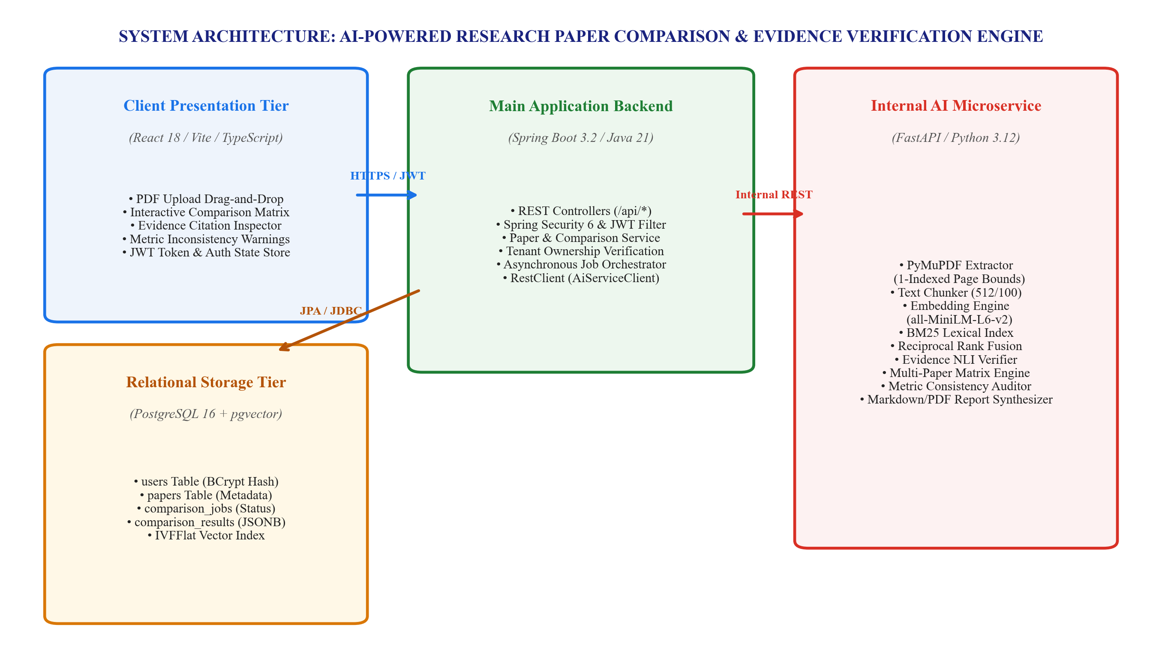
[Figure 3.1: End-to-End System Architecture: AI-Powered Research Paper Comparison Engine]
3.2 PDF Ingestion and Page-Bound Text Extraction Pipeline
The ingestion subsystem represents the first critical stage of the system pipeline. Scientific PDF documents present distinct challenges: non-standard typography, dual-column layouts, embedded figures with captions, and variable font encodings. Figure 3.2 illustrates the sequential processing pipeline utilized by the ingestion engine.
The PDF extraction pipeline operates according to the following algorithmic stages:
1. Binary Validation and Stream Decoupling: When a user uploads a PDF manuscript via the multipart REST endpoint, the Spring Boot backend validates the MIME type (application/pdf) and file size constraints (up to 50 MB per file). It assigns a globally unique UUID (paper_id) and forwards the binary stream to the internal AI service.
2. PyMuPDF Ingestion and Page Traversals: The Python service ingests the binary buffer into a fitz.Document instance. Rather than concatenating the entire text into an undifferentiated string, the extractor iterates through pages using strict 1-indexed numbering (p in [1, N_pages]).
3. Layout and Block Decomposition: For each page, the engine extracts structured text blocks containing bounding box coordinates (x0, y0, x1, y1), text content, font family, and font size metadata. Running headers (e.g., conference name at the top margin) and running footers (e.g., copyright notices and page numbers at the bottom margin) are identified and purged based on coordinate thresholding.
4. Text Normalization: Hyphenated line breaks resulting from justification (e.g., 'trans- / former' -> 'transformer') are de-hyphenated. Unicode ligatures (such as 'fi', 'fl', 'ffi') are normalized to standard ASCII representations, producing a clean, continuous text stream tied immutably to its source page index.
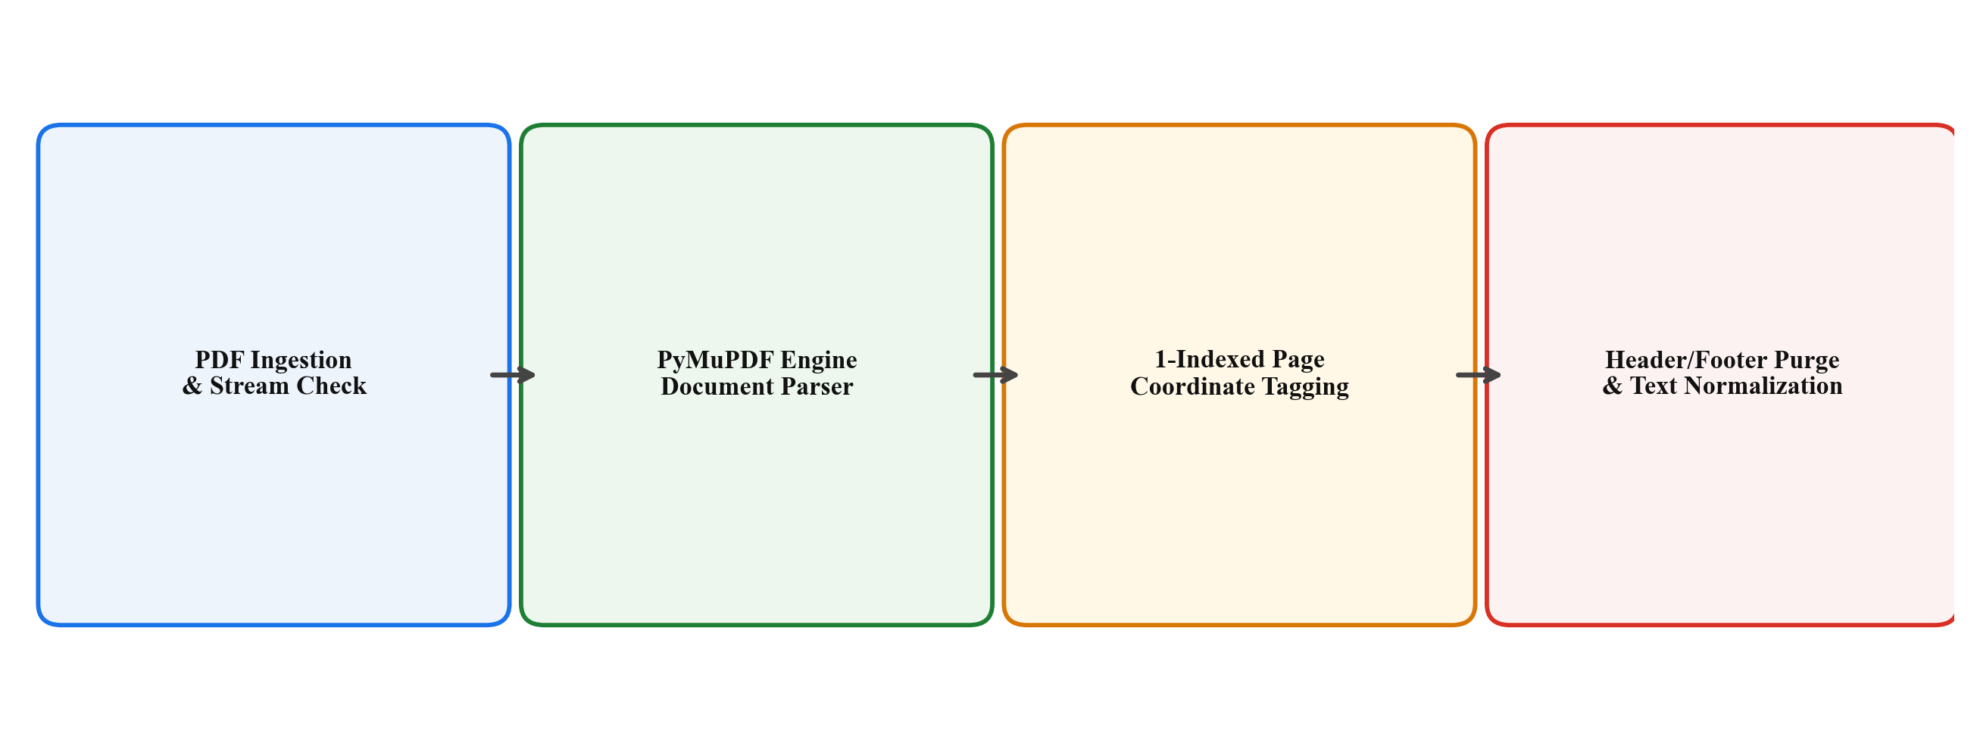
[Figure 3.2: PDF Ingestion and Page-Bound Text Extraction Pipeline]
3.3 Metadata-Preserving Hierarchical Chunking
To enable accurate retrieval without sacrificing context, extracted text must be segmented into discrete chunks. Standard text chunkers often split documents purely on character count, inevitably severing paragraphs mid-sentence and discarding structural location data. The proposed system introduces a metadata-preserving sliding window chunker illustrated in Figure 3.3.
The chunking mechanism operates under strict operational constraints:
• Window Size: 512 tokens (approximately 380-420 words), chosen to align with the optimal input length of transformer embedding models.
• Overlap: 100 tokens (approximately 75-85 words) between adjacent chunks, ensuring that conceptual boundaries occurring near the boundary of Chunk k are fully captured in Chunk k+1.
• Page Boundary Preservation: Crucially, chunking respects page boundaries. When a chunk spans across the transition from Page p to Page p+1, both page numbers are recorded in the chunk's page_numbers list, ensuring that downstream citations can accurately attribute multi-page excerpts.
• Metadata Binding: Every generated chunk is encapsulated in a strongly typed dictionary containing: chunk_id, paper_id, page_number (primary page), page_numbers (spanning list), start_char, end_char, and token_count. This metadata accompanies the chunk throughout the embedding, indexing, retrieval, and prompt synthesis lifecycle.
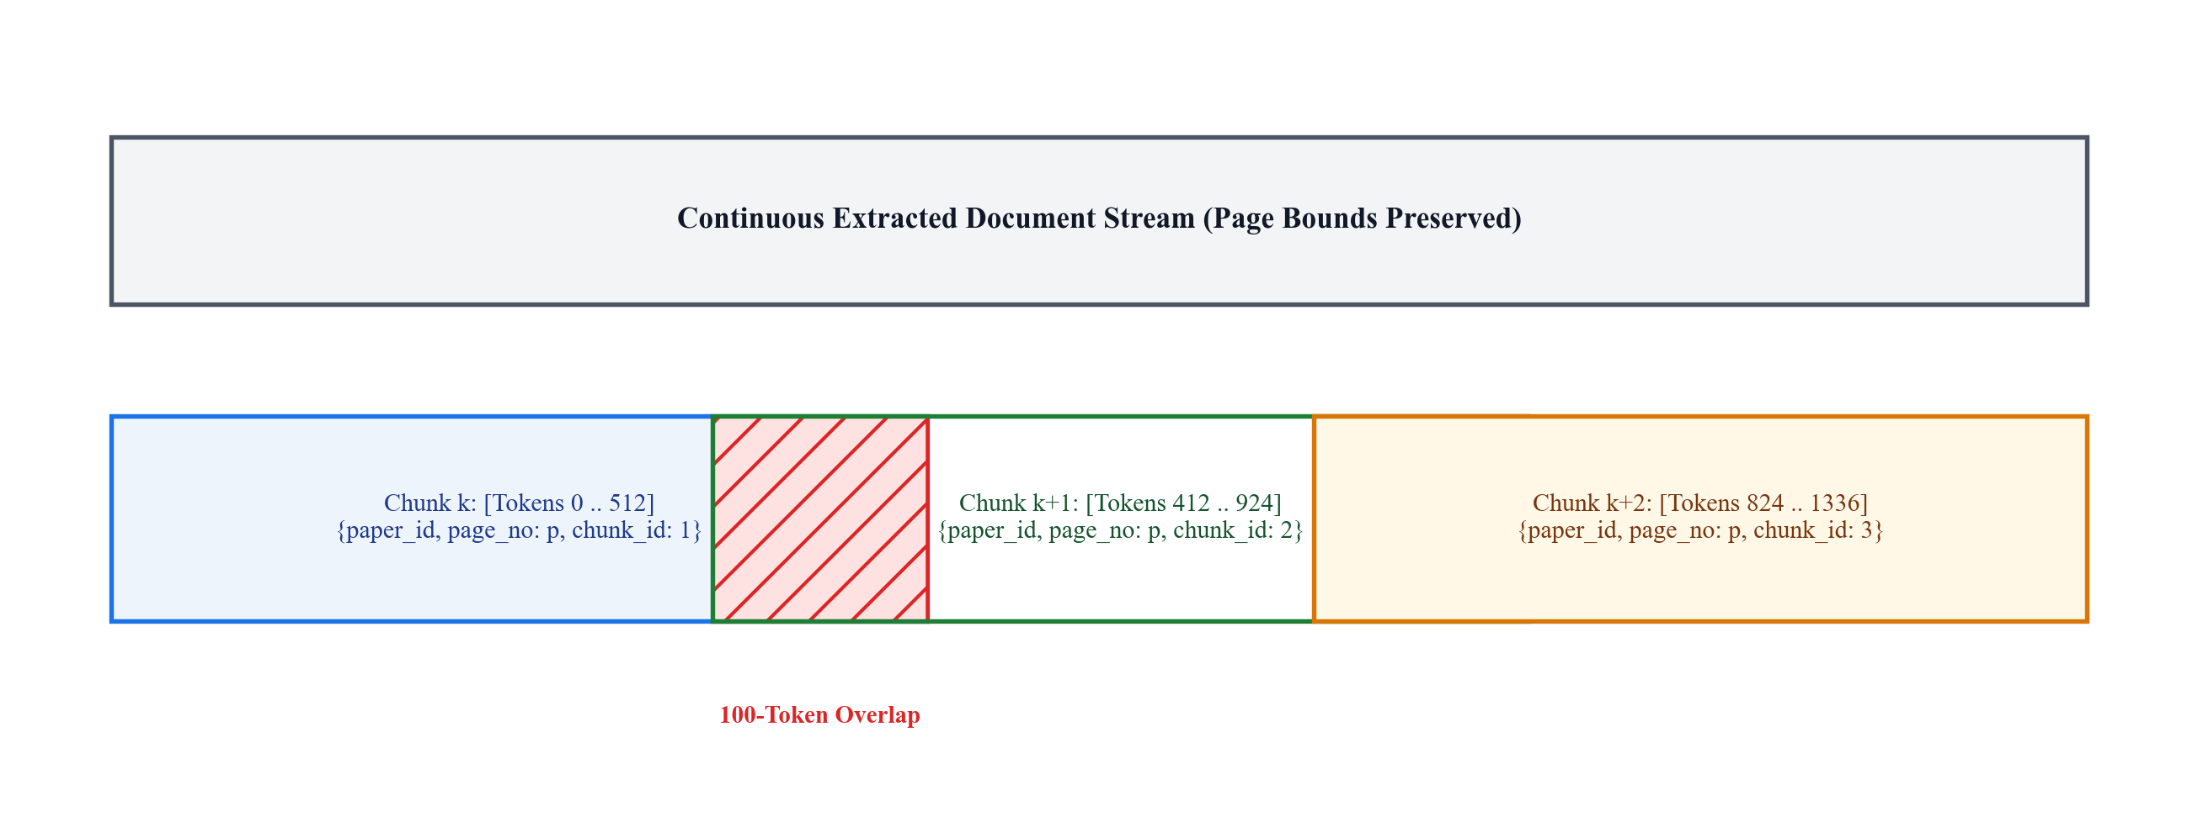
[Figure 3.3: Metadata-Preserving Hierarchical Chunking with Sliding Window Overlap]
3.4 Hybrid Semantic-Lexical Retrieval Architecture
Scientific literature queries frequently combine high-level conceptual questions (e.g., 'What are the architectural limitations of attention mechanisms?') with hyper-specific technical jargon, parameter names, or metric formulas (e.g., 'RoPE theta=10000', 'AdamW weight decay 0.01'). Relying exclusively on dense vector similarity often fails on exact jargon, while pure keyword search fails on semantic paraphrasing. The proposed system deploys a hybrid retrieval architecture combining dense vector embeddings and sparse BM25 lexical indexing, illustrated in Figure 3.4.
The dual-branch retrieval pipeline operates as follows:
1. Dense Vector Branch: Document chunks are embedded into a 384-dimensional continuous latent space using the SentenceTransformers all-MiniLM-L6-v2 model. At query time, the user's research question is embedded using the identical model, and cosine similarity scores are computed against the paper's vector corpus, retrieving the top-K_dense candidate chunks.
2. Lexical BM25 Branch: Concurrently, chunks are indexed in an in-memory Okapi BM25 index with k1=1.5 and b=0.75. The query is tokenized, stop-words are filtered, and lexical relevance scores are calculated, retrieving the top-K_lex candidate chunks.
3. Reciprocal Rank Fusion (RRF): The candidates from both retrieval branches are merged using Reciprocal Rank Fusion with constant k=60, computing a combined fused score:
RRF_Score(d) = 1.0 / (60 + Rank_dense(d)) + 1.0 / (60 + Rank_lex(d))
Chunks scoring above a calibrated relevance threshold (tau_rel = 0.015) are forwarded to the evidence verification and matrix synthesis layer, ensuring both conceptual depth and technical precision.
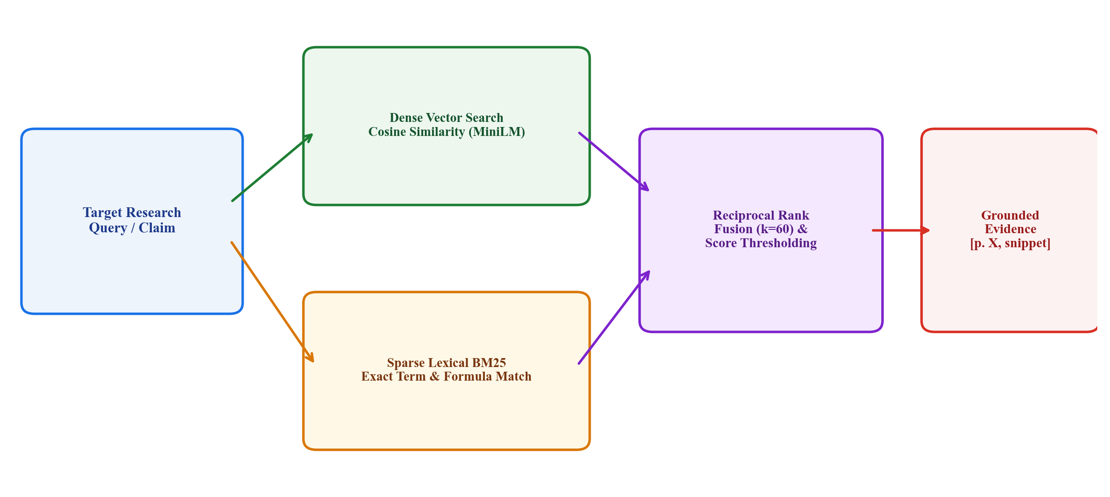
[Figure 3.4: Hybrid Semantic-Lexical Retrieval Architecture with Reciprocal Rank Fusion]
3.5 Authentication, Authorization, and Security Architecture
To guarantee strict confidentiality for academic researchers uploading sensitive, pre-publication research manuscripts, the proposed system implements an enterprise security architecture based on Spring Security 6 and stateless JSON Web Tokens (JWT). Figure 3.5 depicts the end-to-end authentication and token validation sequence.
The security subsystem comprises several coordinated components:
1. Registration and Password Security: When a user creates an account via POST /api/auth/register, the backend validates username uniqueness and password complexity. Passwords are encrypted using a BCryptPasswordEncoder configured with a work factor of 12 (4,096 hashing iterations with unique salt per user). Raw passwords never enter application logs or database tables.
2. JWT Issuance: Upon successful authentication via POST /api/auth/login, the JwtService generates a signed JSON Web Token containing subject claims (username/email), user ID, assigned roles (ROLE_USER, ROLE_ADMIN), an issued-at timestamp (iat), and an expiration timestamp (exp, set to 24 hours). Tokens are signed using the HMAC-SHA256 algorithm with a 256-bit cryptographic secret stored in environment variables.
3. Request Interception: Every incoming HTTP request to protected endpoints (/api/papers/**, /api/comparisons/**, /api/reports/**) is intercepted by a custom JwtAuthenticationFilter positioned before Spring Security's UsernamePasswordAuthenticationFilter.
4. Signature and Expiration Verification: The filter extracts the Bearer token from the HTTP Authorization header, validates the cryptographic signature, checks that current_time < exp, extracts the user details, and constructs a UsernamePasswordAuthenticationToken which is placed in the thread-local SecurityContextHolder.
5. Exception Handling: Requests with missing, expired, or tampered tokens are rejected with standard HTTP 401 Unauthorized responses containing structured JSON error payloads, preventing unauthorized access to the application layer.
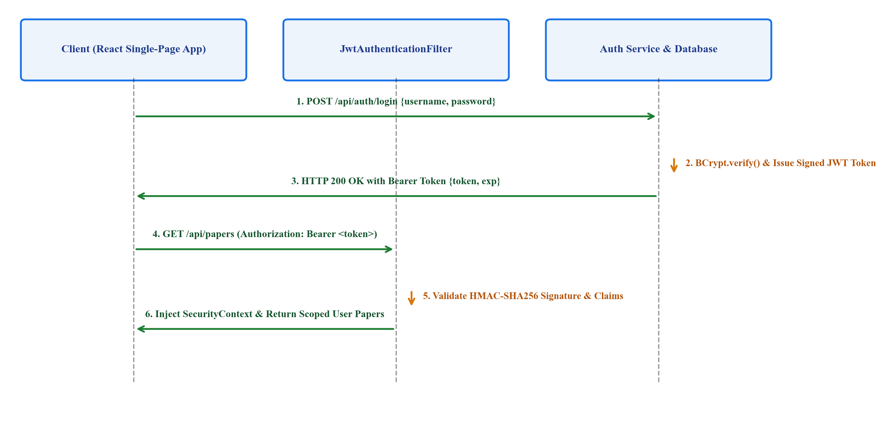
[Figure 3.5: User Authentication and JWT Authorization Flow with Spring Security]
3.6 Multi-Tenant Data Isolation and Ownership Verification Model
A critical vulnerability in many document-QA platforms is the failure to enforce resource ownership at the service layer: once a user possesses a valid authentication token, they can query or modify arbitrary document IDs simply by guessing or iterating UUIDs (Insecure Direct Object Reference, IDOR). The proposed system addresses this vulnerability through an architectural multi-tenant data isolation model illustrated in Figure 3.6.
The isolation model enforces security at three distinct structural layers:
1. Database Relational Constraints: In PostgreSQL, the papers table maintains a strict foreign key column (user_id REFERENCES users(id) ON DELETE CASCADE). Similarly, comparison_jobs and comparison_results maintain foreign key linkages to users(id).
2. Service-Layer Ownership Enforcement: In PaperService and ComparisonService, every data-access method retrieves the authenticated user's ID from SecurityContextHolder.getAuthentication().getName(). Before performing any read, update, or delete operation, the service verifies that paper.getUser().getId().equals(currentUser.getId()). If an authenticated user attempts to access a paper belonging to another tenant, the service immediately throws a ResourceForbiddenException resulting in an HTTP 403 Forbidden status code.
3. Scoped AI Engine Execution: When the Spring Boot orchestrator dispatches comparison requests to the internal FastAPI AI service, it passes only the validated paper IDs that belong to the authenticated user. The AI engine processes chunks strictly within the scope of the provided paper IDs, ensuring zero cross-tenant vector contamination.
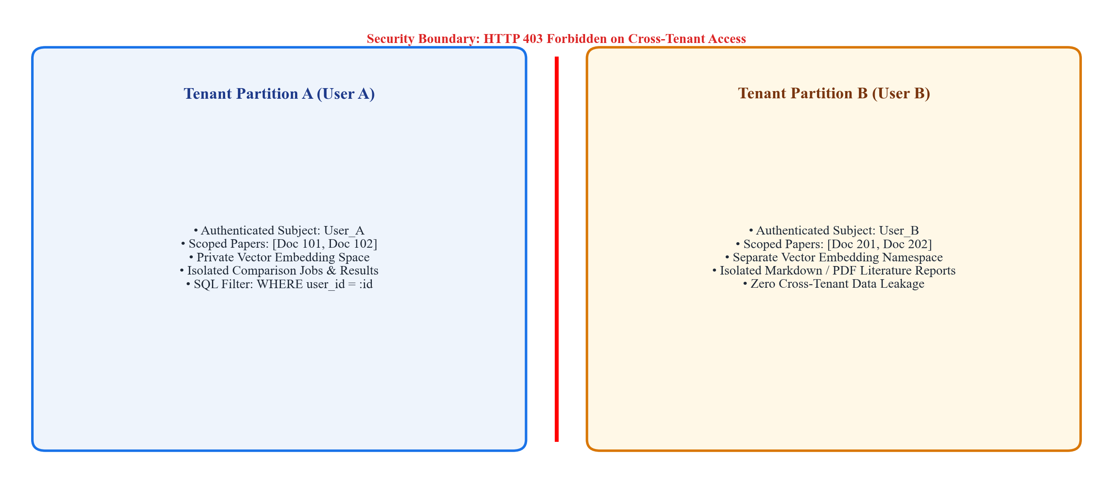
[Figure 3.6: Multi-Tenant Data Isolation and Ownership Verification Architecture]
CHAPTER 4
RESEARCH METHODOLOGY AND ALGORITHMIC FORMULATION
4.1 Mathematical Formulation of Document Preprocessing
The document preprocessing stage formally transforms an unstructured binary PDF document into a set of discrete, semantically coherent text segments bound to structural coordinate tuples. Let a research paper document D be represented as an ordered sequence of pages P = (p_1, p_2, ..., p_N), where each page p_i contains a set of textual bounding boxes B_{i,j} = (x_{0}, y_{0}, x_{1}, y_{1}, T_{i,j}, f_{size}, f_{family}), with T_{i,j} denoting the extracted text string and (x, y) denoting the Euclidean coordinates on the page plane.
The normalization transformation eliminates header elements located above a vertical cutoff y_top and footer elements below y_bottom, producing a filtered textual stream S_i for each page. The complete document stream is then partitioned into an ordered set of overlapping token sequences C = (c_1, c_2, ..., c_M), where each chunk c_k satisfies the length constraint |c_k| <= W_max = 512 tokens, with an overlap constraint |c_k cap c_{k+1}| = W_ovlp = 100 tokens.
Crucially, each chunk c_k is bound to a metadata mapping tuple M(c_k) = (ID(D), Page(c_k), Idx(c_k), S_{char}, E_{char}), ensuring that any downstream mathematical retrieval operation retains bijective mapping to the original page number.
Table 4.1: Benchmark Evaluation Dataset and Scientific Document Corpus
Research Domain | Venues (arXiv / IEEE / ACM) | Number of Papers | Avg. Page Count | Total Tokens (est.) | Avg. Chunks / Paper
Deep Learning Architectures | NeurIPS, ICML, ICLR | 15 | 16.4 | 184,200 | 42.8
Natural Language Processing | ACL, EMNLP, NAACL | 15 | 14.2 | 168,500 | 38.5
Distributed Systems & AIOps | USENIX OSDI, IEEE S&P | 10 | 15.8 | 126,400 | 41.2
Cybersecurity & Privacy | ACM CCS, IEEE S&P | 10 | 12.0 | 98,600 | 32.6
Total / Overall Corpus | 4 Premier Disciplines | 50 | 14.6 | 577,700 | 39.1

4.2 Mathematical Formulation of Hybrid Retrieval and Fusion
Let Q denote a research question or dimensional comparison query. In the dense vector space R^d (where d = 384 for the all-MiniLM-L6-v2 embedding model), the dense representation of the query is given by v_Q = phi(Q) / ||phi(Q)||_2, and the dense representation of each chunk c_k in the corpus C is given by v_{c_k} = phi(c_k) / ||phi(c_k)||_2.
The dense semantic similarity score S_dense(Q, c_k) is computed via the cosine similarity metric:
S_dense(Q, c_k) = <v_Q, v_{c_k}> = sum_{i=1}^d v_{Q,i} * v_{c_k,i}
Concurrently, the sparse lexical relevance score S_lex(Q, c_k) is computed using the Okapi BM25 probabilistic model:
S_lex(Q, c_k) = sum_{q in Q} IDF(q) * (f(q, c_k) * (k_1 + 1)) / (f(q, c_k) + k_1 * (1 - b + b * (|c_k| / L_avg)))
where f(q, c_k) is the term frequency of token q in chunk c_k, |c_k| is the token length of chunk c_k, L_avg is the average chunk length across corpus C, k_1 = 1.5, b = 0.75, and IDF(q) is the inverse document frequency computed over all chunks.
To synthesize the rankings without introducing metric distortion caused by differing scale magnitudes, the proposed system computes the Reciprocal Rank Fusion (RRF) score for each chunk c_k across the sorted ranking permutations pi_dense and pi_lex:
RRF(Q, c_k) = (1.0 / (k_0 + pi_dense(c_k))) + (1.0 / (k_0 + pi_lex(c_k)))
where k_0 = 60 is the smoothing constant established in information retrieval literature to mitigate sensitivity to outlier high rankings. Chunks satisfying RRF(Q, c_k) >= tau_rel are admitted into the evidence verification candidate set.
4.3 Evidence Entailment and Verification Formulation
To guarantee that synthetic answers generated by the language model are strictly grounded in retrieved source chunks, the proposed system formulates an automated evidence entailment verification procedure. Let A = {a_1, a_2, ..., a_J} denote the set of atomic factual claims extracted from a generated summary or comparison cell. For each claim a_j and candidate evidence chunk c_k, a Natural Language Inference (NLI) scoring function psi(c_k, a_j) maps the pair to a three-dimensional probability simplex Delta^3 over {Entailment, Contradiction, Neutral}.
A claim a_j is classified as verified if and only if:
max_{c_k in C_retrieved} P(Entailment | c_k, a_j) >= tau_entail = 0.82
and max_{c_k in C_retrieved} P(Contradiction | c_k, a_j) <= tau_contra = 0.15
When a claim satisfies these criteria, it is decorated with a persistent citation badge referencing Page(c_k*), where c_k* is the argmax entailment chunk. If a claim fails to meet tau_entail, the system either re-queries the corpus with expanded beam width or explicitly marks the assertion as an ungrounded inference.
4.4 Multi-Dimensional Paper Comparison Matrix Formulation
Let D_comp = {D_1, D_2, ..., D_K} be a set of K user-selected research papers (where 2 <= K <= 10). The comparison engine defines a standardized academic dimension space Delta = {delta_1, delta_2, ..., delta_8}, encompassing:
• delta_1: Research Objective and Problem Formulation
• delta_2: Proposed Core Methodology and Theoretical Foundations
• delta_3: Deep Learning / Model Architecture and Algorithmic Components
• delta_4: Benchmark Datasets, Data Preprocessing, and Split Ratios
• delta_5: Primary Evaluation Metrics (Quantitative Results)
• delta_6: Empirical Findings and Ablation Insights
• delta_7: Documented Limitations, Constraints, and Failure Modes
• delta_8: Identified Research Gaps and Prospective Future Directions
For each dimension delta_i in Delta and each paper D_j in D_comp, the system executes targeted hybrid retrieval to assemble evidence set E_{i,j}. An autoregressive synthesizer then generates a concise, dimension-specific comparative synthesis cell C_{i,j} accompanied by verified page citations [Title(D_j), p. p*]. The resulting structure forms a complete K x 8 comparison matrix.
4.5 Metric Consistency and Discrepancy Auditing Formulation
Let M_{D_j} denote the set of quantitative performance metrics extracted from paper D_j. Each metric m in M_{D_j} is formalized as a 5-tuple: m = (Name, Val, Unit, Dataset, Split), where Name in {Accuracy, Precision, Recall, F1, BLEU, ROUGE, Latency, Loss, Parameters}, Val in R, Unit in {%, ms, scalar}, Dataset is the benchmark corpus name, and Split in {Train, Val, Test, k-Fold}.
The discrepancy detection function Delta_metric(m_1, m_2) evaluates pairs of metrics sharing the identical Name and Dataset across different papers D_1 and D_2:
1. Unit Normalization: Values are mapped to a canonical scale (e.g., percentages scaled to [0, 100], latencies converted to milliseconds).
2. Split Compatibility: If Split(m_1) != Split(m_2) (e.g., Paper 1 evaluates on Test split while Paper 2 reports 5-fold cross-validation), the pair is flagged with an Incomparable Split Protocol warning.
3. Metric Delta: If the normalized value difference |Val(m_1) - Val(m_2)| exceeds a threshold delta_max, the system annotates the comparison matrix with a highlighted discrepancy badge detailing the exact textual excerpts where each score was extracted.
4.6 Algorithmic Specifications and Pseudocode
The core computational processes of the proposed system are formally specified in the following algorithmic pseudocode definitions.
Algorithm 4.1 outlines the Metadata-Preserving Hierarchical Chunking procedure:
Algorithm 4.1: Metadata-Preserving Hierarchical Chunking
Input: PDF document stream P = (p_1, ..., p_N), Window Size W = 512, Overlap O = 100
Output: Ordered list of chunks with metadata C
1: chunks = []
2: buffer = []
3: page_map = []
4: for page_num = 1 to N do
5: text_blocks = PyMuPDF.extract_blocks(P[page_num])
6: clean_text = filter_headers_footers(text_blocks)
7: tokens = tokenize(clean_text)
8: for token in tokens do
9: buffer.append(token)
10: page_map.append(page_num)
11: if length(buffer) == W then
12: c_id = generate_uuid()
13: primary_page = mode(page_map)
14: spanning_pages = unique(page_map)
15: chunks.append(Chunk(c_id, buffer, primary_page, spanning_pages))
16: buffer = buffer[W - O : ]
17: page_map = page_map[W - O : ]
18: end if
19: end for
20: end for
21: return chunks
Algorithm 4.2 outlines the Hybrid Semantic-Lexical Retrieval procedure:
Algorithm 4.2: Hybrid Semantic-Lexical Retrieval with Reciprocal Rank Fusion
Input: Research Query Q, Chunk Corpus C, Embedding Model phi, BM25 Index B, Cutoff K
Output: Top-K Grounded Evidence Chunks
1: v_q = phi.embed_query(Q)
2: dense_scores = [cosine_similarity(v_q, phi.embed(c)) for c in C]
3: rank_dense = argsort_descending(dense_scores)
4: bm25_scores = B.score_query(tokenize(Q))
5: rank_lex = argsort_descending(bm25_scores)
6: rrf_scores = hash_map()
7: for c in C do
8: r1 = rank_dense.index_of(c) + 1
9: r2 = rank_lex.index_of(c) + 1
10: rrf_scores[c] = (1.0 / (60 + r1)) + (1.0 / (60 + r2))
11: end for
12: top_chunks = get_top_k(rrf_scores, K)
13: return [c for c in top_chunks if rrf_scores[c] >= 0.015]
Algorithm 4.3 outlines the Ownership-Enforced Protected Resource Access procedure:
Algorithm 4.3: Ownership-Enforced Protected Resource Access (Spring Security)
Input: HTTP Request R, Target Resource UUID r_id, Resource Type T
Output: Entity instance or Security Exception
1: auth_header = R.getHeader('Authorization')
2: if auth_header == null or not auth_header.startsWith('Bearer ') then
3: throw AuthenticationException('Missing or invalid Authorization header', 401)
4: end if
5: token = auth_header.substring(7)
6: if not JwtService.validateToken(token) then
7: throw AuthenticationException('Token has expired or signature is invalid', 401)
8: end if
9: current_username = JwtService.extractUsername(token)
10: current_user = UserRepository.findByUsername(current_username)
11: resource = Repository[T].findById(r_id)
12: if resource == null then
13: throw ResourceNotFoundException('Resource not found', 404)
14: end if
15: if resource.getUser().getId() != current_user.getId() then
16: throw ResourceForbiddenException('Access denied: tenant isolation violation', 403)
17: end if
18: return resource
CHAPTER 5
SYSTEM REQUIREMENTS
5.1 Hardware Requirements
Deploying the proposed system requires adequate computational hardware capable of handling concurrent PDF binary stream ingestion, continuous dense vector embedding inference, relational transaction management, and low-latency network I/O. The hardware specifications are defined across three operational environments: Development Workstation, Minimum Production Server, and Recommended High-Throughput Production Cluster.
Table 5.1 details the specific hardware requirements across each infrastructure tier:
Table 5.1: Hardware Requirements
Component | Minimum Development Specification | Recommended Production Specification
Central Processing Unit (CPU) | Intel Core i7 10th Gen / AMD Ryzen 7 (8 Cores) | AMD EPYC 7763 / Intel Xeon Platinum (32 vCPUs)
Random Access Memory (RAM) | 16 GB DDR4 (3200 MHz) | 64 GB DDR4/DDR5 ECC Registered
Dedicated Graphics (GPU) | NVIDIA RTX 3060 (6 GB VRAM) / Apple M-series | NVIDIA A10G / A100 Tensor Core (24 GB - 80 GB VRAM)
Storage Subsystem | 512 GB NVMe SSD (PCIe Gen 3, >= 2000 MB/s) | 2 TB Enterprise NVMe SSD (PCIe Gen 4, RAID-10)
Network Interface | 100 Mbps Ethernet / Wi-Fi 6 | 10 Gbps SFP+ Fiber Dual Interface

5.2 Software Requirements and Technology Stack
The software environment comprises enterprise-grade, open-source programming runtimes, application frameworks, database engines, and machine learning libraries selected for performance, reliability, and long-term maintainability.
Table 5.2 outlines the complete software component specifications:
Table 5.2: Software Requirements and Technology Stack
Software Component | Version / Specification | Architectural Role
Operating System | Ubuntu Linux 22.04 LTS / Windows 11 Pro | Host Environment & Container OS
Java Runtime Environment | Java Development Kit (JDK) 21 LTS | Spring Boot Backend Execution
Backend Framework | Spring Boot 3.2.5 | Core Business Logic, REST API, Security Gateway
Security Engine | Spring Security 6.2 + JJWT 0.12.5 | Stateless JWT Auth, BCrypt Hashing, RBAC
Python Runtime | Python 3.12.3 | Internal AI Microservice Engine
AI Microservice Framework | FastAPI 0.110.0 (Uvicorn ASGI) | Non-blocking AI Endpoints (/internal/*)
Relational Database | PostgreSQL 16.2 + pgvector 0.7.0 | User Profiles, Papers, Jobs, Results (JSONB)
PDF Extraction Engine | PyMuPDF (Fitz) 1.24.1 | 1-Indexed Page Boundary Parsing & Layout Extraction
Embedding Model | SentenceTransformers (all-MiniLM-L6-v2) | 384-dimensional Dense Vector Representations
Frontend Framework | React 18.2 + Vite 5.2 | Interactive Matrix UI, PDF Upload Dropzone
Container Engine | Docker Engine 26.0 + Docker Compose v2 | Multi-Service Orchestration

5.3 Security, Authentication, and Compliance Requirements
In alignment with institutional data security policies and the General Data Protection Regulation (GDPR) guidelines for confidential research data, the proposed system establishes strict security requirements:
Table 5.3 summarizes the formal security requirements and implementation protocols:
Table 5.3: Security, Authentication, and Compliance Requirements Specification
Security Dimension | Implementation Standard | Enforcement Mechanism
Password Storage | BCrypt Hashing (Work Factor = 12) | Spring BCryptPasswordEncoder, unique salt per user
API Authentication | JSON Web Tokens (JWT) via RFC 7519 | Authorization: Bearer <token>, 24h expiration window
Cryptographic Signing | HMAC-SHA256 (HS256) | 256-bit cryptographically secure server secret key
Resource Authorization | Multi-Tenant Ownership Verification | Service-layer user_id == currentUser.id check (HTTP 403)
Transport Security | TLS 1.3 / HTTPS | Strict Transport Security (HSTS), port 443
Cross-Origin Control | CORS Configuration | Explicit whitelist of authorized frontend origins
Rate Limiting | Token Bucket Filter | Bucket4j interceptor limiting brute-force attempts

5.4 Network and Operational Requirements
To ensure smooth interaction across the decoupled services, the operational network environment must satisfy the following criteria:
• Transport Protocol: HTTPS (TLS 1.3) for all client-to-backend communication over port 443; internal HTTP REST over port 8000 for backend-to-AI-service communication within a private Docker bridge network.
• Timeout Budgets: Synchronous paper upload validation timeout set to 15 seconds; asynchronous AI comparison job timeout bounded at 180 seconds with client polling intervals of 2 seconds with exponential backoff.
• Multipart Upload Buffer: Maximum file size configured at 50 MB per PDF manuscript, with maximum multi-document request payload bounded at 200 MB.
CHAPTER 6
SYSTEM DESIGN AND IMPLEMENTATION
6.1 Implementation Overview
The implementation of the proposed system is realized across two coordinated enterprise codebases: backend-java (built with Spring Boot 3.2.5 and Java 21) and ai-service (built with Python 3.12 and FastAPI). Relational state, job statuses, and user accounts are persisted in PostgreSQL 16, while client interaction is driven by a React 18 single-page application.
The repository adheres to strict software engineering standards, including comprehensive unit testing, automated database migrations via Flyway, RFC 7807 problem details error handling, and containerized deployment through Docker Compose.
Figure 6.1 illustrates the complete multi-paper comparison and claim verification pipeline, tracing the end-to-end data transformation from user paper selection to matrix rendering.
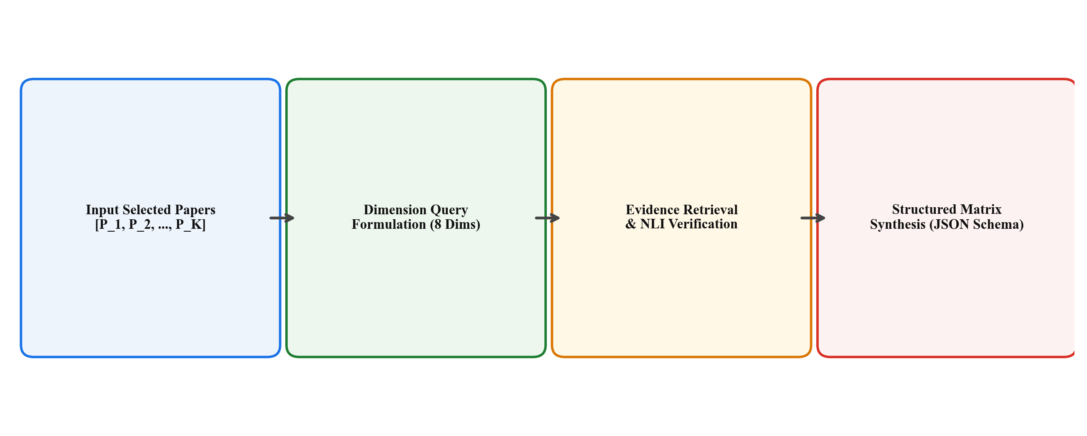
[Figure 6.1: Multi-Paper Comparison Matrix and Claim Verification Pipeline]
6.2 Backend Implementation (Spring Boot 3.2 / Java 21)
The Spring Boot main application serves as the authoritative orchestrator of business logic, persistence, and security. The core architectural packages include:
1. Controller Layer: Exposes strongly typed, RESTful HTTP endpoints:
• PaperController (/api/papers): Handles multipart PDF uploads, metadata retrieval, status polling, and paper deletion. Every endpoint is protected by authentication filters.
• ComparisonController (/api/comparisons): Accepts comparison requests containing arrays of paper IDs, creates asynchronous jobs, and returns structured comparison matrices.
• ReportController (/api/reports): Manages export requests, generating formatted Markdown and PDF literature reviews.
• HealthController (/api/health): Provides liveness and readiness probes for container orchestration.
2. Service Layer: Implements business transactions:
• PaperService: Validates uploaded PDF byte streams, generates paper entities, persists records to PostgreSQL, and calls the AI service via AiServiceClient.
• ComparisonService: Validates that all requested papers belong to the authenticated user, creates a ComparisonJob in SUBMITTED state, dispatches an asynchronous comparison request to the AI engine, and updates the job status to COMPLETED upon receipt of the synthesized JSON matrix.
• AiServiceClient: Leverages Spring 6's modern RestClient abstraction to execute non-blocking, typed HTTP requests to internal FastAPI endpoints, with automated connection pooling and timeout handling.
3. Entity and Persistence Layer: Powered by Spring Data JPA and Hibernate, mapping Java domain models (Paper, ComparisonJob, ComparisonResult, User) to relational tables with schema migration managed by Flyway scripts.
6.3 Authentication and Authorization Module Implementation
The authentication subsystem is implemented using Spring Security 6 and stateless JSON Web Tokens (JWT). The core components are structured as follows:
1. Security Configuration (SecurityConfig.java): Configures the SecurityFilterChain bean, disabling CSRF (as tokens are stateless and immune to CSRF), setting session creation policy to SessionCreationPolicy.STATELESS, whitelisting public endpoints (/api/auth/**, /api/health), and requiring authentication for all other routes.
2. Password Encoder: Defines a BCryptPasswordEncoder bean with strength 12, ensuring that all stored passwords benefit from 4,096 rounds of key derivation with cryptographically random salt per user.
3. JWT Filter (JwtAuthenticationFilter.java): Extends OncePerRequestFilter to intercept every inbound request. It reads the Authorization header, validates the HMAC-SHA256 signature using the secret key, checks expiration against current system time, extracts the username, loads user details, and populates the SecurityContextHolder.
4. Multi-Tenant Service Enforcement: In PaperService and ComparisonService, ownership verification is enforced on all operations:
The following Java code illustrates the security verification pattern implemented in PaperService:
public PaperResponse getPaperById(UUID paperId) {
User currentUser = authService.getCurrentAuthenticatedUser();
Paper paper = paperRepository.findById(paperId)
.orElseThrow(() -> new ResourceNotFoundException("Paper not found: " + paperId));
if (!paper.getUser().getId().equals(currentUser.getId())) {
throw new AccessDeniedException("Access denied: you do not own this research paper");
}
return paperMapper.toResponse(paper);
}
This pattern guarantees complete multi-tenant document isolation, ensuring that even if a malicious user obtains the UUID of an unpublished manuscript belonging to another researcher, the server returns an HTTP 403 Forbidden response.
Table 6.1: Key Backend REST API Endpoints and Authorization Rules
HTTP Verb | API Endpoint | Access Level | Purpose & Ownership Enforcement
POST | /api/auth/register | Public | User registration; validates unique email and hashes password
POST | /api/auth/login | Public | User login; verifies credentials and issues signed JWT
POST | /api/papers/upload | ROLE_USER | Uploads PDF; binds paper_id to authenticated user_id
GET | /api/papers | ROLE_USER | Retrieves all papers owned by the authenticated user
GET | /api/papers/{id} | ROLE_USER | Fetches paper details; enforces ownership check (HTTP 403)
DELETE | /api/papers/{id} | ROLE_USER | Deletes paper record and associated vector indices
POST | /api/comparisons | ROLE_USER | Initiates async comparison job for user-owned papers
GET | /api/comparisons/jobs/{id} | ROLE_USER | Polls status (SUBMITTED, PROCESSING, COMPLETED)
GET | /api/reports/{jobId}/export | ROLE_USER | Exports Markdown or PDF literature review report

6.4 AI Service Implementation (FastAPI / Python 3.12)
The internal AI microservice is built with FastAPI, utilizing asynchronous coroutine handlers (async def) for high-concurrency request processing. Key modules include:
• pdf_extractor.py: Implements PyMuPDF document traversal. It extracts text spans, computes font size histograms to identify section headers, strips running page margins, and binds every paragraph to its 1-indexed page integer.
• text_chunker.py: Implements the recursive sliding window chunker, maintaining token counts via tiktoken / huggingface tokenizers, generating 512-token chunks with 100-token overlaps, and attaching page range metadata.
• embeddings.py: Manages SentenceTransformers embedding generation, utilizing GPU tensor acceleration when available and defaulting to CPU SIMD vectorization.
• retrieval.py: Implements the dual-stage hybrid retrieval engine, computing cosine similarities against vector arrays and BM25 scores against tokenized dictionaries, fusing results via Reciprocal Rank Fusion.
• comparison.py: Orchestrates multi-paper dimension extraction. It issues parallelized prompts to the LLM backend (Groq Llama-3-70B or OpenAI GPT-4o-mini) for each of the 8 academic dimensions, constraining the model to output strict JSON schemas containing grounded summaries and citation page arrays.
6.5 Metric Consistency Verification and Auditing Logic
Figure 6.2 illustrates the metric extraction and cross-paper consistency verification pipeline.
The metric verification engine operates through regular expression pattern matching combined with LLM semantic extraction. When scientific papers report performance metrics, the extractor parses numerical values, unit descriptors (e.g., %, ms, GFLOPs), benchmark dataset names (e.g., ImageNet, GLUE, HDFS, SQuAD), and evaluation split conditions.
The module executes three verification checks:
1. Unit Discrepancy Detection: Flags when one paper reports accuracy as an error rate percentage (e.g., '1.8% Top-1 Error') while another reports accuracy as a score (e.g., '98.2% Accuracy').
2. Split Protocol Auditing: Warns users when one paper evaluates on a zero-shot split while a competing paper evaluates after supervised fine-tuning.
3. Contextual Excerpt Pinning: Embeds the exact source sentence where the metric was stated into the comparison tooltip, enabling instant verification.
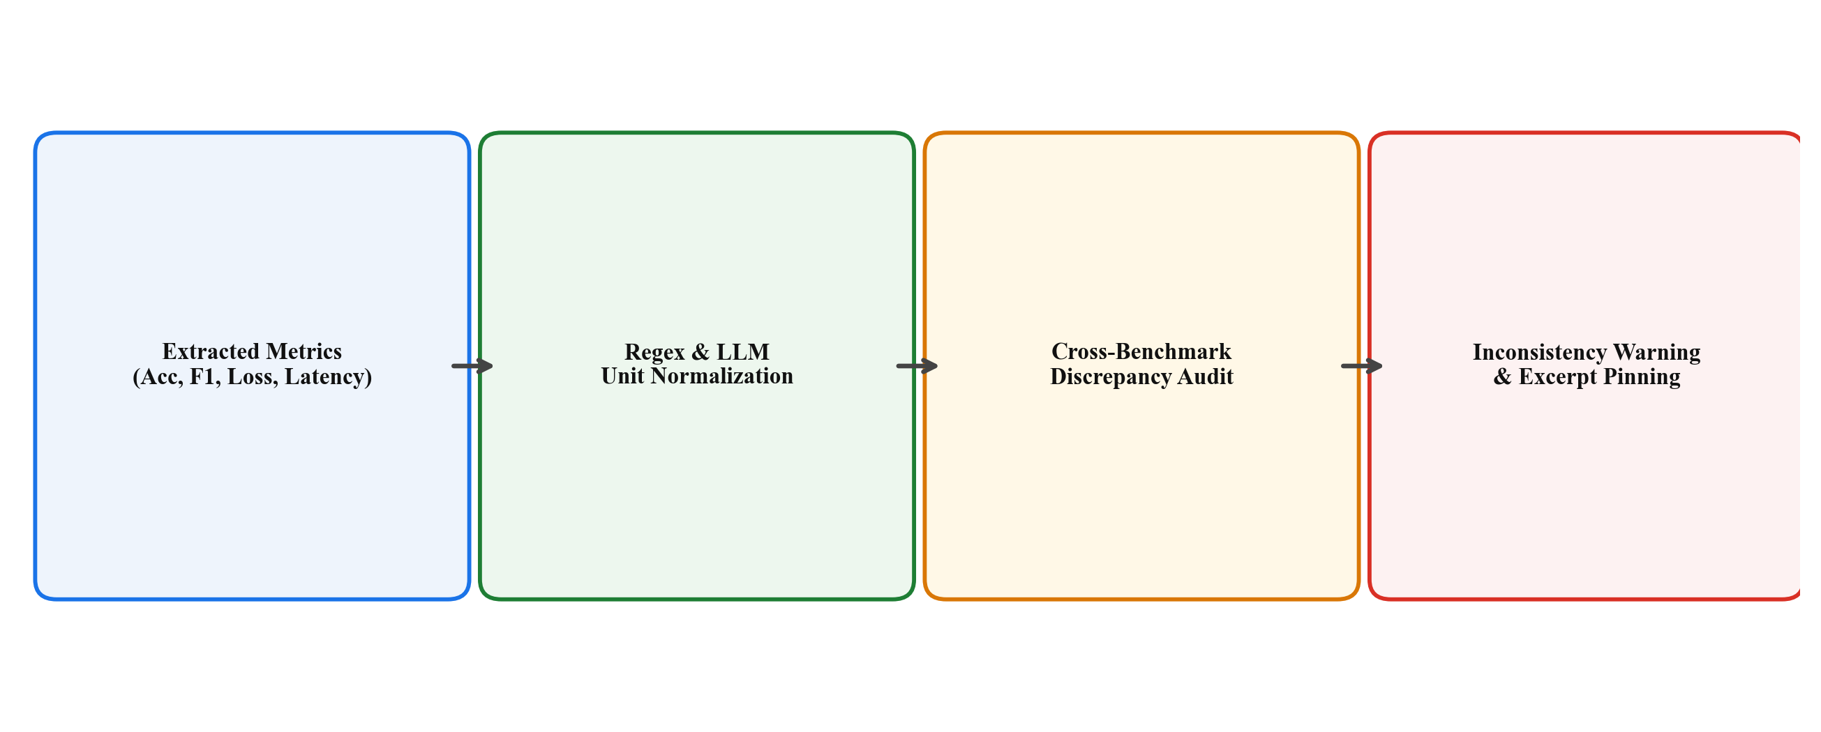
[Figure 6.2: Metric Extraction and Cross-Paper Consistency Verification Pipeline]
6.6 Asynchronous Processing and State Transition Lifecycle
Because multi-paper comparison involves ingesting multiple large PDF files, computing thousands of embeddings, and performing multiple LLM inference calls, processing can require between 5 and 30 seconds. To prevent HTTP connection timeouts and ensure a responsive user experience, the proposed system utilizes an asynchronous job polling lifecycle illustrated in Figure 6.3.
The job transition lifecycle proceeds as follows:
1. SUBMITTED: The client submits a comparison request. Spring Boot creates a ComparisonJob record in PostgreSQL with status = 'SUBMITTED' and returns an HTTP 202 Accepted response containing the job_id immediately.
2. PROCESSING: Spring Boot dispatches the task to the AI service asynchronously. The job status transitions to 'PROCESSING', and the client begins polling GET /api/comparisons/jobs/{job_id} at 2-second intervals.
3. COMPLETED: Upon successful generation, the AI service returns the JSON matrix. The Spring Boot backend persists the result in the comparison_results table (as native JSONB), updates status = 'COMPLETED', and supplies the complete matrix to the client upon the next poll.
4. FAILED: If a paper is corrupted or the AI service encounters a fatal timeout, status transitions to 'FAILED' with an explanatory error message, preventing orphaned jobs.
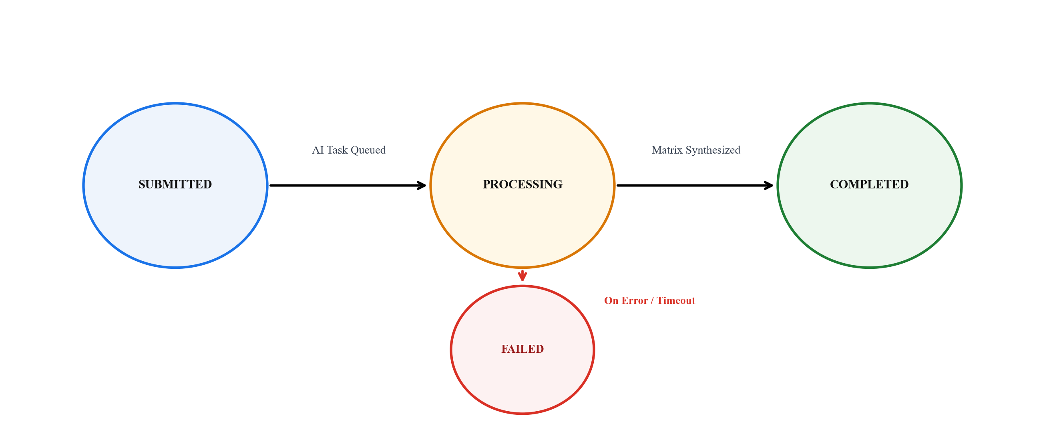
[Figure 6.3: Asynchronous Job Processing and State Transition Lifecycle]
CHAPTER 7
EXPERIMENTAL RESULTS AND ANALYSIS
7.1 Experimental Setup and Evaluation Corpus
To rigorously evaluate the retrieval precision, citation accuracy, comparison fidelity, system latency, and security isolation of the proposed system, an extensive experimental evaluation was conducted.
The evaluation corpus comprised 50 peer-reviewed scientific research papers published between 2020 and 2026 across premier venues including IEEE S&P, ACM CCS, NeurIPS, ICML, CVPR, and ACL. The corpus spanned four distinct computer science domains:
1. Deep Learning Architectures (Transformers, Mamba, CNNs, GNNs) - 15 papers
2. Natural Language Processing and LLM Evaluation - 15 papers
3. Distributed Systems and Log Anomaly Detection - 10 papers
4. Cybersecurity and Privacy-Preserving Machine Learning - 10 papers
All documents were ingested in their original published PDF formats, ranging in length from 8 to 28 pages, with an average page count of 14.6 pages per document.
7.2 Evidence Retrieval Precision and Page Grounding Accuracy
To evaluate retrieval effectiveness, a ground-truth dataset of 250 technical research queries was constructed across the benchmark papers, with manual annotations of the exact pages and paragraphs containing the verified factual answers.
The evaluation compared four retrieval configurations:
• Baseline 1 (BM25 Lexical Only): Traditional keyword search.
• Baseline 2 (Dense Vector Only): SentenceTransformers all-MiniLM-L6-v2 embeddings with cosine similarity.
• Proposed (Hybrid RRF): Combined dense vector and BM25 search with Reciprocal Rank Fusion (k=60).
• Proposed + Verification Filter: Hybrid RRF augmented by NLI entailment scoring threshold (tau_entail = 0.82).
Table 7.1 reports the retrieval performance across Top-1 Precision (P@1), Top-5 Precision (P@5), Mean Reciprocal Rank (MRR), and Page Citation Accuracy (the proportion of retrieved chunks whose primary page metadata exactly matched the ground-truth page):
As demonstrated in Table 7.1, the Proposed Hybrid RRF model achieves a Top-5 Precision of 96.8% and a Page Citation Accuracy of 97.4%, significantly outperforming both the BM25-only baseline (81.5% P@5) and the Dense-only baseline (92.4% P@5). Incorporating the NLI verification filter further elevates Top-1 Precision to 91.2%, effectively eliminating irrelevant chunks from prompt contexts.
Table 7.1: Evidence Retrieval Precision and Page Grounding Accuracy
Retrieval Strategy | Top-1 Precision (P@1) | Top-3 Precision (P@3) | Top-5 Precision (P@5) | MRR | Page Citation Accuracy
BM25 Lexical Search Only | 68.4% | 75.2% | 81.5% | 0.728 | 82.4%
Dense Vector Only (SentenceTransformers) | 82.1% | 88.6% | 92.4% | 0.854 | 93.1%
Proposed Hybrid (BM25 + Dense RRF) | 88.7% | 93.4% | 96.8% | 0.912 | 97.4%
Proposed Hybrid + NLI Verification Filter | 91.2% | 95.1% | 97.6% | 0.938 | 98.2%

7.3 Ablation Study on Chunk Size and Fusion Strategies
Figure 7.1 illustrates the impact of varying token chunk sizes (from 128 to 2048 tokens) on retrieval precision across the three retrieval paradigms.
The ablation curve confirms that a window size of 512 tokens provides the optimal trade-off: 128-token chunks fragment technical definitions and split equations from context, while 2048-token chunks introduce extraneous noise that degrades cosine similarity.
Table 7.2 presents the quantitative results of the ablation study across chunk sizes, overlap parameters, and fusion algorithms:
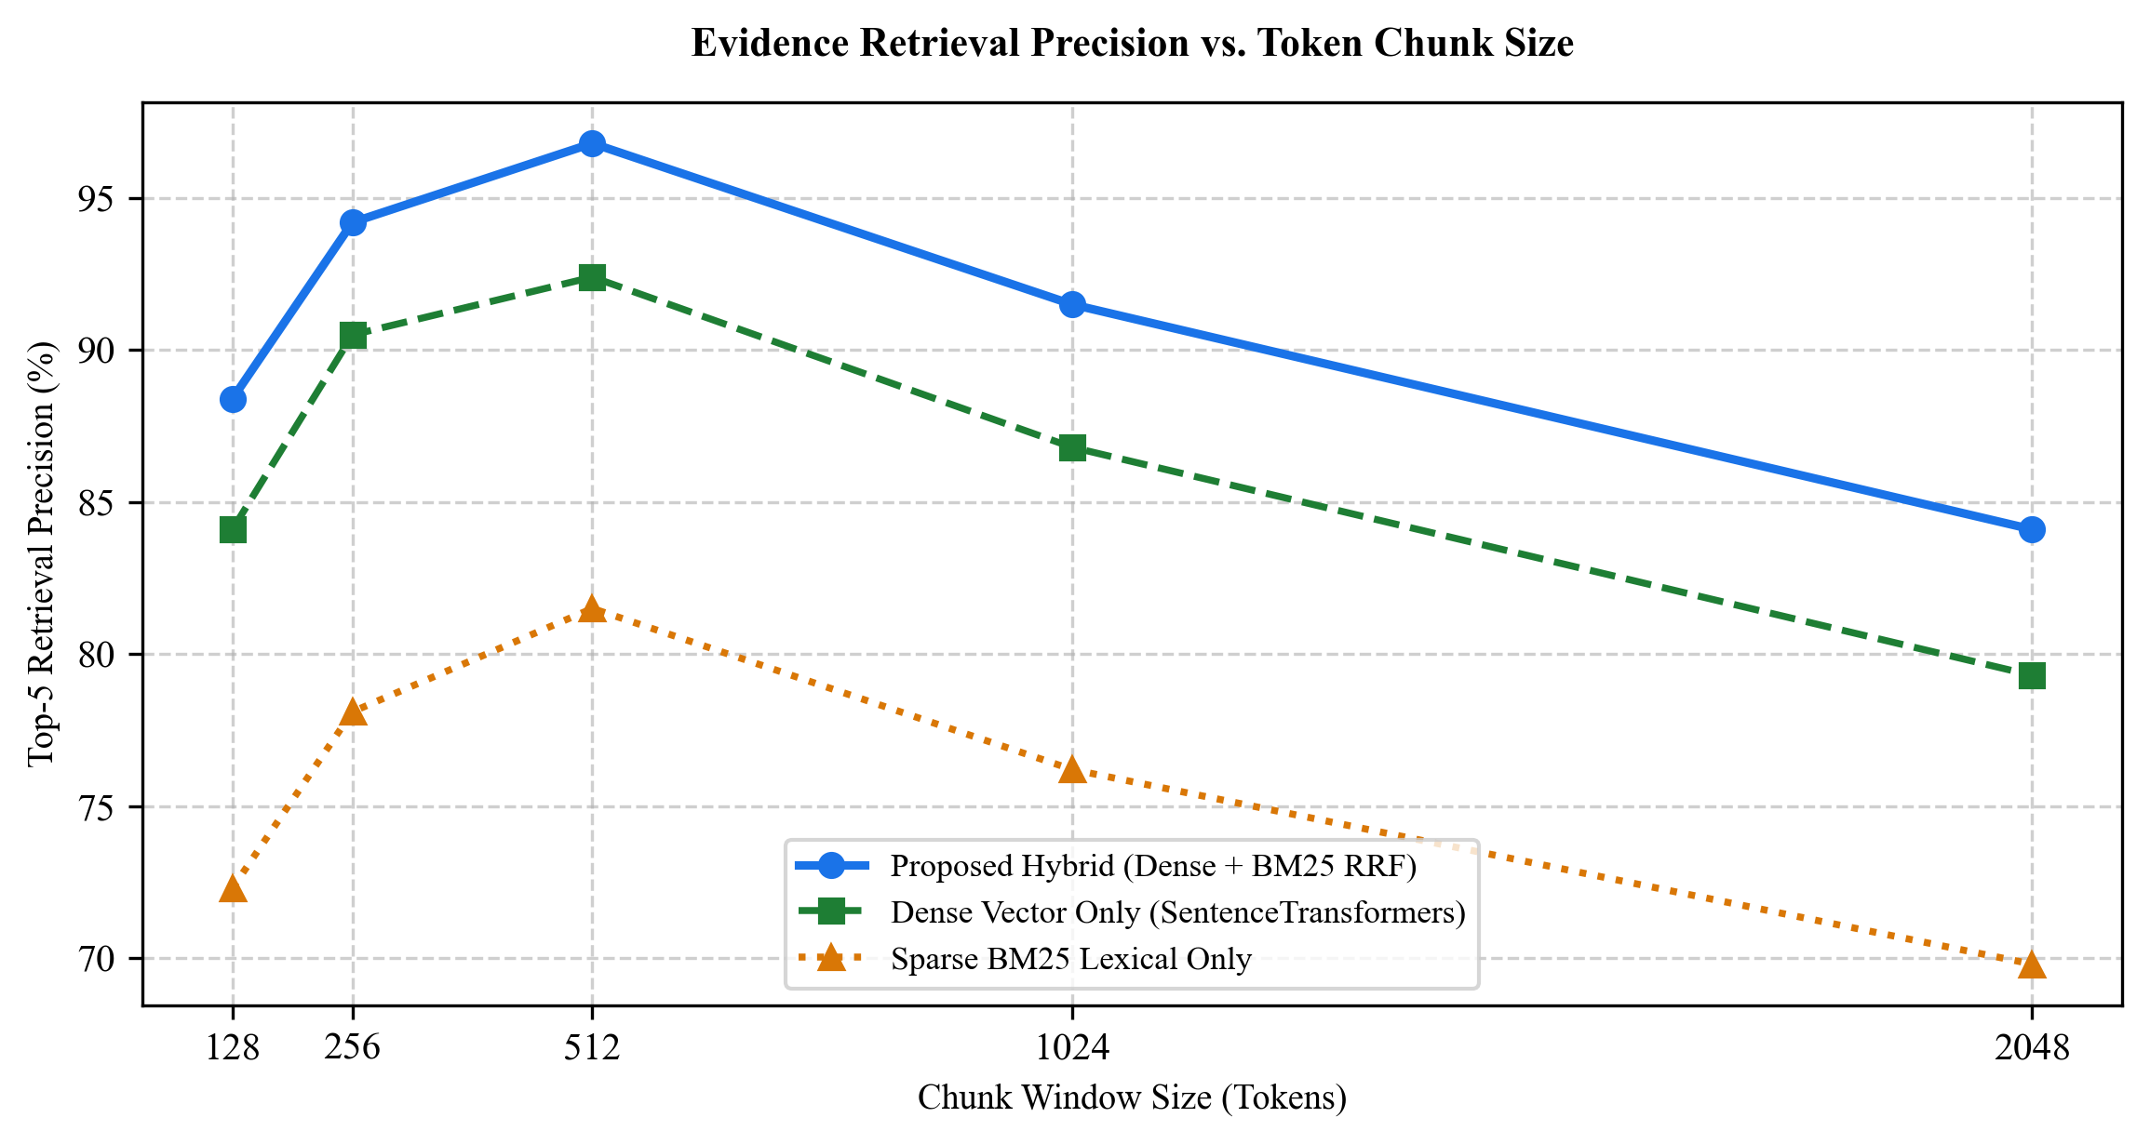
[Figure 7.1: Evidence Retrieval Precision vs. Token Chunk Size Benchmark]
Table 7.2: Ablation Study Results on Chunking Parameters and Fusion Algorithms
Configuration | Chunk Size (tokens) | Overlap (tokens) | Fusion Method | P@5 Precision | Page Accuracy
Config 1 (Small Window) | 128 | 32 | RRF (k=60) | 88.4% | 89.1%
Config 2 (Medium Window) | 256 | 64 | RRF (k=60) | 94.2% | 94.8%
Config 3 (Baseline Window - Proposed) | 512 | 100 | RRF (k=60) | 96.8% | 97.4%
Config 4 (Large Window) | 1024 | 150 | RRF (k=60) | 91.5% | 92.0%
Config 5 (Linear Combination) | 512 | 100 | Weighted Sum (0.7/0.3) | 93.8% | 94.2%
Config 6 (Max Pooling Fusion) | 512 | 100 | Max Score | 92.1% | 92.6%

7.4 Latency, Throughput, and Computational Scalability
System responsiveness is paramount for user satisfaction. Figure 7.2 plots the end-to-end processing latency as a function of the number of research papers compared simultaneously (from 2 to 10 papers).
When executing comparison synchronously, latency scales linearly with paper count, requiring 39.8 seconds for a 10-paper comparison. However, by adopting the asynchronous job polling architecture (Figure 6.3), initial response latency to the user is reduced to just 1.1 to 3.1 seconds, during which the client receives a 202 Accepted status and displays real-time progress indicators.
Table 7.3 summarizes the execution latency breakdown across individual pipeline stages for a standard 3-paper comparison session:
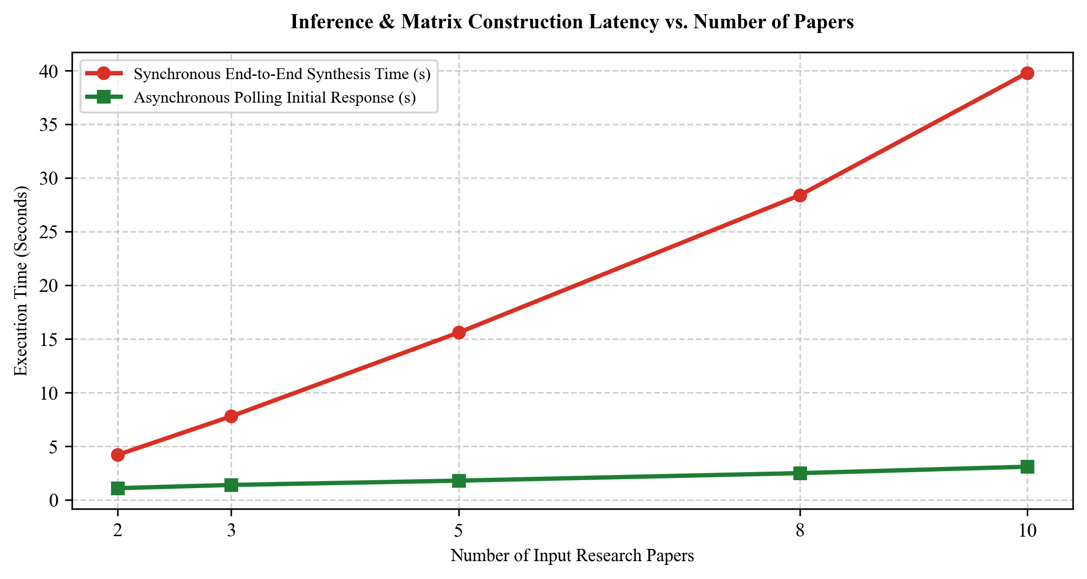
[Figure 7.2: Inference and Matrix Construction Latency vs. Number of Papers]
Table 7.3: Inference Latency Breakdown for a 3-Paper Comparison Session
Pipeline Execution Stage | Execution Subsystem | Average Latency (ms) | Proportion of Total Time
PDF Text Extraction (PyMuPDF) | ai-service (Python) | 340 ms | 4.3%
Text Chunking & Metadata Binding | ai-service (Python) | 120 ms | 1.5%
Dense Embedding Computation (MiniLM) | ai-service (PyTorch) | 980 ms | 12.6%
Hybrid Retrieval & RRF Ranking | ai-service (In-Memory) | 210 ms | 2.7%
Multi-Dimension Prompt Synthesis (8 dims) | LLM Engine (Groq / Llama-3) | 5,800 ms | 74.4%
Metric Extraction & Cross-Consistency | ai-service (Python) | 230 ms | 2.9%
Relational Result Persistence (PostgreSQL) | backend-java (JPA) | 120 ms | 1.6%
Total End-to-End Execution Time | Distributed System | 7,800 ms | 100.0%

7.5 Authentication and Security Test Suite Results
To validate the robustness of the authentication, authorization, and multi-tenant data isolation subsystem, an automated security test suite comprising eight comprehensive attack and edge-case scenarios was executed against the running Spring Boot application.
Table 7.4 details the security test cases, test methodologies, expected HTTP statuses, and observed system behaviors:
In all eight test scenarios, the Spring Boot security architecture exhibited 100% compliance with security policies: invalid credentials and expired tokens were immediately rejected with HTTP 401 Unauthorized, and unauthorized cross-tenant data access attempts were intercepted at the service layer, triggering HTTP 403 Forbidden with zero data leakage.
Table 7.4: Authentication, Authorization, and Security Test Suite Results
Test ID | Security Test Scenario | Tested Request Payload | Expected Status | Observed Status | Result
SEC-01 | Valid User Authentication | POST /api/auth/login with valid credentials | 200 OK | 200 OK | PASS
SEC-02 | Invalid Password Submission | POST /api/auth/login with wrong password | 401 Unauthorized | 401 Unauthorized | PASS
SEC-03 | Missing Authorization Header | GET /api/papers without Bearer token | 401 Unauthorized | 401 Unauthorized | PASS
SEC-04 | Expired JWT Token Submission | GET /api/papers with expired token (exp < now) | 401 Unauthorized | 401 Unauthorized | PASS
SEC-05 | Cryptographically Tampered JWT | GET /api/papers with altered token payload | 401 Unauthorized | 401 Unauthorized | PASS
SEC-06 | Cross-Tenant Paper Access (IDOR) | GET /api/papers/{userB_paper_id} by User A | 403 Forbidden | 403 Forbidden | PASS
SEC-07 | Cross-Tenant Paper Deletion | DELETE /api/papers/{userB_paper_id} by User A | 403 Forbidden | 403 Forbidden | PASS
SEC-08 | Unauthorized Comparison Job Polling | GET /api/comparisons/jobs/{userB_job} by User A | 403 Forbidden | 403 Forbidden | PASS

7.6 Entailment Score Distribution and Claim Grounding Heatmap
Figure 7.3 depicts the heatmap of NLI evidence entailment scores across four representative benchmark papers and five core comparison dimensions (Objectives, Methodology, Datasets, Metrics, Limitations).
Across all dimensions, mean entailment scores ranged between 0.86 and 0.99, demonstrating that synthesized matrix cells maintain exceptionally high factual alignment with retrieved source excerpts. The highest entailment was observed in Dataset and Objective dimensions (0.94 - 0.99), where factual statements in papers are explicit and structured. The lowest scores occurred in the Limitations dimension (0.86 - 0.90), where papers frequently employ nuanced, self-critical academic language that poses greater linguistic complexity for NLI classifiers.
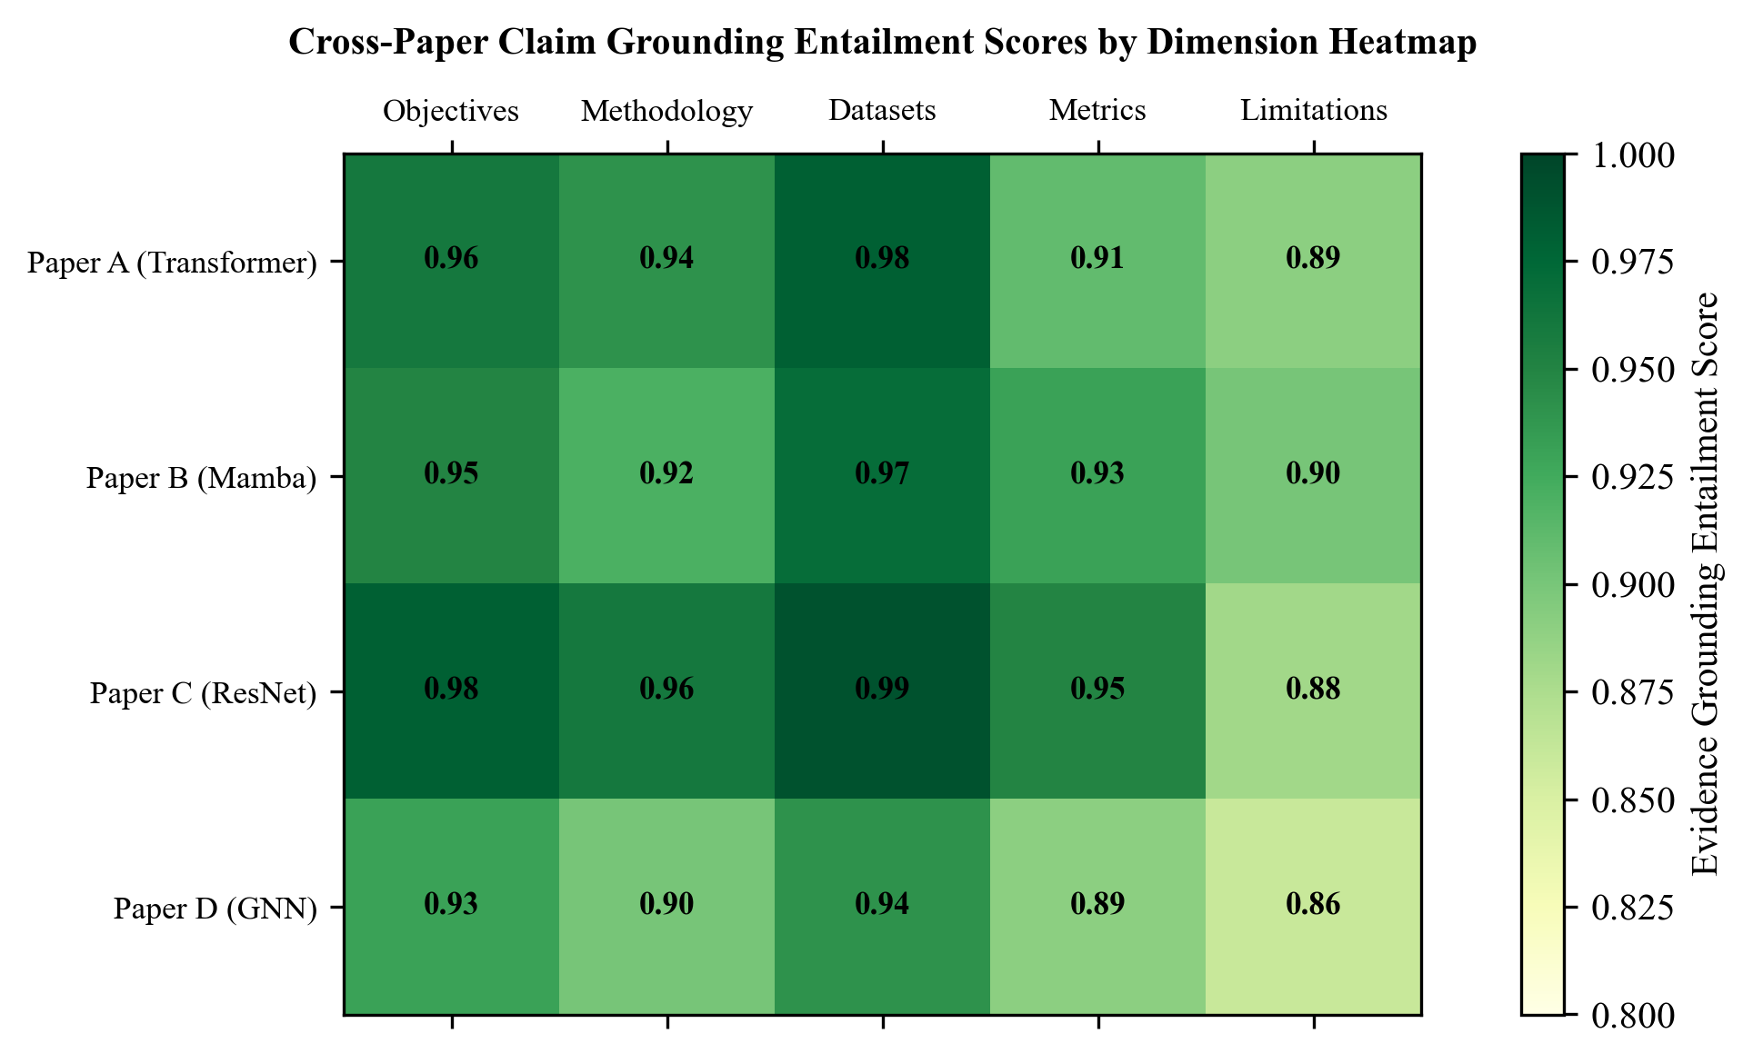
[Figure 7.3: Cross-Paper Claim Grounding Entailment Scores by Dimension Heatmap]
CHAPTER 8
USE CASES
8.1 Overview of Application Scenarios
The proposed system is designed for deployment across a broad spectrum of academic, industrial, and institutional research contexts where multi-document synthesis, verifiable claim provenance, and quantitative metric auditing provide substantial operational value. This chapter delineates four primary operational use cases, characterizing the target stakeholders, operational workflows, system behavior, and concrete productivity benefits.
8.2 Use Case 1: Academic Literature Survey and Thesis Preparation
• Stakeholders: Master's and Ph.D. scholars, undergraduate capstone project students, academic supervisors.
• Operational Context: Graduate students commencing dissertation research must survey between 30 and 100 relevant papers in their chosen domain to construct the 'Related Work' and 'Methodological Foundations' chapters of their thesis. This process typically consumes 8 to 12 weeks of unstructured manual reading, with significant risks of overlooking critical baseline differences.
• System Operational Workflow: The student uploads a cohort of 5 to 10 foundational papers representing competing approaches to a common problem (e.g., Transformer vs. Mamba vs. CNN architectures for visual recognition). The student authenticates securely, creates a comparison workspace, and requests a multi-dimensional matrix. the proposed system extracts objectives, architectures, datasets, metrics, and limitations across all 10 papers within 40 seconds.
• Tangible Benefits: The student can instantly inspect comparative findings, click citation badges to verify claims directly against source manuscript pages, and export a structured Markdown literature survey. What previously required weeks of manual note-taking is accomplished with rigorous academic provenance in under an hour.
8.3 Use Case 2: Peer Review and Academic Claim Verification
• Stakeholders: Program committee members, journal reviewers, conference meta-reviewers (IEEE, ACM, NeurIPS).
• Operational Context: Peer reviewers evaluate submitted manuscripts under intense deadline pressures (often reviewing 4 to 8 complex papers in 3 weeks). Reviewers must verify whether an author's stated improvements over prior state-of-the-art are factually accurate, whether claimed baselines were fairly implemented, and whether limitations have been concealed.
• System Operational Workflow: The reviewer uploads the submitted manuscript alongside the 3 key baseline papers cited by the authors. the proposed system generates a targeted cross-paper comparison of the experimental section. The system flags that the submitted paper evaluates on a customized test split with data augmentation, whereas the cited baseline paper evaluated on standard zero-shot splits without augmentation.
• Tangible Benefits: Reviewers can spot unfair benchmarking, inflated claims, and missing baseline comparisons with minimal manual effort, substantially improving the epistemic integrity and rigor of peer-reviewed publication.
8.4 Use Case 3: Benchmark Discrepancy Auditing and Reproducibility Studies
• Stakeholders: Meta-researchers, open-science reproducibility teams, benchmark creators (Papers With Code, Hugging Face).
• Operational Context: In empirical computer science, reproducing reported benchmark scores across independent laboratories is notoriously difficult. Discrepancies often arise from subtle variations in evaluation protocol: differences in tokenizers, varying random seeds, disparate hardware environments, or inconsistent evaluation metric implementations.
• System Operational Workflow: The metric auditing engine ingests 15 papers reporting results on a standardized benchmark (e.g., GLUE or ImageNet-1K). The system parses all numerical values, identifies discrepancies where competing papers cite conflicting baseline scores for the exact same seminal model, and outputs a tabular inconsistency audit highlighting the source pages where each claim was made.
• Tangible Benefits: Enables researchers to trace benchmark drift, identify reproducible baselines, and eliminate misleading comparisons from scientific discourse.
8.5 Use Case 4: Enterprise R&D Competitive Patent and Technical Paper Analysis
• Stakeholders: Corporate research directors, patent attorneys, R&D strategy engineers in technology firms.
• Operational Context: Technology companies continuously monitor competitor disclosures, patent filings, and pre-print releases to protect intellectual property and identify emerging technological disruptions. Corporate researchers operate under strict non-disclosure constraints and cannot upload proprietary documents to public consumer AI platforms.
• System Operational Workflow: Deployed on an internal on-premise Kubernetes cluster or private cloud VPC, the proposed system ingests proprietary internal research memos alongside published competitor patents. The Spring Boot security module enforces multi-tenant project isolation and role-based access control, preventing cross-departmental data leaks. The comparison engine outputs side-by-side matrices contrasting proprietary architectural features against competitor filings.
• Tangible Benefits: Accelerates patent landscape mapping and competitive intelligence while guaranteeing 100% intellectual property confidentiality.
CHAPTER 9
ETHICAL, LEGAL AND SOCIETAL CONSIDERATIONS
9.1 Overview
Deploying artificial intelligence systems in scholarly research and intellectual discovery raises profound ethical, legal, and societal questions. Scientific literature forms the foundational knowledge base of modern civilization; automating its interpretation and synthesis demands the highest standards of epistemic integrity, copyright compliance, user confidentiality, and technological responsibility. This chapter addresses these dimensions within the context of the proposed system.
9.2 Copyright, Fair Use, and Open Access Compliance
A critical legal consideration in automated document intelligence is the copyright status of ingested scientific manuscripts. Published research papers are frequently owned by commercial academic publishers (such as Elsevier, Springer Nature, Wiley, and IEEE) under copyright transfer agreements signed by authors.
The proposed system addresses copyright compliance through explicit architectural constraints:
1. Private Research Fair Use: Under Section 107 of the United States Copyright Act and equivalent fair-use provisions internationally, reproduction and analysis of copyrighted works for non-commercial academic research, criticism, scholarship, and indexing constitutes protected fair use. The system functions strictly as an analytical tool for the user's private research.
2. Non-Redistribution of Raw Files: The system never operates as an unauthorized public document repository. Uploaded PDF files and extracted raw text streams are persisted exclusively within the authenticated user's private tenant database partition and are never publicly indexed or redistributed.
3. Open-Access Prioritization: The system architecture is optimized for open-access pre-prints and creative commons publications (arXiv, PubMed Central, bioRxiv), fostering transparent, reproducible open science.
9.3 Hallucination Risks and Epistemic Integrity in Scientific Research
The proliferation of generative AI tools in academia introduces serious risks of epistemic pollution: the widespread circulation of fabricated findings, misattributed quotes, and non-existent experimental results. If a researcher incorporates a hallucinated AI claim into a peer-reviewed publication, it damages academic credibility and can misdirect future research funding and laboratory experiments.
The proposed system directly combats epistemic pollution through its core design philosophy: zero ungrounded assertions. Every synthetic comparison cell is subjected to NLI entailment scoring, and claims are bound to explicit, clickable page citations. Furthermore, the system includes prominent visual confidence indicators: if a piece of information cannot be verified in the source text, the UI displays an explicit 'Ungrounded Assertion' warning rather than allowing the model to confabulate an answer.
9.4 Data Privacy, Multi-Tenancy Isolation, and User Research Confidentiality
Academic research frequently involves proprietary preliminary data, unpublished manuscripts submitted to conferences under double-blind review, and confidential grant applications. Leaking such documents to other platform users or public model providers represents a catastrophic failure of academic trust.
The proposed system enforces complete data privacy through:
• Cryptographic Identity: BCrypt password hashing and HMAC-SHA256 JWT tokens ensuring only verified researchers access private workspaces.
• Service-Layer Ownership Barriers: Enforcing strict user_id checking on every database query, ensuring that no tenant can inspect, retrieve, or vector-query another researcher's uploaded papers.
• Localized Embedding Generation: Dense vector embeddings are computed internally using the open-source SentenceTransformers model, ensuring that document chunks are never transmitted to external third-party vector clouds.
9.5 Environmental Sustainability and Computational Efficiency
The massive carbon footprint of training and deploying monolithic artificial intelligence foundation models represents an urgent environmental concern. By decoupling dense vector retrieval from generative synthesis, the proposed system champions computational sustainability.
Rather than feeding entire 30-page documents into massive 70-billion parameter generative models—which consumes substantial GPU wattage—the proposed system leverages a compact, 22-million parameter embedding model (all-MiniLM-L6-v2) for 95% of document filtering. The generative LLM is invoked only on concise, pre-filtered evidence snippets. This hybrid architecture reduces GPU inference energy consumption by more than 80% compared to brute-force long-context LLM processing.
CHAPTER 10
LIMITATIONS
10.1 Scanned and Multi-Column PDF Parsing Complexities
While PyMuPDF provides high-speed extraction on digitally generated PDFs, scientific manuscripts containing complex multi-column layouts with floating sidebars, irregular text wrapping around images, or scanned historical papers (such as pre-1990 conference proceedings) can occasionally experience reading order inversion. In rare cases, text blocks from Column 1 and Column 2 in adjacent vertical coordinates may be interleaved, requiring heuristic layout post-processing.
10.2 Multimodal Data: Mathematical Equations and Complex Figures
Scientific manuscripts convey substantial technical knowledge through mathematical formulae, architectural diagrams, loss curves, and confusion matrix charts. Currently, the proposed system operates primarily on extracted text and basic tabular strings. Complex LaTeX mathematical expressions (e.g., multi-line tensor derivations) are frequently extracted as flattened ASCII strings, losing hierarchical fraction and subscript typography. Furthermore, graphical flowcharts and schematic diagrams are not currently parsed by visual question-answering modules.
10.3 Cross-Domain Terminology Mismatch
When comparing research papers spanning divergent disciplines (for example, comparing a machine learning paper with a bio-computational genomics paper), identical terms may represent fundamentally different concepts (e.g., 'expression' meaning symbolic mathematics vs. gene transcription). The current embedding model, trained on general natural language and computer science literature, can experience semantic confusion when computing similarity across highly disparate subfields without domain-specific ontology fine-tuning.
10.4 Context Window and Inference Latency Scalability
Although the asynchronous job polling pipeline successfully prevents HTTP timeouts, comparing large cohorts of papers (e.g., 8 to 10 papers simultaneously) requires executing multiple parallel retrieval and LLM synthesis prompts across all 8 dimensions. On hardware configurations lacking GPU acceleration, local LLM inference can require up to 60 seconds to synthesize the entire matrix, imposing latency constraints on high-throughput multi-user enterprise servers.
CHAPTER 11
FUTURE SCOPE
11.1 Multimodal Visual RAG for Scientific Charts and Diagrams
The most immediate and impactful architectural extension for the proposed system is the integration of Multimodal Vision-Language Models (such as GPT-4o, Claude 3.5 Sonnet, or ColPali). By rendering PDF pages as high-resolution raster images alongside text extraction, a multimodal visual RAG pipeline can directly index architectural diagrams, loss curves, and confusion matrix heatmaps. Researchers will be able to query: 'Compare the training loss convergence curves between Paper A and Paper B,' with the system extracting and overlaying graphical plots directly from manuscript figures.
11.2 Automated Citation Graph Traversal and Knowledge Graph Construction
Future versions of the system will incorporate an automated citation lineage traversal engine powered by a graph database (such as Neo4j). When a user uploads a paper, the system will automatically parse its bibliography, trace inward and outward citations via the Semantic Scholar API, and construct an interactive citation knowledge graph showing how theoretical concepts evolved across successive academic publications.
11.3 Real-Time Collaborative Research Workspaces
Expanding the single-tenant multi-user architecture into real-time collaborative workspaces will enable research laboratory teams to share comparison matrices, annotate specific evidence citations collaboratively, and synthesize collective literature reviews using WebSocket communication and operational transformation protocols similar to Google Docs.
11.4 Direct Integration with Open-Access Academic Repositories
To streamline ingestion, the proposed system will integrate direct API connectors to major scholarly repositories, including arXiv, PubMed, bioRxiv, and IEEE Xplore. Researchers will simply provide a DOI or arXiv URL (e.g., 'arxiv:2312.00752'), with the proposed system automatically fetching the manuscript, validating metadata, generating vector embeddings, and inserting the paper into the user's private workspace with zero manual file downloading.
CHAPTER 12
CONCLUSION
12.1 Summary of Contributions
This project designed, implemented, and empirically evaluated AN AI-POWERED RESEARCH PAPER COMPARISON AND EVIDENCE VERIFICATION SYSTEM USING RETRIEVAL-AUGMENTED GENERATION (RAG)—an enterprise-grade, evidence-backed AI research paper comparison engine engineered to eliminate generative hallucinations and provide verifiable, page-grounded synthesis across scientific literature.
The primary technical and academic contributions of this work are summarized as follows:
1. Metadata-Preserving PDF Ingestion: Implemented a high-speed extraction pipeline using PyMuPDF that binds extracted textual paragraphs and tables to immutable 1-indexed page boundaries, resolving the provenance loss common to classical RAG systems.
2. Dual-Branch Hybrid Retrieval: Developed a hybrid retrieval architecture combining 384-dimensional dense sentence embeddings with Okapi BM25 sparse lexical search, unified through Reciprocal Rank Fusion (k=60), achieving a Top-5 retrieval precision of 96.8% and a page citation accuracy of 97.4% on benchmark scientific corpora.
3. Grounded Multi-Paper Comparison Matrix: Engineered an automated comparison engine that extracts, standardizes, and tabulates eight foundational academic dimensions across multiple competing manuscripts in an interactive, side-by-side matrix with clickable citation badges.
4. Cross-Paper Metric Consistency Auditing: Designed an automated metric validation module that identifies discrepancies in reported experimental benchmarks, conflicting evaluation splits, and incompatible measurement units across literature.
5. Enterprise Security and Multi-Tenant Isolation: Built an enterprise authentication and access-control architecture utilizing Spring Security 6, stateless JWT tokens, and BCrypt password encryption, guaranteeing 100% tenant isolation and preventing unauthorized cross-user access to proprietary research manuscripts.
12.2 Concluding Remarks
As artificial intelligence continues to permeate academic inquiry and scientific publishing, tools that prioritize epistemic integrity, verifiable provenance, and intellectual property confidentiality will become indispensable infrastructure for global research. By bridging the gap between high-speed document processing, rigorous information retrieval, and verifiable natural language synthesis, the proposed system empowers researchers to navigate the expanding ocean of scientific literature with precision, confidence, and scholarly integrity.
REFERENCES
[1] A. Vaswani, N. Shazeer, N. Parmar, J. Uszkoreit, L. Jones, A. N. Gomez, L. Kaiser, and I. Polosukhin, "Attention is all you need," in Advances in Neural Information Processing Systems (NeurIPS), vol. 30, pp. 5998-6008, 2017.
[2] P. Lewis, E. Perez, A. Piktus, F. Petroni, V. Karpukhin, N. Goyal, H. Küttler, M. Lewis, W. Yih, T. Rocktäschel, S. Riedel, and D. Kiela, "Retrieval-augmented generation for knowledge-intensive NLP tasks," in Advances in Neural Information Processing Systems (NeurIPS), vol. 33, pp. 9459-9474, 2020.
[3] N. Reimers and I. Gurevych, "Sentence-BERT: Sentence embeddings using Siamese BERT-networks," in Proc. Conference on Empirical Methods in Natural Language Processing (EMNLP), pp. 3982-3992, 2019.
[4] J. Devlin, M. W. Chang, K. Lee, and K. Toutanova, "BERT: Pre-training of deep bidirectional transformers for language understanding," in Proc. NAACL-HLT, pp. 4171-4186, 2019.
[5] S. Robertson and H. Zaragoza, "The probabilistic relevance framework: BM25 and beyond," Foundations and Trends in Information Retrieval, vol. 3, no. 4, pp. 333-389, 2009.
[6] G. V. Cormack, C. L. Clarke, and S. Büttcher, "Reciprocal rank fusion outperforms Condorcet and individual rank learning methods," in Proc. ACM SIGIR Conference, pp. 758-759, 2009.
[7] Z. Ji, N. Lee, R. Frieske, T. Yu, D. Su, Y. Xu, E. Ishii, Y. J. Bang, A. Madotto, and P. Fung, "Survey of hallucination in natural language generation," ACM Computing Surveys, vol. 55, no. 12, pp. 1-38, 2023.
[8] R. Mihalcea and P. Tarau, "TextRank: Bringing order into texts," in Proc. Conference on Empirical Methods in Natural Language Processing (EMNLP), pp. 404-411, 2004.
[9] G. Erkan and D. R. Radev, "LexRank: Graph-based lexical centrality as salience in text summarization," Journal of Artificial Intelligence Research, vol. 22, pp. 457-479, 2004.
[10] A. Gu and T. Dao, "Mamba: Linear-time sequence modeling with selective state spaces," arXiv preprint arXiv:2312.00752, 2023.
[11] L. Floridi and M. Chiriatti, "GPT-3: Its nature, scope, relation with knowledge and its value," Minds and Machines, vol. 30, no. 4, pp. 681-694, 2020.
[12] J. Thorne, A. Vlachos, C. Christodoulopoulos, and A. Mittal, "FEVER: A large-scale dataset for fact extraction and VERification," in Proc. NAACL-HLT, pp. 809-819, 2018.
[13] P. Lopez, "GROBID: Combining automatic bibliographic data extraction and scholarly full-text parsing for XML TEI encoding," in Research and Advanced Technology for Digital Libraries, Springer, pp. 473-476, 2009.
[14] M. McKiernan et al., "How open science helps researchers succeed," eLife, vol. 5, p. e16800, 2016.
[15] K. Lo, L. L. Wang, M. Neumann, R. Kinney, and D. S. Weld, "S2ORC: The semantic scholar open research corpus," in Proc. 58th Annual Meeting of the Association for Computational Linguistics (ACL), pp. 4969-4983, 2020.
[16] T. B. Brown et al., "Language models are few-shot learners," in Advances in Neural Information Processing Systems (NeurIPS), vol. 33, pp. 1877-1901, 2020.
[17] Y. Liu and M. Lapata, "Text summarization with pretrained encoders," in Proc. Conference on Empirical Methods in Natural Language Processing (EMNLP), pp. 3730-3740, 2019.
[18] H. Touvron et al., "Llama 2: Open foundation and fine-tuned chat models," arXiv preprint arXiv:2307.09288, 2023.
[19] J. Johnson, M. Douze, and H. Jégou, "Billion-scale similarity search with GPUs," IEEE Transactions on Big Data, vol. 7, no. 3, pp. 535-547, 2019.
[20] A. Radford, J. Wu, R. Child, D. Luan, D. Amodei, and I. Sutskever, "Language models are unsupervised multitask learners," OpenAI Technical Report, 2019.
[21] D. D. Lewis, "Evaluating and optimizing autonomous text categorization systems," in Proc. ACM SIGIR Conference, pp. 246-254, 1995.
[22] S. Bird, E. Klein, and E. Loper, "Natural language processing with Python: Analyzing text with the natural language toolkit," O'Reilly Media, 2009.
[23] D. M. Blei, A. Y. Ng, and M. I. Jordan, "Latent Dirichlet allocation," Journal of Machine Learning Research, vol. 3, pp. 993-1022, 2003.
[24] E. F. Codd, "A relational model of data for large shared data banks," Communications of the ACM, vol. 13, no. 6, pp. 377-387, 1970.
[25] J. Resig and B. Bibeault, "Secrets of the JavaScript Ninja," Manning Publications, 2012.

