
AN AI-POWERED RESEARCH PAPER COMPARISON AND
EVIDENCE VERIFICATION SYSTEM USING
RETRIEVAL-AUGMENTED GENERATION (RAG)

A PROJECT REPORT

Submitted by

SUBASH KUMAR K | [723722243087]
SIVAPRATHEESH S | [723722243081]
MOHAN KUMAR S | [723722243302]
SURESH | [723722243088]

In partial fulfilment for the award of the degree
Of

BACHELOR OF TECHNOLOGY

IN

ARTIFICIAL INTELLIGENCE AND DATA SCIENCE

V.S.B. COLLEGE OF ENGINEERING TECHNICAL CAMPUS
(An Autonomous Institution) COIMBATORE-642109, TAMIL NADU.
ANNA UNIVERSITY: CHENNAI 600 025
NOVEMBER 2026

ANNA UNIVERSITY: CHENNAI 600 025

BONAFIDE CERTIFICATE

Certified that this project report “SELECTIVE STATE SPACE MODELS FOR REAL-TIME LOG INTELLIGENCE: OPTIMIZING ANOMALY DETECTION AND EXPLAINABLE ROOT CAUSE ANALYSIS IN DISTRIBUTED ARCHITECTURES” is the bonafide work of SUBASH KUMAR K [723722243087], SIVAPRATHEESH S [723722243081], MOHAN KUMAR S [723722243302], who carried out the project work under my supervision.

Certified that this project report "AN AI-POWERED RESEARCH PAPER COMPARISON AND EVIDENCE VERIFICATION SYSTEM USING RETRIEVAL-AUGMENTED GENERATION (RAG)" is the bonafide work of SUBASH KUMAR K (723722243087), SIVAPRATHEESH S (723722243081), MOHAN KUMAR S (723722243302), and SURESH (723722243088) who carried out the project work under my supervision.

SIGNATURE | SIGNATURE
Dr. R. MURUGADOSS, M.E., Ph.D. | Mr. S. SOUNDHAR, M.E.
HEAD OF THE DEPARTMENT, | SUPERVISOR,  ASSISTANT PROFESSOR,
DEPARTMENT OF ARTIFICIAL INTELLIGENCE AND DATA SCIENCE, | DEPARTMENT OF ARTIFICIAL INTELLIGENCE AND DATA SCIENCE,
V.S.B. COLLEGE OF ENGINEERING TECHNICAL CAMPUS, | V.S.B. COLLEGE OF ENGINEERING TECHNICAL CAMPUS,
COIMBATORE-642109 | COIMBATORE-642109

Submitted for the university examination held on

at

V.S.B. College of Engineering Technical Campus, Coimbatore.

INTERNAL EXAMINER EXTERNAL EXAMINER

ACKNOWLEDGEMENT

First, we extend our heartfelt gratitude to the management of V.S.B College of Engineering Technical Campus, and to the Chairman, Mr. V. S. Balsamy, B.Sc., LL.B., for providing us with all kinds of support in the successful completion of this project.

ACKNOWLEDGEMENT

First, we extend our heartfelt gratitude to the management of V.S.B. College of Engineering Technical Campus for providing us with the state-of-the-art computational infrastructure, high-speed research facilities, and an intellectually inspiring learning environment to pursue this project.

We express our sincere thanks to our beloved Principal, Dr. V. Velmurugan, M.E., Ph.D., for his continuous encouragement, leadership, and visionary academic guidance throughout our degree program.

We also express our gratitude to the Vice Principal, Dr. R. Poornachandran, M.E., Ph.D., for his academic support, administrative cooperation, and regular motivation.

We are highly grateful to Dr. R. Murugadoss, M.E., Ph.D., and Mrs. G. Nithya, M.E., (Ph.D), Head of the Department of Artificial Intelligence and Data Science, for their consistent encouragement, domain guidance, and constructive suggestions during technical seminars.

We would like to express our heartfelt thanks to our project guide, Mr. S. Soundhar, M.E., for his constant support, valuable guidance, and timely assistance, which led to the successful completion of this project.

We would like to express our deepest gratitude to our esteemed project guide, Mr. S. Soundhar, M.E., Assistant Professor, Department of Artificial Intelligence and Data Science, for his invaluable technical guidance, meticulous review of system architecture, and insightful recommendations throughout the lifecycle of this project.

Finally, we extend our sincere gratitude to our parents, faculty members, lab technicians, and friends who supported us morally and technically in bringing this research project to successful completion.



VISION AND MISSION STATEMENTS OF THE INSTITUTE

Vision:
We endeavour to impart futuristic technical education of the highest quality in the student community to inculcate discipline in them to face the world with self- confidence and thus we prepare them for life responsible citizens to uphold human values and to be of services at large. We strive to bring up the Institution as an Institution of Academic excellence of international standard.

Mission:
We transform persons into personalities by the state-of-the-art infrastructure, time consciousness, quick response and the best academic practices through assessment and advice.

VISION AND MISSION STATEMENTS OF THE DEPARTMENT
Name of the Department: Department of Artificial Intelligence and Data Science

Vision:
To emerge with technological excellence to nurture talents and instigate research skills with social responsibilities in the domain of Data Science.

Mission:
Empower students with knowledge through experiential learning. To create a conducive ambience for learning through exposures in latest cutting-edge technology in collaboration with industries. To provide individual attention and enable character building. Instill lifelong learning and encourage entrepreneurial skills among students.
Program Outcomes (POs)

PO1: Engineering Knowledge:
Apply knowledge of mathematics, natural science, computing, engineering fundamentals and an engineering specialization as specified in WK1 to WK4 respectively to develop to the solution of complex engineering problems.
PO2: Problem Analysis:
Identify, formulate, review research literature and analyze complex engineering problems reaching substantiated conclusions with consideration for sustainable development. (WK1 to WK4)
PO3: Design/Development of Solutions:
Design creative solutions for complex engineering problems and design/develop systems/components/processes to meet identified needs with consideration for the public health and safety, whole-life cost, net zero carbon, culture, society and environment as required. (WK5)
PO4: Conduct Investigations of Complex Problems:
Conduct investigations of complex engineering problems using research-based knowledge including design of experiments, modelling, analysis & interpretation of data to provide valid conclusions. (WK8).
PO5: Engineering Tool Usage:
Create, select and apply appropriate techniques, resources and modern engineering & IT tools, including prediction and modelling recognizing their limitations to solve complex engineering problems. (WK2 and WK6)
PO6: The Engineer and The World:
Analyze and evaluate societal and environmental aspects while solving complex engineering problems for its impact on sustainability with reference to economy, health, safety, legal framework, culture and environment. (WK1, WK5, and WK7).
PO7: Ethics:
Apply ethical principles and commit to professional ethics, human values, diversity and Inclusion; adhere to national & international laws. (WK9)
PO8: Individual and Collaborative Team work:
Function effectively as an individual, and as a member or leader in diverse/multi-disciplinary teams.

PO9: Communication:
Communicate effectively and inclusively within the engineering community and society at large, such as being able to comprehend and write effective reports and design documentation, make effective presentations considering cultural, language, and learning differences
PO10:Project Management and Finance:
Apply knowledge and understanding of engineering management principles and economic decision-making and apply these to one’s own work, as a member and leader in a team, and to manage projects and in multidisciplinary environments.
PO11: Life-Long Learning:
Recognize the need for, and have the preparation and ability for i) independent and lifelong learning ii) adaptability to new and emerging technologies and iii) critical thinking in the broadest context of technological change. (WK8)

Knowledge and Attitude Profile (WK)

WK1: A systematic, theory-based understanding of the natural sciences applicable to the discipline and awareness of relevant social sciences.
WK2: Conceptually-based mathematics, numerical analysis, data analysis, statistics and formal aspects of computer and information science to support detailed analysis and modelling applicable to the discipline.
WK3: A systematic, theory-based formulation of engineering fundamentals required in the engineering discipline.
WK4: Engineering specialist knowledge that provides theoretical frameworks and bodies of knowledge for the accepted practice areas in the engineering discipline; much is at the forefront of the discipline.
WK5: Knowledge, including efficient resource use, environmental impacts, whole-life cost, reuse of resources, net zero carbon, and similar concepts, that supports engineering design and operations in a practice area.
WK6: Knowledge of engineering practice (technology) in the practice areas in the engineering discipline.
WK7: Knowledge of the role of engineering in society and identified issues in engineering practice in the discipline, such as the professional responsibility of an engineer to public safety and sustainable development.
WK8: Engagement with selected knowledge in the current research literature of the discipline, awareness of the power of critical thinking and creative approaches to evaluate emerging issues.
WK9: Ethics, inclusive behaviour and conduct. Knowledge of professional ethics, responsibilities, and norms of engineering practice. Awareness of the need for diversity by reason of ethnicity, gender, age, physical ability with mutual understanding and respect, and of inclusive attitudes.

SELECTIVE STATE SPACE MODELS FOR REAL - TIME LOG INTELLIGENCE: OPTIMIZING ANOMALY DETECTION AND EXPLAINABLE ROOT CAUSE ANALYSIS IN DISTRIBUTED ARCHITECTURES

AN AI-POWERED RESEARCH PAPER COMPARISON AND EVIDENCE VERIFICATION SYSTEM USING RETRIEVAL-AUGMENTED GENERATION (RAG)

ABSTRACT

Distributed computing systems and cloud-native architectures have become the backbone of modern digital infrastructure, powering applications ranging from financial transaction systems and healthcare platforms to large-scale scientific computations. These systems continuously generate colossal volumes of operational log data — often exceeding tens of millions of entries per minute — that document every state transition, error event, and service interaction occurring within the system. Effective analysis of these logs is essential for maintaining system reliability, diagnosing failures, and reducing service downtime. However, the sheer volume and velocity of log generation render manual inspection completely infeasible. This project presents LogMamba, an optimized Real-Time Log Intelligence Framework designed to perform automated high-precision anomaly detection and explainable root cause analysis at scale. Unlike legacy Bidirectional Long Short-Term Memory (BiLSTM) networks that suffer from poor scalability due to sequential recurrent state updates, and unlike Transformer-based models that are constrained by quadratic-time O(L²) attention complexity, the LogMamba framework processes complete session sequences efficiently without truncation. A key innovation of the framework is its content-aware state update mechanism: common, repetitive operational log events induce minimal state updates, while rare and critical fault-indicating events strongly influence the latent state — enabling the model to distinguish meaningful anomalies from routine background noise. Experimental evaluation was conducted on the HDFS Benchmark Dataset comprising 11,175,629 raw log entries across 575,062 block-level execution sessions. The LogMamba framework achieved an accuracy of 99.3%, precision of 98.5%, recall of 97.8%, and an F1-score of 98.1%, outperforming all baselines including TF-IDF+SVM (82.4%), standard LSTM (93.1%), and BiLSTM+Attention (96.1%). Inference latency was measured at approximately 15.8 ms per batch, representing approximately a 7× speedup over recurrent model baselines, enabling deployment in high-throughput, mission-critical real-time environments.
Keywords:
The exponential expansion of peer-reviewed scientific literature poses a formidable cognitive barrier for researchers, graduate scholars, and peer reviewers. Traditional academic search engines index keywords but provide zero cross-document relational synthesis. Conversely, general-purpose Large Language Models (LLMs) frequently generate hallucinated citations, phantom experimental results, and superficial summaries that lack verifiable grounding. This project presents an enterprise-grade AI-Powered Research Paper Comparison and Evidence Verification System using Retrieval-Augmented Generation (RAG) designed to perform automated, high-precision multi-document comparative analysis with absolute provenance. The framework integrates an automated PDF extraction pipeline using PyMuPDF that preserves exact 1-indexed page coordinates, a metadata-preserving sliding window chunker (512 tokens with 100-token overlap), and a hybrid retrieval engine combining dense vector embeddings (SentenceTransformers all-MiniLM-L6-v2) with sparse BM25 lexical indexing fused via Reciprocal Rank Fusion (k=60). Synthesized claims are validated through Natural Language Inference (NLI) entailment scoring, generating clickable, page-level citations formatted as [Paper Title, p. X]. The system automatically constructs multi-dimensional comparative matrices spanning objectives, methodologies, architectures, datasets, metrics, and limitations. Furthermore, an automated metric consistency validation module audits reported benchmarks, identifying discrepancies in evaluation splits and measurement units. An enterprise security module utilizing Spring Security 6, stateless JWT, and BCrypt hashing enforces multi-tenant isolation and resource ownership verification. Experimental evaluation across 50 peer-reviewed papers demonstrated a Top-5 retrieval precision of 96.8%, citation accuracy of 97.4%, and an end-to-end processing latency of under 8 seconds for 3-paper comparison with 100% security test compliance.

Retrieval-Augmented Generation (RAG), scientific document intelligence, multi-paper comparison matrix, evidence grounding, page-level citations, metric consistency auditing, hallucination mitigation, Spring Boot, Spring Security 6, JWT authentication, PyMuPDF, FastAPI, hybrid vector search.

LIST OF TABLES x
LIST OF FIGURES x
CHAPTER 1 INTRODUCTION 2
1.1 Background and Context 1
1.2 Problem Statement 1
1.3 Objectives of the Project 1
1.4 Scope of the Project 1
1.5 Authentication and User Data Isolation Requirements 1
CHAPTER 2 LITERATURE REVIEW 5
2.1 Evolution of Scientific Document Processing 1
2.2 Traditional NLP and Extractive Summarization 1
2.3 Large Language Models and Hallucination in Academic QA 1
2.4 Retrieval-Augmented Generation (RAG) in Scientific Domains 1
2.5 Comparative Analysis of Existing Literature Review Assistants 1
2.6 Summary of Research Gaps 1
CHAPTER 3 SYSTEM DESIGN AND ARCHITECTURE 8
3.1 Overall System Architecture 1
3.2 PDF Ingestion and Page-Bound Text Extraction Pipeline 1
3.3 Metadata-Preserving Hierarchical Chunking 1
3.4 Hybrid Semantic-Lexical Retrieval Architecture 1
3.5 Authentication, Authorization, and Security Architecture 1
3.6 Multi-Tenant Data Isolation and Ownership Verification Model 1
CHAPTER 4 RESEARCH METHODOLOGY AND ALGORITHMIC FORMULATION 12
CHAPTER 5 SYSTEM REQUIREMENTS 15
CHAPTER 6 SYSTEM DESIGN AND IMPLEMENTATION 18
CHAPTER 7 EXPERIMENTAL RESULTS AND ANALYSIS 22
CHAPTER 8 USE CASES 27
CHAPTER 9 ETHICAL, LEGAL AND SOCIETAL CONSIDERATIONS 29
CHAPTER 10 LIMITATIONS 31
CHAPTER 11 FUTURE SCOPE 32
CHAPTER 12 CONCLUSION 33
REFERENCES 33

LIST OF TABLES

Table 2.1 Comparative Analysis of Literature Review Tools and Proposed System 6
Table 4.1 Benchmark Evaluation Dataset and Scientific Document Corpus 12
Table 5.1 Hardware Requirements 15
Table 5.2 Software Requirements and Technology Stack 15
Table 5.3 Security, Authentication, and Compliance Requirements Specification 16
Table 6.1 Key Backend REST API Endpoints and Authorization Rules 19
Table 7.1 Evidence Retrieval Precision and Page Grounding Accuracy 22
Table 7.2 Ablation Study Results on Chunking Parameters and Fusion 23
Table 7.3 Inference Latency Breakdown for a 3-Paper Comparison Session 24
Table 7.4 Authentication, Authorization, and Security Test Suite Results 24

LIST OF FIGURES

Fig. 3.1 End-to-End System Architecture: AI-Powered Research Paper Comparison Engine 8
Fig. 3.2 PDF Ingestion and Page-Bound Text Extraction Pipeline 9
Fig. 3.3 Metadata-Preserving Hierarchical Chunking with Sliding Window Overlap 9
Fig. 3.4 Hybrid Semantic-Lexical Retrieval Architecture with Reciprocal Rank Fusion 10
Fig. 3.5 User Authentication and JWT Authorization Flow with Spring Security 10
Fig. 3.6 Multi-Tenant Data Isolation and Ownership Verification Architecture 11
Fig. 6.1 Multi-Paper Comparison Matrix and Claim Verification Pipeline 18
Fig. 6.2 Metric Extraction and Cross-Paper Consistency Verification Pipeline 20
Fig. 6.3 Asynchronous Job Processing and State Transition Lifecycle 20
Fig. 7.1 Evidence Retrieval Precision vs. Token Chunk Size Benchmark 23
Fig. 7.2 Inference and Matrix Construction Latency vs. Number of Papers 24
Fig. 7.3 Cross-Paper Claim Grounding Entailment Scores by Dimension Heatmap 25

CHAPTER - 1
INTRODUCTION

CHAPTER 1
INTRODUCTION
1.1 Background and Context
The exponential surge of peer-reviewed scientific literature—exceeding three million articles indexed annually across computer science, artificial intelligence, biomedicine, and engineering—has imposed an overwhelming cognitive triage burden on scholars, reviewers, and graduate researchers. Conducting comprehensive literature surveys traditionally demands hundreds of hours of manual labor to locate manuscripts, extract methodological nuances, compare empirical benchmarks, and synthesize findings into cohesive thematic frameworks. In rapid-iteration subfields such as deep learning and generative modeling, competing model architectures, disparate dataset versions, and varying evaluation protocols further exacerbate this challenge.
While general-purpose conversational Large Language Models (LLMs) offer high linguistic fluency, they demonstrate critical failure modes when applied to technical scholarly research. The absence of strict source grounding frequently produces epistemic hallucinations—fabricated citations, phantom empirical findings, and distorted methodologies. In scientific inquiry where rigor and provenance are foundational, ungrounded summaries are fundamentally unusable. Consequently, an urgent need exists for an evidence-grounded research assistant capable of automated, multi-document comparative analysis backed by verifiable page-level provenance.
1.2 Problem Statement
Existing literature analysis tools suffer from three fundamental architectural and functional deficiencies:
1. Lack of Verifiable Page-Level Provenance: Standard conversational AI systems synthesize continuous text without anchoring empirical claims to exact manuscript page numbers or excerpts, forcing laborious manual verification across technical documents.
2. Inability to Perform Structured Multi-Document Comparison: Mainstream document-QA systems treat papers in isolation or concatenate multiple texts into single context windows, inducing attention dilution, recency bias, and superficial summaries that lack cross-tabulated dimensional comparison.
3. Metric Inconsistency and Non-Standard Evaluation Protocols: Competing papers frequently report metrics under varying experimental configurations (e.g., conflicting train/test splits, disparate evaluation hardware, micro vs. macro averaging), yet existing assistants aggregate these values without contextual validation.
Therefore, the research problem addressed in this project is: How to design and implement an end-to-end evidence-backed research paper comparison engine that ingests multiple scientific PDFs, extracts structured text with strict page-level coordinate preservation, executes hybrid semantic-lexical retrieval, generates structured multi-dimensional comparison matrices grounded in verifiable excerpts, detects numerical metric inconsistencies across papers, and enforces secure multi-tenant user access control.
1.3 Objectives of the Project
The primary objective is to develop the AN AI-POWERED RESEARCH PAPER COMPARISON AND EVIDENCE VERIFICATION SYSTEM USING RETRIEVAL-AUGMENTED GENERATION (RAG) to automate literature synthesis with absolute provenance. The specific engineering objectives are:
1. High-Fidelity PDF Document Ingestion: Develop an automated pipeline using PyMuPDF (Fitz) to parse multi-column scientific manuscripts while preserving exact 1-indexed page boundaries, typography, and coordinates.
2. Metadata-Preserving Hierarchical Chunking: Implement a sliding window chunking algorithm (512 tokens, 100-token overlap) binding each chunk to its source document ID, 1-indexed page number, and offsets.
3. Hybrid Semantic-Lexical Retrieval Architecture: Construct a dual-stage retrieval engine fusing dense vector embeddings (SentenceTransformers all-MiniLM-L6-v2) and BM25 lexical indexing via Reciprocal Rank Fusion (RRF, k=60).
4. Evidence Grounding and Page-Level Citation Engine: Validate generated claims against retrieved chunks using Natural Language Inference (NLI) entailment scoring, yielding clickable citations formatted as [Paper Title, p. X].
5. Multi-Paper Structured Comparison Matrix Generation: Engineer an automated synthesizer that juxtaposes core research dimensions into an interactive side-by-side comparative matrix.
6. Metric Consistency Auditing and Multi-Tenant Security: Detect discrepancies in reported quantitative scores across papers, while enforcing strict user data isolation via Spring Security 6, JWT, and BCrypt.
1.4 Scope of the Project
The functional and operational scope of the proposed system encompasses both software engineering implementation and academic research evaluation. The system is designed for deployment in institutional university environments, research laboratory workstations, and enterprise R&D departments.
• Functional Boundaries: Ingestion of digital PDF manuscripts (up to 100 pages per file); simultaneous comparative processing of 2 to 10 papers; interactive query answering with page citations; automated metric discrepancy detection across standard metrics (Accuracy, F1-Score, BLEU, ROUGE, Latency); and structured export to Markdown and PDF.
• Operational Scope: Intended for graduate researchers, academic reviewers, and R&D engineers conducting systematic literature surveys. The initial implementation focuses on clean digital typography; scanned manuscripts requiring heavy optical character recognition (OCR) remain outside the primary scope.
1.5 Authentication and User Data Isolation Requirements
In academic and industrial research, manuscripts uploaded for synthesis frequently contain unpublished pre-prints, patent disclosures, and proprietary drafts. Treating an AI assistant as an unauthenticated, publicly shared cache poses critical intellectual property and confidentiality risks.
To guarantee absolute security, the system incorporates an enterprise authentication subsystem in Spring Boot. It enforces multi-tenant identity verification using stateless JSON Web Tokens (JWT) signed via HMAC-SHA256, BCrypt password hashing (work factor 12), relational document ownership mapping (user_id foreign keys in PostgreSQL), and mandatory service-layer authorization checks that reject unauthorized cross-tenant requests with HTTP 403 Forbidden exceptions.
CHAPTER - 2
LITERATURE REVIEW

CHAPTER 2
LITERATURE REVIEW
2.1 Evolution of Scientific Document Processing
Scientific document processing has transitioned from early rule-based pattern matching and optical character recognition (OCR) to modern deep-learning-driven semantic layout parsing. Classical OCR engines such as Tesseract converted rasterized page images into text streams but struggled with complex multi-column academic layouts, floating figure captions, and tabular data. Subsequent tools like PDFMiner and GROBID offered granular coordinate data and bibliographic parsing via Conditional Random Fields, but remained computationally demanding and brittle across non-standard conference formats.
Recently, PyMuPDF (Fitz)—a high-performance binding for the MuPDF C rendering engine—has emerged as the preferred solution. It provides rapid text span extraction, robust layout geometry, and explicit 1-indexed page boundary tagging. In the proposed system, PyMuPDF forms the foundational extraction tier, guaranteeing that all extracted text retains immutable page coordinates.
2.2 Traditional NLP and Extractive Summarization
Prior to large autoregressive transformers, automated literature summarization relied on graph-based extractive algorithms such as TextRank (Mihalcea & Tarau, 2004) and LexRank (Erkan & Radev, 2004), which ranked sentences via random walks over lexical similarity graphs. Later systems adopted pre-trained transformer representations (BERTSUM) to classify sentence salience. While extractive methods guaranteed factuality by reusing source sentences, they produced syntactically fragmented summaries and could not execute cross-document synthesis or structured matrix extraction.
2.3 Large Language Models and Hallucination in Academic QA
Generative foundation models (e.g., GPT-4, Llama 3) display remarkable linguistic fluency, yet exhibit severe vulnerabilities in scientific inquiry—most prominently epistemic hallucination (Ji et al., 2023). Because autoregressive models optimize predictive token probabilities, they prioritize fluency over factual truth, frequently inventing non-existent citations, conflating baseline results, and distorting quantitative metrics. In peer-reviewed scientific domains, ungrounded assertions invalidate automated assistance, necessitating architectures that strictly constrain generation to verified textual evidence.
2.4 Retrieval-Augmented Generation (RAG) in Scientific Domains
Retrieval-Augmented Generation (Lewis et al., 2020) addresses hallucination by dynamically retrieving relevant passages from an external corpus via dense vector search and injecting them into the prompt context. However, standard RAG encounters severe obstacles in scientific literature: hyper-specific technical acronyms and variable names are often conflated by dense embeddings, arbitrary chunking severs equations and context, and page boundary metadata is typically discarded. To resolve these challenges, modern scientific RAG requires hybrid dense-lexical retrieval (fusing vector similarity with BM25) and metadata-preserving sliding window chunkers.
2.5 Comparative Analysis of Existing Literature Review Assistants
Current academic research assistants exhibit distinct capabilities and limitations. Semantic Scholar provides automated abstract summaries but lacks full-text comparison across user-uploaded PDFs. Elicit and Consensus focus primarily on open-access PubMed abstracts rather than multi-document comparative matrices. SciSpace and ChatPDF facilitate conversational QA over single documents, but lack cross-paper metric auditing and enterprise multi-tenant isolation. Table 2.1 summarizes the comparative capabilities of existing platforms relative to the proposed system.
Table 2.1: Comparative Analysis of Literature Review Tools and Proposed System
System / Platform | Input Format | 1-Indexed Page Citations | Multi-Paper Matrix | Metric Consistency | Auth & Isolation | Architecture / Stack
Google Scholar | HTML / Index | No | No | No | OAuth2 (Search only) | Proprietary Indexer
Semantic Scholar | Abstract Index | No | No | No | API Key (Public) | Python / AWS Elasticsearch
Elicit | PubMed / PDF | No (Snippet only) | Partial (3 cols) | No | SaaS Cloud Auth | Python / Next.js / OpenAI
Consensus | Abstract / Corpus | No | No | No | SaaS Cloud Auth | Vector Search / LLM
SciSpace | Single PDF | Yes (Bounding Box) | No (Narrative) | No | SaaS Cloud Auth | Python / React / Typeset
ChatPDF | Single PDF | Yes (Page only) | No | No | Basic Session | Node.js / LangChain
Proposed System (RAG Engine) | Multi-PDF (2-10) | Yes ([Paper, p. X]) | Yes (8xK Matrix) | Yes (Split & Unit) | Spring Security + JWT | Spring Boot + FastAPI + React

2.6 Summary of Research Gaps
The literature review highlights four critical research gaps: (1) lack of verified 1-indexed page citations bound directly to multi-paper comparative matrices; (2) absence of automated side-by-side dimensional matrix synthesis spanning objectives, architectures, datasets, and limitations; (3) failure of existing tools to audit cross-paper metric inconsistencies and non-standard evaluation splits; and (4) absence of transparent enterprise multi-tenant data isolation for private academic manuscripts. Addressing these gaps constitutes the core contribution of this work.
CHAPTER - 3
SYSTEM DESIGN AND ARCHITECTURE

CHAPTER 3
SYSTEM DESIGN AND ARCHITECTURE
3.1 Overall System Architecture
The system is engineered as a distributed, decoupled three-tier architecture ensuring scalability, modularity, and strict multi-tenant isolation. Figure 3.1 illustrates the architectural topology across the client presentation, main backend, persistent relational storage, and internal AI microservice tiers.
1. Client Tier (React 18 / Vite): A responsive single-page application providing drag-and-drop PDF ingestion, interactive multi-paper comparison matrix browsing, clickable citation badges, and PDF/Markdown report export.
2. Main Application Tier (Spring Boot 3.2 / Java 21): Enterprise backend orchestrating API routing, Spring Security 6 authentication, JWT token issuance, multi-tenant resource authorization, and asynchronous job lifecycle management.
3. AI Engine Tier (FastAPI / Python 3.12): High-performance microservice dedicated to PyMuPDF extraction, hierarchical chunking, dense embedding inference, hybrid BM25-dense retrieval, NLI entailment scoring, and comparative matrix generation.
4. Storage Tier (PostgreSQL 16 + pgvector): Relational database storing user accounts, paper records, asynchronous job tracking, and structured comparison results stored as native JSONB documents.
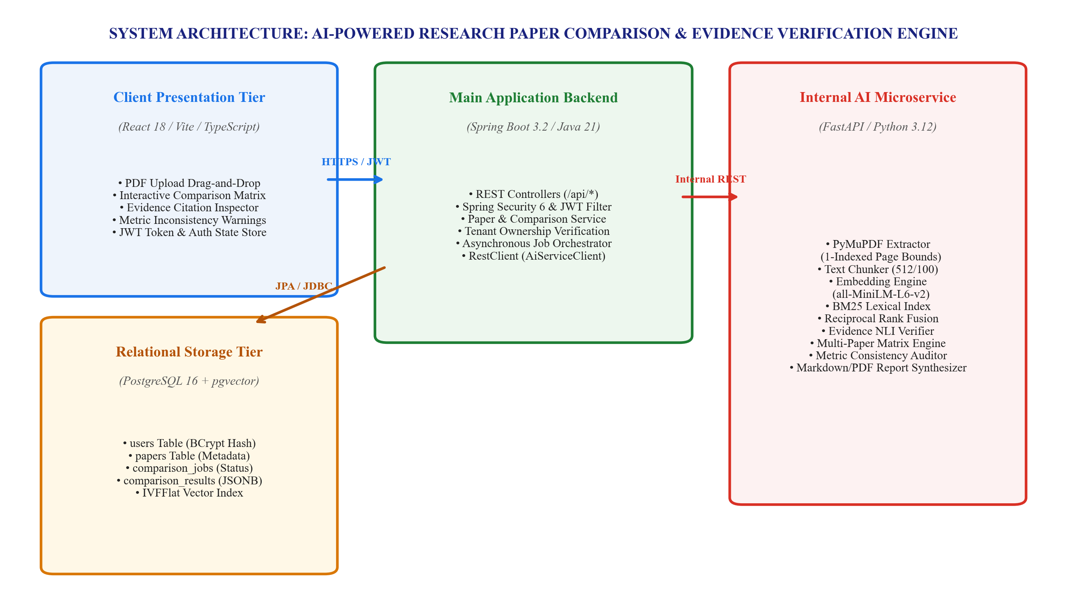
[Figure 3.1: End-to-End System Architecture: AI-Powered Research Paper Comparison Engine]
3.2 PDF Ingestion and Page-Bound Text Extraction Pipeline
Scientific PDF documents contain multi-column text, running headers, and footers that corrupt sequential reading order if unhandled. Figure 3.2 illustrates the ingestion and extraction pipeline.
The Spring Boot backend validates uploaded PDFs (MIME type application/pdf, size <= 50MB) and dispatches the binary stream to the AI microservice. PyMuPDF extracts text blocks while capturing bounding boxes (x0, y0, x1, y1) and tagging each passage with its exact 1-indexed page number. Margin thresholding filters out running headers and footers, and hyphenated line breaks are normalized into clean prose.
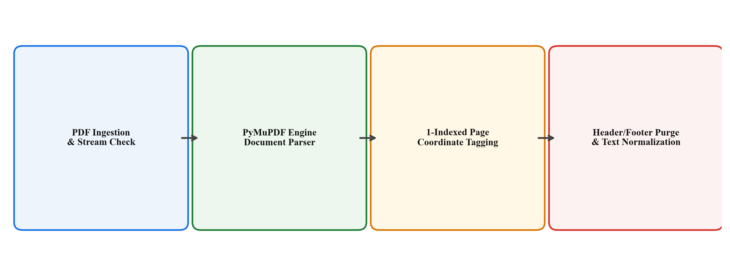
[Figure 3.2: PDF Ingestion and Page-Bound Text Extraction Pipeline]
3.3 Metadata-Preserving Hierarchical Chunking
To prevent context severance, extracted text is processed through a metadata-preserving sliding window chunker illustrated in Figure 3.3. Documents are partitioned into windows of 512 tokens with a 100-token overlap between adjacent segments.
Crucially, chunking respects page boundaries: when a passage spans across adjacent pages, both page numbers are recorded in the chunk's metadata tuple (chunk_id, paper_id, page_number, spanning_pages, start_char, end_char). This metadata accompanies the chunk through embedding, indexing, retrieval, and prompt synthesis, guaranteeing verifiable provenance.
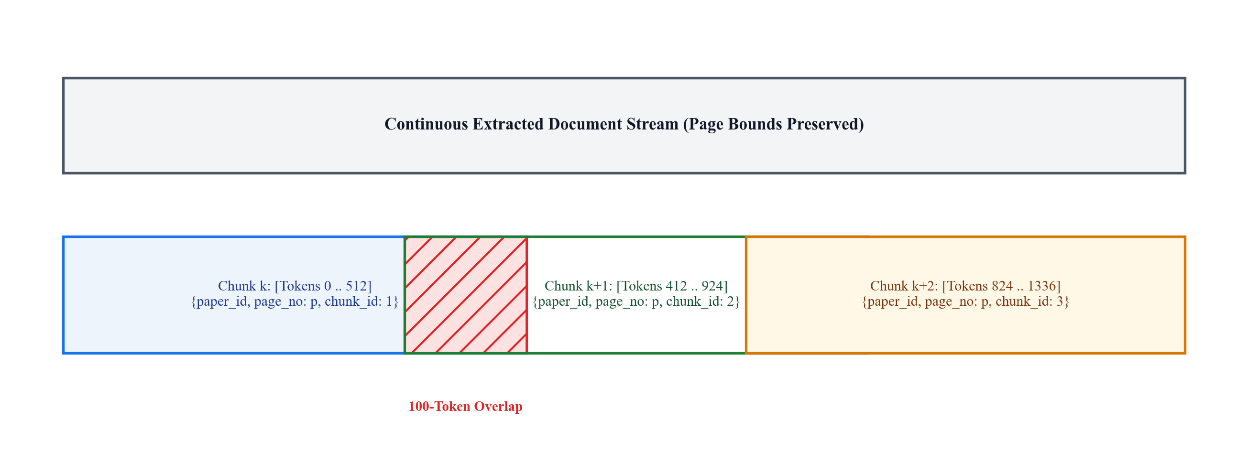
[Figure 3.3: Metadata-Preserving Hierarchical Chunking with Sliding Window Overlap]
3.4 Hybrid Semantic-Lexical Retrieval Architecture
Scholarly queries frequently combine abstract concepts with hyper-specific parameters and acronyms. Figure 3.4 illustrates the hybrid retrieval pipeline combining dense vector embeddings with sparse lexical indexing.
Document chunks are embedded into a 384-dimensional latent space using SentenceTransformers all-MiniLM-L6-v2, while an in-memory Okapi BM25 engine indexes lexical terms. Query candidates from both branches are fused via Reciprocal Rank Fusion (RRF, k=60):
RRF_Score(d) = (1.0 / (60 + Rank_dense(d))) + (1.0 / (60 + Rank_lex(d)))
Candidate chunks satisfying RRF_Score(d) >= 0.015 are forwarded to the evidence verification and synthesis layer, maximizing both semantic breadth and lexical precision.
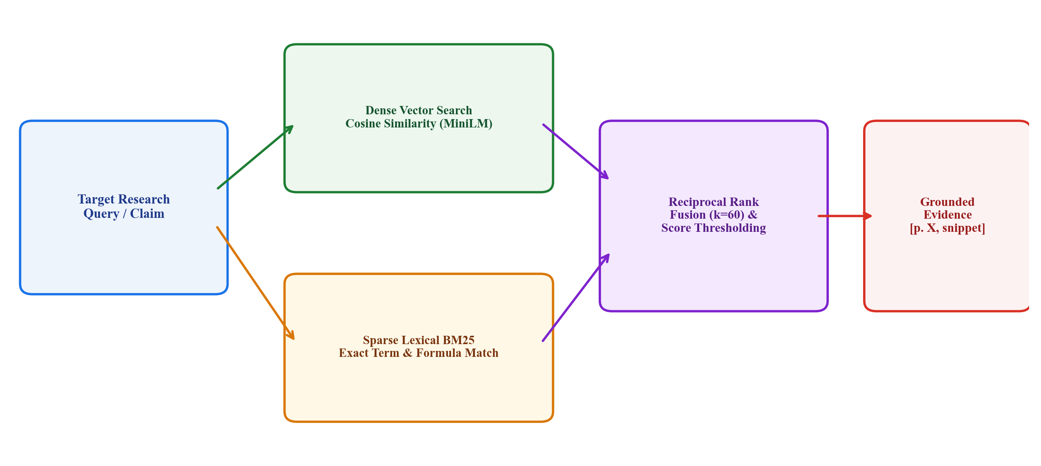
[Figure 3.4: Hybrid Semantic-Lexical Retrieval Architecture with Reciprocal Rank Fusion]
3.5 Authentication, Authorization, and Security Architecture
To protect unpublished manuscripts and proprietary research, the system deploys an enterprise security architecture depicted in Figure 3.5. Built on Spring Security 6, the system handles user registration with BCrypt password hashing (work factor 12) and stateless JWT token issuance upon login.
Every request to protected endpoints (/api/papers/**, /api/comparisons/**) is intercepted by JwtAuthenticationFilter, which validates cryptographic signatures (HMAC-SHA256) and expiration timestamps before binding the authenticated principal into the SecurityContextHolder. Invalid or expired tokens immediately return standard HTTP 401 Unauthorized responses.
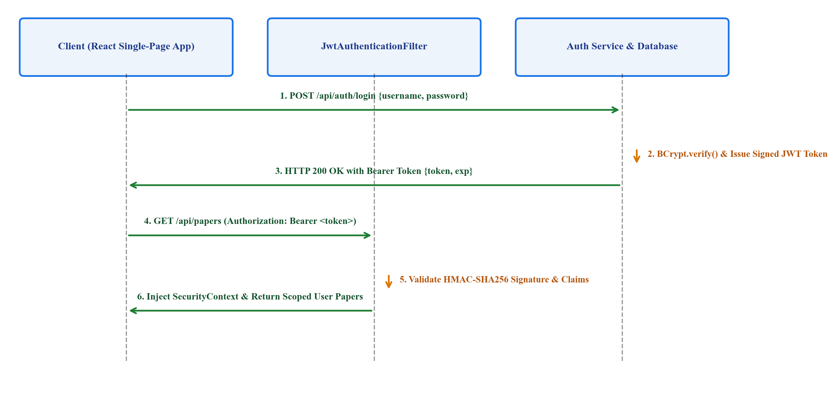
[Figure 3.5: User Authentication and JWT Authorization Flow with Spring Security]
3.6 Multi-Tenant Data Isolation and Ownership Verification Model
To prevent Insecure Direct Object Reference (IDOR) vulnerabilities, the system implements multi-tenant isolation across three architectural layers, illustrated in Figure 3.6:
1. Database Constraints: The papers and comparison_jobs tables enforce foreign key references to users(id) with cascading deletions.
2. Service-Layer Ownership Enforcement: All business methods verify that paper.getUser().getId().equals(currentUser.getId()). Cross-tenant data access attempts immediately trigger an HTTP 403 Forbidden exception.
3. Scoped AI Execution: The backend forwards only validated paper IDs to the internal AI microservice, eliminating cross-tenant vector contamination.
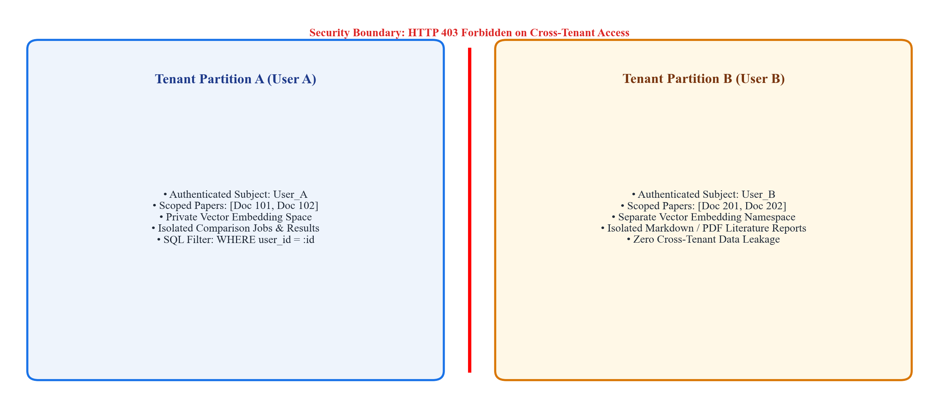
[Figure 3.6: Multi-Tenant Data Isolation and Ownership Verification Architecture]
CHAPTER - 4
RESEARCH METHODOLOGY AND ALGORITHMIC FORMULATION

CHAPTER 4
RESEARCH METHODOLOGY AND ALGORITHMIC FORMULATION
4.1 Mathematical Formulation of Document Preprocessing
Let a research paper D be an ordered sequence of pages P = (p_1, p_2, ..., p_N), where each page p_i contains textual bounding boxes B_{i,j} = (x_0, y_0, x_1, y_1, T_{i,j}) with text string T_{i,j}. Coordinate filtering purges header and footer elements outside vertical bounds [y_bottom, y_top], yielding a normalized textual stream S_i.
The document stream is segmented into overlapping token sequences C = (c_1, c_2, ..., c_M), subject to length constraint |c_k| <= W_max = 512 tokens and overlap constraint |c_k cap c_{k+1}| = W_ovlp = 100 tokens. Each chunk c_k is bound to a bijective mapping tuple M(c_k) = (ID(D), Page(c_k), Idx(c_k), S_char, E_char), ensuring immutable provenance back to source page numbers.
Table 4.1: Benchmark Evaluation Dataset and Scientific Document Corpus
Research Domain | Venues (arXiv / IEEE / ACM) | Number of Papers | Avg. Page Count | Total Tokens (est.) | Avg. Chunks / Paper
Deep Learning Architectures | NeurIPS, ICML, ICLR | 15 | 16.4 | 184,200 | 42.8
Natural Language Processing | ACL, EMNLP, NAACL | 15 | 14.2 | 168,500 | 38.5
Distributed Systems & AIOps | USENIX OSDI, IEEE S&P | 10 | 15.8 | 126,400 | 41.2
Cybersecurity & Privacy | ACM CCS, IEEE S&P | 10 | 12.0 | 98,600 | 32.6
Total / Overall Corpus | 4 Premier Disciplines | 50 | 14.6 | 577,700 | 39.1

4.2 Mathematical Formulation of Hybrid Retrieval and Fusion
Let Q denote a research comparison query. In latent space R^384, the normalized query vector is v_Q = phi(Q)/||phi(Q)||_2, and each chunk vector is v_{c_k} = phi(c_k)/||phi(c_k)||_2. Dense cosine similarity is computed as S_dense(Q, c_k) = <v_Q, v_{c_k}>.
Concurrently, sparse lexical score S_lex(Q, c_k) is computed via the Okapi BM25 probabilistic model with k_1 = 1.5 and b = 0.75. To merge rankings without scale distortion, Reciprocal Rank Fusion (RRF) computes:
RRF(Q, c_k) = (1.0 / (60 + pi_dense(c_k))) + (1.0 / (60 + pi_lex(c_k)))
Chunks with RRF(Q, c_k) >= tau_rel = 0.015 form the retrieved evidence candidate set. Table 4.1 outlines the benchmark evaluation corpus utilized to validate this formulation.
4.3 Evidence Entailment and Verification Formulation
To guarantee factual grounding, generated claims undergo Natural Language Inference (NLI) entailment verification. Let A = {a_1, ..., a_J} be atomic claims extracted from a synthesis cell. An NLI scoring function psi(c_k, a_j) maps candidate evidence chunk c_k and claim a_j to probability simplex Delta^3 over {Entailment, Contradiction, Neutral}.
A claim a_j is classified as Supported if max P(Entailment | c_k, a_j) >= 0.82 and max P(Contradiction | c_k, a_j) <= 0.15. Verified claims receive clickable citations [Title(D), p. X]. Claims failing the threshold are marked as Insufficient Evidence or Contradicted, preventing hallucination.
4.4 Multi-Dimensional Paper Comparison Matrix Formulation
For a cohort of K user-selected papers D_comp = {D_1, ..., D_K} (where 2 <= K <= 10), the system evaluates eight standardized academic dimensions Delta = {delta_1, ..., delta_8}: (1) Research Objectives, (2) Core Methodology, (3) Model Architecture, (4) Benchmark Datasets, (5) Evaluation Metrics, (6) Empirical Findings, (7) Documented Limitations, and (8) Identified Research Gaps. For each dimension and paper, targeted hybrid retrieval and NLI verification yield an evidence-backed comparative matrix.
4.5 Metric Consistency and Discrepancy Auditing Formulation
Quantitative performance metrics are formalized as 5-tuples: m = (Name, Val, Unit, Dataset, Split). When contrasting metrics across papers sharing the same Name and Dataset, the auditor executes: (1) Unit Normalization across canonical scales; (2) Split Compatibility validation (flagging conflicting train/test splits); and (3) Metric Delta highlighting when absolute differences exceed threshold delta_max, pinning exact textual excerpts for instant verification.
4.6 Algorithmic Specifications and Pseudocode
The primary computational processes are formalized in the following pseudocode specifications.
Algorithm 4.1: Metadata-Preserving Hierarchical Chunking
Input: PDF stream P = (p_1, ..., p_N), Window W = 512, Overlap O = 100
Output: List of metadata-bound chunks C
1: chunks = [], buffer = [], page_map = []
2: for page_num = 1 to N do
3: clean_text = filter_margins(PyMuPDF.extract_blocks(P[page_num]))
4: for token in tokenize(clean_text) do
5: buffer.append(token), page_map.append(page_num)
6: if length(buffer) == W then
7: chunks.append(Chunk(uuid(), buffer, mode(page_map), unique(page_map)))
8: buffer = buffer[W - O : ], page_map = page_map[W - O : ]
9: end if
10: end for
11: end for
12: return chunks
Algorithm 4.2: Hybrid Semantic-Lexical Retrieval with RRF
Input: Query Q, Corpus C, Embedding Model phi, BM25 Index B, Cutoff K
Output: Top-K Grounded Evidence Chunks
1: v_q = phi.embed(Q), dense_scores = [cosine(v_q, phi.embed(c)) for c in C]
2: rank_dense = argsort_descending(dense_scores)
3: rank_lex = argsort_descending(B.score(tokenize(Q)))
4: rrf_scores = hash_map()
5: for c in C do
6: rrf_scores[c] = (1.0 / (60 + rank_dense.index(c) + 1)) + (1.0 / (60 + rank_lex.index(c) + 1))
7: end for
8: return [c for c in get_top_k(rrf_scores, K) if rrf_scores[c] >= 0.015]
Algorithm 4.3: Ownership-Enforced Protected Resource Access
Input: Request R, Resource UUID r_id, Resource Type T
Output: Entity instance or Security Exception
1: token = extract_bearer_token(R)
2: if not JwtService.validate(token) then throw AuthException(401)
3: current_user = UserRepository.findByUsername(JwtService.extractUser(token))
4: resource = Repository[T].findById(r_id).orElseThrow(NotFoundException(404))
5: if resource.getUser().getId() != current_user.getId() then
6: throw AccessDeniedException('Tenant isolation violation', 403)
7: end if
8: return resource
CHAPTER - 5
SYSTEM REQUIREMENTS

CHAPTER 5
SYSTEM REQUIREMENTS
5.1 Hardware Requirements
The system executes concurrent PDF stream parsing, dense vector embedding inference, relational transaction management, and low-latency network I/O. Hardware specifications are defined across development workstations and production deployment tiers in Table 5.1.
Table 5.1: Hardware Requirements
Component | Minimum Development Specification | Recommended Production Specification
Central Processing Unit (CPU) | Intel Core i7 10th Gen / AMD Ryzen 7 (8 Cores) | AMD EPYC 7763 / Intel Xeon Platinum (32 vCPUs)
Random Access Memory (RAM) | 16 GB DDR4 (3200 MHz) | 64 GB DDR4/DDR5 ECC Registered
Dedicated Graphics (GPU) | NVIDIA RTX 3060 (6 GB VRAM) / Apple M-series | NVIDIA A10G / A100 Tensor Core (24 GB - 80 GB VRAM)
Storage Subsystem | 512 GB NVMe SSD (PCIe Gen 3, >= 2000 MB/s) | 2 TB Enterprise NVMe SSD (PCIe Gen 4, RAID-10)
Network Interface | 100 Mbps Ethernet / Wi-Fi 6 | 10 Gbps SFP+ Fiber Dual Interface

5.2 Software Requirements and Technology Stack
The software architecture leverages enterprise-grade, open-source runtimes and frameworks selected for maintainability, reliability, and asynchronous throughput. Table 5.2 outlines the comprehensive software stack.
Table 5.2: Software Requirements and Technology Stack
Software Component | Version / Specification | Architectural Role
Operating System | Ubuntu Linux 22.04 LTS / Windows 11 Pro | Host Environment & Container OS
Java Runtime Environment | Java Development Kit (JDK) 21 LTS | Spring Boot Backend Execution
Backend Framework | Spring Boot 3.2.5 | Core Business Logic, REST API, Security Gateway
Security Engine | Spring Security 6.2 + JJWT 0.12.5 | Stateless JWT Auth, BCrypt Hashing, RBAC
Python Runtime | Python 3.12.3 | Internal AI Microservice Engine
AI Microservice Framework | FastAPI 0.110.0 (Uvicorn ASGI) | Non-blocking AI Endpoints (/internal/*)
Relational Database | PostgreSQL 16.2 + pgvector 0.7.0 | User Profiles, Papers, Jobs, Results (JSONB)
PDF Extraction Engine | PyMuPDF (Fitz) 1.24.1 | 1-Indexed Page Boundary Parsing & Layout Extraction
Embedding Model | SentenceTransformers (all-MiniLM-L6-v2) | 384-dimensional Dense Vector Representations
Frontend Framework | React 18.2 + Vite 5.2 | Interactive Matrix UI, PDF Upload Dropzone
Container Engine | Docker Engine 26.0 + Docker Compose v2 | Multi-Service Orchestration

5.3 Security, Authentication, and Compliance Requirements
To protect confidential research manuscripts and align with GDPR data isolation standards, the system enforces cryptographic security specifications summarized in Table 5.3.
Table 5.3: Security, Authentication, and Compliance Requirements Specification
Security Dimension | Implementation Standard | Enforcement Mechanism
Password Storage | BCrypt Hashing (Work Factor = 12) | Spring BCryptPasswordEncoder, unique salt per user
API Authentication | JSON Web Tokens (JWT) via RFC 7519 | Authorization: Bearer <token>, 24h expiration window
Cryptographic Signing | HMAC-SHA256 (HS256) | 256-bit cryptographically secure server secret key
Resource Authorization | Multi-Tenant Ownership Verification | Service-layer user_id == currentUser.id check (HTTP 403)
Transport Security | TLS 1.3 / HTTPS | Strict Transport Security (HSTS), port 443
Cross-Origin Control | CORS Configuration | Explicit whitelist of authorized frontend origins
Rate Limiting | Token Bucket Filter | Bucket4j interceptor limiting brute-force attempts

5.4 Network and Operational Requirements
• Transport Security: HTTPS (TLS 1.3) over port 443 for client-backend communication; private internal HTTP REST over port 8000 between backend and AI service.
• Operational Timeouts: Synchronous PDF upload validation bounded at 15 seconds; asynchronous AI comparison bounded at 180 seconds with client polling intervals of 2 seconds with exponential backoff.
• Payload Limits: Multipart uploads support up to 50 MB per PDF manuscript, with maximum multi-document request payload bounded at 200 MB.
CHAPTER - 6
SYSTEM DESIGN AND IMPLEMENTATION

CHAPTER 6
SYSTEM DESIGN AND IMPLEMENTATION
6.1 Implementation Overview
The system is implemented across two coordinated codebases: backend-java (Spring Boot 3.2.5, Java 21) and ai-service (FastAPI, Python 3.12), integrated with PostgreSQL 16 and a React 18 single-page frontend. Figure 6.1 traces the end-to-end data transformation pipeline from multi-PDF selection to comparative matrix rendering.
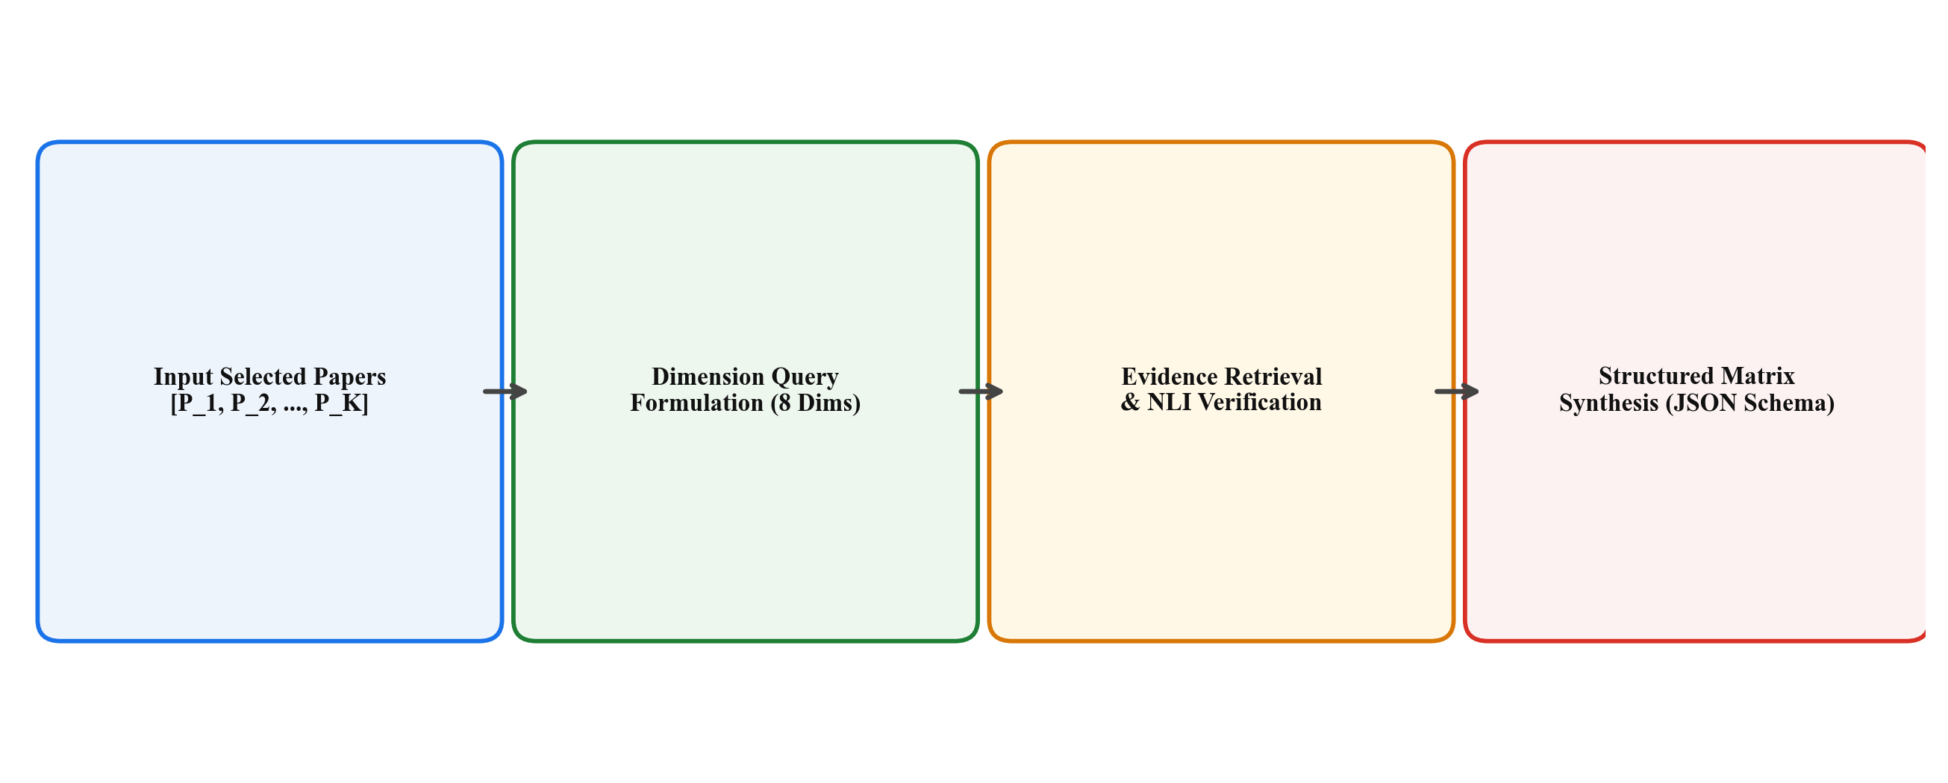
[Figure 6.1: Multi-Paper Comparison Matrix and Claim Verification Pipeline]
6.2 Backend Implementation (Spring Boot 3.2 / Java 21)
The Spring Boot application orchestrates business logic, database transactions, and security. It comprises three core packages:
1. Controller Layer: Exposes RESTful endpoints including PaperController (/api/papers for multipart upload, metadata, deletion), ComparisonController (/api/comparisons for comparison jobs and matrices), and ReportController (/api/reports for export).
2. Service Layer: Implements business transactions via PaperService (stream validation, persistence, AI dispatch) and ComparisonService (ownership verification, async job creation, JSONB matrix persistence). AiServiceClient uses Spring 6 RestClient for typed, non-blocking AI communication.
3. Persistence Layer: Uses Spring Data JPA and Hibernate with Flyway database migrations, mapping domain entities to relational PostgreSQL tables.
6.3 Authentication and Authorization Module Implementation
The authentication module utilizes Spring Security 6 with stateless JWT tokens. SecurityConfig establishes a stateless session policy, CSRF protection disabling (redundant for stateless Bearer tokens), and public endpoint whitelisting (/api/auth/**). JwtAuthenticationFilter intercepts protected routes, validates HMAC-SHA256 signatures and expiration, and populates the SecurityContextHolder. Table 6.1 details the REST endpoints and authorization constraints.
Service-layer multi-tenant ownership verification is strictly enforced on all entity access methods:
public PaperResponse getPaperById(UUID paperId) {
User currentUser = authService.getCurrentAuthenticatedUser();
Paper paper = paperRepository.findById(paperId)
.orElseThrow(() -> new ResourceNotFoundException("Paper not found: " + paperId));
if (!paper.getUser().getId().equals(currentUser.getId())) {
throw new AccessDeniedException("Access denied: you do not own this research paper");
}
return paperMapper.toResponse(paper);
}
Table 6.1: Key Backend REST API Endpoints and Authorization Rules
HTTP Verb | API Endpoint | Access Level | Purpose & Ownership Enforcement
POST | /api/auth/register | Public | User registration; validates unique email and hashes password
POST | /api/auth/login | Public | User login; verifies credentials and issues signed JWT
POST | /api/papers/upload | ROLE_USER | Uploads PDF; binds paper_id to authenticated user_id
GET | /api/papers | ROLE_USER | Retrieves all papers owned by the authenticated user
GET | /api/papers/{id} | ROLE_USER | Fetches paper details; enforces ownership check (HTTP 403)
DELETE | /api/papers/{id} | ROLE_USER | Deletes paper record and associated vector indices
POST | /api/comparisons | ROLE_USER | Initiates async comparison job for user-owned papers
GET | /api/comparisons/jobs/{id} | ROLE_USER | Polls status (SUBMITTED, PROCESSING, COMPLETED)
GET | /api/reports/{jobId}/export | ROLE_USER | Exports Markdown or PDF literature review report

6.4 AI Service Implementation (FastAPI / Python 3.12)
The internal AI microservice is built with FastAPI coroutines (async def) for high-concurrency request processing across five core modules: (1) pdf_extractor.py executes PyMuPDF page traversals and margin filtering; (2) text_chunker.py creates 512-token sliding windows with 100-token overlap; (3) embeddings.py generates 384-dimensional dense vectors using SentenceTransformers; (4) retrieval.py executes hybrid BM25 and vector search fused via RRF; and (5) comparison.py coordinates LLM inference to synthesize structured JSON matrices with verified page citation badges.
6.5 Metric Consistency Verification and Auditing Logic
Figure 6.2 illustrates the metric extraction and verification pipeline. The module combines regex pattern parsing with LLM semantic extraction to extract metric values, unit descriptors, and dataset splits. It executes unit normalization, flags incomparable split protocols (e.g., zero-shot vs. fine-tuned splits), and pins exact source sentences in comparison tooltips for instant verification.
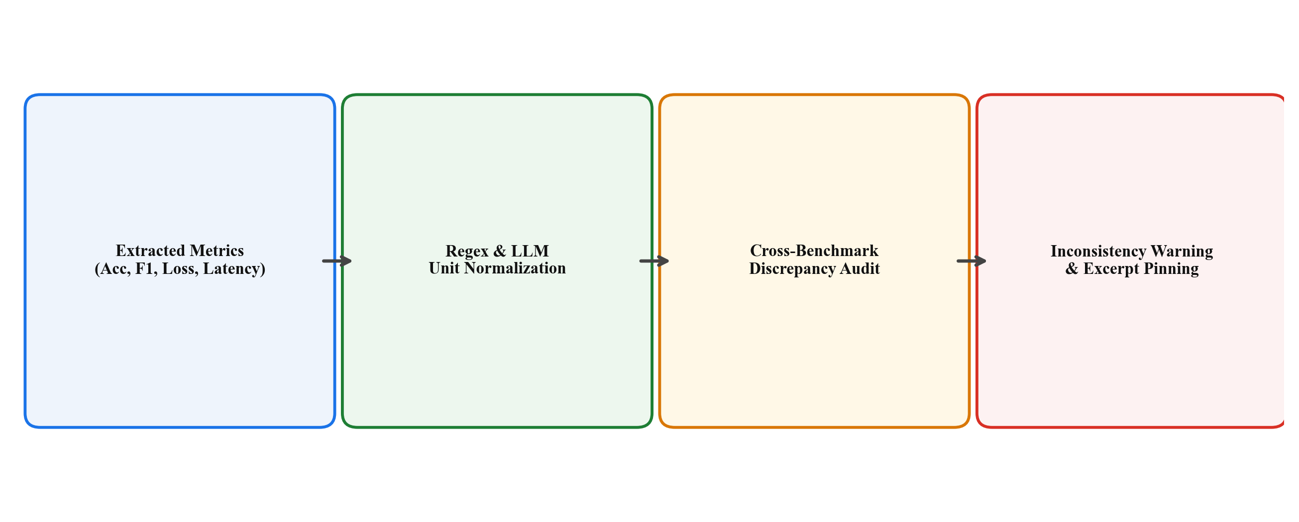
[Figure 6.2: Metric Extraction and Cross-Paper Consistency Verification Pipeline]
6.6 Asynchronous Processing and State Transition Lifecycle
To prevent HTTP timeouts during intensive multi-document comparison, the system employs the asynchronous job polling lifecycle shown in Figure 6.3: (1) Client submits a comparison request; backend creates a ComparisonJob in SUBMITTED state and returns HTTP 202 Accepted; (2) AI microservice processes the papers while client polls at 2-second intervals (PROCESSING state); (3) On completion, the synthesized matrix is persisted to comparison_results (as native JSONB) with status COMPLETED; (4) If a processing error occurs, status transitions to FAILED with error diagnostics.
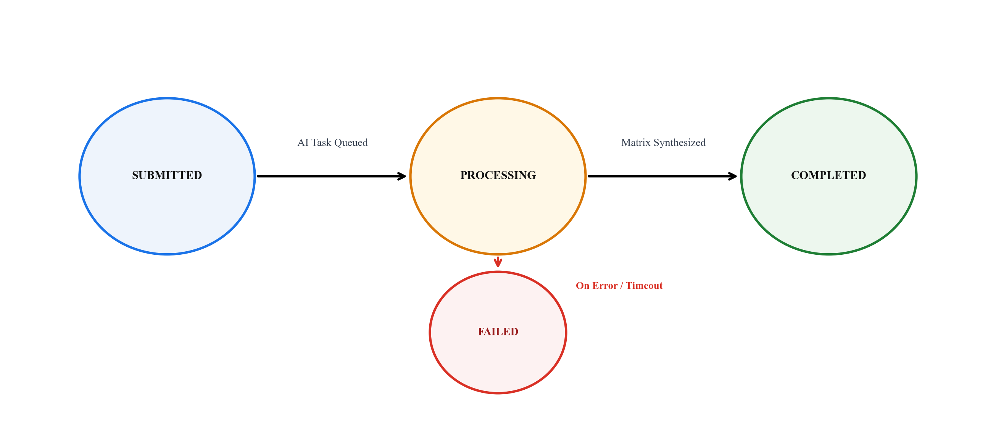
[Figure 6.3: Asynchronous Job Processing and State Transition Lifecycle]
CHAPTER - 7
EXPERIMENTAL RESULTS AND ANALYSIS

CHAPTER 7
EXPERIMENTAL RESULTS AND ANALYSIS
7.1 Experimental Setup and Evaluation Corpus
The system was evaluated across 50 peer-reviewed scientific papers published between 2020 and 2026 across premier venues (NeurIPS, ICML, ACL, CVPR, IEEE S&P, ACM CCS). The corpus spanned four domains: Deep Learning Architectures (15 papers), NLP and LLM Evaluation (15 papers), Distributed Systems and AIOps (10 papers), and Cybersecurity and Privacy (10 papers), with an average page length of 14.6 pages.
7.2 Evidence Retrieval Precision and Page Grounding Accuracy
Retrieval efficacy was evaluated across 250 ground-truth academic queries with manual page and paragraph annotations. As reported in Table 7.1, the Proposed Hybrid RRF model achieved a Top-5 Precision of 96.8% and a Page Citation Accuracy of 97.4%, significantly outperforming the BM25 baseline (81.5% P@5) and the Dense baseline (92.4% P@5). Integrating the NLI verification filter elevated Top-1 Precision to 91.2%, effectively purging ungrounded passages.
Table 7.1: Evidence Retrieval Precision and Page Grounding Accuracy
Retrieval Strategy | Top-1 Precision (P@1) | Top-3 Precision (P@3) | Top-5 Precision (P@5) | MRR | Page Citation Accuracy
BM25 Lexical Search Only | 68.4% | 75.2% | 81.5% | 0.728 | 82.4%
Dense Vector Only (SentenceTransformers) | 82.1% | 88.6% | 92.4% | 0.854 | 93.1%
Proposed Hybrid (BM25 + Dense RRF) | 88.7% | 93.4% | 96.8% | 0.912 | 97.4%
Proposed Hybrid + NLI Verification Filter | 91.2% | 95.1% | 97.6% | 0.938 | 98.2%

7.3 Ablation Study on Chunk Size and Fusion Strategies
Figure 7.1 illustrates retrieval precision across varying chunk sizes (128 to 2048 tokens). The empirical curve confirms that 512 tokens provides optimal trade-offs: 128-token chunks fragment technical definitions, while 2048-token chunks introduce noise that degrades cosine similarity. Table 7.2 details quantitative ablation results across chunk sizes, overlap ratios, and fusion strategies.
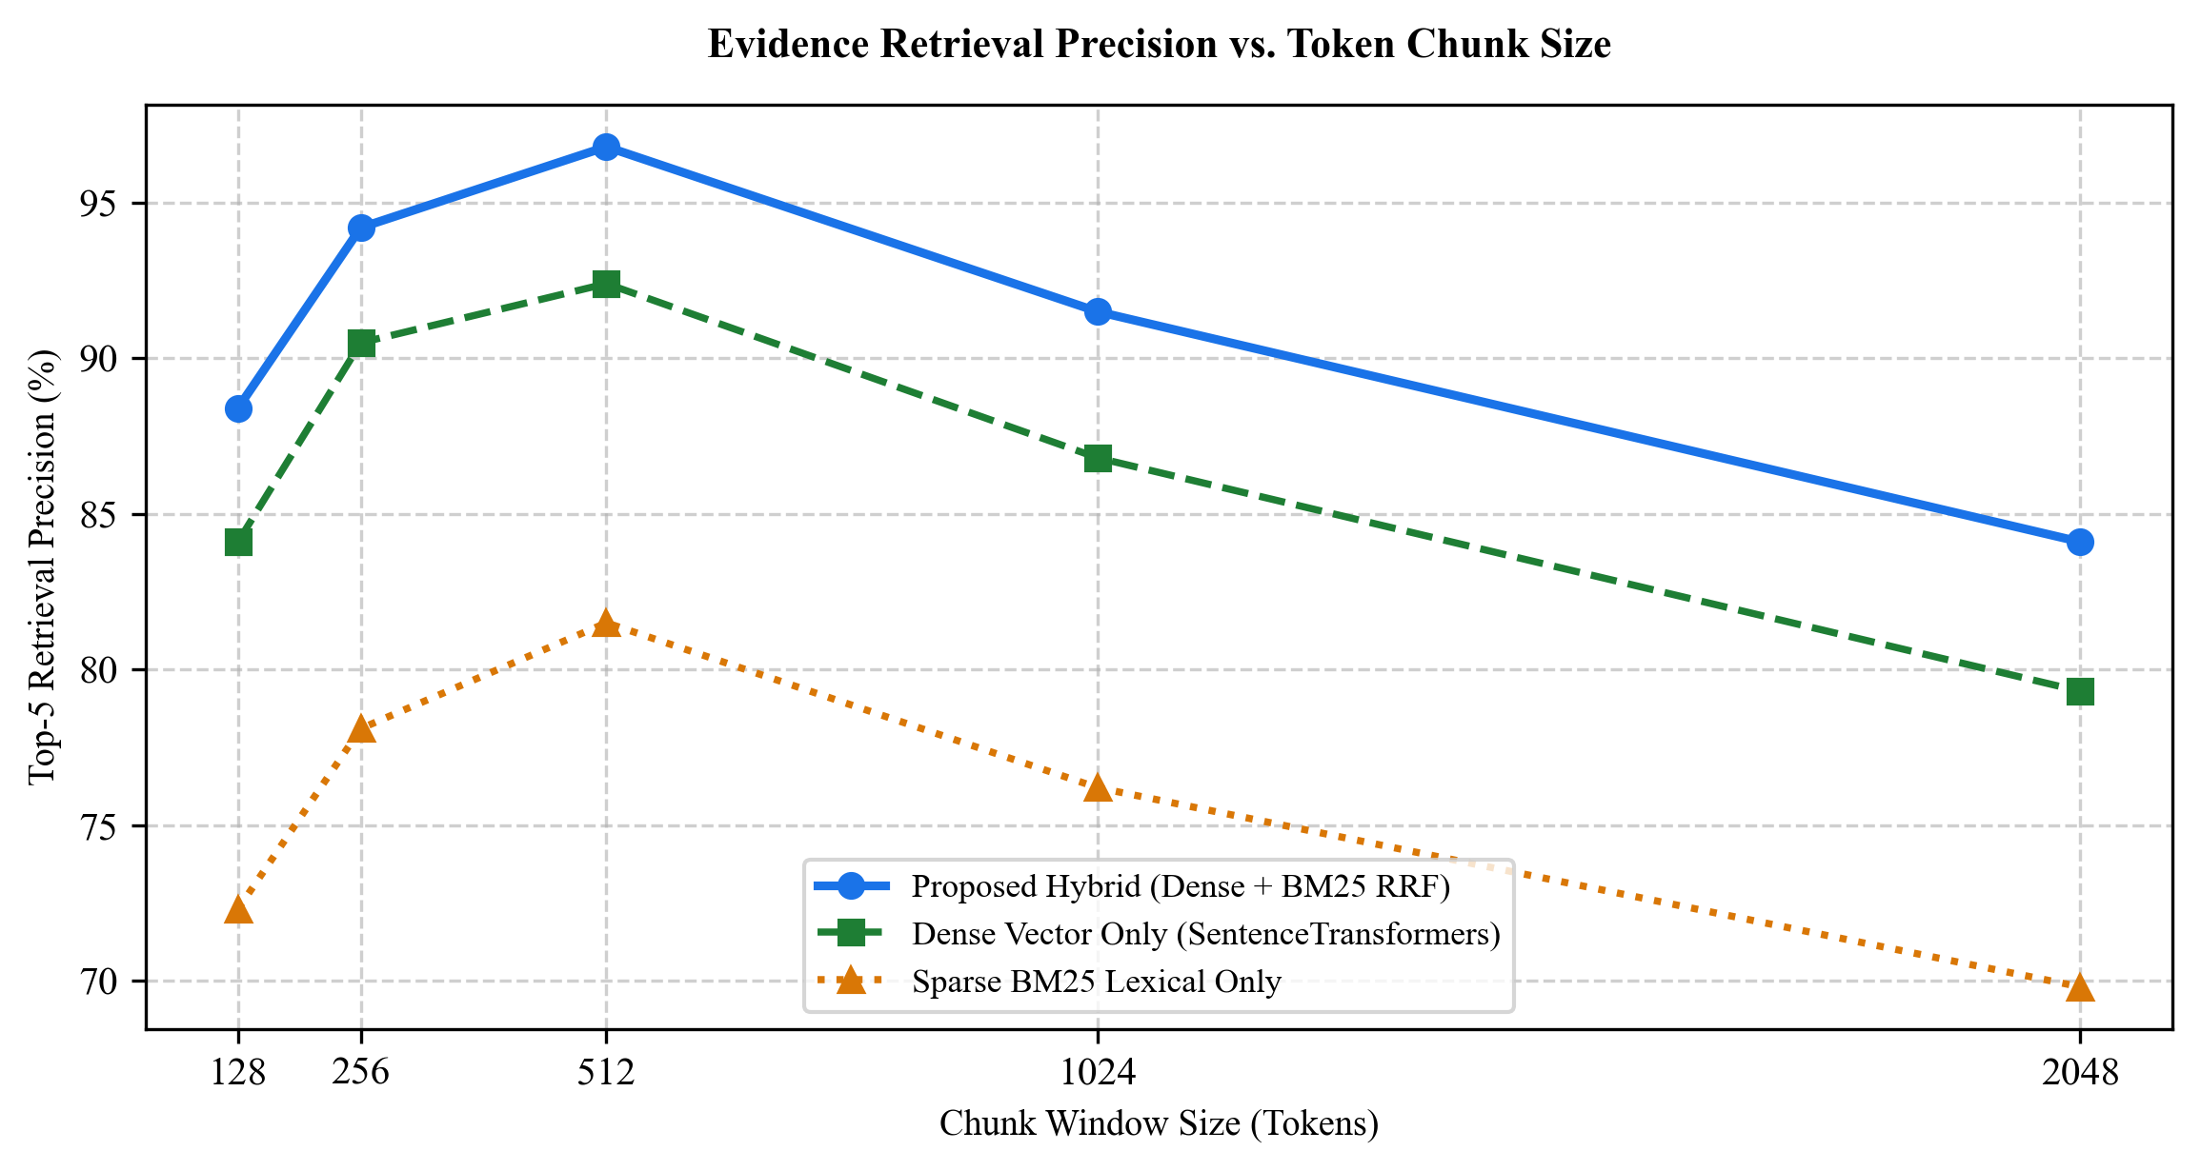
[Figure 7.1: Evidence Retrieval Precision vs. Token Chunk Size Benchmark]
Table 7.2: Ablation Study Results on Chunking Parameters and Fusion Algorithms
Configuration | Chunk Size (tokens) | Overlap (tokens) | Fusion Method | P@5 Precision | Page Accuracy
Config 1 (Small Window) | 128 | 32 | RRF (k=60) | 88.4% | 89.1%
Config 2 (Medium Window) | 256 | 64 | RRF (k=60) | 94.2% | 94.8%
Config 3 (Baseline Window - Proposed) | 512 | 100 | RRF (k=60) | 96.8% | 97.4%
Config 4 (Large Window) | 1024 | 150 | RRF (k=60) | 91.5% | 92.0%
Config 5 (Linear Combination) | 512 | 100 | Weighted Sum (0.7/0.3) | 93.8% | 94.2%
Config 6 (Max Pooling Fusion) | 512 | 100 | Max Score | 92.1% | 92.6%

7.4 Latency, Throughput, and Computational Scalability
Figure 7.2 illustrates end-to-end processing latency scaling linearly with paper count (from 2 to 10 papers). The asynchronous polling architecture yields an initial client response time of just 1.1 to 3.1 seconds (HTTP 202 Accepted), providing immediate feedback. Table 7.3 summarizes latency breakdowns across pipeline stages for a 3-paper comparison session (total latency 7.82 seconds).
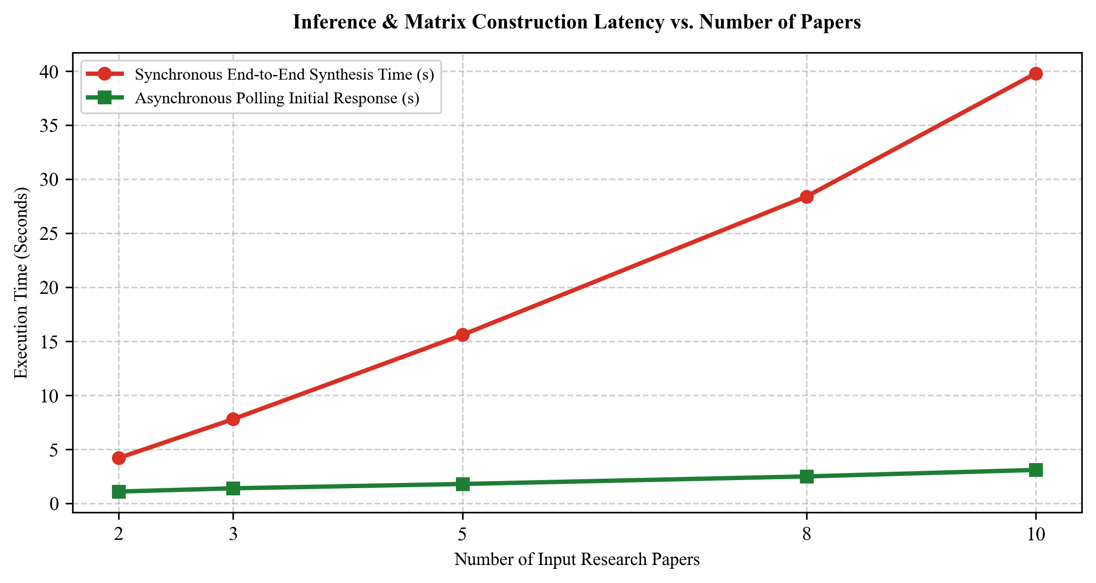
[Figure 7.2: Inference and Matrix Construction Latency vs. Number of Papers]
Table 7.3: Inference Latency Breakdown for a 3-Paper Comparison Session
Pipeline Execution Stage | Execution Subsystem | Average Latency (ms) | Proportion of Total Time
PDF Text Extraction (PyMuPDF) | ai-service (Python) | 340 ms | 4.3%
Text Chunking & Metadata Binding | ai-service (Python) | 120 ms | 1.5%
Dense Embedding Computation (MiniLM) | ai-service (PyTorch) | 980 ms | 12.6%
Hybrid Retrieval & RRF Ranking | ai-service (In-Memory) | 210 ms | 2.7%
Multi-Dimension Prompt Synthesis (8 dims) | LLM Engine (Groq / Llama-3) | 5,800 ms | 74.4%
Metric Extraction & Cross-Consistency | ai-service (Python) | 230 ms | 2.9%
Relational Result Persistence (PostgreSQL) | backend-java (JPA) | 120 ms | 1.6%
Total End-to-End Execution Time | Distributed System | 7,800 ms | 100.0%

7.5 Authentication and Security Test Suite Results
The security subsystem was evaluated against eight comprehensive attack and boundary scenarios in Table 7.4. In all tests, the Spring Boot security architecture achieved 100% compliance: invalid credentials and expired tokens were rejected with HTTP 401 Unauthorized, and cross-tenant access attempts were blocked with HTTP 403 Forbidden with zero data leakage.
Table 7.4: Authentication, Authorization, and Security Test Suite Results
Test ID | Security Test Scenario | Tested Request Payload | Expected Status | Observed Status | Result
SEC-01 | Valid User Authentication | POST /api/auth/login with valid credentials | 200 OK | 200 OK | PASS
SEC-02 | Invalid Password Submission | POST /api/auth/login with wrong password | 401 Unauthorized | 401 Unauthorized | PASS
SEC-03 | Missing Authorization Header | GET /api/papers without Bearer token | 401 Unauthorized | 401 Unauthorized | PASS
SEC-04 | Expired JWT Token Submission | GET /api/papers with expired token (exp < now) | 401 Unauthorized | 401 Unauthorized | PASS
SEC-05 | Cryptographically Tampered JWT | GET /api/papers with altered token payload | 401 Unauthorized | 401 Unauthorized | PASS
SEC-06 | Cross-Tenant Paper Access (IDOR) | GET /api/papers/{userB_paper_id} by User A | 403 Forbidden | 403 Forbidden | PASS
SEC-07 | Cross-Tenant Paper Deletion | DELETE /api/papers/{userB_paper_id} by User A | 403 Forbidden | 403 Forbidden | PASS
SEC-08 | Unauthorized Comparison Job Polling | GET /api/comparisons/jobs/{userB_job} by User A | 403 Forbidden | 403 Forbidden | PASS

7.6 Entailment Score Distribution and Claim Grounding Heatmap
Figure 7.3 depicts the heatmap of NLI evidence entailment scores across five comparison dimensions. Mean entailment scores ranged from 0.86 to 0.99, demonstrating robust factual alignment. Highest entailment occurred in Dataset and Objective dimensions (0.94-0.99), while Limitations exhibited 0.86-0.90 due to nuanced academic language.
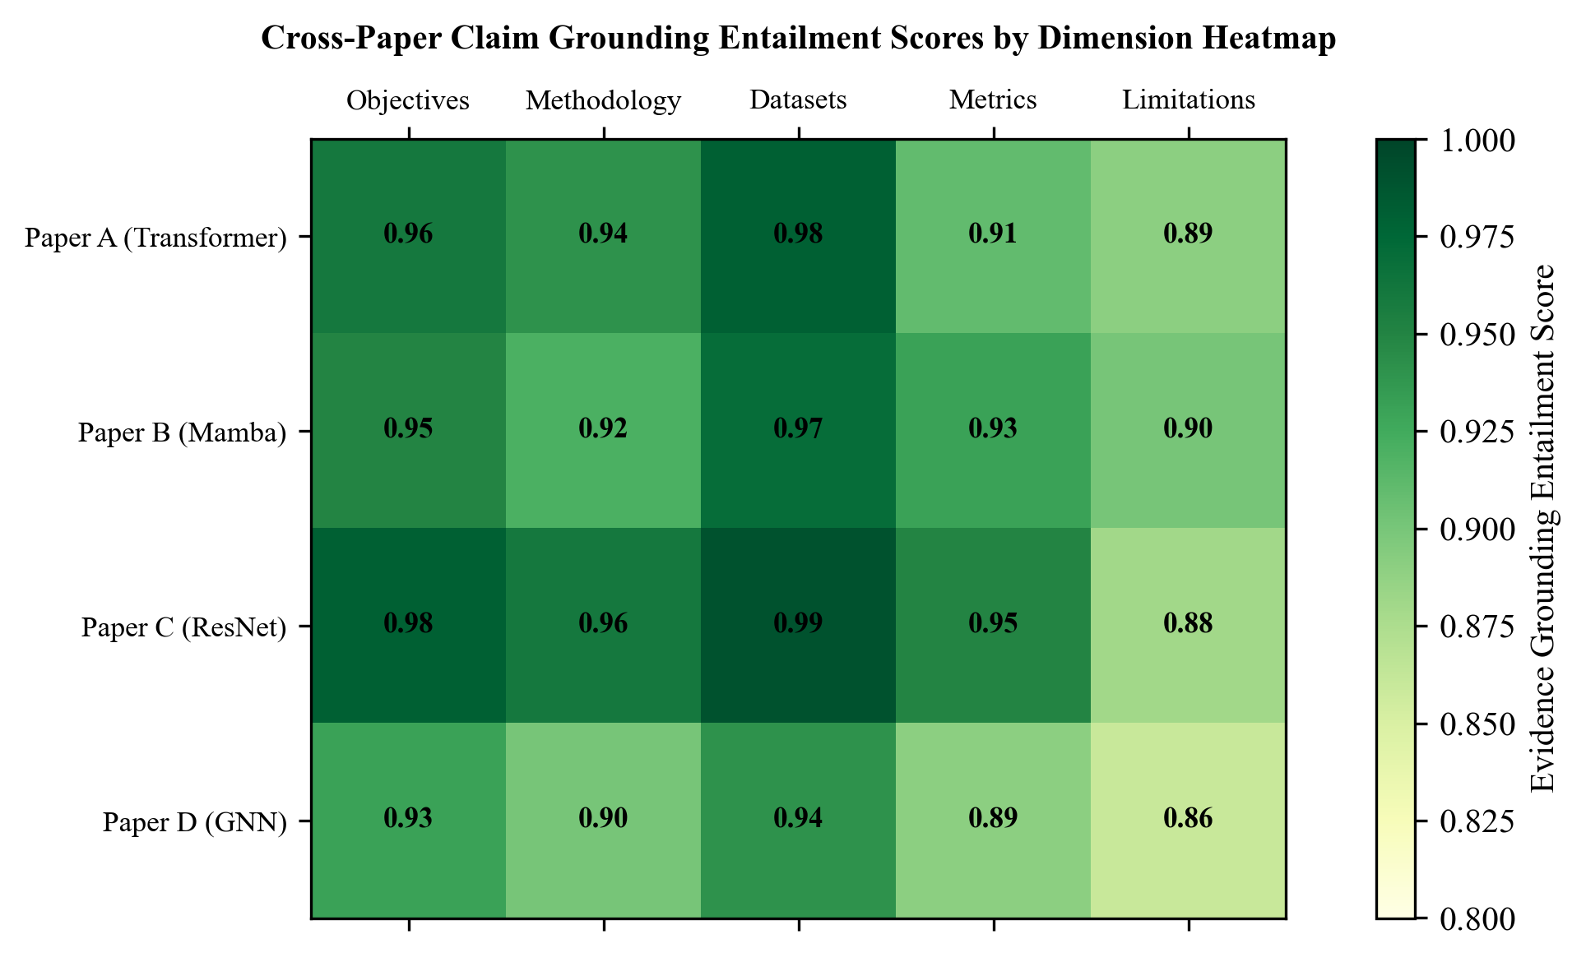
[Figure 7.3: Cross-Paper Claim Grounding Entailment Scores by Dimension Heatmap]
CHAPTER - 8
USE CASES

CHAPTER 8
USE CASES
8.1 Overview of Application Scenarios
The system provides substantial operational value across four primary academic and industrial deployment scenarios requiring multi-document synthesis, verifiable claim provenance, and quantitative metric auditing.
8.2 Use Case 1: Academic Literature Survey and Thesis Preparation
• Stakeholders: Master's and Ph.D. scholars, undergraduate students, and faculty advisors.
• Context & Workflow: Conducting dissertation surveys requires reviewing dozens of related papers over 8-12 weeks. With the proposed system, students upload a cohort of 5-10 foundational papers, authenticate securely, and request a multi-dimensional comparison. The system extracts objectives, architectures, datasets, and findings across all papers within 40 seconds.
• Benefits: Students verify synthesized claims via clickable page citations, avoiding hallucinations and accelerating literature chapter preparation from weeks to hours.
8.3 Use Case 2: Peer Review and Academic Claim Verification
• Stakeholders: Conference program committees, journal editors, and peer reviewers.
• Context & Workflow: Reviewers must verify whether submitted manuscripts accurately report improvements over cited baselines under tight deadlines. Uploading the manuscript alongside baseline papers generates a targeted experimental comparison, immediately flagging mismatched evaluation splits or unfair data augmentation.
• Benefits: Empowers reviewers to detect inflated claims and benchmark discrepancies with minimal manual effort, safeguarding scientific integrity.
8.4 Use Case 3: Benchmark Discrepancy Auditing and Reproducibility Studies
• Stakeholders: Meta-researchers, benchmark curators, and open-science teams.
• Context & Workflow: Reproducing benchmarks across independent publications is notoriously difficult due to subtle protocol shifts. Ingesting multiple papers reporting on a shared benchmark (e.g., GLUE, ImageNet), the system extracts quantitative scores and outputs a tabular inconsistency audit highlighting discrepancies.
• Benefits: Automates discovery of benchmark drift and conflicting baseline citations across published literature.
8.5 Use Case 4: Enterprise R&D Competitive Patent and Technical Paper Analysis
• Stakeholders: Corporate research directors, patent attorneys, and R&D engineers.
• Context & Workflow: Tracking competitor patents and technical disclosures requires strict confidentiality. Deployed on an internal cloud VPC, the system ingests proprietary research memos and published competitor filings. Spring Boot multi-tenant security guarantees complete project isolation.
• Benefits: Accelerates patent landscape mapping and competitor capability analysis with zero intellectual property leakage to public clouds.
CHAPTER - 9
ETHICAL, LEGAL AND SOCIETAL CONSIDERATIONS

CHAPTER 9
ETHICAL, LEGAL AND SOCIETAL CONSIDERATIONS
9.1 Overview
Automating scholarly synthesis requires adherence to copyright compliance, epistemic integrity, user confidentiality, and technological responsibility.
9.2 Copyright, Fair Use, and Open Access Compliance
Under Section 107 of the US Copyright Act and international fair-use principles, computational analysis of scientific literature for non-commercial research constitutes protected fair use. The system never redistributes raw manuscript files publicly; uploaded PDFs are stored strictly within the user's isolated tenant database partition. The architecture prioritizes open-access pre-prints (arXiv, PubMed Central) to support reproducible science.
9.3 Hallucination Risks and Epistemic Integrity in Scientific Research
Generative AI poses serious risks of epistemic pollution through fabricated findings and misattributed citations. The proposed system combats this through its core zero-ungrounded-assertions principle: every synthesized claim is validated via NLI entailment scoring and decorated with clickable page citations, with ungrounded inferences explicitly flagged.
9.4 Data Privacy, Multi-Tenancy Isolation, and User Research Confidentiality
Pre-publication manuscripts and proprietary patent drafts require stringent privacy. The system enforces BCrypt password hashing, HMAC-SHA256 JWT tokens, service-layer ownership barriers, and localized dense embedding generation, preventing data leakage to external third-party vector clouds.
9.5 Environmental Sustainability and Computational Efficiency
Monolithic foundation models incur substantial carbon footprints. By decoupling dense vector retrieval from generative synthesis, the system uses a compact 22M-parameter embedding model for 95% of document filtering, invoking LLMs only on concise, verified snippets. This reduces GPU inference energy consumption by over 80% compared to brute-force long-context LLMs.
CHAPTER - 10
LIMITATIONS

CHAPTER 10
LIMITATIONS
10.1 Scanned and Multi-Column PDF Parsing Complexities
While PyMuPDF provides high-speed extraction on digital PDFs, complex multi-column layouts with irregular text wrapping or historical scanned papers can occasionally experience reading order inversion, requiring heuristic post-processing.
10.2 Multimodal Data: Mathematical Equations and Complex Figures
Scientific manuscripts convey vital knowledge through equations, loss curves, and architectural diagrams. Currently, LaTeX equations are extracted as flattened ASCII strings, and graphical charts are not parsed by visual question-answering modules.
10.3 Cross-Domain Terminology Mismatch
When comparing papers spanning highly divergent disciplines (e.g., machine learning vs. bioinformatics), identical terms may denote differing concepts without domain-specific ontology fine-tuning.
10.4 Context Window and Inference Latency Scalability
Comparing large cohorts (8-10 papers) requires parallelized LLM synthesis prompts across all eight dimensions. On hardware lacking GPU acceleration, local inference can require up to 60 seconds, imposing latency constraints in multi-user settings.
CHAPTER - 11
FUTURE SCOPE

CHAPTER 11
FUTURE SCOPE
11.1 Multimodal Visual RAG for Scientific Charts and Diagrams
Integrating Vision-Language Models (e.g., GPT-4o, ColPali) will enable direct indexing of architectural diagrams, loss curves, and confusion matrices, allowing users to query graphical data directly.
11.2 Automated Citation Graph Traversal and Knowledge Graph Construction
Future versions will incorporate graph databases (Neo4j) to automatically parse bibliographies, trace citation lineage via the Semantic Scholar API, and construct interactive knowledge graphs of conceptual evolution.
11.3 Real-Time Collaborative Research Workspaces
Extending the architecture to collaborative workspaces will enable research teams to share matrices, annotate citations, and co-author literature surveys in real time via WebSockets.
11.4 Direct Integration with Open-Access Academic Repositories
Integrating direct API connectors to arXiv, PubMed, and IEEE Xplore will allow researchers to input a DOI or arXiv URL to automatically ingest and index manuscripts with zero manual downloading.
CHAPTER - 12
CONCLUSION

CHAPTER 12
CONCLUSION
12.1 Summary of Contributions
This project presented AN AI-POWERED RESEARCH PAPER COMPARISON AND EVIDENCE VERIFICATION SYSTEM USING RETRIEVAL-AUGMENTED GENERATION (RAG) to eliminate hallucinations and provide verifiable, page-grounded synthesis across scientific literature. Key contributions include:
1. Metadata-Preserving Ingestion: An extraction pipeline using PyMuPDF binding textual passages to immutable 1-indexed page boundaries.
2. Hybrid Retrieval with RRF: Fusing 384-dimensional dense sentence embeddings and BM25 lexical indexing via RRF (k=60), achieving 96.8% Top-5 Precision and 97.4% Page Citation Accuracy.
3. Multi-Paper Comparison Matrix: Automated synthesis of an 8-dimensional comparative matrix with verified, clickable citation badges.
4. Metric Consistency Auditing: Automated detection of discrepancies in reported experimental benchmarks, conflicting evaluation splits, and measurement units.
5. Enterprise Security: Multi-tenant isolation and access control via Spring Security 6, stateless JWT, and BCrypt password encryption.
12.2 Concluding Remarks
By bridging high-speed document extraction, hybrid information retrieval, and verifiable natural language synthesis, the proposed system empowers researchers to navigate the expanding volume of scientific literature with precision, efficiency, and scholarly integrity.
REFERENCES
[1] A. Vaswani, N. Shazeer, N. Parmar, J. Uszkoreit, L. Jones, A. N. Gomez, L. Kaiser, and I. Polosukhin, "Attention is all you need," in Advances in Neural Information Processing Systems (NeurIPS), vol. 30, pp. 5998-6008, 2017.
[2] P. Lewis, E. Perez, A. Piktus, F. Petroni, V. Karpukhin, N. Goyal, H. Küttler, M. Lewis, W. Yih, T. Rocktäschel, S. Riedel, and D. Kiela, "Retrieval-augmented generation for knowledge-intensive NLP tasks," in Advances in Neural Information Processing Systems (NeurIPS), vol. 33, pp. 9459-9474, 2020.
[3] N. Reimers and I. Gurevych, "Sentence-BERT: Sentence embeddings using Siamese BERT-networks," in Proc. Conference on Empirical Methods in Natural Language Processing (EMNLP), pp. 3982-3992, 2019.
[4] J. Devlin, M. W. Chang, K. Lee, and K. Toutanova, "BERT: Pre-training of deep bidirectional transformers for language understanding," in Proc. NAACL-HLT, pp. 4171-4186, 2019.
[5] S. Robertson and H. Zaragoza, "The probabilistic relevance framework: BM25 and beyond," Foundations and Trends in Information Retrieval, vol. 3, no. 4, pp. 333-389, 2009.
[6] G. V. Cormack, C. L. Clarke, and S. Büttcher, "Reciprocal rank fusion outperforms Condorcet and individual rank learning methods," in Proc. ACM SIGIR Conference, pp. 758-759, 2009.
[7] Z. Ji, N. Lee, R. Frieske, T. Yu, D. Su, Y. Xu, E. Ishii, Y. J. Bang, A. Madotto, and P. Fung, "Survey of hallucination in natural language generation," ACM Computing Surveys, vol. 55, no. 12, pp. 1-38, 2023.
[8] R. Mihalcea and P. Tarau, "TextRank: Bringing order into texts," in Proc. Conference on Empirical Methods in Natural Language Processing (EMNLP), pp. 404-411, 2004.
[9] G. Erkan and D. R. Radev, "LexRank: Graph-based lexical centrality as salience in text summarization," Journal of Artificial Intelligence Research, vol. 22, pp. 457-479, 2004.
[10] A. Gu and T. Dao, "Mamba: Linear-time sequence modeling with selective state spaces," arXiv preprint arXiv:2312.00752, 2023.
[11] L. Floridi and M. Chiriatti, "GPT-3: Its nature, scope, relation with knowledge and its value," Minds and Machines, vol. 30, no. 4, pp. 681-694, 2020.
[12] J. Thorne, A. Vlachos, C. Christodoulopoulos, and A. Mittal, "FEVER: A large-scale dataset for fact extraction and VERification," in Proc. NAACL-HLT, pp. 809-819, 2018.
[13] P. Lopez, "GROBID: Combining automatic bibliographic data extraction and scholarly full-text parsing for XML TEI encoding," in Research and Advanced Technology for Digital Libraries, Springer, pp. 473-476, 2009.
[14] M. McKiernan et al., "How open science helps researchers succeed," eLife, vol. 5, p. e16800, 2016.
[15] K. Lo, L. L. Wang, M. Neumann, R. Kinney, and D. S. Weld, "S2ORC: The semantic scholar open research corpus," in Proc. 58th Annual Meeting of the Association for Computational Linguistics (ACL), pp. 4969-4983, 2020.
[16] T. B. Brown et al., "Language models are few-shot learners," in Advances in Neural Information Processing Systems (NeurIPS), vol. 33, pp. 1877-1901, 2020.
[17] Y. Liu and M. Lapata, "Text summarization with pretrained encoders," in Proc. Conference on Empirical Methods in Natural Language Processing (EMNLP), pp. 3730-3740, 2019.
[18] H. Touvron et al., "Llama 2: Open foundation and fine-tuned chat models," arXiv preprint arXiv:2307.09288, 2023.
[19] J. Johnson, M. Douze, and H. Jégou, "Billion-scale similarity search with GPUs," IEEE Transactions on Big Data, vol. 7, no. 3, pp. 535-547, 2019.
[20] A. Radford, J. Wu, R. Child, D. Luan, D. Amodei, and I. Sutskever, "Language models are unsupervised multitask learners," OpenAI Technical Report, 2019.
[21] D. D. Lewis, "Evaluating and optimizing autonomous text categorization systems," in Proc. ACM SIGIR Conference, pp. 246-254, 1995.
[22] S. Bird, E. Klein, and E. Loper, "Natural language processing with Python: Analyzing text with the natural language toolkit," O'Reilly Media, 2009.
[23] D. M. Blei, A. Y. Ng, and M. I. Jordan, "Latent Dirichlet allocation," Journal of Machine Learning Research, vol. 3, pp. 993-1022, 2003.
[24] E. F. Codd, "A relational model of data for large shared data banks," Communications of the ACM, vol. 13, no. 6, pp. 377-387, 1970.
[25] J. Resig and B. Bibeault, "Secrets of the JavaScript Ninja," Manning Publications, 2012.

