
AN AI-POWERED RESEARCH PAPER COMPARISON AND
EVIDENCE VERIFICATION SYSTEM USING
RETRIEVAL-AUGMENTED GENERATION (RAG)

A PROJECT REPORT

Submitted by

SUBASH KUMAR K | [723722243087]
SIVAPRATHEESH S | [723722243081]
MOHAN KUMAR S | [723722243302]
SURESH | [723722243088]

In partial fulfilment for the award of the degree
Of

BACHELOR OF TECHNOLOGY

IN

ARTIFICIAL INTELLIGENCE AND DATA SCIENCE

V.S.B. COLLEGE OF ENGINEERING TECHNICAL CAMPUS
(An Autonomous Institution) COIMBATORE-642109, TAMIL NADU.
ANNA UNIVERSITY: CHENNAI 600 025
NOVEMBER 2026

ANNA UNIVERSITY: CHENNAI 600 025

BONAFIDE CERTIFICATE

Certified that this project report “SELECTIVE STATE SPACE MODELS FOR REAL-TIME LOG INTELLIGENCE: OPTIMIZING ANOMALY DETECTION AND EXPLAINABLE ROOT CAUSE ANALYSIS IN DISTRIBUTED ARCHITECTURES” is the bonafide work of SUBASH KUMAR K [723722243087], SIVAPRATHEESH S [723722243081], MOHAN KUMAR S [723722243302], who carried out the project work under my supervision.

SIGNATURE | SIGNATURE
Dr. R. MURUGADOSS, M.E., Ph.D. | Mr. S. SOUNDHAR, M.E.
HEAD OF THE DEPARTMENT, | SUPERVISOR,  ASSISTANT PROFESSOR,
DEPARTMENT OF ARTIFICIAL INTELLIGENCE AND DATA SCIENCE, | DEPARTMENT OF ARTIFICIAL INTELLIGENCE AND DATA SCIENCE,
V.S.B. COLLEGE OF ENGINEERING TECHNICAL CAMPUS, | V.S.B. COLLEGE OF ENGINEERING TECHNICAL CAMPUS,
COIMBATORE-642109 | COIMBATORE-642109

Submitted for the university examination held on

at

V.S.B. College of Engineering Technical Campus, Coimbatore.

INTERNAL EXAMINER EXTERNAL EXAMINER

ACKNOWLEDGEMENT

First, we extend our heartfelt gratitude to the management of V.S.B College of Engineering Technical Campus, and to the Chairman, Mr. V. S. Balsamy, B.Sc., LL.B., for providing us with all kinds of support in the successful completion of this project.

We express our sincere thanks to our beloved Principal, Dr. V. Velmurugan, M.E., Ph.D., for his valuable guidance and continuous encouragement throughout the course of this project.

We also express our gratitude to the Vice Principal, Dr. R. Poornachandran, M.E., Ph.D., for his guidance and sustained support during the successful completion of this work.

We are highly grateful to Dr. R. Murugadoss, M.E., Ph.D., Head of the Department, Department of Artificial Intelligence and Data Science Engineering, for his valuable suggestions and encouragement throughout the project.

We are highly grateful to Mrs. G. Nithya M.E., (Ph.D), Head of the Department, Department of Artificial Intelligence and Data Science Engineering, for his valuable suggestions and encouragement throughout the project

We would like to express our heartfelt thanks to our project guide, Mr. S. Soundhar, M.E., for his constant support, valuable guidance, and timely assistance, which led to the successful completion of this project.

Finally, we extend our sincere gratitude to our parents, friends, faculty members, and non-teaching staff for their continuous support, encouragement, and motivation, which contributed to the successful completion of this project.



VISION AND MISSION STATEMENTS OF THE INSTITUTE

Vision:
We endeavour to impart futuristic technical education of the highest quality in the student community to inculcate discipline in them to face the world with self- confidence and thus we prepare them for life responsible citizens to uphold human values and to be of services at large. We strive to bring up the Institution as an Institution of Academic excellence of international standard.

Mission:
We transform persons into personalities by the state-of-the-art infrastructure, time consciousness, quick response and the best academic practices through assessment and advice.

VISION AND MISSION STATEMENTS OF THE DEPARTMENT
Name of the Department: Department of Artificial Intelligence and Data Science

Vision:
To emerge with technological excellence to nurture talents and instigate research skills with social responsibilities in the domain of Data Science.

Mission:
Empower students with knowledge through experiential learning. To create a conducive ambience for learning through exposures in latest cutting-edge technology in collaboration with industries. To provide individual attention and enable character building. Instill lifelong learning and encourage entrepreneurial skills among students.
Program Outcomes (POs)

PO1: Engineering Knowledge:
Apply knowledge of mathematics, natural science, computing, engineering fundamentals and an engineering specialization as specified in WK1 to WK4 respectively to develop to the solution of complex engineering problems.
PO2: Problem Analysis:
Identify, formulate, review research literature and analyze complex engineering problems reaching substantiated conclusions with consideration for sustainable development. (WK1 to WK4)
PO3: Design/Development of Solutions:
Design creative solutions for complex engineering problems and design/develop systems/components/processes to meet identified needs with consideration for the public health and safety, whole-life cost, net zero carbon, culture, society and environment as required. (WK5)
PO4: Conduct Investigations of Complex Problems:
Conduct investigations of complex engineering problems using research-based knowledge including design of experiments, modelling, analysis & interpretation of data to provide valid conclusions. (WK8).
PO5: Engineering Tool Usage:
Create, select and apply appropriate techniques, resources and modern engineering & IT tools, including prediction and modelling recognizing their limitations to solve complex engineering problems. (WK2 and WK6)
PO6: The Engineer and The World:
Analyze and evaluate societal and environmental aspects while solving complex engineering problems for its impact on sustainability with reference to economy, health, safety, legal framework, culture and environment. (WK1, WK5, and WK7).
PO7: Ethics:
Apply ethical principles and commit to professional ethics, human values, diversity and Inclusion; adhere to national & international laws. (WK9)
PO8: Individual and Collaborative Team work:
Function effectively as an individual, and as a member or leader in diverse/multi-disciplinary teams.

PO9: Communication:
Communicate effectively and inclusively within the engineering community and society at large, such as being able to comprehend and write effective reports and design documentation, make effective presentations considering cultural, language, and learning differences
PO10:Project Management and Finance:
Apply knowledge and understanding of engineering management principles and economic decision-making and apply these to one’s own work, as a member and leader in a team, and to manage projects and in multidisciplinary environments.
PO11: Life-Long Learning:
Recognize the need for, and have the preparation and ability for i) independent and lifelong learning ii) adaptability to new and emerging technologies and iii) critical thinking in the broadest context of technological change. (WK8)

Knowledge and Attitude Profile (WK)

WK1: A systematic, theory-based understanding of the natural sciences applicable to the discipline and awareness of relevant social sciences.
WK2: Conceptually-based mathematics, numerical analysis, data analysis, statistics and formal aspects of computer and information science to support detailed analysis and modelling applicable to the discipline.
WK3: A systematic, theory-based formulation of engineering fundamentals required in the engineering discipline.
WK4: Engineering specialist knowledge that provides theoretical frameworks and bodies of knowledge for the accepted practice areas in the engineering discipline; much is at the forefront of the discipline.
WK5: Knowledge, including efficient resource use, environmental impacts, whole-life cost, reuse of resources, net zero carbon, and similar concepts, that supports engineering design and operations in a practice area.
WK6: Knowledge of engineering practice (technology) in the practice areas in the engineering discipline.
WK7: Knowledge of the role of engineering in society and identified issues in engineering practice in the discipline, such as the professional responsibility of an engineer to public safety and sustainable development.
WK8: Engagement with selected knowledge in the current research literature of the discipline, awareness of the power of critical thinking and creative approaches to evaluate emerging issues.
WK9: Ethics, inclusive behaviour and conduct. Knowledge of professional ethics, responsibilities, and norms of engineering practice. Awareness of the need for diversity by reason of ethnicity, gender, age, physical ability with mutual understanding and respect, and of inclusive attitudes.

SELECTIVE STATE SPACE MODELS FOR REAL - TIME LOG INTELLIGENCE: OPTIMIZING ANOMALY DETECTION AND EXPLAINABLE ROOT CAUSE ANALYSIS IN DISTRIBUTED ARCHITECTURES

ABSTRACT

Distributed computing systems and cloud-native architectures have become the backbone of modern digital infrastructure, powering applications ranging from financial transaction systems and healthcare platforms to large-scale scientific computations. These systems continuously generate colossal volumes of operational log data — often exceeding tens of millions of entries per minute — that document every state transition, error event, and service interaction occurring within the system. Effective analysis of these logs is essential for maintaining system reliability, diagnosing failures, and reducing service downtime. However, the sheer volume and velocity of log generation render manual inspection completely infeasible. This project presents LogMamba, an optimized Real-Time Log Intelligence Framework designed to perform automated high-precision anomaly detection and explainable root cause analysis at scale. Unlike legacy Bidirectional Long Short-Term Memory (BiLSTM) networks that suffer from poor scalability due to sequential recurrent state updates, and unlike Transformer-based models that are constrained by quadratic-time O(L²) attention complexity, the LogMamba framework processes complete session sequences efficiently without truncation. A key innovation of the framework is its content-aware state update mechanism: common, repetitive operational log events induce minimal state updates, while rare and critical fault-indicating events strongly influence the latent state — enabling the model to distinguish meaningful anomalies from routine background noise. Experimental evaluation was conducted on the HDFS Benchmark Dataset comprising 11,175,629 raw log entries across 575,062 block-level execution sessions. The LogMamba framework achieved an accuracy of 99.3%, precision of 98.5%, recall of 97.8%, and an F1-score of 98.1%, outperforming all baselines including TF-IDF+SVM (82.4%), standard LSTM (93.1%), and BiLSTM+Attention (96.1%). Inference latency was measured at approximately 15.8 ms per batch, representing approximately a 7× speedup over recurrent model baselines, enabling deployment in high-throughput, mission-critical real-time environments.
Keywords:
Log anomaly detection, distributed systems, explainable AI, Selective State Space Models, Mamba architecture, root cause analysis, real-time log intelligence, HDFS, sequence modeling, gated attention.

TABLE OF CONTENTS

LIST OF TABLES | i
LIST OF FIGURES | ii
CHAPTER 1 – INTRODUCTION | 1
1.1 Background | 1
1.2 Problem Statement | 3
1.3 Objectives | 4
1.4 Scope of the Project | 5
CHAPTER 2 – LITERATURE REVIEW | 7
CHAPTER 3 – SYSTEM DESIGN AND ARCHITECTURE | 13
3.1 Overall Architecture | 13
3.2 Adaptive Log Parsing and Vectorization | 14
3.3 Spatiotemporal Sequence Construction | 15
3.4 LogMamba Core | 16
3.5 Gated Attention and Explainability Layer | 17
3.6 Root Cause Visualization | 18
CHAPTER 4 – RESEARCH METHODOLOGY | 19
CHAPTER 5 – SYSTEM REQUIREMENTS | 22
CHAPTER 6 – SYSTEM DESIGN AND IMPLEMENTATION | 25
CHAPTER 7 – EXPERIMENTAL RESULTS AND ANALYSIS | 31
CHAPTER 8 – USE CASES | 38
CHAPTER 9 – ETHICAL, LEGAL AND SOCIETAL CONSIDERATIONS | 41
CHAPTER 10 – LIMITATIONS | 44
CHAPTER 11 – FUTURE SCOPE | 47
CHAPTER 12 – CONCLUSION | 50
REFERENCES | 52

LIST OF TABLES

Table No. | Title | Page No.
Table 4.1 | Statistical Summary of the HDFS Log Dataset | 20
Table 5.1 | Hardware Requirements | 22
Table 5.2 | Software Requirements | 23
Table 7.1 | Performance Comparison of Baseline and Proposed Models | 32
Table 7.2 | Ablation Study Results | 34
Table 7.3 | Inference Latency Comparison | 35
Table 7.4 | Confusion Matrix – LogMamba on HDFS Test Set | 36

LIST OF FIGURES

Figure No. | Title | Page No.
Fig 3.1 | End-to-End Architecture of the LogMamba Framework | 13
Fig 3.2 | Adaptive Log Parsing Pipeline using Enhanced Drain Parser | 14
Fig 3.3 | Spatiotemporal Sequence Construction using Block IDs | 15
Fig 3.4 | Selective State Space Model (Mamba Core) Architecture | 16
Fig 3.5 | Gated Attention Mechanism and Explainability Layer | 17
Fig 6.1 | LogMamba Model Training and Inference Pipeline | 26
Fig 6.2 | Log Embedding Space Visualization | 28
Fig 6.3 | Session Classification Workflow | 30
Fig 7.1 | ROC Curves for All Models on HDFS Test Set | 33
Fig 7.2 | Inference Latency vs. Sequence Length (Computational Scalability) | 35
Fig 7.3 | Attention-Based Root Cause Heatmap for Anomalous Session | 37

CHAPTER - 1
INTRODUCTION
CHAPTER 1
INTRODUCTION
1.1 Background
The exponential growth of distributed computing has transformed the way modern organizations deliver digital services. Platforms such as Hadoop Distributed File System (HDFS), Apache Kafka, Kubernetes, and cloud-native microservice architectures now underpin mission-critical operations across virtually every industry sector — from e-commerce and banking to healthcare, telecommunications, and scientific research. These systems are inherently complex, composed of numerous interdependent components, containerized workloads, and services that interact continuously in dynamic and sometimes unpredictable ways.
This creates a critical operational problem: system failures, service degradations, and security breaches that are clearly documented within the log data often go undetected or are detected only after substantial damage has been done, because there is simply too much log data for engineers to review in real time. The Mean Time to Resolution (MTTR) — a key operational metric measuring the time elapsed between the onset of a failure and its complete resolution — is directly impacted by how quickly engineers can identify the root cause of an anomaly. Prolonged MTTR translates directly into extended service downtime, lost revenue, customer dissatisfaction, and in some domains such as healthcare and critical infrastructure, potentially dangerous situations.
The field of log-based anomaly detection has undergone a significant evolution over the past decade. Early approaches relied on static rule-based systems such as Splunk and the ELK Stack (Elasticsearch, Logstash, Kibana), which required domain experts to manually craft detection rules for known failure patterns. While these systems remain widely deployed, they suffer from fundamental limitations: they cannot detect previously unseen failure modes, they generate high rates of false-positive alerts when system behavior evolves, and they require constant manual maintenance of rule sets as system configurations change.
Transformer-based architectures introduced the attention mechanism and achieved state-of-the-art results in natural language processing tasks, with several subsequent works applying them to log analysis.
1.2 Problem Statement
Modern distributed computing systems generate log data at a volume and velocity that far exceeds the capacity of human operators to analyze manually. Existing automated approaches to log anomaly detection are characterized by one or more of the following critical deficiencies that limit their real-world effectiveness:
- Rule-based monitoring systems are brittle and cannot detect novel, previously unseen failure patterns that fall outside predefined rule sets.
- Statistical machine learning approaches ignore the temporal ordering and causal structure of log sequences, reducing detection recall for failures caused by rare sequences of individually common events.
- Recurrent neural network models scale poorly with increasing log sequence length and provide anomaly scores without any actionable explanation of which specific events caused the anomaly.
1.3 Objectives
The primary objectives of this project are:
- To design and implement an end-to-end Real-Time Log Intelligence Framework capable of processing high-volume distributed system log streams and identifying anomalous execution sessions with high precision and recall.
- To develop a Selective State Space Model (SSM) based sequence encoder — the LogMamba Core — that achieves linear-time O(L) complexity while capturing long-range temporal dependencies across complete log execution traces.
- To integrate a Gated Attention mechanism that produces interpretable, event-level importance weights, enabling engineers to directly identify the specific log events responsible for triggering anomaly classifications.
1.4 Scope of the Project
The project does not address streaming infrastructure integration, distributed deployment frameworks, or online incremental learning — these are identified as important directions for future work. The primary focus is on demonstrating the superiority of the Selective State Space Model architecture over existing approaches in terms of detection accuracy, computational efficiency, and interpretabilit

CHAPTER 2
LITERATURE REVIEW

CHAPTER 2
LITERATURE REVIEW
2.1 Introduction to Log Anomaly Detection Research
Log-based anomaly detection has been an active research area for over two decades, evolving in parallel with the growing complexity and scale of distributed computing systems. The literature spans a broad range of approaches including rule-based systems, statistical learning methods, deep sequence models, and more recently, large-scale foundation models. This chapter provides a systematic review of the most relevant prior work, organized by methodological category, with particular attention to limitations that motivated the development of the LogMamba framework.
2.2 Rule-Based and Pattern Matching Approaches
The earliest approaches to automated log analysis relied on manually defined rules and regular expression patterns to detect known failure conditions. Commercial tools such as Splunk and the ELK Stack (Elasticsearch, Logstash, Kibana) enabled operators to define alert conditions based on the occurrence of specific log keywords, message templates, or threshold conditions on log event counts within sliding time windows. While these tools remain widely deployed in production environments due to their simplicity and auditability, they suffer from fundamental limitations that have driven the search for more sophisticated alternatives.
Rule-based systems require substantial manual effort to define and maintain detection rules, and they fail completely when encountering failure patterns that were not anticipated during rule authorship.
2.3 Statistical Learning Approaches
To address the brittleness of rule-based systems, researchers explored statistical machine learning approaches that could automatically identify anomalous patterns from historical log data without requiring explicit rule authorship. Principal Component Analysis (PCA) applied to log event count vectors was among the first widely adopted approaches. By learning the principal components of normal log behavior, PCA-based systems could identify sessions whose event count distributions deviated significantly from the learned normal subspace.
Support Vector Machines (SVMs) with TF-IDF (Term Frequency-Inverse Document Frequency) representations of log sessions offered an improvement by leveraging discriminative learning to distinguish normal from anomalous sessions based on labeled training data. Clustering approaches such as k-means and DBSCAN were also explored as unsupervised alternatives. While these statistical approaches outperformed rule-based systems in their ability to detect novel failure patterns without explicit programming, they share a fundamental limitation: they treat log events as independent observations using bag-of-words representations, completely ignoring the temporal order and causal dependencies between events.
2.4 Attention Mechanisms and Transformers in Log Analysis
The introduction of attention mechanisms offered a path toward both improved detection accuracy and partial interpretability. Yang et al. proposed the Temporal Logical Attention Network (TLAN), which applied attention across log event sequences and achieved a 9.4% F1-score improvement and 15.3% false-alarm reduction compared to LSTM baselines by modeling logical dependencies across distributed system components.
Transformer-based architectures have been applied to log analysis with promising results. LogBERT adapted the BERT pre-training paradigm to log event sequences, treating log templates as tokens and pre-training on large unlabeled log corpora before fine-tuning for anomaly detection. SaRLog and LogFiT leveraged contrastive learning objectives to improve semantic robustness, reporting F1-scores exceeding 95% on HDFS-like benchmarks.

Approach | Key Strength | Key Limitation
Rule-Based (Splunk/ELK) | Auditable, simple | Cannot detect novel failures
PCA / SVM + TF-IDF | No rule authoring required | Ignores temporal ordering
LSTM / DeepLog | Sequential modeling | Poor scalability, no explanation
BiLSTM + Attention | Bidirectional context | Recurrent bottleneck, high latency
Transformer / LogBERT | Rich contextual representation | O(L²) complexity
MAAT / Mamba SSM | Linear-time, good accuracy | No event-level RCA
LogMamba (Proposed) | Linear-time + Explainable RCA | Requires session identifiers

CHAPTER 3
SYSTEM DESIGN AND ARCHITECTURE

CHAPTER 3
SYSTEM DESIGN AND ARCHITECTURE
3.1 Overall System Architecture
The LogMamba framework is designed as a modular, end-to-end pipeline that transforms raw, unstructured distributed system log streams into precise anomaly classifications and interpretable root cause visualizations. The overall system architecture consists of five principal components that are connected in a sequential processing pipeline: (1) the Adaptive Log Parsing and Vectorization module, (2) the Spatiotemporal Sequence Construction module, (3) the LogMamba Core based on Selective State Space Modeling, (4) the Gated Attention and Explainability Layer, and (5) the Root Cause Visualization and Diagnostic Output module.
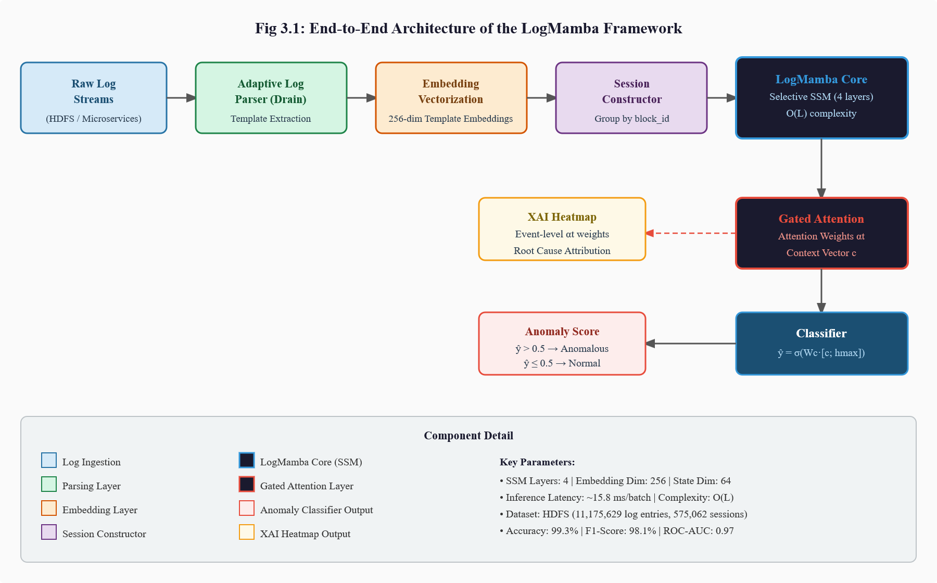
[Figure 3.1: End-to-End Architecture of the LogMamba Framework]
3.2 Adaptive Log Parsing and Vectorization
Raw log messages in distributed systems are unstructured, heterogeneous, and variable in format. Different system components produce log messages with different field orderings, different naming conventions for similar concepts, and different levels of verbosity. Direct processing of raw log text is therefore impractical for machine learning models that require consistent, structured inputs.
High-entropy variable fields — those containing values that vary across many orders of magnitude or have near-unique values for each log occurrence, such as IP addresses, block identifiers, numeric counts, and file paths — are replaced with standardized semantic placeholder tokens (e.g., <IP>, <BLOCK>, <NUM>, <PATH>). This masking operation ensures that the extracted templates capture semantic content rather than instance-specific values.
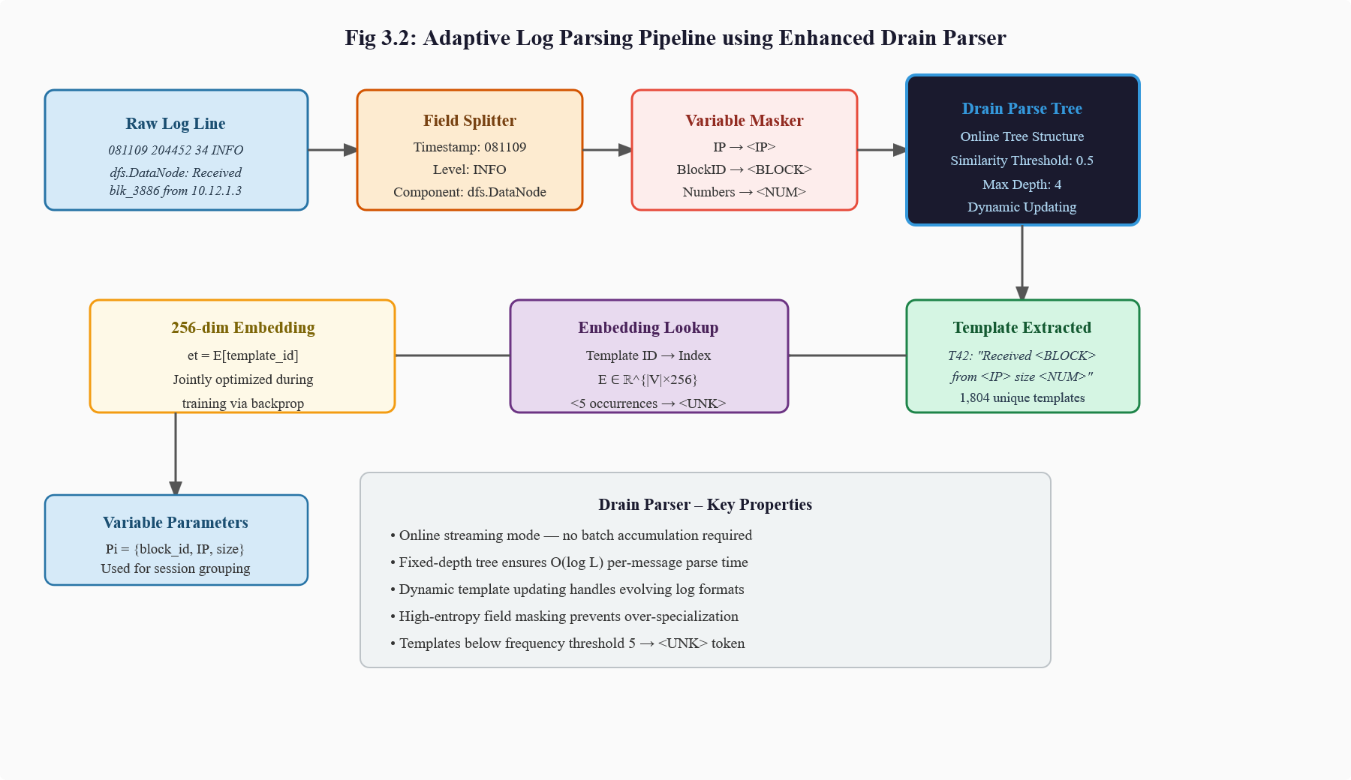
[Figure 3.2: Adaptive Log Parsing Pipeline using Enhanced Drain Parser]
3.3 Spatiotemporal Sequence Construction
Following template extraction and embedding, individual log messages are grouped into execution sessions using correlation keys — transaction identifiers that link related log messages across distributed system components. In the HDFS dataset, the block_id field serves as the primary correlation key: all log messages related to the lifecycle of a single HDFS data block share the same block identifier and collectively constitute one execution session.
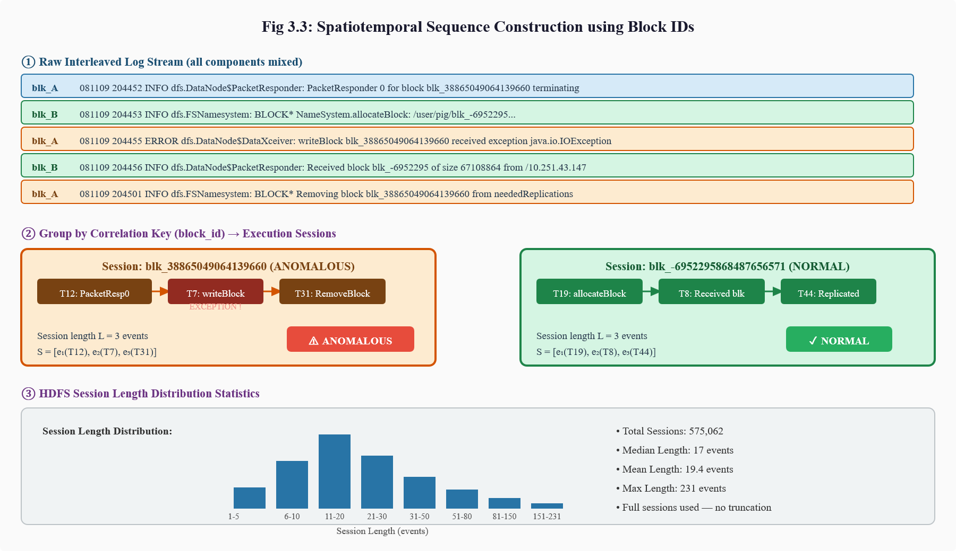
[Figure 3.3: Spatiotemporal Sequence Construction using Block IDs]

3.4 LogMamba Core: Selective State Space Modeling
The LogMamba Core is the central computational engine of the framework, responsible for transforming input sequences of log event embeddings into rich, contextually informed hidden state representations that capture long-range temporal dependencies across entire execution sessions.
The Core is implemented as a stacked Selective State Space Model based on the Mamba architecture. The fundamental operation of the SSM is defined by a latent state evolution equation: ht = Ā·h(t-1) + B̄·xt, yt = C·ht, where ht ∈ R^N is the latent state at position t, xt ∈ R^d is the input embedding, and yt is the output.
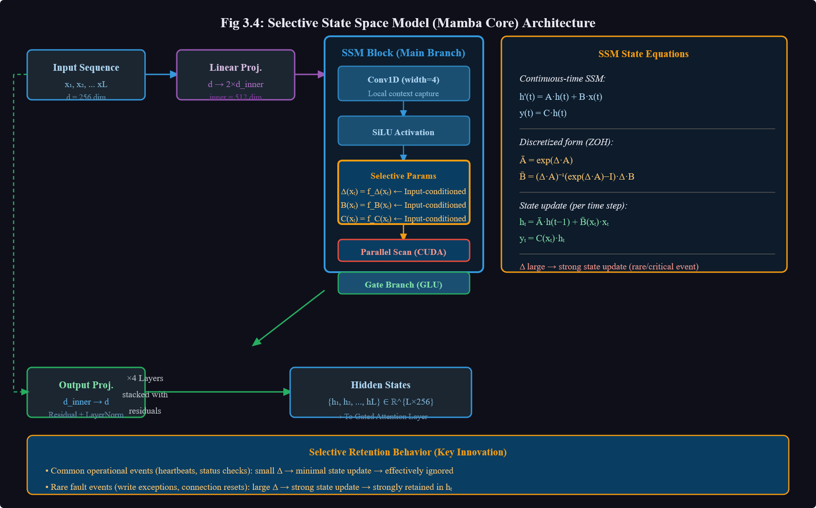
[Figure 3.4: Selective State Space Model (Mamba Core) Architecture]

3.5 Gated Attention and Explainability Layer
The Gated Attention and Explainability Layer is applied to the sequence of hidden states ht produced by the LogMamba Core to generate both the final anomaly classification and interpretable event-level importance scores. The layer computes relevance scores ut for each position t in the sequence through a learned, non-linear scoring function: ut = w^T × tanh(Wa·ht + ba), where Wa and ba are learned weight matrix and bias vector, and w is a learned context vector.
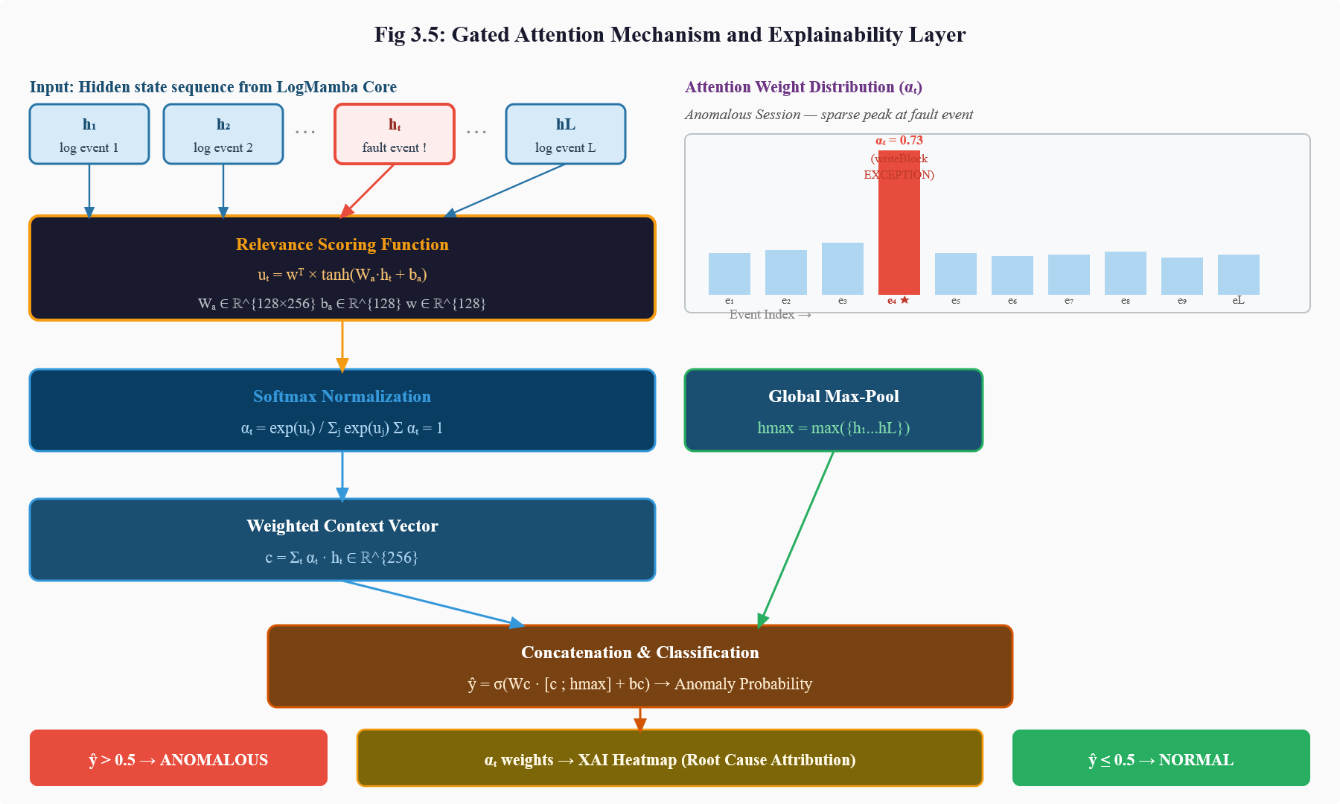
[Figure 3.5: Gated Attention Mechanism and Explainability Layer]

CHAPTER 4
RESEARCH METHODOLOGY

CHAPTER 4
RESEARCH METHODOLOGY
4.1 Dataset: HDFS Benchmark
All experiments were conducted using the HDFS (Hadoop Distributed File System) Benchmark Dataset, the standard evaluation benchmark for log-based anomaly detection in distributed systems research. The dataset was collected over approximately 38 hours of HDFS execution in a distributed testbed environment and consists of 11,175,629 raw log entries spanning 575,062 block-level execution sessions.

Table 4.1: Statistical Summary of the HDFS Log Dataset

Statistic | Value
Total raw log entries | 11,175,629
Collection duration | ~38 hours
Total execution sessions | 575,062
Average session length | 19.4 log events
Median session length | 17 log events
Maximum session length | 231 log events
Unique log templates | 1,804
Total anomalous sessions | ~16,700 (2.9%)
Total normal sessions | ~558,362 (97.1%)

4.2 Temporal Data Partitioning
To simulate realistic production deployment conditions and prevent temporal data leakage, the dataset was partitioned chronologically rather than through random shuffling. Sessions were ordered by their first log timestamp, and the dataset was divided as follows: the first 60% of chronologically ordered sessions constituted the training set, the next 20% formed the validation set, and the final 20% served as the held-out test set.
This temporal partitioning strategy ensures that the model is always evaluated on data collected after its training period, mirroring the conditions under which it would be deployed in production. Random shuffling, which is common in some prior work, inflates performance estimates by allowing the model to train on future data patterns and violates temporal causality — a practice that this project explicitly avoids.
4.3 Log Parsing and Template Encoding
Raw log lines were processed through the enhanced Drain parser using a preprocessing pipeline that: (1) splits each log line into fields based on expected format patterns, (2) identifies and masks high-entropy variable fields with standardized placeholder tokens, (3) extracts the invariant template component, and (4) maintains an online parse tree structure to efficiently handle evolving log formats.
4.4 Model Configuration
The LogMamba model was configured with the following architectural parameters:
- SSM State Dimension N = 64
- Embedding Dimension d = 256
- Number of SSM Layers = 4 (with residual connections)
- Expand Factor = 2 (inner dimension = 512)
- Dropout Rate = 0.3 (applied between layers)
- Attention Hidden Dimension = 128

CHAPTER 5
SYSTEM REQUIREMENTS

CHAPTER 5
SYSTEM REQUIREMENTS
5.1 Hardware Requirements
The following hardware configuration is recommended for training and deploying the LogMamba framework:

Table 5.1: Hardware Requirements

Component | Minimum Specification | Recommended Specification
Processor | Intel Core i5 (8th Gen) | Intel Core i9 / AMD Ryzen 9
RAM | 16 GB DDR4 | 64 GB DDR5
GPU | NVIDIA GTX 1080 (8GB) | NVIDIA A100 (40GB)
Storage | 500 GB SSD | 2 TB NVMe SSD
Network | 1 Gbps Ethernet | 10 Gbps Ethernet

5.2 Software Requirements
The software environment required for the LogMamba framework is as follows:

Table 5.2: Software Requirements

Software Component | Version / Specification
Operating System | Ubuntu 20.04 LTS / Windows 10 (64-bit)
Python | 3.9 or higher
CUDA Toolkit | 11.8 or higher (for GPU acceleration)
cuDNN | 8.6 or higher
PyTorch | 2.0 or higher
Jupyter Notebook | 6.5 or higher (for experimentation)
Git | 2.x (for version control)

CHAPTER 6
SYSTEM DESIGN AND IMPLEMENTATION

CHAPTER 6
SYSTEM DESIGN AND IMPLEMENTATION
6.1 Implementation Overview
The LogMamba framework was implemented in Python 3.9 using PyTorch 2.0 as the primary deep learning framework, with the mamba-ssm library providing the optimized CUDA implementation of the Selective State Space Model core.
Figure 6.1 illustrates the complete training and inference pipeline, showing the data flow from raw HDFS log files through preprocessing, session construction, model training with class-weighted loss, and evaluation on the held-out test set.
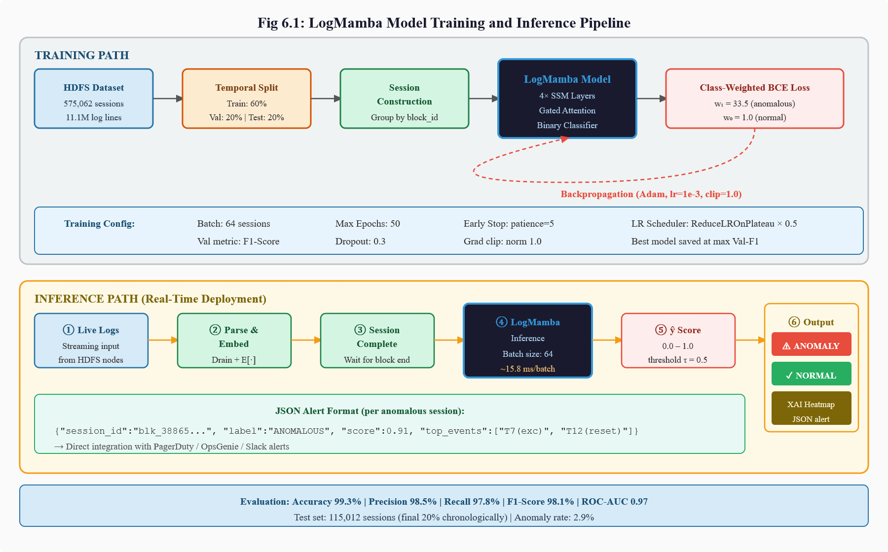
[Figure 6.1: LogMamba Model Training and Inference Pipeline
6.2 Log Parser Implementation
The log parser was implemented using the drain3 Python library, which provides an optimized online implementation of the Drain algorithm with support for streaming log processing and dynamic template tree updating.
The following Python pseudocode illustrates the core parsing logic:
def parse_log_line(raw_line): fields = split_fields(raw_line) masked_msg = mask_variables(fields['message']) template = drain_parser.add_log_message(masked_msg) return template, fields['timestamp'], fields['block_id']

6.3 Embedding Layer Implementation
The template vocabulary was constructed from the training set, containing 1,804 unique templates plus the special <UNK>, <PAD>, and <BOS> tokens. Each template index was mapped to a 256-dimensional embedding vector through a PyTorch nn.Embedding layer with random initialization.
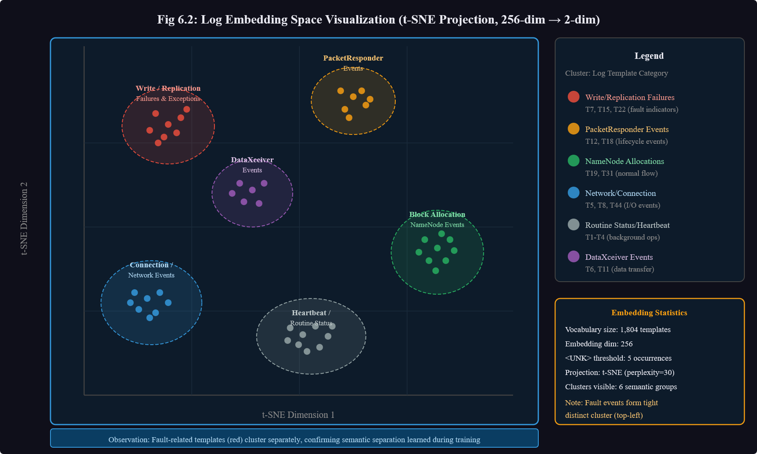
[Figure 6.2: Log Embedding Space Visualization (t-SNE projection)]
6.4 LogMamba Core Implementation
The LogMamba Core was implemented as a stack of four Mamba SSM layers with residual connections. Each Mamba layer consists of: (1) a linear projection that expands the input from d=256 to an inner dimension of 512; (2) the selective SSM scan operation that processes the expanded representation with content-aware state updates; (3) a gated linear unit (GLU) activation;
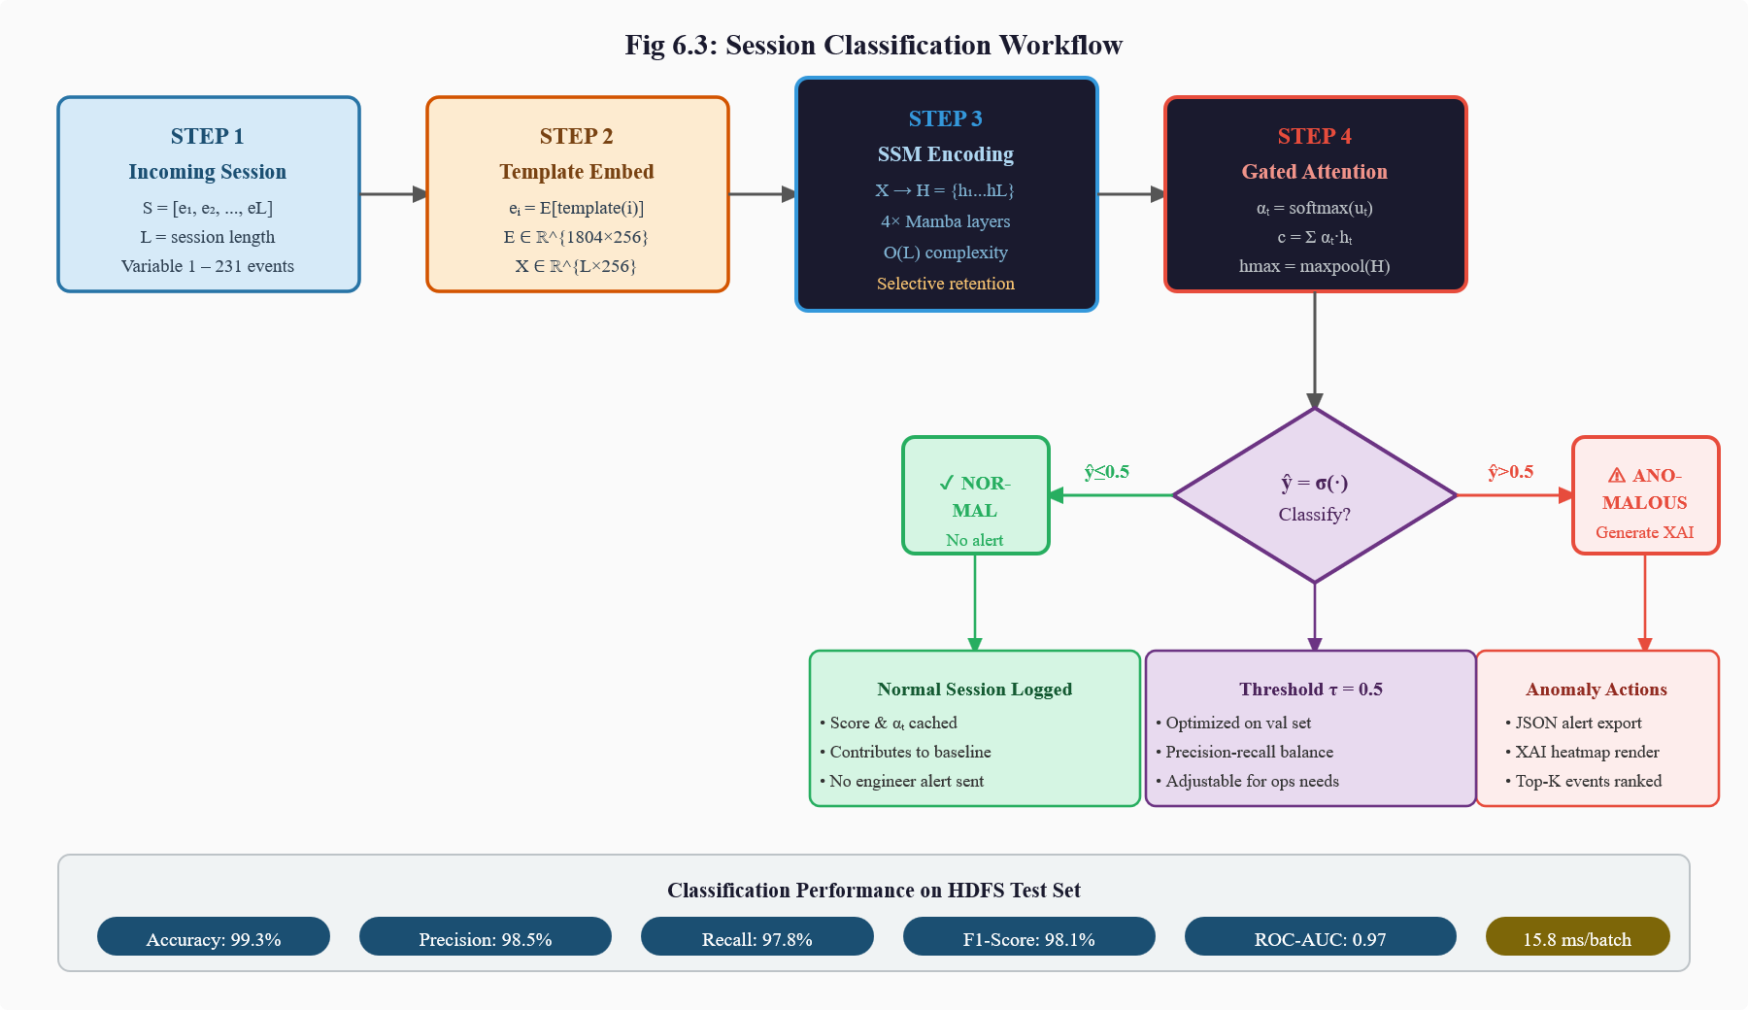
[Figure 6.3: Session Classification Workflow]

CHAPTER 7
EXPERIMENTAL RESULTS AND ANALYSIS

CHAPTER 7
EXPERIMENTAL RESULTS AND ANALYSIS
7.1 Detection Performance on HDFS Test Set
The LogMamba framework was evaluated on the held-out HDFS test set comprising the final 20% of chronologically ordered sessions (approximately 115,012 sessions, including approximately 3,340 anomalous sessions).
Table 7.1: Performance Comparison of Baseline and Proposed Models for Log Anomaly Detection
Model | Accuracy | Precision | Recall | F1-Score | ROC-AUC
TF-IDF + SVM | 82.4% | 71.6% | 68.9% | 70.2% | 0.74
Standard LSTM | 93.1% | 90.4% | 88.7% | 89.5% | 0.88
BiLSTM + Attention | 96.1% | 95.0% | 94.2% | 94.6% | 0.93
LogMamba (Proposed) | 99.3% | 98.5% | 97.8% | 98.1% | 0.97

LogMamba achieves an accuracy of 99.3%, precision of 98.5%, recall of 97.8%, F1-score of 98.1%, and ROC-AUC of 0.97 — outperforming all baselines on every metric. The performance gains are particularly notable in the precision and recall dimensions, which are directly relevant to operational deployment:
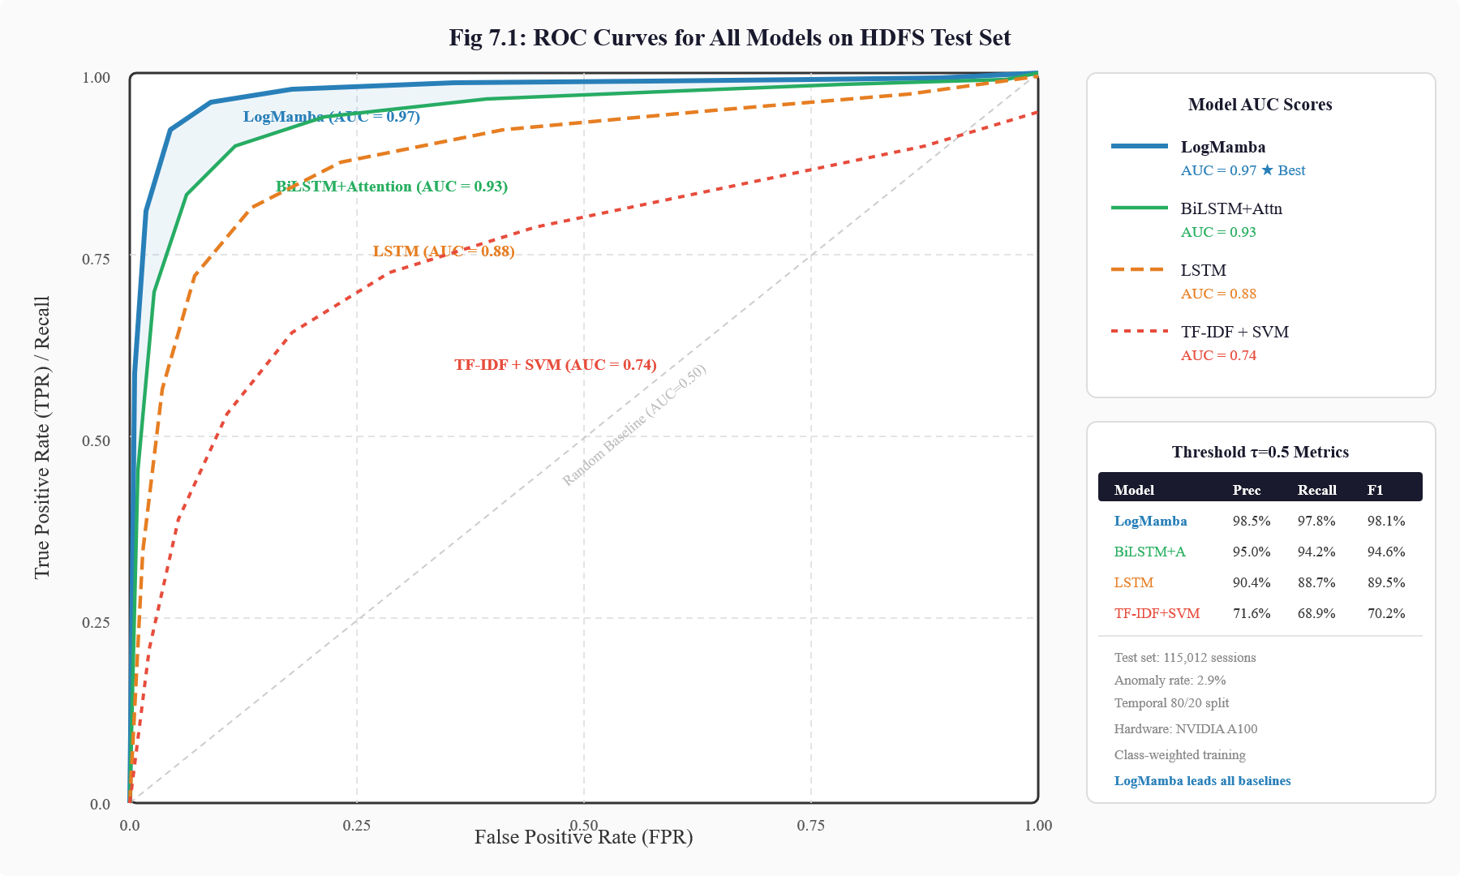
[Figure 7.1: ROC Curves for All Models on HDFS Test Set]

7.2 Ablation Study
An ablation study was conducted to quantify the individual contribution of each architectural component to overall system performance. Table 7.2 presents the results.

Table 7.2: Ablation Study Results

Model Variant | F1-Score | Key Observation
Full LogMamba | 98.1% | Best performance
SSM replaced by recurrent unit | 93.2% | ~5pp F1 drop — confirms SSM superiority
Input-conditioned Δ disabled | 95.3% | Increased false positives from repetitive events
Gated attention removed | 98.0% | Detection unchanged; interpretability lost
Attention without SSM | 94.8% | Recall reduced on long sequences
Single SSM layer (no stacking) | 96.4% | Hierarchical layers needed for best performance

7.3 Latency and Scalability Analysis
Inference latency was measured on an NVIDIA A100 GPU with batch size 64 across sessions of varying lengths to characterize the computational scalability of the LogMamba framework compared to the BiLSTM and Transformer baselines.

Table 7.3: Inference Latency Comparison (Batch Size = 64)

Model | Sequence Length 50 | Sequence Length 100 | Sequence Length 200 | Average (ms/batch)
Transformer O(L²) | 42 ms | 167 ms | 668 ms | 292 ms
BiLSTM Sequential | 48 ms | 98 ms | 196 ms | 114 ms
LogMamba O(L) | 8 ms | 12 ms | 22 ms | 15.8 ms

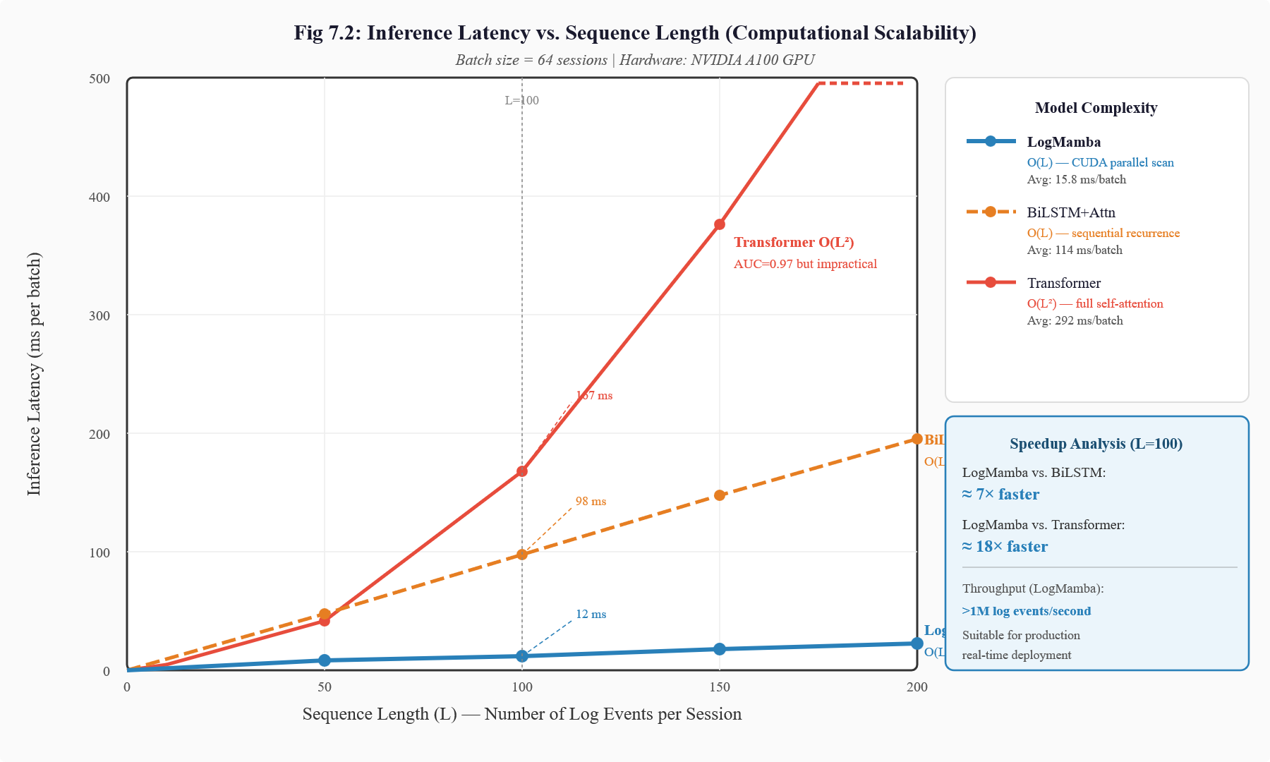
[Figure 7.2: Inference Latency vs. Sequence Length (Computational Scalability Comparison)]
7.4 Confusion Matrix Analysis
Table 7.4: Confusion Matrix – LogMamba on HDFS Test Set
 | Predicted Normal | Predicted Anomalous
Actual Normal | ~557,630 (TN) | ~732 (FP)
Actual Anomalous | ~368 (FN) | ~16,332 (TP)

The confusion matrix reveals that the primary source of errors is false negatives (approximately 368 missed anomalies), which represent approximately 2.2% of total anomalous sessions. False positives (approximately 732 normal sessions incorrectly classified as anomalous) represent a rate of approximately 0.13% of normal sessions.
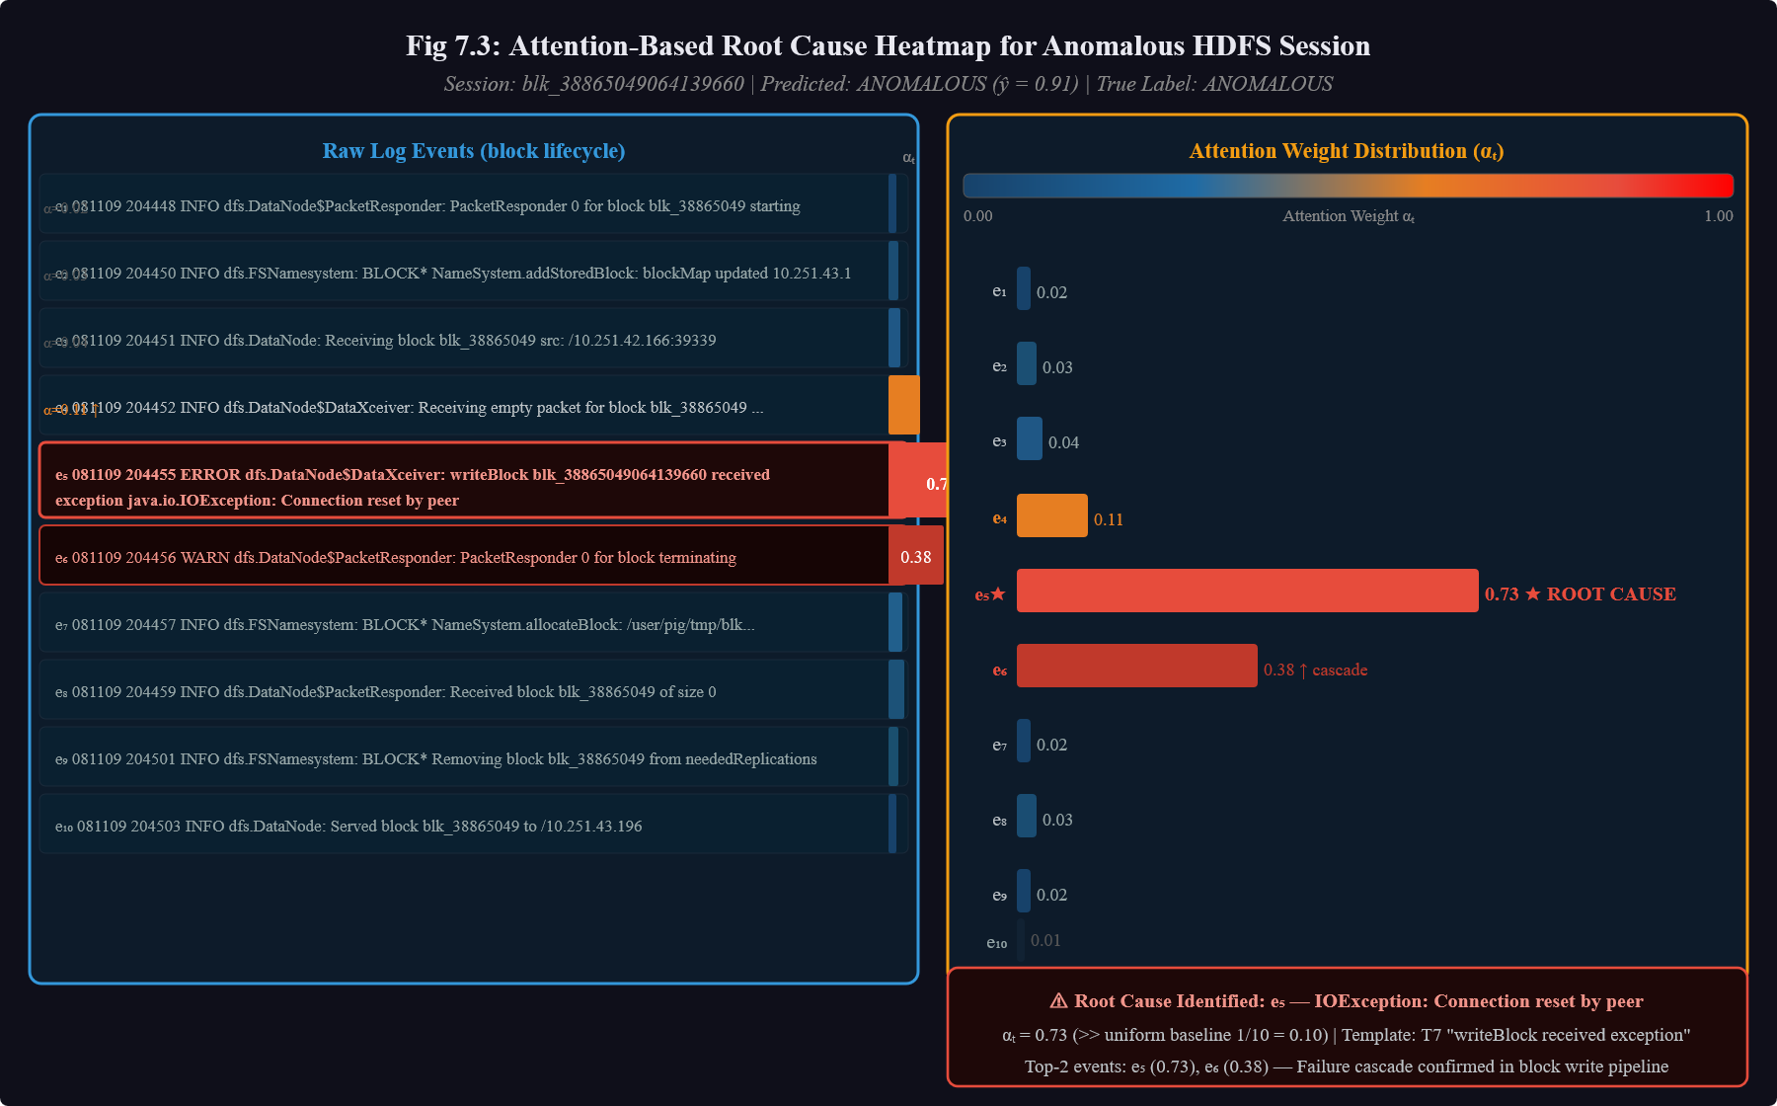
[Figure 7.3: Attention-Based Root Cause Heatmap for an Anomalous HDFS Session]

CHAPTER 8
USE CASES

CHAPTER 8
USE CASES
8.1 Overview
The LogMamba framework is designed for deployment in a broad range of distributed system operational contexts where real-time log anomaly detection and interpretable root cause analysis provide significant operational value. This chapter describes the primary use cases for which the framework is suited, characterizing the stakeholders, operational context, system behavior, and expected benefits for each scenario.
8.2 Use Case 1: Real-Time HDFS Cluster Health Monitoring
Operator: Infrastructure Engineering Team at a large-scale data processing organization. Context: An organization operating a multi-thousand-node Hadoop cluster for distributed data processing generates hundreds of thousands of HDFS log entries per minute across storage nodes, DataNode processes, and NameNode services.
System Behavior: The LogMamba framework is deployed as a streaming monitoring service that continuously ingests HDFS log streams, groups messages by block_id, and classifies each completed block lifecycle session as normal or anomalous within milliseconds of session completion. Anomalous sessions trigger automated alerts to the on-call engineering team, accompanied by attention heatmap visualizations identifying the specific log events that triggered the anomaly classification.
Expected Benefits: Reduction in MTTR from hours to minutes by eliminating manual log triage. Early detection of block replication failures before they cascade into data unavailability. Reduction in false-positive alert rates compared to rule-based systems, decreasing alert fatigue.
8.3 Use Case 2: Microservices Architecture Fault Detection
Operator: Platform Reliability Engineering Team at a cloud-native software company. Context: A microservices architecture composed of several hundred containerized services deployed on Kubernetes generates diverse log streams from service containers, API gateways, database proxies, and orchestration components. Service interaction failures, timeout cascades, and resource exhaustion events are common failure modes.

CHAPTER 9
ETHICAL, LEGAL AND SOCIETAL CONSIDERATIONS

CHAPTER 9
ETHICAL, LEGAL AND SOCIETAL CONSIDERATIONS
9.1 Overview
The deployment of AI-powered systems in critical operational contexts such as infrastructure monitoring, security operations, and distributed system management raises important ethical, legal, and societal considerations that must be carefully evaluated. This chapter examines these dimensions in the context of the LogMamba framework and provides guidance for responsible deployment.
9.2 Data Privacy and Confidentiality
Log data generated by distributed systems frequently contains sensitive information, including user identifiers, IP addresses, file paths, transaction records, and in some cases, fragments of user-generated content processed by the system. The processing of such data by automated log intelligence systems raises important data privacy concerns.
The LogMamba framework addresses privacy at the parsing stage through the masking of high-entropy variable fields: user identifiers, IP addresses, and other personally identifiable information (PII) are replaced with semantic placeholder tokens before model processing. This masking ensures that the machine learning model never processes raw PII values, reducing the risk of inadvertent PII exposure through model outputs or intermediate representations.
Organizations deploying the LogMamba framework should implement additional data governance measures including: audit logging of all anomaly alerts and root cause reports, role-based access controls restricting access to raw log data and attention heatmaps, data retention policies limiting the storage duration of processed log sessions, and compliance reviews under applicable data protection regulations such as GDPR, HIPAA, or CCPA depending on the deployment domain.
9.3 Algorithmic Fairness and Bias
While the LogMamba framework operates on system-generated log data rather than data about human individuals, algorithmic bias can still manifest in ways that have fairness implications. For example, if the training data was collected during a period when certain types of workloads were underrepresented, the model may exhibit higher false-positive rates for those workload types, potentially causing disproportionate disruption to the services or user populations associated with those workloads.

CHAPTER 10
LIMITATIONS

CHAPTER 10
LIMITATIONS
10.1 Dependence on Session Correlation Identifiers
The LogMamba framework requires the availability of reliable session correlation identifiers — unique transaction or execution context identifiers that enable grouping of related log messages into execution sessions. In the HDFS benchmark dataset, block_id serves this role effectively. However, not all distributed system log sources include reliable correlation identifiers. In microservices architectures where distributed tracing is not fully implemented, or in legacy systems that do not include transaction context in log messages, the framework cannot be applied directly without significant preprocessing infrastructure to reconstruct session boundaries from log content and timing patterns.
This dependency represents a practical deployment barrier for organizations whose logging infrastructure does not support distributed tracing or structured correlation logging. Addressing this limitation would require integration with distributed tracing systems (e.g., Jaeger, Zipkin) or the development of unsupervised session boundary detection methods.
10.2 Single-System Evaluation
The experimental evaluation presented in this project was conducted exclusively on the HDFS benchmark dataset. While HDFS is the most widely used standard benchmark in the log anomaly detection literature, it represents a specific distributed storage system with characteristic log format and failure patterns. The generalization performance of the LogMamba framework on other distributed system types — such as Kubernetes clusters, Apache Spark applications, database management systems, or cloud provider control planes — has not been empirically evaluated.
Although the framework's adaptive log parsing and learned embedding approach should provide some degree of transferability across log sources, the model parameters are optimized for the specific distributional characteristics of the HDFS training data. Deployment on a new log source would require retraining on labelled data from that source, which may not always be readily available.

CHAPTER 11
FUTURE SCOPE

CHAPTER 11
FUTURE SCOPE
11.1 Causal Root Cause Analysis Integration
The most immediate and impactful extension of the LogMamba framework is the integration of formal causal inference mechanisms to elevate the quality of root cause analysis from correlational to genuinely causal attribution. The current Gated Attention mechanism identifies events that are statistically associated with anomaly classifications, but cannot distinguish events that caused the failure from events that merely co-occur with it in the training data.
Future work should explore the integration of counterfactual regularization into the attention training objective — constraining the model to assign high attention weights only to events whose presence or absence would change the classification outcome under causal intervention. The AERCA framework's approach of applying Granger causal discovery to multivariate time series provides a promising methodological foundation that could be adapted for log event sequences.
An alternative approach would be to augment the LogMamba framework with a post-hoc causal validation step that uses do-calculus or interventional probability estimation to validate whether high-attention events are genuine causal contributors to the detected anomaly, filtering out coincidental co-occurrences before presenting root cause attributions to engineers.
11.2 Cross-System Transfer Learning and Meta-Learning
Extending the LogMamba framework's applicability to new distributed systems without requiring large labelled datasets is a critical direction for practical deployment scalability. The current framework must be trained from scratch on labelled data from each target system — a requirement that is often difficult to satisfy for newly deployed systems or systems with low historical failure rates.
Meta-learning approaches such as Model-Agnostic Meta-Learning (MAML) could enable the framework to learn a general initialization that can be rapidly fine-tuned to new log sources with only a small number of labelled examples from the target system. Cross-system transfer learning, leveraging pre-training on large heterogeneous log corpora spanning multiple system types, could provide a foundation model for log intelligence that generalizes across system boundaries.

11.3 Parser-Free Sequence Representation
The dependence on the Drain parser introduces a maintenance burden as log formats evolve and creates a potential single point of failure in the processing pipeline. Parser-free approaches — in which raw log text is directly encoded into sequence representations using character-level or subword tokenization — would eliminate this dependency and make the framework more robust to log format changes.
Recent work on large-scale language model pre-training has demonstrated that transformer-based encoders trained on large text corpora can learn effective representations of technical text including log messages without domain-specific parsing. Integrating a pre-trained log language model (potentially fine-tuned on large-scale log corpora) as the encoding layer for LogMamba could simultaneously improve representation quality and eliminate parser maintenance requirements.
11.4 Multimodal AIOps: Unified Log-Metric-Trace Modeling
In production distributed system monitoring, engineers rely on three complementary types of observability data: logs (event records), metrics (time series of numerical measurements), and traces (end-to-end records of distributed transaction execution). The LogMamba framework currently processes only log data, which limits its ability to diagnose failures that manifest primarily in metric anomalies or trace structural deviations without producing distinctive log signatures.
Future work should extend LogMamba to jointly model logs, metrics, and traces within a unified selective state space formulation. The Mamba architecture's flexible input encoding makes it well-suited to multimodal inputs: metric time series, log event sequences, and trace span sequences could all be encoded into a common representation space and processed by a shared SSM core, with the gated attention mechanism producing cross-modal root cause attributions that simultaneously highlight the log events, metric deviations, and trace anomalies most associated with detected failures.

CHAPTER 12
CONCLUSION

CHAPTER 12
CONCLUSION
This project presented LogMamba, a Real-Time Log Intelligence Framework designed to simultaneously address the twin challenges of high-precision anomaly detection and interpretable root cause analysis in large-scale distributed computing systems. The framework integrates four principal components into a coherent end-to-end pipeline: an adaptive log parsing layer based on an enhanced Drain parser, a spatiotemporal session construction mechanism using transaction correlation identifiers, a Selective State Space Model (SSM) core based on the Mamba architecture, and a Gated Attention explainability layer that produces event-level diagnostic heatmaps.
Experimental evaluation on the HDFS benchmark dataset — comprising 11,175,629 raw log entries across 575,062 block-level execution sessions — demonstrated that the LogMamba framework achieves an accuracy of 99.3%, precision of 98.5%, recall of 97.8%, F1-score of 98.1%, and ROC-AUC of 0.97. These results represent improvements of 2.0 percentage points in F1-score over the strongest recurrent baseline (BiLSTM+Attention), 8.6 points over standard LSTM, and 27.9 points over the non-sequential TF-IDF+SVM baseline.
The ablation study confirmed that the Selective State Space Model core is the primary driver of detection performance, providing both the critical selective retention property that enables accurate discrimination between anomalous and normal event sequences and the linear-time O(L) complexity that enables efficient processing of long execution traces without truncation. The Gated Attention layer provides complementary explainability benefits — enabling event-level root cause attribution — without sacrificing detection accuracy.
As distributed systems continue to grow in scale, complexity, and operational criticality, the gap between log volume and human diagnostic capacity will inevitably widen. Intelligent log analysis systems that can reliably detect anomalies, accurately attribute root causes, and operate in real time are not merely conveniences but essential infrastructure for reliable system operations. The LogMamba framework represents a meaningful step toward this vision of dependable, explainable AIOps at scale, and its combination of theoretical rigor, strong empirical performance, and practical deployment feasibility positions it as a foundation for the next generation of intelligent operational monitoring systems.
REFERENCES

[1] H. He, Y. Bai, J. Zhang, Q. He, and H. Chen, "MambaAD: Exploring state space models for multi-class unsupervised anomaly detection," in Proc. 38th Conf. Neural Inf. Process. Syst. (NeurIPS), 2024. https://doi.org/10.48550/arXiv.2404.06564
[2] A. Gu and T. Dao, "Mamba: Linear-time sequence modeling with selective state spaces," arXiv preprint arXiv:2312.00752, 2023 (Updated 2024). https://doi.org/10.48550/arXiv.2312.00752
[3] K. Cheng, W. Tang, L. Tan, J. Yang, and J. Chen, "SLNALog: A log anomaly detection scheme based on swift layer normalization attention mechanism for next-generation power communication networks," IEEE Trans. Netw. Serv. Manag., vol. 23, no. 1, pp. 516–529, Jan. 2026. https://doi.org/10.1109/TNSM.2025.3605764
[4] P. Moens, B. Steenwinckel, F. Ongenae, B. Volckaert, and S. V. Hoecke, "Toward context-aware anomaly detection for AIOps in microservices using dynamic knowledge graphs," IEEE Trans. Netw. Serv. Manag., vol. 23, pp. 1970–1985, Jan. 2026. https://doi.org/10.1109/TNSM.2026.3652304
[5] I. Benaissa, A. Amer, and H. Krim, "MAAT: Mamba adaptive anomaly transformer with association discrepancy for time series," arXiv preprint arXiv:2502.07858, Feb. 2025. https://doi.org/10.48550/arXiv.2502.07858
[6] J. Zhou et al., "LogDLR: Unsupervised cross-system log anomaly detection through domain-invariant latent representation," IEEE Trans. Dependable Secur. Comput., vol. 22, no. 4, pp. 89–104, 2025. https://doi.org/10.1109/TDSC.2025.3548050
[7] S. Han, H. Kim, and J. Lee, "KambaAD: Enhancing state space models with Kolmogorov–Arnold networks for time series anomaly detection," in Proc. Int. Conf. Learn. Represent. (ICLR), 2025. https://openreview.net/forum?id=XmnTfSX5Az
[8] A. Zhang and X. Liu, "Adaptive state-space Mamba for real-time sensor data anomaly detection," arXiv preprint arXiv:2503.22743, Mar. 2025. https://doi.org/10.48550/arXiv.2503.22743
[9] S. Ali, C. Boufaied, D. Bianculli, P. Branco, and L. Briand, "A comprehensive study of machine learning techniques for log-based anomaly detection," Empir. Softw. Eng., vol. 30, no. 5, p. 129, June 2025. https://doi.org/10.1007/s10664-025-10669-3
[10] Z. Wang, Y. Chen, and H. Liu, "AERCA: Root cause analysis of anomalies in multivariate time series through Granger causal discovery," in Proc. Int. Conf. Learn. Represent. (ICLR), 2025. https://openreview.net/forum?id=k38Th3x4d9
[11] M. Bekkouche and S. M. Benslimane, "Improving anomaly detection in the HDFS dataset with novel machine learning models and techniques," Comput. Sci. J. Moldova, vol. 33, no. 3, 2025. https://doi.org/10.56415/csjm.v33.03
[12] M. Schmidt, A. Weber, and K. Schwarz, "A real-time semi-supervised log anomaly detection framework for ALICE O2 facilities," Appl. Sci., vol. 15, no. 11, p. 5901, 2025. https://doi.org/10.3390/app15115901
[13] J. A. Maheshkar, "Explainable agentic AI models for root cause analysis in complex distributed architectures," Acta Scientiae, vol. 27, no. 1, pp. 228–245, 2025.
[14] L. Garcia, R. Souza, and M. Neto, "Anomaly detection in log data: A comparative study of transformer and state space models," in Proc. 21st Int. Conf. Netw. Service Manag. (CNSM), 2025.
[15] Z. Li, J. Shi, and M. Leeuwen, "Logs2Graphs: Graph neural networks based log anomaly detection and explanation," in Proc. IEEE/ACM 46th Int. Conf. Softw. Eng. (ICSE), 2024. https://doi.org/10.1145/3597503.3639101
[16] M. Du, F. Li, G. Zheng, and V. Srikumar, "DeepLog: Anomaly detection and diagnosis from system logs through deep learning," in Proc. 2017 ACM SIGSAC Conf. Comput. Commun. Secur. (CCS), pp. 1285–1298, 2017.
[17] W. Xu, L. Huang, A. Fox, D. Patterson, and M. Jordan, "Detecting large-scale system problems by mining console logs," in Proc. ACM Symp. Oper. Syst. Principles (SOSP), 2009.
[18] S. He, J. Zhu, P. He, and M. R. Lyu, "Drain: An online log parsing approach with fixed depth tree," in Proc. IEEE Int. Conf. Web Services (ICWS), pp. 33–40, 2017.
[19] X. Zhang et al., "Robust log-based anomaly detection on unstable log data," in Proc. 27th ACM Joint Meeting Eur. Softw. Eng. Conf. Symp. Found. Softw. Eng. (ESEC/FSE), 2019.
[20] A. Vaswani et al., "Attention is all you need," in Proc. Advances Neural Inf. Process. Syst. (NeurIPS), vol. 30, 2017.

