GALGOTIAS EDUCATIONAL INSTITUTIONS

(Galgotias College of Engineering and Technology)
Knowledge Park-II, Greater Noida, Uttar Pradesh, 201310



MCA
Python Programming Lab File - BMC 351 SESSION - 2026-27 (Odd)
SEMESTER- III

Submitted to-

Ms. Suhani (Assistant Professor)
Submitted by-Yashi Gupta

Roll No-

2500970140216

Department Of Computer Applications

INDEX

S. No | Objective of the Experiment | Date of Experiment | Date of Submission | Sign
1 | Program based on Input Output
2 | Programs based on the concepts of Building Python Modules, Obtaining user Data, Printing desired output.
3 | Programs based on the concepts of: Conditional if statements, Nested if statements, Using else if and elif
4 | Programs based on the concepts of Iteration using different kinds of loops, Usage of Data Structures: Strings, Lists, Tuples, Sets, Dictionary
5 | Program to create Student Report Card Generator
6 | Program based on the concepts of User-defined modules and Standard Library (random, numpy, scipy, sys, Math Module, String Module, List Module).
7 | Program to calculate and display the total bill for items using user input.
8 | Program based on Exception Handling
9 | Program based on Simple Data Analysis
10 | Program based on Pandas.
11 | Weekly Temperature Data Analysis and Visualization
12 | Program to visualize monthly sales data using a bar chart with the matplotlib library.
13 | Program to display the percentage distribution of expenses in different categories using a matplotlib pie chart.
14 | Program to develop an employee payroll system using single inheritance.

EXPERIMENT 1

Objective: Program based on Input Output.

Problem Statement: Write a Python program to demonstrate basic input and output operations by accepting a user’s name, age, and height, then displaying the collected information using both standard print statements and formatted output with f-strings.

Program:

# Taking different types of inputs name = input("Enter your name: ") age = int(input("Enter your age: "))
height = float(input("Enter your height in meters: "))

# Displaying the collected information print("\n--- Student Information ---") print("Name:", name)
print("Age:", age) print("Height:", height, "meters")

# Using f-string for formatted output
print(f"\nHello {name}! You are {age} years old and {height:.2f} meters tall.")

Output:

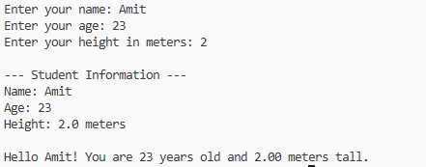

EXPERIMENT 2

Objective: Programs based on the concepts of Building Python Modules, Obtaining user data & Printing desired output.

Problem Statement: The task is to write a Python program using a user-defined module to accept a person’s first name, last name, and age in years, then display their full name, age in years, and equivalent age in months.

Program:

mymodule.py (User-defined module) # mymodule.py
def full_name(first, last): return f"{first} {last}"
def age_in_months(age_years): return age_years * 12

Main.py(Main Program)
import mymodule

# user-defined module # Taking user input
first = input("Enter your first name: ") last = input("Enter your last name: ")
age = int(input("Enter your age in years: "))
# Using functions from user-defined module name = mymodule.full_name(first, last) months = mymodule.age_in_months(age)
# Printing the desired output print("\n--- User Details ---") print(f"Full Name : {name}") print(f"Age in Years : {age}") print(f"Age in Months : {months}")

Output:

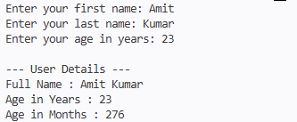

EXPERIMENT 3

Objective: Programs based on the concepts of Conditional if statements, Nested if statements & Using else if and elif

Problem Statement: The task is to write a Python program to determine a student’s grade based on marks using conditional statements, nested if statements, and elif, and display appropriate feedback messages.

Program:

# Program to demonstrate if, nested if, elif, and else
marks = int(input("Enter your marks (0-100): ")) # Using if-elif-else
if marks >= 90:
print("Grade: A+") elif marks >= 75:
print("Grade: A") elif marks >= 60:
print("Grade: B") elif marks >= 50:
print("Grade: C")
else:
print("Grade: Fail")

# Nested if example print("\nPass Status:") if marks >= 50:
print("You have passed.") if marks >= 90:
print("Excellent performance!")

else:
else:
print("Good job!")

print("You need to work harder.")

Output:
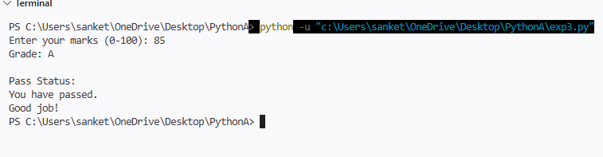

EXPERIMENT 4

Objective: Programs based on the concepts of Iteration using different kinds of loops Usage of Data Structures (Strings, Lists, Tuples, Sets, and Dictionaries).

Problem Statement: The task is to develop a Python program that demonstrates iteration using various loop constructs and different built-in data structures. The program should iterate over a string, list, tuple, set, and dictionary using for loops, showcasing the characteristics of each data structure. Additionally, it should use a while loop to print a sequence of numbers from 1 to 5. This exercise helps in understanding the differences between mutable and immutable data structures, ordered and unordered collections, and the appropriate looping techniques for each type.

Program:

# String iteration using for loop
word = "Python" print("String Iteration:") for char in word:
print(char, end=" ") print("\n")

# List iteration using for loop
print("List Iteration:") marks = [85, 90, 75, 88]
for mark in marks: print(mark)

# Tuple iteration using for loop
print("\nTuple Iteration:")
subjects = ("Math", "Science", "English") for subject in subjects:
print(subject)
# Set iteration using for loop print("\nSet Iteration:") unique_numbers = {1, 2, 3, 2, 1} for num in unique_numbers:
print(num)

# Dictionary iteration using for loop
print("\nDictionary Iteration:")

student = {"name": "Alice", "age": 20, "grade": "A"} for key, value in student.items():
print(f"{key} : {value}")
# While loop example print("\nWhile Loop Iteration:") i = 1
while i <= 5: print(f"Count: {i}") i += 1

Output:

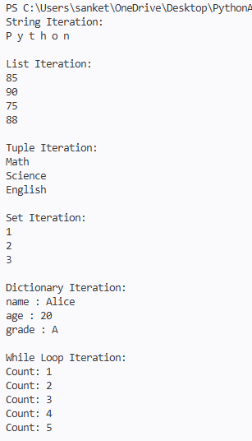

EXPERIMENT 5

Objective: Program to create Student Report Card Generator.

Problem Statement: The task is to write a Python program to generate a student’s report card by accepting personal details and marks in three subjects, calculating the total and percentage, determining the grade using conditional statements, and displaying the report in a formatted layout.

Program:

# Student Report Card Generator # Accepting student details
name = input("Enter Student Name: ") roll_no = input("Enter Roll Number: ") # Accepting marks for 3 subjects
sub1 = int(input("Enter marks in Mathematics: ")) sub2 = int(input("Enter marks in Science: ")) sub3 = int(input("Enter marks in English: "))
# Calculating total and percentage total = sub1 + sub2 + sub3 percentage = total / 3
# Determining grade if percentage >= 90:
grade = "A+"
elif percentage >= 75: grade = "A"
elif percentage >= 60: grade = "B"
elif percentage >= 50: grade = "C"
else:
grade = "Fail"
# Displaying the report card
print("\n===== Student Report Card =====") print(f"Name : {name}")
print(f"Roll No. : {roll_no}")

print(f"Mathematics: {sub1}") print(f"Science : {sub2}") print(f"English : {sub3}") print(f"Total Marks: {total}") print(f"Percentage : {percentage:.2f}%") print(f"Grade : {grade}")
print("================================")

Output:

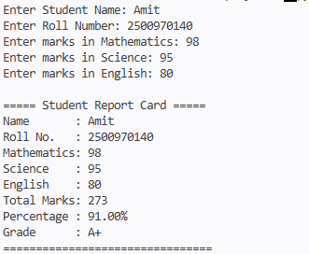

EXPERIMENT 6

Objective: Program based on the concepts of User-defined modules and Standard Library (random, numpy, scipy, sys, math, string, and list module concepts).

Problem Statement: The task is to write a Python program that demonstrates the use of both user-defined modules and standard library modules (random, numpy, scipy, sys, math, string) along with list operations. The program should perform random number generation, statistical analysis, mathematical operations, string manipulation, and custom function calls from a user-created module.

Program:

myutils.py (User-defined module)
# myutils.py
from unicodedata import name def greet(name):
return f"Hello, {name}! Welcome to the Python utility program." def square(num):
return num ** 2

main.py (Main program)
import random import numpy as np
from scipy import stats import sys
import math import string
import myutils # user-defined module # Greeting
name = input("Enter your name: ") print(myutils.greet(name))

# Random number generation
rand_list = random.sample(range(1, 100), 5) print("Random numbers:", rand_list)

# Numpy array and mean

np_arr = np.array(rand_list)
print("Mean (NumPy):", np.mean(np_arr))

# Scipy - mode of the list
mode_val = stats.mode(np_arr, keepdims=True) print("Mode (SciPy):", mode_val.mode[0])

# Math module usage
num = float(input("Enter a number to find its square root: ")) print("Square root (math):", round(math.sqrt(num), 2))

# String module usage
letters = string.ascii_lowercase
print("First 5 lowercase letters (string module):", letters[:5])

# List operation
print("Squared list (using user-defined module):", [myutils.square(x) for x in rand_list])

# Sys module usage
print("Python version info (sys):", sys.version)

Output:

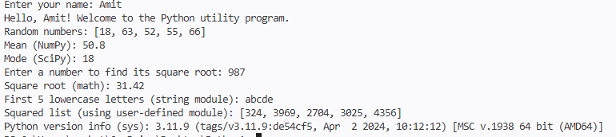

EXPERIMENT 7

Objective: Program to calculate and display the total bill for items using user input.

Problem Statement: The task is to write a Python program to take item details (name, quantity, price) from the user, calculate each item's cost, and compute the total bill.

Program:

# Program to calculate and display total bill for items
# Input number of items
n = int(input("Enter number of items: ")) total = 0.0
for i in range(n):
item_name = input(f"Enter name of item {i+1}: ") qty = int(input(f"Enter quantity of {item_name}: "))
price = float(input(f"Enter price per unit of {item_name}: ")) cost = qty * price
total += cost
# Display total bill print("\n------ BILL ")
print(f"Total Bill Amount: ₹{total:.2f}")

Output:
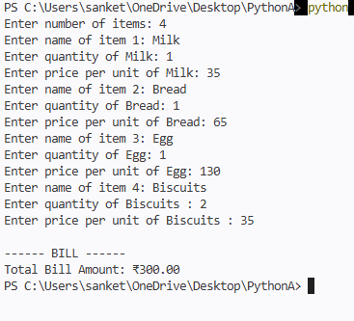

EXPERIMENT 8

Objective: Program based on Exception Handling.

Problem Statement: The task is to write a Python program to demonstrate exception handling by taking two integers as input, performing division, and handling possible errors such as division by zero and invalid inputs.

Program:

# Program to demonstrate Exception Handling in Python
try:
num1 = int(input("Enter the numerator: ")) num2 = int(input("Enter the denominator: ")) result = num1 / num2
print(f"The result of division is: {result}") except ZeroDivisionError:
print("Error: Division by zero is not allowed.") except ValueError:
print("Error: Please enter valid integers.") finally:
print("Program execution completed.")

Output:
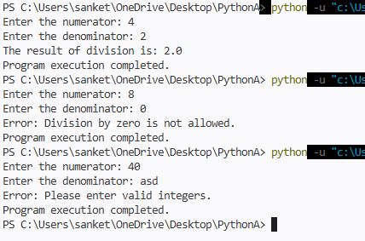

EXPERIMENT 9

Objective: Program based on Simple Data Analysis.

Problem Statement: The task is to write a Python program to perform simple data analysis on a given list of student marks. The program should calculate and display the total marks, average marks, highest mark, and lowest mark using Python’s built-in functions such as sum(), len(), max(), and min().

Program:
# Program: Simple Data Analysis # sample data: marks of student
marks = [85, 90, 76, 88, 95, 67, 80]
# performing data analysis total = sum(marks) average = total / len(marks) highest = max(marks) lowest = min(marks)
# displaying results print("Student Marks:", marks) print("Total Marks:", total) print("Average Marks:", average) print("Highest Marks:", highest) print("Lowest Marks:", lowest)

Output:
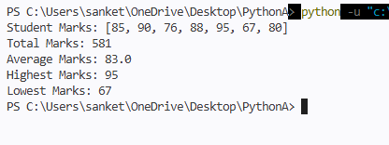

EXPERIMENT 10

Objective: Program based on Pandas.

Problem Statement: The task is to write a Python program using the Pandas library to create and display student data in a tabular form. The program should create a DataFrame from a dictionary containing "Name", "Age", and "Marks" fields, display the complete data, and then display only the first two records using the head() function.

Program:

# Program to demonstrate basic use of Pandas import pandas as pd
# Creating a DataFrame using dictionary data = {
"Name": ["Alice", "Bob", "Charlie", "David"], "Age": [20, 22, 19, 21],
"Marks": [85, 90, 75, 88]
}
df = pd.DataFrame(data)
# Displaying the complete DataFrame print("Student Data:")
print(df)
# Displaying only first 2 rows print("\nFirst 2 Records:") print(df.head(2))

Output:
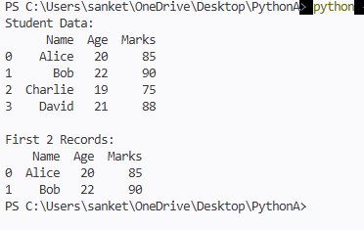

EXPERIMENT 11

Objective: Program for Weekly Temperature Data Analysis and Visualization.

Problem Statement: The task is to write a Python program to perform weekly temperature data analysis and visualize the trend using the matplotlib library. The program should calculate the total, average, highest, and lowest temperatures for a week and plot a line graph showing temperature variations across the days of the week.

Program:
# Program: Weekly Temperature Data Analysis and Visualization import matplotlib.pyplot as plt
# Step 1: Input weekly temperature data
temperatures = [32, 34, 30, 29, 31, 33, 35] # Example temperatures days = ["Mon", "Tue", "Wed", "Thu", "Fri", "Sat", "Sun"]
# Step 2: Analyze data total = sum(temperatures)
average = total / len(temperatures) highest = max(temperatures) lowest = min(temperatures)
# Step 3: Display analysis results print("Weekly Temperature Analysis:") print("Total Temperature:", total)
print("Average Temperature:", round(average, 2)) print("Highest Temperature:", highest) print("Lowest Temperature:", lowest)
# Step 4: Visualization
plt.plot(days, temperatures, marker='o', color='blue', linestyle='') plt.title("Weekly Temperature Trend")
plt.xlabel("Days of the Week") plt.ylabel("Temperature (°C)") plt.grid(True)
plt.show()

Output (Console):

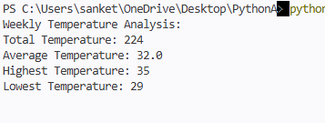

Graph Output:

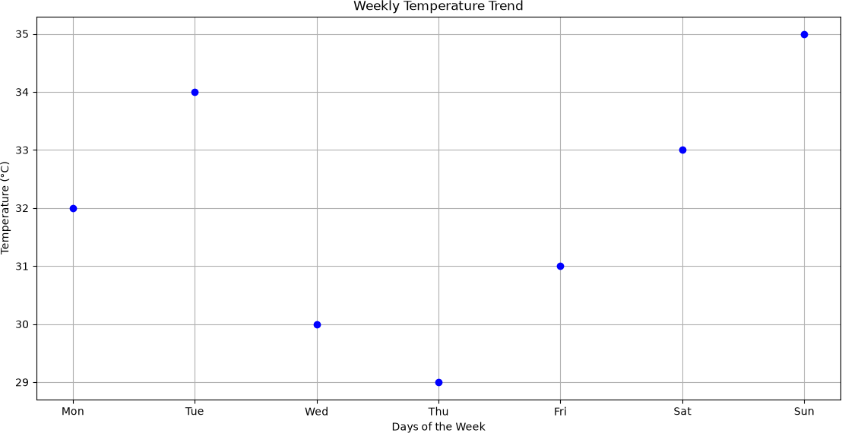

EXPERIMENT 12

Objective: Program to visualize monthly sales data using a bar chart with the matplotlib library.

Problem Statement: The task is to write a Python program to visualize monthly sales data using a bar chart with the matplotlib library. The program should display sales figures for each month, customize the chart with labels and a title, and use colors to enhance readability.

Program:
# Program to visualize monthly sales data using a bar chart import matplotlib.pyplot as plt
# Data
months = ["Jan", "Feb", "Mar", "Apr", "May", "Jun",
"Jul", "Aug", "Sep", "Oct", "Nov", "Dec"]
sales = [12000, 15000, 17000, 14000, 20000, 25000,
22000, 21000, 23000, 24000, 26000, 30000]
# Plotting bar chart
plt.bar(months, sales, color='skyblue') # Adding labels and title plt.xlabel("Months")
plt.ylabel("Sales in INR") plt.title("Monthly Sales Data - 2025") # Display the bar chart
plt.show()

Graph Output:

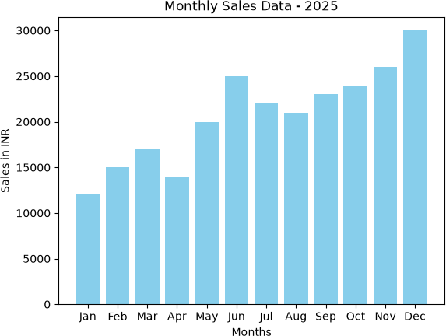

EXPERIMENT 13

Objective: Program to display the percentage distribution of expenses in different categories using a matplotlib pie chart.
Problem Statement: The task is to write a Python program to visualize monthly sales data using a bar chart with the matplotlib library. The program should display sales figures for each month, customize the chart with labels and a title, and use colors to enhance readability.

Program:
import matplotlib.pyplot as plt # Input expense categories
categories = ["Rent", "Food", "Transport", "Entertainment", "Others"]
expenses = [15000, 8000, 3000, 2000, 1000]
# Plot the pie chart
plt.pie(expenses, labels=categories, autopct='%1.1f%%', startangle=90)
# Add title
plt.title("Percentage Distribution of Monthly Expenses") # Display chart
plt.show()

Graph Output:

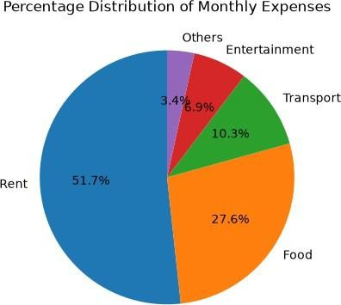

EXPERIMENT 14

Objective: Program to develop an employee payroll system using single inheritance. Learning Outcomes:
Problem Statement: The task is to write a Python program to develop an employee payroll system using single inheritance. The program should use a parent class Employee to store basic employee details and a child class Payroll to calculate salary components such as HRA, DA, PF, and Tax, and compute the net salary.

Program:

# Program to develop an Employee Payroll System using Single Inheritance # Parent Class
class Employee:
def init (self, emp_id, name, basic_salary): self.emp_id = emp_id
self.name = name self.basic_salary = basic_salary

# Child Class
class Payroll(Employee):
def init (self, emp_id, name, basic_salary): super(). init (emp_id, name, basic_salary) self.hra = 0.10 * basic_salary # 10% HRA self.da = 0.05 * basic_salary # 5% DA self.pf = 0.08 * basic_salary # 8% PF self.tax = 0.02 * basic_salary # 2% Tax self.net_salary = 0
def calculate_salary(self):
self.net_salary = (self.basic_salary + self.hra + self.da) - (self.pf + self.tax) def display_payroll(self):
print("\n----- Employee Payroll ")
print(f"Employee ID : {self.emp_id}") print(f"Name : {self.name}") print(f"Basic Salary : ₹{self.basic_salary:.2f}") print(f"HRA : ₹{self.hra:.2f}")
print(f"DA : ₹{self.da:.2f}")

print(f"PF : ₹{self.pf:.2f}")
print(f"Tax : ₹{self.tax:.2f}")
print(f"Net Salary : ₹{self.net_salary:.2f}")

# Main Program
emp_id = input("Enter Employee ID: ") name = input("Enter Employee Name: ")
basic_salary = float(input("Enter Basic Salary: ₹")) payroll = Payroll(emp_id, name, basic_salary) payroll.calculate_salary()
payroll.display_payroll()

Output:



