Java Access Modifiers Practice Questions
Level 1 (Easy)
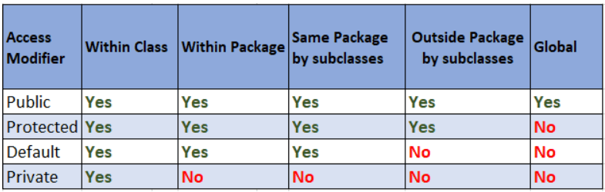
Question 1: Student Information System
Create a Student class.
Requirements:
- studentName should be public.
- rollNumber should be private.
- course should be protected.
- collegeName should have default access.
Create getter and setter methods for rollNumber.
From the main() method:
- Set all values.
- Print all accessible values.
- Access the private variable using getter.

Question 2: Bank Account
Create a class named BankAccount.
Requirements:
- Account Holder Name → public
- Account Number → private
- Balance → private
Methods:
- deposit()
- withdraw()
- checkBalance()
Conditions:
- Balance cannot become negative.
- Deposit amount cannot be negative.

Question 3: Employee Salary
Create an Employee class.
Requirements:
- employeeName → public
- employeeId → private
- salary → private
Create methods:
- setSalary()
- getSalary()
Condition:
Salary cannot be less than 15,000.

Question 4: Mobile Phone
Create a Mobile class.
Variables:
- Brand
- Model
- IMEI Number
- Price
Requirement:
Only IMEI Number should be private.
Create getter and setter for IMEI Number.

Question 5: Car Details
Create a Car class.
Variables:
- Brand
- Model
- Engine Number
- Price
Make the Engine Number private.
Display all details using methods.

Level 2 (Medium)
Question 6: ATM Machine
Create an ATM class.
Variables:
- accountHolder
- pin
- balance
Requirements:
- PIN must be private.
- Balance must also be private.
Methods:
- login()
- withdraw()
- deposit()
- checkBalance()
Condition:
Withdrawal should only happen after entering the correct PIN.

Question 7: Hospital Management
Create a Patient class.
Variables:
- patientName
- patientId
- medicalHistory
- doctorName
Requirements:
Medical History should be private.
Create methods:
- addMedicalHistory()
- displayPatient()

Question 8: College Result System
Create a StudentResult class.
Variables:
- Student Name
- Roll Number
- Marks
Requirements:
Marks should be private.
Methods:
- setMarks()
- calculateGrade()
- displayResult()

Question 9: E-Commerce Product
Create a Product class.
Variables:
- Product Name
- Product ID
- Price
- Stock
Requirements:
Price and Stock should be private.
Methods:
- purchase()
- addStock()
- displayProduct()
Conditions:
Stock should never become negative.

Question 10: Movie Ticket Booking
Create a MovieTicket class.
Variables:
- Movie Name
- Seat Number
- Ticket Price
- Booking Status
Requirements:
Booking Status should be private.
Methods:
- bookTicket()
- cancelTicket()
- showStatus()

Level 3 (Advanced)
Question 11: Online Banking System
Create two classes.
Account
Private Variables:
- accountNumber
- balance
- PIN
Public Methods:
- deposit()
- withdraw()
- changePIN()
- checkBalance()

Bank
Methods:
- transferMoney()
- createAccount()

Question 12: Employee Payroll
Create classes:
Employee
Private Variables:
- Salary
- Bonus
Protected Variables:
- Department
Public Variables:
- Name
Create Payroll class to calculate monthly salary.

Question 13: Library Management
Classes:
- Book
- Student
- Library
Requirements:
Book ID should be private.
Methods:
- issueBook()
- returnBook()
- searchBook()

Question 14: School Management System
Classes:
- Student
- Teacher
- Principal
Requirements:
Fees should be private.
Only the Principal can update fees.
Students can only view fees.

Question 15: Online Shopping Cart
Create classes:
- Product
- Customer
- Cart
Requirements:
Product Price should be private.
Methods:
- addProduct()
- removeProduct()
- calculateBill()

Level 4 (Package-Based Access Modifier Practice)
These questions help students understand public, private, protected, and default across packages.

Question 16: University Management
Package 1:
- Student
Package 2:
- Main
Try accessing:
- public
- protected
- default
- private variables
Observe which variables are accessible.

Question 17: Animal Management
Package:
animals
Classes:
- Animal
- Dog
Another Package:
zoo
Class:
- Zoo
Use different access modifiers and verify accessibility.

